TELOMERE INSTABILITY AND THE FORMATION AND TRANSMISSION OF RADIATION INDUCED DNA DAMAGE.

(TELORAD)

FINAL REPORT

February 2000 to January 2003

Contract : FIGH-CT1999-0009

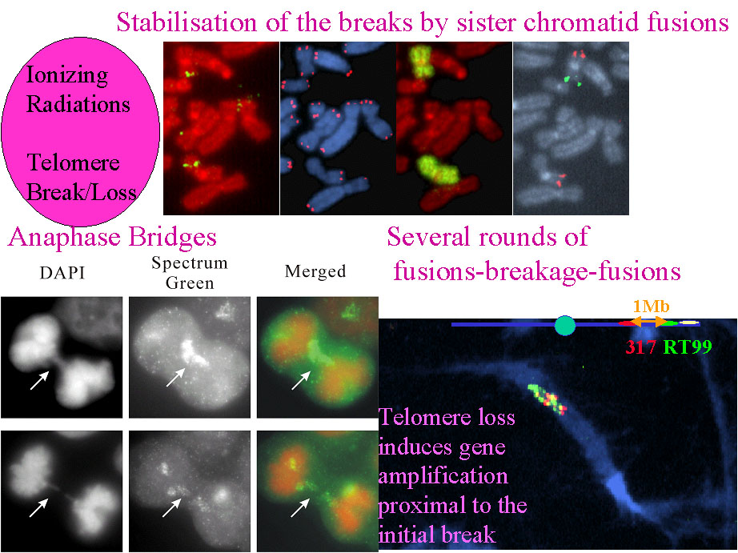

Partners
- Laure Sabatier | CEA-  Coordinator | Commissariat à l’Energie Atomique Fontenay-aux-Roses | France
- Maria Blasco | CNB | National Centre of Biotechnology Madrid | Spain
- Anna Genesca | UAB | Universitat Autonoma de Barcelona | Spain
- Predrag Slijepcevic | UBRUN | Brunel University | UK
- José-Luis Fernandez | COG | Centro Oncologico de Galicia | Spain
- Elena Giulotto | UNIPV | Università di Pavia, Pavia | Italy
- Chiara Mondello | IGBE - CNR | Istituto di Genetica Biochimica ed Evoluzionistica, Pavia | Italy
TABLE OF CONTENTS
TABLE OF CONTENTS 2
INTRODUCTION 3
OBJECTIVES 4
PROGRESS & RESULTS 5
WP1. Radiosensitivity of telomerase-, telomeric proteins- and repair deficient mice and cells 5
Task 1.1. Survival of telomerase and repair-deficient mice upon radiation. 5
Task 1.2. Determination of induction of cytogenetic damage and DNA breakage upon radiation in MEFs and cell lines 5
Task 1. 3. Rescue of short telomeres by telomerase prevents chromosomal instability and loss of cell viability in telomerase deficient mice 10
Task 1. 4. Generation of double mutants for telomerase and DNA repair and telomeric proteins and study of their radiosensitivity 10
Task 1. 5. Analysis of DNA breakage level and repair in splenocytes from mice 11
Task 1.6. Telomere length as a marker for chromosomal radiosensitivity 14
Task 1.7 Set up the models to analyze the influence of telomere binding proteins in Radiosensitivity 16
WP2. Radiosensitivity and repair of interstitial telomeric sites (ITS) . 17
Task 2.1. Sensitivity to breakage of ITS and efficiency of repair with time 17
2.1.1. Naturally occuring ITS 17
2.1.2. Artificially introduced ITS 21
2.1.3 ITS derived from rearrangements 23
Task 2.2.Sensitivity to breakage of ITS in repair-deficient cells 25
Task 2.3.Formation of new ITS 28
WP 3 Mechanisms of capping of radiation induced DNA Breaks 29
Task 3.1 The analysis of capping of radiation induced DNA breaks in human cells and in mice deficient for telomerase 29
3.1.1. Capping events in human cells without telomerase 29
3.1.2 Capping events in mouse cells without telomerase 30
Task 3.2 The analysis of capping events in mice and human cells deficient in DNA repair genes 32
3.2.1 Capping of breaks in DNA-PKcs-/- mice 32
3.2.2. Capping of breaks in human cells derived from patients with ataxia-telangiectasia (A-T) 34
3.2.3 Development of a non-radioactive TRAP assay 36
Task 3.3 The analysis of capping events in meiotic cells of telomerase knockout mice 36
Task 3.4 Capping events after telomere loss 37
WP4. Transmission of radiation induced DNA damage 39
Task 4.1 Transmision of radiation induced DNA damage in mice with dysfunctional telomeres 39
Task 4.2 Determination of gene amplification upon radiation in MEFs and cell lines. 39
Task 4.3 Gene amplification drived by telomere loss. 43
MAIN ACHIEVEMENTS 45
DISCUSSION / MAIN ACHIEVEMENTS 46
PUBLICATIONS 50

INTRODUCTION
Risk estimation for the induction of cancer by radiation in human populations is based on epidemiological data. Most of the extrapolations (at low dose, at low dose rate, partial exposure, etc.…) are limited by their ignorance of the mechanisms of cancer induction. Large sets of data have been accumulated to determine the quality and quantity of radiation induced DNA damage. Loss of DNA repair capacity is often observed in radiosensitive individuals. When TELORAD started, many genes involved in DNA repair were identified and some of them were found to be involved in radiosensitive disorders. However the level of variation in individual response is so high that it may be expected that many other genes were to be discovered (some of them having been discovered meanwhile). Until now it has not been possible to forge a definitive link between the rate of induced DNA breaks and individual cancer risk estimate.

Ionising radiation damages DNA and induces mutations and chromosomal anomalies. DNA double strand breaks (DSB) produced by ionizing radiations pose a particular hazard to cells. DSB can be stabilized through chromosome rearrangements or capped by the acquisition of telomeres, giving rise to a terminal deletion. Persistent DSBs can lead to carcinogenesis through activation of oncogenes, loss of tumor-supressor genes or loss of heterozygosity. If they occur in germ cells, terminal deletions are known to be associated with abortions and a wide variety of birth defects in humans and possibly hereditary effects.Broken chromosomes are highly unstable (fusions, deletions) and are quickly repaired. Telomeres, the very ends of the chromosomes act as natural caps and prevent chromosomes from fusion with one another. The proteins involved in telomere maintenance play a role in the distinction between radiation-induced DNA breaks which are subject to repair and telomeres.

TELORAD is focused on specific candidate genes involved in DNA-repair and on genes involved in telomere maintenance and aims to advance their knowledge of the mechanisms underlying DNA damage processing and stabilisation and then transmission trough cell divisions, the first steps towards radiation-induced tumours.

The relevance of the models used , mice with genetic backgrounds lacking telomerase, PARP, ATM, DNA-PKs, Ku 80, double mutant mice and cells overexpressing specific genes are the tools which have been awaited for several years to address the questions of interconnections between the non homologous end joining pathway and telomere maintenance. These two pathways are crucial one for DNA repair, one for tumour development (85% of tumours present telomerase activity). Evidence is accumulating indicating that the two pathways are linked and in yeast, it has been demonstrated that DNA repair deficient cells present telomere phenotypes.

TELORAD will address the question of the mechanistic link between these two process in mammalian cells (mice, hamster and human to determine the mechanistic link between telomeres, telomerase, telomere binding proteins and DNA repair genes and their respective roles in cellular radiosensitivity. Mechanisms of stabilisation of broken chromosome ends, a starting point in the transmission of radiation induced damage, will be studied. Short telomeric arrays are also present at intrachromosomal locations, probably reflecting species evolution. The stability of these Interstitial Telomeric Sequences (ITS) will be studied. Long term consequences, such as gene amplification will be investigated to identify the involvement of telomere maintenance in radiosensitivity of individuals.

OBJECTIVES
The aim of TELORAD is to study telomere instability and the formation and transmission of radiation induced DNA damage.

TELORAD will be split into four workpackages, each one with specific objectives

The work content in WP1 aims to determine the mechanistic link between telomerase, telomeric proteins and DNA repair genes in radiosensitivity. TELORAD will characterize radiosensitivity of mice deficient in telomerase (mTER-/-) and telomeric proteins (TRF1-/-) and compare it with that of mice deficient in DNA-PKcs, Ku, PARP and ATM proteins as well as wild type (wt) mice. This will also serve as an important control database prior to generating double mutant mice. Six generations of mTR-/- are available with decreasing telomere length, providing tools to study the consequences of telomere shortening at the level of organismes. Other mutant mouse will be used for PARP, DNAPKcs, Ku80 and ATM and double mutants will be generated by crosses . These animal models will permit many insights into the relation between DNA repair genes and telomere maintenance.

In the human genome TTAGGG sequences are not located only at the ends of linear chromosomes, short arrays are present at intrachromosomal locations. WP2 is focused on the determination of the propensity of Interstitial Telomeric Sequence (ITS) to breakage and on the determination of the role of telomerase and DNA repair genes in the sentivity to breakage and in the efficiency of repair of ITS. One important point will be to determine if ITS are more prone to initial breakage repaired less or misrepaired more frequently than random sequences.Thus the main challenge of WP2 is to answer the question : Are ITS hot spots for radiation breakage?

WP3 deals with the characterisation of capping of radiation-induced DNA breaks. Broken DNA ends can be stabilised by DNA capping. Chromosome healing has been observed in mouse embryonic stem cells. It has been speculated that capping of DSB following exposure to ionizing radiations may be mediated by telomerase. Alternatively, DSB may be stabilized by telomere capture, a recombination based mechanism. The telomerase RNA-knockout mice and repair-deficient mice will be particularly useful for the examination of the contribution of both telomerase and recombination based processes to mammalian DNA capping.Insight into the mechanisms of capping of radiation-induced DNA breaks is crucial to the understanding of the biological consequences of exposure to ionizing radiation. Two mechanisms of stabilization of radiation-induced breaks: recombination mediated telomere capture, and chromosome healing by telomerase will be particularly studied.

In WP4, the question addressed is be the transmission of stabilised DNA damage. Chromosome rearrangements are poorly transmitted trough cell divisions. 50% of dicentric chromosomes disappear at each cell division, and 30% of complex rearrangements. Thus in few cell divisions after irradiation, only transmissible rearrangements are retained: e.g. translocations,and inversions. Very few deletions are observed. By contrast, radiation-induced solid tumours (except thyroid tumours) present a high level of chromosome imbalances and gene amplification. TELORAD aims to contribute to understanding the mechanisms underlying the transmission of stabilised broken ends and chromosome alterations detected in tumours. Interest is focused on gene amplification and chromosome imbalances as detected in human radiation-induced tumours.

PROGRESS & RESULTS
WP1. Radiosensitivity of telomerase-, telomeric proteins- and repair deficient mice and cells
Task 1.1. Survival of telomerase and repair-deficient mice upon radiation.
Maria Blasco and her team have studied the effect of ionizing radiation on the survival of wild-type, first generation (G1) and late generation (G5) telomerase deficient mice, Terc-/-, upon the administration of cumulative doses of gamma rays. The telomerase deficient mice with short telomeres are more radiosensitive than the wild-type or the G1 mice, indicating that telomere length is one of the biological determinants of radiation sensitivity in mammals (Goytisolo et al., 2000). This study also suggests that a combination of telomerase inhibitors and radiotherapy would be an effective way to kill tumor cells. This task has been performed in collaboration with the sub-contractor Simon Bouffler. More recently, in collaboration with TELORAD contractor Jose Luis Fernandez, Maria Blasco and her team have determined that the late generation Terc-/- MEF have a significantly slower rate of double strand break repair than the wild-type controls (unpublished data).
Task 1.2. Determination of induction of cytogenetic damage and DNA breakage upon radiation in MEFs and cell lines
Predrag Slijepcevic earlier work suggested that scid mice have abnormal processing of telomeres . This abnormality is complex and involves both telomere elongation and telomeric fusions (TFs). To investigate if DNA-PKcs deficiency is directly responsible for this telomere phenotype Predrag Slijepcevic and his team used a somatic genetic approach. DNA-PKcs deficiency in a scid cell line has been complemented by introducing a fragment from human chromosome 8 that contains an intact copy of this gene. The resulting cell line has been named scid 100E. As a negative control they used the same scid cell line in which a fragment from human chromosome 8 lacking the gene encoding DNA-PKcs was introduced. Resulting cell line has been named scid 50D. All cell lines have been obtained from Dr. C. Kirchgessner, Stanford University. To investigate radiosensitivity of these cell lines Predrag Slijepcevic and his team measured frequencies of chromosome breaks and gaps following irradiation with 1 Gy gamma rays. Results of this experiment are shown in Fig. 1.

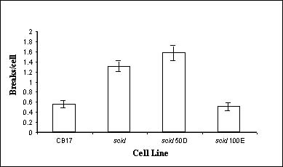
Figure 1. Frequencies of chromatid breaks/cell in four cell lines following exposure to 1.0 Gy gamma rays. The difference in frequencies of breaks between scid and scid100E cells is statistically significant (p<0.05).
As expected, radiosensitivity phenotype was eliminated in scid cells following introduction of the gene encoding DNA-PKcs (Fig. 1). Next, Predrag Slijepcevic and his team wanted to investigate if introduction of DNA-PKcs had any effect on telomere length and frequencies of TFs. their results revealed that introduction of DNA-PKcs reverted telomere length to the level found in wild type CB17 cells (Fig. 2 A). Telomere length in the negative control cell line scid50D was not changed (Fig 2 A). Similarly, TFs in scid cells disappeared almost completely after introducing functional DNA-PKcs but remained unchanged in negative control cells (Fig 2 B). These results suggest that DNA-PKcs plays a direct role in telomere maintenance.

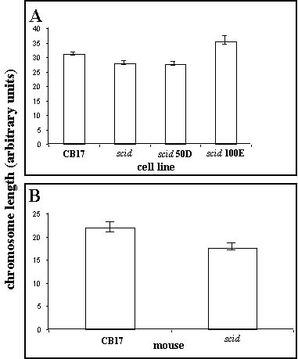
Figure 2. Telomere length (A) and telomeric fusions (B) in four cell lines.

In addition, they observed that chromosomes prepared from the scid cell line are much more condensed than chromosomes from the complemented scid cell line, scid 100E, after treatment with equal concentrations of colcemid (Fig. 3 A). The same effect was observed when scid mice are used and compared against wild type CB17 mice (Fig. 3B). This suggests that either DNA-PKcs deficiency causes a defect in chromatin condensation, or that DNA-PKcs deficient cells respond more strongly to colcemid treatment than wild type cells.
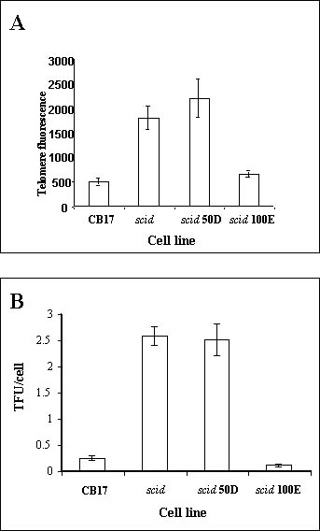
Figure 3. Chromosome length in four cell lines (A) and mice (B). Chromosome length was measured digitally after treatment of cells or mice with equal concentrations of colcemid. One wild type CB17 mouse and one scid mouse were used. Chromosomes were prepared from mouse bone marrow cells.

To examine further mechanisms of telomere elongation in scid cells Predrag Slijepcevic and his team used a scid cell line deficient in homologous recombination (HR). In this cell line one of the key HR genes, RAD54, was inactivated by dominant negative approach. Similarly RAD54 deficiency was induced in wild type CB17 cells. Cell lines have been obtained form C. Kirchgessner, Stanford University. Analysis of telomere length in these cell lines revealed that scid cells deficient in HR show telomere shortening in comparison with parental scid cells (Fig 4 A). In contrast, no difference in telomere length was observed between wild type CB17 cells and CB17 cells lacking functional RAD54. These results suggest that telomere elongation in scid cells may be partially due to HR and that HR does not significantly contribute to telomere maintenance in wild type mouse cells. This work will be continued within TELOSENS. Predrag Slijepcevic and his team want to investigate contribution of telomerase to telomere maintenance in scid cells. They also observed presence of TFs without telomeric signals at fusion points in scid cells with deficient RAD54 (Fig. 4 B) another indication of telomere shortening in this background. In contrast, the only type of TF found in scid cells is that with telomeric signals at the fusion points (Fig 4 B).

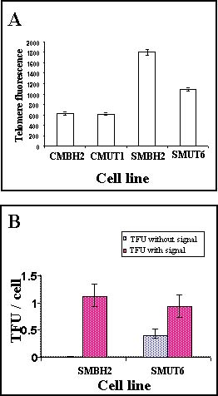
Figure 4.A. Telomere length measured by Q-FISH in four cell lines. CMBH2 is a CB17 cell line with an empty vector. CMUT1 is a CB17 cell line in which RAD54 was inactivated by dominant negative approach. SMBH2 is a scid cell line with an empty vector. SMUT6 is a scid cell line in which RAD54 was inactivated by a dominant negative approach.
Figure 4.B. Frequencies of telomeric fusions/cell in scid cell lines with and without functional RAD54.
In collaboration with another TELORAD partner, Dr Blasco, Predrag Slijepcevic and his team examined telomere maintenace in Ku deficient mice. In line with above results Ku mice show similar telomere phenotype: telomere elongation and high level of TFs (see report of M. Blasco).
One of the predictions from their early results is that telomere maintenance and radiosensitivity may be linked (see above). To investigate further this link Predrag Slijepcevic and his team used two mouse lymphoma cell lines named LY-S and LY-R. LY-R is a parental cell line and it is known to have normal response to ionizing radiation (IR). After prolonged in vitro culture this cell line spontaneously transforms into an IR sensitive cell line termed LY-S. The LY-S cell line was the first mammalian cell line known too be sensitive to IR (Alexander and Mikulski 1961). Exact nature of IR sensitivity of LY-S cells remains unknown but it is clear that these cells have abnormal processing of DSBs in comparison to parental cells. To test the link between radiosensitivity and telomere mainteance Predrag Slijepcevic and his team examined telomere length in these two cell lines. their results revealed normal telomere length in LY-R cells but about seven-fold reduction in telomere length in LY-S cells (Fig 5 A-C). Telomerase activity (Fig 5 D) and all components of telomerase enzyme (not shown) are normal in both cell lines and no difference was observed between cell lines in this respect. Their results, therefore, support the view that there is a link between telomere mainteance and radiosensitivity.

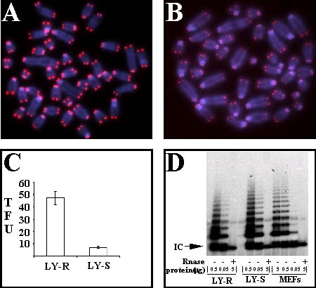
Figure 5. A/ A metaphase spread from an LY-R cell. B/ A metaphase spread from an LY-S cell.
C/ Telomere length measurement in LY-R and LY-S cells by Q-FISH. D/ Telomerase activity in LY-R and LY-S cells measured by the TRAP assay. MEFs (mouse embryonic fibroblasts) were used as control.

Task 1. 3. Rescue of short telomeres by telomerase prevents chromosomal instability and loss of cell viability in telomerase deficient mice
During the TELORAD project, Maria Blasco and her team demonstrated that is possible to prevent chromosomal instability, as well as, the phenotypes associated to critical telomere shortening by re-introducing a copy of the Terc gene in the telomerase-deficiente mice (Samper et al., 2001). These findings indicate (i) that critically short telomeres are responsible of the chromosome end-to-end fusions, as well as of the premature aging pathologies associated to telomerase deficiency present in these mice, and (ii) that both chromosomal instability and premature aging phenotypes can be prevented by rescuing short telomeres through reintroduction of telomerase. This study has also provided evidence that telomerase preferentially acts on critically short telomeres instead of normal-length telomeres. Of relevance for this project, the radiosensitive phenotype of cells and mice with short telomeres can be prevented through elongation of the short telomeres by telomerase re-introduction.
Finally, these findings have important implications for the potential use of telomerase as a putative therapy to prevent age-associated diseases or premature aging syndromes that are characterized by a faster rate of telomere shortening (Werner syndrome, Bloom syndrome, etc).

Task 1. 4. Generation of double mutants for telomerase and DNA repair and telomeric proteins and study of their radiosensitivity
During the TELORAD contract, Maria Blasco and her team have generated increasing generations (mice with progressively shorter telomeres) of the following double knock out mouse models for telomerase (Terc-/-) and DNA double strand break repair proteins. PARP was also included, since it had been proposed to have a role in telomere capping.

1) Terc^{-/-}/DNA-PKcs^{-/-}
2) Terc^{-/-}/Ku86^{-/-}
3) Terc^{-/-}/PARP-1^{-/-}

First, Maria Blasco and her team characterized telomere length and function in Ku86-/-, DNA-PKcs-/- and PARP-/- single knock-out mice and cells. They found that both components of the non-homologous end-joing pathway, Ku86 and DNA-PKcs, are essential for preventing end-to-end fusions independently of telomere length. Hence, these proteins have a fundamental role in telomeric capping (Samper et al., 2000; Goytisolo et al., 2001). In contrast, PARP-1 deficiency did not result in loss of telomere capping or in loss of telomere repeats (Samper et al., 2002), suggesting that this protein does not have a major role in telomere protection.
To understand the functional interactions between these different activities at the telomere, Maria Blasco and her team studied telomere length and function in the different double knock-out mouse models described above. The study of increasing generations of Terc-/-/Ku86-/- mice demonstrated that Ku86 function mediates both end-to-end chromosomal fusions and apoptosis triggered by critically short telomeres in telomerase-deficient mice (Espejel et al., 2002a). These results indicate that the non-homologous end-joining pathway (NHEJ) is central in processing and signaling telomere dysfunction.
In addition, Maria Blasco and her team have demonstrated that Ku86 acts as a negative regulator of telomerase at the telomere, since its absence leads to a telomerase-mediated telomere elongation (Samper et al., 2000; Espejel et al., 2002a). As part of the characterization of Ku-deficient mice, they have identified telomere-dependent senescence-like arrest in mouse embryonic fibroblasts derived from either telomerase deficient or Ku86 deficient mice (Espejel et al., 2002b). This finding indicates that the mechanisms leading to cell arrest as a consequence of telomere dysfunction are common to human and mouse.
Maria Blasco and her team have also studied telomere length and function in increasing generations of the Terc-/-/DNA-PKcs-/- mice. The results obtained revealed that DNA-PKcs cooperates with telomerase in maintaining telomere length (Espejel et al., 2002c). In particular, mice doubly deficient in Terc and DNA-PKcs show a faster rate of telomere shortening that each of the single mutant mice, suggesting that in the absence of telomerase, DNA-PKcs deficiency results in a faster rate of telomere loss.
The study of increasing generations of the Terc-/-/PARP-1-/- mice is currently being finished in the laboratory. In particular, Maria Blasco and her team find that PARP-1 deficiency does not influence the rate of telomere loss in the absence of telomerase, suggesting that is not an important activity for telomere length maintenance, in agreement with previous results published by them(Samper et al., 2001a).
Task 1. 5. Analysis of DNA breakage level and repair in splenocytes from mice
DBD-FISH is a new procedure, developed in José Luis Fernandez laboratory, that allows to analyse DNA breakage and repair in the whole genome or within specific DNA sequence areas, cell by cell. Cells immersed in an agarose matrix on a slide are deproteinized and treated with an alkaline unwinding solution that transforms DNA breaks into restricted single-stranded DNA (ssDNA) motifs which are targets for hybridization of DNA probes. As breaks increase with dose, more ssDNA is produced and more probe hybridizes, increasing the intensity and surface of the signal. The probe used selects the chromatin area to be analysed (Fernández et al, 2002; Fernández and Gosálvez, 2002) Due to their novelty, previously to analyse splenocytes from normal and mutant mice, José Luis Fernandez and his team initially began to establish the procedure in normal human blood leukocytes. The whole genome and three different human satellite DNA families have been assayed for X-ray initially induced DNA breaks: whole alphoids, satellite 1, and 5 base pairs (bp) classical satellites: D1Z1, D9Z3 and DYZ1 loci (Fig. 6)

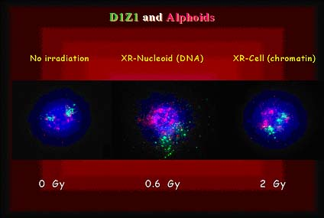
Figure 6. DBD-FISH signals from human blood leukocytes, analysing the 5 bp classical satellite DNA of chromosome 1 (D1Z1 locus) in green, and the whole alphoids, in red. Here is an example of an unirradiated cell, a nucleoid exposed to 0.6 Gy and a cell exposed to 2 Gy of X-rays.
They observed that different sequences exhibit different background signals, 5 bp classical satellites containing a high concentration of alkali-labile sites. Irradiation of nucleoids revealed a differential sensitivity of the sequences to the alkaline denaturation. That is, the alkaline unwinding solution generates around half of the signal when breaks are present in the 5bp classical DNA satellites as when the same density of breaks is present in the genome overall. After correction for this, chromatin containing 5 bp classical satellites exhibited a slightly higher sensitivity to X-ray induced breakage. The minimum detectable dose was 0.1 Gy for the whole genome, 0.2 Gy for the alphoids and satellite 1, and 0.4 Gy for the 5 bp classical DNA satellites. Human telomeres behave as strand breaks, contributing to basal DNA breaks, appearing labeled in un-irradiated cells (Vázquez-Gundín et al., 2002).

After establishing the technical bases in humans, José Luis Fernandez and his team began with DBD-FISH with a whole genome probe in splenocytes for normal and mutant mice. Mouse cells showed 50 times more background labeling in the genome overall than humans, taking into account that both species exhibit the same genome size. This basal labeling was concentrated in specific nuclear regions that were identified as those containing the mouse major satellite DNA. Thus, this satellite exhibit a great amount of alkali-labile sites, possibly to allow a dense chromatin packing, resembling the 5 bp classical satellites of the human genome. This has relevant implications in interspecific chromatin structure, as well as in the tendency to fragility and recombination characteristic of these specific DNA sequence areas (Rivero et al., 2001).

From the technical point of view, this finding supposed a problem to go on with DBD-FISH in mouse cells, due to their high background. Other problem with the task was the fact that splenocytes, non-cycling cells, showed a very reduced repair rate, even in normal non-mutant mice. Other final problem was that DBD-FISH identifies mainly single-strand breaks (ssb), whereas most of repair-deficiencies in KO mice are related to double-strand break (dsb) repair.

To overcome the latter problem, José Luis Fernandez and his team decided to work with a human cell line (MO59J) repair-deficient for dsb, as a model to try to adapt their technique for dsb detection. When cells are lysed and electrophoresed in gel under neutral conditions, following the neutral comet-tail test, the electrophoretic migration is related to the dsb yield. Afterwards, if José Luis Fernandez and his team perform the DBD-FISH (i.e. unwinding and hybridization) with a whole genome probe, they obtain a FISH signal from the comet. The mean fluorescence intensity of this signal is related to the ssDNA unwound from the DNA breaks (mainly ssb) present in the comet. Otherwise, the length or surface area of this same signal is dependent on the dsb yield. After assaying different conditions, a protocol for DBD-FISH on neutral comets was established. The study with the dsb repair-deficient cell line and with H2O2-treated leukocytes, demonstrated that this procedure detects both ssb and dsb simultaneously, in single cells (Fernández et al., 2001), being the method of choice for testing the KO mice described in the project. Images based on this work were selected as cover print for the Number I, October 15, 2001 of Experimental Cell Research (Fig. 7). Further work is in progress to study the best mathematical parameters to analyze the breakage level induced within specific human DNA sequences, using DBD-FISH on neutral comets. Moreover, a new approach of DBD-FISH performing a two-dimensional electrophoresis either under alkaline or neutral conditions is now in progress, trying to develop another system for simultaneous ssb and dsb detection in single cells, exclusively based on morphological parameters.

The problem of using non-cycling splenocytes, with reduced repair capacity, was overcame by the employment of Mouse Embryonic Fibroblasts (MEFs), provided by Maria Blasco. Finally, the intense background of mouse cells due to their high density of constitutive alkali-labile sites, was reduced by using an acid unwinding, much weaker than the alkaline. This provided a linear dose-response, not saturated in the high-dose range necessary for dsb study.

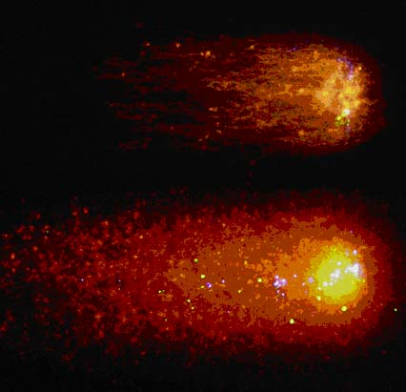
Figure 7. Cover print for the Number I, October 15, 2001 of Experimental Cell Research, showing DBD-FISH signals on neutral comets from an unirradiated human blood leukocyte (above) and from another one exposed to 40 Gy of X-rays (below), hybridising with a whole genome probe (red), a D1Z1 locus probe (green) and a DYZ1 locus probe (blue). Whereas the migration length should be related to the dsb yield, the mean fluorescence intensity is indicative of the ssb level.

Thus, after this extensive fine-tuning, José Luis Fernandez and his team have an original system, adapted for the aim of the task: DBD-FISH on neutral comets, using an acid denaturation step, in mouse MEFs irradiated with 80 Gy of X-rays. This work was very time-consuming for their laboratory, around 16 months. Thus, they decided to focus exclusively in the whole genome, i.e. to hybridise a whole genome probe, and not to use specific probes, to go on with the rest of the study. their preliminary results demonstrate that the Ku -/- MEFs show a strong deficiency in dsb repair, rejoining only around 30% of induced dsb. Unexpectedly, the PARP -/- MEFs showed a normal ssb repair rate, without differences with that of control wild-type. This suggests that the radiosensitivity due to the lack of PARP activity is not related to the repair kinetics of ssb. In relation to TERC -/- MEFs, those from the First generation exhibit a similar repair kinetics than the wild-type, for both ssb and dsb. Nevertheless, their results with the fourth generation seem to reveal an slower dsb repair rate, around 50% being unrejoined one hour after irradiation (Fig. 8).

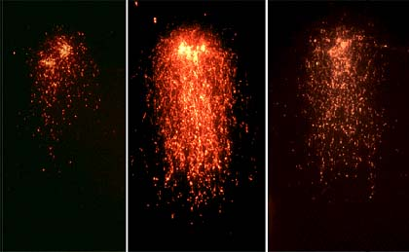
Figure 8. DBD-FISH on neutral comets from MEFs hybridised with a whole genome probe. Left: unirradiated cell. Middle: cell exposed to 80 Gy of X-rays. Right: Cell exposed to 80 Gy of X-rays, leaving 60 min of repair. The migration lenth, indicative of dsb, is only slightly decreased after the repair time.

Task 1.6. Telomere length as a marker for chromosomal radiosensitivity
Maria Blasco and her team have collaborated with TELORAD contractor Predrag Slijepcevic to study the radiation sensitivity of several tumor-derived cell lines showing significant differences in telomere length. The conclusions of these studies are that tumor with shorter telomeres are more radiosensitive (McIlrath et al., 2001). These results agree with the increased radiosensitivity of telomerase deficient mice with short telomeres as discussed above.

To investigate if this link holds in a different model system Predrag Slijepcevic and his team used human lymphocytes from 24 breast cancer patients and 5 normal individuals. They monitored radiosensitivity of lymphocytes using G2 assay and measured telomere length in these cells using Q-FISH. Their results revealed a significant negative correlation between these two parametares i.e. the shorter the telomeres the higher sensitivity to IR (Fig 9). Therefore, their results further support the view that telomere maintenance and radiosensitivity are linked. This line of investigation will be continued under the TELOSENS project by examining telomere maintenance in cells from patients with different forms of DSB deficiencies.

To investigate the link between radiosensitivity and telomere maintenance further Predrag Slijepcevic and his team used Chinese hamster cells as another useful model. They obtained Chinese hamster cell lines deficient in DNA-PKcs, Ku ATM and genes involved in HR from various sources. All cell lines are radiosensitive. Predrag Slijepcevic and his team then investigated telomere mainteance in these cell lines. Summary of this study is presented in Table 1. Interestingly, none of the cell lines showed clear evidence of telomere dysfunction i.e. TFs (Table 1). However, in the case of some DNA-PKcs and Ku deficient cell lines Predrag Slijepcevic and his team observed changes in telomere length i.e. telomere elongation, in comparison with parental cells. This suggests that both proteins may be involved in telomere length regulation.
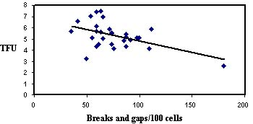
Figure 9. Telomere length in telomere fluorescence units (TFU) in lymphocytes from 24 breast cancer patients and 5 normal individuals and frequencies of chromatid breaks and gaps in lymphocytes from the same individuals detected by the G2 assay. A correlation analysis a significant inverse correlation between chromosomal radiosensitivity and telomere length (p<0.05).

Table 1. Results of telomere length measurements, average numbers of dicentric chromosomes, average chromosome numbers, numbers of chromosomes >1 ITS and results of TRAP assay for each cell line. Asterisks indicate statistical difference in comparison with parental wild type cell line.

Cell line | Telomere Fluorescence  (arbitrary units) | Dicentric chromosome / cell | Chromosome number / cell | >1 interstitial telomeric signal/chromosome / cell | TRAP
CHO9 | <100 | 0 | 21.0 + 0.11 | 1.70 + 0.096 | Positive
XR-C1 | 157.0 + 11.0* | 0.08 + 0.02 | 20.7 + 0.14 | 1.98 + 0.040 | Positive
XR-C2 | 154.1+ 4.1* | 0.02 + 0.02 | 20.88 + 0.171 | 0.98 + 0.078 | Positive
V79B | 190.5 + 3.8 | 0 | 20.58 + 0.137 | 0.12 + 0.046 | Positive
XR-V15B | 215.4 + 4.0* | 0.32 + 0.083* | 19.98 + 0.195 | 0.06 + 0.034 | Positive
XR-V16B | 188.5 + 3.4 | 0 | 20.68 + 0.144 | 0.02 + 0.020 | Positive
AA8 | <100 | 0.06 + 0.034 | 19.64 + 0.089 | 0 | Positive
irs1SF | <100 | 0.14 + 0.054 | 19.30 + 0.512 | 2.34 + 0.109* | Positive
V79 | 188.0 + 5.27 | 0 | 19.58 + 0.149 | 0 | Positive
irs1 | 184.2 + 18.9 | 0 | 22.30 + 0.231* | 2.5 + 0.162* | Positive
irs2 | 166.4 + 6.7* | 0.14 + 0.060 | 19.70 + 0.170 | 0.02 + 0.020 | Positive
CHO-K1 | <100 | 0.06 + 0.034 | 22.52 + 0.135 | 2.68 + 0.088 | Positive
xrs5 | <100 | 0.02 + 0.020 | 21.74 + 0.228 | 2.36 + 0.102 | Positive

Task 1.7 Set up the models to analyze the influence of telomere binding proteins in Radiosensitivity
Maria Blasco and her team have transduced human primary fibroblasts (IMR90) with a pBabe retroviral vector containing either wild-type TRF1 or a dominant negative version of it, which lacks the DNA binding domain. The transduced IMR90 cells have been selected for puromycin resistance and will be used in the future to study the effect of wild-type or dominant negative TRF1 expression on the radiosensitivity of human primary cells.
In collaboration with her subcontractor Eric Gilson, Laure Sabatier and her team investigated the control of telomere length by the human telomeric proteins TRF1 and TRF2. They established telomerase positive cell lines where one can induce the targeting of these telomeric proteins to specific telomeres. These targeting leads to telomere shortening. This indicates that these proteins act in cis to repress telomere elongation. Howerver these proteins behaved differently. Inhibition of telomerase activity by a modified oligonucleotide did not further increase the pace of telomere erosion caused by TRF1 targeting, suggesting that telomerase itself is the target of TRF1 regulation. In contrast, TRF2 targeting and telomerase inhibition have additive effects. The possibility that TRF2 can activate a telomeric degradation pathway was directly test in human primary cells that do not express telomerase. In these cells, overexpression of full length TRF2 leads to an increase rate of telomere shortening (Ancelin et al, 2002).The analysis of the role of TRF1 has permitted to investigate the influence of telomere proximity and composition on the expression of a EGFP reporter gene. In transient transfection assays, telomeric DNA does not repress EGFP in cis but rather slightly increases its expression. By contrast, in stable cell lines, the same reporter construct appears repressed when inserted at a subtelomeric location. This repression is transiently alleviated by increasing the dosage of the TTAGGG Repeat Factor 1 (TRF1) without an apparent modification of telomere length. These findings demonstrate that TPE in human cells is dependent on a specific organization of the telomeric chromatin (Koering et al, 2002). Other proteins involved in radiosensitivity have been tested : Parp1 and Parp2 (Menissier-deMurcia et al, 2003). Such models could be useful to study the influence of telomeric proteins in the radiosensitivity of human cells.
Laure Sabatier and her team developed a new method to measure telomere length : an accurate, simple and rapid method for telomere length measurement (Figure 10).

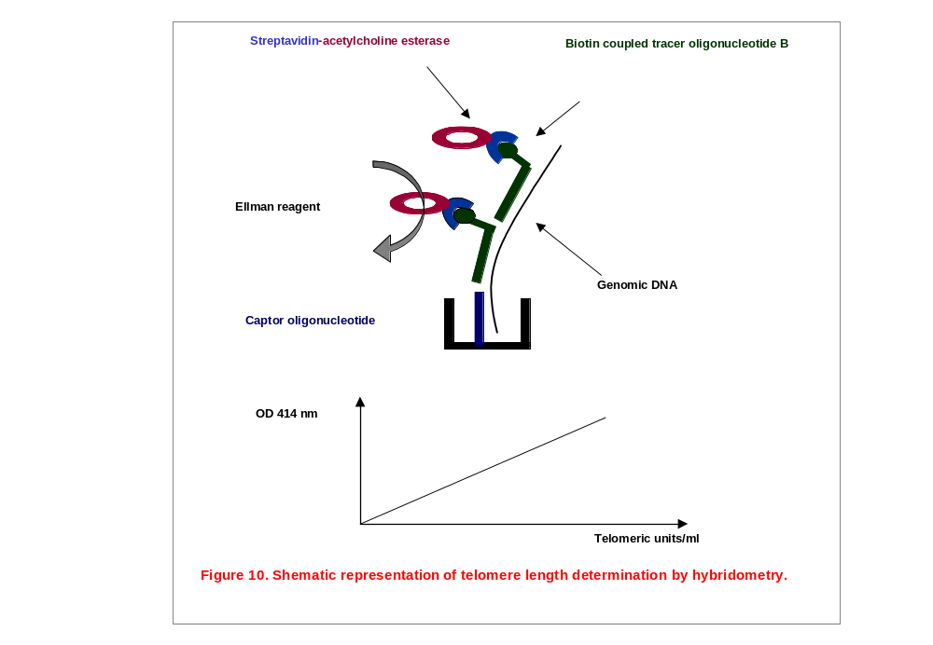
Traditionally, Southern Blotting of enzyme-digested DNA is performed, which suppose 1 to 5 μg of purified DNA and 5 days experimentation. An innovative, accurate and rapid hybridometric technique based on affinity of telomeric DNA with an oligonucleotide covalently fixed on microplate and enzymatic detection of the complex has been developped in her laboratory and patented. This technique can be performed in one day on crude NaOH cell lysate of much more different samples in the same experimentation than Southern blotting. A patent has been obtained for this technic (Potocki et al, 2001; Freulet-Marrière et al, Submitted)

WP2. Radiosensitivity and repair of interstitial telomeric sites (ITS) .
During speciation chromosomes have undergone many rearrangements which some have led to the internalization of telomeric sequences. DNA sequences identical to the telomeric repeats are present at intrachromosomal sites (interstitial telomeric sites or ITS) and at least one hundred of such sequences have been identified in the human genome by fluorescence in situ hybridization (FISH) (Azzalin et al. Cytogenet. Cell Genet. 78, 112; 1997). It has been suggested that ITS are sites of prefential chromosome breakage. This hypothesis derives mainly from cytogenetic evidence indicating that sites of chromosome breakage, recombination and amplification often colocalize with internal telomeric sequences. However most of these data have been obtained in Hamster cells in which ITS colocalizes frequently with centromeric and heterochromatic regions. Thus the radiosensitivity of ITS in other species (including human) is questionable.

Task 2.1. Sensitivity to breakage of ITS and efficiency of repair with time
2.1.1. Naturally occuring ITS
Primates
To address the proneness to break of euchromatic natural ITS, Laure Sabatier and her team first have selected different species of apes (Cerco Mona mona, Cerco Diana diana, Cebus capucinus and Macaca fascicularis). Because their karyotypes have been shown to result from evolutionary chromosomal fusions or fissions (Figure 1), they expected to easily detect ITS. FISH using telomeric PNA probe was applied on fibroblasts from these different species. Unfortunately, two of them failed to show a detectable FISH signal and the two other ones presented easily detectable ITS but which were located near centromeric region, as observed in hamster cells. They became then less interesting to assess the sensitivity of telomeric sequences rather than heterochromatic sequences (Figure 11). Laure Sabatier and her team focused then their work on finding new species with euchromatic ITS.

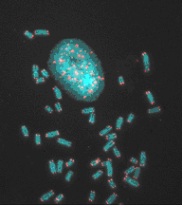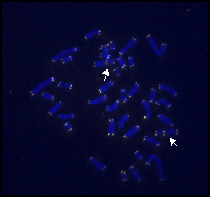
Figure 11 : FISH of telomeric PNA probe on Primates chromosomes.

Pig
Laure Sabatier and her team have easily detected one, using telomeric PNA probe, on the pig chromosome 6 which long arm presents homologous fragments with human chromosomes 1, 18 and 19 (Figure 12). ZOO-FISH with human chromosome 1, 18 and 19 painting probes on pig chromosomes has allowed them to detect this ITS at the junction of the human chromosomes 19 and 1 fragments (Figure 13).

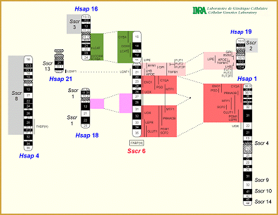
Figure 12: Homology between Human (HSAp) chromosomes and Pig (SSCr) chromosome 6.

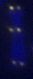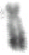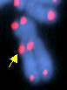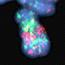
Figure 13: Detection by FISH of the telomeric PNA probe, of the ITS located at the junction of the homologous fragments of human chromosomes 1 (red) and 19 (green) on the pig chromosome 6.

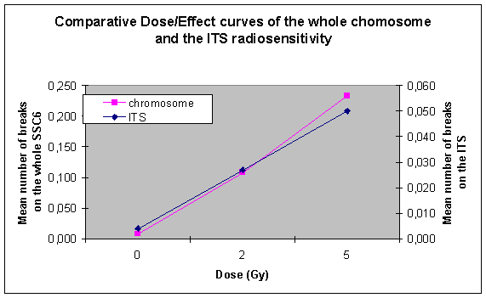
Figure 14: Comparative Dose/Effect curves of the radiosensitivity of the ITS and the whole chromosome 6.
Laure Sabatier and her team performed then the radio sensitivity study of this natural euchromatic ITS after a γ- irradiation at 2 and 5 Gy. The number of radio induced breaks occurring between the 19 and 1 human chromosomal fragments containing the ITS has been compared to the expected number of breaks, obtained when the total number of breaks occurring on the whole chromosome is plotted against the size of the ITS. In this case, no difference has been observed suggesting that this natural ITS does not enhance the radiosensitivity of the evolutionary junction site (Figure 14). It still remains interesting to compare the number of radio induced breaks occurring between the 19 and 1 human chromosomal fragments containing the ITS with the breaks involving the 1/18 junction.

Human
To assess the radio-sensitivity of ITS in human cells, Laure Sabatier and her team have compared the locations of radiosensitive sites (RSS) in human chromosomes with those of ITS published by Elena Giulotto’s team, using FISH of a telomeric DNA probe on human metaphases (Azzalin C. et al., 1997). Chromosomes from human irradiated metaphases were R-banded and each detectable breakpoint was assigned to a cytogenetic band allowing them to build a map of the RSS. Using this approach, some ITS appear to preferentially co-localize with RSS. Nevertheless, the most radiosensitive sites do not correspond to the purest and longest ITS as the chromosome 2q13 band, containing the telomeric repeat sequences resulting from the telomere fusion of ancestral chromosomes, is not referred as a very radio-sensitive site. Thus, ITS does not seem to enhance the proneness to break of the chromosome region where it is located but radiosensitive sites exist along human chromosomes and ITS have been associated to some of them (Figure 15).

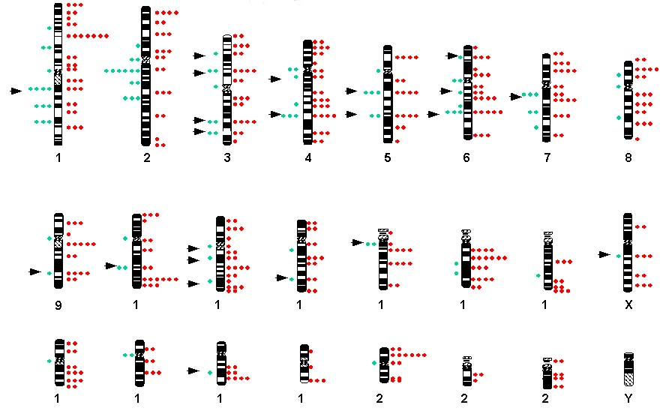
Figure 15 : Map of the RSS vs ITS Arrows point the common sites. 153 RSS are assigned, 111 on G-bands, 9 on R-bands and 13 in heterochromatin. 52 ITS were detected: 24 on R-bands, 15 on G-bands and 13 on heterochromatin. 22 ITS colocalize with RSS: 15 on G-bands, 6 on R-bands and 1 in heterochromatin

Since the length variability of some short human ITS has been described and their instability has been reported in some gastric tumors, Laure Sabatier and her team decided to analyze their instability in a human cell line during the immortalization process after transformation with the antigen T of SV40 virus. This cell line has some chromosomal rearrangements concerning the long arm of chromosome 1 and chromosomes 13, 16, 19 and they wanted to see if they involve also ITS. Sequences of ITS located on the chromosome 1q, 13, 16 and 19 were found on databanks. The analysis of these loci and those previously described, was made by PCR. The PCR products, generated by primers flanking the telomeric repeats, were analyzed on non-denaturing polyacrylamide gels stained with ethidium bromide. The loci 1q, 13, 16 and 19 do not exhibit any polymorphism in the population, so their analyses with this method couldn’t give any information about the loss of heterozygosity or chromosome deletion. For all the loci analyzed, no modification appeared in the amplification pattern of DNA from different passages during immortalization process, indicating that the ITS studied are stable and are not involved in the chromosomal rearrangements seen in this cell line. This result heightens that ITS do not present spontaneous instability.
Elena Giulotto and Chiara Modello and her teams cloned six human ITS and, on the basis of the sequence of the corresponding genomic fragments, they classified them in three cathegories: 1) repetitions of a few hundred bais pairs of exact and degenerate hexamers oriented in one direction and localized within subtelomeric domains (subtelomeric ITS); 2) pairs of extended blocks of exact and degenerate hexamers oriented head-to head and derived from the telomeric fusion of ancestral chromosomes (fusion ITS); 3) short direct repetitions of 7-10 hexamers (short ITS). Sequence analysis of the ITS found in databases allowed them to confirm this classification. In Figure 16, the sequence organization of the different types of ITS that are present in the human genome is sketched.

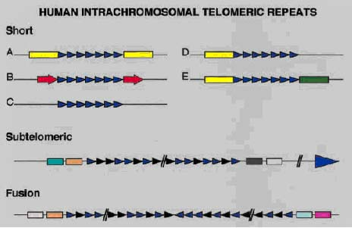
Figure 16: Sequence organization of the human intrachromosomal telomeric repeats.
Blue triangles represent precise TTAGGG units, black triangles degenerate units. In the short interstitial telomeric sequences (ITS), the telomeric array: A) interrupts precisely a repèetitive element (yellow boxes); B) is flanked by direct repeats (red arrows); C) is flanked by unique sequences; D) interrupts a transposable element on one side only; E) is inserted at the junction between two different repetitive elements (yellow and green boxes). Different kinds of subtelomeric low copy repeats (colored boxes) flank the subtelomeric ITS and the fusion ITS.

While the first two types of ITS have been already described, sequences belonging to the third class were not identified before and seem to be particularly interesting. In several ITS from this cathegory the telomeric repetitions interrupt exactly the consensus sequence of transposable elements. In addition, in some of the short ITS the telomeric stretch is flanked by the direct repetition of a 10-41 bp sequence. The analysis of the junction sequences in the different systems indicated that DSB repair is associated with the same DNA modifications both when breaks are induced in the genome and on episomal molecules. The repair pathways seem therefore to operate in the same way on chromosomal DNA and on small circular molecules. These results suggest that the short ITS were inserted in the human genome during the repair of double strand breaks.
In order to determine whether chromosome regions containing interstitial telomeric sequences are prone to radiation induced breakage, Elena Giulotto, Chiara Mondello and her teams analyzed an ITS belonging to the third group and localized in the 2q31region. They originally cloned this ITS in a phage vector and showed that it contained a stretch of 10 exact T2AG3 and 1 degenerate unit. From the sequence of the regions flanking the ITS, unique primers were designed and the corresponding PAC clone was isolated by PCR from the ordered RPCI-5 human PAC library. In addition, a PAC containing a random sequence from chromosome 2p15 was isolated. Lymphoblastoid cells derived from a normal individual were irradiated with γ-rays (2 and 4 Gy) and metaphases prepared after 24 hours were hybridized in situ with the PAC containing the 2q31 ITS and with the 2p15 PAC. Chromosome aberrations (breaks and chromosome rearrangements) involving the two regions were analyzed. In 50 mitoses for each dose, no splitted hybridization signals were detected with any probe, while four rearrangements (1 after 2 Gy and 3 after 4 Gy) were observed in the proximity of the 2p15 locus and 5 (1 after 2 Gy and 4 after 4 Gy) in the proximity of the 2q31 locus. These results indicate that the ITS containing region is not more prone to breakage than a random chromosome region.
Since these results did not support the original hypothesis, during the course of the project Elena Giulotto, Chiara Mondello and her teams substituted this task with a new task aiming at testing whether telomeric repeats can be inserted at a break site during DNA double-strand break (DSB) repair Task 2.3.

2.1.2. Artificially introduced ITS
Due to the difficulties to investigate naturally occurring human ITS, Laure Sabatier and her team have selected a rather stable human cell line, SNG 28, transfected with a plasmid containing 800 bp of telomeric sequences which is inserted in an euchromatic locus on the long arm of the chromosome 4. Laure Sabatier and her team have also selected the parental cell line without any transfection and a cell line containing only the plasmid sequences at an interstitial site, as controls. In a previous work, they scored the number of chromosome rearrangements involving this artificial ITS (Desmaze C. et al., 1999). The results demonstrated that the spontaneous occurrence of chromosome breaks in artificially introduced ITS followed the same intrinsic chromosomal instability as that seen in the parental cell line. their conclusions were that human ITS are not prone to spontaneous breakages. The three clones were irradiated at 2 and 5 Gy with γ-rays and according to their results, it seems that the proneness of ITS to break should not be so effective in human cells, when the ITS is located in an euchromatin region in a rather stable chromosomal context (Table 2). The already described radiosensitivity of ITS was found in rodent cell lines with a context of instability and for which the ITS are located in heterochromatin region. Considering the differences of the cellular models, Laure Sabatier and her team suggested that they could be at the origin of the discrepancies between the response to ionizing radiations. They selected then an unstable clone previously characterized, Q18 and performed the same radiosensitivity study of the artificially introduced ITS. By chance, the transfected telomeric sequences were inserted at a junction in a rearranged chromosome containing two junctions. After irradiation at 2 and 5 Gy with gamma rays Laure Sabatier and her team have compared the rate of breaks of this ITS containing junction with the other junction and with the artificially introduced ITS of the rather stable clone, SNG28 (Table 3). Altogether, the results confirmed that the transfected telomeric sequences have not enhanced the radiosensitivity of the insertion site but they suggest that some regions, as chromosome junctions can be more prone to break than expected.

Table 2: Specific effect of irradiation on integrated sequences.
 | Percentage of breaks in the region of the integrated sequences
 | chromosome 4 in SNG28 |  |  |  |  | chromosome 7 in SNG19
Dose (Gy) | whole chromosome | expected | observed | rate* |  | whole chromosome | expected | observed | rate*
0 | 6 | 0,12 | 0 |  |  | 0 | 0 | 0
2 | 26 | 0,52 | 7 | 13,5 |  | 12 | 0,36 | 3 | 8,3
5 | 44 | 0,88 | 15 | 17,0 |  | 56 | 1,68 | 20 | 11,9
* observed/expected
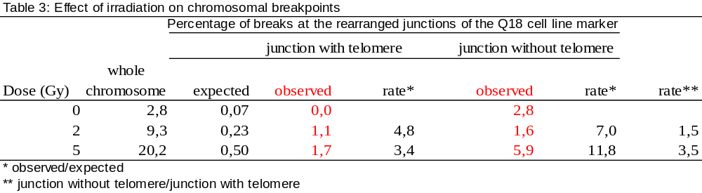

At the same time, Laure Sabatier and her team developed a molecular approach by PCR using primers specific of the plasmid sequence and repetitive sequences present in the human genome (Alu). The difficulties to obtain a specific amplification pattern before irradiation with the Alu primers have driven them to choose new primers, deriving from the plasmid rescue genomic sequences. Laure Sabatier and her team made long range PCR on DNA extracted from irradiated and non-irradiated cells. Suitable primers for the amplification of both the whole plasmid and the junctions between plasmid (with and without telomeric repeats) and genomic DNA have been chosen. Another approach involves restriction endonuclease digestion of DNA, followed by Southern blot and hybridization with plasmid DNA as probe. Two different endonuclease digestions have been performed to determine which of the plasmid or the insertion region was more radiosensitive and unstable. The irradiated and non-irradiated cells DNA has been digested with the enzymes SacI and NdeI to analyze if there were broken inside the plasmid sequence. These two enzymes, in fact, cut at each extremities of the integrated plasmid, giving a digestion fragment that contains the whole plasmid. If there is at least a DSB inside the plasmid, two different bands are expected after the hybridization.
As there is not any BclI restriction site inside the plasmid, Laure Sabatier and her team used it for the second digestion. Only one band containing the whole plasmid and its flanking sequences is expected. If the plasmid insertion site is radiosensitive, in the irradiated samples, the probe should hybridize a band with a lower molecular weight than in the not irradiated control.
Unfortunately, no modification could be detected by both approaches, suggesting that the rearrangements could be not frequent enough to be highlighted by these techniques.

While ITS in CHO cells have been shown to be prone to amplification by Breakage-Fusion-Bridge mechanism and to be sensitive to ionizing radiations, their results and those of other partners strongly support the idea that the proneness of ITS to break largely depend on the regions where they are located along the chromosome structure. Indeed, the proximity of heterochromatin, in CHO cells, or the particular structure of breakpoint junctions, in the Q18 cell line, seem to play a key role in the sensitivity of the telomeric sequences. Moreover, Laure Sabatier and her team failed to demonstrate any relationship between the size of the telomeric sequences and the frequency of radio induced breaks, as it is the case for the human chromosome 2q13 ITS according to their mapping data and FISH experiments from partner 6 and 7. However, these results did not exclude small rearrangements of a few base pairs in the cloned ITS, as it was already demonstrated for telomeric sequences inserted in the APRT gene of hamster cells (Kilburn).

All together, these results strongly suggest that the (TTAGGG) repeats, which are specific of the sequence of mammalian chromosomes telomeres, are not at the origin of the spontaneous or radio induced chromosome aberrations but rather the structure, the condensation/decondensation or the modification of the chromatin conformation could be involved in the chromosome sensitivity.

2.1.3 ITS derived from rearrangements
The analysis of the molecular organization of the Chinese hamster ITS showed that the pericentromeric ITS are composed of extensive and essentially continuous arrays of telomeric-like sequences. Moreover, three short ITS were cloned and sequenced. These sequences were similar to the short human ITS and could originate from repair of DSBs. In this regard, a peculiarity of these three sequences is the AT richness of their flanking sequences; AT-rich DNA is known to be unstable and prone to break.
Elena Giulotto, Chiara Mondello and her teams analyzed the chromosome aberrations in four PALA resistant cell lines (PRM-180, PRM-180C2, PRM-180C3, PRM-210) carrying new ITS of centromeric origin around the amplified CAD genes. In the PRM-180 cell line the amplified DNA is localized on one marker chromosome bearing a block of telomeric sequences at the centromere, like the unamplified chromosome, and a new extended array of centromeric origin at the q arm terminus. In PRM-180C2, which derives from PRM-180, an additional marker chromosome carrying amplified CAD genes is characterized by the presence of two new blocks of telomeric sequences surrounding the amplified region. In PRM-180C3 the marker chromosome contains two new blocks of telomeric sequences generated during the amplification; in PRM-210 one new block was present in the middle of its marker chromosome short arm. The PRM-180C2 and PRM-180C3 lines showed an increased sensitivity to ƴ-ray irradiation compared to parental CHOK1 cells. A possible explanation of this finding is that radiation sensitive variants, present in the CHOK1 parental population, preferentially undergo gene amplification.
The amplified cell lines and the parental cell line were then irradiated with γ-rays (2 and 4 Gy) and, 18 hours later, chromosome aberrations were scored. In order to localize the break sites relative to the ITS, chromosome preparations were hybridized in situ with a telomeric PNA probe. The total number of both spontaneous and radiation induced aberrations was 2-4 times higher in the four PALA resistant cell lines compared to the parental line, indicating that in the amplified lines all chromosomes are prone to breakage. In addition, in the PALA resistant cell lines, the number of spontaneous chromatid and chromosome type aberrations (breaks and gaps) was 3 to 4.4 times higher on the amplified markers compared to normal chromosomes of similar size; following irradiation, the number of aberrations on the marker chromosomes was up to 18 times higher. Interestingly, eighteen different radiation induced fragile sites, with great expression frequencies (5-20%), were detected on the four marker chromosomes; five of these sites are located in the proximity of the ITS. Figure 17 shows the distribution of the break sites in three of the amplified marker chromosomes.

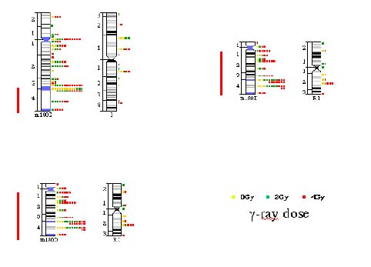
Figure 17 : Distribution of spontaneous and ƴ-ray induced break sites on three marker chromosomes containing amplified DNA (red line) and on normal chromosomes of similar lenght. Each square corresponds to a break.

In order to determine whether the ITS are preferential sites of breakage, Elena Giulotto, Chiara Mondello and her teams compared the expected and the observed frequencies of chromosome aberrations localized on ITS. For each cell line, the total length of the chromosome regions occupied by the FISH signals and the total length of the chromosomes were calculated in arbitrary units using the IpLab program. The fraction of the genome occupied by the ITS was calculated by dividing the two values and this corresponds to the expected frequency of aberrations on ITS in the hypothesis that the aberrations were randomly distrubuted. The results showed that the spontaneous chromosome aberrations localized on ITS are 1.5 to 2.3 more frequent than expected ; however, following irradiation, the fraction of aberrations observed on the ITS is not significantly different from the expected fraction (Table 4).

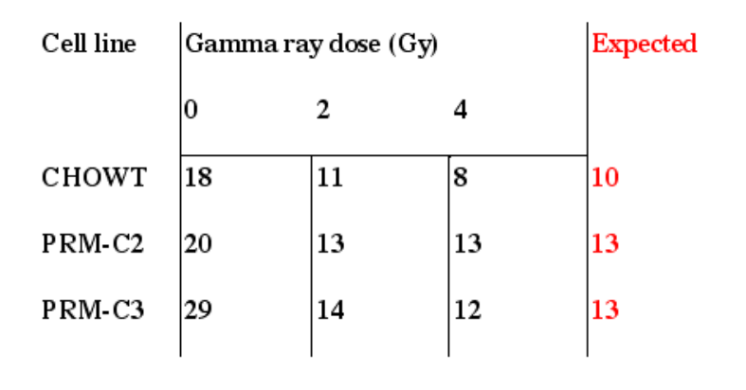
Table 4 : Percentage of the observed and expected chromosomal aberrations localized on ITS.

Another approach is led by Predrag Slijepcevic and his team. Their earlier results have shown sensitivity of interstitial telomeric sites (ITSs) in Chinese hamster cells to spontaneous and radiation-induced chromosome breakage (Slijepcevic et al. 1996). To investigate ITS sensitivity to radiation further Predrag Slijepcevic and his team used mouse scid cells. These cells show telomere dysfunction in the form of TFs. When two chromosomes fuse their telomeres become ITSs. Fused chromosomes in mouse cells are similar to Robertsonian (Rb) translocations. However, true Rb translocations do not have telomeric sequences at fusion points. Predrag Slijepcevic and his team identified at least two clonal Rb-like chromosomes in the scid cell line: Rb (12;19) and Rb (3;14) that have strong ITSs. They next monitored breakage sensitivity of these ITSs in comparison to true Rb chromosomes found in the wild type CB17 cells. their results revealed lack of both spontaneous and radiation-induced chromosome breakage at ITSs in scid cells (Fig 18).

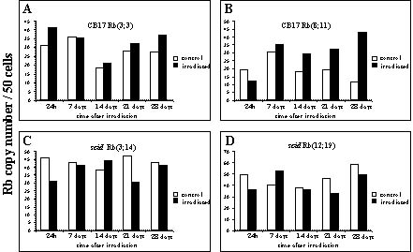
Figure 18. Frequencies of Rb chromosomes in CB17 and scid cells following irradiation with 4.0 Gy gamma rays. The difference between control and irradiated scid samples was not statistically significant.

Given that ITSs sensitivity to spontaneous and radiation-induced chromosome breakage is observed in DNA proficient Chinese hamster cells it is possible that lack of functional DNA-PKcs may be responsible for the observed lack of chromosome breakage at ITSs in scid cells. This possibility is consistent with the view that when functional DNA-PKcs is introduced in scid cells TFs almost completely disapear in these cells possibly true chromosome breakage at ITSs.

Task 2.2.Sensitivity to breakage of ITS in repair-deficient cells
DBD-FISH on Chinese hamster cells using a Whole Genome probe evidences an heterogeneous labelling, either in the control-unirradiated or X-ray exposed cells. A simultaneous hybridisation with a telomeric probe demonstrates that the DNA sequences with strong labelling in the whole genome probe correspond to ITS (Fig. 19). Thus, the ITS exhibit the highest alkali-sensitivity of the genome of the Chinese hamster. This result is quite unexpected since the ITS are GC rich regions, initially not easy to be denatured by the alkali. This suggests that this native DNA contains a high density of alkali-labile sites, which may be related to a special chromatin structure. This could be involved in a particular tight chromatin packing and could condition their proneness to breakage and recombination at the chromosomal level. It must be remembered that this same high frequency of constitutive alkali-labile sites were detected in the 5 bp DNA satellites of human and in the major satellite of mouse, as previously described. Moreover, the relative density of constitutive alkali-labile sites may explain why some ITS are sensitive whereas some may not. Finally, to go on with the study of the damage in the whole genome, it was necessary to perform a suppression hybridisation of the ITS in the whole genome probe, incubating this with excess unlabeled telomeric DNA.

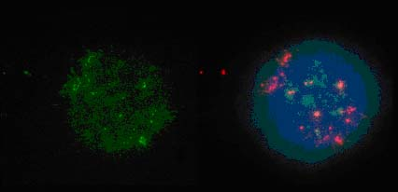
Figure 19. Unirradiated Chinese hamster cells, processed for DBD-FISH. Hybridisation with a whole genome probe (green, left) demonstrates DNA sequence areas of high alkali- sensitivity, which colocalise with the telomeric sequences (red, right).

Irradiation of nucleoids, i. e., practically naked DNA, demonstrated that ITS exhibit a similar alkaline unwinding rate, and migration ability, to that of the whole genome, so no correction for this factor was necessary for comparison of the radiosensitivity between ITS and the whole genome after cell irradiation. Thus, cells were exposed to 0, 12, 25 and 50 Gy of X-rays (Fig. 20). The relative increase in the mean fluorescence intensity (ssb) related to the specific background signal, was similar either for the whole genome or for ITS, so a same density of ssb were induced in ITS compared to the whole genome. Otherwise, the relative increase in the length of the DBD-FISH signal (dsb) for ITS was half to that of the whole genome. This result could be explained by a more difficult mobilization of the ITS by the electrophoresis.

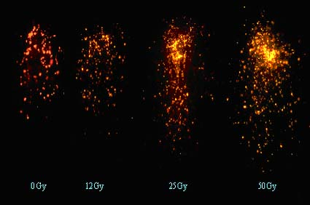
Figure 20. Examples of DBD-FISH signals from neutral comets, hybridising the ITS from Chinese hamster cells, exposed to increasing doses of X-rays.

To analyse the repair kinetics for ssb and dsb, cells were irradiated in their flasks, allowing to repair at 37ºC for 0, 15, 30 and 60 min. Control-unirradiated cells, together with all the different repair times for the same cell line, were placed in different microgels on the same slide. Thus, all experimental points were simultaneously processed under the same experimental conditions. José Luis Fernandez and his team obtained that the repair rate of ssb within ITS is similar to that of the whole genome, and is not influenced by the DNA-PKcs activity, as expected. Initially, the repair rate of dsb within ITS is much slower than in the whole genome, in control cells. Interestingly, when there is no DNA-PKcs activity, the repair rate of dsb within ITS is practically not impaired, unlike dsb in the whole genome (Fig. 21). This suggests the possibility that different DNA sequences or chromatin organisations show different preferential pathways of dsb repair, which will be a topic for future work.

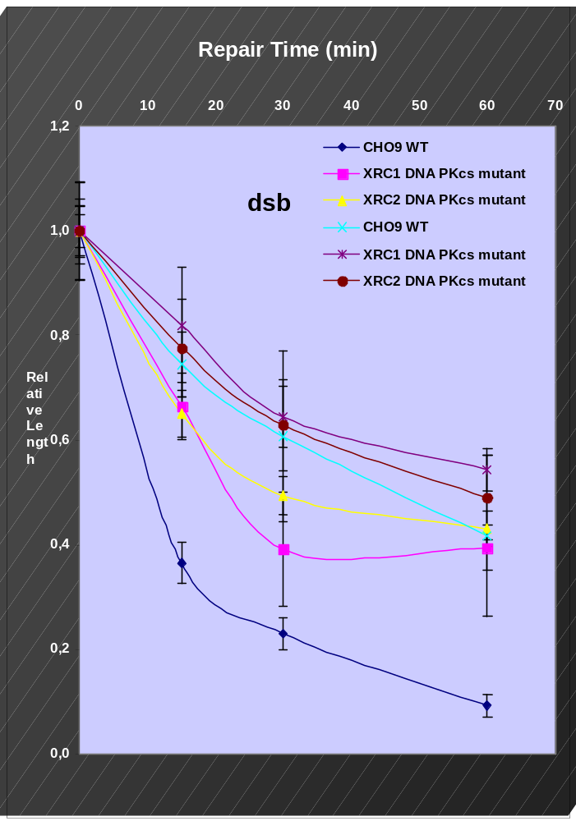
Whole Genome
Telomeric sequences
Figure 21 Repair rate of dsb in the whole genome (black lettering) and in the ITS (red lettering) from Chinese hamster cell lines, normal (CHO) and mutants without DNA-PKcs activity (XRC1 and XRC2).

Finally, a comparison of the sensitivity to ionising radiation an nitric oxide (NO) damage was performed in CHO cells, using conventional DBD-FISH, without the electrophoretic step. The density of initially radiation-induced ssb and alkali-labile sites in the ITS was similar to that induced in the whole genome, as described before. Nevertheless, the ITS showed three times more damage relatively to the whole genome, after NO doses. This illustrates the ability of DBD-FISH to detect intragenomic differences in DNA damage. Moreover, it also highlights the sensitivity of telomeric sequences to other relevant sources of DNA damage, since NO is a physiological molecule that is in excess in certain pathological conditions.

Task 2.3.Formation of new ITS
DSBs are the main type of lesion induced in the DNA molecule by ionizing radiations; unraveling the pathways involved in their repair is of great relevance in the study of radiation consequences in the genome. However, as ionizing radiations induce random breaks in the genome, they proposed to induce enzymatic breakage within a specific sequence in order to be able to analyze the joints produced after repair.
To introduce specific breaks into DNA molecules Elena Giulotto, Chiara Mondello and her teams used the I-SceI system of S. cerevisiae, or restriction enzymes.
I-SceI is a rare cutter endonuclease recognizing and cleaving whithin an 18 bp sequence (Colleaux L. et al. Cell 44, 521; 1986). Elena Giulotto, Chiara Mondello and her teams constructed different cellular systems suitable to study repair at the I-SceI recognition site. They obtained hamster cells containing the site integrated in a single chromosomal locus and they induced the break by transfecting the cells with a plasmid containing the gene coding for the endonuclease and the hygromycin resistance gene as selectable marker (Liang F.L.et al. PNAS 95, 5172; 1988). Repair junctions were amplified by PCR from pools of hygromycin resistant colonies and cloned. Out of 57 junctions sequenced 39 were independent. Due to the stable expression of the nuclease, in all the repair junctions the I-SceI site was modified. In the majority of the junctions (36) deletions were found that spanned from 1 to 20 nucleotides around the break site; in the remaining repair sites, deletions extended from 21 to 100 nucleotides. Insertions were found in 7 out of 39 junctions; in 5 of them, 1 to 14 bp were inserted, in the 2 remaining junctions longer fragments (162 and 174 bp), deriving from the transfected plasmid or from bacterial DNA, were present. In all cases except one, insertions were associated with small deletions.
Elena Giulotto, Chiara Mondello and her teams also constructed three human cell lines containing the I-SceI site integrated in a single chromosomal locus and they analyzed the repair junctions produced after stable expression of the I-SceI endonuclease. In the tree cell lines, from 25 to 30 junctions were sequenced. In contrast to what found in the Chinese hamster cell line, in all the human lines, unmodified junctions were detected. The percentages of unmodified repair sites varied in the three clones and corresponded to 4%, 20% and 52%, respectively. The low frequency of modified I-SceI sites in one of the line could reflect a low accessibility of the site to the nuclease due to the organization of the genomic region in which the site integrated. Again, in more than 90% of the modified junctions there were deletions; in two lines more than 80% of the deletions were from 1 and 20 nucleotides long, and the remaining spanned from 21 to 100 nucleotides. In the third line, the class comprising the longest deletions were more represented containing 44% of the junctions. The percentage of insertions at the break site ranged from 14% to 26%, and generally involed less than 6 nucleotides.
In a complementary approach, Elena Giulotto, Chiara Mondello and her teams isolated two human and hamster cell lines that stably express the I-SceI nuclease; they then transfected into these cells an episomal plasmid containing the I-SceI target site and the neomicin gene as selectable marker. Pools of G418 resistant clones were isolated and the plasmid recovered by Hirt extraction. After Dpn1 digestion of the plasmid DNA, the junction fragments were amplified by PCR and cloned. In the two human cell lines, 67% and 92% of the fragments contained a modified I-SceI site, indicating that these lines stably expressing the nuclease are an efficient system to study DNA modifications introduced during non-homologous end joining. In contrast, in the majority (82%) of the fragments from the hamster cell lines the I-SceI site was intact, suggesting that the nuclease is not expressed properly in this system. Among the 56 independent junctions sequenced from human cells, 54 contained deletions; approximately 70% of the deletions ranged from 1 to 20 nucleotides, the remaining comprised from 21 to 100 nucleotides. Insertions were generally associated with deletions, and involved less than 6 nucleotides.
Elena Giulotto, Chiara Mondello and her teams also used restriction enzymes to introduce specific breaks into episomal plasmids, which were then transfected into hamster cells and, after recircularization, recovered by Hirt to analyze the repair junctions. Restriction enzymes were used to produce 3’ overhangs complementary to the telomeric repeat. Out of 46 junctions sequenced, 28 were modified. The organization of the repair sites was similar to that observed on the episomal plasmid bearing the I-SceI site in human cells. Deletions were the predominat modifications of the break site; insertions (6 out of 28) were predominantly associated with the loss of nucleotides at the break site and were generally less than 5 nucleotides long.
Altogether, 36 repair junctions containing insertions were sequenced and in none of them telomeric repeats were detected. This is not surprising because Elena Giulotto, Chiara Mondello and her teams expect that the insertion of telomeric repeats during DSB repair is a rare event. Therefore, in order to test whether this event can occur, they are constructing libraries representing large numbers of repair events to be screened with the telomeric probe. So far Elena Giulotto, Chiara Mondello and her teams have constructed two libraries of PCR products from hamster cells transiently transfected with the linearized plasmid (transfection efficiency about 60%), each derived from about 2x106 cells The two libraries, formed by about 1.5x105 and 6x104 colonies respectively, were screened with a telomeric probe, but no positive clones were identified. An extensive sequence analysis of repair junctions in these systems showed that deletions are the most frequent modification associated with DSB repair; insertions are rare events, they are generally a few nucleotide long and are associated with the loss of nucleotides at the break site.

WP 3 Mechanisms of capping of radiation induced DNA Breaks
Task 3.1 The analysis of capping of radiation induced DNA breaks in human cells and in mice deficient for telomerase
3.1.1. Capping events in human cells without telomerase
The analysis of capping events is also being performed in human cells. As telomerase-negative human cells, the primary lung fibroblast human strain IMR90 transfected with an empty pBAbe plasmid has been used. As control, telomerase-positive cells from the same strain have been obtained by Maria Blasco and her team by introducing a plasmid encoding for the mouse telomerase catalytic subunit.
Even though IMR90 cells grow very slowly, metaphase chromosomes were obtained by using an early passage of the cells and by lengthening the Colcemid treatment. Non irradiated IMR90 pBAbe and IMR90 pBAbe mTERTcells have been characterised by M-FISH (Vysis probes) and telomeric and centromeric PNA probes (Perspective Biosystems). A total of 20 metaphases were analysed for IMR90 pBAbe and 24 for IMR90 pBAbe mTERT. All of them showed a normal 46,XX karyotype. No spontaneous chromosome aberrations were observed in any of the strains.
Unsuccessfully, the characterization of the radiation induced DNA damage in the IMR90 cells has not been possible due to difficulties in their post-irradiation growth. In a three times repeated experiment, an irradiation exposure of 1Gy γ-rays was shown to be excessive for cells to recover and to allow their cytogenetic analysis. Lower radiation doses are going to be tested, but it will be difficult to reach a satisfactory compromise between cell viability and frequency of aberrations. All the further works have been performed in mice deficient for telomerase
3.1.2 Capping events in mouse cells without telomerase
Telomere length was shown to influence the ionizing radiation (IR) sensitivity. Using the telomerase-deficient mouse model, null for the telomerase RNA gene (mTerc), Goytisolo et al (2000) and Wong et al (2000) independently demonstrated that short telomeres in late-generation mTerc^{-/-} mice result in organism hypersensitivity and in an increased chromosomal damage after IR exposure. The reason for the increased chromosomal radio-sensitivity was not known, since non-homologous end joining (NHEJ), the major mechanism involved in repairing radiation-induced double strand breaks (DSBs) was not found to be influenced by the functional status of telomeres. To provide insight into the radiosensitizing effect of telomere shortening, Anna Genesca and her team carried out an exhaustive cytogenetic analysis of the spontaneous and radiation-induced chromosomal aberrations in telomerase deficient and wild type mice. To identify the specific chromosomes involved in the aberrations, they used an M-FISH protocol to paint all mouse chromosomes in a three-round hybridization. Anna Genesca and her team examined the presence of telomeric signals at the ends of each chromosome and each chromosome fragment by applying a telomeric PNA probe on the same slides.

For each genotype and for each radiation dose, Anna Genesca and her team analyzed embryonic fibroblasts (MEFs) derived from the littermates of a single pregnant female. In the non-irradiated telomerase knockout-MEFs analyzed in the present study, the chromosomes that most frequently failed to show labeled telomeres were 13p, 18p and 19p and q. Analysis of the spontaneous chromosome aberrations in these embryos showed that, as expected, the chromosomes most frequently lacking telomeric signals were involved in end-to-end fusions. All of these were p-arm fusions affecting chromosomes 18 or 19. They were therefore probably isochromosomes, resulting from sister-chromatid fusion. No chromosome aberrations were found in non-irradiated wild-type mice.
In irradiated mice, the analysis was carried out in the first two divisions after irradiation, since MEFs were cultured for 54h after irradiation. Coinciding with the previously reported observations, Anna Genesca and her team noted that the frequency of radiation-induced chromosomal aberrations was higher in mTerc^{-/-} mice than in wild-type mice (42,62% vs 28,57%). Table 5 shows the types and frequencies of aberrations observed in mTerc^{+/+} and G3 mTerc^{-/-} MEFs after in vivo exposition to γ-rays. In irradiated telomerase-knockout littermate embryos, the chromosomes that most frequently lacked telomeric signals were 4q, 6p, 11q, 12q and 19q (figure 22A). Again, the chromosomes most frequently involved in aberrations (figure 22B) coincided with the set of chromosomes that most frequently lacked telomeric signals. The aberrations affecting chromosomes 4, 11 12 and 19 were mainly dicentrics (figure 22C, D and E), which were never accompanied by acentric fragments, as expected if deriving from q-to-q end fusions resulting from telomere erosion. In contrast to end-to-end fusions, the aberrations affecting other chromosomes were usually accompanied by their complementary configurations, as expected if resulting from the rejoining of two broken ends, for instance, dicentric chromosomes plus one or two acentric fragments. Interestingly, in addition to these two categories of chromosome aberrations, a third kind of rearrangement was frequently observed in irradiated mTerc^{-/-} mice (table 5). This consisted of a mixed-type aberration resulting from a broken chromosome joined to the end of an unbroken chromosome with eroded telomeres (see figure 23A and 23B for a representative example). To summarize, in cells with normal-length telomeres, a single type of rearrangement is expected to be produced after radiation exposure, namely, that resulting from the rejoining of two broken ends. In contrast, in cells with shortened telomeres, three kinds of exchange-type chromosomal aberrations are expected to be produced. The first of these is derived from the fusion of two broken ends; the second is derived from the end-to-end fusion of two entire chromosomes and the third results from a broken fragment joined to the end of a chromosome with eroded telomeres. The presence of this new kind of rearrangement in irradiated G3 mTerc^{-/-} mice, but not in wild-type may explain the increased induction of chromosome aberrations in mice with short telomeres. Given a radiation-induced break in a chromosome, the possibilities of rejoining are dramatically different in mTerc^{+/+} mice in comparison to mTerc^{-/-} mice. In cells with normal telomere length, the broken chromosome can only rejoin another broken end, with a high probability of restoring the original chromosome if the number of breaks is low. On the contrary, in telomerase-null mice, there may be several chromosomes with eroded telomeres to which the broken end can join, thus making the restoration of the original chromosome more unlikely. As a consequence, higher chromosome sensitivity is observed in mTerc^{-/-} mice in comparison to wild-type mice.

Table 5. Types and frequencies of chromosome aberrations in MEFs of mTerc^{+/+} and G3 mTerc^{-/-} mice exposed to 2Gy of γ-rays.

 | mTerc^{+/+} |  | G3 mTerc^{-/-}
 | Number | Frequency | Number | Frequency
End-to-end Chromosome Fusions*  p to p  p to q  q to q  Subtotal | -  -  -  - | -  -  -  - | 1  1  7  9 | 0,0082  0,0082  0,0574  0,0738
Break-Produced Aberrations*  Translocation  Dicentric  Insertion  Deletion  Excess acentric fragment  Subtotal | 12  2  1  2  5  22 | 0,1558  0,0259  0,0129  0,0259  0,0649  0,2857 | 16  7  2  2  5  32 | 0,1311  0,0574  0,0164  0,0164  0,0410  0,2622
Mixed-Type Aberrations*  p end-centric fragment (=dic)  p end-acentric fragment (=t)  q end-centric fragment (=dic)  q end-acentric fragment (=t)  Subtotal | -  -  -  -  - | -  -  -  -  - | 1  -  5  5  11 | 0,0082  -  0,0410  0,0410  0,0902
Total Aberrations | 22 | 0,2857 | 52 | 0,4262
*The observed aberrations were classified under three categories: 1) End-to-end chromosome fusions, between the ends of two chromosome with shortened telomeres, giving rise to dicentric chromosomes or Robertsonian translocations, depending on whether they occurred between q arms or p arms of different chromosomes, or giving rise to isochromosomes if they occurred between the ends of two sister chromatids; 2) Break-produced aberrations, resulting after the induction of two breaks and the rejoining of the broken ends, or alternatively from non-rejoined broken ends; and 3) Mixed type aberrations, resulting from the rejoining of a broken chromosome and an unbroken chromosome with eroded telomeres.

The carcinomas of elderly humans are characterized by the presence of non-reciprocal translocations (Atkin, 1986), which lead to the loss of heterozygosity and to changes in gene dosage. Artandi et al (2000) presented evidence that telomere attrition in telomerase-deficient p53 mutant mice promotes the development of carcinomas by a process of fusion-bridge-breakage that leads to the formation of non-reciprocal translocations. This process begins when telomeres shorten below a critical length and fuse to form a dicentric chromosome. At anaphase, this dicentric may be pulled to opposite ends of the cell, forming a bridge. Subsequent breakage will generate broken chromosomes. Anna Genesca and her team propose that these broken chromosomes may fuse not only to other broken ends, but also to chromosomes having shortened telomeres. In both cases, non-reciprocal translocations or new dicentric chromosomes can be generated, the later leading to the fusion-bridge-breakage cycle proposed by McClintock.

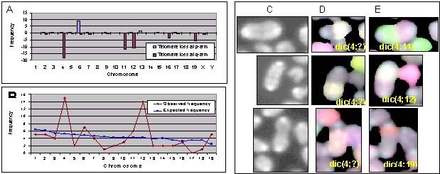
Figure 22. In irradiated G3 mTerc^{-/-} MEFs, the chromosomes with short telomeres are those more frequently involved in aberrations. (A) Distribution of the failure to label telomeres among chromosomes. (B) Observed and expected frequencies of involvement of the different chromosomes in aberrations in irradiated G3 mTerc^{-/-} mice. (C, D and E) Partial metaphases showing q-q arm fusions of different chromosomes. (C) DAPI staining showing the fused chromosomes. (D and E) Hybridizations with the different rounds of the mouse M-FISH reveal that the chromosomes involved in the dicentric chromosomes are: chromosomes 4 and 11 in the first metaphase; chromosome 4 and 12 in the second metaphase and chromosomes 4 and 19 in the third metaphase, which correspond to those chromosomes most frequently failing to label telomeres.

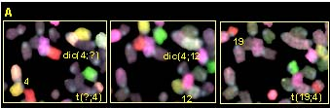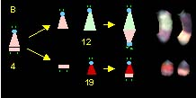
Figure 23. Representative figure showing that shortened telomeres join to DSBs interfering with their correct repair (A) M-FISH hybridization from an irradiated G3 mTerc^{-/-} MEF showing mixed-type aberrations: dic(4;12) and t(19;4). (B) Scheme showing the possible origin of the two mixed aberrations. Critically short telomeres at 12q and 19q interfered with the correct rejoining of the broken chromosome 4, producing two rearrangements. It is interesting to note that a single break resulted in two rearrangements, which, in normal telomere length cells, would need a minimum of three breaks to be produced.

Task 3.2 The analysis of capping events in mice and human cells deficient in DNA repair genes
3.2.1 Capping of breaks in DNA-PKcs^{-/-} mice
NHEJ repair pathways participate in the formation of chromosome aberrations, thus influencing radiation sensitivity of cells. Additionally, NHEJ proteins may also influence the radiation sensitivity of cells as a consequence of their protective function at telomeres. To provide insight into the mechanisms of capping of breaks in cell environments deficient in DNA repair genes and into the possible radio-sensitizing effect of telomere dysfunction, Anna Genesca and her team carried out an exhaustive cytogenetic analysis of DNA-PKcs-/- embryonic fibroblasts following exposure to γ-rays. They investigated the rejoining of broken chromosomes in absence of DNA-PKcs and whether dysfunctional telomeres in DNA-PK knockouts, similarly to what happens with short telomeres, join to broken chromosomes interfering with their correct repair.

DNA-PK-deficient mice showed a higher yield of spontaneous chromosome aberrations in comparison with DNA-PK-proficient mice. After irradiation, chromosome aberrations were 20 times more frequent in knockouts than in wild-type mice (table 6), as expected by the role of DNA-PKcs in DNA repair. Among break-produced aberrations, exchange-type aberrations are thought to arise from the misrepair of DSBs. Radiation-induced breaks are joined by non-homologous repair pathways frequently producing chromosome rearrangements. Given the defect of DNA-PKcs-/- mice in NHEJ, exchange-type aberrations were not expected to increase in the knockout mice. However, Anna Genesca and her team observed that exchange-type aberrations in DNA-PKcs-/- MEFs increased significantly after radiation exposure. They can now conclude that these cells are able to join the broken ends of the chromosomes, even without DNA-PK (see figure 24 for a representative example). Deficiency in DNA-PK activity in human cells has also been reported not to influence the final fraction of DNA DSB rejoined, although rejoining was slower as compared to human cells proficient in DNA-PK activity (DiBiase at al, 2000).

Table 6. Spontaneous and radiation-induced aberrations in DNA-PKcs^{-/-} mice.
DNA-PKcs genotype and dose | Number of cells scored | Total break-produced aberrations (per cell) | Total non-exchange type aberrations (per cell) | Total exchange type aberrations (per cell)
+/+ 0Gy | 122 | 8 (0,065) | 6 (0,049) | 2 (0,016)
-/- 0Gy | 131 | 33 (0,252) | 24 (0,183) | 9 (0,069)
+/+ 2Gy | 55 | 3 (0,054) | 2 (0,036) | 1 (0,018)
-/- 2Gy | 93 | 100 (1,075) | 25 (0,269) | 75 (0,806)

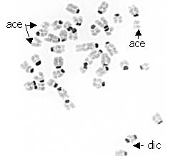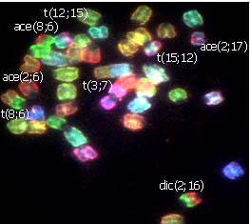
Figure 24. Irradiated DNA-PKcs^{-/-} embryonic fibroblast with several chromosome aberrations, all of them rejoined in spite of the defect in NHEJ repair pathway.

End-to-end fusions were only observed in the knockout but not in the wild-type mice (table 7). Most fusions had TTAGGG repeats at the point of fusion. Thus, they are the result of telomere dysfunction instead of telomere shortening. Joining of dysfunctional telomeres to broken chromosome ends was observed in only one cell (figure 25). Thus, in contrast to telomerase knockouts, the interference of dysfunctional telomeres in the correct repair of DNA breaks in DNA-PK mice contributes only marginally to the radiation sensitivity of this mouse model. It is possible that the contribution of dysfunctional telomere-DSB joining to radiation sensitivity is much more important in scid mice, which present a higher frequency of end-to-end fusions,

Table 7. End-to-end fusions in DNA-PKcs-/- mice.
DNA-PKcs genotype and dose | Number of cells scored | Total telomeric fusions (per cell) | Fusions with TTAGGG repeats | Telomere-DSB fusions (per cell)
+/+ 0Gy | 122 | - | - | -
-/- 0Gy | 131 | 9 (0,068) | 9 (100%) | -
+/+ 2Gy | 55 | - | - | -
-/- 2Gy | 93 | 5 (0,054) | 4 (80%) | 1 (0,011)

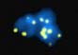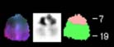
Figure 25. Rejoining of a broken end to a dysfunctional telomere in DNA-PKcs^{-/-} embryonic fibroblast..

3.2.2. Capping of breaks in human cells derived from patients with ataxia-telangiectasia (A-T)
Provided the ability of telomerase to add telomeric sequences to the chromosomes and in light of the short regions of complementarity required for telomerase to add new TTAGGG repeats, it has been speculated that telomerase may participate in processes of chromosomal repair by de novo synthesis of telomere repeats at DSBs in a process called chromosome healing. In addition, it has been presumed that de novo formation of telomeres could preferentially occur in cells that have difficulties in rejoining the ends of DSBs (Sprung et al 1999). Cornforth and Bedford (1985) analysed solid-stained prematurely-condensed chromosomes of A-T cells exposed to X-rays and reported that the fraction of residual breaks, apparently unrepaired, was five to six times greater in A-T cells than in normal cells. Some of these apparently unrejoined chromosome breaks could well be the substrate for telomerase to add new telomeric repeats. In the present study, an M-FISH protocol was combined with a telomeric and centromeric labeling using PNA probes to characterize the rejoining pattern and the telomere status of radiation-induced chromosome aberrations in A-T cells, in order to determine whether radiation-induced breaks are stabilized by the addition of new telomeric sequences or whether they remain uncapped.

Since the analysis of the capping of radiation-induced chromosome breaks can only be performed in stable cells, Anna Genesca and her team carried out a pilot study to assess the chromosomal stability of the two A-T cell lines. They rejected a fibroblast cell line that was shown to be very unstable. On the contrary, the application of M-FISH procedures to two unirradiated lymphoblastoid cell lines, one A-T and one normal, demonstrated their stability. Anna Genesca and her team then investigated whether, after radiation exposure, the A-T cell line chosen for chromosome capping analysis behaved according to the expected pattern. That is to say, they assessed whether radiation-induced residual breaks, which could be potential substrates for telomerase, were induced much more frequently in A-T cells than in normal cells. To this end, chromosome analysis was carried out by M-FISH after exposition of the cells at the G0 stage to 1Gy of γ-rays. In both cell lines, the great majority of the aberrations were of the chromosome type, characteristic of the irradiation of a G0 stage cell population. As expected, the frequency of aberrant metaphases was higher in the A-T (50,0%) than in the normal cell line (36,6%). Table 8 shows the results on the types of induced aberrations with respect to whether they had a rejoined (complete and incomplete exchanges), or an unrejoined (terminal deletions) pattern.

Table 8. Frequencies of rejoined and unrejoined-type aberrations in irradiated A-T and normal cells.
 | A-T cells  Number of aberrations  (frequency) | Normal cells  Number of aberrations  (frequency)
Complete exchanges | 5 (0,053) | 28 (0,341)
Incomplete exchanges | 25 (0,266) | 8 (0,097)
Terminal deletions | 39 (0,415) | 6 (0,073)
Interstitial deletions | 6 (0,064) | 1 (0,012)
Fraction of aberrations with unrejoined ends | 64/75  (85,3%) | 14/43  (32,6%)

Having established the chromosomal stability of the lymphoblastoid cell lines and the production of a great number of unrejoined deleted chromosomes in A-T cells, their objective was to analyse the formation of new telomeres at broken chromosome ends. The hybridisation of telomeric sequences using PNA probes allowed unambiguous analysis of A-T and normal metaphases for the presence of additional telomere pairs suggestive of chromosome healing. This analysis was carried out in the same metaphases previously analysed for their M-FISH pattern, all of which contained 46 centromeres; thus, 92 pairs of telomeres would be expected in each metaphase. Additional telomeres at the ends of the chromosomes or chromosome fragments were never observed in A-T cells, in spite of the high number of truncated chromosomes produced in A-T cells after IR exposure. Thus, new telomeres long enough to be detected by the methodology used in the present study (resolution limit of telomeric PNA probe is 150 bp) have not been detected either in A-T or in normal lymphoblastoid cells. their results, showing a lack of healing of broken chromosomes, are in accordance with the recently reported radiation-induced sequestration of telomerase at the nucleolar sites in response to DNA damage, probably to avoid enzyme’s access to DSBs (Wong et al, 2002). However, the results to their study do not preclude the existence of de novo formation of telomeres at the broken DNA ends in other mammalian cell environments, such as germline or early embryonic cells with high telomerase levels or in cells with a complete loss of NHEJ pathways.

The minimal number of breaks estimated to have been produced in A-T cells after M-FISH and telomere analysis was 126 and 89 in normal cells. The number of reactive ends initially produced has been estimated by doubling the minimal number of breaks. The fraction of reactive ends remaining open or unable to rejoin in A-T cells was 52.4% while only 15.7% did so in normal cells (table 9 and figure 26, the latter as a representative example). This represents a fraction of non-repaired residual breaks that is 3.3 times higher in A-T than in normal cells. At present, the nature of the radiation-induced lesions recognised by the product of ATM is unknown, but it is evident that an important fraction of DNA breaks remain open in A-T cells or are not amenable to rejoining.

Table 9. Fraction of chromosome ends that remain open or unable to rejoin
 | A-T | Normal | t-test
Minimal Number of Breaks | 126 | 89 | P<0,05
Reactive Ends Generated | 252 | 178 | P<0,0001
Ends Remaining Open | 132 | 28 | P<0,0001
Fraction of Reactive Ends Generated that Remain Open or Unable to Rejoin | 52,4% | 15,7%

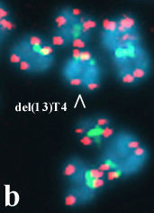
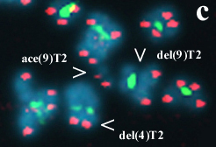
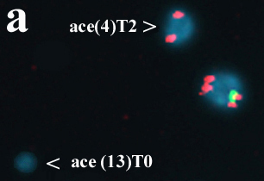
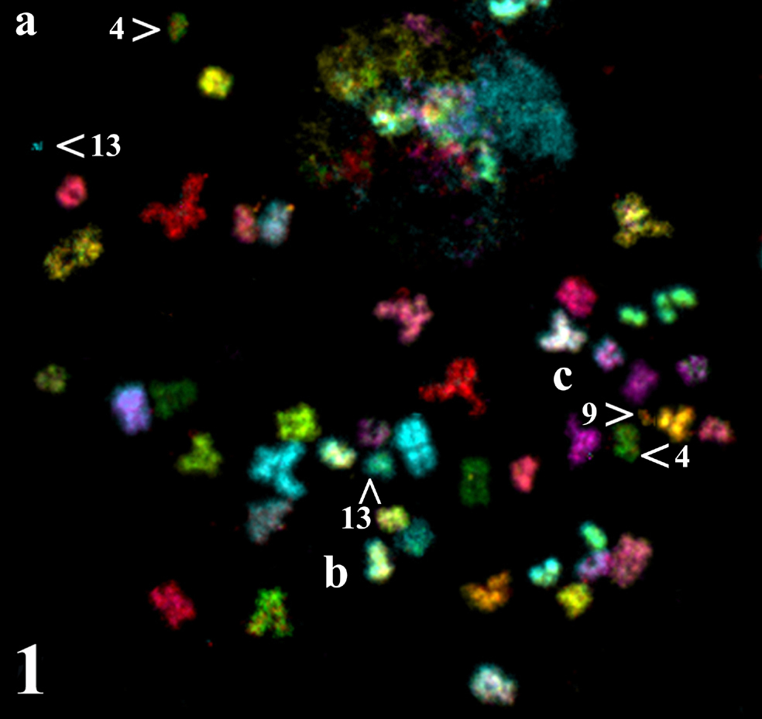
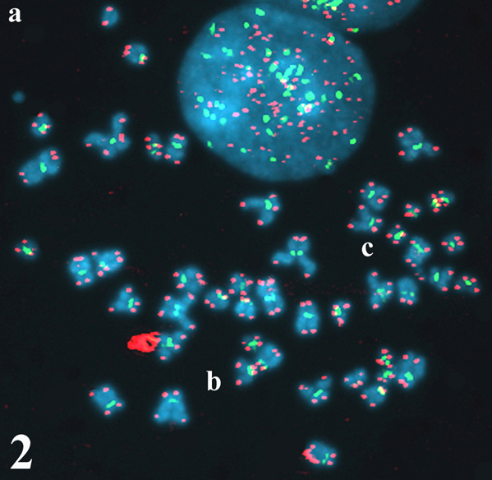
Figure 26. Metaphase of an irradiated A-T cell with several uncapped broken chromosome ends. 1. M-FISH image. Deleted chromosomes and the corresponding acentric fragments found in this metaphase are indicated by arrowheads in squares a, b, and c. 2. The telomere and centromere labelling of the same metaphase reveals the capping status of the centric and acentric fragments. Squares a, b and c are amplified below the metaphase images. a. The acentric fragment of chromosome 4 is capped at only one end with a telomere pair (T2). The broken chromosome end remains open. Acentric fragment from chromosome 13 shows no telomeric signals (T0), as it originates from an interstitial deletion in chromosome 13. b. Accordingly, deleted chromosome 13 presents four telomeric signals (T4). c. Centric fragments of chromosomes 4 and 9 show a pair of telomeric signals at only one end. The broken ends of both chromosomes remain open. The same occurs with the acentric fragment of chromosome 9. In summary, this metaphase underwent a minimum of four breaks and generated 8 broken-ends. Only fragments originating from chromosome 13 have rejoined by capping their ends. The rest remain open.
3.2.3 Development of a non-radioactive TRAP assay
An additional task not included in the workplan has been carried out. Anna Genesca and her team has developed a new sensitive and reliable protocol for the non-radioactive detection of telomerase activity in cell culture protein extracts.

Task 3.3 The analysis of capping events in meiotic cells of telomerase knockout mice
Meiotic cells are somewhat special in the analysis of capping of DNA breaks for at least two reasons. First, telomerase has been shown to be capable of capping chromosome breaks in mammalian germ cells. And second, at the early stages of meiosis, telomeres associate closely with each other. Their proximity may promote recombination events. To investigate the capping of breaks in meiotic cells Anna Genesca and her team have analyzed spermatocytes at the metaphase stage of the first meiotic division (figure 27). Telomerase knockout and wild type adult male mice were irradiated in vivo and sacrificed 1 and 14 days post irradiation (dpi). Given the timing of meiosis in male mice, cells at metaphase I one day post irradiation were at diplotene at time of irradiation (no S phase between irradiation and analysis). At 14 dpi, cells were at pre-meiotic divisions at time of irradiation (one or more S-phases between irradiation and analysis).

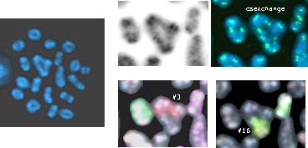
Figure 27. Radiation-induced chromosome exchange in a spermatocyte.

At 1dpi the frequency of induced aberrations was higher in the knockouts than in the wild type mice (table 10). Fourteen days post irradiation, the yield of aberrations in both types of mice was similar. In spermatocytes of the knockout mice at the metaphase I stage end-to-end fusions have not been observed. It is likely that meiotic cells have stronger controls against cells with short telomeres than somatic cells. Therefore, DNA breaks in meiotic cells do not join to chromosomes with shortened telomeres and, in contrast to what happens in embryonic fibroblasts of telomerase knockouts, short telomeres in meiotic cells do not interfere with the correct repair of broken DNA ends. Anna Genesca and her team are now analysing an earlier stage (prophase I) to check whether cells with short telomeres have not yet been eliminated and they may join to DNA breaks. With regard to the labelling of broken ends by the addition of new telomeric sequences, they have observed a single meiotic cell with an additional pair of telomeres which is compatible with healing (figure 28).
Table 10. Rejoined and unrejoined chromosome aberrations in meiotic cells of telomerase knockout mice.
 | N. of cells  analyzed | Number of aberrations | Frequency per cell | Unrejoined pattern | Rejoined pattern
mTerc +/+ | 30 | - | - | - | -
mTerc-/- | 45 | - | - | - | -
mTerc+/+ 1dpi | 51 | 26 | 0,500 | 18 (69%) | 8 (31%)
mterc-/- 1dpi | 40 | 45 | 1,125 | 35 (77%) | 10 (22%)
mTerc+/+ 14dpi | 20 | 5 | 0,250 | 3 (60%) | 2 (40%)
mTerc-/- 14dpi | 56 | 10 | 0,170 | 5 (50%) | 5 (50%)

Figure 28.

Task 3.4 Capping events after telomere loss
To study the consequences of telomere loss, Laure Sabatier and her team used a cellular model established in collaboration with John Murnane (Radiation Oncology Research Laboratory, University of California). EJ-30 human bladder cell carcinoma cell line was transfected with plasmids containing telomeric repeat sequences that “seed” new telomeres when integrated on end of a “marker” chromosome. These plasmids contain a neo gene for positive selection in G418, as well as a Herpes Simplex thymidine kinase (HSV-tk) gene for negative selection in ganciclovir. Loss of the HSV-tk gene is used to identify cells that have lost the telomere on the end of the marker chromosome. Laure Sabatier and her team observed 1) chromosome instability 2) gene amplification via breakage/fusion/bridge (B/F/B) cycle 3) chromosome imbalances (gain and loss of chromosome arms) (Fouladi et al, 2000; Lo et al, 2002). The comparison between the instability observed in human cell model and in mouse embryonic fibroblasts has been performed in SUSGENINRADCAR project. In TELORAD Laure Sabatier and her team focused her study on the mechanism of capping events. Chromosomes lacking one telomere remain unstables until they are capped. The events involved in the addition of telomeres on to the end of a broken chromosome was investigated. The marker chromosome often regained a telomere and become stable. In most instances, telomere addition was associated with the non reciprocal translocation of fragments of other chromosome. However, some of the marker chromosomes that had regained a telomere showed no detectable translocation, suggesting that telomere addition could have occurred by either break-induced replication -BIR- (which involves a one-ended recombination event in which a free DNA end invades a homologous sequence), or de novo addition by telomerase (Figure 29) BIR was suspected because the duplication of the telomere from the other end of the chromosome on the broken end was observed, as previously described in yeast.

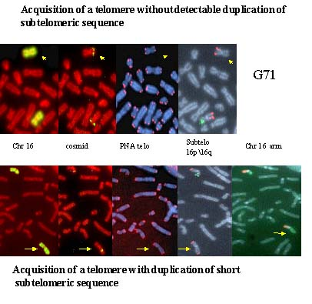
Figure 29 : Capping events after telomere loss.

The ability to add telomeres to the ends of broken chromosomes could therefore play an important role in preventing the chromosome rearrangements leading to cancer. However, the different mechanisms of telomere acquisition have different implications for the overall stability of the genome. The addition of a telomere by de novo addition by telomerase or the duplication of another telomere would result in the creation of a new telomere. In contrast, the addition of a telomere by nonreciprocal translocation simply transfers a telomere from one chromosome to another. Although this stabilizes the recipient chromosome, the donor chromosome would be without a telomere, and therefore would be likely to become unstable and initiate B/F/B cycles. Thus, telomere acquisition by nonreciprocal translocation would not result in an overall increase in the stability of the genome, but simply transfer the instability from one chromosome to another (Figure 30). The loss of a single telomere will therefore result in a cascade of chromosome instability involving both gene amplification and nonreciprocal translocations not only on the chromosome that initially has lost the telomere, but on other chromosomes as well (Sabatier et al, submitted). Further perspectives lead in the identification of the BIR mechanism in human cells and the genetic components involved in telomere capping by nonreciprocal translocation, telomerase elongation or BIR. A major question will be the potential interaction between short telomere or spontaneous broken ends and radiation-induced breaks.

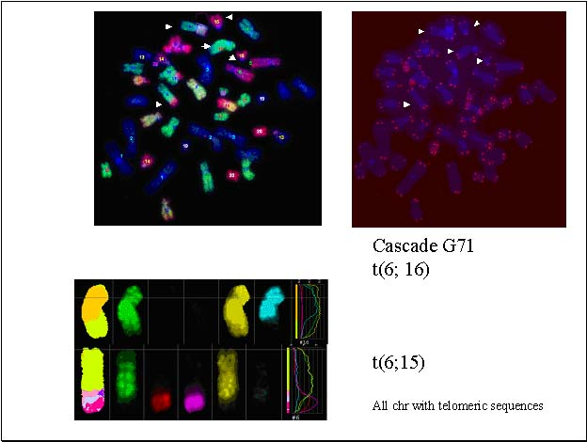
Figure 30 : Chromosome Instability cascade after telomere loss.

WP4. Transmission of radiation induced DNA damage

The study of transmission of radiation induced DNA damage will be performed on the same cellular models developped in previous WPs.

Task 4.1 Transmision of radiation induced DNA damage in mice with dysfunctional telomeres
Studies of radiation sensitivity and radiation-induced chromosomal instability in MEF derived from the above mentioned mouse models are underway. These studies will help to unravel the different functional interactions at telomeres in response to DNA double strand breaks. As a preliminary study performed during the TELORAD project, Maria Blasco and her team have characterized the transmission of the chromosomal instability induced by telomere dysfunction using serial bone marrow transplantations onto irradiated wild-type or late generation telomerase deficient mice. The results obtained indicate that dysfunctional telomeres result in a decreased repopulation ability of bone marrow stem cells coincidental with an increased end-to-end chromosomal aberrations that are stably transmitted in bone marrow cells (Samper et al., 2002).

Task 4.2 Determination of gene amplification upon radiation in MEFs and cell lines.
Breaks in the DNA molecule are one of the major types of damage induced by ionizing radiations. Several cell lines are available that are hypersensitive to γ-rays because of defects either in the cell cycle response to damage, or in the repair of DSBs. Elena Giulotto, Chiara Mondello and her teams analyzed gene amplification ability in cells hypersensitive to γ-irradiation because of different genetic defects, namely: rodent cells defective in DNA-PKcs, human ataxia telangiectasia (AT) fibroblasts and rodent AT-like mutants, and telomerase deficient mouse embryo fibroblasts. Moreover, they evaluated the effect of γ -rays and hydrogen peroxide (H2O2) treatment on gene amplification. H2O2, besides being a product of water hydrolysis induced by γ-rays, is also produced by the cellular metabolism itself and it is therefore a source of endogenous DNA damage. Gene amplification was analyzed by determining the frequency and the rate of colonies resistant to PALA, since in rodent cells resistance to this agent is mainly due to amplification of the CAD gene.
The DNA-PKcs deficient cell lines analyzed were the ionizing radiation hypersensitive hamster mutant V3, together with its clone V3 147f, in which the defect had been complemented by transfection with a YAC containing the human DNA-PKcs gene, and mouse embryo fibroblasts (MEFs) established in vitro from animals in which DNA-PKcs had been ablated by homologous recombination (given tothemby Guillermo Taccioli, Boston University).
In the hamster cells, the frequency and the rate of PALA resistant clones was tested at doses of PALA ranging from 4 to 12 times the LD50, which was 40 μM PALA in V3, V3 147f, and parental AA8 cells. At all PALA doses, the frequency and the rate of resistant clones were higher in V3 compared to AA8 and to V3 147f. In V3, the increments in the frequency of PALA resistant clones ranged from 12 to 64 times, while the increments in the rate of resistant clones ranged from 20 to 120 times. These results indicate that DNA-PKcs deficiency is associated with an increased gene amplification ability. FISH analysis of the CAD gene, on metaphases from PALA resistant clones isolated from the three cell lines, showed a similar organization of the amplified DNA, suggesting that gene amplification occurs through the same mechanisms, regardless of the presence of a functional DNA-PKcs (Figure 31). In particular, the structure of the amplification bearing chromosomes is compatible with an origin of the amplified DNA through bridge-breakage-fusion cycles.

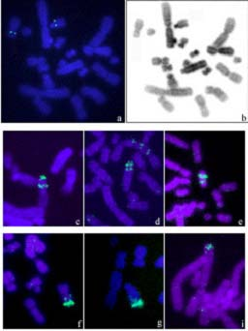
Figure 31: Localization of the CAD gene on the chromosomes of the V3 cell lines and of PALA resistant clones. A) Mitosis of the V3 cell line: the yellow hybridization signals on chromosome Z8 (big arrow) and on chromosome 7 (short arrow) are visible; in B) the same mitosis is shown after DAPI staining; C, D, and E: examples of ladder-like amplified structures in PALA resistant clones isolated from AA8 (C), V3 (D) and V3 147f (E); F, G, and H, examples of condensed amplified structure in PALA resistant clones from AA8 (F), V3 (G), and V3 147f (H).

DNA-PKcs deficient MEFs were analyzed before and after immortalization in culture. Elena Giulotto, Chiara Mondello and her teams found that primary DNA-PKcs deficient cells, as well as wild type cells, do not generate PALA resistant clones, while in immortalized MEFs, the frequency of PALA resistant clones was higher than in wild type cells.
Gene amplification was then analyzed in the V3 cell line after γ -ray irradiation. After irradiation with differrent doses of γ-rays (1 Gy to 4 Gy for V3; 1 Gy to 8 Gy for AA8) cells were seeded in the presence of PALA; in parallel, chromosome aberrations and cell survival were analyzed at each dose. Both in V3 and in AA8, the frequency of PALA resistant clones decreased after γ-ray exposure, however, if this value was corrected for the percentage of cells actually surviving to irradiation, the frequency of PALA resistant clones increased with the dose of γ-rays. In each line, the major increment in gene amplification (an order of magnitude) was found after a γ-ray dose reducing survival to about 1% (4 Gy for V3, 8 Gy for AA8) and inducing several chromosome aberrations in almost all the cells (in V3, an average of 7.9 aberrations per mitosis in 100% of the mitoses, in AA8 an average of 5.0 aberrations per mitosis in about 90% of the mitoses). In both cell lines, the most frequent types of aberrations were chromosome fragments, followed by dicentric chromosomes in AA8, and by complex rearrangements like triradial and quadriradial chromosomes and chromatidic associations in V3. When the frequency of PALA resistant clones was compared at the same γ -ray dose the increment was higher in V3 compared to AA8.
Similar results were obtained when gene amplification was analyzed after cellular pretreatment with H2O2. V3 showed a higher sensitivity to H2O2 compared to AA8. Doses reducing survival to about 1% (250 µM for V3 and 600 µM for AA8) caused the maximum increment in gene amplification in both cell lines (one-two orders of magnitude). However, chromosome damage induced by these treatments was less severe compared to that induced by γ-ray doses causing similar reduction in survival. In fact, even at H2O2 doses reducing survival to 1%, the percentage of aberrant mitoses did not exceed 60% and the mean number of anomalies per aberrant mitosis was lower than 4. This finding confirms that H2O2 toxicity is due to its widespread damaging effect on different biological molecules and suggests that H2O2 treatment can stimulate gene amplification through pathways that do not necessarily implicate the direct induction of DSBs in the DNA molecule.
AT is a human hereditary syndrome characterized by X-ray hypersensitivity, due to an altered control of the cell cycle in response to DNA damage, by chromosomal instability and tumor proneness.Elena Giulotto, Chiara Mondello and her teams analyzed PALA resistance in AT fibroblasts and in two hamster cell lines with an AT-like phenotype. They did found an increased amplification ability in the rodent mutant cells, in fact the frequency and the rate of PALA resistant clones were up to 30 and 40 times higher in the mutants compared to wild type cells, respectively. However, no amplification was detected in the human fibroblasts.
Elena Giulotto, Chiara Mondello and her teams have then analyzed gene amplification in immortalized embryo fibroblasts derived from different generations of mouse strains deficient in telomerase activity (given tothemby Maria Blasco). These strains were obtained by germline inactivation of the gene coding for the telomerase RNA component (mTR-/- mice). In cells from mTR-/- mice, the decrease in telomere length with generations is paralleled by an increased chromosomal instability (Blasco et al., Cell 91, 25; 1997). In addition, in the late generation mice, hypersensitivity to ionizing radiations was found (Goytisolo et al, J Exp Med 155, 345; 2000). Elena Giulotto, Chiara Mondello and her teams studied gene amplification in cells from wild type mice, from generation 1 (G1) and generation 6 (G6) mTR-/- mice by determining the frequency of colonies resistant to PALA. PALA resistance was analyzed at two different concentrations of the agent (80 and 160 µM). In the three cell lines, similar frequency of PALA resistant colonies were observed at the lowest PALA dose, while at the highest dose the frequency of PALA resistant clones was 2 fold higher in G1 and 4 fold higher in G6 cells compared to wild type cells. It is worthwhile noticing that, as expected, in wild type cells the frequency of PALA resistant colonies is lower (about 5 times) at the higher PALA dose; on the contrary, in the telomerase deficient cells only a small decrease in the frequency is observed (1.6 times and 1.2 times in G1 and in G6 cells, respectively). A possible explanation for this observation is that in G1 cells, and to a greater extent in G6 cells, mutations leading to PALA resistance confer resistance to both low and high concentrations of the drug. To get insights into the mechanisms leading to PALA resistance in the different cell lines, Elena Giulotto, Chiara Mondello and her teams isolated PALA resistant clones and they analyzed the CAD gene organization on mitotic chromosomes by FISH. To this purpose, using primers specific for the promoter region of the mouse CAD gene, they isolated the corresponding PAC clone from an ordered mouse PAC library by PCR. Elena Giulotto, Chiara Mondello and her teams showed by FISH that this PAC is localized close to the centromere on the long arm of the mouse chromosome 5. In the three clones isolated from wild type cells Elena Giulotto, Chiara Mondello and her teams found that the CAD gene was amplified. In two clones, gene amplification was intrachromosomal and the amplified regions were organized in ladder like structures (Figure 32A); frequently, the centromeric region was amplified together with the CAD gene, suggesting that breakage events occurred preferentially in this region. In one clone, amplification was extrachromosomal with the CAD gene present on double minutes (Figure 32B). Surprisingly, no amplification was observed in the PALA resistant clones isolated from G6 cells (three clones) and from G1 cells (one clone). In all of them, a FISH signal attributable to a single copy of the CAD gene was observed on chromosome 5 (Figure 32C and D). Moreover, in the mutants, Elena Giulotto, Chiara Mondello and her teams did not find evidence of an increase in CAD gene copy number through chromosomal non-disjunction. Other mechanisms must therefore be responsible for resistance to PALA.

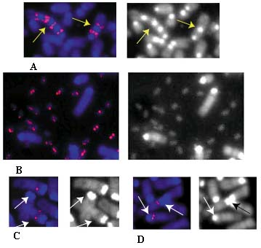
Figure 32: CAD gene organization on the mitotic chromosomes of PALA resistant mutants derived from wild type cells (A and B), telomerase deficient G1 (C) and G6 cells (D). In wild type cells, the amplification of the CAD gene, intrachromosomal in A and extrachromosoal in B, is evident. In telomerase deficient cells, only hybridization signals attributable to a single copy CAD gene are detected.

Elena Giulotto, Chiara Mondello and her teams also analyzed PALA resistance in the telomerase deficient cells after irradiation with γ-rays. Small differences in γ-ray sensitivity were found among the three cell lines, in fact the γ-ray doses reducing survival to 50% were 5.2, 4.2, and 3 Gy in wild type, G1 and G6 cells, respectively. In all the lines, similar increments in the frequency of PALA resistant clones were detected after treatment with the same γ-ray dose (4 and 8 Gy). This suggests that γ-rays induce PALA resistance to similar extents in the three cell lines despite the fact that different resistance mechanisms seem to operate in the different cell lines. One PALA resistant clone was isolated from each cell line after pretreatment with γ-rays and, again, Elena Giulotto, Chiara Mondello and her teams found CAD gene amplification in the wild type clone but not in the G1 and G6 clone.

As previously mentioned, DNA-PKcs is important in the maintenance of chromosomal stability; moreover, recent data show that it also plays a role in telomere capping preventing chromosomal end-to-end fusions. To investigate the role of DNA-PKcs in telomere functionality, Elena Giulotto, Chiara Mondello and her teams analyzed the frequency of TFs in the mouse embryo fibroblasts (MEFs) defective in the DNA-PKcs gene prior and after spontaneous immortalization in culture. They performed FISH with a probe for the telomeric repeats on mitotic chromosomes. They defined as telomeric fusions (TF) the fused chromosomes carrying the hybridization signal at the joining site. their results suggest that in primary cells DNA-PKcs deficiency has a limited effect, if any, on TF formation and on telomere functionality, while it further increases chromosomal instability in immortalized cells. In fact, in primary DNA-PKcs-/- Elena Giulotto, Chiara Mondello and her teams found only 1 TF out of 183 mitoses analyzed, and no TFs in wild type and heterozygote MEFs (out of 50 mitoses each). In contrast, in immortalized DNA-PKcs mutant cells the frequency of TFs was significantly higher compared to wild type and heterozygote cells. The percentage of mitoses with TFs ranged from 35.3% to 100% in DNA-PKcs deficient MEFs, whereas, in wild type and in heterozygous MEFs, it ranged from 2.6% and 10%. The average number of TFs/mitosis varied between 0,37 and 2,65 in DNA-PKcs-/- and between 0,03 and 0,10 in wild type cells. Together with TFs, Elena Giulotto, Chiara Mondello and her teams also detected metacentric chromosomes in which the telomeric signal at the joining site was missing. The frequency of this anomaly, which resembles the Robertsonian translocations found in wild mice and that likely derives from the fusion of two telocentric chromosomes at or near their centromere, increased in the immortalized cells, but was independent from the DNA-PKcs genotype.

Finally, Elena Giulotto, Chiara Mondello and her teams analyzed the organization of the amplified DNA in a newly established human colon carcinoma cell line. In this line a marker chromosome originated from the amplification of the pericentromeric region of chromosome 1. To provide insights into the molecular mechanism that generated this marker chromosome, they performed fluorescence in situ hybridization experiments using a panel of probes mapping near the centromere of chromosome 1 and three probes for different satellite sequences. In human tumours different mechanisms can contribute to the genesis of amplified DNA. The results on the analysis of the marker chromosome in the human colon cancer cell line showed that the amplification was not the result of a single mechanism but it required the intervention of several rearrangements including unequal exchange, chromatid breackage followed by fusion of the sister chromatids, and loss of centromeric heterochromatin. Finally, the chromosome was stabilized by the addition of new telomeres.

Task 4.3 Gene amplification drived by telomere loss.
The development of genomic instability is considered to be an important step in generating the multiple genetic changes required for cancer. One consequence of genomic instability is the overexpression of oncogenes due to gene amplification. Gene amplification can occur by multiple mechanisms, including the breakage/fusion/bridge (B/F/B) cycle that occurs following the fusion of chromosomes lacking telomeres that protect their ends. The breakage/fusion/bridge (B/F/B) cycle has been demonstrated to be a mechanism for gene amplification in hamster cells but it has not been directly linked to gene amplification in human cells. In collaboration with John Murnane, Laure Sabatier and her team used the cell model described in WP3 to analyze the consequences of telomere loss. They observed that the loss of a telomere and adjacent subtelomeric sequences was associated with sister chromatid fusion leading to large inverted duplications and prolonged periods of instability (Fouladi et al, 2000). The characterization of the “amplicon” on stretched chromosomes demonstrates that most breaks occurred within 1 Mb of the site of fusion. Breaks occurring near the site of fusion would be consistent with J; Murnane observation that approximately 50% of the marker chromosomes were close to their original length despite having undergone fusion and breakage one or more times (Fouladi et al, 2000).

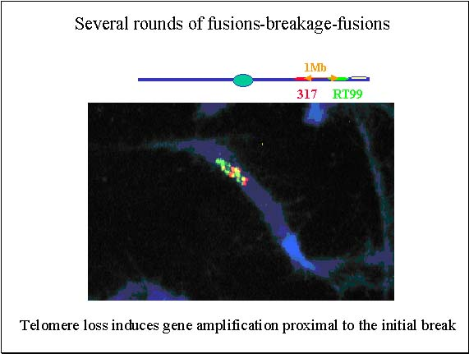
Figure 33 : Amplification detected on stretched chromosome (coverprint of Neoplasia)The presence of as many as 6 separate hybridization signals with cosmid RT99 in some metaphase spreads demonstrated that this chromosome had been involved in at least 3 B/F/B cycles.

The amplification of subtelomeric DNA on the marker chromosome in many cells in the population provides conclusive evidence that B/F/B cycles initiated by spontaneous telomere loss can be an early event in gene amplification in human tumor cells.

MAIN ACHIEVEMENTS

Deliverable | Deliverable title | Delivery date | Nature | Dissemin. | Statut
1 | Annual progress report 1 | 12 | Re | RE | achieved
2 | DNA breakages and chromosome damages induced by in vivo or in vitro irradiation (mouse, MEFs and cell lines)KO for telomerase and DNA repair genes :- Normal mice:.wt; -Single mutant mice .mTR-/- ; PARP-/- ; DNA-PKcs-/- ; Scid ; Ku 80-/- ; | 12 | Da | PU | achieved
3 | Surrvival, cell cycle profile and apoptosis following irradiation of mice or cells. | 12-36 | Da | PU | achieved
4 | Determine survival curves of irradiated mice. | 12-36 | Da | PU | achieved
5 | Pathological analysis of irradiated mice : histology of spleen, thymus and gut. | 12-36 | Da | PU | achieved
6 | Quantification of ITS radiosensitivity in human cell lines. | 12 | Da | PU | achieved
7 | Determination of radiosensitivity of ITS in pig primary cells. | 36 | Da | PU | Achieved (Da/Re)
8 | Role of ITS localisation in ITS radiosensitivity | 36 | Da | PU | achieved
9 | Characterization of telomere capping in irradiated meiotic cells. | 36 | Da | PU | achieved
10 | Determination of the role of telomerase and DNA repair genes in the prevention of anarchic capping of spontaneous breaks occurring in meiotic cells. | 24 | Da | PU | achieved
11 | Quantification DNA breakages and chromosome damages induced by in vivo or in vitro irradiation (mouse, MEFs and cell lines)KO for telomerase and DNA repair genes : Double mutant mice: .mTR-/- /dominant negative mTRF1 ; mTR-/- /DNA-PKcs-/- ; mTR-/- /Ku80-/- ; mTR-/- /PARP-/- ; (data on controls and part of mutants) | 36 | Da | PU | achieved
12 | Influence of cell irradiation on telomere binding of hTRF1 and hTRF2 (controls) | 36 | Da | PU | achieved
13 | Characterization of new ITS formation. | 36 | Da | PU | achieved
14 | Mechanistic link between DNA-PKs and telomerase in ITS radiosensitivity.(in CHO) | 36 | Da | PU | achieved
15 | Characterization of telomere capping in irradiated somatic cells | 36 | Da | PU | achieved
16 | Determination of the role of telomerase, DNA repair genes in the stabilisation of DNA broken ends. Identification of the mechanisms underlying capping of damaged DNA | 36 | Da | PU | achieved
17 | Role of telomere loss in gene amplification | 36 | Da | PU | achieved
18 | Set up models permitting to define the relationship between telomerase and DNA repair genes in the transmission of radiation induced chromosome damages. | 36 | Da |  | achieved
19 | Characterisation of chromosome damage in the progeny of irradiated human cells in different background of telomere binding proteins deficiencies | 36 | Da | PU | achieved
20 | Determination of the role of DNA-PK and telomerase deficiency in gene amplification | 36 | Da | PU | achieved
21 | Effects of unrepaired radiation induced DNA breaks in gene amplification. | 36 | Da | PU | achieved
22 | Annual progress report 2 | 24 | Re | RE | achieved
23 | Final Report | 36 | Re | RE | achieved

All milestones and deliverables have been completed to schedule (Publications in high impact-peer-reviewed journals).

DISCUSSION / MAIN ACHIEVEMENTS

Work on radiosensitivity of telomerase-, telomeric proteins- and DNA repair deficient mice and cells has provided different biological endpoints indicating that telomere length is one of the biological determinants of radiation sensitivity in mammals.

1)Mice with short telomeres are highly sensitive to split dose gamma radiation and components of the non-homologous end joining pathway, DNA repair process; Ku86 and DNA-PKcs, have an important role in protecting telomeres from fusions. Telomere length is a marker for chromosomal radiosensitivity. Tumor-derived cell lines with shorter telomeres are usually more radiosensitive. However, the link between telomere maintenance and radiosensitivity is not strong in all model systems. For example, in the case of radiosensitive Chinese hamster cell lines Predrag Slijepcevic and his team have not been able to detect telomere In the case dysfunction in the form of Telomeric Fusions (TFs) but they have been able to detect abnormalities in telomere length. Similar situation exists in plant A. thaliana. Ku mutants of this plant show no TFs in contrast to mouse but do show abnormal telomere elongation (Riha et al. 2002; Bundock et al. 2002). Other model systems are more in line with mouse and human cells. For example C. elegans radiosensitive mutants show both telomere dysfunction and extreme telomere shortening (Ahmed and Hodgkin, 2000; Lim et al. 2001).
TELORAD results, therefore, support the view that there is a link between telomere maintenance and radiosensitivity in mouse and Human cells. Moreover a preliminary study has shown a significant negative correlation between telomere length and chromosomal radiosensitivity in lymphocytes from breast cancer patients and it has been reported that human fibroblasts in late passages that have short telomeres are radiosensitive in comparison with the same fibroblasts in early passages that have long telomeres (Rubio et al. 2002).

This line of investigation will be continued under the TELOSENS project to characterize the role of telomeres in individual radiosensitivity.

2) telomerase preferentially acts on critically short telomeres instead of normal-length telomeres. Of relevance for this project, the radiosensitive phenotype of cells and mice with short telomeres can be prevented through elongation of the short telomeres by telomerase re-introduction. These findings have important implications for the potential use of telomerase as a putative therapy to prevent age-associated diseases or premature aging syndromes that are characterized by a faster rate of telomere shortening (Werner syndrome, Bloom syndrome, etc).

3) During TELORAD basic research has been improved linking DNA repair, cell apoptosis and telomere dysfunction. It was demonstrated that the non-homologous end-joining pathway (NHEJ) is central in processing and signaling telomere dysfunction. Moreover the mechanisms leading to cell arrest as a consequence of telomere dysfunction are common to human and mouse.

4) New models have been developed. They will permit to study the influence of telomeric proteins in the radiosensitivity of human cells.

The radiosensitivity of interstitial telomeric sites is different in hamster and human cells. Human ITS are not hot spot for chromosome breakage. Specific chromatin structure could constitute such hot spots
Interstitial telomeric repeat sequences are detected as breakage hotspots in hamster cells. Up to now such results have failed to be observed in human cells. Further studies are ongoing to address the proneness of natural ITS to breakage. To identify why hamster ITSs are sensitive to ionizing radiation, it has been proposed that radiation-induced DNA DSBs located within ITSs may be preferentially targeted by telomerase because of their complementarity with the telomerase RNA template. The consequence of this may be chromosome breakage within ITSs as a result of telomerase-mediated healing. Alternatively, preferential breakage may be the result of the hyper-recombination activity of ITSs. However none of these hypothesis has been confirmed in human cells.

1) DNA sequences identical to the telomeric repeats are present at intrachromosomal sites (interstitial telomeric sites or ITS) and at least one hundred of such sequences have been identified in the human genome by fluorescence in situ hybridization (FISH) These interstitial telomeric sequences (ITS) should result from the internalization of telomeres deriving from fusions of chromosomes, inversions, translocations or transposition during the phylogenic evolution. It is not excluded that short ITS were also inserted in the human genome during the repair of double strand breaks. This hypothesis was tested during TELORAD. The analysis of the short ITS from the human genome let propose that this type of ITS derives from double-strand breaks that occurred in the germ line and were repaired through a mechanism possibly involving the telomerase enzyme. According to this model, a free 3’ end could be recognized by telomerase that would add a few TTAGGG repeats; the complementary strand would be synthesized by a DNA polymerase and the integrity of the double strand restored with the intervention of a ligase activity. An alternative model involves the insertion of a double-strand DNA fragment of telomeric repeats with a mechanism similar to the insertion of transposable elements. The presence of direct repeats flanking several ITs suggests that some of the breaks repaired through the mechanisms proposed are staggered (3’ protruding). An extensive sequence analysis of repair junctions in these systems showed that deletions are the most frequent modification associated with DSB repair; insertions are rare events, they are generally a few nucleotide long and are associated with the loss of nucleotides at the break site.

2) Interstitial telomeric repeat sequences are detected as breakage hotspots in hamster cells. ITS from Chinese hamster cells show a particular chromatin structure which results in a high density of alkali-labile sites, that may explain their sensitivity to breakage and recombination at the chromosomal level.ITS from Chinese hamster cells exhibit a slower rejoining rate of dsb compared to that of the whole genome, that is not influenced by DNA-PKcs activity.

3) ITS are not hot spots for chromosome breakage in human cells. All together, TELORAD results strongly suggest that the (TTAGGG) repeats, which are specific of the sequence of mammalian chromosomes telomeres, are not at the origin of the spontaneous or radio induced chromosome aberrations but that rather the structure, the condensation/decondensation or the modification of the chromatin conformation could be involved in the chromosome sensitivity.

The characterization of different DNA sequences or chromatin organisations showing different preferential pathways of dsb repair might be a topic for future work.

The analysis of the mechanisms of capping of radiation-induced DNA breaks are crucial for understanding the biological consequences of exposure to ionizing radiation.

1) Shortened telomeres do not only join to other short telomeres but also to radiation-induced DNA breaks. Short telomeres are thus interfering the correct repair of DNA breaks and this may explain the increased radiation sensitivity observed in late generation telomerase knockout mice .This new type of joining between short telomeres and DNA breaks may also contribute to chromosomal instability during tumorigenesis by the formation of non-reciprocal translocations and other rearrangements.
An important fraction of breaks in A-T cells do not rejoin. In spite of this, no evidence for de novo telomere acquisition events has been obtained and therefore, broken chromosome ends in A-T cells remain open or unable to rejoin. Dysfunctional telomeres have also the potential to join to radiation-induced DNA breaks, thus interfering with their correct repair. However, in DNA-PKcs^{-/-} mice this type of joining contributes only marginally to the radiation sensitivity of these animals. Even though the obvious NHEJ deficiency, cells without DNA-PKcs are still able to join the broken ends of the chromosomes. DNA breaks in meiotic cells do not join to chromosomes with shortened telomeres and, in contrast to what happens in embryonic fibroblasts of telomerase knockouts, short telomeres in meiotic cells do not interfere with the correct repair of broken DNA ends.

2) Capping of a lost telomere involves several mechanisms. In majority, telomere addition was associated with the non reciprocal translocation of fragments of other chromosome. This event has great consequences in the cell because the loss of a single telomere will therefore result in a cascade of chromosome instability involving both gene amplification and nonreciprocal translocations not only on the chromosome that initially has lost the telomere, but on other chromosomes as well. Telomere addition have occurred by either break-induced replication -BIR- de novo addition by telomerase

Further studies are required to confirm and to characterize the potential interaction between short telomere or spontaneous broken ends and radiation-induced breaks. Such findings might contribute to explain the age-effect vs long term effect of radiation-exposure.

Studies on transmission of DNA damage has shown that DNA repair gene defects increase the probability of gene amplification

1) Dysfunctional telomeres result in a decreased repopulation ability of bone marrow stem cells coincidental with an increased end-to-end chromosomal aberrations that are stably transmitted in bone marrow cells B/F/B cycles initiated by spontaneous telomere loss can be an early event in gene amplification in human tumor cells.

2) Similarly to the DNA-PKcs defect, a defect in the AT gene is not sufficient to make normal cells able to amplify, while increases the probability of gene amplification in hamster cells, that are permissive for this process. The results obtained with telomerase negative immortalized MEFs suggest that telomerase deficiency is associated with an inhibition of gene amplification, The results on the analysis of the marker chromosome in the human colon cancer cell line showed that the amplification was not the result of a single mechanism but it required the intervention of several rearrangements including unequal exchange, chromatid breackage followed by fusion of the sister chromatids, and loss of centromeric heterochromatin. Finally, the chromosome was stabilized by the addition of new telomeres confirming the mechanisms described in WP3.

3) The direct study of telomere loss has permitted to characterize the consequences of such events that could occurred spontaneously or be induced by radiations. Telomere loss induces 1) chromosome instability 2) gene amplification via breakage/fusion/bridge (B/F/B) cycle 3) chromosome imbalances (gain and loss of chromosome arms). Telomere loss* would play a major role in the hypothetical scheme of radiation oncogenesis that was proposed from the analysis of radiation-induced human tumours : a) induction of recessive gene mutations (direct effect of radiations) b) accumulation of genomic alteration in the irradiated* tissues with aging* and proliferation* of irradiated and non irradiated cells c) unmasking*, amplification*… of radiation induced or pre-existing mutations d) loss of tumor suppressor functions, initiation and progression of multistage carcinogenesis (Chauveinc et al, 1999).

Further interest will be focused on gene amplification and chromosomes imbalances as detected in human radiation-induced tumours. Variation in these processes may rely on the selection of specific chromosome imbalances in tumours due to abnormal telomere maintenance.

Technical breakthroughs
- Use of combined SKY/Q-FISH technology for identification of the involvement of telomeres in chromosomal aberrations
- Easy and quick technic to measure telomere length
- Technical developing of DBD-FISH procedure, to be adapted for human, mouse, and Chinese hamster cells.
- Simultaneous quantification of ssb and dsb in single cells, in the whole genome or within specific DNA sequence areas.
- A new sensitive and reliable protocol for the non-radioactive detection of telomerase activity in cell culture protein extracts.
- A new assay to analyze the induction and the persistence of aneuploidies in binucleated cells at interphase. This assay can also be applied to aneuploidies resulting from telomere shortening or dysfunction in mice

Conclusion
TELORAD shows that telomere radiosensitivity and telomere capping are significant steps on the formation and the transmission of radiation-induced damage. Clear associations with DNA damage response and tumour development are emerging in respect of chromosomal instability associated with the structure/ function of the telomeric repeat sequences that cap the ends of chromosomes. Telomere metabolism is closely linked with certain DNA repair proteins and shortening and alteration of telomeres can trigger apoptotic response and/or chromosomal instability and/or amplification via post-irradiation cycles of telomeric fusion-breakage-fusion. The heterogeneity of telomere maintenance intra and inter individual let suspect an important role in cancer susceptibility. It remains to evaluate the impact of such findings on low-level radiation risk estimation and individual radiation-induced risk. This would contribute to the advance of knowledge in radioprotection, an essential prerequisite for the safe use of ionising radiations.

PUBLICATIONS

TELORAD produces 51 publications. 39 papers are published or in press in peer-reviewed journals with high impact factors (TELORAD mean IF is 7,33 when the mean IF of all the impacted journals is 1,47 and the mean IF of the specialized journal in Radiobiology, Radioprotection is 2,37), 5 book chapters were published, 1 patent was obtained, 6 papers are submitted or in preparation.

- Ancelin K., Bruneli M., Bauwens S., Brun C., Ricoul M., Pommier J.P., Sabatier L., Gilson E. The control of telomere elongation by chromatin : TRF1 and TRF2 are cis-acting players and evidence for distinct mechanisms Mol Cell Biol. 2002 May;22(10):3474-87.
- Azzalin C.M., Nergadze S.G., and Giulotto E., Human intrachromosomal telomeric-like repeats: sequence organization and mechanisms of origin. Chromosoma, 110: 75-82 (2001).
- Blasco M.A., (2002). Mouse models to study the role of telomeres in cancer, aging and DNA repair. E. J. Cancer 38, 2222-2228.
- Blasco M.A., (2003). Telomerase and cancer: a tale with many endings. Curr. Op. Genetics and Development 13, 70-76
- Bouffler S.D., Blasco M.A., Cox R., Smith P.J., (2001) Telomeric sequences, radiation sensitivity and genomic instability. Int. J. Radiat. Biol. 77, 995-1005.
- Desmaze C., Pirzio L., Blaise R., Sprung C.N., Murnane J.P., and Sabatier L.« Telomeric repeat sequences inserted in interstitial regions of human chromosomes show radiosensitivity similar to plasmid sequences or recombination junctions» submitted
- Desmaze C., Soria J.C., Freulet-Marrière M.A., Mathieu N., and Sabatier L.”Telomere driven genomic instability in cancer cells” Cancer Letters in press
- Desmaze, C., Alberti, C., Martins, L., Pottier, G., Sprung, C. N., Murnane, J. P., Sabatier, L. (1999). "The influence of interstitial telomeric sequences on chromosome instability in human cells." Cytogenet Cell Genet 86(3-4): 288-95.
- Espejel S., and Blasco M.A., (2002b). Identification of telomere-dependent “senescence-like” arrest in mouse embryonic fibroblasts. Exp Cell Res 276, 242-248
- Espejel S., Franco S., Sgura A., Gae D., Bailey S., Taccioli G., and Blasco M.A., (2002c). Functional interaction between DNA-PKcs and telomerase in telomere length maintenance. EMBO J. 21, 6275-6287
- Espejel S., Franco, S., Rodríguez-Perales S., Bouffler S.D., Cigudosa J.C., and Blasco M.A., (2002a). Mammalian Ku86 mediates chromosomal fusions and apoptosis caused by critically short telomeres. EMBO J. 21, 2207-2219
- Faravelli M., Bertoni L., Azzalin C.M., Chernova O., Attolini C., Mondello C., and Giulotto E., Molecular organization of telomeric sequences in Chinese hamster. Gene, 283: 11-16 (2002).
- Fernández J.L., Gosálvez J., “Application of FISH to detect DNA damage: DNA Breakage Detection-FISH (DBD-FISH)”. In “In situ detection of DNA damage: Methods and Protocols”. V. Didenko, ed “Methods in Molecular Biology” series, Humana Press. Inc., Totowa, New Yersey; Methods in Molecular Biology 203: 203-216 (2002).
- Fernández J.L., Goyanes V., Gosálvez J., “DNA Breakage Detection-FISH (DBD-FISH)”. In “FISH technology-Springer lab manual”. B. Rautenstrauss and Thomas Liehr, eds. Springer-Verlag, Heidelberg Chapter 22, pp. 282-290 (2002).
- Fernández J.L., Vázquez-Gundín F., RiveroM.T., Genescá A., Gosálvez J., Goyanes V., “DBD-FISH on neutral comets: simultaneous analysis of DNA single- and double-strand breaks in individual cells.” Experimental Cell Research 270: 102-109 (2001).
- Finnon P., Wong H.P., Silver ARJ., Slijepcevic P., Bouffler S.D., Long but dysfunctional telomeres correlate with chromosomal radiosensitivity in a mouse AML cell line. International Journal of Radiation Biology, 77, 1151-1162, 2001.
- Fouladi B., Miller D., Sabatier L., Murnane J.P. The role of telomere loss in chromosome instability in a human tumor cell line. Neoplasia 2000 2 (6) 540-555.
- Freulet-Marrière M.A., Potocki-Veronese G., Deverre J.R., Sabatier, L.Rapid method for mean telomere length measurement by hybridometry assay directly from cell lysates. Submitted
- Goytisolo E., Samper J., Matín-Caballero P., Finnon E., Herrera J.M., Flores S.D Bouffler., and M.A Blasco., (2000). Short telomeres result in organismal hypersensitivity to ionizing radiation in mammals. J. Exp. Med. 192, 1625-1636
- Goytisolo F.A., and Blasco M.A., (2001). Many ways to telomere dysfunction: in vivo studies using mouse models. Oncogene 21, 584-591.
- Goytisolo F.A., Samper E., Edmonson S., Taccioli G.E., and Blasco M.A.,(2001). Absence of DNA-PKcs in mice results in anaphase bridges and in increased telomeric fusions with normal telomere length and G-strand overhang. Mol. Cell Biol. 21, 3642-3651.
- I Ponsa JF Barquinero., R Miró J Egozcue., A Genescà. Non-disjunction and chromosome loss in gamma irradiated human lymphocytes: a FISH analysis using centromere-specific probes. Radiation Research 155: 424-431, 2001
- Koering C., Pollice A., Zibella M.P., Martins L.M., Sabatier L., Brun C., Serge Bauwens S., Pulitzer J.F., Gilson E. TRF1 dosage and deacetylation modulate telomeric silencing in human cells. EMBO reports, 2002, oct 22.
- Latre L., Tusell L., Martín M., Miró M., Egozcue J., Blasco M.A., Genescà A., Shortened telomeres join to DNA breaks interfering with their correct repair. Experimental Cell Research (in press)
- Lo*, A. W. I., Sabatier*, L., Fouladi, B., Pottier G., Ricoul M., Murnane J.P. DNA amplification by breakage/fusion/bridge cycles initiated by spontaneous telomere loss in a human cancer cell line. Neoplasia 2002, 4(6):531-538.*co-first authors.
- Martín M., Genescà A., Latre L., Ribas M., Miró R., Egozcue J., Tusell L., Radiation-induced chromosome breaks in A-T cells remain open. International Journal of Radiation Biology (in press).
- Mathieu N, Pirzio L., Desmaze C., Freulet M.A. and Sabatier L. « Telomere and chromosomal instability » Cellular Molecular Life Science in preparation
- McIlrath J., Bouffler S., Samper E., Cuthbert A., Wojcik A., Szumiel I., Bryant P.E., Riches A.C., Thompson A., Blasco M.A., Newbold R.F., Slijepcevic P., Telomere length abnormalities in mammalian radiosensitive cells. Cancer Research, 61, 912-915, 2001.
- Ménissier-de Murcia J., Ricoul M., Tartier L., Niedergang C., A. Huber A., Schreiber V., Amé J.C., Dierich A., LeMeur M., Sabatier L., Chambon P., de Murcia G. Genetic interaction between PARP-1 and PARP-2 in chromosome stability and development. EMBO J. in press
- Mondello C., Faravelli M., Pipitone L., Rollier A., Di Leonardo A., and Giulotto E., Gene amplification in fibroblasts from ataxia telangiectasia patients and in X-ray hypersensitive Chinese hamster mutants. Carcinogenesis, 22: 141-145 (2001).
- Mondello C., Guasconi V., Giulotto E., and Nuzzo F., Gamma ray and hydrogen peroxide induction of gene amplification in hamster cells deficient in DNA double strand break repair. DNA repair, 1: 483-493 (2002).
- Mondello C., Rebuzzini P., Dolzan M., Edmonson S., Taccioli GE., and Giulotto E., Increased gene amplification in immortal rodent cells deficient for the DNA-dependent protein kinase catalitic subunit. Cancer Res., 61: 4520-4525 (2001).
- Neglia M., Bertoni L., Mondello C., and Giulotto E., Fragility of Chinese hamster chromosomes carrying amplified CAD genes after γ-ray treatment. Annales de Génétique, 44, Supplement 1: 27 (2001).
- Neglia M., Bertoni L., Mondello C., and Giulotto E., Iinstability of Chinese hamster chromosomes carrying amplified CAD genes after γ -ray treatment. In preparation
- Neglia M., Bertoni L., Zoli W., and Giulotto E., Amplification of the pericentromeric region of chromosome 1 in a newly established colon carcinoma cell line. Cancer Genet. Cytogenet., 142: 1-8 (2003).
- Nuzzo F., Guasconi V., Giulotto E., and Mondello C., Gene amplification and chromosome damage after g-rays and H2O2 treatment in Chinese hamster cells defective in DSB repair. Annales de Génétique, 44, Supplement 1: 137 (2001).
- Pommier J.P, Sabatier L. Analysis of the telomere length distribution, Digital image processing and statistical analysis. Methods in Molecular Biology, vol 191, « Telomeres and Telomerase : Methods and protocols. Eds J.A. Double and M.J. Thompson. Humana press Eds, 2002
- Potocki G., Sabatier L., Benech H., Grassi J., Deverre JR . Procédé de détection et d’analyse quantitative de molécules d’acides nucléiques comprenant une étape d’extraction par une base forte et applications. French Patent 2001 (International patent on going)
- Rebuzzini P., Lisa A., Giulotto E., and Mondello C., Chromosomal end-to-end fusions in immortalized mouse embryo fibroblasts deficient in the DNA-dependent protein kinase catalytic subunit. Submitted.
- Rivero M.T., Vazquez-Gundin F., Goyanes V., Campos A., Blasco M.A., Gosalvez J., and Fernandez J.L., (2001). High frequency of constitutive alkali-labile sites in mouse major satellite DNA, detected by DNA breakage detection-fluorescence in situ hybridization. Mutat Res. 483, 43-50.
- Sabatier L., Fouladi B., Ricoul M., Pottier G., Mathieu N., and Murnane JP. Mechanisms of telomere acquisition during breakage/fusion/bridge cycles in a human cancer cell line. Submitted.
- Samper E., Fernández P., Martín-Rivera L., Bernad A., Blasco M.A., and Aracil, M. (2002). Long-term repopulating ability of telomerase-deficient murine hematopoietic stem cells. Blood 99, 2767-2775
- Samper E., Flores J.M., and Blasco M.A., (2001b). Restoration of telomerase activity rescues chromosomal instability and premature aging in Terc-/- mice with short telomeres. EMBO Reports 2, 800-807
- Samper E., Goytisolo F., Ménissier-de Murcia J., González-Suárez E., Cigudosa J.C., de Murcia G., and Blasco M.A., (2001a). Normal telomere length and chromosomal end-capping in poly (ADP-ribose) polymerase deficient mice and primary cells despite increased chromosomal instability. J.Cell Biol. 154, 49-60
- Samper E., Goytisolo F.A., Slijepcevic P., van Buul P., and Blasco M.A., Mammalian Ku86 protects telomeres from end-to-end fusions independently of the length of TTAGGG repeats and the integrity of the telomeric G-strand overhang. EMBO Reports, 1: 244-252, 2000.
- Serrano M., and Blasco M.A., (2001). Putting the stress on senescence. Curr. Op. Cell Biol. 13, 748-753.
- Slijepcevic P., Telomere length measurement by Q-FISH. Methods in Cell Science, 23, 17-22, 2001.
- Slijepcevic P., Telomere maintenance and mechanismsm of DNA double strand break repair. In: Telomeres and telomerases: Cancer and Biology Editors: Krupp. Publisher: Eurekah, Austeen, Texas, In press, 2003.
- Slijepcevic P., Telomeres and the control of cell division. In: Cell Proliferation and Apoptosis: Theory and Practice. Editors: Hughes & Huseyin Publisher: Bios Scientific Publishers Ltd Oxford, In press, 2003.
- Vázquez-Gundín F., Rivero MT., Gosálvez J., Fernández J.L., “ Radiation-induced DNA breaks in different human satellite DNA sequence areas, analyzed by DNA Breakage Detection-Fluorescence in situ Hybridization”. Radiation Research 157: 711-720 (2002).
- Vázquez-Gundín F., Goyanes V., Campos A., Blasco M.A., Gosálvez J., Fernández JL., “High frequency of constitutive alkali-labile sites in mouse major satellite DNA, detected by DBD-FISH RiveroM.T., Mutation Research 483: 43-50 (2001).

