Figure 1. Hypoxia treatment set-up

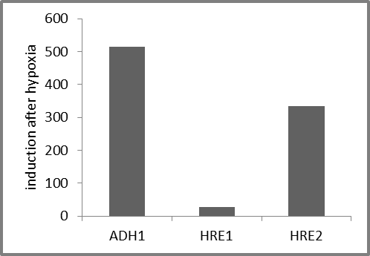Figure 2. Hypoxia responsiveness of ADH1 gene expression

Figure 3. Luminescence of ADH1-LUC seedlings after hypoxia treatment. Note the low signal and variation in signal between seedlings.

Figure 4. Natural variation for the strength of the hypoxia response in Arabidopsis thaliana

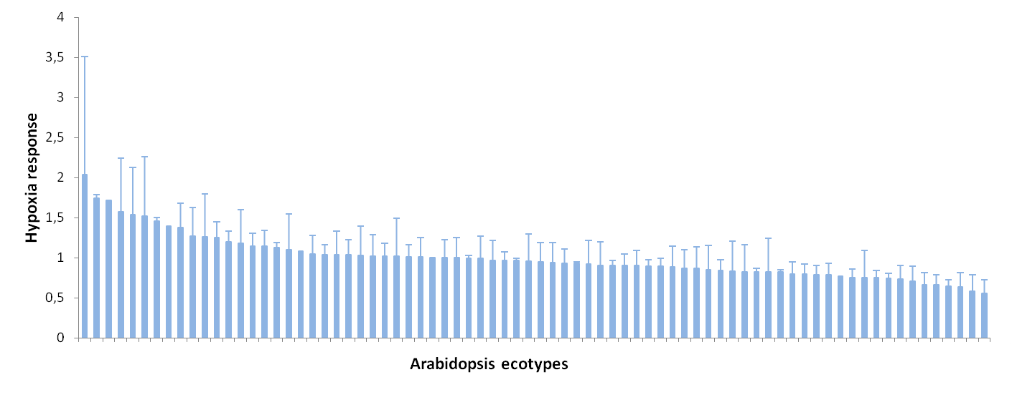
Figure 5. GWAS mapping of hypoxia responsive gene expression on Arabidopsis chromosome 1

