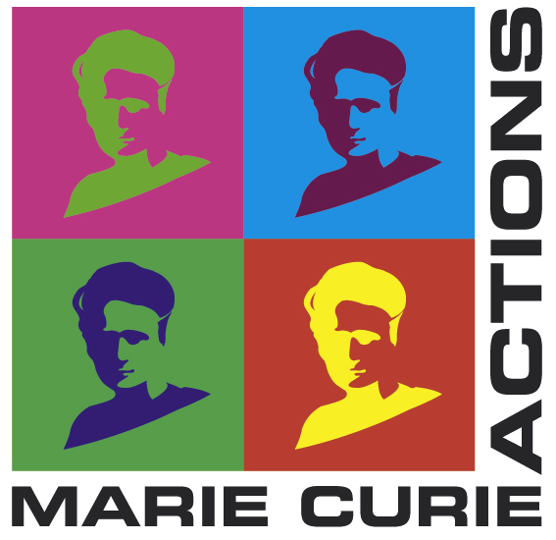
EPOCHS
Egyptian Periodisation - Object Categories as Historical Signatures

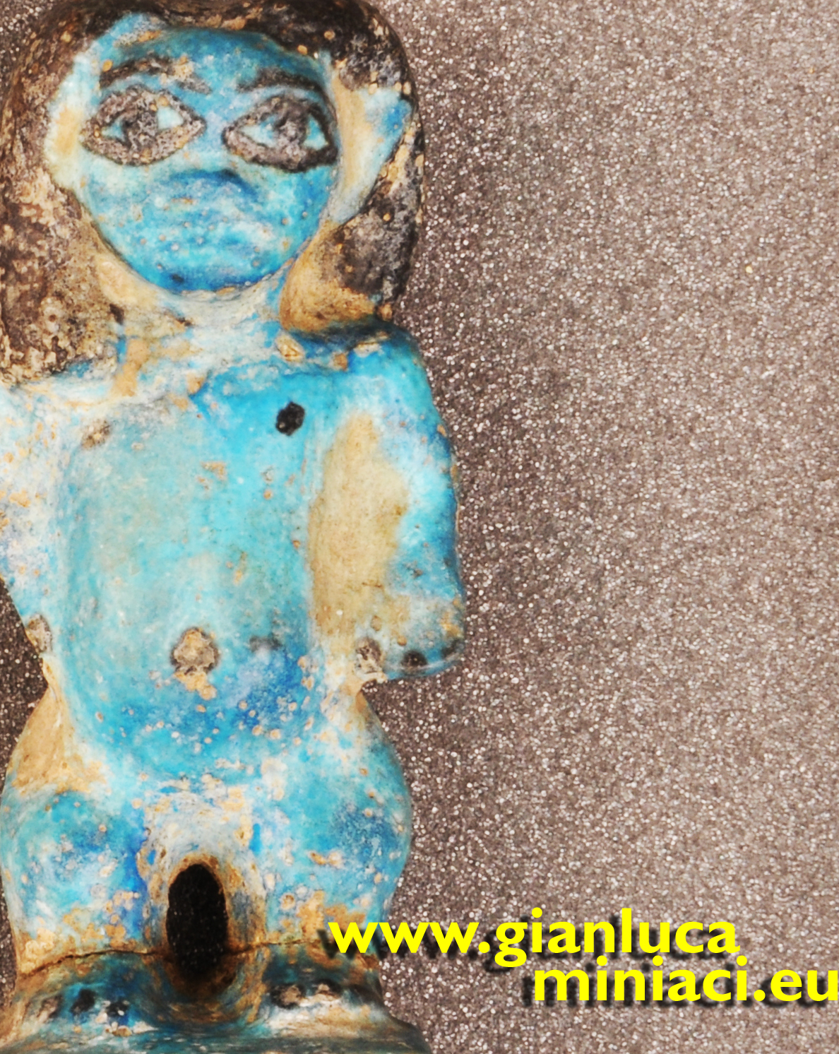
Objectives
The main objective of EPOCHS (Egyptian Periodisation - Object Categories as Historical Signatures) has been to create a linkage of two distinct methodologies: material analysis of the composition of the objects, and theoretical approach to recurrent and changing cultural patterns in material production of the Middle to Late Bronze Age (MBA-LBA) transition in Egypt (1850-1550 BC).
A primary objective of EPOCHS was to establish a parallel-track categorisation and periodisation of material cultural, mapping primary diagnostic object-types, that might be taken as period “signatures”, by:

1. using the framework of “signatures” to identify for each material-cultural phase within the transition period (a) synchronic patterns recurrent across different object-categories, and (b) diachronic variations within each object-category;

2. charting from the archaeological dataset obtained from objectives 1-2 the relationships of Egyptian material production and consumption on the two horizons of (a) endogenous (internal Egyptian regionalism) and (b) exogenous (‘internationalism’, relations between Egyptian and external groups), in order to assess in synthesis the societal impact at local, internal-regional and national levels;

3. reconceptualising problems of ideology in material-cultural products, through the relation between archaeological context and ritual practice;

4. producing a new historical synthesis of results.

Research work
The first part of the project was concentrated on training activities: a) laboratory analysis in the Wolfson Archaeological Science Laboratories in collaboration of the scientific staff of the Institute of Archaeology; b) collection management at the Petrie Museum of Egyptian Archaeology under the supervision of the scientist in charge, Professor Stephen Quirke.

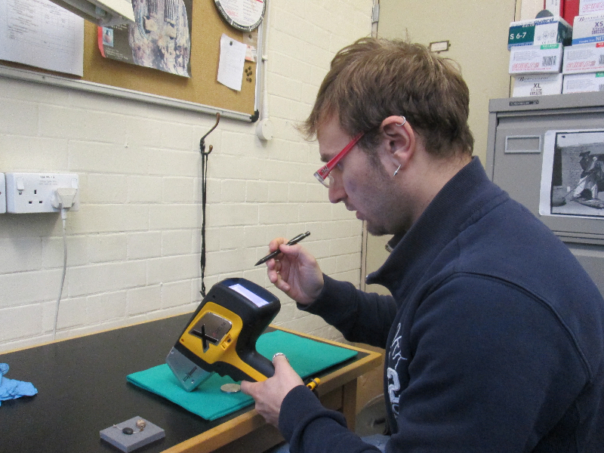
The core of the research strand has focused on selection of artifacts in the museums and the organisation of a cluster of analyses for investigating composition, materials provenance, and traces of wear. For this purpose, the core of the research was carried out at the Egyptian collection of the Petrie Museum; in addition, the researcher examined extensively the major Egyptian collections in the UK (Ashmolean Museum, Oxford, Manchester Museum; Fitzwilliam Museum, Cambridge; Garstang Museum of Archaeology and World Museum, Liverpool; National Museums of Scotland, Edinburgh; Glasgow Museums). Comparative study of the material has been extended to other museums inside and outside EU (Beograd, Berlin, Brussels, Chicago, Copenhagen, Dublin, Florence, Moscow, Paris, Prague, Saint Petersburg, Warsaw, Turin).

The second part of the project has been devoted to the selection and study of object types identifiable as historical signatures for the development of a periodisation system. In this phase the research has been concentrated on one particular category of objects for deeper investigation: faience figurines, in a specific range of forms which seems to appear during the late Middle Bronze Age in Egypt (Middle Kingdom, roughly 1900 BC), together with a new technique in figurine production, where the coarse core has a thin outer layer of finer fabric with glossy bichrome glazed surface. The range of forms disappeared rather abruptly from the archaeological record at the end of the Middle Kingdom. The historical and archaeological development of this type of objects has been extensively studied in the project in many different aspects: material, iconography, conception, groups of objects associated, place and mode of deposition.

The concluding part of the project has involved both dissemination of the research, through conference, workshops, travels and meetings (UCL and external meetings), and writing activity in order to present the results of the project in a comprehensive monograph, which is currently in preparation and expected to be published late in 2014.

Results achieved
EPOCHS has been a pioneer and pilot research project, both in raising new questions in historical and archaeological research, and in combining theoretical approaches with scientific and technological applications. The final results of the EPOCHS project, as presented in the forthcoming publication, demonstrate direct scientific impact above three different strands:

Materiality: any imaginary universe passes through the materials employed for shaping and populate this world. Changes in material use and images/figures production affect each other in a recursive pattern.
Iconography: the late Middle Bronze Age imaginative world in Egypt shows a broad range of forms, from animate to inanimate. Besides a familiar human/animal divide, a number of images show hybrid, “mixed-species” creatures, reproduced in various media, including faience figurines, hippopotamus tusk sections and glazed steatite or bone cuboid-rods.
Groups: objects in their archaeological context are not an isolated, atomic unity as they are regularly associated with other items, showing a different and complementary range of images. The combination of objects (and their images) gave shape to a wider narrative picture, and shed different light on its the imaginative world.

Combining these three strands together, the implications are profound for drawing this well-documented ancient society in the comparative anthropology of humanity - the human understandings of who we are, and how we relate to the world.

Impact
The funding of the project has enabled the researcher to complete a high profile cutting-edge research project at UCL, and to move towards role of world leader in this emerging interdisciplinary terrain of theory and practice, and hence consolidate his position of Europe as a leader in this research area against competition from current USA fieldwork and study.
The researcher has moved from a research environment dedicated to the study of history to a research group focused on the social interpretation of material production, interaction between culture, gender and ethnicity. The mobility has been beneficial in multiple directions, for the candidate, the institution of provenance, and the host institution, by creating efficient integration between the Mediterranean and the Anglo-Saxon approach to research topics.
In addition, the EPOCHS project has constituted the basis for future collaborations and wider international cooperation. The researcher is already involved in a solid networks of collaborations and contacts, bridging across the Europe: University College London, British Museum, Petrie Museum (United Kingdom), Katholieke Universiteit Leuven (Belgium), Univerzita Karlova v Praze (Czech Republic), Centre de Recherche et de Restauration des Musées de France-Palais du Louvre, Ecole Pratique des Hautes Etudes of Paris (France), University of Pisa, University of Salerno (Italy).

Gianluca Miniaci - Institute of Archaeology - University College London, 31-34 Gordon Square, London WC1E 6BT. 0044 7577 00 1910 - www.gianlucaminiaci.eu
g.miniaci@gmail.com, http://www.ucl.ac.uk/archaeology/people/staff/miniaci

