The primary goal is the development of a simple yet accurate method for designing structures with high performance under earthquakes. In essence, we seek to revolutionize the standard process that every professional structural engineer undertakes to seismically design a structure. Recent earthquakes have shown that buildings reflecting current design approaches may reduce the rate of fatalities, but often result to staggering monetary losses and disruption of functionality. To mitigate such consequences, we need to accurately estimate them by integrating seismic hazard and building response, both under the effect of uncertainty. Thus, four objectives are targeted: (a) develop a database of archetype buildings and their associated structural models, (b) quantify the effect of model and analysis uncertainties on the estimated building performance, (c) introduce a simplified approach to practically integrate seismic hazard and building vulnerability, and (d) develop a direct approach to produce a building design that can achieve the desired performance.
To address the first and second objectives, multiple reinforced concrete and steel buildings typical of EU and USA were modeled. Then, a computationally efficient approach was proposed for rapidly establishing the effect of model uncertainties on the seismic performance (Figure 1). For the third objective, a simplified, yet accurate formula was offered for evaluating the seismic performance in terms of the mean annual frequency of damages occurring. Thus, intuition is gained on the structural parameters that influence the seismic behavior of the building, while an analytical estimation of the building performance becomes possible. To fulfil the fourth objective, the concept of Yield Frequency Spectra (see Figure 2) was developed, whereby an engineer can directly determine the required strength and stiffness of the structure given the seismic hazard at the building site and the owner’s requirements on how frequently it sustains low or high levels of damage. Both analytical approximations and accurate numerical solutions are available, encoded in open-source software (available in http://users.ntua.gr/divamva/projects.html#iDesign) that can estimate Yield Frequency Spectra within seconds to provide a reliable design basis for any building and any user requirements.
The overall results achieved so far allow the practical design of structures with controllable consequences under seismic loads. The impact of this statement can only be understood by considering that, contrary to, e.g., smartphones where large teams of top engineers come together to develop a state-of-art device for mass production, each building is a unique design. In the lifetime of any such structure, designed by either the best or the most mediocre of professionals, an earthquake may come to test it. Then, the least capable designs will fail. Thus, having a simple approach that can be followed by non-specialists to produce buildings of practically guaranteed performance is of immeasurable socioeconomic importance, helping mitigate the losses to seismic events and safeguard human life and property.
Finally, the favorable outcome of the project has helped this researcher achieve financial and employment stability by securing a tenure-track position at the National Technical University of Athens and building a research group to sustain future research endeavors.

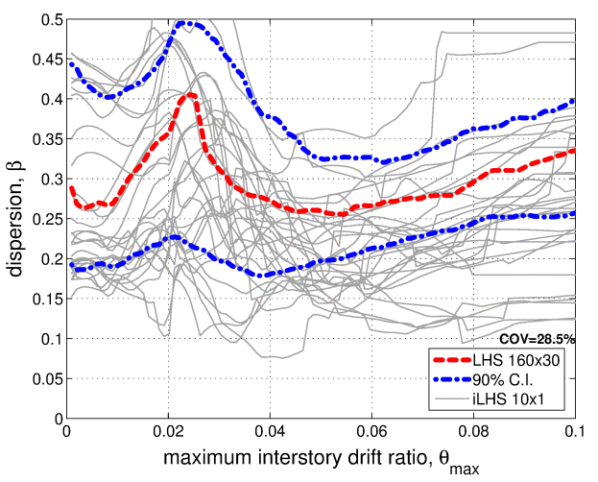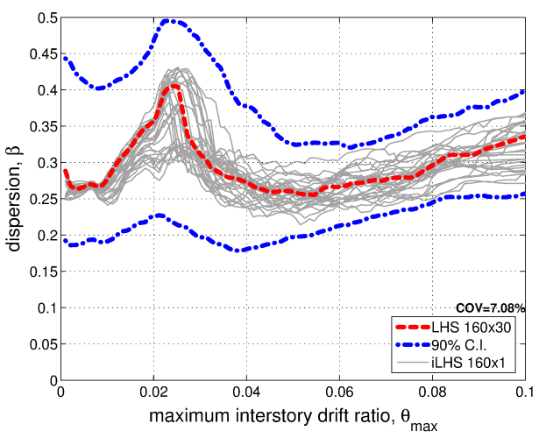
Figure 1: An efficient algorithm based on Latin Hypercube Sampling is employed to estimate the dispersion due to model parameter uncertainty in the seismic capacity of a 9-story steel moment-resisting frame. Using 160 (right) versus 10 (left) realizations of the uncertain model significantly tightens the estimates around the correct answer (red line).
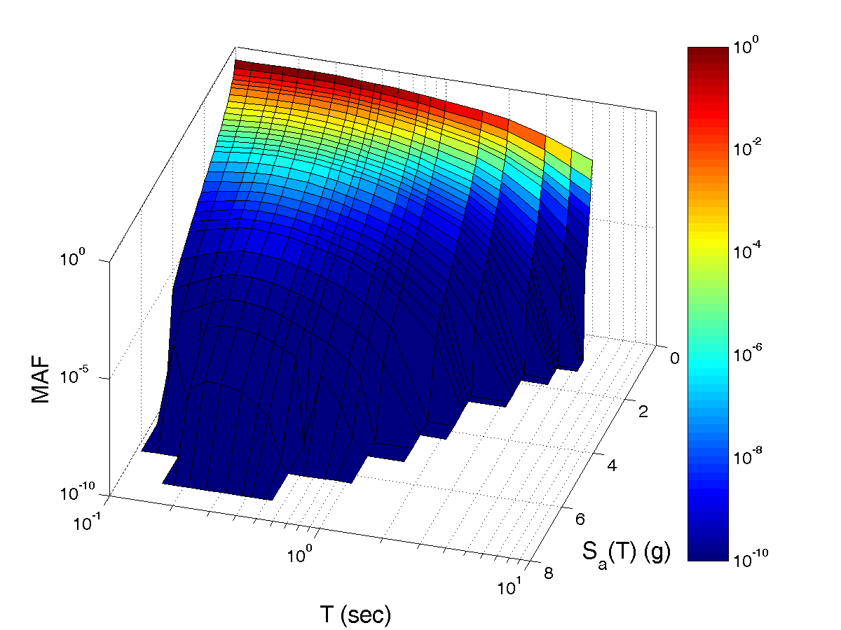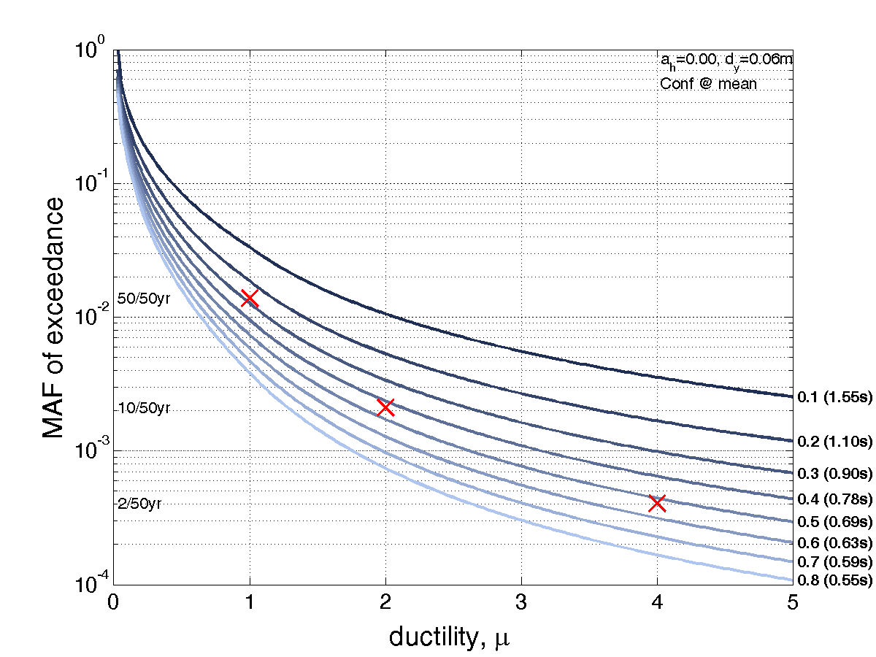
Figure 2: We seek to design a 4-story steel frame building for a high-seismicity site. The hazard surface (left) shows the frequency of different levels of seismic excitation (spectral acceleration) being exceeded at the site for potential (currently unknown) vibration periods of the building. The Yield Frequency Spectra (right) help the engineer find the appropriate period and strength of the structure, shown in the lower right corner, by selecting the closest curve that lies below the specified performance objectives. These are the red X symbols, each representing a maximum allowable frequency of a given global ductility (or damage) occurring in the building.

