Soil nitrification is an ecosystem function of special interest as it modifies the relative availability of the two sources of inorganic N accessible to plants, ammonium (NH₄⁺) and nitrate (NO₃⁻). Two ubiquitous groups of soil organisms, ammonia oxidizers (AO) and arbuscular mycorrhizal fungi (AMF) can have pervasive effects on the form of N that is available to the plants and thus affect their physiology and their competitive interactions. Moreover, NO₃⁻ availability is known to trigger denitrification and consequently downregulating nitrification in agriculture could reduce greenhouse emissions. The aim of the project was to study the interactions between AMF and AO soils with high N availability.

In the original project the fellow formulated the following three objectives.
1. To more extensively test if AM fungi do suppress nitrification rates
2. To investigate which mechanism(s) is responsible for any interactive effects between AM fungi and AO
3. To test the ecological significance of the role of AM fungi on nitrification rates through modelling the relative contribution of AM-plant-status vs plant-species-identity on supported nitrification potential rates.
In this report the following structure is adopted. Firstly some preliminary work that was carried out are presented. The presentation of specific results for each of these three objectives follows. Further scientific output that was linked to the specific Marie Curie project is presented in the end of the report.

0. Preliminary work – assessing microbial diversity

The original project the way it was formulated required in addition to acquiring robust quantitative measures of abundance/ecosystem function rates, assessing the effects of several treatments on microbial community structure. The most commonly used metric to summarize community structure in ecology is community diversity. While the concept of diversity is more or less straight-forward for macro-organisms, in microbial ecology there is a range of unique challenges such as the delineation of microbial taxa based on molecular data.
What became apparent at an early stage of the project was that the existing framework for assessing diversity of the microbial communities was problematic. To address this issue the fellow investigated the extent to which the Leinster and Cobbold indices, a set of inclusive diversity indices that had the potential to account for phylogenetic similarity across taxa, were suitable for work with microbial taxa [1]. In the specific study primary data from three pyrosequencing studies that assayed AMF communities were used and it was shown that in addition to reproducing the results of traditional “point diversity estimates” such as the Shannon diversity index, the non-naïve version of the Leinster and Cobbold indices possess could account for the issues that result from inappropriate taxa delineation.

References:
- Veresoglou SD, Powell JR, Davison J, Lekberg Y, Rillig MC. 2014. The Leinster and Cobbold indices improve inferences of microbial diversity. Fungal Ecology 11: 1-7.

1. Do AM fungi suppress nitrification rates

During his PhD thesis the fellow had shown that in low-productivity environments soil originating from the rhizosphere of mycorrhizal plants exhibits lower nitrification potential rates than soil originating from the rhizosphere of non-mycorrhizal plants (Veresoglou et al. 2011 Journal of Ecology 99: 1339-1349). There has been a subsequent study in the literature that backs these results up (Chen et al. 2013 Pedobiologia 56: 205-212). As originally proposed, two experiments were carried out to test whether this was also the case in more fertile environments. In both experiments compartmentalized mesocosms were used to segregate the effect of hyphae alone from the combined effect of roots and hyphae.
In Experiment 1 the effects of eight plant species grown in monocultures on nitrification potential rates were studied. These eight species (eight replicates each) comprised four genera (two species per genus as follows: Amaranthus retroflexus, A. caudatus, Silene vulgaris, S. otitis, Campanula rotuntifolia, C. trachelium, Bromus erectus, B. sterilis so that in each pair of species one of them was reported to associate with arbuscular mycorrhizas and one not). While trying to run a preliminary experiment to assess mycorrhizal status of the plants we run into several complications in germinating the plant species (for example A. retroflexus only germinated following incubation at 40ºC) that delayed this preliminary experiment to the extent that the mycorrhizal status of the plants was not checked before the experiment so as to stick with the time schedule. Plants were grown for three months and biomass, nitrification potential rates and AM fungal colonization rates of the root were assessed at harvest. Unfortunately only the two Bromus species and S. otitis were at harvest mycorrhizal. Nitrification potential rates at harvest are presented at Fig. 1. Despite a significant compartment effect we could detect no significant effect for mycorrhiza.

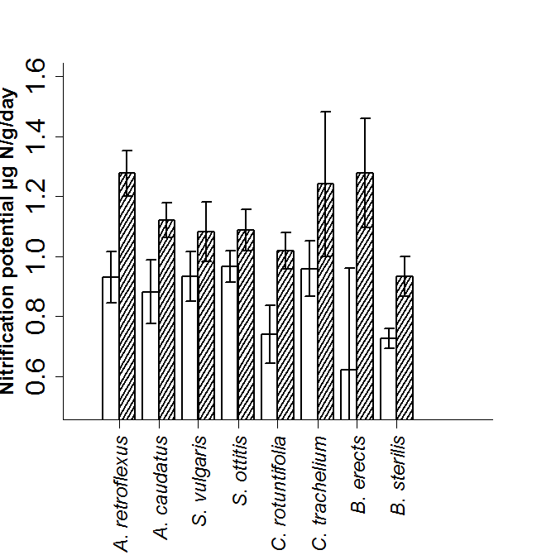

Fig. 1. Nitrification potential at the rhizosphere (unshaded bars) and hyphosphere (shaded bars) compartments (±S.E.) of the eight plant species that were used in Experiment 1. There was a significant compartment effect (a split-plot ANOVA was used) and a significant species effect but no significant mycorrhizal effect irrespective whether we used the a priori AM contrasts or the observed mycorrhizal status at harvest.

In Experiment 2 a single plant species, Plantago lanceolata was grown in compartmentalized mesocosms as in Experiment 1. Prior to the experiment the soil had been steam sterilized (three times in three consecutive days) and incubated for three months at room temperature after a soil filtrate (a 9:1 water:soil solution that following 60 minutes of shaking on a horizontal shaker was filtered through a 20μm sieve) was added to raise the water content to 60% of the water holding capacity. Prior to the initiation of the experiment the soil was left to dry, was mixed and half of it was once again steam-sterilized; both soil “types” were then rewetted with a microbial filtrate. The experimental design that was used was a bifactorial experiment with addition of AMF inoculum (Rhizofagus irregularis spores) and soil “type” as the two factors with six replicates. At harvest the parameters that were assayed were residual inorganic N availability, nitrification potential rates and root colonization. Furthermore soil was frozen for RNA extraction and fingerprinting of the ammonia oxidizing community (amoA genes) through 454-sequencing.
At harvest we could confirm that plants in mycorrhizal treatments had been successfully colonized by AM fungi. However, there was no mycorrhizal effect on nitrification potential rates (assessed through a split plot ANOVA with plant compartment as a nested factor). Despite the excellent quality of our cDNA we could not amplify AO archaea (amoA genes) and this could be related to the extraction method for the microbial community (RT-PCR revealed that the copy numbers were extremely low). Despite significant effects of soil type and plant compartment the effect of the AM treatment on overall AO bacterial community was non-significant (Table 1). When an indicator species analysis was implemented we could only retrieve evidence that two taxa were more abundant in AMF colonized samples (Fig. 2). Phylogenetic diversity of AO bacteria was not a good predictor of nitrification potential rates (Fig. 3).

Table 1. Non-parametric analysis of variance (PERMANOVA) of the bacterial AO community (the Bray-Curtis distances were used to construct the distance matrix). The specific analysis assumes independence of the two mesocosm compartments and as such is more likely to yield significant results. However, the mycorrhizal effects is non-significant. The three factors that were included in the analysis were autoclave (soil type), AM (whether P. lanceolata was mycorrhizal or not) and plant (the compartment of the mesocosm that was assayed. The results were consisted when the analysis was restricted to one of the compartments. The analysis was carried out with the command adonis in the R package “vegan”.
Call:
adonis(formula = data.dist ~ autoclave + AM * plant, permutations = 9999)

Terms added sequentially (first to last)

Df SumsOfSqs MeanSqs F.Model R2 Pr(>F)
autoclave 1 0.5928 0.59283 11.1057 0.18530 0.0001 ***
AM 1 0.0482 0.04823 0.9036 0.01508 0.4641
plant 1 0.2992 0.29925 5.6059 0.09353 0.0006 ***
AM:plant 1 0.0170 0.01704 0.3192 0.00533 0.8850
Residuals 42 2.2420 0.05338 0.70077
Total 46 3.1993 1.00000
---
Signif. codes: 0 ‘***’ 0.001 ‘**’ 0.01 ‘*’ 0.05 ‘.’ 0.1 ‘ ’ 1
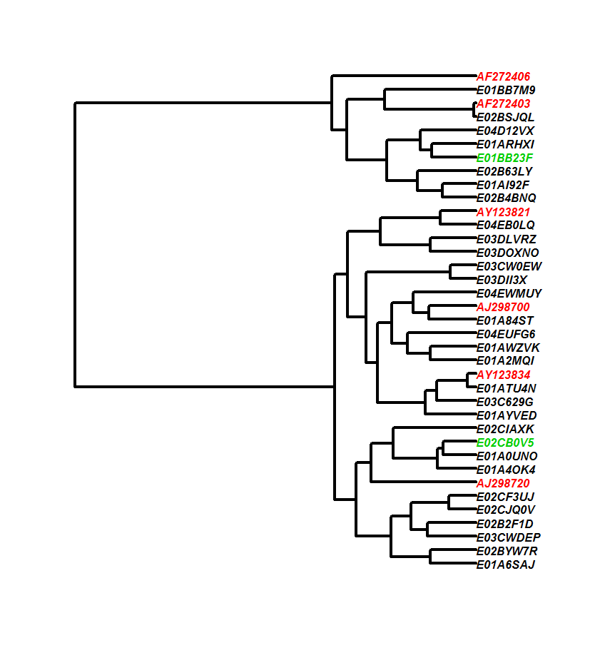
Fig. 2. Phylogenetic relationships across the AO bacterial taxa (amoA gene) that were assayed from Experiment 2 (black and green taxa) and representative AO bacterial taxa from GenBank (red taxa). Deliniation of the AO taxa was based on a 97% similarity threshold as this was implemented through CROP (Hao et al. 2011 Bioinformatics 5: 611-618). The two phylogenetic clusters in the tree corerspond to the Nitrosomonas group (top) and the Nitrospira group (bottom). The Nitrospira genus is believed to contain AO bacteria that are better adapted to low fertility conditions. We were struck by the fact that we could recover such a high ratio of Nitrospira:Nitrosomonas bacteria. Taxa in green are the taxa that following an indicator species analysis were deemed to be good indicators of arbuscular mycorrhiza (they both occurred at higher rates in soil colonized by AMF). The reference taxa were as follows: AF272406: Nitrosomonas oligotropha, AF272403: Nitrosomonas urea, AY123821: Nitrospira briensis, AJ298700: Nitrosoccocus oceani ,AY123834: Nitrospira sp. Nsp5, AJ298720: Nitrospira tenuis. The tree was rooted with the amoA sequence of a gamma-proteobacterium, Nitrosococcus halophilus (AF272521) that was croped from the tree for visulization purposes.

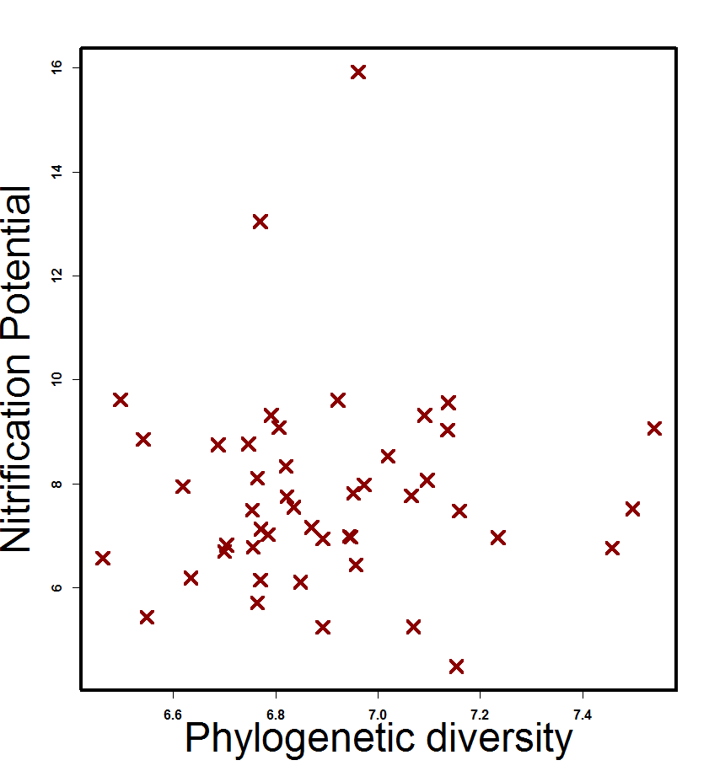

Fig. 3. Phylogenetic diveristy (Faith’s index) of AO bacteria – nitrification potential rates relationships as these were assessed in Experiment 2. No significant relationship could be retrieved even after accoutning for the effects of different treatments.

A manuscript on the results of these two experiments is currently in preparation.

References:
- Veresoglou SD et al. (in prep) Arbuscular mycorrhiza – nitrification community dynamics in high fertility systems.

2. Which mechanism(s) is responsible for any interactive effects between AM fungi and AO

A major issue while addressing the specific objective was that we had been unable to yield any positive results while addressing the first objective. As stated in the original proposal a way to address whether competition between AMF and AO represents a mechanism explaining any negative effects of AMF on nitrification was through experiments in compartmentalized systems. As stated earlier we carried out two such experiments (Experiment 1 and Experiment 2). In both of these experiments we failed to detect either a negative effect of AMF on nitrification potential rates or a significant interaction between AMF and mesocosm compartment (e.g. Fig. 1). In Experiment 2 through assaying AO bacterial community composition we could further assess AMF-linked effects on individual AO bacterial taxa. We did not find evidence that AMF suppressed any AO bacterial taxa. By contrast we detected that the abundance of two AO bacterial taxa was higher in AMF treatments. Although the soils that were used in both experiments were moderately fertile, at harvest in the end of both experiments the availability of NH₄⁺ was low. This was because of the plants having immobilized most of the available nutrients (common in pot experiments) and could have been the reason why the ratio of Nitrospira:Nitrosomonas taxa was high – an additional reason was the assaying of the active microbial community through specifically targeting RNA. Further experimentation is need to assess the conditions under which competition may be a driving factor of detrimental effects of AMF on nitrification.
Another mechanism that was proposed was that of allelopathy. To address this mechanism we proposed using exudates from transformed root organ cultures with and without AMF on growth and activity of AO bacteria. To this end we have isolated and frozen exudates. The fellow travelled last year in Aberdeen to obtain AO bacterial cultures to initiate this experiment. Due to low winter temperatures and high sensitivity of the cultures to temperature fluctuations (they cannot be frozen in glysterol) the cultures where not viable when they were brought in Berlin. One more postage in winter has failed. The experiment is due for 2014.
The fellow made an attempt to address whether any negative effects between AMF abundance and AO bacterial densities could be explained by the distinctiveness of the ecological niches of the two groups of organisms. The concept behind this idea was that possibly AO bacteria rather than being subject to strong biotic interactions with AMF, respond in a distinctive way to abiotic factors. As a result the negative relationship that has been observed in several cases could be simply phenomenological. The ecological niche of AO bacteria has been well described (e.g. Avrahami et al. 2003 Applied and Environmental Microbiology 5: 691-705) and they appear to mostly response to N availability and soil pH. This was not true though for AMF. The fellow leaded a modelling study on the ecological niches of two common AMF families, Acaulosporaceae and Gigasporaceae [3]. One of the intriguing results was that, at least for Acaulosporaceae, soil pH was among the significant occurrence predictors in a way complementary to that of AO bacteria. Yet there appeared to be a large zone of overlap of the ecological niches of Acaulosporaceae and AO bacteria for pH between 5.5 – 7.

References:

- Veresoglou SD, Caruso T, Rillig MC. 2013. Modelling the environmental and soil factors that shape the niches of two common arbuscular mycorrhizal fungal families. Plant and Soil 368: 507-518.

3. The ecological significance of the role of AM fungi on nitrification rates through modelling the relative contribution of AM-plant-status vs plant-species-identity on supported nitrification potential rates.

Given the negative results of the earlier experiments, there was little scope in attempting to test the specific objective. A possible way that the objective could be addressed was through collecting soil from low productivity grasslands in Germany; yet the time constrains did not permit any of the optimization steps that were necessary before running the experiment. The fellow prioritized instead projects that were more related to his personal development.

4. Additional scientific outcomes of the fellowship
The fellowship additionally allowed the fellow to participate in several projects within AG Rillig that led to high quality publication outcomes. The fellow was challenged to perfect his modelling skills in several projects that resulted in high profile publications [3, 4, 7]. The fellow played an important role in the mentoring of two PhD students while carrying out synthesis work that resulted in two published articles [6, 8]. He also mentored an undergraduate student project that led to a manuscript that is currently submitted to Mycorrhiza [13]. He also established collaborations with other postdocs in the group. A manuscript that is currently submitted to Basic and Applied Ecology [14] has been the outcome of extensive collaboration of all postdocs of the group. Several additional publications were the outcome of the interaction of the participant with the AG Rillig lab [1-14]. He finally got the opportunity to interact with peers in different labs while developing his ideas [1, 7]. Upon completing the fellowship, the fellow started a five-year academic position at Freie Universität Berlin. Further collaboration with Professor Matthias Rillig from this new post will allow him to complete publishing the research output of the specific project.

References:
- Veresoglou SD, Rillig MC. 2014 Do closely related plants host similar arbuscular mycorrhizal fungal communities? A meta-analysis. Plant and Soil 377: 395-406.
- Wehner J, Powell JR, Muller LAH, Caruso T, Veresoglou SD, Hempel S, Rillig MC. 2014 Determinants of root-associated fungal communities within Asteraceae in a semiarid grassland. Journal of Ecology 102: 425-436.
- Leifheit EF, Veresoglou SD, Lehmann A, Morris EK, Rillig MC. 2014 Multiple factors influence the role of arbuscular mycorrhizal fungi in soil aggregation - a meta-analysis. Plant and Soil 374: 523-537.
- Veresoglou SD, Penuelas J, Fischer R, Rautio P, Sardans J, Merliä P, Tabakovic-Tosic M, Rillig MC. 2014 Exploring continental-scale stand health - N:P ratio relationships for European forests. New Phytologist 202: 422-430.
- Lehmann A, Veresoglou SD, Leifheit EF, Rillig MC. 2014 Arbuscular mycorrhizal influence on Zinc nutrition in crop plants - a meta-analysis. Soil Biology and Biochemistry 69: 123-131.
- Veresoglou SD, Rillig MC. 2013 Accounting for the adaptation deficit of non-mycorrhizal plants in experiments. Plant and Soil 366: 33-34.
- Verbruggen E, Veresoglou SD, Anderson IC, Caruso T, Hammer EC, Kohler J, Rillig MC. 2013 Arbuscular mycorrhizal fungi - short-term liability but long-term benefits for soil carbon storage. New Phytologist 197: 366-368.
- Veresoglou SD, Barto EK, Menexes G, Rillig MC. 2013 Fertilization affects severity of disease caused by fungal plant pathogens. Plant Pathology 62: 961-969.
- Veresoglou SD, Caruso T, Rillig MC. 2012 Metacommunities and symbiosis: hosts of challenges. Trends in Ecology and Evolution 27: 588-589.
- Donnellan-Barraclough A, Veresoglou SD, Rillig MC (submitted) Silicon additions suppress arbuscular mycorrhizal colonization in cucumber.
- Caruso T, Hammer EC, Hempel S, Kohler J, Morris KE, Veresoglou SD, Opitz N, Wehner J, Rillig MC (submitted) Assessing soil ecosystem processes - diversity relationships in a nature reserve in Central Europe.

