
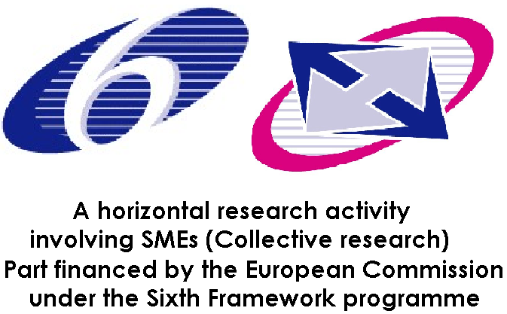

Project Number: COOP – CT – 2006 032367
Project Acronym: Ecosam

The development of a novel, hexavalent chrome-free, environmentally-sustainable pre-treatment for plastic surfaces using molecular self assembly nano-technology

Instrument: Horizontal Research Activities Involving SMEs
Co-Operative Research
Thematic Priority: Framework 6

Project co-funded by the European Commission within the Sixth Framework Programme (2002-2006)
Dissemination Level
PU | Public
PP | Restricted to other programme participants (including the Commission Services) | ✓
RE | Restricted to a group specified by the consortium (including the Commission Services)
CO | Confidential, only for members of the consortium (including the Commission Services)

Final Activity Report

Month 1 - 27

Start date of project: 1st October 2006 (Duration: 27 Months)
Period covered: 1st October 2006 to 31st December 2008
Project coordinator: Dr Roy Huzzard (Smithers Rapra Technology)

Table of Content

1 Summary Description of Project Objectives 3
2 The main challenges 3
3 Contractors involved 5
4 Introduction 6
5 Work Perfomed 6
6 Testing and Characterisation of metallised ABS and Non ABS treated samples 8
6.1 Scanning Electron Microscopic studies 10
7 Discussions 13
7.1 Waste management and treatment 14
8 Conclusive remarks 15

Summary Description of Project Objectives

The Ecosam project has worked to develop a novel surface pre-treatment method for chrome plating on a broad range of plastics. The majority of industries worldwide currently use a hexavalent chrome based pretreatment. The major disadvantage of this is that hexavalent chromium (Cr(VI)) is classified as carcinogenic by the International Agency for Research on Cancer (IARC) and the World Health Organization (WHO). Disposal of waste effluent is also a major issue that companies need to address; cost effective alternatives would improve the environment and reduce the risks to the health of workers in the industry.

The Ecosam process is based on a molecular self-assembly technology (SAM) which eliminates the need for chromium (VI) chemical etching and provides a stable and secure surface suitable for subsequent chrome plating operations. With a possible ban on the use of hexavalent chromium in the future, the need to find an alternative for the chrome based pre-treatment technology could not be greater. Unfortunately, the technology is not easy to replace, though the emergence of molecular self-assembly technology used in the development of sensors could be the answer. This project has used this technology to develop an effective, environmentally friendly and economically feasible solution.

The main challenges

• To eliminate carcinogenic chromic acid from the pre-treatment process.
• To decrease processing time and the number of plating/rinsing tanks.
• To offer greater product flexibility, as the process will not be limited to a single polymer such as acrylonitrile-butadiene-styrene (ABS).
• To reduce waste water and chemicals due to fewer process steps.
• To reduce the cost of the plating process due to elimination of the expensive palladium catalyst.
• To increase process stability compared to classical wet chemical metallization.
• To maintain the performance whilst lowering the cost of the chrome plating process.
• The anticipated outcome of the project will be an optimised process for electroplating on plastic materials that is both more economical and more environmentally friendly.

Contractors involved

List of Participants

Partic. Role | Partic. no. | Participant name | Short name | Country
CO | 1 | Smithers Rapra Ltd | RTL | UK
CR | 2 | Avanzare Innovacion Tecnologica | Avan | Spain
CR | 3 | Faperin S.L. | Fap | Spain
CR | 4 | Chorro Y Verdu S.L. | Chor | Spain
CR | 5 | DMS Plastics Limited | DMS | UK
CR | 6 | Innoplate International B.V. | Inno | Netherlands
CR | 7 | Farba S.A. | Farb | Turkey
CR | 8 | Quality Plated Plastics Ltd | QPP | UK
CR | 9 | PR euroCHEM Ltd | PRC | Ireland
CR | 10 | Asociación de Investigación de Materiales Plásticos | Aim | Spain
CR | 11 | Instituto de tecnologias quimicas emergentes de la Rioja | INTER | Spain

Co-ordinator Contact Details
Dr Roy Huzzard
Project Manager
Smithers Rapra Technology Ltd
Shawbury
Shrewsbury
SY4 4NR

Introduction

This two year project to develop a novel, hexavalent chrome free, environmentally sustainable pre-treatment for plastic surfaces using molecular self - assembly nano-technology started on 1st October 2006 and the total duration was 27 Months. It was divided into eight work packages. The work performed during the whole period of the project is summarised in this report.

Work Perfomed

The need to reduce weight and improve fuel efficiency in automobiles is the biggest driving force for the increased use of electroplated plastics. Materials selected for this project was based on the recommendations of the industrial electroplaters and end users. A design of experiment process was followed to mould a series of test pieces. Optimum injection moulding parameters were set to achieve test pieces with desired properties suitable for electroplating. Acrylonitrile – Butadiene – Styrene Copolymer (ABS), Polycarbonate/Acrylonitrile butadiene Styrene (PC/ABS), Polycarbonate (PC), Polypropylene (PP), Polypropylene with 20% talc. (PC+20% talc) and Polyamide with 40% mineral filler were the materials retained for the project.

Initial laboratory trials using the self assembly process on test plaques that were injection moulded by Faperin were very promising. The Ecosam technology is a new technology proprietary to the partner Avanzare, and developed during the development of sensors to monitor the fermentation process during wine production.

In order to effectively carry out the trials using this new SAM technology, test plaques from the same production batch were pre-treated using the traditional methods and results compared with those pre-treated using the new Ecosam method. ABS which is traditionally for plating in industry was used as a reference material.

The adhesion tests and thermal cycle tests from the laboratory trials gave very promising results. The success of these early trials was followed by the application of the new SAM technology on other selected plastic materials such as ABS/PC, PP, both filled and unfilled

The new Ecosam process is summarised schematically in Figure 30.1 below.
The new process has 3 steps before the use of electroless nickel:
- Etching solution
- Chemical functionalisation
- Nano-particles deposition

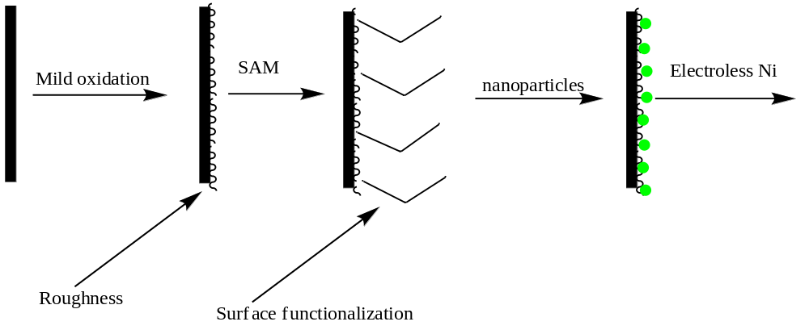
Figure 30.1 – Scheme of the ECOSAM process

The laboratory studies using the Ecosam technology, and subsequent testing provided very good results indicating the viability of the new technology. In order to master all the conditions that can be encountered in the industry, the process was scaled–up. A 100 litre pilot plant was constructed and studies conducted, replicating the laboratory trials but on a larger scale. Various etching temperatures were tried out in the Ecosam process since high etching temperatures causes problems in industry. High temperatures can lead to the release of noxious fumes and increases the energy cost of the process. Good or even better results were obtained by etching the plastics between 40°C and 65°C using the Ecosam process.

Testing and Characterisation of metallised ABS and Non ABS treated samples

The testing and characterisation of both ABS and non ABS samples was undertaken using the standard methods applied in the plating industry and documented in the various international standards.

Some of the results of the Adhesion/peel test from the pilot plant trials are summarised in Table 30.2. The adhesion between the plastic and the metallised layers was almost three times stronger than that obtained for ABS using the traditional chromium plating technique. The accepted peel strength using the traditional method is 9 N/cm. The plated surfaces were chemically resistant as no significant change in brightness was observed after exposure of the Ecosam plated plastics to chemicals.

Table 30.2 – Peel strength for some plated plastics using the Ecosam technology

Material  (Ref.) | Process Temp | NOTES | Force (N) | Force N/cm
PP (3) | 50ºC | Electrolytic Cu.  3.0 A/dm² 1h + 15min. | 49.60 | 19.84
ABS (1) | 50ºC | Electrolytic Cu  3.0 A/dm² 1h. | 40.90 | 16.36
ABS/PC (2) | 50ºC | Electrolytic Cu  3.0 A/dm² 1h + 15min. | 22.83 | 9.13
ABS/PC(5) | 50ºC | Electrolytic Cu  3.0 A/dm² 1h + 15min. | 23.62 | 9.45
ABS (11) | 60ºC | Electrolytic Cu  3.0 A/dm² 1h + 15min. | 26.71 | 10.68
PP (6) | 50ºC | Electrolytic Cu  3.0 A/dm² 1h + 15min. | 53.73 | 21.49

Scanning Electron Microscopic studies
Scanning electron microscopy was conducted on the Ecosam etched ABS and non – ABS samples to observe the distribution of the anchorage points generated as a result of etching; this was compared with the distribution obtained with the current industrial process. The results indicated that the new Ecosam technology for treating the ABS and non ABS samples was more effective as the samples had regular hollows which were well distributed throughout the sample compared to the industrially treated sample that had fused hollows. These fused hollows can be a problem for the nano-deposition of the nano-material and for electroless nickel treatment. A large number of well distributed, small hollows tend to give more keying points per unit surface area than the fused hollows so the load is thought to be spread more evenly resulting in less risk of pull-out and therefore greater adhesion. Figures 30.2 and 30.3 are SEM images of etched ABS/PC and ABS. The Ecosam method was used to etch the samples. The images show an even distribution of hollows that are available as anchorage points.

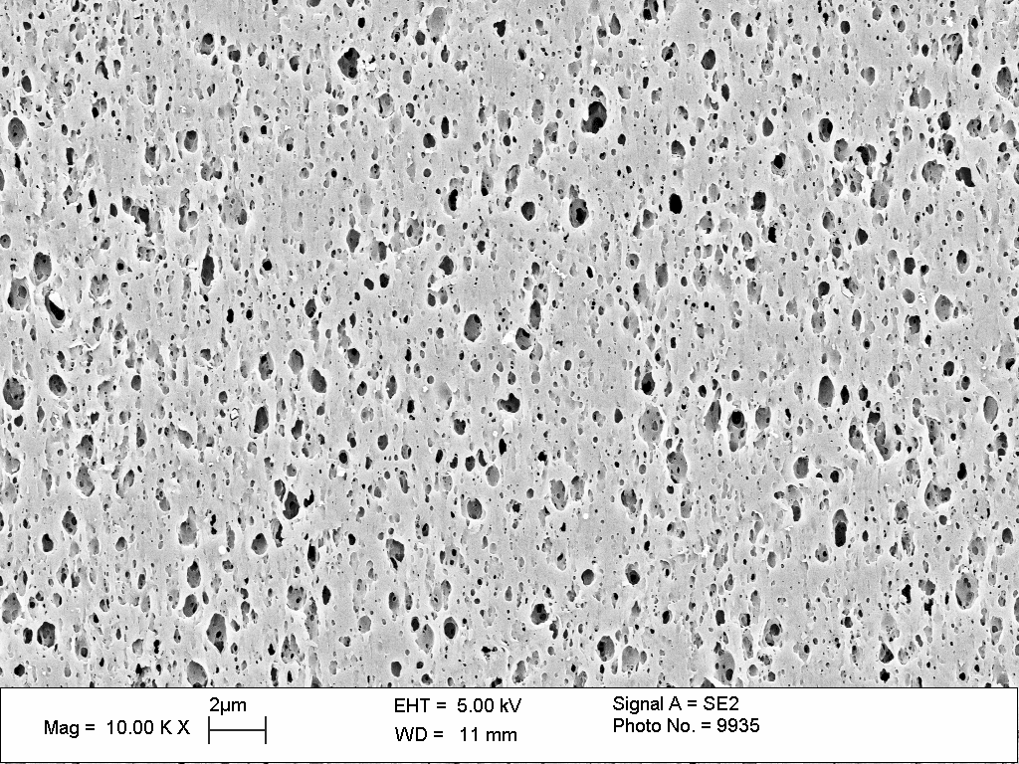
Figure 30.2: PC/ABS 86/135: SEM of etched surface

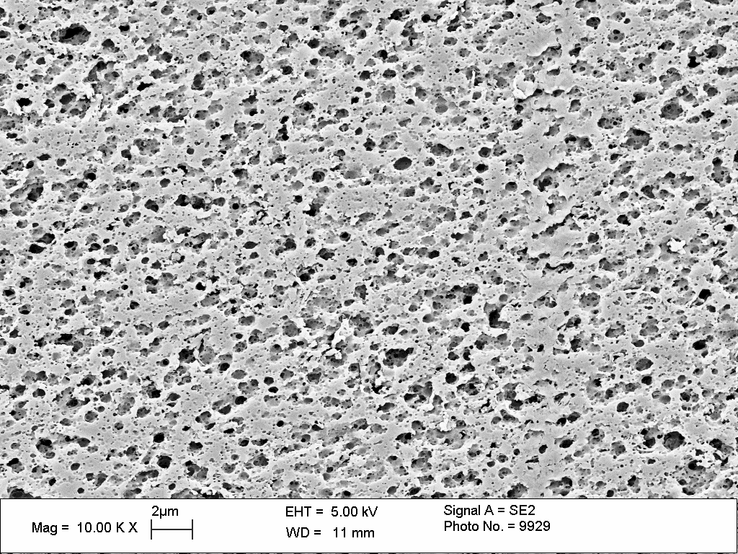
Figure 30.3: SEM of ABS 86/134 etched at 60°C using the Ecosam process

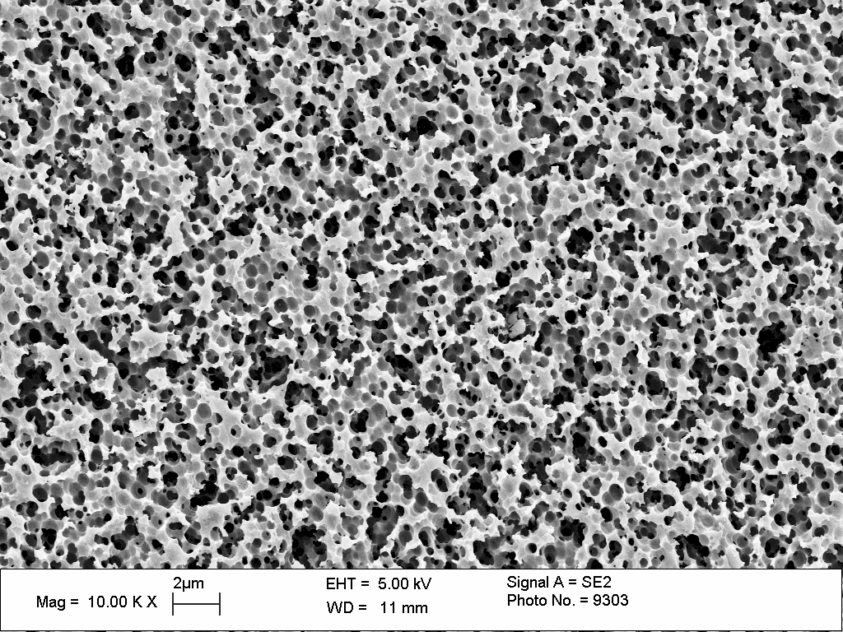
Figure 30.4: Magnified SEM image of etched surface of ABS in an industrial setting

Figure 30.4 is the SEM image of ABS following industrial etching using the traditional method. Many fused hollows can be observed which may result in poor adhesion. Figure 30.5 shows a higher magnification view of the samples shown in Figure 30.3 and 30.4 respectively. Smaller hollows could be seen on the Ecosam pre-treated ABS compared to the industrially pre–treated ABS which shows many fused hollows.
(a)  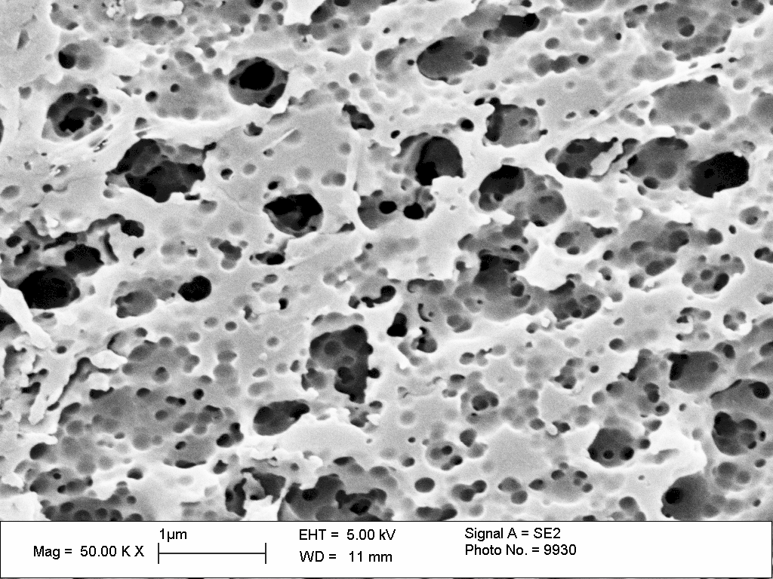 | 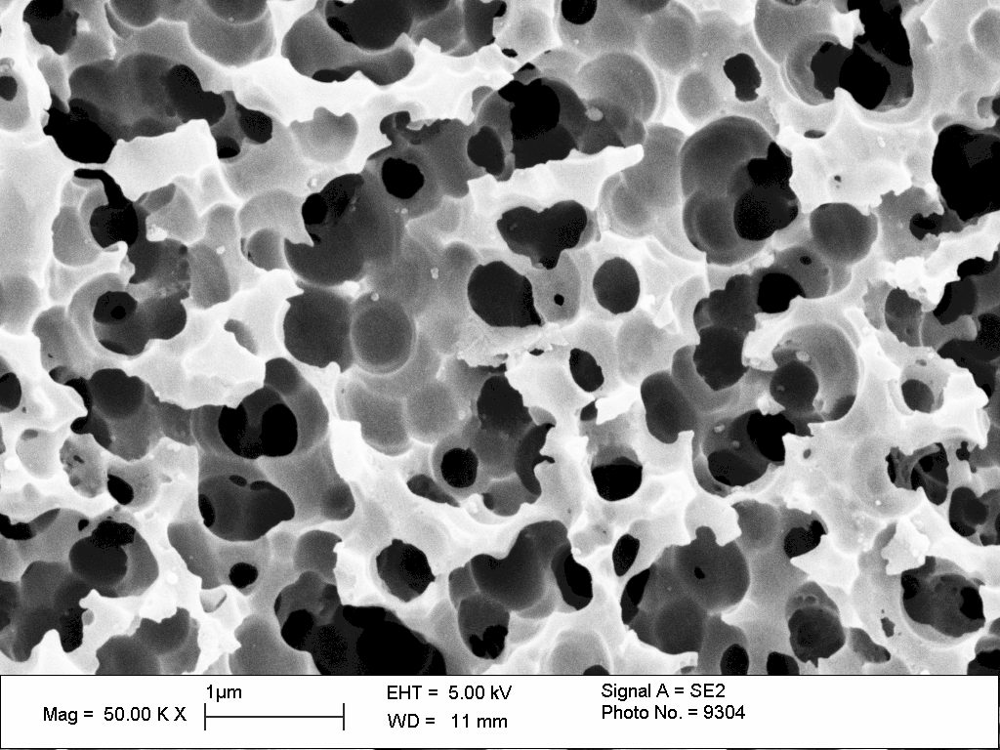  (b)
Figure 29.8: SEM images of ABS treated samples (a) ECOSAM process, (b) industrial process

Discussions

The ABS samples treated at 50°C produced hollows which are well distributed and are beneficial for electroplating. The etching of some of the ABS test pieces which had some stress was directional and the directional nature of the attack produced an alignment of the hollows that became the anchorage points of the metallic layers.

Increasing the temperature increases the attack on the surface of the plastic thereby creating more pores (cavities). Many of the hollows (cavities) fuse forming caverns. There are continuous hollows of nanometre scale on PC-ABS treated at a temperature of 60ºC. The distribution of the hollows created on the PC/ABS samples may not be as beneficial for electroplating as that obtained with the ABS samples treated at 50°C.
Compared to the industrial plating process the new Ecosam process (as can be seen from the SEM images) produces a lot of smaller hollows which act as anchorage points for the nano-particles and improve the plating process compared to the industrial process which results in the production of a lot of fused hollows which are not be good for adhesion of the nano-particles.

Waste management and treatment
While the industrial treatment process has five stages, the new Ecosam process has only three stages for treatment of any waste.
The Ecosam alternative is heated to around 40°C – 65°C compared with typically 87°C for the traditional process. As a result, the cost to heat a processing tank will cost around ½ as much for the Ecosam process compared with the traditional process. The Ecosam process does not require specialist tank linings and engineering materials for agitation or filtration and the effluent is easier to treat, there is little need for the chrome neutraliser and as such less filter cake will be produced. The cake that is produced is recyclable (by removal of nickel and copper) and therefore there are no land fills to fund.

Also the new Ecosam technology is more user friendly in terms of material handling and health and safety and is not a bio hazard or dangerous for marine life.
Aside from the potential costs savings, the main benefits are environmental impact, health and safety and reduced effluent treatment.

Conclusive remarks

- The developed Ecosam process is capable of being used to successfully plate polypropylene that on average has a cost which is almost half that of the conventional ABS used today. That is the cost of PP is 50% less than ABS.
- The advantages of the SAM technology include the elimination of carcinogenic hexavalent chromium and expensive palladium catalysts from the process, improved control and stability of the process, reduction of waste chemicals and reduction of process steps leading to a cost reduction. In addition a wider range of plastics may potentially be plated or alternatively, a surface suitable for painting or printing can be prepared.

