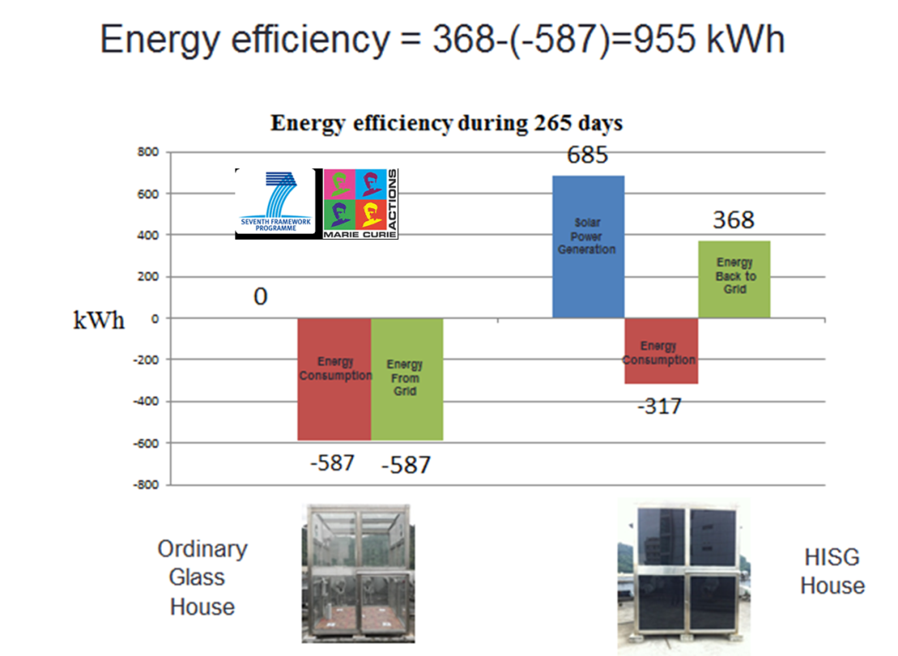

Fig. 2 High capacity energy efficiency glass in the world

