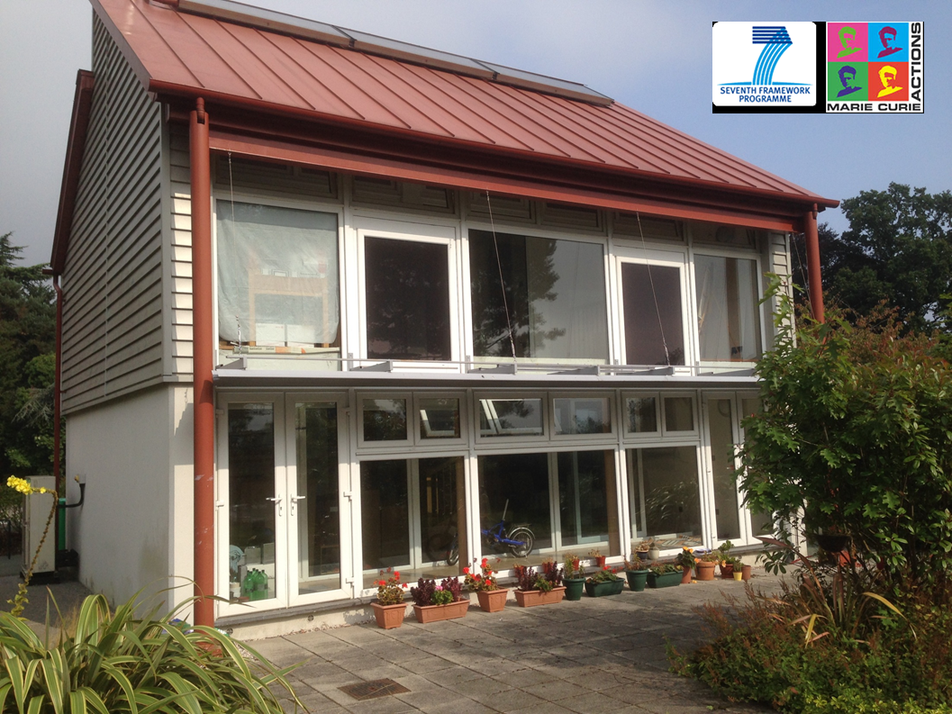
Fig.3 Application on BASF Creative Home

