Publishable report 1
Solar power generation of Heat Insulation Solar Glass on BASF house
Project: DHISGLCB
Chin-Huai Young, Saffa B. Riffat and Erdem Cuce
University of Nottingham
Objective
The objective of this report is to do an experimental study for the Heat Insulation Solar Glass (HISG) in this project to compare the solar power generation between UK and Asian Countries.
HISG structure and mechanism
Fig. 1 shows the structure of the HISG. It indicates that the reflection layer at the back of solar thin film can reflect back the IR to increase the solar power up to 10% and reduce the IR penetration to obtain a good heat insulation during the summer time. In additions, two air spaces on both sides of reflection layer can reduce the U value to save heating consumption during the winter time.
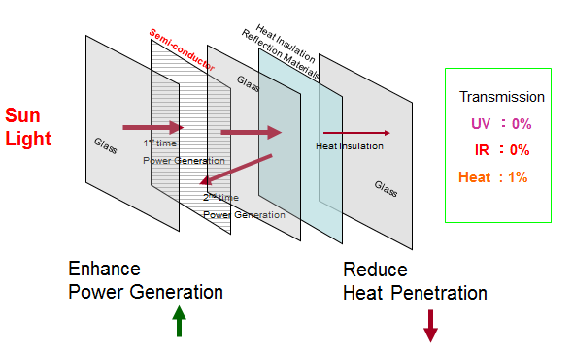
Fig.1 Structure of HISG

Window installation
The first stage of this study is to replace the traditional Double Low-e window to HISG window on the BASF Creative Home in the Campus of University of Nottingham to measure the solar power on a building as shown in Fig.2. The BASF house faces to south with trees at the front of the building and shading above the window which supplies a very good experimental study for this project on shadow effect on the solar power generation of HISG. As well, the test result is also compared with the simultaneous test in the campus of National Taiwan University of Science and Technology (NTUST) to measure the solar power under different location and various climate in EU and Asian Countries. Fig.3 shows the HISG on the BASF house and Fig.4 shows the HISG on the building in Taiwan to do the comparable study.
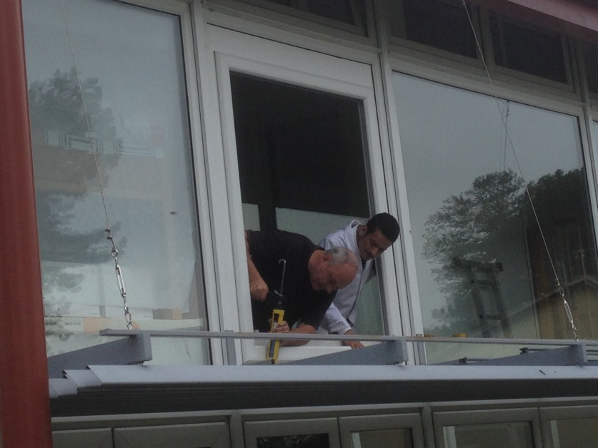
Fig. 2 HISG installation on BASF house in the campus of University of Nottingham
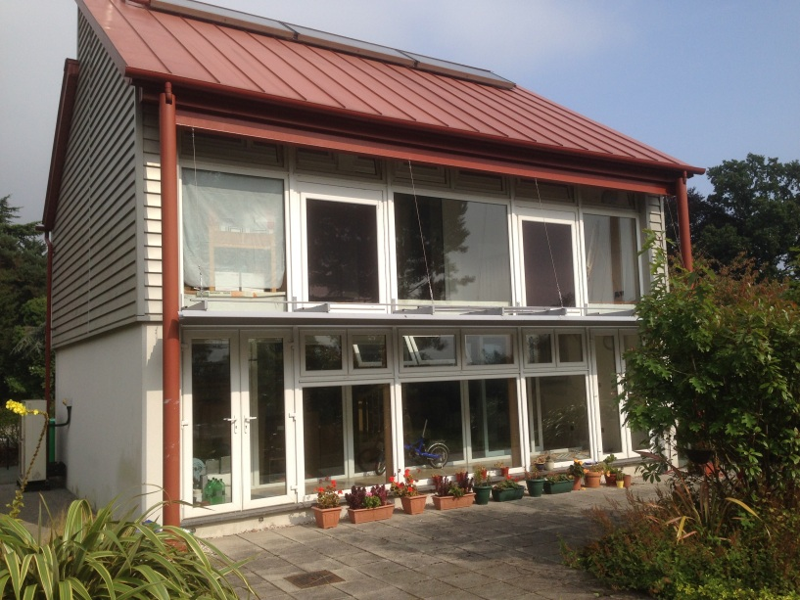
Fig.3 HISG installed on BASF house
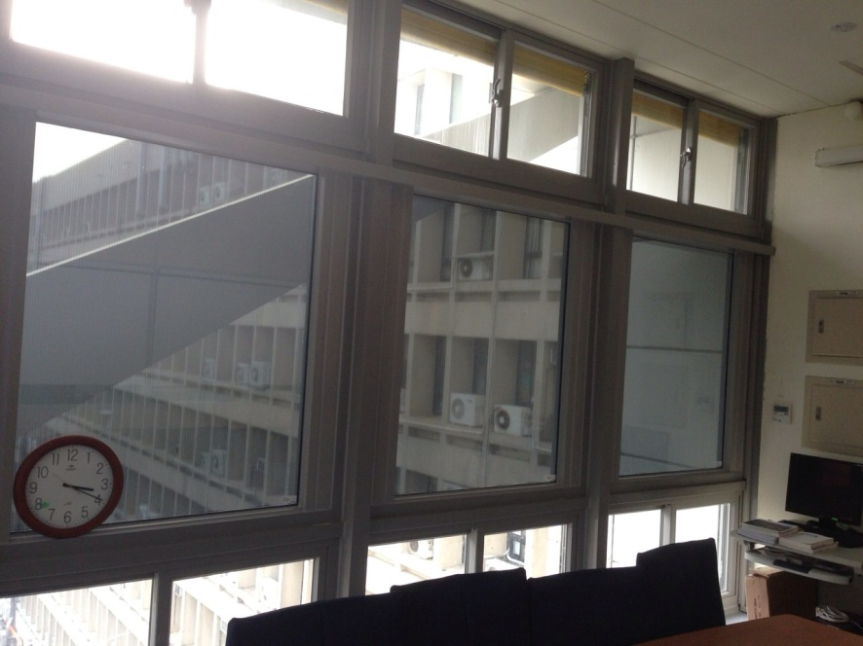
Fig.4 Simultaneous testing in the campus of NTUST for comparison
Experiment configuration
Fig.5 shows the configuration to measure the solar power generation. The HISG was connected to a solar power measurement instrument to collect the solar power generation, temperature and sun intensity. The size of HISG was 1.4 m x 1.1 m with the cross section of 8 mm solar glass+ 6 mm air+ 0.1 mm low-e film+ 6 mm air+ 6 mm glass as shown in Fig.6.
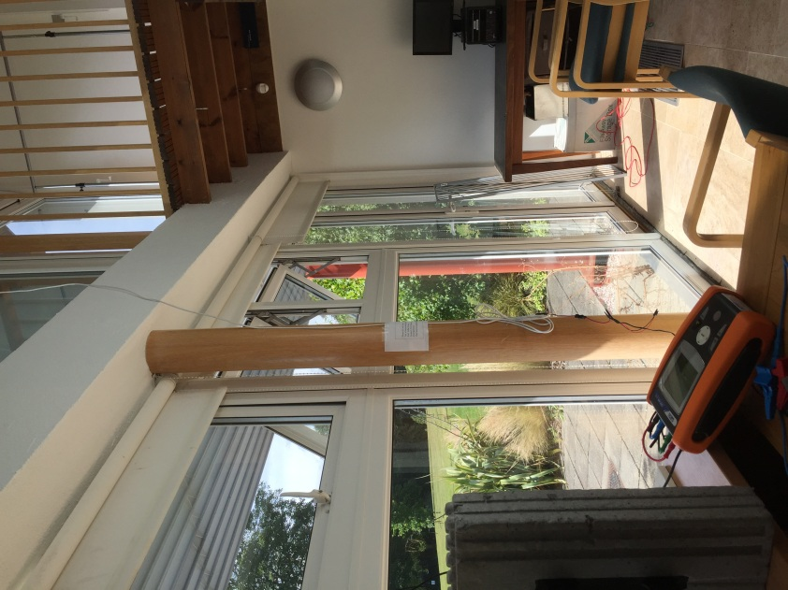
Fig.5 Configuration of test

Fig.6 Tested HISG structures

Test result and analysis
The test result could be classified to four aspects for analysis which were solar power with respect to sun intensity, shadow effect due to sun shading, shadow effect due to tree shadow, time effect and location effect.
- Solar power with respect to sun intensity

The objective of this test is to measure the solar power generation capacity under various weather condition such as sunny day and cloudy day. The test was performed in the winter time of Oct. 2015. The maximum sun intensity measured in the winter time on the vertical position was 768 W/m² and got solar power generation for a 1.1 m x 1.4 m HISG window as 84 W. The tendency of the solar power w.r.t sun intensity looked like linear relationship as shown in Fig. 7. One can predict the maximum solar power under 1000 W/m² sun intensity will be at the value of 121 W based on the calculation of the linear equation.

Fig.7 Solar power generation of HISG on the BASF house

- Shadow effect due to sun shading

The BASF house with sun shading above the window supplied a very good experimental study for HISG on the shadow effect from the sun shading as shown in Fig. 8. The situation is quite normal while we apply the HISG on the building. The test is performed during the summer time in June 2015 and the position of sun is quite different from that in the winter time. The shadow only appeared during the summer time due to the inclined angle of the sun is much higher than that in the winter time. In order to obtain a fair comparison, the sun intensity was designed to lie between 400 to 500 W/m². Fig. 9 showed the shadow effect due to the sun shading. It showed that the more the shadow the less the solar power and looked like linear relationship. The solar cells of HISG are vertically series connected as shown in Fig. 10. The shadow area may only decease the solar power generation but not obstruct the full series connection. That is why we can see the tendency is looked like linear. The test result could be taken into consideration while we apply the HISG on a building with sun shading above the window.
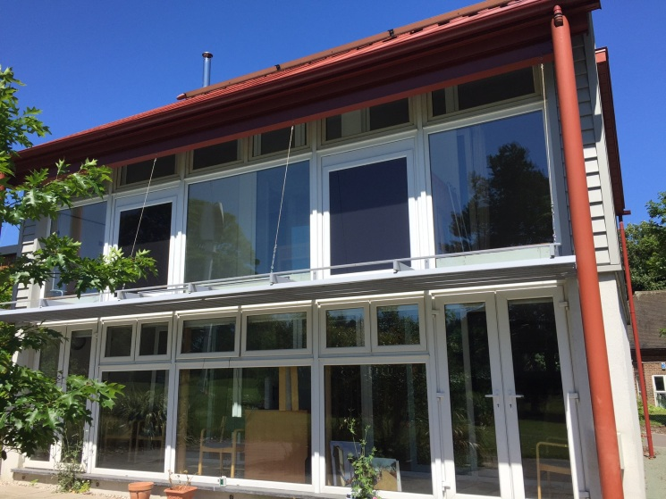
Fig.8 Shadow effect of solar power generation

Fig.9 Shadow effect due to sun shading

Fig. 10 Explanation of shadow effect

- Shadow effect due to trees
The BASF supplied a very good environment for testing the shadow effect due to plants front of buildings. Fig.11 shows the environment of BASF house with tree at the front of building. It exists in many buildings while plants surrounding the building, therefore, the research in this topic can study the shadow effect due to shadow front the building. The inclined angle of sunshine during winter time is very small and it induces the shadow of tree appears on the HISG during 11 am to 1 pm in the winter time. The shadow from tree may induce the decrease of solar power on HISG as shown in Fig. 12. The shadow covered all the HISG area, therefore, the light gained by the HISG mostly came from the reflection from the ground and other substance. The test was based on the same sun intensity at 570 W/m² for comparison. It indicated almost one third of the original solar power was remained due to the shadow from tree. The test result could be taken into consideration while applying the HISG on a building with tree or other building at the front of the HISG.

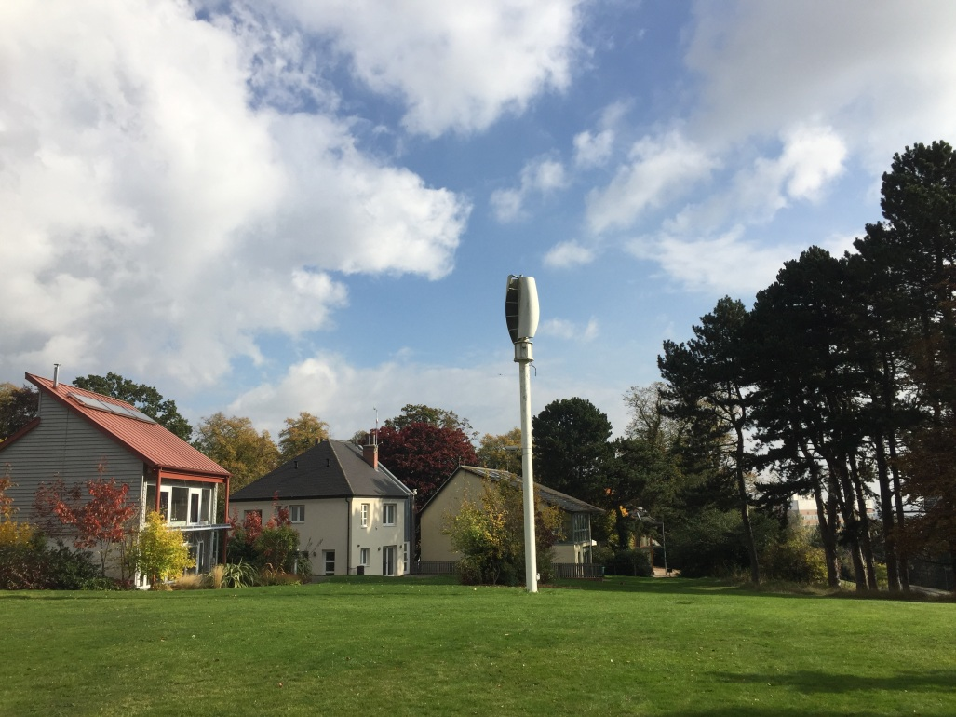
Fig.11 Tree shadow front of BASF house

Fig.12 Shadow effect due to the tree

- Time effect
The test was selected on a sunny day without any cloud in the sky to prevent the cloud effect. Sun intensity detector was attached on the surface of window to measure the sun intensity on the window as shown in Fig. 13. The direct sun intensity of the sunny day on 20th Oct. 2015 was 750-850 W/m² during the day time. It indicated the solar power generation of HISG possessed the same distribution as the sun intensity on the surface of HISG. That means the solar power generation was dependent on the sun intensity on its surface during the sunny day and gained a maximum value around noon.
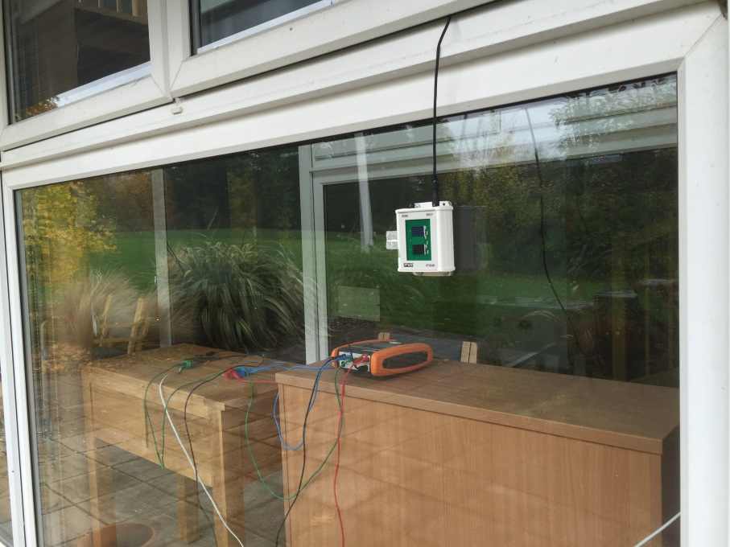
Fig.13 Sun intensity detector

Fig.14 Solar power w.r.t time under sunny day
- Location effect
In order to realize the HISG performed in Asian and European environment, the project built two vertical window with HISG and conducted experiments at the same time for comparison as shown in Fig.3 and Fig.4. The latitude induces the various inclination of sun shine in Asian and European countries. The HISG on BASF house in UK and on TBTC (Taiwan Building Technology Centre) building were tested for this study. Fig.15 showed the big difference between these two locations owing to their different latitude. The test result indicated a significant application was that the HISG gained a very good performance on solar power generation on vertical window in the higher latitude countries especially in the winter time as 27th Feb. 2015 with the similar sun intensity under 855 W/m² at both locations.
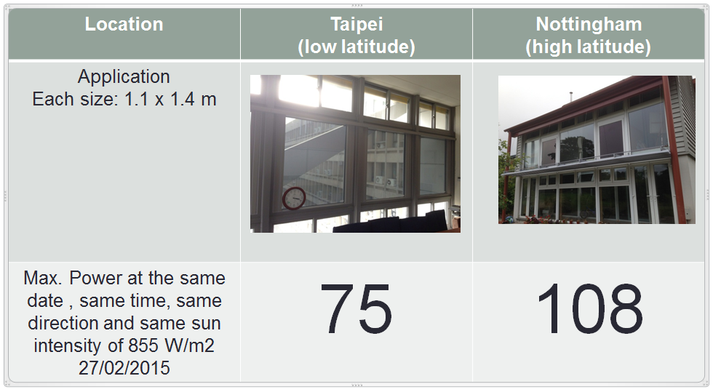
Fig.15 Comparison of Solar power of HISG between Asia and EU on vertical window

Consideration on different application
To consider applications for the HISG on different part on the building, such as window, skylight or roof, solar power generation of HISG on various inclination angles was studied here. In which, the horizontal position represents the installation of HISG on the skylight, the 45 degree inclination angle represents the installation of HISG on the roof and the vertical position represents the installation of HISG on the window. Fig.16 showed the testing of HISG on 27/02/2015 in the campus of University of Nottingham. It indicated the HISG gained a very high power generation on the vertical position during the winter time due to the higher latitude in UK. It is quite different while compared with the countries in the lower latitude. Therefore, it could be concluded that the HISG gained a similar solar power generation both installed on roof or window within the higher latitude countries.
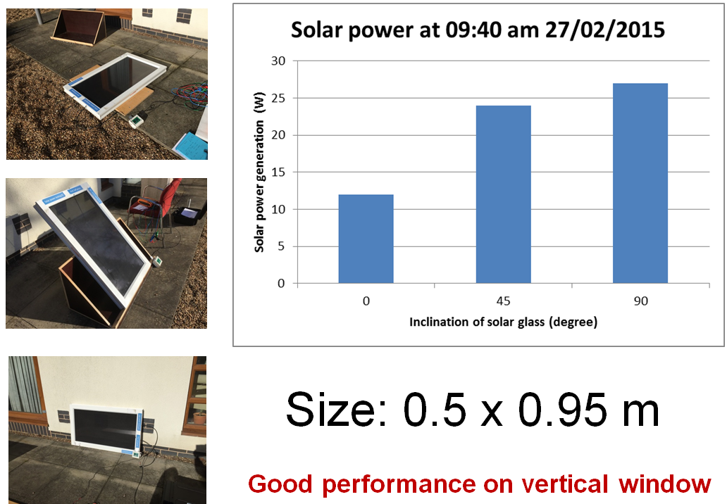
Fig. 16 HISG applied on different situations

Conclusion
The solar power generation of HISG on vertical window gained comparable higher capacity in UK than in Taiwan due to the different latitude. The test result encouraged the application of HISG applied on window in UK or Northern European countries. The test result could be helpful while designing the HISG on the vertical window for low carbon buildings with various shadows and sun intensity. The proposed formulation, Y(solar power generation, W) = 0.1286 X (sun intensity, W/m²)-7.7284W, could be used to predict the solar power of HISG with a size of 1.1 m x 1.4 m w.r.t sun intensity.

Acknowledgement
Highly appreciate to Prof. Saffa Riffat for supplying high quality of experiment facilities and the BASF house for HISG installation and testing to finish this research.
As well, many thanks to Dr. Erdem Cuce for helping installation of HISG on the BASF house. The Vale Window company helped to produce and install HISG on the BASF house is also highly appreciated. I like to say many thanks to EU and Marie Curie project for financial support to this research and University of Nottingham to supply a wonderful research environment.

