Publishable report 2
Development and experimental study of Smart Heat Insulation Solar Glass
Project: DHISGLCB
Chin-Huai Young, Saffa B. Riffat and Lee-Yan Hu
University of Nottingham
Objective
The objective of this research is to develop a new kind of Smart Heat Insulation Solar Glass (SHISG) which could be adjustable on see-through to get a more comfortable indoor environment and more energy efficiency based on the existing successful developed experience on HISG.
Innovative concept
The concept of the innovation is based on the property of glass. The lower the SC value, the lower the solar heat penetration of the glass. As well, the lower the U value, the lower the heat conductivity of the glass. One can adjust the see through of the glass to change the value of U and SC in order to gain higher energy saving on heating and cooling. If we apply the concept on the buildings in tropics zone as shown in Fig.1, we can adjust the see through to be dark to gain lower SC value and prevent the sun heat penetration to save cooling consumption during the sunny day. As well, we can adjust the see through to clear to save lighting consumption during the daytime of cloudy day. In additions, we can also apply this concept on the buildings in frigid zone as shown in Fig.2. When we adjust the see through to clear during day time and gain more sun heat for warming up the house and save heating consumption. Contrarily, we can adjust the glass to dark during the night time to decrease the U value and save heating consumption.
In order to reach the target of this innovative concept, a window with adjustable heat insulation solar glass was designed as shown in Fig.3. Many solar cells was surrounded along the boundary of the glass to generate solar power for suppling the power to adjust the see through of glass. A battery was embedded inside the frame to save the solar power from solar cells during the day time and one DC outlet was designed on the frame to charge the DC facilities such as desktop, Pad or mobile phones, et. cl. One could adjust the see through from the switch on the frame.
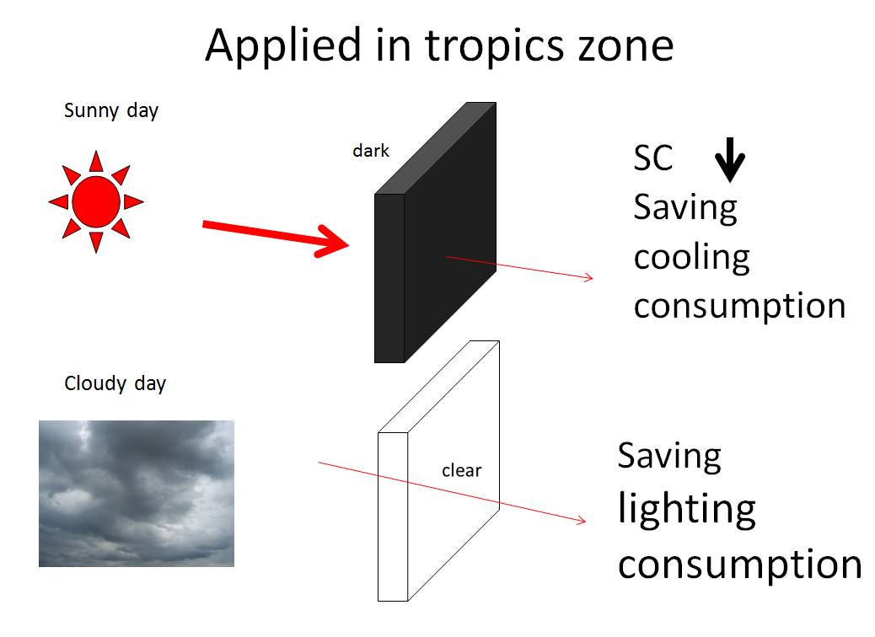
Fig.1 Applied on the buildings in tropics zone

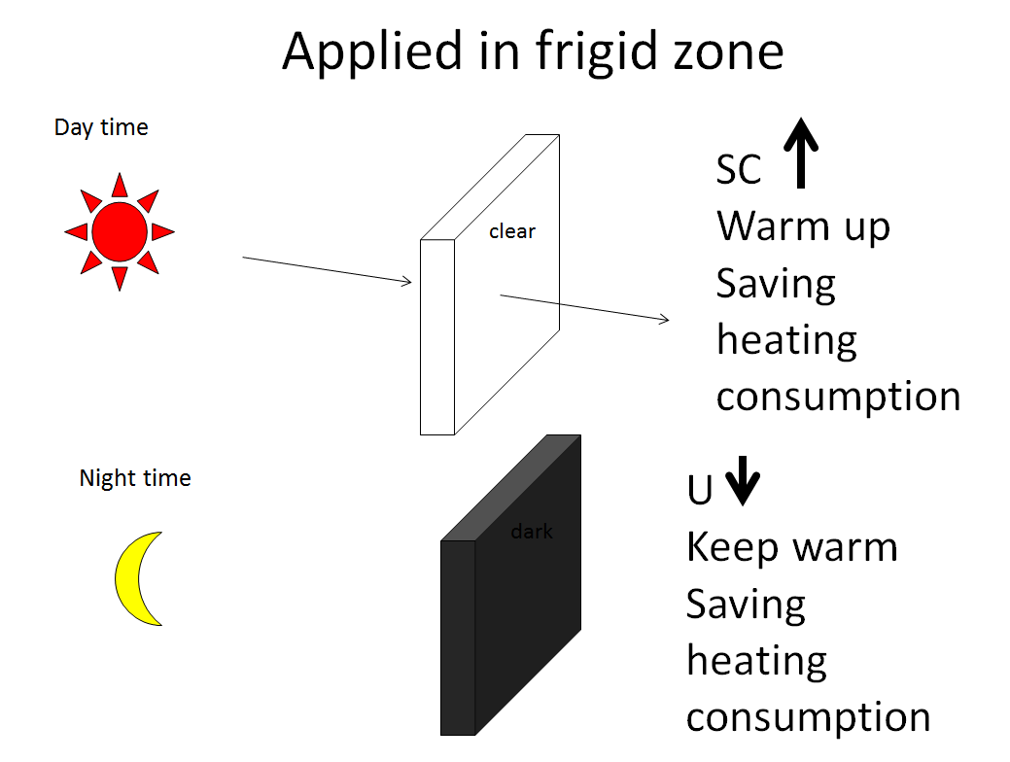
Fig.2 Applied on the buildings in frigid zone
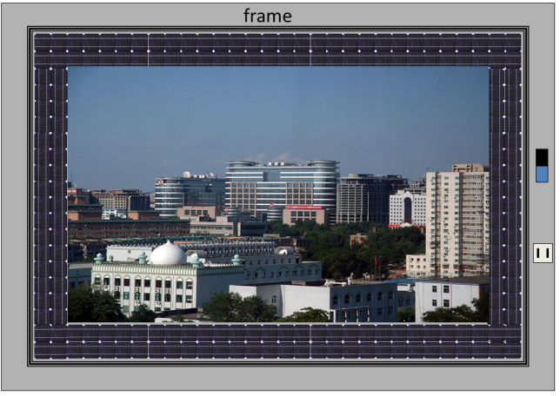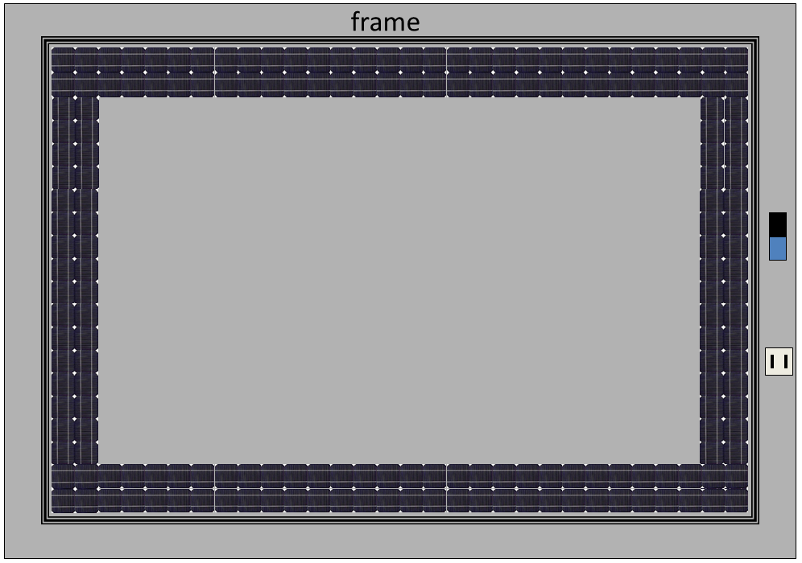
Fig.3 Design concept of SHISG
SHISG structure and mechanism
Fig.4 shows the structures of the SHISG. It included solar cells for solar power generation, heat insulation element for insulation and smart film for see through adjustment. The solar power was stored in a battery inside the frame and the battery supplied the power for smart film.
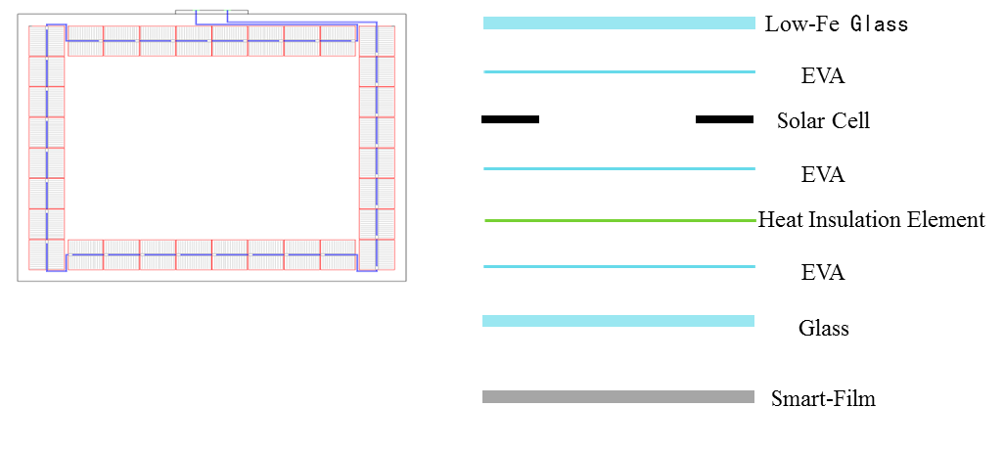
Fig.4 Structures of SHISG
Test configuration
All the testes were performed outside the David Wilson Creative Home in the campus of University of Nottingham. As well, an SHISG window was installed on the David Wilson Creative Home to test its functions. Fig.5 showed the test configuration and environment. The tests included solar power measurement, shading effect, insulation capability and energy consumption.

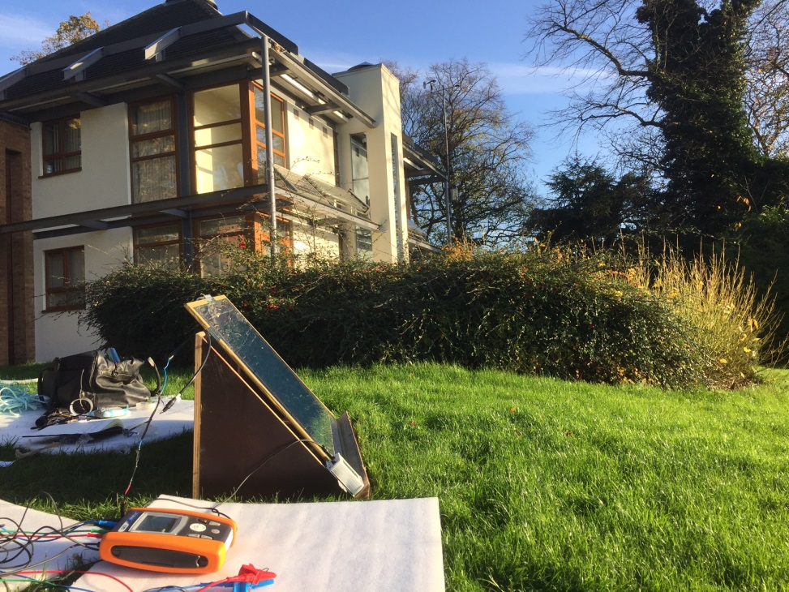
Fig.5 Test configuration of SHISG at the campus of UoN
Adjustable see through
Fig. 6 showed it could work according to the concept and structure of SHISG. The test was performed in the campus of University of Nottingham. The see through of LCD film could be adjusted by switch the power from DC power of solar cells. Fig. 7 showed the adjustable see through effect on David Wilson Creative Home at the campus of University of Nottingham. It could be applied as an electronic curtain which could be connected by an intelligent remote control system to enhance its functions. The traditional curtain could not be handled by an intelligent remote control system due to heavy and not easy to be controlled.
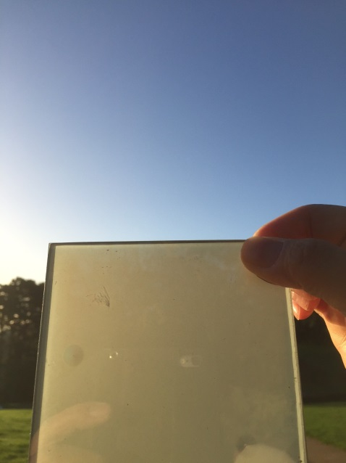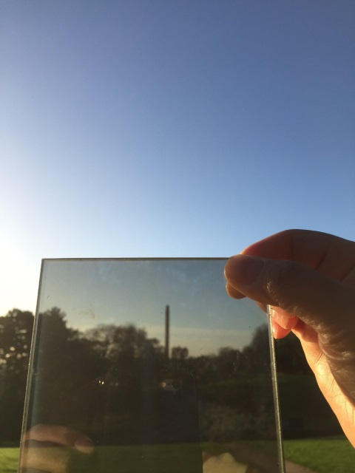
Fig.6 Adjustable see through of LCD film
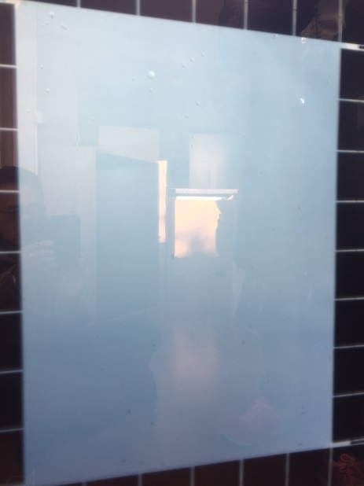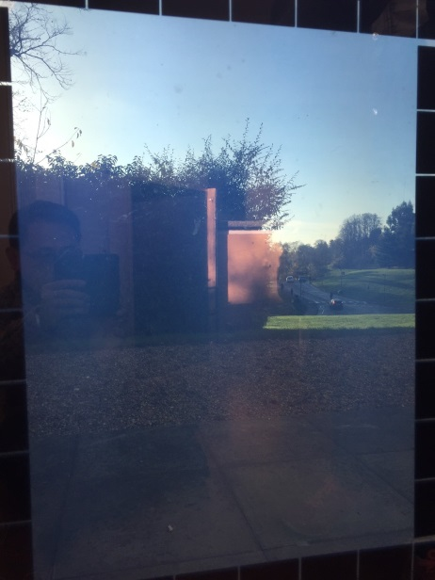
Fig. 7 SHISG window on David Wilson Creative Homes in UoN
Shading effect
The shading effect included three topics for measurement which were light penetration, UV penetration and solar radiation heat penetration.
- Light penetration

Fig.8 showed the testing configuration of light penetration test. Fig. 9 showed the test result of light lamination among three different situations which were outdoor, indoor see through and indoor non see through. It indicated the illumination outdoors was so high due to sunny day. The SHISG can cut a lot of light penetration at the situation of see through to obtain a comfortable visible environment indoors due to its several layers of transparent materials. In additions, the SHISG could reduce more light penetration while at the situation of not see through. The value of 1826 Lux was quite good for the suitable environment of study and we did not need to turn on the light for study and save the lighting consumption. One could adjust the see through from the switch on the frame to get a more comfortable indoor environment according to the conditions of weather.

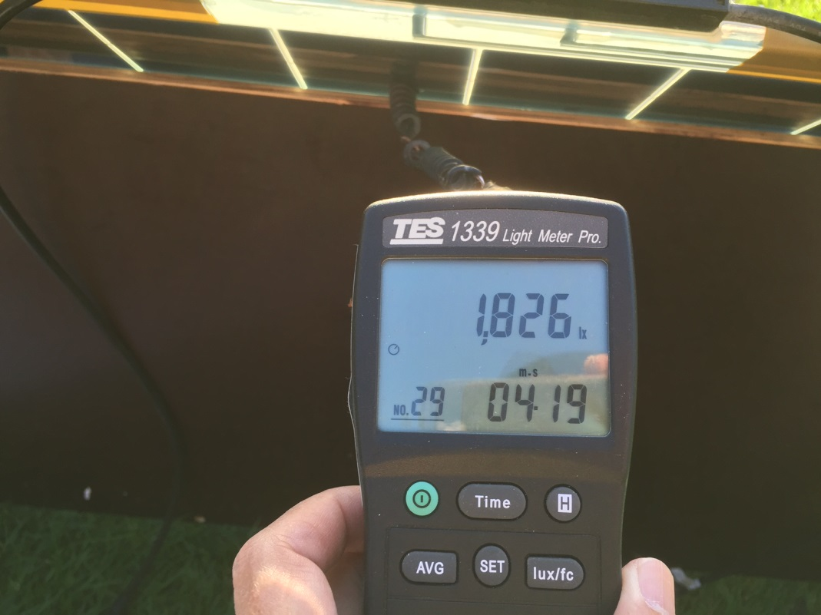

Fig. 8 Light penetration test

Fig. 9 Test result of light penetration

- UV penetration

As one knows that the UV is not good for the indoor environment due to damage of furniture and human body. The SHISG gained a full shading to all the UV both in see through and not see through situation as shown in Fig.11. It means one can enjoy stay at home by installing the SHISG for the window or skylight.
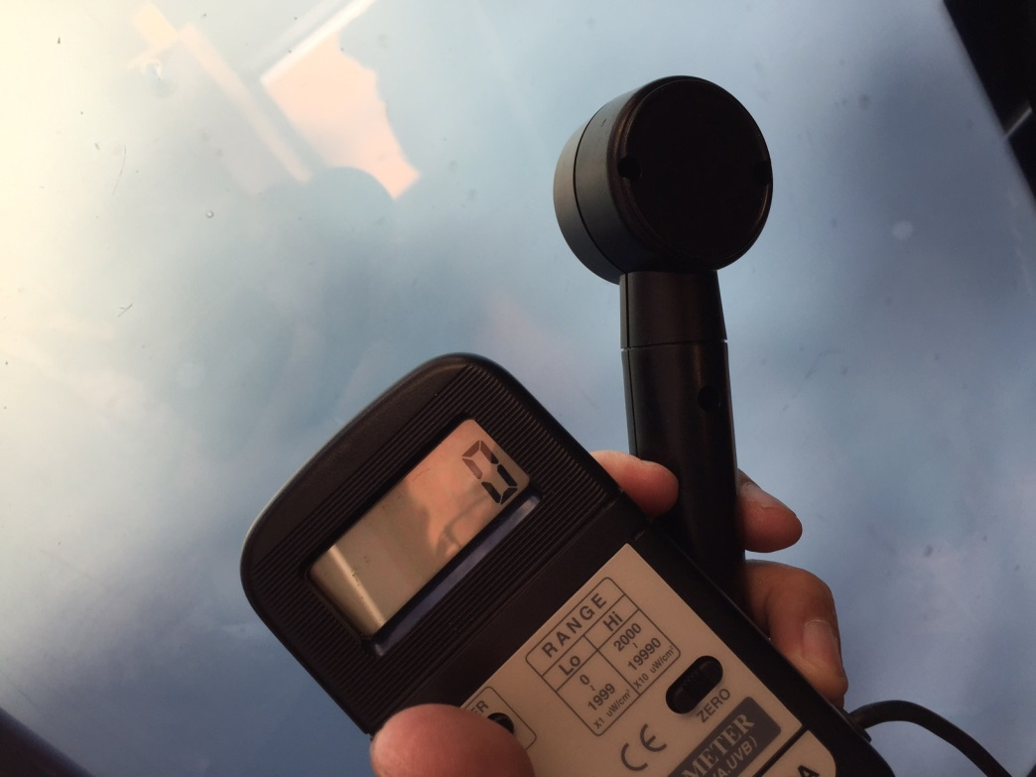

Fig.10 UV penetration test

Fig.11 Test result of UV penetration

- Solar radiation heat penetration

The shading of solar radiation shown in Fig. 13 was quite high both in the situation of see through and not see through due to there was an insulation layer embedded inside the SHISG. It can save cooling consumption or get a comfortable indoor environment during the summer time.
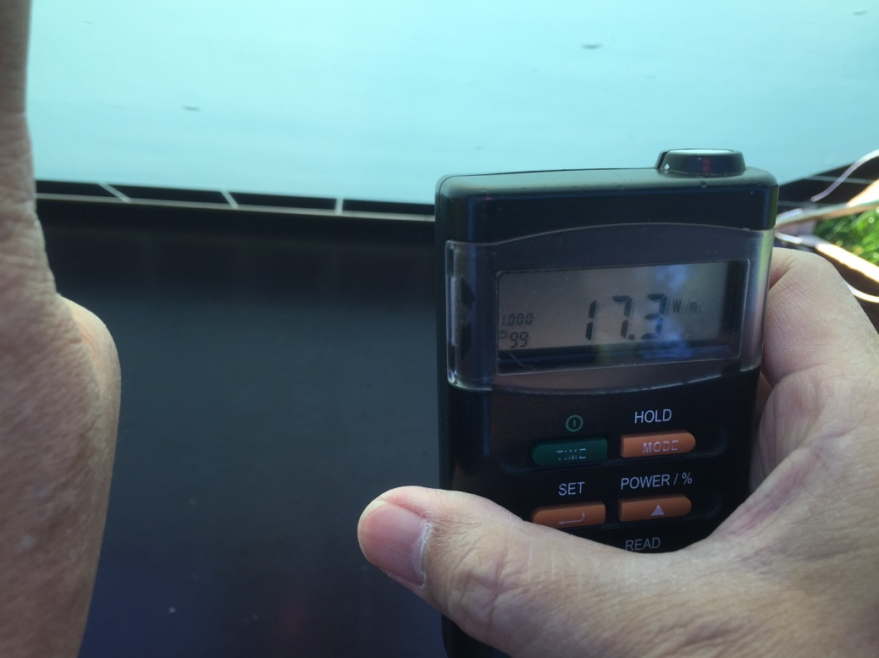

Fig. 12 Solar radiation heat penetration test

Fig. 13 Test result of penetration of Solar radiation heat
Solar power generation

The test was performed in Feb. 2015 at the inclination angle of 45 degrees to measure the solar power generation of this developed 1m x 1m SHISG. Table 1 and showed the test results of solar power generation based on various climate and direction parameters. It indicated the solar power generation gained the maximum value in the direction of south and on a sunny day. It was almost the same in each direction during the raining day or cloudy day due the lower sun intensity, especially on a raining day. The smart film named Electro Chromic (EC) needed power supply of 1W under the situation of not see through. If we assumed the average hours of a SHISG window under the situation of not see through as 8 hours per day, then it needed 8 Wh per day to operate. According to the test result, the solar power could not supply the EC film only during the raining day, but it was enough during the cloudy and sunny day. The battery embedded inside the frame could store the power during the sunny and cloudy day and supply the power during raining day and at night.
Table 1 the solar power generation of SHISG in one day
Directions | Raining day | Cloudy day | Sunny day
East (Wh) | 7 | 19 | 47
West (Wh) | 7 | 23 | 59
South (Wh) | 7 | 20 | 91
North (Wh) | 7 | 17 | 21
Max. sun intensity (W/m²) | 136 | 495 | 716
Average sun intensity (W/m²) | 60 | 176 | 492

Fig.14 Solar power generation of SHISG under various climate and directions

Energy consumption
In order to know the energy consumption of a SHISG window, we set up a test chamber in National Taiwan University of Science and Technology in 2015 due to the Marie Curie project is a kind of international cooperation project. Four 100 W lights acted as sun simulator at the distance of 60 cm front of SHISG window and there was a big 2m x 2m x 2m cubic chamber behind the SHISG window to simulate indoor environment. A cooling system was installed inside the chamber as shown in Fig.15. The cooling test continued for 8 hours to compare the energy consumption among 10 mm ordinary glass, see through SHISG and not see through SHISG. Fig. 16 showed the SHISG could save cooling energy consumption while compared with ordinary glass due to the insulation film inside the glass. The cooling energy consumption of SHISG was lower while under the not see through condition due to the function of not see through could be a shading of heat from outdoors. During the summer time, one can adjust the SHISG to not see through to save more cooling expense. Compared with 10 mm ordinary glass, the not see through SHISG could save 36% cooling consumption during the summer time.
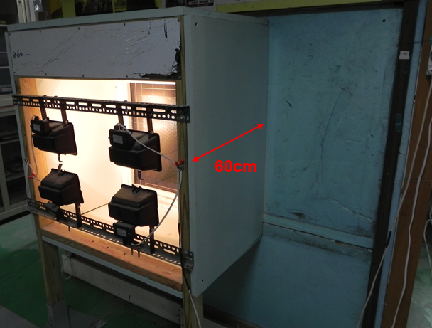
Fig.15 Test configuration of energy consumption for SHISG

Fig.16 Cooling consumption test result

Innovative multi-functions
The SHISG window had many innovative multi-functions. It included solar power generation, adjustable see through, UV shading, saving energy consumption which were described in previous sections. As we indicated in the innovative concept, a battery was embedded inside the frame to store the solar power from solar cells during the day time to supply the power not only for smart film but also DC electronic products such as DC light, DC fans, desktop and mobile phones as shown in Fig. 17 and Fig.18. You can also design any elements related to this mechanism to many innovation commercial products. A commercial application of SHISG could be applied as project screen for business or entertainment purpose. Even more, one can apply the SHISG as a commercial advertisement display board during the night time on a tall building such as shown in Fig.20. The solar power could be stored during the day time and apply at the night time for display. That means the SHISG tall building may possess multi-functions which include energy saving, anti-UV, comfortable indoor environment, business or entertainment display screen and advertisement display and income during the night time.
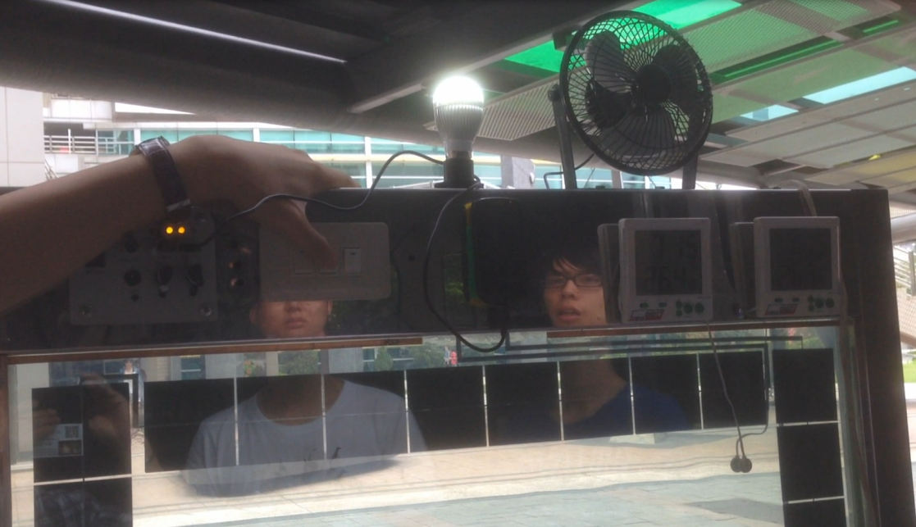
Fig.17 SHISG can supply the power of light and fans

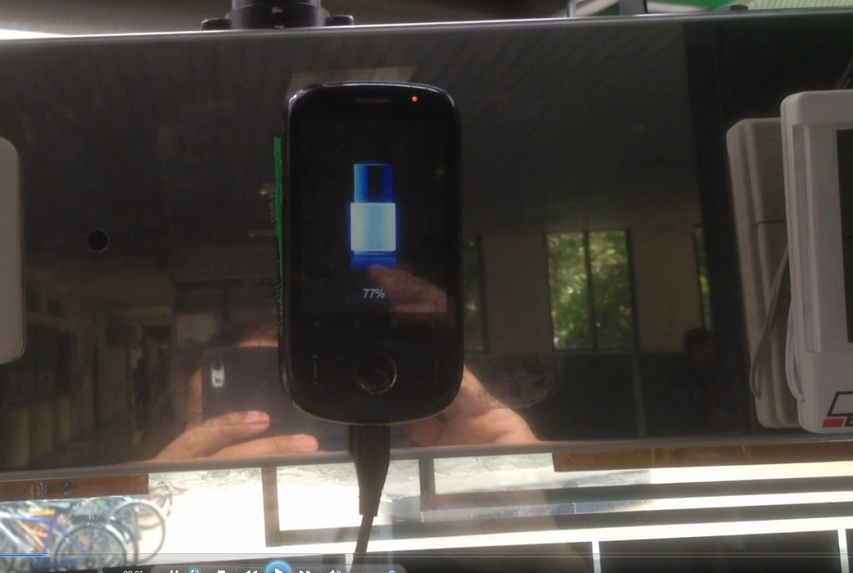
Fig.18 SHISG can supply the power for mobile phones
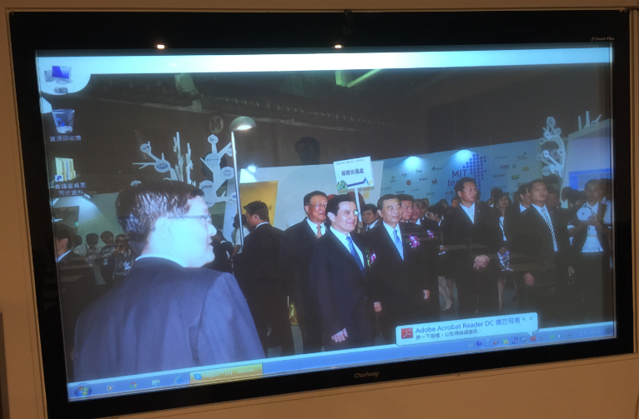
Fig.19 SHISG could become a project screen while not see through
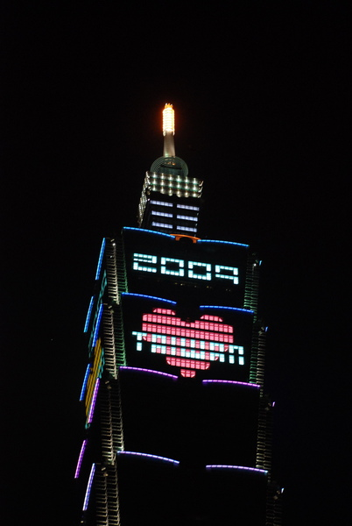
Fig.20 Future application of SHISG window for commercial advertisement on a tall building
Conclusion
The successful developed SHISG in this project was a kind of multi-functional innovative window to improve the indoor environment, adjust the see through of glass, obtain zero UV indoors, become a power supply sources of DC electronic devices, become a display screen for meeting for entertainment and apply on a tall building for a commercial advertisement. Successful invention comes from unlimited innovation, the SHISG should be widely applied in the future for a better life of human beings.
Acknowledgement
Many thanks to Prof. Saffa Riffat for suppling the David Wilson Creative Home at the campus of University of Nottingham for this research. It is also highly appreciate to National Taiwan University of Science and Technology to set up the testing chamber for experiment of energy consumption. Finally, I do thank EU and Marie Curie Project for financial support to this research and University of Nottingham to supply a wonderful research environment and facilities.

