Publishable report 3

Energy efficiency simulation and economic assessment of Heat Insulation Solar Glass

Project: DHISGLCB

Chin-Huai Young, Saffa B. Riffat and Eleni Papavarnava

University of Nottingham

**Objective**

A computer simulation was performed here to predict the energy efficiency of HISG while applied on a low carbon building. It included solar power simulation, energy consumption simulation and economic assessment. The main objective is to realize the energy efficiency of HISG before application on real buildings.

**HISG structure and mechanism**

Fig. 1 shows the structure of the HISG. It indicates that the reflection layer at the back of solar thin film can reflect back the IR to increase the solar power up to 10% and reduce the IR penetration to obtain a good heat insulation during the summer time and save cooling energy consumption. In additions, two air spaces on both sides of reflection layer can reduce the U value to save heating consumption during the winter time.

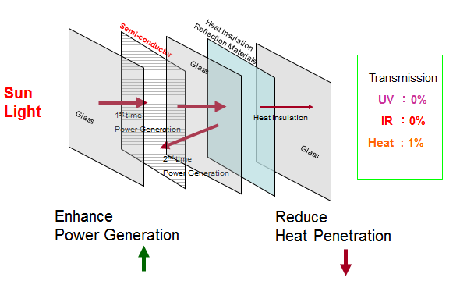

Fig.1 Structure of HISG

**Examination of accuracy**

The accuracy examination of a simulation software and its process is quite important before we do a real simulation. In order to know the accuracy of the simulation software, we built two 3m x 3m x 3m glass houses in May 2014 in the campus of National Taiwan University of Science and Technology (NTUST) to compare the testing result and simulation result as shown in Fig.2, in which one was normal glass house and another one was HISG glass house. Fig.3 and Fig.4 showed the computer simulation of solar power generation and energy consumption on the house. Table 1 showed the solar power simulation and testing on 15/09/2014 and 13/02/2015 respectively to increase the reliability of accuracy of simulation software. It indicated the error between testing and simulation was within 14% on two different dates. The comparison of simulation and testing on energy consumption shown in Table 2 indicated that the errors between simulation and testing were 14.59 and 8.02 on cooling and heating respectively. The errors between simulation and testing on solar power generation and energy consumption looked reasonable and reliable to predict the energy efficiency of HISG on a low carbon building.

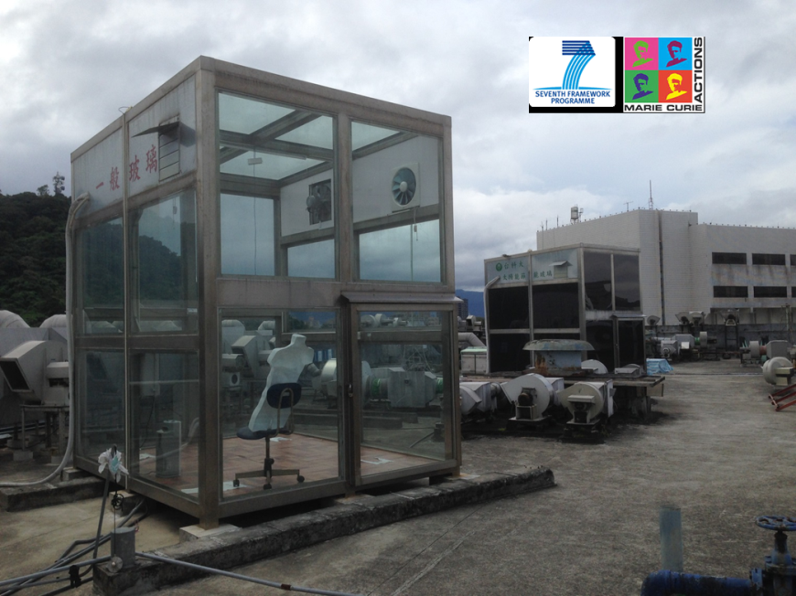

Fig.2 Glass house for testing and simulation

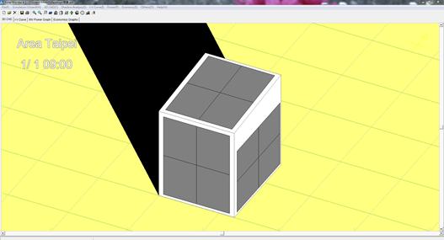

Fig.3 Simulation of solar power generation of HISG glass house

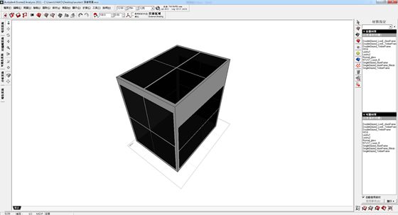

Fig.4 Simulation of energy consumption of glass houses

Table 1 Comparison between test and simulation of solar power generation

|  |  |  |  |  |  |  |  |  |
| --- | --- | --- | --- | --- | --- | --- | --- | --- |
| Date | Methods | East  (W) | South  (W) | West  (W) | North  (W) | Roof  (W) | Total solar power  (W) | Error (%) |
| 15/09  /2014 | test | 0.9 | 1 | 1.2 | 0.3 | 2.6 | 6 | 13.83 |
| simulation | 1.27 | 1.42 | 1.26 | 0.75 | 2.13 | 6.83 |
| 13/02  /2015 | test | 0.5 | 1.4 | 1 | 0.2 | 1.6 | 4.7 | 12.98 |
| simulation | 0.69 | 1.19 | 0.68 | 0.36 | 1.17 | 4.09 |

Table 2 Comparison between test and simulation of energy consumption

|  |  |  |  |
| --- | --- | --- | --- |
| Method | Test | Simulation | Error  (%) |
| Comparison | Energy consumption (kWh) | Energy consumption (kWh) |
| cooling | 2.7 | 3.09 | 14.59 |
| heating | 2.3 | 2.12 | 8.02 |

**Simulation on a real building**

A simulation on a real building was taken into consideration in this section based on the previous reliable prediction accuracy of the simulation software. For the calculation of the energy consumption when HISG is integrated on a public building, a large skylight with dimensions 25.7m x 25.7m is designed to simulate a shopping centre, with a minimum height of 3.7m. The inclined roof was made by fenestration materials. There were two kinds of glass taken into consideration in this simulation, which were normal glass and HISG. Fig.5 showed the diagram of simulation skylight. In order to compare the energy efficiency of HISG at different location in the world, we selected London, Abu Dhabi, Larnaca, Tokyo and Taipei for comparison. In which, Abu Dhabi represented equator countries, Larnaca represented tropics countries, Taipei represented semi-tropics countries and London and Tokyo represented temperate zone. Three common window systems that have been studied were the Ordinary double glazing, the Low-E double glazing and the air filled HISG as shown in Table 1.

Table 1 Properties of the three window types for simulation

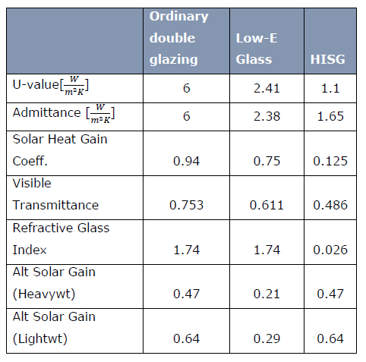



Fig.5 Diagram of simulation skylight.

1. Simulation of solar power

Based on the reasonable accuracy of the solar power simulation software described in the previous section, we simulated the skylight and got the solar power generation at different location in the world shown in Fig.6. It indicated the maximum solar power generation of the HISG skylight occurred in Abu Dhabi due to high sun intensity and longer sunny hours in this area. The lower solar power generation occurred in London due to lower sun intensity and shorter sunny hours of the city.

Fig.6 Solar power generation of HISG at different location in the world

1. Simulation of energy consumption

Fig. 7 showed the comparison of cooling consumption of these three kinds of skylight at different location in the world. It indicated clearly that the cooling load in London was almost zero due to the indoor environment is comfortable and no cooling is necessary during the summer time. Contrarily, the cooling load in Abu Dhabi was quite high all the year due to the hot weather in this area. The HISG reduced a lot of cooling consumption while compared with ordinary double glazing and low-e double glazing due to its higher capacity of heat insulation at all the locations in the world.

Fig.7 Cooling consumption of the simulation building

Fig. 8 showed the heating consumption of the simulation building. It indicated the heating energy demand is quite low in the city of Abu Dhabi due to the hot climate in this area. The cooling consumption was almost zero in London but the heating consumption is the highest among these simulation cities due to the cold climate in UK. Both the cooling and heating consumption were needed at the cities in Asia such as Taipei and Tokyo owing to the weather is very hot in the summer time and cold in the winter time in these countries. The HISG performed very well on energy saving for heating at any cities in the world especially in the cold countries such as UK and Japan. Fig.9 showed the total energy consumption of the simulation building. It indicated the HISG could save the energy demand all the year at any cities in the world. The tendency of the energy consumption saving is quite similar at all the cities in the world due to the HISG can save both cooling and heating consumption. The total energy consumption of HISG at Larnaca in Cyprus was only 29% of ordinary double glazing because the weather in Cyprus in quite different during the summer time and winter time, for example, the temperature could be highest at 39 ℃ during the summer time and lowest at 7 ℃ during the winter time. The reason was that the higher was the temperature during the summer time the higher capacity of insulation of HISG. As well, the lower was the temperature during the winter time the higher capacity of insulation of HISG.

Fig.8 Heating consumption of the simulation building

Fig.9 Total energy consumption of the simulation building

**Energy efficiency of HISG**

The HISG could both generate solar power and decrease cooling and heating energy consumption at all the cities in the world owing to its high capacity on solar power generation and heat insulation. The calculation of energy efficiency is based on the energy consumption minus the solar power supplied, in which, it is called energy demand from grid. Fig.10 showed the energy demand of each kinds of skylight at different cities in the world. It indicated the HISG could decrease a lot of energy demand from grid, especially, it could remain power feeding back to grid at Larnaca in Cyprus. It is quite unique in the world that the glass can supply the cooling and heating consumption and remain power feeding back to grid. The contribution is quite brilliant for decreasing the CO2 emission on the topic of global warming.

Fig.10 Energy demand from grid of simulation building

**Environment contributions**

The HISG performed great contribution on decreasing CO2 for the world. Fig. 11 showed the contribution of HISG decreasing a lot of CO2 emission at any cities in the world. It was surprised that the CO2 emission of HISG on a building at Larnaca in Cyprus was even minus. That means the application of HISG can even contribute like a tree to absorb CO2 for the world. It is quite exciting that the HISG performs a great contribution for decreasing the crisis of global warming.

After comparing HISG with two common insulation glass, it was very clearly that the HISG possessed the best energy efficiency in the world. The HISG should be highly applied in the world for solving the problem of global warming. We deeply hope the HISG could be widely applied on the low carbon buildings for the next generation to get a more economic environment and prevent the disaster due to global warming.

Fig.11 HISG performed great contribution on decreasing CO2 emission

**Economic assessment of HISG**

The HISG has been proved to perform great contribution on the decreasing CO2 for environment in the previous discussions. The economic assessment of HISG was discussed in this section based on the extra investment of HISG on a building and the capital earned back due to its saving expense from grid. The HISG and ordinary double glazing were compared here. The simulation building in Fig. 5 was assessed in this section and the investment capital and charge on electricity of each city was taken into consideration here. As well, the feed in grid income of each city was also taken into consideration for calculation based on the different policy of each country. Table 2 showed the Investment capital of these two types of glass for skylight on the simulation building. Table 3 showed the capital earned back of HISG due to energy saving and Table 4 showed the capital income due to feed in grid income of each city. The total money earned back combined the capital earned back due to energy saving and feed in grid income. Table 5 showed the final result of economic assessment of HISG applied at different city in the world. The HISG applied in Abu Dhabi obtained the shortest payback period of 4.99 years due to the high solar power generation and high energy saving in the middle east countries. In general speaking, the investment assessment of HISG depends on the location of the building. The more solar power and more energy saving could result in the better for the investment of HISG.

Table 2 The investment of differnet types of glass on a bulding

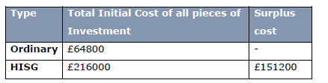

Table 3 The capital saving of HISG on energy consumption

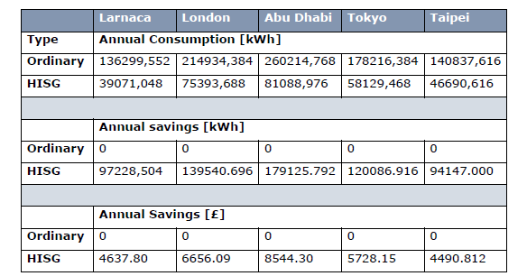

Table 4 The capital earned of HISG on feed in grid income

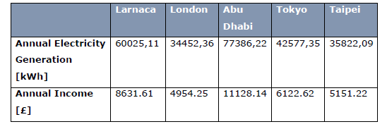

Table 5 The economic assessment of HISG at different cities in the world

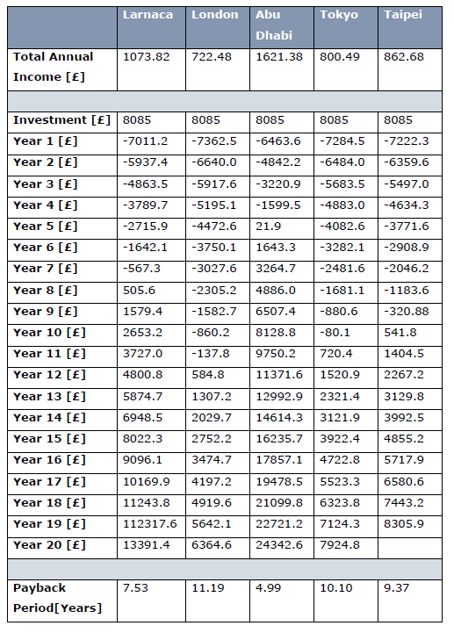

**Conclusion**

The HISG performed a great contribution on deceasing the CO2 emission for solving the problem of global warming. The research here showed the HISG is a kind of unique glass in the world which can generate solar power to cover all the cooling and heating energy consumption and still remain power to feed back to grid. It is worthwhile to promote on the low carbon buildings to prevent the crisis from global warming and supply a good ecological environment for our next generation.

**Acknowledgement**

It is very appreciate to Prof. Saffa Riffat for suppling the wonderful environment and facilities to do the test and simulation work in the Department of Architecture and Built Environment in the University of Nottingham to finish this research. As well, many thanks to Eleni Papavarnava to help the work of simulation and economic assessment on HISG. Finally, I do deeply thank to EU and Marie Curie project for financial support to this research. In additions, many thanks to University of Nottingham to supply a wonderful research environment and facilities to finish this project.