1. FINAL PUBLISHABLE SUMMARY REPORT

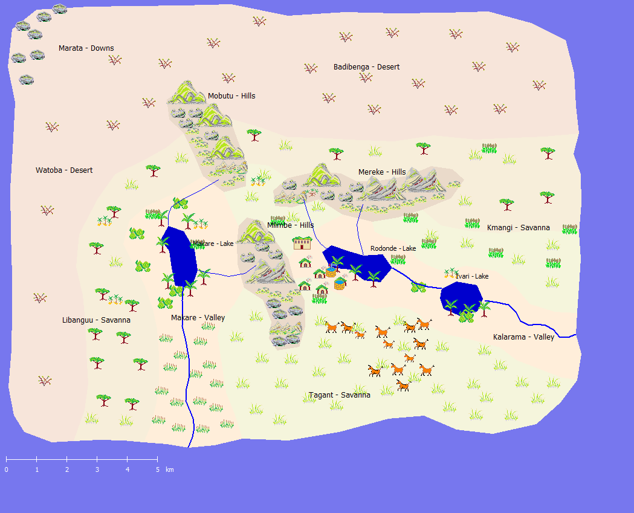
Figure 1: Screen shot of the Moro-simulation (developed by Lutsevich and Dörner).

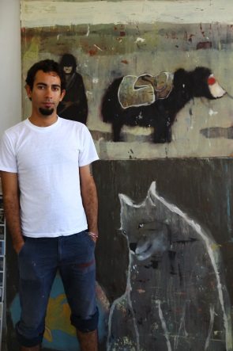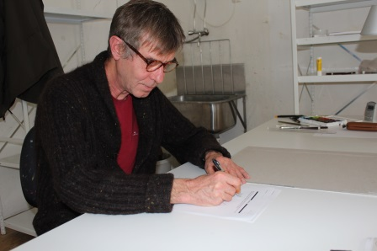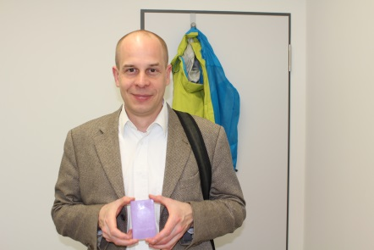
Figure 2: Cuban painter Alejandro Campins, Russian painter Nikita Alexeev, and German composer Benjamin Schweitzer.

