SIXTH FRAMEWORK PROGRAMME
PRIORITY: NMP
Nanotechnology and nanoscience,
knowledge based multifunctional materials,
new production processes and devices




SPECIFIC TARGETED RESEARCH PROJECT

Final Activity Report Period: 01.01.2004 - 30.06.2007

Project acronym: CIDNA

Project full title: Control of assembly and charge transport dynamics of immobilized DNA

Proposal no.: NMP4-CT-2003-505669

Project coordinator
name: Prof. Dr. M. E. Michel-Beyerle

Project coordinator
organisation name: Technical University of Munich (D)
Contents

Publishable executive summary
General project objectives 3
Contractors list 4
1. Work Performed and Results Achieved 5
2. Novel Scientific and Technology Strategies 11
3. Final Plan for Using and Disseminating the Knowledge 12
Publishable executive summary

General project objectives
CiDNA was created with a view on opening new avenues in DNA-based biophysics, biochemistry and biotechnology with special focus on high temporal and spatial resolution towards the mesoscopic and single-molecule levels. The objectives were to be approached by cooperation between ten internationally recognized scientific partners and an industry partner active at the cutting edge of biotechnology.
Three major lines of fundamental and applied research were pursued with special emphasis on the dynamics of DNA-structures both in solution and immobilized on solid (metallic) surfaces in direct contact with an aqueous medium. The lines of cooperation were aiming at:
- New scientific pathways, where immobilized DNA structures in a functional state could be addressed at spatial levels ranging from solid/electrolyte monolayer down to single-molecule resolution. A particular objective was to reach a stage where the topology of DNA structures at conducting surfaces could be mapped and controlled.
- The dynamics of dye-labeled DNA conformations immobilized on surfaces controlled by fluorescence in a time range from picoseconds to minutes. This approach profits from established methods relying on ultrafast time resolution of identical systems in aqueous solution. The approach is in contrast to most, if not all, previous characterizations of immobilized DNA structures which rest on steady state spectroscopy.
- The development of broad platforms for design, chemical synthesis, and comprehensive chemical and physical characterization of DNA-based molecular probes. These platforms are based on novel DNA chemistry and physics. The availability of the broad perspective of molecular design, chemical synthesis, and structural characterization leading to a wealth of building blocks is characteristic for an ambitious interdisciplinary programme such as CiDNA. Molecular building blocks include the rigid Locked Nucleic Acids (LNA) and supramolecular architectures involving DNA/LNA-structures modified by fluorophores and redox markers. These efforts are complemented by design and synthesis of linker elements for the attachment of DNA to electrochemical surfaces. A detailed understanding of the electronic properties of the different building blocks including linker groups and their optimization is crucial for the successful design of DNA-based electrochemical sensors.
Contractors list
Contractor and Responsible Scientist | Country | Main role in project
College de France, Paris  Prof. Jean-Marie Lehn  Dr. Marie-Paule Teulade-Fichou | F | Synthesis of tailored oligonucleotides including multistranded structures | Design & Synthesis
Inst. of Chemical Technology, Prague  Prof. Vladimir Kral  Inst. of Organic Chem. & Biochem., Prague  Dr. Michal Hocek | CZ  CZ | Design and synthesis of modified nucleotides and optimized linkers  Design and synthesis of modified nucleotides and optimized linkers | Design & Synthesis
Uni. of South Denmark, Odense  Prof. Jesper Wengel  EXIQON A/S, Vedbaek | DK  DK | Synthesis of functionalized LNA for charge transfer studies  Synthesis of unmodified LNAs | Design & Synthesis
Universität Basel  Prof. Bernd Giese | CH | Design and synthesis of structure-conserving modifications of DNA | Charge Transfer (CT) Mechanisms
Technische Universität München  Prof. Maria Elisabeth Michel-Beyerle  Prof. Notker Rösch | D | Control of charge transport and DNA topology on conducting surfaces. Femtosecond time resolved spectroscopy of DNA  constructs in solution  QM calculations and MD simulations of modified DNA hybrids | Charge Transfer (CT) Mechanisms
MPI f. Biophys. Chem., Göttingen  Prof. Christian Griesinger | D | NMR structures of modified DNA hybrids | Charge Transfer (CT) Mechanisms
Comm. à l'Energie Atomique, Paris  Dr. Fabrice Charra | F | STM induced luminescence and charge transport in labelled DNA hybrids | Interfacial CT, Luminescence & Electrochemistry
Tech. Uni. of Denmark, Lyngby  Prof. Jens Ulstrup | DK | Ensemble and Single Molecule based electrochemistry of DNA hybrids | Interfacial CT, Luminescence & Electrochemistry
Project Coordinator
Prof. Maria E. Michel-Beyerle
Department Chemie Tel.: +49-89-2891-3400
Technische Universität München Fax : +49-89-2891-3026
Lichtenbergstr. 4, D-85748 Garching michel-beyerle@ch.tum.de
website: http://www.CiDNA.de
1. Work Performed and Results Achieved

CiDNA has opened new areas in DNA science by its broad perspectives and its boundary-traversing approaches. These areas relate to the design and synthesis of tailored reporter molecules, and precisely controlled charge transfer pathways in DNA structures, rationalized and substantiated by computational modelling. Moreover, CiDNA has contributed to a detailed understanding of folding and unfolding processes of DNA duplexes and its modifications. The necessary DNA modifications comprise base replacement or semicapping by aromatic molecules as well as backbone locking by restricting the mobility of the sugars (LNA). On the basis of detailed understanding of active components studied in solution, CiDNA has opened areas where novel DNA structures as well as large supramolecular architectures can be immobilized on solid supports and controlled in the ensemble and at the single-molecule level. Electrical field effects on the topology of DNA constructs and single-molecule conductivity in novel “switch” patterns have been observed.
Results towards the general objectives were only possible by the joint efforts of the CiDNA groups. The cooperative success highlighted in sections 1.1 to 1.3 stands for representative lines of developments and does not cover all of the achievements.

1.1 Interfacial Dynamics of DNA-based Molecular Systems
The processes underlying hybridisation, denaturation and renaturation of DNA in solution and upon immobilization were a major CiDNA objective. The properties of immobilized DNA have been studied by fluorescence lifetime imaging in confocal microscopy addressing dye-labeled DNA strands bound to gold surfaces (Fig. 1a). Surface images of a heterogeneous domain structure shown in Fig. 1a establish the need of spatial resolution even on the ensemble level in order to derive information on the role of molecular packing. Fluorescence lifetime imaging carries information on the proximity and geometry of an excited dye molecule to the gold surface. Roughly speaking, at a close distance, the excitation energy is transferred to the metal (Fig. 1b) and concomitantly, the fluorescence lifetime of the dye is short (100 ps, Fig. 1c, black line). Repeating such excited state lifetime measurements under the control of an electrochemical potential shows that these domain structures observed in zero external field change to an average structure where the terminal dye shows longer lifetimes reflecting a larger distance from the surface as illustrated in Fig. 1b and 1c, red line. This control of topology via excited state lifetimes of labeled DNA domains is the realisation of the basic CiDNA concept and constitutes a novel approach.

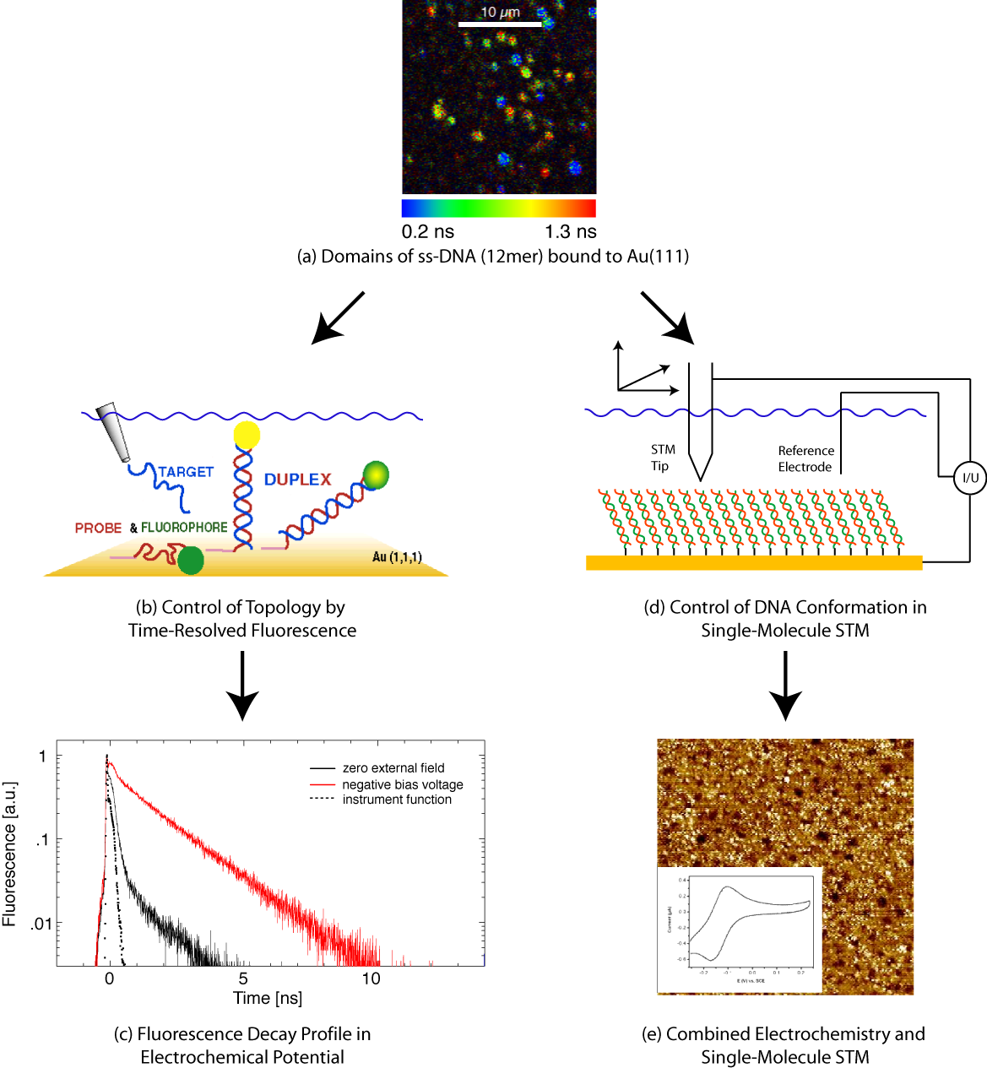

Figure 1 Studies of DNA structures immobilized on Au(111)

In complementary studies, the behaviour of immobilized DNA structures has been imaged and controlled at the single-molecule level. Two approaches have been followed, both using scanning tunnelling microscopy (STM) as the primary tool. In one approach, an oligonucleotide could be imaged to single-molecule resolution in ultra-high vacuum (UHV). Although the experimental conditions were far from the in vivo aqueous environment of DNA, the unique technique of STM current-induced luminescence could in return be exploited in comparative STM imaging. The alternative approach is based on electrochemically controlled STM directly performed in the aqueous environment (in situ STM), i.e. under biological conditions as sketched in Fig. 1d. These studies have provided structural mapping of the packing of electrochemically controlled monolayers complementary to the fluorescence-based electrochemical studies. In situ STM has revealed contrasts of single- and double-strand oligonucleotides and disclosed completely new patterns of in situ tunnelling spectroscopy of redox-marked oligonucleotides. The bright spots in Fig. 1e are caused by redox-based conducting channels for electron “hopping” along a chain of cationic ruthenium complexes. These complexes are assumed to be aligned along the negatively charged phosphates of the DNA backbone, acting here as a one-dimensional template for the conductivity. Such observations for which the theoretical frames have been worked out are central in the CiDNA programme.

1.2. Design and Synthesis of Important Components of DNA-based Structures and Superstructures
New kinds of synthetic DNA-based molecular systems with specific structures have been a major CiDNA achievement. The modifications pertain to fluorescent and redox marker groups as well as multifarious pendant groups suitable for linking single- and double-strands to solid supports. Dye-labeled DNA and LNA containing double strands were instrumental for detailed studies of the charge transfer mechanisms. Their design, synthesis and structural characterisation hold innovative discoveries per se.

Linking of DNA to surfaces. The attachment of single-strand oligonucleotides to surfaces has been a central topic of the CiDNA programme. Tethered single-strands have been combined with various linker groups providing space for duplex formation with complementary strands from the solution. A representative example is given in Fig. 2a and 2b. A promising alternative approach is the direct attachment of sulfur-modified nucleosides to a gold surface (Fig 2c). This approach is provides the shortest possible distance between the DNA construct and the surface. As indicated in Fig. 2a, specific aromatic three-branched dye systems bind DNA on highly oriented pyrolytic graphite, thus offering an attractive alternative to the widely used gold surfaces.

Dye- and redox labeling of DNA for studies of charge transfer and electronic conductivity. Nucleotides with photoactive and redox active groups have been designed and synthesised. Optimizing the choice of redox markers (as e.g. ferrocence, Fig 3a) and dye molecules allows the control of charge transfer processes in DNA far beyond present-day commercial options. Novel fluorophore-labeled probes with high capacity for mismatch detection have been developed.

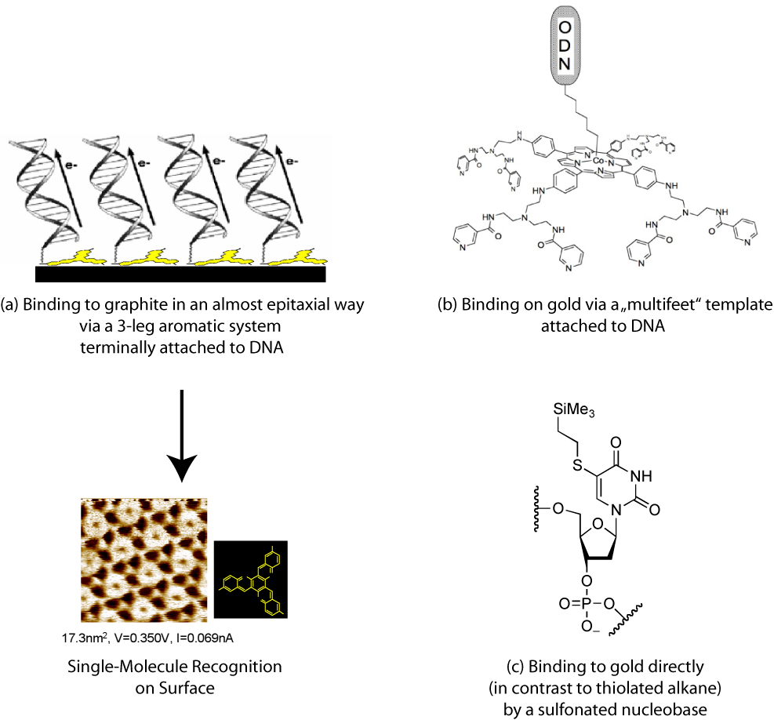
Figure 2 Different types of linkers developed in the CiDNA programme for binding DNA
on (a) pyrolytic graphite and (b, c) on gold.

Complex DNA structures. Design, synthesis, structural characterization and fluorophore-labeling have been extended from duplex to triplex (Fig. 3c) and quadruplex (Fig. 3d) DNA supermolecular units. As shown in Figs. 2a and 3c, multi-branched aromatic dye systems are not only important as linker elements, but also play a central role in the stabilisation of triplex DNA. In analogy, also the quadruplex structures can be stabilized by fluorophores. Such quadruplex structures offering high structural rigidity and stability are important with respect to emulating biological telomers. Since charge injecting fluorophores are selectively intercalated at guanine quartet sites without the need of elaborate covalent linking, quadruplex structures hold promise as novel types of molecular-scale electronic units.

Rigid DNA backbone. The novel class of nucleic acids, the locked nucleic acids (LNA) locks the conformation of the backbone sugars via insertion of an oxy-methylene group (Fig. 3b). This modification increases the stability and rigidity of the duplex.

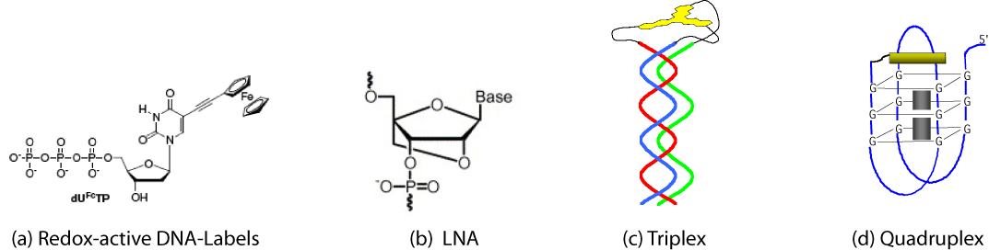

Figure 3. Some modifications and complex structures of DNA.

Substitution of DNA by LNA nucleotides leads to gradual conformational transitions of doublestrands from B- towards A-form. These conformational changes also affect electronic interactions among neighbouring nucleotides and in this way the conductivity of the strands. The role of these transitions for the electronic interaction between the nucleotides and therefore for the electronic conductivity has been analyzed by comprehensive molecular dynamics (MD) and electronic structure computations. The electronic interactions in systematically varied DNA/LNA tracts are determined by a subtle interplay of different forces, and favourable conductivity requires special care in the molecular design of the sequences. Considering these MD-simulations, it is interesting to note, that hole injection is affected by the increased rigidity of LNA modifications (Fig. 4c).

1.3 Charge Transfer Dynamics in Double-Stranded DNA
The elucidation of the controversially discussed mechanisms of short-range charge injection and long-range charge transport through double-stranded oligonucleotides in solution have been a CiDNA starting point and an area brought to blossom by CiDNA’s interdisciplinary efforts. These successful studies involve design, synthesis, NMR structural analysis, charge transfer dynamics, and computational modelling. The dynamics of purine oxidation initiated by semicapped rhodamine reveals two conformations, which differ in their electronic coupling to guanine. These characteristic changes of the electronic couplings are substantiated by both the NMR structure (Fig. 4a) and MD simulations (Fig. 5). Computational studies have also disclosed local rhodamine dynamics on top of the DNA stack as well and provided mapping of electronic interactions between rhodamine and the adjacent base pair in unprecedented degrees of molecular detail of the potential energy profile.
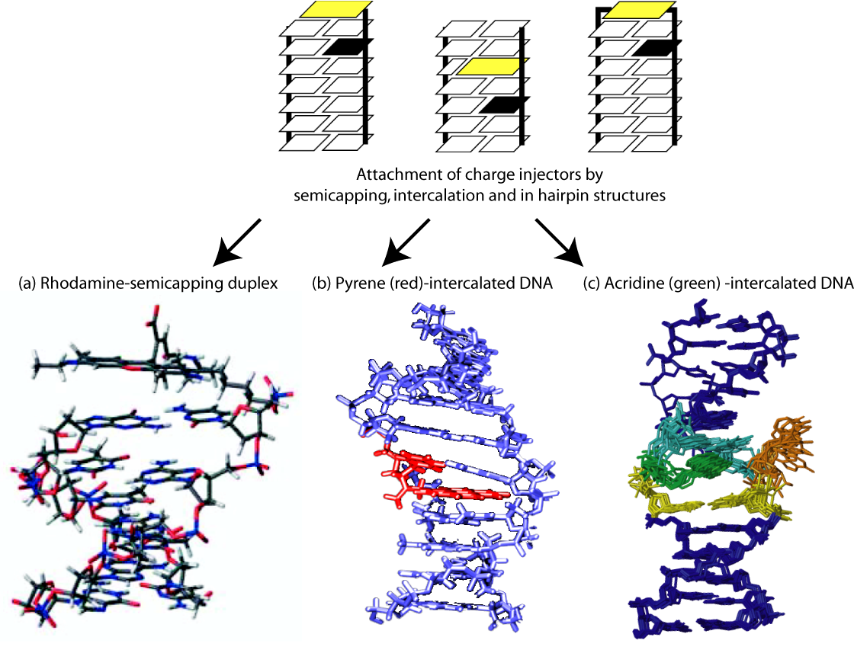
Figure 4 Representative schemes and structures of dye/DNA systems studied in the CiDNA programme. Top: Hole injecting dye molecules (yellow) covalently attached to the backbone and separated from the hole accepting purine bases (black) by one A:T base pair. Bottom: NMR structures.

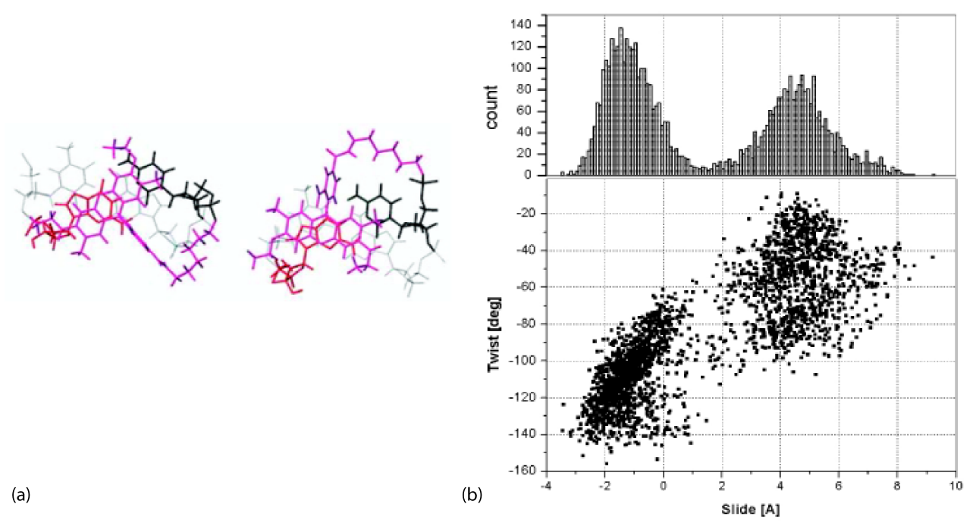
Figure 5 (a) NMR structures of two conformations of rhodamine semicapped on the DNA duplex according to Fig. 4 a and (b) MD simulations providing detailed information on these conformers.
A detailed study of charge injection into DNA by an intercalated acridinium (Fig 4c) combined all the powerful tools of NMR structure, sub-picosecond to nanosecond time-resolved spectroscopy, NMR structural analysis and quantum chemical computational efforts. This approach provided a self-consistent explanation of the charge injection process in all its aspects and allowed to apply established concepts of electron transfer theory. This study has removed several problems related to structure/dynamics correlations of charge injection and their implications with respect to mechanism. In this acridinium/DNA system, the molecular “hopping” mechanism, which is also expected to govern the DNA conduction process, was mapped in unprecedented detail. Such an insight into the mechanism of single step electron transfer is most relevant for the development of strategies towards interfacial electron transfer at conducting surfaces.

2. Novel Scientific and Technology Strategies
2.1 Scientific Interactions and Cooperation
The “multi-dimensional” scientific network established by CiDNA lead to the so far most detailed understanding of charge transfer in DNA. This understanding is based on NMR structural analysis of the DNA duplex in parallel to the resolution of ultrafast time-resolved dynamics and cutting-edge theoretical and computational efforts. This combined attack on a problem by members of the CiDNA may serve as a paradigm for future studies on the structure and function of complex biological units.
Along these lines, mapping of the dynamics of DNA bound to a gold surface and the effects of both, electric fields and surface packing, has been initiated. This is for the first time that lifetime profiles of reporter dyes attached to a defined position in the DNA structure have been instrumental for the control of conformational changes controlled by an electrochemical potential. These pilot experiments on the mesoscopic scale of the confocal microscope are suited to direct the future experimental strategy for the assessment of the properties of immobilised bio-systems involving bio-polymers as DNA, proteins, and complex architectures involving both.
The dynamic surface mapping of immobilized DNA provides the bridge to novel CiDNA-based scientific strategies. STM, particularly the electrochemically controlled in situ STM, supports the feasibility of visualizing and controlling a single-molecule DNA-system in an aqueous medium, i.e. under biological conditions.
The accumulation of indicidual and joint results within the CiDNA teams has finally led to a new conceptual framework in experiment and theory which asks for fast and consequential continuation in order not to loose momentum and European leadership in this competitive field of biotechnology.

2.2 Lines of Novel Technology Strategies
CiDNA has primarily focused on the assembly and charge transfer dynamics of DNA in solution and upon immobilisation. The detailed understanding of such processes is a necessary requirement for technological progress in DNA-based nanostructures.
A crucial pre-requisite for the important class of DNA-based sensors is the structural control of both, the immobilised DNA single-strands (probe) and their hybridisation with the target strands. In this context, the CiDNA programme is of utmost relevance for the development of reliable diagnostic tools, including tools based on electrochemistry. Electrochemical diagnostics may also map the active DNA structures at the level of single molecule resolution utilizing scanning probe microscopy. In addition, the multitude of fluorophore and redox marked DNA and DNA/LNA together with the different surface linkers offer a wealth of new components for the development of optimized devices for biosensing and even DNA-based electronics employing also more complex, supramolecular architectures.
With the goal of creating stable DNA constructs at surfaces, the locked nucleic acids (LNA) offer unprecedented opportunities for industrial applications in biosensing, diagnostics, gene therapy and possibly prospects in molecular electronics. It has been a privilege of the consortium that the inventor of LNA, Professor Jesper Wengel, was a member of the CiDNA consortium.

3. Final Plan for Using and Disseminating the Knowledge
Major instruments of disseminating the knowledge accumulated by the members of the CiDNA teams are international, refereed journals, where CiDNA results have been or are about to be published. CiDNA results have also been communicated at major international conferences and in lectures at prominent scientific institutions, where CiDNA members have often enjoyed the status of invited speakers. Since CiDNA members are teaching at universities, the results of this programme became an important part in science education.
Although four patents have been filed, there is, however, no doubt that given adequate funding, several other CiDNA results would be directly suitable for both national and international patent filing. Most of the members of the CiDNA consortium have extended their relations or developed new relations with industry during the duration of the project. The most important contacts are directed towards companies active in high-value analysis products for gene expression and global provision of locked nucleic acids, microscopy and laser applications.
In addition, CiDNA results have been disseminated in other ways addressing broader audiences:
Several book chapters and a monograph have emerged from the programme. While stringently scientifically oriented, the scopes of these monographs go beyond the CiDNA objectives and set these into broader perspectives of, bioelectrochemistry and electrochemical sensors for genomics and proteomics.
CiDNA results have, finally, been communicated to wider audiences including engineers, administrators as well as scientists from nearby fields and decision makers in science policy. CiDNA members consider it as an important obligation to communicate new results to the young generation. In this spirit, results have been communicated during high-school teaching stimulating interest in science. Overall the CiDNA scientific communication and dissemination has therefore accorded with expectations laid down in the proposal and initially stated objectives.
The most effective plan of dissemination of CiDNA results in the future is active and fast continuation of DNA research to which the present programme provided such successful basis. This will lead to intense industrial contacts on the one hand and to academic and public lecturing, patents and scientific publications on the other.

