
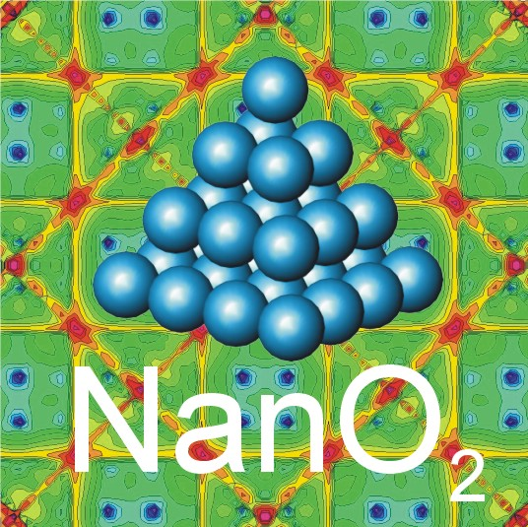

STRP 505670-1 NANO2

NanO₂

Oxidation of Nanomaterials

3.4.1.1.: Long-term interdisciplinary research into understanding phenomena, mastering processes and developing research tool Expanding knowledge in size-dependent phenomena

Final Report DM2 1.1.2006-31.3.2007

Date of preparation: 20.6.2007

Project Coordinator: Dr. Andreas Stierle

Organisation name: Max-Planck Gesellschaft zur Förderung der Wissenschaften e.V.

Table of Contents | Page
Section 1 - Project Execution: Oxidation of Nanomaterials | 3
Section 2 - Dissemination and Use | 15
Section 3 - Final Management Report | See extra document
Section 4 - Final Report on the distribution of the Community’s contribution | To be delivered
Section 5 – Final Science and Society Questionaire | See extra document
Section 6 – Final Reporting Questionaire on Workforce Statistics | See extra document
Section 5 – Final Socio-Ecomonic Reporting Questionaire | See extra document

1. Project Execution: Oxidation of Nanomaterials

Understanding the oxidation of surfaces, interfaces and nanoparticles under ambient oxygen pressures and the technical ability to atomically control the oxidation of nanomaterials under industrially and environmentally relevant conditions are considered to be important milestones for future nanotechnologies. In fact, the potential of nanotechnology to forge innovations and improvements in the chemical, automotive, environmental, electronic, and energy sectors is to a large extent limited by a lack of understanding regarding nano-oxidation. The control of oxidation under operational conditions is of utmost importance for the enhanced performance of catalysts involved in applications ranging from fuel cells and chemical production to electronic sensors for automotive and environmental monitoring applications. Oxidation under ambient conditions determines the stability, functionality and long term performance of metallic particles in their working environment. To achieve sustainable growth in nanotechnology, a deep and systematic understanding what parameters of the nanomaterials control its behaviour under ambient oxygen pressures is mandatory.

Substantial effort has been devoted to understanding oxidation fundamentals within the past few decades using pioneering-type experiments under highly idealized conditions, such as very low oxygen pressures (10⁻⁶ mbar), and idealized, model material systems (single crystals). However, understanding the oxidation of single crystal surfaces in vacuum doesn’t enable prediction of the oxidation behaviour of a device made of nanoparticles operating at ambient oxygen pressure. Four key barriers that prevent this extension of the fundamental knowledge to high pressure conditions and material systems of industrial relevance have been identified (see Table 1 and Figure 1).

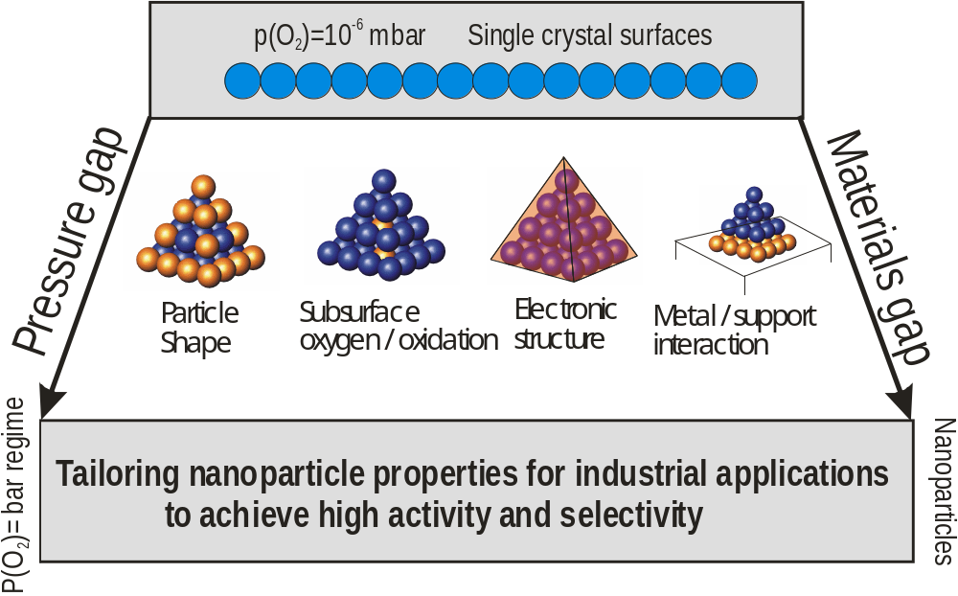

Fig. 1: NanO₂ objectives

1. Lack of quantitative understanding of influence of particle size and shape upon the oxidation process
2. Unexplored role of dissolved oxygen in subsurface regions of the
nanomaterial
3. Unknown electronic structure and thermodynamic behaviour of
nanosized particles and adsorbates
4. Unexplored nanoparticle / support interactions

Tab.1 Key Barriers for Controlling Oxidation of Nanomaterials

The main mission of NanO₂ is to bridge this pressure- and materials-gap in the understanding of the interaction of oxygen with metallic nanoparticles, so that industrially relevant conditions are scientifically understood (see Figure 1).
Within NanO₂ these barriers we overcome by systematically investigating the size and shape dependence of high pressure oxidation of nanomaterials in a novel approach: surface sensitive in-situ techniques for high oxygen pressures and temperatures and ab-initio thermodynamic calculations will be combined in a unique, revolutionary way to tailor the nanomaterial shape and to predict their performance in industrial processes and under environmental conditions.

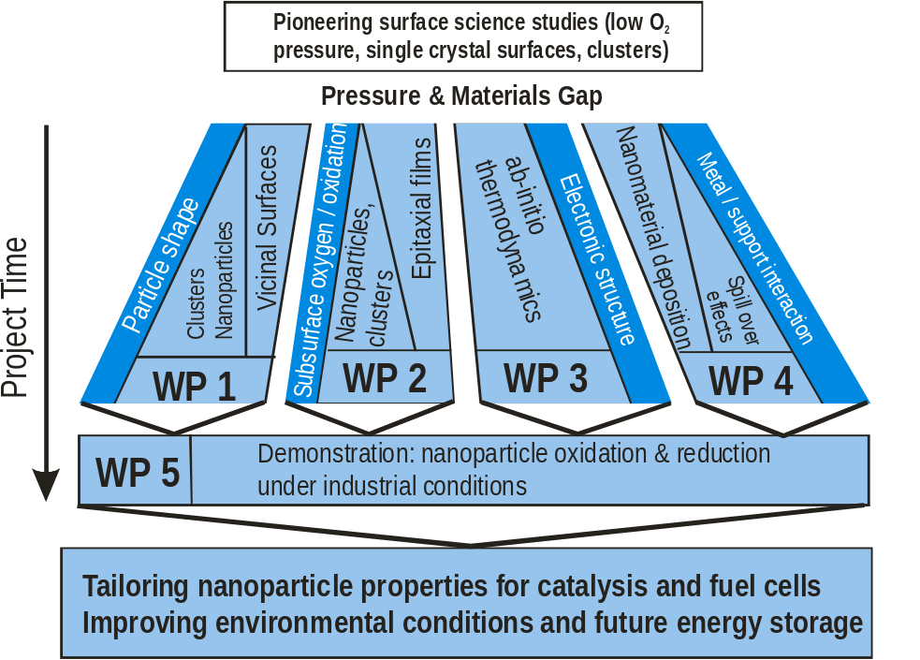

Fig. 2: NanO₂ workpackages

The NanO₂ consortium consists of 9 partners from 6 EU member states, including one industrial partner. The project provides the critical mass of resources by synergistically combining the best European experts from 7 different European countries in advanced analytical techniques and oxidation theory, with industrial expertise. The consortium is composed in the following way:
- Max Planck Institut für Metallforschung, Stuttgart (Germany), Oxidation Group, coordinator (MPI-MF)
- European Synchrotron Radiation Facility, Surface Science Group, Grenoble (France) (ESRF)
- University of Leiden, Interface Group, Leiden (The Netherlands) (U.Lei)
- National Italian Synchrotron Radiation Facility ELETTRA, Spectro-microscopy Group, Trieste (Italy) (ELETTRA)
- University of Vienna, Institute for Computational Material Science, Vienna (Austria) (IMP)
- University of Lund, Department of Synchrotron Radiation Research, Lund (Sweden) (U.Lu)
- Justus Liebig Universität, Department for Physical Chemistry, Gießen (Germany) (U.Gieß)
- Haldor Topsøe, Lyngby (Denmark) (HTAS)
- Fritz Haber Institut der Max Planck Gesellschaft, Theory Department, Berlin (Germany) (FHI)
- Technical Univerity Vienna, Institut für allg. Physik, Department Surface Physics, Vienna (Austria) (IAP)

The four key barriers identified for controlled high pressure oxidation have been efficiently tackeled in working packages 1 - 4. The NanO₂ project also strived to demonstrate nanoparticle oxidation & reduction under industrial conditions (WP5). These activities are schematically illustrated in Fig 2. The work packages are built such, that at each level of the project, the results obtained are already of high scientific interest on their own, such as the oxidation behaviour of vicinal surfaces, the influence of reduced dimensionality on the oxidation effect, electronic properties or the growth of particles with controlled size and shape. Only the synergetic combination of the results of the different work packages will allow one to entangle the much more complicated oxidation behaviour of nanoparticles, because in this case the individual results of the different work packages must be combined.
The objectives of NanO₂ have been addressed in a multi-disciplinary way, including a huge variety of novel and standard surface and material science techniques, such as (high pressure) scanning tunneling microscopy, high pressure in-situ x-ray diffraction, (high pressure) cross-section transmission electron microscopy, high resolution core level spectroscopy / spectro-microscopy, low energy electron diffraction, Auger electron spectroscopy, atomic force microscopy, molecular beam epitaxy for sample preparation, low energy electron microscopy,
scanning electron microscopy, Fourier transform infrared spectroscopy, extended x-ray absorption fine structure, and very powerful theoretical tools such as density functional theory, ab-initio molecular dynamics and kinetic Monte Carlo simulations. Figure 3 (a) shows a photograph of the high pressure compatible UHV surface x-ray diffraction chamber, which allows the investigation of surfaces and nanoparticles in-situ, during chemical reactions. In Figure 3 (b), a schematic view of the high pressure scanning tunneling microscope is given which was used within NanO₂ to investigate surfaces under high pressure reaction conditions.

a)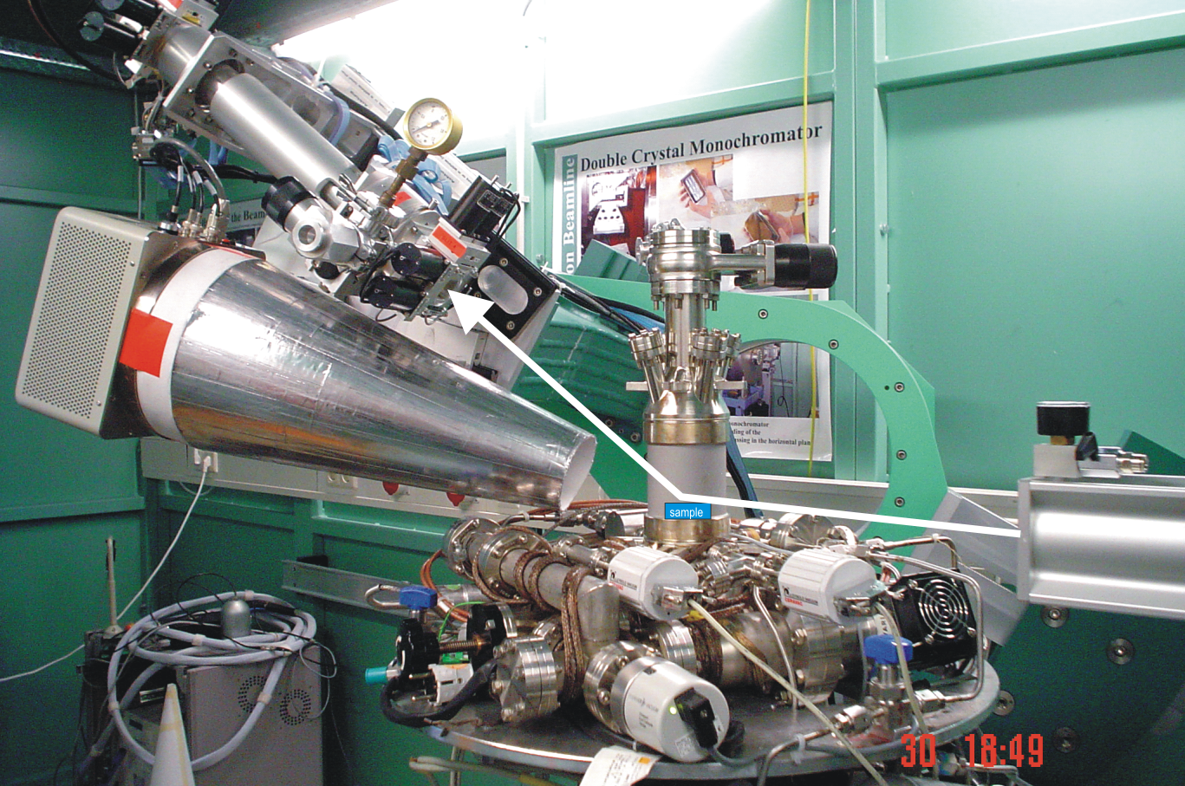 b)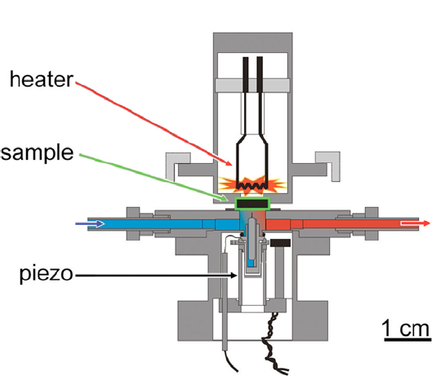

Fig. 3: (a) High pressure in-situ surface x-ray diffraction chamber mounted on the heavy duty diffractometer at the MPI-MF beamline at the synchrotron radiation source ANKA. (b) schematic view of an in-situ high pressure scanning tunneling microscope installed at the University of Leiden.

Materials under investigation were 3/4/5d transition metals such Ru, Rh, Pd, Ag, Pt and Cu, which are of industrial importance because of their strong catalytic activity. The work of NanO₂ has focused on the following points: the oxidation behaviour of different vicinal surfaces, such as Rh(553), Pd(553), Pt(553) was studied by a combination of experimental techniques surrounded by theoretical calculations. The first results clearly demonstrated that steps on a surface act as very important nucleation centres for the so called “surface oxide” layers, consisting of an oxygen / metal ion / oxygen trilayer, which are already known from the oxidation of “zero” miscut surfaces. These surface oxide layers eventually transform into bulk oxide islands at elevated O₂ pressures / temperatures and one of the key questions addressed within NanO₂ is, whether the surface oxide layers or the bulk oxide islands are responsible for the strong catalytic activity of the late transition metals. Another open question is the role of subsurface oxygen for the oxidation of transition metals, which was postulated by theoretical calculations for the late 4d transition metals. Experiments on ultrathin Rh film deposited on O precovered Ru surfaces could not confirm the stability of subsurface oxygen. To understand the influence of reduced dimensions, the oxidation behaviour of ultra thin Mg films deposited on Au(110) was investigated as a model system and a strong thickness dependence on the oxidation rate was found, which could be explained by the formation of quantum well states. In-situ x-ray diffraction experiments demonstrate that Pd particles on MgO undergo oxidation at pressures for which bulk oxide formation on Pd single crystal surfaces many be kinetically hindered. This result is an important step in understanding, whether the formation of surface oxide layers play at all a role for the oxidation of nanoparticles.
The work of NanO₂ has concentrated on the following points: the oxidation behaviour of vicinal and single crystal surfaces of Pd(553), Pd(223), Rh(223), Pt(553) and Pd(111) was characterized as a function of the oxygen pressure and temperature by a multi-technique approach. A general observation is that the formation of surface oxide layers is strongly influenced by the period of the step pattern on the vicinal surfaces and that surface oxide growth along the steps takes place. On the other hand, the formation of new facets was observed during the oxygen exposure of Pd nanoparticles on MgO, which could be induced by the formation of surface oxides on the new facets. The particle shape change was addressed theoretically by a combination of DFT results on the oxygen interaction with different single crystal orientations and the Wulff construction, which is an important ingredient for an atomic scale understanding of the particle reshaping process. A strong size dependence was observed for the oxidation of Pd on MgO(100): for particle sizes smaller than 4 nm a much faster bulk oxide formation was observed. Since the final goal of NanO₂ is to understand the structure and reactivity of nanoparticles during a chemical reaction in-situ on an atomic scale, in-situ x-ray diffraction and STM experiments were performed under reaction conditions on a Pt(110) single crystal. The experiments demonstrated that under reaction conditions novel surface oxo-carbonates might be present which drive the reaction. A theoretical treatment of surfaces under such reaction conditions was developed by the theory group within NanO₂, allowing now for the first time to predict surface phase diagrams under dynamic equilibrium conditions of a chemical reaction. Finally, alloy surfaces have been investigated in-situ during a chemical reaction, demonstrating that the NanO₂ approach can also be expanded to more complex systems, like compound materials.

The dissemination of the results obtained by NanO₂ is performed in different ways: publication in high reputation scientific journals continues (in total 51 accepted publications, additionally 4 submitted publications and 43 publications in preparation) and presentation at various conferences by invited or contributed talks given by members of the NanO₂ consortium is performed. In addition NanO₂ involved also the training and exchange of Postdocs and PhD students between the different partners, which is an important aspect of the interlinked work within the project. Finally, the NanO₂ web site was continuously updated, serving as an information platform for recent achievements of the project.

Contact Information:

Dr. Andreas Stierle (Coordinator)  Max Planck Institut für Metallforschung Heisenbergstr. 3  D-70569 Stuttgart, Germany  Phone: +497116891842  Fax: +497116891942  NanO₂ secretary: +497116891925 | web site: www.nano2.net

Project objectives and major achievements

The main objective of NanO₂ was to understand and control the oxidation of nanomaterials in industrially and environmentally relevant conditions. NanO₂ has aimed overcome the pressure and materials gap from single crystalline surface oxidation studies at near-UHV conditions to the ambient pressure oxidation of nanoparticles. The key parameters exploited in NanO₂ to tailor nano-oxidations were the material, the size and the shape of the nanoparticle as well as the substrate material. NanO₂ focused on 4/5d transition metals (Pd, Rh, Ru and Pt) and 3d metals (Cu) which were already applied or will potentially be applied in industry, as in the catalytic oxidation of methane, in methanol and ammonia synthesis, or in hydrocarbon conversion processes for fuel cells.
The four key barriers that have been overcome are:

- Lack of understanding, how particle size and shape influences high-pressure oxidation.
The size and shape of nanosized particles necessarily must influence their oxidation rate, because they determine the number of under-coordinated atoms sitting at the edges and corners of the cluster. These atoms are highly reactive and represent the active centers for the reaction. In addition, the equilibrium shape of a nanoparticle depends on the surrounding gas atmosphere according to the Wulff diagram, which accounts for the surface energy change resulting from gas adsorption. NanO₂ aims to unravel the influence of nano-size and -shape onto high-pressure oxidation by novel insitu experiments combined with new ab-initio thermodynamics. This will allow future technologies to tailor size and shape of nanoparticles for a controlled enhancement of the reactivity and selectivity in oxidation / reduction processes.

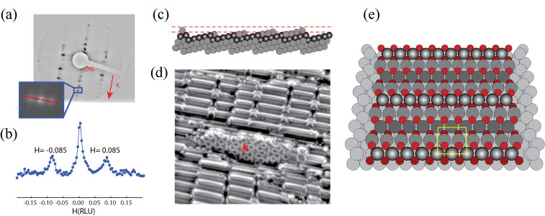
Fig. 4 (a) LEED image from the oxygen induced (332) faceted Pd(553) surface. (b) SXRD H-scan in reciprocal space as indicated by the inset in (a). (c) Model of the the faceting process, rows are added to the step-edge. (d) STM image from the reconstructed (332) surface. (e) Model of the reconstructed (332) surface (bright-grey: step-edge Pd atoms, dull-gray: terrace Pd atoms, bright-red: O atoms above the surface, dark-red: O atoms below the surface).

As an important ingredient for the shape reconstruction by the Wulff diagram, individual facet orientations and vicinal orientations between the different facets were studied as a function of the gas pressure and temperature. NanO₂ has bridged the pressure gap for a large variety of different materials, low index surfaces and vicinal surfaces. In particular, the following achievements have been made:

- To Increase knowledge on the oxidation of single crystal surfaces under industrially relevant conditions for the systems Rh(100), Rh(111), Ru(0001), Pd(111), Pd(100), Pt(110), Pt(111): the formation of a surface oxide trilayer O/ME ion/O is observed as a common feature before the bulk oxide formation sets in.

- Oxidation of vicinal surfaces for the example of Pt(553), Rh(553), Pd(553); Rh(111) with holes: the role of steps is identified as nucleation center for the growth of surface oxide trilayers; the trilayer stability can induce a reorganisation of the step structure, (see Figure 4 as an example for the oxygen induced change from Pd(553) to (332) facets).

- Characterization of the oxidation of vicinal and single crystal surfaces of Pd(553), Pd(223), Rh(223) and Pt(553), Pd(111) as a function of oxygen pressure and temperature by a multi-technique approach. As a general feature it is established, that the formation of ultrathin surface oxide layers on vicinal surfaces is strongly influenced by the atomic structure and periodicity of the steps. Oxide growth is observed to take place along the steps accompanied by a rearrangement of the step structure. The surface oxide structures differ from those observed on the corresponding “0” miscut single crystal surfaces.

- Characterization of the oxidation of vicinal and single crystal surfaces of Pd(553), Pd(110), Rh(110) and Rh(111), Pd(111), Ag(111) as a function of oxygen pressure and temperature by a multi-technique approach and their CO reduction. Development of novel surface oxide structural models for these systems.

- Proposal of a novel structural model for the oxygen induced, p(4x4) reconstruction on Ag(111), which was in the last decades believed to be a prototype for a surface oxide playing a role in catalytic reactions.

- Lack of information on the formation and role of oxygen dissolved in subsurface regions.
It has been shown that materials such as Pd, Rh, and Ru can store large amounts of atomic oxygen at specific temperatures and higher oxygen pressures inside their lattice. This oxygen is present during chemical reactions and predetermines the reactivity and selectivity of these processes. The formation of this so-called subsurface oxygen is a precursor to the oxide formation process, which can be considered as a long-range ordering process of subsurface oxygen. The size-reduction of bulk materials towards nanoparticles or epitaxial films will strongly influence the formation of the subsurface oxygen that competes with oxidation. NanO₂ will provide, for the first time, experimental techniques to quantitatively address the in-situ formation of sub-surface oxygen and will also highlight the role of subsurface oxygen on applications.

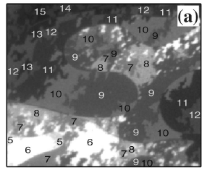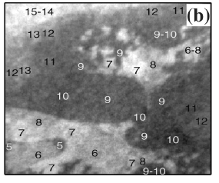
Fig. 5 (a) Low energy electron microscpe image, where the numbers show the local thickness of the Mg film in atomic layers. (b) X-ray photoelectron emission microscope image of the lateral distribution of the Mg oxide, illustrating the electron confinement effect on the oxidation rate.

To deliver a fundamental understanding of the so-called “subsurface oxygen”, NanO₂ has undertaken several efforts to prepare artificial subsurface oxygen under controlled conditions. In all cases investigated, subsurface oxygen was not stable and the concept of subsurface oxygen in the sense of lattice dissolved oxygen, that is made responsible for chemical reactions, has to be questioned. Instead, the formation of meta-stable oxide films was observed, which take over the role of an oxygen buffer. A strong influence of the system size on the reactivity has been observed, which exemplifies the importance of quantum size effects for the reactivity. The following points have been addressed in detail:

- Oxidation of ultrathin epitaxial Rh films on Ru(0001) and on Au(110): an enhanced stability of chemisorbed oxygen phases is observed.

- observation of a strong thickness dependence of the oxidation rate of Mg films on Au(110): the role of film thickness dependent quantum well states for oxidation reactions is identified, see Figure 5.

- Observation of a strong size dependence of the oxidation of Pd nanoparticles on MgO(100): particles smaller than 4 nm are much more reactive towards oxidation.

- Characterization of a artificial subsurface oxygen on Ru(0001) covered by epitaxial Rh films: subsurface oxygen is not stable and segregates to the surface.

- Oxidation and reduction of Ru(0001) and comparison with industrial Ru catalysts: it was demonstrated that knowledge created on the oxidation of Ru(0001) and Rh(10-10) surfaces can be extrapolated to the oxidation of Ru nanoparticles.

- Observation of novel surface oxides for ultrathin Pd films on Rh(111).

- Investigation of the atmospheric pressure oxidation of Ir(111). As oxidation mechanism the formation of trilayer stacks was observed, transforming into rutile bulk oxide for thicker IrO₂ films.

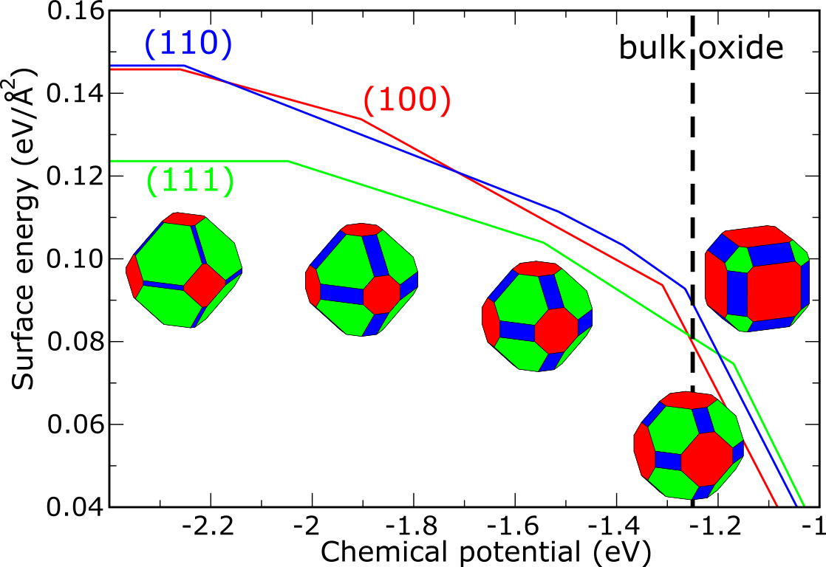
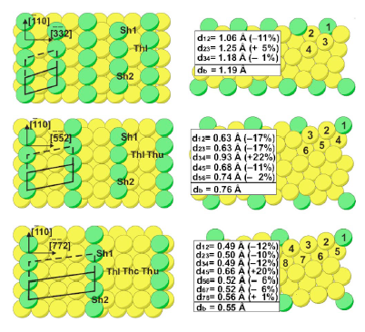
(a) (b)

Fig. 6 (a) Theoretical calculation of oxygen adsorption structures on vicinal Pd(11N) surfaces (b) Theoretical investigation of oxygen induced shape changes of Rh particles as a function of the oxygen chemical potential.

- The reduction of ultrathin Rh cap layers for EUVL optics was investigated; H₂ can
be employed at room temperature to clean the Ru surface.

- Unknown electronic structure and thermodynamic behaviour of nanosized particles and adsorbates.
Due to their reduced size, the electronic properties of nanomaterials change and even undergo metal/insulator transitions, which strongly influence the adsorption properties of oxygen at a cluster. NanO₂ has extended the theoretical work from single crystal surfaces at elevated pressures and temperatures using ab-initio and kinetic Monte-Carlo techniques, towards the description of vicinal surfaces. NanO₂ has embarked into ab-initio modelling of the oxidation of nanosized materials at high oxygen pressures and high temperatures, thereby allowing a rigorous comparison with experiment and enabling reliable prediction of oxidation properties. Based on the energetics known fro the single crystal and vicinal surfaces, the environmentally induced shape change of nanoparticles can be evaluated using the Wulff construction. The theory groups have addressed the following points in detail:

- The CO oxidation reaction over Pd(100) was investigated by ab initio Monte Carlo simulations, demonstrating that the sqrt 5 surface oxide is stable under industrial CO oxidation conditions.

- The adsorption of oxygen on various facets of Rh and Pd has been investigated by DFT and molecular dynamics simulations (see Figure 6).

- First-principles kinetic Monte Carlo simulations on CO oxidation reactions allowing for the first time to predict reaction rates on single crystal surfaces.

- Theoretical treatment of the vicinal O/Pd(11N) surfaces (see Figure 6 (a)), O/Rh(331), O/Rh(553) subsurface O/Pd(111), oxidation of Pd(100), stability of PdO nanoparticles

- Theoretical Description of the particle shape as a function of the oxygen chemical potential by a combination of DFT results from the oxygen interaction with different single crystal facets and the Wulff construction (see Fig. 6 (b)).

- First-principles kinetic Monte Carlo simulations on CO oxidation reactions allowing for the first time to predict reaction rates on single crystal surfaces.

- Unexplored nano particle / support interaction.
Metallic clusters for applications are usually supported by oxides, which play an important role for the overall functionality of the nanostructure. Via the interfacial energies, the metal/support (substrate) interaction determines nanoparticle shape, which is of paramount importance to nanoparticle reactivity and selectivity. Nanoparticle shape is influenced by the possible formation of subsurface oxygen, which adds an additional strain dependent energy term. Atoms sitting at the interface between the cluster and the oxide substrate are in a peculiar chemical condition and are suspected to play an important role in catalytic reactions as a result of their unique boundary conditions. NanO₂ has grown nano-sized Pd, Rh, Ru, and Cu particles with defined shapes on insulating and conducting oxide substrates, such as Al₂O₃, MgO, ZnO. In addition, “spill-over effects” of oxygen from the nanoparticle onto the substrate were investigated. A full structural characterization of the nanoparticles was performed by x-ray diffraction and transmission electron microscopy and a novel x-ray diffraction scheme for the in-situ structural analysis of nanoparticles was developed, which allows to study the shape of nanoparticles on the atomic scale. In the following, the most important achievements are listed:

a)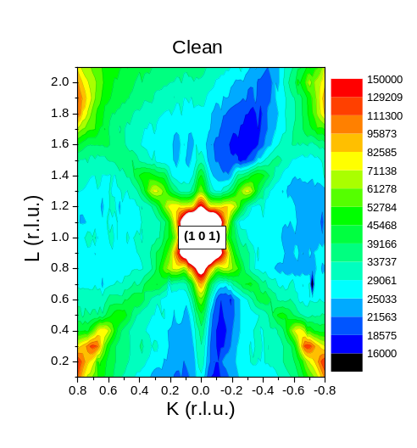 | 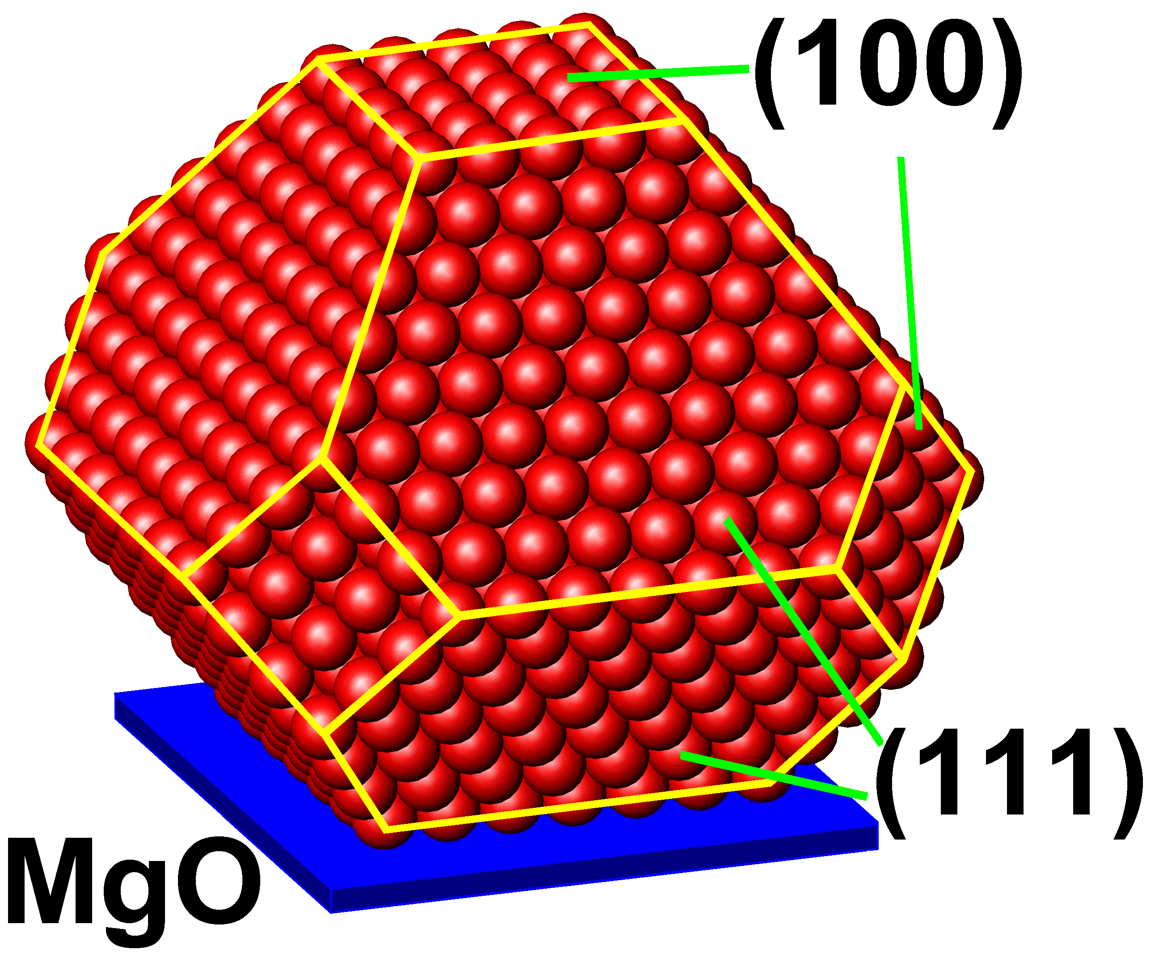  b)
Fig 7a: X-ray diffraction map of Pd particles on Mg(100), b: corresponding particle shape

- Preparation of Pd nanoparticles on MgO, investigation of nanoparticle oxidation and comparison with Pd single crystal surface oxidation, implementation of nanoparticle x-ray investigation. Pd nanoparticles oxidize already under conditions, at which a surface oxide kinetically hinders the formation of bulk oxide.

- First X-ray observation of the 3D diffraction pattern of 6 nm Pd and Rh nanoparticles on MgO(100) (see Figure 7(a+b)). The scattering from the individual types of facets can be recorded up to high momentum transfer through the Βrilloin zone, yielding information on the facet crystallography on an atomic scale. Oxygen adsorption induced shape changes of the nanoparticles can be observed in-situ.

- follow particle shape changes during a chemical reaction, like CO oxidation.

- Atomically resolved high resolution TEM images have been obtained from Pd and Rh nanoparticles on MgO, Al₂O₃ and ZnO, exhibiting also the presence of surface oxide layers on Rh particles.

- A complete experimental stability diagram has been measured for oxygen on Pd low index, vicinal surfaces and nanoparticles an different substrates. Chemically more active substrates, such as ZnO, are found to lower kinetic barriers for the PdO bulk oxide formation.

With the information on the influence of nanoparticles size and -shape on high pressure oxidation, and on nanoparticle´s ability to for surface oxides, the oxidation and reduction behaviour of nanomaterials under industrial conditions can be controlled with a new quality of knowledge and precision. NanO₂ aimed to tailor nanoparticle properties for oxidation / reduction cycles for industrial applications such as heterogeneous catalysis, gas sensors, or fuel cells. Various systems from single crystal surfaces to vicinal surfaces have been investigated under near atmospheric pressure CO oxidation conditions. At the end of the NanO₂ nanoparticle oxidation & reduction under industrial conditions was demonstrated.

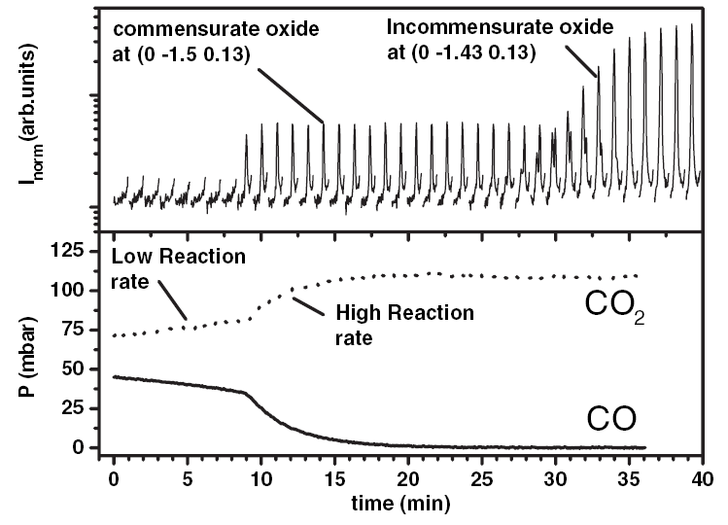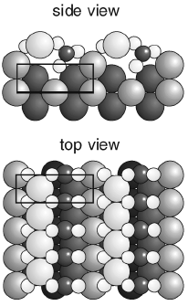
(a) (b)
Fig 8a: X-ray diffraction scans during a CO oxidation reaction over Pt(110), b: commensurate Pt – O – C structure only stable under reaction conditions.
The following systems have been studied in detail under oxidation / reduction conditions by a multi-technique approach:

- In-situ TEM study of the shape change of Cu nanoparticles on different substrates in H₂ and H₂O atmospheres

- Demonstration that Potassium acts as a promotor for the oxidation of Rh(110) surfaces.

- First observation of the formation of a novel surface oxide present during the CO oxidation on a Pt(110) single crystal, only present at high pressures close to industrial reaction conditions, see Figure 8.

- The partial methanol oxidation over Ru/RuO₂ was investigated.

- The oxidation of Rh microparticles was investigated by XPS. The results demonstrate that each particle acts as independent microreactor.

- Experiments on epitaxial Cu and Pd particles have been performed under industrially relevant reaction conditions.

- First structural in-situ investigation of a Pt₂₅Rh₇₅ alloy single crystal during a chemical reaction.

NanO₂ has reached all milestones defined within the project and all deliverables were fulfilled. From the results obtained during the duration of NanO₂, it becomes clear that the NanO₂ consortium has performed work beyond the project’s objectives and that NanO₂ has created a new state of the art in the strongly expanding scientific field of the oxidation and chemical reactions on nano-materials. As a result 50 publications are already accepted, and overall nearly 100 publications in highly ranked journals are expected. A huge number of 300 additional dissemination activities in the form of talks and posters at international conferences have been performed, which are expressing the very high impact that the work of NanO₂ is expected to have.

2. Dissemination and Use

- NanO₂ has created novel fundamental knowledge, that has been made available in the form of publications in accessible international journals, such as Physical Review Letters, Physical Review B, Angewandte Chemie Intational Edition, Surface Science, Journal of Electron Spectroscopy and related Phenomena, Catalysis Today, Journal of Physical Chemistry, Topics in Catalysis, Journal of Physics Condensed Matter, Oil & Gas Science and Technology, Journal of Catalysis, Journal of Chemical Physics, Journal of Physical Chemistry and Chemical Physics, Bulletin of the Materials Research Society. The broad distribution of journals reflects the multi-disciplinary approach of NanO₂. More than 50 publications are accepted and about 40 additional publications are in preparation.

- 300 talks and posters at international scientific conferences

- Organization of the international workshop on the “Stability and reactivity of Nanomaterials” in 2006 at Irsee (Germany) with 50 participants.

- NanO₂ web site www.nano2.net

- Education of PhD students.
The following PhD and Diploma thesis have been completed within NanO₂:
  - J. Klikovits, in preparation (TU Vienna)
  - A. Farkas, in preparation (U. Giess)
  - R. Westerström, in preparation (U.Lu)
  - J. Gustafson, (U.Lu), Oxidation of some Late Transition Metal Surfaces: Structural Studies from UHV to Atmospheric Pressure
  - L. Köhler, in preparation (U.Vienna)
  - M. Ackermann, in preparation (U.Leiden)
  - M. Todorova, (FHI), “Oxidation of Palladium Surfaces”
  - A. Reicho, in preparation (MPI-MF).
  - P. Nolte, in preparation (MPI-MF).
  - C. Ellinger, (MPI-MF), “In-situ oxidation studies of Pt surfaces”

Final Publication List

Accepted publications:

1. L. Aballe, A. Barinov, A. Locatelli, S. Heun, M. Kiskinova, Tuning surface reactivity via Electron Quantum Confinement, Phys. Rev. Lett. 93 (2004) 196103. (ELETTRA)

2. J. Aßmann, D.a Crihan, M. Knapp, E. Lundgren, E. Löffler, M. Muhler, V.Narkhede, H. Over, M. Schmid, P. Varga, Understanding the structural deactivation of Ruthenium catalysts on atomic scale, Angewandte Chemie Int. Ed. 44 (2005) 917. (IAP, U.Lu)

3. B.L.M. Hendriksen, S.C. Bobaru, J.W.M. Frenken, Oscillatory CO oxidation on Pd(100) studied with in situ scanning tunneling microscopy, Surf. Sci. 552 (2004) 229. (U.Lei)

4. L. Köhler, G. Kresse, M. Schmid, E. Lundgren, J. Gustafson, A. Mikkelsen, M. Borg, (J. Yuhara, J. N. Andersen, M. Marsman, and P. Varga, “High-coverage oxygen structures on Rh(111) - adsorbate repulsion and site preference is not enough”, Phys. Rev. Lett. 93 (2004) 266103. (IMP, U.Lu, IAP)

5. J. Gustafson, A. Mikkelsen, M. Borg, J. N. Andersen, E. Lundgren, C. Klein, W. Hofer, M. Schmid, P. Varga, L. Köhler, G. Kresse, N. Kasper, A. Stierle and H. Dosch, Structure of a thin oxide film on Rh(100), Phys. Rev. B 71 (2005) 115442. (U.Lu, IAP, MPI-MF)

6. B.L.M. Hendriksen, S.C. Bobaru, J.W.M. Frenken, Bistability and oscillations in CO oxidation studied with Scanning Tunneling Microscopy inside a reactor, Catalysis Today 105, (2005) 234. (U.Lei)

7. M. Todorova, K. Reuter, and M. Scheffler, Density-Functional Theory Study of the Initial Oxygen Incorporation in Pd(111), Phys. Rev. B 71 (2005) 195403. (FHI)

8. J. G. Wang, W. X. Li, M. Borg, J. Gustafson, A. Mikkelsen, T. M. Pedersen, E. Lundgren, J. Weissenrieder, J. Klikovits, M. Schmid, B. Hammer, and J. N. Andersen, One-dimensional PtO₂ oxide at Pt steps: formation and reaction with CO, Phys. Rev. Lett. 95 (2005) 256102. (U.Lu, IAP)

9. Y. B. He, M. Knapp, E. Lundgren, and H. Over, Ru(0001) model catalyst under oxidizing and reducing reaction conditions: In-situ high-pressure surface x-ray diffraction study,
J. Phys. Chem. B 109 (2005) 21825. (U.Lu, U. Giess)

10. A. Stierle, N. Kasper, H. Dosch, J. Gustafson, A. Mikkelsen, J. N. Andersen, and E. Lundgren, A surface x-ray study of the structure and morphology of the oxidized Pd(001) surface, J. Chem. Phys. B 122 (2005) 044706. (MPI-MF, U.Lu)

11. E. Lundgren, J. Gustafson, A. Resta, J. Weissenrieder, A. Mikkelsen, J. N. Andersen L. Köhler, G. Kresse, J. Klikovits, A. Biederman, M. Schmid, and P. Varga, The surface oxide as a source of O on Rh(111), J. Electron Spectrosc. Relat. Phen. 144-147 (2005) 367-372. (U.Lu, IMP, IAP)

12. Y.B. He, A.P. Seitsonen, and H. Over, Irregular stacking sequence in the initial growth of ultrathin Rh films on Ru(0001), Phys. Rev. B 72 (2005) 075432. (U.Giess)

13. B.L.M. Hendriksen, S.C. Bobaru, J.W.M. Frenken, Looking at heterogeneous catalysis at atmospheric pressure using tunnel vision, Topics in Catalysis 36 (2005) 43. (U.Lei)

14. M.D. Ackermann, T.M. Pedersen, B.L.M. Hendriksen, O. Robach, S.C. Bobaru, I. Popa, C. Quiros, H. Kim, B. Hammer, S. Ferrer, J.W.M. Frenken, Structure and reactivity of surface oxides on Pt(110) during catalytic CO oxidation, Phys. Rev. Lett. 95 (2005) 255505. (U.Lei, ESRF)

15. R. Blume, H. Niehus, H. Conrad, A. Böttcher, L. Aballe, L.Gregoriatti, A. Barinov, and M. Kiskinova, Identification of subsurface oxygen species during oxidation of Ru(0001) and the phases formed at different reaction temperatures, J. Phys. Chem. B 109, (2005) 14052. (Elettra)

16. S. Günther, F. Esch, M. del Turco, C. Africh, G. Comelli, M. Kiskinova, K-stabilized high oxygen coverage states on Rh(110): a low pressure pathway to formation of surface oxide,
J. Phys. Chem. B 109 (2005) 11980. (Elettra)

17. P. Dudin, A. Barinov, L. Gregoratti, F. Esch, C. Alfrich, G. Comelli, and M. Kiskinova, Initial oxidation of a Rh(110) surface with molecular and atomic oxygen and reduction of the surface oxide with hydrogen, J. Phys. Chem. B 109 (2005) 13649. (Elettra)

18. E. Lundgren, A. Mikkelsen, J. N. Andersen, G. Kresse, M. Schmid, and P. Varga, Surface oxides on close-packed surfaces of late transition metals (invited paper), J. Phys. Cond. Matter 18 (2006) R481-R499. (U.Lu, IMP, IAP)

19. M. Schmid, A. Reicho, A. Stierle, I. Costina, J. Klikovits, P. Kostelnik, O. Dubay, G. Kresse, J. Gustafson, E. Lundgren, J.N. Andersen, H. Dosch, and P. Varga, Structure of Ag(111)-p(4x4)-O: no silver oxide, Phys. Rev. Lett. 96, (2006) 146102. (IMP, IAP, MPI-MF, U.Lu)

20. M. Knapp, D. Crihan, A. Resta, E. Lundgren, J.N. Andersen, A.P. Seitsonen, M. Schmid, P. Varga, and H. Over, Unusual process of water formation on RuO₂(110) by hydrogen exposure at room temperature, J. Phys. Chem. B 110 (2006) 14007-14010. (U.Lu, IAP, U. Giess)

21. J. Klikovits, M. Schmid, J. Gustafson, A. Mikkelsen, A. Resta, E. Lundgren, J. N. Andersen, and P. Varga, Kinetics of the reduction of the Rh(111) surface oxide: Linking spectroscopy and atomic-scale information, J. Phys. Chem. B 110 (2006) 9966-9975. (U.Lu, IAP)

22. P. Kostelník, N. Seriani, G. Kresse, A. Mikkelsen, E. Lundgren, V. Blum, T. Sikola, P. Varga, and M. Schmid, The Pd(100)-(√5×√5)R27˚-O surface oxide: a LEED,DFT and STM study, Surf. Sci. 601 (2007) 1574. (IMP, U.Lu, IAP)

23. J. Gustafson, A. Resta, A Mikkelsen, R. Westerström, J. N. Andersen, E. Lundgren, J. Weissenrieder, M. Schmid, P. Varga, N. Kasper, X.Torrelles, S. Ferrer, F. Mittendorfer, G. Kresse, Oxygen induced step-bunching and faceting of Rh(553): Experiment and theory
Phys. Rev. B 74 (2006) 035401. (U.Lu, IAP, IMP)

24. Y. B. He, A.P. Seitsonen, H. Over, Ultrathin Rh films on Ru(0001): Oxidation and Confinement; J. Chem. Phys. 124 (2006) 034706. (U.Giess)
25. A. Kiejna, G. Kresse, J. Rogal, A. De Sarkar, K. Reuter, and M. Scheffler, Comparison of the Full-Potential and Frozen-Core Approximation Approaches to Density-Functional Calculations of Surface, Phys. Rev. B 73, (2006) 035404. (IMP, FHI)

26. K. Reuter and M. Scheffler, First-Principles Kinetic Monte Carlo Simulations for Heterogeneous Catalysis: Application to the CO Oxidation at RuO₂(110), Phys. Rev. B 73, (2006) 045433. (FHI)

27. J. Schnadt, A. Michaelides, J. Knudsen, R.T. Vang, K. Reuter, E. Laegsgaard, M. Scheffler, and F. Besenbacher, Revisiting the Structure of the p(4x4) Surface Oxide on Ag(111), Phys. Rev. Lett. 96 (2006) 146101. (FHI)

28. K. Reuter, Nanometer and Sub-Nanometer Thin Oxide Films at Surfaces of Late Transition Metals, in “Nanocatalysis”, p. 343-376, U. Heiz, U. Landman (Eds.), Springer, Berlin (2006). ISBN 978-3-540-32645-8. (FHI)

29. Y. Zhang, J. Rogal and K. Reuter, Density-Functional Theory Investigation of Oxygen Adsorption at Pd(11N) Vicinal Surfaces (N=3,5,7): Influence of Neighboring Steps, Phys. Rev. B 74 (2006) 125414. (FHI)

30. K. Reuter, Insight Into a Pressure and Materials Gap: CO Oxidation at „Ruthenium“ Catalysts, Oil & Gas Science and Technology, Vol. 61, 471 (2006). (FHI)

31. J. Rogal, K. Reuter, and M. Scheffler, First-Principles Statistical Mechanics Study of the Stability of a Sub-Nanometer Thin Surface Oxide in Reactive Environments: CO Oxidation at Pd(100), Phys. Rev. Lett. 98 (2007) 046101. (FHI)

32. R. Blume, M. Havecker, S. Zafeiratos, D. Teschner, E. Kleimenov, A. Knop-Gericke, R. Schlögl A. Barinov, P. Dudin, M. Kiskinova, Catalytically active states of Ru(0001) catalyst in CO oxidation reaction, J. Cat. 239 (2006) 354. (Elettra)

33. C. Dri, C. Africh, F. Esch, G. Comelli, O. Dubay, L. Kohler, F. Mittendorfer, G. Kresse, P. Dudin and M. Kiskinova, Initial oxidation of the Rh(110) surface: Ordered adsorption and surface oxide structures, J. Chem. Phys 125 (2006), 94701. (Elettra, IMP)

34. S. Günther, R. Hoyer, H. Marbach, R. Imbihl, F. Esch, M. del Turco, C. Africh, G. Comelli, M. Kiskinova, K and mixed K+O adlayers on Rh(110), J. Chem. Phys. 124 (2006) 1470. (Elettra)

35. I. Costina, M. Schmid, H. Schiechl, M. Gajdos, A. Stierle, S. Kumaragurubaran, J. Hafner, H. Dosch, P. Varga Combined STM, LEED and DFT study of Ag(100) exposed to oxygen near atmospheric pressures, Surf. Sci. 600 (2006) 617 (MPI-MF, IAP).

36. N. Kasper, A. Stierle, P. Nolte, Y. Jin-Phillipp, T. Wagner, D. G. de Oteyza, H. Dosch, In-situ oxidation study of MgO(100) supported Pd nanoparticles, Surf. Sci. 600 (2006) 2860 (MPI-MF).

37. A. Reicho, A. Stierle, I. Costina, H. Dosch, Stranski-Krastanov oxide growth on Ag(111) at atmospheric oxygen pressures, Surf. Sci. 601 (2007) L19-L23 (MPI-MF).

38. M. Knapp, D. Crihan, A.P. Seitsonen, E. Lundgren, A. Resta, J. N. Andersen, and H. Over
Complex Interaction of Hydrogen with the RuO2(110) surface, J. Phys. Chem. C. 111 (2007) 5363 (U.Lu, U.Giess)

39. R. Blume, M. Hävecker, S. Zafeiratos, D. Teschner, A. Knop-Gericke, R. Schlögl, P. Dudin, A. Barinov, and M. Kiskinova, Oxidation of methanol on Ru catalyst: effect of the reagents partial pressures on the catalyst oxidation state and selectivity, Cat. Tod. 124 (2007) 71 (Elettra)

40. R. Blume, M. Havecker, S. Zafeiratos, D. Teschner, E. Kleimenov, A. Knop-Gericke, R. Schlögl A. Barinov, S. Lizzit P. Dudin, M. Kiskinova, Monitoring in-situ Catalytically Active States of Ru Catalysts for Different Methanol Oxidation Pathways, PCCP, in press. (2007) (Elettra)

41. A. Kiejna, G. Kresse, J. Rogal, A. De Sarkar, K. Reuter, and M. Scheffler, Comparison of the Full-Potential and Frozen-Core Approximation Approaches to Density-Functional Calculations of Surfaces, Phys. Rev. B (in press). (FHI,IMP)

42. B. Temel, H. Meskine, K. Reuter, M. Scheffler, and H. Metiu, Does Phenomenological Kinetics Provide an Adequate Description of Heterogeneous Catalytic Reactions?, J. Chem. Phys. (in press). (FHI)

43. J. Rogal and K. Reuter, Ab initio Atomistic Thermodynamics for Surfaces: A Primer, NATO-VKI Lecture Notes on “Experiment, Modeling and Simulation of Gas-Surface Interactions for Reactive Flows in Hypersonic Flights”, Rhode-St-Genèse (B), (in press). (FHI)

44. M. Knapp, D. Crihan, A.P. Seitsonen, E. Lundgren, A. Resta, J. N. Andersen, and H. Over
Complex Interaction of Hydrogen with the RuO2(110) surface, J. Phys. Chem. B. in press (U. Lu, U. Giess)

45. Y. B. He, A. Goriachko, C. Korte, A. Farkas, G. Mellau, P. Dudin, L. Gregoriatti, A. Barinov, M. Kiskinova, A. Stierle, N. Kasper, S. Bajt, and H. Over, Oxidation and reduction of ultrathin nano-crystalline Ru films on Si(100): a model system for Ru-capped EUVL optics, submitted to J. Phys. Chem. C (in press) (U.Giess, ELETTRA, MPI-MF)

46. A. Stierle, I. Costina, S. Kumaragurubaran, and H. Dosch, In-situ x-ray diffraction study of Ag (100) at ambient oxygen pressures, J. Phys. Chem. C, in press (MPI-MF).

Submitted:

47. R. Westerström, J. Gustafson, A. Resta, A. Mikkelsen, J. N. Andersen, E.Lundgren, N. Seriani, F. Mittendorfer, M. Schmid, J. Klikovits, P. Varga, M. D. Ackermann, J. W. M. Frenken, N. Kasper, A. Stierle, Oxidation of Pd(553): from ultrahigh vacuum to atmospheric pressure, submitted (U.Lu, IMP, IAP, U.Lei, MPI-MF).

48. E. Lundgren, J. G. Wang, M. Ackermann, R. Westerström, J. Gustafson, A. Resta, A. Mikkelsen, J. N. Andersen, O. Balmes, X. Torrelles, J. W. M. Frenken, and B. Hammer.
Structure and reactivity of a model catalyst alloy under realistic conditions, submitted. (U.Lu, U.Lei)

49. J. Rogal, K. Reuter, and M. Scheffler, CO Oxidation at Pd(100): A First-Principles Constrained Thermodynamics Study, Phys. Rev. B submitted (FHI)

50. Y. Zhang, V. Blum, and K. Reuter, On the Accuracy of First-Principles Lateral Interactions: O at Pd(100), Phys. Rev. B. submitted (FHI)

Papers in preparation:

51. J. Rogal, K. Reuter, and M. Scheffler, Atomic-Scale Insight into High-Pressure CO Oxidation Catalysis at Pd(100): The Relevance of Sub-Nanometer Thin Surface Oxides, Phys. Rev. Lett. in preparation. (FHI)

52. F. Esch, P. Dudin, A. Barinov, L. Gregoratti, G. Comelli, M. Kiskinova, O. Dubay, G. Kresse, Growth and structure of thin oxide film on Rh(110), in preparation. (ELETTRA, IMP)

53. F. Esch, S. Günther, M. Kiskinova et al, Effect of K on the structural transformations of the Rh(110) in oxygen ambient, in preparation. (ELETTRA)

54. W. X. Li, B. Hammer, J. Weissenrieder, J. Gustafson, M. Borg, A. Mikkelsen, E. Lundgren, J. N. Andersen, Oxygen adsorption and the CO-oxidation reaction on Pt(111) and Pt(553): The role of steps, in preparation. (U.Lu)

55. J. Gustafson, A Mikkelsen, M. Borg, E. Lundgren, L. Köhler, G. Kresse, M. Schmid, P. Varga, The oxidation of Rh(111) and Rh(100), in preparation. (U.Lu, IMP, IAP)
N. Kasper, A. Stierle, T. Wagner, H. Dosch, “Oxidation of Pd / MgO(001) nanoparticles: an in-situ x-ray study”, in preparation. (MPI-MF)

56. J. Gustafson, F. Mittendorfer, A. Resta, A. Mikkelsen, R. Westerström, E. Lundgren, J. N. Andersen, J. Weissenrieder, G. Kresse, X. Torelles, S. Ferrer, N. Kasper, M. Schmid, and P. Varga, Atomistic origins for oxygen induced step rearrangement, in preparation. (U.Lu,IAP,IMP,ESRF,MPI-MF)

57. J. Klikovits, M. Schmid, J. Gustafson, A. Mikkelsen, A. Resta, E. Lundgren, J. N. Andersen, and P. Varga, Kinetics of the reduction of the Rh(111) surface oxide: Linking spectroscopy and atomic scale information, in preparation. (U.Lu, IAP)

58. J. Gustafson, A Mikkelsen, M. Borg, E. Lundgren, L. Köhler, G. Kresse, M. Schmid, P. Varga, The oxidation of Rh(111) and Rh(100),, in preparation. (U.Lu; IAP, IMP)

59. Y.B. He, A.P. Seitsonen, and H. Over, Ultrathin Pd films on Ru(0001): initial growth and oxidation, in preparation. (U.Gieß)

60. Y.B. He, A.P. Seitsonen, and H. Over, Atomic geometry of chemisorbed oxygen on Ir(111): a combined study of LEED and DFT, in preparation. (U.Gieß)

61. J. Rogal, K. Reuter, and M. Scheffler, Atomic-Scale Insight into High-Pressure CO Oxidation Catalysis at Pd(100): The Relevance of Sub-Nanometer Thin Surface Oxides, Phys. Rev. Lett., in preparation. (FHI)

62. T. W. Hansen, P. L. Hansen, J. Sehested, B. S. Clausen, A. K. Datye, S. Helveg, J. Catal, Anomalous particle migration, 2005, in preparation. (HTAS)

63. N. Kasper, A. Stierle, P. Nolte, T. Wagner, Y. Jin-Phillip, D. G. de Oteyza, H. Dosch, In-situ oxidation study of Pd nanoparticles on MgO(001) from UHV to ambient pressures, in preparation. (MPI-MF)

64. N. Kasper, A. Stierle, H. Dosch, In-situ oxidation study of Pd(111), in preparation. (MPI-MF)

65. P. Nolte, N. Kasper, A. Stierle, Y. Jin-Phillip, H. Dosch, Structure and reactivity of Rh particles on Al₂O₃, in preparation (MPI-MF).

66. P. Nolte, N. Kasper, A. Stierle, Y. Jin-Phillip, H. Dosch, Size dependent oxidation study of Pd particles on MgO(100) by high energy x-ray diffraction , in preparation (MPI-MF).

67. J. Gustafson, E. Lundgren, A. Resta, R. Westerström, A. Mikkelsen, F. Mittendorfer, G. Kresse, M. Schmid, P. Varga, X. Torrelles and J. N. Andersen, Oxidation of Rh(111): chemisorption and formation of surface and bulk oxides, in preparation (U.Lu, IAP, IMP)

68. S. Gardonio, L. Gregoratti, P. Dudin, A. Barinov, M. Kiskinova, Oxidation of thin Rh films deposited on Au(110) surface. (Elettra)

69. L. Gregoratti, P. Dudin, A. Barinov, M. Kiskinova, Reactivity at different dimensions: from Rh single crystal to nanoparticles. (Elettra)

70. P. Nolte, A. Stierle, N. Kasper, Y. Jin-Phillipp, H. Reichert, A. Rühm, J. Okasinski, S. Schöder, H. Dosch, Size dependent oxidation of MgO supported Pd nanoparticles studied with High Energy Microbeam X-ray diffraction. (MPI-MF,ESRF)

71. J. Klikovits, E. Napetschnig, M. Schmid, O. Dubay, N. Seriani, G. Kresse, and P. Varga,
The zoo of surface oxides on Pd(111). (IAP)

72. C. Ellinger, et al., Atmospheric pressure oxidation of Pt(111) single crystal surfaces and thin fims (MPI-MF)

73. J. Gustafson, el al., Transient bulk oxide formation during the high pressure oxidation of Rh(100) (U.Lu, MPI-MF)

74. A. Stierle, et al. Extended x-ray absorption fine structure investigation of Rh nanoparticles on a model oxide support (MPI-MF,HTAS)

75. P. Nolte, et al. Growth, oxidation and reduction of Pd and Rh nanoparticles on Al₂O₃ (MPI-MF)

76. J. Phys. Cond. Mat. special issue on gas / solid interfaces, edited by E. Lundgren and H. Over (U.Lund, U.Gieß).

77. MRS bulletin on Novel in-situ probes for nanocatalysis, edited by A. Stierle and A. Molenbroek (MPI-MF, HTAS)

78. A. Reicho, A. Stierle, I. Costina, V. Vonk, and H. Dosch, S. Thiess, T.-L. Lee, and J. Zegenhagen, The oxidation of Ag(111) studied by surface sensitive x-ray techniques (MPI-MF, ESRF)

79. N. Kasper, A. Stierle, P. Nolte, H. Dosch, Oxidation of Pd(111): Structure, Epitaxy and Stability Regions of Surface and Bulk Oxides, as obtained from in-situ X-ray studies. (MPI-MF).

80. Y. He, A. Farkas, H. Over, A. Stierle, H. Dosch, Oxidation of Ir(111) at atmospheric pressures (U. Gieß, MPI-MF)

81. F. Mittendorfer, N. Seriani, O. Dubay, G. Kresse, The morphology of mesoscopic Rh and Pd nanoparticles under oxidizing conditions (IMP).

82. P. Nolte, N. Kasper, Y. Jin-Phillipp, A. Stierle, H. Dosch, Oxygen induced surface reconstructions of Rh nanoparticles on MgO(100). (MPI-MF)

83 P. Nolte, N. Kapser, A. Stierle, Y. Jin-Phillipp, H. Dosch, Shape and Structure of Pd nanoparticles on MgO(100) under oxidation / reduction cycles (MPI-MF).

84. E. Lundgren, et al, Oxidation of Pd(223) and Rh(223), (U.Lu, MPI-MF, IAP, IMP)

85. R. Westerström, et al. Oxygen induced reconstructions of the Pd(110) surface, (U.Lu, MPI-MF, IMP)

86. M. Ackermann, et al., CO oxidation over Pt(111) and Pt(110) model catalysts, (U.Lei, ESRF).

87. A. Michaelidis, et al., DFT investigation of the ethylen epoxidation on Ag(111) (FHI).

88. E. Lundgren, et al., CO reduction of surface oxides on Pd(100), (U.Lu,FHI).

89. MRS Bulletin on “Novel in-situ probes in nanocatalysis”, edited by A. Stierle and A. Molenbroek.

Talks & Posters:

Talks:

G. Kresse, L. Köhler, “Ultra-thin oxide films on metal substrates: Is there a general construction principle ?'', Institut für Physikalische Chemie (Wandelt), Bonn (Germany), January 29, 2004. (Invited) (IMP)

F. Mittendorfer, “Oxidation of stepped Rh surfaces”, JRP/NSOS 1st International Workshop , Schloss Seggau, Leibnitz, October 1, 2004. (IMP)

A.M. Molenbroek, “GENNESYS New Opportunities for Catalysis”, GENNESYS meeting, Stuttgart, Germany, November 11-12, 2004. (Invited) (HTAS)

O.Balmes, NDCAT French German summer school in catalysis, Saarbruck Sept. 28 – Oct. 1, 2004. (HTAS)

A.M. Molenbroek, “Industrial Applications”, Workshop on ‘Our Future Light Source’ Sept. 27-29, 2004, Lund, Sweden. (Invited) (HTAS)

S. Helveg, "Atomic-scale Imaging of Catalyst Dynamics", 13th International Conference on Catalysis, Paris, July 11-16, 2004. (HTAS)

S. Helveg, ”Atomic-scale imaging of Heterogeneous Catalysts in Reactive Gas environ-ments”, SCANDEM Workshop, Risø, Denmark, June 2004. (Invited) (HTAS)

S. Helveg , “In situ TEM of Supported Metal Nanoclusters”, Workshop "Catalysis from First Principles", Magleås, Denmark, June 2004. (Invited) (HTAS)

H. Over, “Understanding the Structural Deactivation of Ru Catalysts on Atomic Scale”, CECAM Lyon, France, November 4-6, 2004. (U.Gieß)

P. Varga, “Formation and structure of two-dimensional surface oxides”, Symposium on Surface Physics 2004, Shizukuishi, Iwate Japan, January 22, 2004 (invited) (IMP)

P. Varga, “Adsorption on and reduction of surface oxides”, Workshop: In situ atomic scale characterization of surfaces under high pressures: recent advances in experiment and theory, CECAM, Lyon, France, November 5, 2004 (invited) (IMP)

P. Varga, “Reduction of the surface oxide layer on Rh(111) by CO and H₂, International Workshop “Nanoscience on Surfaces“, Schloss Seggau, Leibnitz, Austria, October 18, 2004. (IMP)

N. Kasper, “Oxidation of Pd nanoparticles”, Talk at the 6th Warren Symposium at Ringberg Castle, Ringberg Castle, Germany, January 12-15, 2005. (MPI-MF)

J.N. Andersen, J. Gustafson, M. Borg, A. Mikkelsen, J. Weissenrieder, E. Lundgren, W. X. Li, B. Hammer, “The CO-oxidation reaction on Pt(111) and Pt(553): The role of steps”, The 64th Physical Electronics Conference, David, California, June 21-23, 2004. (U.Lu)

J. N. Andersen, J. Gustafson, M. Borg, A. Mikkelsen, J. Weissenrieder, E. Lundgren, W. X. Li, B. Hammer “The CO-oxidation reaction on Pt(111) and Pt(553): The role of steps”, AVS 51st International Symposium & Exhibition Anaheim, CA, USA, November 14-19, 2004. (U.Lu)

J. Gustafson, “The formation and stability of oxide films on Rh(111)” (talk), Symposium on surface science 2004, St. Christoph am Arlberg, Austria, Feb. 29 - March 6, 2004. (U.Lu)

E. Lundgren, “The oxidation of some late transition metals: from UHV to ambient oxygen partial pressures” (talk).-The APS March Meeting, Montreal, Canada, March 22-26, 2004. (U.Lu)
36. E. Lundgren,“The oxidation of Rh(111)” (talk), Official seminar at Elettra, Trieste, Italy. April 2004. (U.Lu).

J. N. Andersen, “The CO-oxidation reaction on Pt(111) and Pt(553): The role of steps” (talk) The 64th Physical Electronics Conference, David, California, 21-23 June 2004. (U.Lu)

J. N. Andersen, “Step induced changes of adsorption properties and reactivities: Pt(111) and Pt(553)”, The APS March Meeting, Montreal, Canada, 22-26 March 2004. (U.Lu)

E. Lundgren, “In-situ investigations of the initial oxidation of some late transition metals” VIIIth European Conference on Surface Crystallography and Dynamics (ECSCD), July18-21, 2004, Segovia, Spain. (Invited) (U.Lu)

E. Lundgren, “The oxidation of some late transition metals: from UHV to ambient oxygen partial pressures” , XIVth International Conference on Vacuum Ultraviolet Radiation Physics (VUV), July19-23, 2004, Cairns, Australia. (Invited) (U.Lu)

J. N. Andersen, “Surface structure: core levels and simulations”, 1st International Workshop “Nanoscience on Surfaces“ Schloss Seggau, Seggauberg 1, A-8430 Leibnitz, Austria, October 18-20, 2004. (Invited) (U.Lu)

E. Lundgren, “In-situ investigations of the oxidation of the Rh(111) and Pd(100) surfaces”, Surface Science Research Centre, University of Liverpool, UK, October 20, 2004. (Invited) (U.Lu)

E. Lundgren, “The oxidation of some late transition metals: from UHV to ambient oxygen partial pressures”, CECAM workshop on “In situ atomic scale characterization of surfaces under high pressures: recent advances in experiment and theory.”, Lyon, France, Nov. 4-6, 2004. (U.Lu)

Joost Frenken: “Model Catalysts Observed in Action: STM and SXRD, from Vacuum to High Pressure” (abstract 1), Fritz-Haber-Institut, Berlin, Germany, January 29, 2004.(Invited) (U.Lei)
Joost Frenken: “Surface Science … and Imaging”, Advanced School on Field-Atom-Surface Interactions, CNRS Scientific Center, Les Houches, France, May 3-7, 2004. (Invited) (U.Lei)
Joost Frenken: “Can SPM become as fast as LEEM?”, 4th International Conference on LEEM/PEEM, Twente, The Netherlands, May 10-13, 2004. (Invited) (U.Lei)
Joost Frenken: “Model Catalysts Observed “in Action”: STM and SXRD, from Vacuum to High Pressures”, Leiden Institute of Chemistry, The Netherlands, VanMarum- Colloquium, May 25, 2004. (Invited) (U.Lei)

Joost Frenken: "Experiments on Working Model Catalysts: STM and SXRD at elevated temperatures and pressures", Workshop on Catalysis from First Principles, Hoesterkoeb, Denmark, June 7-9, 2004.(Invited) (U.Lei)

Bas Hendriksen: “Model Catalysts Observed in Action: STM and SXRD, From Vacuum to High Pressure”, 5th Nordic-Baltic Scanning Probe Microscopy Workshop, Trondheim, Norway, June 16-19, 2004. (Invited) (U.Lei)

Bas Hendriksen: “Dynamics of Surface Chemistry under ‘Practical’ Reaction Conditions”, Lorentz-Workshop on Collective Aspects of Stochastic Non-Equilibrium Phenomena at Surfaces and Interfaces, Lorentz Center, Leiden , The Netherlands, June 14-25, 2004. (Invited) (U.Lei)

Joost Frenken: “Direct Observation of Dynamic Surface Processes with Scanning Probes”, given as recipient of the 2004 IUVSTA Prize in Science (see http://www.iuvsta.org/) 16th International Vacuum Congress (IVC-16, ICSS-12, NANO-8, AIV-17), Venice, Italy, June 28 - July 2, 2004. (Invited) (U.Lei)

Bas Hendriksen: “Oscillatory CO oxidation at atmospheric pressure studies with STM” , CECAM Workshop on Dynamics at the Mesoscale: Theory, Modelling and Experiments, Lyon, France, September 8-11, 2004. (Invited) (U.Lei)

53. J.W.M. Frenken: “Surfaces under pressure”, MESA+ Colloquium, University of Twente, Enschede, The Netherlands, September 14, 2004. (Invited) (U.Lei)

J.W.M. Frenken: “Surface structure of active catalysts during high-pressure chemical reactions”, Workshop on Surface and Interface Science at ESRF, Grenoble, France, September 30 - October 1, 2004. (Invited) (U.Lei)

J.W.M. Frenken: “Seeing catalysts at work at high pressures, using STM and SXRD”, CECAM Workshop on in situ atomic scale characterization of surfaces under pressures: recent advances in experiment and theory, Lyon, France, November 4-6, 2004. (Invited) (U.Lei)
J.W.M. Frenken: “Seeing catalysts at work”, Van ‘t Hoff Institute for Molecular Science (HIMS), Amsterdam, The Netherlands, December 8, 2004. (Invited) (U.Lei)

M.D. Ackermann: “High-pressure surface X-ray diffraction on a working model catalyst”, Wetenschappelijke FOM-dagen Gecondenseerde Materie, Veldhoven, The Netherlands, December 14-15, 2004. (Invited) (U.Lei)

J. Rogal, “Composition of the Surface Oxide on Pd(100) in an O₂ and CO Environment“ (talk). DPG Frühjahrstagung 2004, Regensburg (D), March 2004. ((FHI)

M. Todorova, J. Rogal, K. Reuter, and M. Scheffler, “Stability of Pd Surface Oxides at Ambient Pressures", Conference on Computational Physics (CCP2004), Genova (I), 09/2004. (FHI)

K. Reuter, “With ab initio to the Mesoscale? Challenges and Prospects for the Modelling of Heterogeneous Catalysis” (talk), Freie Universität Berlin, Theoretisches Kolloquium, Berlin (D), Feb. 9, 2004. (FHI)

K. Reuter, “The Steady-State of Heterogeneous Catalysis, studied with First- Principles Statistical Mechanics” (talk), March Meeting of the American Physical Society (APS), Montreal (CAN), March 23, 2004. (FHI)

K. Reuter, “With ab initio to the Mesoscale? Challenges and Prospects for the Modeling in Heterogeneous Catalysis” (talk), Condensed Matter and Materials Physics Conference (CMMP04), Warwick (GB), April 6, 004. (FHI)

K. Reuter, “The Steady-State of Heterogeneous Catalysis, studied with First- Principles Statistical Mechanics” (talk), Workshop of RTN “Surface Active Sites and Emission Control Analysis”, Magdeburg (D), May 13, 2004. (FHI)

K. Reuter, “The Steady-State of Heterogeneous Catalysis, studied with First-Principles Statistical Mechanics” (talk), Spring Meeting of the European Materials Research Society (E-MRS 2004), Strassbourg (F), May 26,2004 (FHI)

K. Reuter, “The Steady-State of Heterogeneous Catalysis, studied with First-Principles Statistical Mechanics” (talk), ESF Workshop on Catalysis from First Principles, Magleas (DK), June 7, 2004 (FHI)

K. Reuter, “Towards a Predictive Modeling of the Mesoscale: Matching Density-Functional Theory with Statistics” (talk), Conference on Electronic Structure Simulations of Nanostructures (ESSN2004), Jyväskylä (FIN), June 20, 2004, “Towards a Predictive Modeling of the Mesoscale: Matching Density-Functional Theory with Statistics” (talk). (FHI)

M. Scheffler, “New Insights into Heterogeneous Catalysis by Ab Initio Statistical Mechanics” (talk), School of Physics, The University of Sydney, Sydney (AUS), January 2004: (FHI)

M. Scheffler, “New Insights into Heterogeneous Catalysis by Ab Initio Statistical Mechanics” (talk), Symposium on Surface Physics 2004 (SSP'04), Shizukuishi (J), January 2004. (FHI)

M. Scheffler, “New Insights into Heterogeneous Catalysis by Ab Initio Statistical Mechanics” (talk), Computational Science & Engineering Department, CCLRC Daresbury Laboratory, Daresbury (U.K.), February 2004. (FHI)

M. Scheffler, “Get Real! The Importance of Complexity for Understanding the Function of Surfaces” (talk), MPG/UCSB Workshop on Future Trends in Materials, UCSB, Santa Barbara (U.S.A.), February 2004. (FHI)

M. Scheffler, “Computational Nanoscale Research that will Catalyze Industrial Processes” (talk), Physics Days 2004 - The XXXVIII Annual Conference of the Finnish Physical Society, Oulu (FIN), February 2004. (FHI)

M. Scheffler, “Computational Nanoscale Research that will Catalyze Industrial Processes” (talk), Sonderkolloquium zur Gründung des Instituts für Theoretische Festkörperphysik im IFW, Dresden (D), May 2004. (FHI)

M. Scheffler, “Nanometer-Scale Physics -- the Examples of Semiconductor Quantum Dots and Heterogeneous Catalysis” (talk), 2004 ICTP Spring College on Science at the Nanoscale, Trieste (I), May 2004. (FHI)

K. Reuter, “Nanometer and sub-Nanometer Thin Films at Surfaces of Late Transition Metals”, Institute for Metal Research (IMR), Chinese Academy of Sciences Shenyang (RC), 09/2004. (Invited) (FHI)

K. Reuter, “The Steady-State of Heterogeneous Catalysis, studied with First-Principles Statistical Mechanics”, CECAM Workshop “In-situ Atomic Scale Characterization of Surfaces under High Pressures: Recent Advances in Experiment and Theory”, Lyon (F), 11/2004. (Invited) (FHI)

K. Reuter, “The Steady-State of Heterogeneous Catalysis, studied with First-Principles Statistical Mechanics”, CCLRC Workshop “Surfaces: Out of UHV and into the Real World”, Daresbury (GB), 11/2004. (Invited) (FHI)

K. Reuter, “The Steady-State of Heterogeneous Catalysis, studied with First-Principles Statistical Mechanics”, Universität Konstanz, Kolloquium des SFB 513, Konstanz (D), 12/2004. (Invited) (FHI)

M. Scheffler, “The Steady-State of Heterogeneous Catalysis, studied by First-Principles Statistical Mechanics”, Conference on Computational Physics (CCP2004), Genova (I), 09/2004. (Invited) (FHI)

M. Scheffler, “Interaction of Oxygen with Metal Surfaces“, Workshop on Surface Science Quo Vadis?, Schloss Ringberg (D), 09/2004. (Invited) (FHI)

M. Scheffler, “Interaction of Oxygen with Metal Surfaces“, Dalian Institute of Chemical Physics (DICP), Chinese Academy of Sciences, Dalian (RC), 09/2004. (Invited) (FHI)

M. Scheffler, “Interaction of Oxygen with Metal Surfaces“, Institute for Metal Research (IMR), Chinese Academy of Sciences, Shenyang (RC), 09/2004. (Invited) (FHI)

M. Scheffler, “Statistical Mechanics from First Principles: Application to Surface Chemical Reactions and Heterogeneous Catalysis”, Department of Materials Science and Engineering, Massachusetts Institute of Technology (MIT), Cambridge (USA), 10/2004. (Invited) (FHI)

M. Scheffler, “Statistical Mechanics from First Principles“, CCP9 Conference, Daresbury (GB), 11/2004. (Invited) (FHI)

M. Kiskinova, “Initial oxidation stages of some metals and thin films”, FHI Berlin, November 2004. (Invited). (ELETTRA)

M. Kiskinova, “x-ray spectromicroscopy of nanostructured materials” (talk), Spring College on Science at the Nanoscale, Trieste, Italy, May 24- June 11, 2004. (ELETTRA)

L. Gregoratti, “ESCA microscopy beamline at Elettra” (talk), IVC-16 conference Venice, Italy, ‘May 28- June 2, 2004. (ELETTRA)

A. Stierle, “Oxidation of Nano-Materials”, University of Aarhus, Denmark, December 2004, (invited). (MPI-MF)

A. Stierle, “Oxidation of Nano-Materials”, University of Gießen, December 2004, (invited). (MPI-MF)

A. Stierle, “In-situ Study of the Interaction of O₂ with Ag(111)”, High pressure meeting at CECAM (2004) (invited). (MPI-MF)

A. Stierle, “Nano-Oxidation”, Surface science workshop ESRF, September 2004. (MPI-MF)

A. Stierle, “Oxidation of Ag surfaces from UHV to atmospheric pressures” (talk), Stuttgart- Oxford Mingle, May 10, 2004 (Stuttgart). (MPI-MF)

A. Reicho, “In-situ observation of oxygen on Ag(111)” (talk), DPG Frühjahrstagung 2004, Regensburg (D), March 2004. (MPI-MF)

P.Varga, “Stability of and Metal Nucleation at Surface Oxides”
Symposium on surface Physics 2005 (SSP´05) Shizukuishi, Iwata, Japan, January 28, 2005 (Invited) (IAP)

P.Varga, “Ordered Aluminium Oxide Film on NiAl(110): Structure and Nucleation Centers”
Symposium on Surface Science (3S´05) Les Arcs, France, March 13, 2004 (Invited) (IAP)

P.Varga, “Structure Analysis of 2-dim. Surface Oxides by STM and DFT”
International Workshop on Surface Physics 2005, Polanica Zdroj, Poland, September 10, 2005 (Invited) (IAP)

P.Varga, “Structure Analysis of two-dimensional Surface Oxides by STM and DFT”
Material Research Society Fall meeting, Boston, USA, November 30, 2005 (Invited) (IAP)

P.Varga, “Formation and Reduction of Surface Oxides Studied on Atomic Scale”
5th International Symposium on Atomic Level Characterizations for New Materials and Devices, Big Island, Hawaii, USA, December 7, 2005. (Invited) (IAP)

J. N. Andersen, “Reactions on Nanostructured Surfaces: High Resolution Core Level Photoemission Investigations”
5th Stranski-Kaischew Surface Science Workshop – Pamporovo, Bulgaria, “Nanophenomena at surfaces – fundamentals of exotic condensed matter properties”, February 19-25, 2005. (Invited) (U.Lu)

J. N. Andersen, “Recent studies of adsorption and surface reactions by core level spectroscopy and other methods”,
Workshop on Computer Simulation of Surface and Interface Phenomena, Trieste, Italy, December 15-16, 2005. (Invited) (U.Lu)

E. Lundgren, “In situ studies of oxidation and other surface reactions at higher pressures”, Frontier Conference on Synchrotron Radiation and Related Methods in Advanced Materials Science, Maxlab, Lund, Sweden, January 19-20, 2005. (Invited) (U.Lu)

E. Lundgren, “In situ studies of oxidation and other surface reactions at higher pressures”,
Chemistry department, University of Padova, Trieste, Italy. October 2005. (Invited) (U.Lu)

H. Over, “Understanding the Structural Deactivation of Ruthenium Dioxide Catalysts on Atomic Scale”
in the seminar of Prof. David King ,Cambridge, Great Britain, August 2005. (Invited) (U.Gieß)

H.Over, “Ruthenium as an Oxidation catalyst”
FHI, Berlin, Germany, September 2005. (Invited) (U. Gieß).

H. Over, “Ruthenium and Ruthenium Dioxide Surface Chemistry”
EUVL symposium, San Diego, United States, November 2005. (Invited) (U. Gieß)

K. Reuter, “Relevance of Oxide Formation in Oxidation Catalysis: An Emerging Trend Understanding from First-Principles Statistical Mechanics?”
89th Int. Bunsen Discussion Meeting “Chemical Processes at Oxide Surfaces: From Experiment to Theory”, Meschede, Germany, June 2005. (Invited) (FHI)

K. Reuter, “The Steady-State of Heterogeneous Catalysis, studied with First-Principles Statistical Mechanics”
10th Symposium on Surface Physics (SSP-10), Prague, Czech Republic, July 2005. (Invited) (FHI)

K. Reuter, “The Steady-State of Heterogeneous Catalysis, studied with First-Principles Statistical Mechanics”,
American Conference on Theoretical Chemistry, Los Angeles, United States, July 2005. (Invited) (FHI)

K. Reuter, “The Steady-State of Heterogeneous Catalysis, studied with First-Principles Statistical Mechanics”,
Psi-k 2005 Conference, Schwäbisch-Gmünd, Germany, September 2005. (Invited) (FHI)

K. Reuter, “First-Principles Statistical Mechanics for Heterogeneous Catalysis” Workshop “Multiscale Modeling in Condensed Matter and Materials Sciences”, Los Angeles, United States, October 2005. (Invited) (FHI)

K. Reuter, “First-Principles Statistical Mechanics for Heterogeneous Catalysis”
Int. IFP Conference on “Research Advances in Rational Design of Catalysts and Sorbents”, Lyon, France, December 2005. (Invited) (FHI)

M. Scheffler, “Adsorption and Reaction Dynamics of Oxygen at Metal Surfaces, Studied by First-Principles Statistical Mechanics”
2005 Gordon Research Conference on Dynamics at Surfaces, Andover, New Hampshire, United States, August 2005. (Invited) (FHI)

M. Scheffler, “Surface Chemistry and Catalysis from First Principles”
4th Int. Symposium on Surface Science and Nanotechnology (ISSS-4), Omiya, Saitama, Japan, November 2005. (Invited) (FHI)

M. Scheffler, “Statistical Mechanics from First Principles: Application to Nanometer-Scale Phenomena at Surfaces”
Symposium at the University of Trieste, Trieste, Italy, November 2005. (Invited) (FHI)

M. Scheffler, “Catalytic Properties of Nanometer and Sub-Nanometer Thin Oxide Films at Surfaces of Late Transition Metals Studied by Ab Initio Statistical Mechanics”
PacifiChem 2005 Conference, Honolulu, Hawaii, United States, December 2005. (Invited) (FHI)

S. Helveg, “Atomic-scale imaging of heterogeneous catalysts in their working state”
Workshop entitled “Dynamic in situ electron microscopy as a tool to meet the challenges of the nanoworld” at Arizona State University, USA, January 2006. (Invited) (HTAS)

S. Helveg, “Nanotechnology in Catalysis”
Conference entitled "Micro- og Nanofabrication for the Future- about globalisation and our capabilities in Denmark" at the Danish Technological Institute, Denmark, October 2005. (Invited) (HTAS)

S. Helveg, “Atomic-scale imaging of adsorption-induced surface dynamics in metal nanocluster catalysts”, ECOSS23, Berlin, Germany, September 2005. (Invited) (HTAS)

A.M. Molenbroek, “In situ Characterization of (De)Activation of Cu Methanol Catalys”,
19th North American Catalysis Society Meeting, Philadelphia, USA, May 22-27, 2005. (Invited) (HTAS)

A.M. Molenbroek, “In situ characterization methods in catalysis at Haldor Topsøe A/S”,
Dep. Of Chem. Eng., Lund University, Lund, Sweden, April 29, 2005. (Invited) (HTAS)

S. Helveg, “Atomic-Scale Imaging of Heterogeneous Catalysts in their Working State”
Topsøe Catalysis Forum, Symposium "Frontiers in Catalysis: A Molecular View of Industrial Catalysis" honouring J. R. Rostrup-Nielsen and H. Topsøe , Havreholm, Denmark, February 2005. (Invited) (HTAS)

J.W.M. Frenken, “Direct observation of dynamic surface processes with scanning probes”,
31 January–4 February, 2005, 16th Biennial Congress 2005 “Physics for the Nation”, Australian Institute of Physics, Canberra, Australia. (Invited) U.Lei)
J.W.M. Frenken, BL.M. Hendriksen, M.D. Ackermann, S.C. Bobaru, O. Robach, I. Popa, H. Kim, S. Ferrer, “Seeing catalysts at work at high temperatures and high pressures, using STM” , MRS Spring Meeting, San Francisco, U.S.A. 28 March–1 April, 2005. (Invited) (U:Lei)

J.W.M. Frenken, B.L.M. Hendriksen, S.C. Bobaru, M.D. Ackermann, “Atomic-scale studies of catalytic surfaces under reaction conditions”, 18-22 July, 2005, 8th International Conference on the Structure of Surfaces, ICSOS-8, Munich, Germany, (Invited) (U.Lei)
J.W.M. Frenken, “Live observation of working model catalysts by STM and SXRD”
Workshop on Opportunities in Nanocatalysis,.Tarrytown, New York, U.S.A., October 19-21, 2005, (Invited) (U.Lei)
M. Kiskinova, 2005 - European Conference on Applications of Surface and Interface Analysis (ECASIA05) – Vienna, Austria, September, 25-29, (Invited) (Elettra)

M. Kiskinova, 2005 - 52nd International AVS Symposium, Boston, USA, October, 30-November 4, 2005, (Invited) (Elettra)

L. Gregoratti,
2005 – XXII Biannual Meeting of the Spanish Microscopy Society – Grenada, Spain, June 28- July 1, 2005, (Invited) (ELETTRA)

A. Stierle, International Workshop on Oxide Surfaces IV, Aussois, France, January 2005 (Invited) (MPI-MF)

A. Stierle, International Max-Planck Research School ”Interfaces of Oxides”, Stuttgart, Germany, July 2005. (MPI-MF)

A. Stierle, International Conference on the Structure of Surfaces 8, Munich, Germany, July 2005. (MPI-MF)

P.Varga, “Interface and Surface Structure of the Aluminium Oxide Film grown on AlNi(110); a Combined STM and DFT Analysis”
13th International Congress on Thin Films, 8th International Conference on Atomically Controlled Surfaces, Interfaces and Nanostructures, Stockholm, Sweden, June 20, 2005. (IAP)

J. Klikovits, “Finite Size Effects in Oxidation of Pd Nanoclusters?”
Workshop "Nanoscience on Surfaces", Reinischkogel/Stmk., Austria, November 21, 2005. (IAP)

J. Klikovits, “Correlating Microscopic and Macroscopic Data for the Reduction of the Surface Oxide on Rh(111) by Applying Avrami Kinetics”
55. Jahrestagung der Österr. Physikalischen Gesellschaft (ÖPG), Univ. Wien, Austria, September 27, 2005. (IAP)

J. Klikovits, “Reduction of the surface oxide layer on Rh(111) by H_{2”}
2nd Int. Workshop "Nanoscience on Surfaces", Obergurgl/Tirol, Austria, April 28, 2005. (IAP)

J. Klikovits, “Reduction of the surface oxide layer on Rh(111) by H_{2”}
69. Jahrestagung der Deutschen Physikalischen Gesellschaft (DPG), Berlin, Germany, March 5, 2005. (IAP)

J. Gustafson, A. Resta, A. Mikkelsen, R. Westerström, J.N. Andersen, J. Weissenrieder, E. Lundgren, F. Mittendorfer, G. Kresse, X. Torelles, S. Ferrer, N. Kasper, M. Schmid, P. Varga,
“Atomistic Reasons for the Oxygen Induced Step Bunching on Rh(553”, AVS 52nd International Symposium, Boston, MA, USA, October 30-November 4 2005. (U.Lu)

J. Gustafson, A. Resta, A. Mikkelsen, R. Westerström, J. Andersen, J. Weissenrieder, E. Lundgren, F. Mittendorfer, G. Kresse, X. Torrelles, S. Ferrer, N. Kasper, M. Schmid, P. Varga, “Oxygen induced fusing of steps on the atomic scale”,
ECOSS-23, 2005, Berlin, Germany, September 5-9, 2005. (U.Lu)

J. Gustafson, J. Weissenrieder, A. Resta, R. Westerström, A. Mikkelsen, F. Mittendorfer, G. Kresse, N. Kasper, X. Torrelles, S. Ferrer, M. Schmid, P. Varga, J. N. Andersen, and E. Lundgren, “Atomic scale study of oxygen induced faceting of Rh(553)”,
Symposium on Surface Science, Les Arcs 1800, France , June 20-22, 2005. (U.Lu)

J.Gustafson and E. Lundgren, “Oxygen-induced Fusing of Steps on the Atomic Scale”, Physical Electronics Conference, University of Wisconsin, Madison, WI, USA; June 20-22, 2005. (U.Lu)

J. Rogal, K. Reuter, and M. Scheffler, „Atomic-Scale Insight into High-Pressure CO Oxidation Catalysis atPd(100): The Relevance of Sub-Nanometer Thin Surface Oxides”,
European Conference on Surface Science (ECOSS 23), Berlin, Germany, September 5-9, 2005. (FHI)

J. Rogal, K. Reuter, and M. Scheffler, „Atomic-Scale Insight into High-Pressure CO Oxidation Catalysis at Pd(100): The Relevance of Sub-Nanometer Thin Surface Oxides”,
Psi-k 2005 Conference, Schwäbisch-Gmünd , Germany, September 2005. (FHI)

Y.B. He and H. Over, “WP2 Report: Subsurface Oxygen and Oxidation in Confinement”
NanO2 midterm meeting, June 23-24, Trieste, Italy. (U.Gieß)

O. Balmes, “In situ Atomic Imaging of Industrial Catalysts”,
Cemistry highlights 2004 in C&E News, American Chemical Society, Talk at MPI- MF, Stuttgart, Germany, July 2005. (HTAS)

N. Kasper, “Oxidation of Pd Nanoparticles: in-situ X-Ray Diffraction Study”,
Seminar about Condensed Matter Physics, Stuttgart University / MPI-MF, Germany, July 2005. (MPI-MF)

G. Kresse, “Structure of the ultrathin aluminum oxide film on NiAl(110)”,
89th International Bunsen Discussion Meeting, ``Chemical processes at oxide surfaces: from experiment to theory'', Meschede, Germany, June 15-17, 2005. (IMP)

G. Kresse, “Ultrathin surface oxides: structural determination and properties”,
Psi-k 2005 Schwäbisch Gmünd, Germany, September 17-21, 2005. (IMP)

G. Kresse, “Structure of the ultrathin aluminum oxide film on NiAl(110)”,
European Conference on Surface Science (ECOSS 23), Berlin, Germany, September 04-09, 2005. (IMP)

F. Mittendorfer, “The oxidation of Rh(553)”,
Symposium on Surface Science 2005, LesArcs, France, March 13-19, 2005. (IMP)
F. Mittendorfer,”The oxidation of stepped Rh surfaces - a DFT study”,
European Conference on Surface Science (ECOSS 23), Berlin (Germany), September 4-11, 2005. (IMP)
F. Mittendorfer,”The oxidation of stepped Rh surfaces - a DFT study”,
Psi-K Conference 2005, Schwäbisch-Gmünd, Germany, September 17-21, 2005. (IMP)
F. Mittendorfer,”The oxidation of stepped Rh surfaces - a DFT study”,
Meeting of the Österreichische Physikalische Gesellschaft, Vienna, Austria, September 27-29, 2005. (IMP)
F. Mittendorfer, “Reactivity of nanostructures at stepped Rh surfaces”,
3rd International Workshop "Nanoscience at surfaces", Reinischkogel, Austria, November 21-23, 2005. (IMP)
J. Harl, G. Kresse, “DFT calculations for the Cu(110) striped phase: quantum well behaviour and stress stabilization”,
Joint research project meeting, April 26-29, 2005. (IMP)

B.L.M. Hendriksen, “The cat that acts like a cat – Why the catalytic oxidation of CO oscillates at atmospheric pressure”,
This Weeks Discoveries Faculty of W&N, Leiden University, Leiden, The Netherlands, February 22, 2005. (U.Lei)
S.C. Bobaru, B.L.M. Hendriksen, M.D. Ackermann, I. Popa, J.W.M. Frenken, “Rougness: origin of oscillating CO oxidation at atmospheric pressure”,
VIth Netherlands’ Catalysis and Chemistry Conference, Noordwijkerhout, The Netherlands, March 7-9, 2005. (U.Lei)
M.D. Ackermann, O. Robach, B.L.M. Hendriksen, I. Popa, S. Bobaru, H. Kim, H. Isern, J.W.M. Frenken, S. Ferrer, “Catalytic CO oxidation on Pd and Pt model catalysts studied by STM and SXRD in-situ under semi-realistic conditions”,
Symposium on Surface Science (3S), Les Arcs, France, March 13-19, 2005. (U.Lei)
J.W.M. Frenken,”Scanning tunneling microscopy and spectroscopy: how it works and why and Scanning Probe Microscopy applied to practical processes: catalysis and friction”,
Surface Science School on Nouveaux Outils pour l’Etude in Situ des Surfaces et Nano-Objects, Aussois, France, May 8-13, 2005. (U.Lei)
J.W.M. Frenken, “Seeing” catalysts at work”
Physikalisches Kolloquium, Ruprecht Karls Universität Heidelberg, Heidelberg, Germany, May 27, 2005. (U.Lei)
J.W.M. Frenken, B.L.M. Hendriksen, M.D. Ackermann, S.C. Bobaru, S. Ferrer, O. Robach, I. Popa, H.J. Kim, “Oxides in catalysis followed in-situ by tunnel and X-ray vision”
Summer School Stuttgart, Interfaces of Oxides, Stuttgart, Germany, July 4-8, 2005. (U.Lei)
M.D. Ackermann, B.L.M. Hendriksen, S.C. Bobaru, O. Robach, I. Popa, Ho Young Kim, E. Lundgren, S. Ferrer, J.W.M. Frenken, “In-situ surface X-ray diffraction structure determinations of working model catalyst”,
ECOSS-23, Berlin, Germany, September, 4-9, 2005. (U.Lei)
B.L.M. Hendriksen, S.C. Bobaru, M.D. Ackermann, I. Popa, J.W.M. Frenken, “A new explanation for oscillatory CO oxidation at atmospheric pressure”
ECOSS-23, Berlin, Germany, September 4-9, 2005. (U.Lei)
M.D. Ackermann, I. Popa, O. Robach, B.L.M. Hendriksen, S.C. Bobaru, H. Isern, J.W.M. Frenken, S. Ferrer, “Surface oxides in CO oxidation: Role and reactivity”,
ESRF Students Day, Grenoble, France, October, 2005. (U.Lei)
Pavel Dudin, 2005 – The 8th International Conference on the Strucutre of Surfaces (ICSOS-8) – Munich, Germany, 15-18 July 2005. (Elettra)

E. Lundgren, R. Westerström, J. Gustafson, A. Resta, A. Mikkelsen, J. N. Andersen, X. Torrelles, O. Balmes, M. Ackermann, J. G. Wang, B. Hammer,
Structure and reactivity of a Pt₂₅Rh₇₅(100) surface
International workshop on “The reactivity and stability of surfaces and nanoparticles at elevated pressures”, September 27-30 (2006), Irsee, Germany. (U.Lu, ESRF)

E. Lundgren, R. Westerström, J. Gustafson, A. Resta, A. Mikkelsen, J. N. Andersen, X. Torrelles, O. Balmes, M. Ackermann, J. G. Wang, B. Hammer,
Structure and reactivity of a Pt₂₅Rh₇₅(100) surface
ECOSS-24, September 4-8 (2006), Paris, France (U.Lu, ESRF)

R. Westerström, J. Gustafson, A. Resta, A Mikkelsen, J. N. Andersen, E. Lundgren, N. Seriani, F. Mittendorfer, M. Schmid, J. Klikovits, P. Varga, M. Ackermann, N. Kasper and A. Stierle,
Oxygen Interaction with the Pd(553) surface.
ECOSS-24, September 4-8 (2006), Paris, France (U.Lu, IAP, IMP, MPI-MF)

E. Lundgren, R. Westerström, J. Gustafson, A. Resta, A. Mikkelsen, J. N. Andersen, X. Torrelles, O. Balmes, M. Ackermann, J. G. Wang, B. Hammer.
Structure and reactivity of a Pt₂₅Rh₇₅(100) surface
Surface Science symposium, February 5-March 11, 2006, St Anton, Austria. (U.Lu, ESRF)

J. G. Wang, W. X. Li, M. Borg, J. Gustafson, A. Mikkelsen,T. M. Pedersen, E. Lundgren, J. Weissenrieder, J. Klikovits, M. Schmid, B. Hammer, and J. N. Andersen
One-dimensional PtO₂ oxide at Pt steps: formation and reaction with CO
Annual APS March Meeting, March12-17, 2006, Baltimore, USA. (U.Lu, IAP)

J. N. Andersen, A. Resta, E. Lundgren, A. Mikkelsen
Pinpointing where CO molecules reside and react on stepped surfaces, Oral
AVS 53rd International Symposium and Exhibition San Francisco, CA, USA,
Oct 12-17 2006. (U.Lu)

S. Matera, H. Meskine, K. Reuter, M. Scheffler, and H. Metiu, Frühjahrstagung der Deutschen Physikalischen Gesellschaft, Regensburg (D), 03/2007: “Comparison of Phenomenological Kinetics and kMC Modelling of CO Oxidation at RuO₂(110)“ (Contributed Talk) (FHI)

J. Meyer and K. Reuter, Frühjahrstagung der Deutschen Physikalischen Gesellschaft, Regensburg (D), 03/2007: “Sub-Surface Oxygen in Pd(100): Density-Functional Theory Calculations“ (Contributed Talk) (FHI)

H. Meskine, K. Reuter and M. Scheffler, Frühjahrstagung der Deutschen Physikalischen Gesellschaft, Dresden (D), 03/2006: “Analysis of the Compensation Effect observed in First Principles kinetic Monte-Carlo Simulations of Heterogeneous Catalysis“ (Contributed Talk) (FHI)

H. Meskine, K. Reuter and M. Scheffler, Workshop on Advances in Computational Materials Science, Ringberg (D), 06/2006: “Analysis of the Compensation Effect observed in First-Principles kinetic Monte-Carlo Simulations of Heterogeneous Catalysis” (Invited Talk) (FHI)

H. Meskine, K. Reuter, H. Metiu, and M. Scheffler, March Meeting of the American Physical Society (APS), Denver (USA), 03/2007: “Scrutinizing Concepts in Chemical Kinetics: Sensitivity Analysis and Mean-Field Approximation” (Contributed Talk) (FHI)

H. Meskine, K. Reuter, and M. Scheffler, Frühjahrstagung der Deutschen Physikalischen Gesellschaft, Regensburg (D), 03/2007: “Is there a ``rate determining step'' in the catalytic oxidation of CO over RuO₂(110)?” (Contributed Talk) (FHI)

E. Lundgren, “Structure and reactivity of a Pt₂₅Rh₇₅ alloy under realistic conditions2
ESRF Users meeting, ESRF, Grenoble, France. February 6-8, 2007. (Invited) (U.Lu)

E. Lundgren, “Structure and reactivity of a Pt₂₅Rh₇₅(100) surface”
New Zealand Institute of Chemistry Conference (NZIC) December 2-6, 2006. (Invited) (U.Lu)

E. Lundgren , “In situ studies of oxidation and other surface reactions at higher pressures”
Fysikum, University of Stockholm, Stockholm, Sweden. September 26, 2006. (Invited) (U.Lu)

J. N. Andersen, “Shining light on surface structures and reactions”
Catalysis from first principles, Lyon, France, Sept 11-14, 2006 (Invited) (U.Lu)

J. N. Andersen, “Probing adsorption behavior and reactions at low-coordinated sites”
American Chemical Society 233rd National Meeting & Exposition
Chicago, IL USA, March 25-29, 2007 (Invited) (U.Lu)

6. S. Matera, H. Meskine, K. Reuter, M. Scheffler, and H. Metiu, Frühjahrstagung der Deutschen Physikalischen Gesellschaft, Regensburg (D), 03/2007: “Comparison of Phenomenological Kinetics and kMC Modelling of CO Oxidation at RuO₂(110)“ (Contributed Talk) (FHI)

J. Meyer and K. Reuter, Frühjahrstagung der Deutschen Physikalischen Gesellschaft, Regensburg (D), 03/2007: “Sub-Surface Oxygen in Pd(100): Density-Functional Theory Calculations“ (Contributed Talk) (FHI)

H. Meskine, K. Reuter and M. Scheffler, Frühjahrstagung der Deutschen Physikalischen Gesellschaft, Dresden (D), 03/2006: “Analysis of the Compensation Effect observed in First Principles kinetic Monte-Carlo Simulations of Heterogeneous Catalysis“ (Contributed Talk) (FHI)

H. Meskine, K. Reuter and M. Scheffler, Workshop on Advances in Computational Materials Science, Ringberg (D), 06/2006: “Analysis of the Compensation Effect observed in First-Principles kinetic Monte-Carlo Simulations of Heterogeneous Catalysis” (Invited Talk) (FHI)

H. Meskine, K. Reuter, H. Metiu, and M. Scheffler, March Meeting of the American Physical Society (APS), Denver (USA), 03/2007: “Scrutinizing Concepts in Chemical Kinetics: Sensitivity Analysis and Mean-Field Approximation” (Contributed Talk) (FHI)

H. Meskine, K. Reuter, and M. Scheffler, Frühjahrstagung der Deutschen Physikalischen Gesellschaft, Regensburg (D), 03/2007: “Is there a ``rate determining step'' in the catalytic oxidation of CO over RuO₂(110)?” (Contributed Talk) (FHI)

Karsten Reuter University of St. Andrews, Chemistry Seminar, St. Andrews (UK), 01/2006: “First-Principles Statistical Mechanics for Heterogeneous Catalysis” (Invited) (FHI)

Karsten Reuter, Institut für Kristallzüchtung im Forschungsverbund Berlin e.V., Institutskolloquium, Berlin (D), 01/2006: “First-Principles Statistical Mechanics for Heterogeneous Catalysis” (Invited) (FHI)

Karsten Reuter, 19th CSP Workshop on “Recent Developments in Computer Simulation Studies in Condensed Matter Physics”, University of Georgia, Athens (USA), 02/2006: “First-Principles Statistical Mechanics for Heterogeneous Catalysis” (Invited) (FHI)

Karsten Reuter, ExxonMobil Research Labs, Research Seminar, Annandale (USA), 02/2006: “First-Principles Statistical Mechanics for Heterogeneous Catalysis” (Invited) (FHI)

Karsten Reuter, March Meeting of the American Physical Society (APS), Baltimore (USA), 03/2006: “First-Principles Statistical Mechanics for Heterogeneous Catalysis” (Invited)

Karsten Reuter, KNAW Conference on “Multi-scale Modelling: Electrons, Molecules and (Bio)Materials”, Amsterdam (NL), 04/2006: “First-Principles Statistical Mechanics for Heterogeneous Catalysis” (Invited) (FHI)

Karsten Reuter, Kolloquium des SFB 555, Berlin (D), 05/2006: “First-Principles Statistical Mechanics Approaches for Heterogeneous Catalysis“ (Invited) (FHI)

Karsten Reuter, 10th Symposium on the Chemical Physics of Materials of the Dalian Institute of Physics, Dalian (RC), 06/2006: “First-Principles Statistical Mechanics Approaches to Heterogeneous Catalysis” (Invited) (FHI)

Karsten Reuter, 6th Annual Workshop of the International Center for Quantum Structures, Beijing (RC), 06/2006: “First-Principles Statistical Mechanics Approaches to Heterogeneous Catalysis” (Invited) (FHI)

Karsten Reuter, iNano School “Surface Reactivity and Nanocatalysis”, Fuglsø (DK), 06/2006: “Bridging the Pressure Gap” (Invited) (FHI)

Karsten Reuter, Lorentz Center Workshop on “Predicting Catalysis: Ammonia Production from First-Principles”, Leiden (NL), 06/2006: “First-Principles Statistical Mechanics for Heterogeneous Catalysis” (Invited) (FHI)

- Karsten Reuter, Max-Planck-Institut für Eisenforschung, Institutskolloquium, Düsseldorf (D), 07/2006: “First-Principles Statistical Mechanics Approaches for Heterogeneous Catalysis“(Invited) (FHI)

- Karsten Reuter, COST Workshop on “Multiscale Modeling of Extended Defects and Phase Transformations at Material Interfaces”, Wroclaw (PL), 09/2006: “First-Principles Statistical Mechanics Approaches to Heterogeneous Catalysis” (Invited) (FHI)

Karsten Reuter, University of Oxford, Material Modeling Laboratory Seminar, Oxford (UK), 11/2006: “Novel Insights into the Function of Heterogeneous Catalysts through First-Principles Statistical Mechanics” (Invited) (FHI)

Karsten Reuter, Universidad Autónoma de Madrid, Seminario Dept. Materia Condensada, Madrid (E), 11/2006: “Novel Insights into the Function of Heterogeneous Catalysts through First-Principles Statistical Mechanics” (Invited) (FHI)

Karsten Reuter, Int. Workshop on “Computational Methods for Nanoscale Systems”, Hong Kong (HK), 12/2006: “First-Principles Statistical Mechanics for Oxidation Catalysis” (Invited) (FHI)

Karsten Reuter, 233rd National Meeting of the American Chemical Society, Chicago (USA), 03/2007: “Microscopic Insight into the Function of Heterogeneous Catalysts from First-Principles Statistical Mechanics” (Invited) (FHI)

J. Rogal, K. Reuter and M. Scheffler, Frühjahrstagung der Deutschen Physikalischen Gesellschaft, Dresden (D), 03/2006: ”A First-Principles Statistical Mechanics Investigation of the Stability of a Thin Surface Oxide in Reactive Environments” (Contributed Talk) (FHI)

J. Rogal, K. Reuter, and M. Scheffler, Workshop on the Reactivity and Stability of Surfaces and Nanoparticles at Elevated Pressures, Kloster Irsee (D), 09/2006: “A First-Principles Statistical Mechanics Investigation of the Stability of a Thin Surface Oxide in Reactive Environments” (Contributed Talk) (FHI)

J. Rogal, Workshop on Catalysis from 1st Principles, Lyon (F), 09/2006: ”A First-Principles Statistical Mechanics Investigation of the Stability of a Thin Surface Oxide in Reactive Environments” (Invited Talk) (FHI)

J. Rogal, Workshop on Progress in Anisotropic Wet Chemical Etching, Levi (FIN), 11/2006: “First-Principles Statistical Mechanics for Heterogeneous Catalysis” (Invited Talk) (FHI)

J. Rogal, E. Lundgren, J. Andersen, and K. Reuter, Frühjahrstagung der Deutschen Physikalischen Gesellschaft, Regensburg (D), 03/2007: “Adsorption on a Surface Oxide: A Combined DFT and XPS Study“ (Contributed Talk) (FHI)

Matthias Scheffler, ICMR-ICTP Advanced Workshop on Recent Developments in Inorganic
Materials, Trieste (I), 01/2006: “The Function of Heterogeneous Catalysts:
New Insights by First-Principles Statistical Mechanics“(Invited talk) (FHI)

Matthias Scheffler, Materials Research Outreach Symposium (MROP), UCSB, Santa Barbara (USA), 01/2006: “Catalysis from First Principles“(Invited talk) (FHI)

Matthias Scheffler, Institute for Interfacial Catalysis (IIC), Pacific Northwest National Laboratory (PNNL), Richland (USA), 05/2006: “Novel Insights into Heterogeneous Catalysis by First-Principles Statistical Mechanics” (Invited talk) (FHI)

Matthias Scheffler, University of California (PIRE-ECCI), Santa Barbara (USA), 05/2006: “Insights into the Physics of the Earth Core, Quantum Dots, Catalysis, and Mad Cow Disease” (Invited talk) (FHI)

Matthias Scheffler, Physikalisches Kolloquium, Universität Würzburg (D), 06/2006: “Festkörperphysik und Materialwissenschaften mit ab initio Statistischer Mechanik“ (Invited talk) (FHI)

Matthias Scheffler, 11th International Conference on Theoretical Aspects of Catalysis (ICTAC-11), Schmöckwitz (D), 06/2006: “Novel Insights into Heterogeneous Catalysis by First-Principles Statistical Mechanics” (Invited talk) (FHI)

Matthias Scheffler, DOE Workshop on Basic Research Needs for Advanced Nuclear Energy Systems, Washington, D.C. (USA), 07/2006: “Ab Initio Modeling of Corrosion and Catalysis“(Invited talk) (FHI)

Matthias Scheffler, Colloquium celebrating the 30th Anniversary of the Korea Research Institute of Chemical Technology (KRICT), Daejeon (ROK), 08/2006: “Computational Nano-Scale Research - Novel Insights into the Function of Heterogeneous Catalysis” (Iinvited talk) (FHI)

Matthias Scheffler , Conference on Computational Physics 2006 (CCP 2006), Gyeongju (ROK), 08/2006: “Novel Insights into Heterogeneous Catalysis by First-Principles Statistical Mechanics” (Plenary talk) (FHI)

Matthias Scheffler, CCP5 Annual Conference 2006 on Phase Behaviour From Molecular Simulation,
IPI, University of Bradford (UK), 09/2006: “Surface Chemistry and Catalysis Studied
by First-Principles Statistical Mechanics“ (Plenary lecture) (FHI)

Matthias Scheffler, International Conference on Quantum Simulators and Design (QSD2006), Hiroshima University (J), 12/2006: “Ab Initio Multiscale Modeling of the Function of Materials: Success Stories and Unsolved Challenges” (Invited talk) (FHI)

Y. Zhang, J. Rogal and K. Reuter, Frühjahrstagung der Deutschen Physikalischen Gesellschaft, Dresden (D), 03/2006: “The Ordering Behavior of Oxygen at Pd(100) Studied With a First-Principles Lattice-Gas Hamiltonian Approach“ (Contributed Talk) (FHI)

Y. Zhang, J. Rogal, and K. Reuter, Workshop on the Reactivity and Stability of Surfaces and Nanoparticles at Elevated Pressures, Kloster Irsee (D), 09/2006: “Density-Functional Theory Investigation of Oxygen Adsorption at Pd(11N) Vicinal Surfaces (N=3,5,7): Influence of Neighboring Steps“ (FHI)

Y. Zhang, V. Blum and K. Reuter, Frühjahrstagung der Deutschen Physikalischen Gesellschaft, Regensburg (D), 03/2007: “On the Accuracy of First-Principles Lateral Interactions: Oxygen at Pd(100)” (Contributed talk) (FHI)

Maya Kiskinova: 2006-1st - EuCheMS European Chemistry Congress, Budapest (Hungary) 27 - 31 August, (Invited Talk) (Elettra)

Maya Kiskinova: 2006 - E-MRS Fall Meeting’06, Symposium ‘Nanomaterials in Catalysis, Warsaw (Poland) 4-8 September 2006, Key Lecture. (Elettra)

Pavel Dudin: NanO2 workshop: 27.9-30.9.2006, midterm meeting (Invited) (Elettra)

N. Kasper, A. Stierle, P. Nolte, and H. Dosch, “Oxidation of Pd(111) Single Crystal Surface: In-situ X-ray Diffraction studies”, DPG Spring Meeting, Dresden, 28.03.2006 (talk) (MPI-MF)

P. Nolte, A. Stierle, N. Kasper, C. Ellinger, N.Y. Jin-Philipp, G. Richter, H. Dosch, “Growth and in-situ oxidation of Rhodium nanoparticles on α-Al₂O₃(0001)”, DPG Spring Meeting, Dresden, 25.03.2006 (talk) (MPI-MF)

N. Kasper „From close-packed Surfaces toward Nanoparticles: Size-Effects and Atomic Steps in the Surface Oxidation of Pd”ESRF (Grenoble), 29.06.2006 (talk) (MPI-MF)

N. Kasper „From close-packed Surfaces toward Nanoparticles: Size-Effects and Atomic Steps in the Surface Oxidation of Pd”, Research Center Rossendorf, 11.07.2006 (talk) (MPI-MF)

N. Kasper, A. Stierle, P. Nolte, N.Y. Jin- Phillipp, H. Dosch, J. Gustafson, R. Westerström, E. Lundgren “ From close-packed Surfaces toward Nanoparticles: Size-Effects and Atomic Steps in the Surface Oxidation of Pd”, 9th Intern Conf. on Surface X-Ray and Neutron Scattering, Taipei, Taiwan 2006, 16-20.07.2006 (talk) (MPI-MF)

P. Nolte, A. Stierle, N. Kasper, H. Reichert, A. Rühm, J. Okasinski, S. Schöder, and H. Dosch, “Growth and Oxidation of Pd/MgO(001) Nanoparticles studied with High-Energy Microbeam X-Ray Diffraction”, 9th Intern Conf. on Surface X-Ray and Neutron Scattering, Taipei, Taiwan, 16-20.07.2006, Poster Presentation(MPI-MF)

A. Stierle, In-situ Oxidation Studies of Nano Materials,
Chinese Academy of Science – MPG Inauguration Workshop Dalian (2006) (invited). (MPI-MF)

A. Stierle, Oxidation and Corrosion on the Atomic Scale,
Max-Planck-Institut für Eisenforschung, Düsseldorf (2006) (invited). (MPI-MF)

A. Reicho, A. Stierle, I. Costina, H. Dosch, S. Thiess, J. Zegenhagen, “The Structure of O-p(4×4)/Ag(111): results from surface sensitive x-ray techniques”, DPG Spring Meeting, Dresden, 25.03.2006 (talk) (MPI-MF)

A. Stierle, “The interaction of oxygen with Ag(111): a comparison of recent experimental and theoretical results”, NanO2 workshop Kloster Irsee, September 2006. (MPI-MF)

N. Kasper, “Surface oxides on Pd(111)”, NanO2 workshop Kloster Irsee, September 2006. (MPI-MF)

A. Stierle, “Oxidation / reduction cycles of metallic nanopartciles”, DPG spring meeting 2007, Dresden. (MPI-MF)

Posters:

L. Köhler, G. Kresse, J. Gustafson, E. Lundgren, and M. Schmid, “Self-limited growth of a thin oxide layer on Rh(111): a DFT study”, ECSCD-8, Segovia, Spain, July 18-21, 2004. (IMP, U.Lu)

L. Köhler, G. Kresse, J. Gustafson, E. Lundgren, and M. Schmid, “Ultrathin oxide films on the Rh(111) and Rh(100) surfaces”, XIV. Workshop on Computational Materials Science, Geremeas, Italien, September 18-23, 2004. (IMP, U.Lu)

L. Köhler, G. Kresse, J. Gustafson, E. Lundgren, and M. Schmid, “Ultrathin oxide films on the Rh(111) and Rh(100) surfaces”, 54. Jahrestagung der Österreichischen Physikalischen Gesellschaft, Linz, September 18-23, 2004.(IMP, U.Lu)
J. Rogal, K. Reuter, and M. Scheffler, “Composition of the (√5x√5)R27° Surface Oxide on Pd(100) in an O₂ and CO Environment”, VIII European Conference on Surface Crystallography and Dynamics, ECSCD-8, Segovia (E), July 18, 2004.(FHI)

J. N. Andersen, J. Gustafson, M. Borg, A. Mikkelsen, J. Weissenrieder, E. Lundgren “The CO-oxidation reaction on Pt(111) and Pt(553): The role of steps”, XIVth International Conference on Vacuum Ultraviolet Radiation Physics (VUV), Cairns, Australia, July 19-23, 2004. (U.Lu)

J. Gustafson, M. Borg, A. Mikkelsen, E. Lundgren, J. N. Andersen, C. Klein, W. Hofer, M. Schmid, P. Varga, L. Köhler, G. Kresse, N. Kasper and A. Stierle, “Initial Oxidation of Rh(100)”, XIVth International Conference on Vacuum Ultraviolet Radiation Physics (VUV), Cairns, Australia, July 19-23, 2004. (U. Lu, IAP, IMP, MPI-MF)

M.D. Ackermann, B.L.M. Hendriksen, S.C. Bobaru, J.W.M. Frenken, O. Robach, H.J. Kim, C. Quiros and S. Ferrer: “Oxide formation at elevated pressures measured by in-situ STM and SXRD on Pt(111) and Pt(110)” Vth Netherlands Catalysis and Chemistry Conference, Noordwijkerhout, The Netherlands, March 8-10, 2004. (U. Lei, ESRF)

M.D. Ackermann, O. Robach, B.L.M Hendriksen, S. Bobaru, H. Young Kim, I. Popa, H Isern, J.W.M Frenken, S. Ferrer: ”A live look at CO oxidation on the Pt(110) surface with Surface X-Ray Diffraction and Scanning Tunneling Microscopy”, ESRF Experimental Division Science Days, Aussois, France (winner of the poster prize), May 26-28, 2004. (U. Lei, ESRF)

S.C. Bobaru: “Oscillatory CO oxidation on platinum single crystals studied with“ in situ” scanning tunneling microscope”, Dutch Scanning Probe Microscopy Day, Amsterdam, The Netherlands, November 5, 2004. (U.Lei)

J.W.M. Frenken: “Live observations of model catalysts in action” (abstract 10), SIMU 2004 Conference on “Bridging the scales”, Genova, Italy, August 29-31, 2004.(U.Lei)

O. Balmes, S. Helveg, J. B. Wagner, P. L. Hansen, J. R. Rostrup-Nielsen, H. Topsøe and B. S. Clausen, “Dynamic shape changes in supported Cu nanocrystals - studied by in situ HR-TEM”,. IWOX4 in Torino/Aussois, January 4-8, 2005. (HTAS)

W.Hofer, C.Klein, M.Schmid, P.Varga, L.Köhler, G.Kresse, J.Gustafson, A,Mikkelsen, M.Borg, J.N.Andersen, E.Lundgren, “Structure of the surface oxide on Rh(100)” 54. Annual Meeting of Austrian Physical Society, Linz, Austria, September 29, 2004. (IAP, U.Lu)

L.Köhler, G.Kresse, J.Gustafson, E.Lundgren, M.Schmid, “Ultrathin oxide films on the Rh(111) and Rh(100) surfaces”, 54. Annual Meeting of Austrian Physical Society, Linz, Austria, September 29, 2004. (IMP, U.Lu)

H.Gabasch, K.Hayek, B.Klötzer, Ch.Klein, P.Varga, “The oxidation of Pd(111) studied by PTDS and STM:The role of subsurface and surface oxygen”, 16th International Vacuum Congress, Venice, Italy, June 29, 2004. (IAP)

N. Kasper, „Oxidation of Pd / MgO (001) nanoparticles: in-situ X-ray study”, 8. Surface X-ray and Neutron Scattering Conference, Bad Honnef, June 2004. (MPI-MF)

J. Rogal, “Composition of the (√5x√5)R27° Surface Oxide on Pd(100) in an O₂ and CO Environment” (poster), ESF Workshop on Catalysis from First Principles, Magleas (DK), June 2004: (FHI)

Yunbin He, Ari P. Seitsonen, and Herbert Over, “Ultrathin Rh films on Ru(0001): growth and oxidation”, European Conference on Surface Science (ECOSS 23), Berlin, Germany, September 4-9, 2005. (U. Gieß)

J. Rogal, K. Reuter and M. Scheffler, ”Atomic-Scale Insight into High-Pressure CO Oxidation Catalysis at Pd(100): The Relevance of Sub-Nanometer Thin Surface Oxides”, IPAM Long Term Workshop on Bridging Time and Length Scales in Materials Science and Bio-Physics, Los Angeles, United States, October 2005. (FHI)

Y. Zhang, J. Rogal, and K. Reuter, “Density-Functional Theory Study of Oxygen Adsorption at Vicinal Pd Surfaces”, European Conference on Surface Science (ECOSS 23), Berlin, Germany, September 2005. (FHI)

J.W. Andreasen, R. Feidenhans'l, A. Andreasen, S. Helveg, J. Rathje, and A.M. Molenbroek, “ASAXS in situ study of particle sintering in a catalyst for methanol synthesis”, Hasylab Users Meeting , Hamburg, Germany, January 27-28, 2005. (HTAS)

O. Balmes, S. Helveg, J. B. Wagner, P. L. Hansen, J. R. Rostrup-Nielsen, H. Topsøe and B. S. Clausen, “Dynamic shape changes in supported Cu nanocrystals -studied by in situ HR-TEM”, IWOX4 in Torino/Aussois, France, January 4-8, 2005. (HTAS)

J. Harl, G. Kresse, “Ab-initio study of the O/Cu(110) striped phase”, European Conference on Surface Science (ECOSS 23), Berlin, Germany, September 04-11, 2005. (IMP)

J. Harl, G. Kresse, “Ab-initio study of the O/Cu(110) striped phase”, Psi-K Conference 2005, Schwäbisch-Gmünd, Germany, September 17-21, 2005. (IMP)

J. Harl, G. Kresse, “Ab-initio study of the O/Cu(110) striped phase”, Meeting of the Österreichische Physikalische Gesellschaft, Vienna, Austria, September 27-29, 2005. (IMP)

N. Kasper, A. Stierle, I. Costina, A. Reicho, P. Nolte, D. G. de Oteyza, G. Richter, M. Kelsch, N.Y. Jin- Phillipp, F. Phillipp, H. Dosch, “Surface / Bulk Oxidation of Pd / MgO (001) nanoparticles,
Poster presentation for 23rd European Conference on Surface Science, ECOSS 23, Berlin, Germany, September 4–9, 2005. (MPI-MF)

N. Kasper, A. Stierle, T. Wagner, M. Kelsch, F. Phillipp, and H. Dosch,
“Oxidation of Pd / MgO (001) nanoparticles: in-situ X-ray study”,
Poster presentation at the The Fourth International Workshop on Oxide Surfaces, Torino University, Torino Italy - Centre Paul Langevin, Aussois, France, (January 04-08, 2005). (MPI-MF)

W. Hofer (gem. Mit C. Klein, M. Schmid, P. Varga, L. Köhler, G. Kresse, J. Gustafson,
A. Mikkelsen, M. Borg. J.N. Andersen and E. Lundgren)
“Structure of thin oxide film on Rh(100)”,
69. Jahrestagung der Deutschen Physikalischen Gesellschaft (DPG), Berlin/D, 4.3.2005

W. Hofer (gem. Mit C. Klein, M. Schmid, P. Varga, L. Köhler, G. Kresse, J. Gustafson,
A. Mikkelsen, M. Borg. J.N. Andersen and E. Lundgren)
“Structure of thin oxide film on Rh(100)”,
Europ. Conf. on Applications of Surface and Interface Analysis (ECASIA’05), TU Wien, 27.9.2005

J. Klikovits (gem. mit M. Schmid, J. Gustafson, E. Lundgren und P. Varga)
“Correlating spectoscopy and atomic scale information: Reduction of the Rh(111) surface oxide”,
Europ. Conf. on Applications of Surface and Interface Analysis (ECASIA’05), TU Wien,
27.9.2005

M. Schmid, J. Klikovits, L. Köhler, G. Kresse, J. Gustafson, A. Mikelsen, M. Borg,
E. Lundgren, J.N. Andersen, P. Varga
“Surface oxides on Rh(111), Rh(100) and Pd(111)”,
8th Int. Conf. on the Structure of Surfaces (ICSOS 8), München/D, 21.7.2005

A. Reicho, ECOSS 23, Berlin, September 2005.

A. Reicho, et al., “Oxidation of Ag(111)”,
Poster presentation at the The Fourth International Workshop on Oxide Surfaces, Torino University, Torino Italy - Centre Paul Langevin, Aussois, France, January 04-08, 2005. (MPI-MF)

B.L.M. Hendriksen, “High-pressure scanning tunneling microscop”
Egmond II Workshop Casimir Research School, Egmond aan Zee, The Netherlands, May 22-24, 2005. (U.Lei)
M.D. Ackermann, “Oxide formation on Pt(110) and Pt(111) at elevated pressures studied by in-situ STM and X-ray diffraction”
Egmond II Workshop Casimir Research School, Egmond aan Zee, The Netherlands, May 22-24, 2005. (U.Lei)
B.L.M. Hendriksen, J.W.M. Frenken, “Numerical modeling of roughness induced reaction rate oscillations”,
ECOSS-23, Berlin, Germany, September 4-9, 2005. (U.Lei)

S.C. Bobaru, B.L.M. Hendriksen, M.D. Ackermann, J.W.M. Frenken, “Oscillatory CO oxidation on platinum single crystals studied with in situ scanning tunneling microscope”
New Trends in Catalysis, Bruxelles, Belgium, October 11-13, 2005. (U.Lei)
C.T. Herbschleb, S.C. Bobaru, J.W.M. Frenken, “Oxidation of Pt(100) at ambient pressure”
Dutch Scanning Probe Microscopy Day 2005, Eindhoven, The Netherlands, November 4, 2005. (U.Lei)

M.D. Ackermann, S.C. Bobaru, B.L.M. Hendriksen, J.W.M. Frenken: “The physics of high-pressure chemical reactions on model catalyst surface”,
Annual Scientific Meeting FOM-Decemberdagen, Veldhoven, The Netherlands, December 13-14, 2005. (U.Lei)
Pavel Dudin, 2005 – The 4th PSI Summer School on Condensed Matter Research - Zuoz, Switzerland, 14-21 August 2005. (Elettra)

R. Westerström, J. Gustafson, A. Resta, A Mikkelsen, J. N. Andersen, E. Lundgren, N. Seriani, F. Mittendorfer, M. Schmid, J. Klikovits, P. Varga, M. Ackermann, N. Kasper and A. Stierle, Oxygen Interaction with the Pd(553) surface.
International workshop on “The reactivity and stability of surfaces and nanoparticles at elevated pressures”, September 27-30 (2006), Irsee, Germany. (U.Lu, IAP, MPI-MF)

Y.B. He, A. Farkas, A. Goriachko, G. Mellau, C. Korte, P. Dudin, L. Gregoriatti, M. Kiskinova, and Herbert Over
2. Oxidation and reduction of Ru particles and Ru nano-films supported on MgO(001)
Poster: ECOSS (Paris, 2007) (U.Giess, ELETTRA)
H. Over, Model Catalysis and Surface Chemistry
Materialtag auf Schloss Rauischholtzhausen (30.6.2006) (U.Giess)
H. Over (eingeladener Vortrag)
SMRS Tagung in Chicago (30. Juli- 2. August 2006): Oxidation and Reactivity of 'Ru-based Model Catalysts': Synchrtron Radiation Studies' (U.Giess)
H. Over and Y.B. He: Kloster Irsee (NanO2 workshop: 27.9-30.9.2006): Oxidation and Reduction of Ruthenium: From Single Crystal to Nanocrystalline Films (U.Giess)
H. Meskine, K. Reuter and M. Scheffler, iNano School “Surface Reactivity and Nanocatalysis”, Fuglsø (DK), 06/2006: “Analysis of the Compensation Effect observed in First-Principles kinetic Monte-Carlo Simulations of Heterogeneous Catalysis” (FHI)

H. Meskine, K. Reuter, and M. Scheffler, Workshop on Catalysis from 1st Principles, Lyon (F), 09/2006: ”Analysis of the Compensation Effect observed in First-Principles kinetic Monte-Carlo Simulations of Heterogeneous Catalysis” (FHI)

H. Meskine, K. Reuter, and M. Scheffler, Workshop on the Reactivity and Stability of Surfaces and Nanoparticles at Elevated Pressures, Kloster Irsee (D), 09/2006: ”Analysis of the Compensation Effect observed in First-Principles kinetic Monte-Carlo Simulations of Heterogeneous Catalysis” (FHI)

H. Meskine, K. Reuter and M. Scheffler, iNano School “Surface Reactivity and Nanocatalysis”, Fuglsø (DK), 06/2006: “Analysis of the Compensation Effect observed in First-Principles kinetic Monte-Carlo Simulations of Heterogeneous Catalysis” (FHI)

H. Meskine, K. Reuter, and M. Scheffler, Workshop on Catalysis from 1st Principles, Lyon (F), 09/2006: ”Analysis of the Compensation Effect observed in First-Principles kinetic Monte-Carlo Simulations of Heterogeneous Catalysis” (FHI)

H. Meskine, K. Reuter, and M. Scheffler, Workshop on the Reactivity and Stability of Surfaces and Nanoparticles at Elevated Pressures, Kloster Irsee (D), 09/2006: ”Analysis of the Compensation Effect observed in First-Principles kinetic Monte-Carlo Simulations of Heterogeneous Catalysis” (FHI)

J. Rogal, K. Reuter and M. Scheffler, Workshop on Advances in Computational Materials Science, Ringberg (D), 06/2006: ”Atomic-Scale Insight into High-Pressure CO Oxidation Catalysis at Pd(100): Relevance of Sub-Nanometer Thin Surface Oxides” (FHI)

Y. Zhang. V. Blum and K. Reuter, Workshop on Advances in Computational Materials Science, Ringberg (D), 06/2006: “The Ordering Behavior of Oxygen at Pd(100) Studied With a First-Principles Lattice-Gas Hamiltonian Approach” (FHI)

Y. Zhang, V. Blum and K. Reuter, 24th European Conference on Surface Science (ECOSS 24), Paris (F), 09/2006: “The Ordering Behavior of Oxygen at Pd(100) Studied with a First-Principles Lattice-Gas Hamiltonian Approach” (FHI)

P. Nolte, “Growth and oxidation of supported Rh and Pd nanoparticles”, NanO2 workshop Kloster Irsee, September 2006. (MPI-MF)

P. Nolte, “Growth and in-situ Oxidation of Pd Nanoparticles on α-Al₂O₃(0001) ”, SNI workshop 2006, Hamburg, October 2006. (MPI-MF)

A. Reicho, „In-situ Oberflächenröntgenbeugung an sauerstoffinduzierten Rekonstruktionen auf Ag(111)“, SNI workshop 2006, Hamburg, October 2006. (MPI-MF)

N. Kasper, “Surface Oxidation of Pd(111): close-packed and vicinal surfaces.” XTOP Baden-Baden, September 2006. (MPI-MF)

N. Y. Jin-Phillipp, “Transmission electron microscopy of oxide supported Pd and Rh nanoparticles”, NanO₂ workshop Kloster Irsee, September 2006. (MPI-MF)

A. Stierle., “Structure and Stability of Oxygen Induced Surface Reconstructions on Ag(111)”, Bunsentagung Juni 2006 (Erlangen). (MPI-MF)

