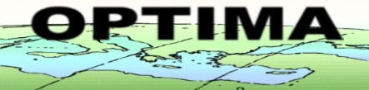

INCO-CT-2004-509091

OPTIMA

Optimisation for Sustainable Water Resources Management

Instrument type: Specific targeted research or innovation project

Priority name: SP1-10

Publishable final Activity Report

Period covered: from 07/01/2004 to 06/30/2007 Date of preparation: 10/08/2007

Start date of project: 07/01/2004 Duration: 36 months

1. Project execution

Project objectives

The overall aim of OPTIMA was to develop, implement, test, critically evaluate, and exploit an innovative, scientifically rigorous yet practical approach to integrated water resources management intended to increase efficiencies and to reconcile conflicting demands. Based on the European Water Framework Directive (2000/60/EC) and the concepts of the Dublin Statement, the approach equally considers economic efficiency, environmental compatibility, and social equity as the pillars of sustainable development. The integration of complete economic assessment for both monetary and non-monetary components summarized as elements of a cost-benefit approach has facilitated communication with stakeholders in terms of monetary units and concepts.

Water is a key resource in the Mediterranean region, and efficient use and allocation are paramount to sustainable development, in particular in the coastal zone of the South and East, undergoing fast economic development, land use and demographic change. Consequently, the project has addressed both the importance if not dominance of the socio-political and economic aspects, but also the importance of a reliable, consistent, and shared information basis for the policy and decision making process. Empowerment through scientifically based but policy relevant information is a key concept (AG 21, Chapter 40, Water Framework Directive 2000/60/EC, Dublin Statement), and was supported by a participatory, open and easily access yet scientific rigorous approach to integrated water resources management. The methodology developed in OPTIMA has successfully extended and applied multi-criteria optimization and mathematical programming methodology into an interactive, participatory and web-based approach by:
- Developing the objectives, criteria and constraints in close cooperation with stakeholders and actors in an interactive approach, including monetary and non-monetary valuation, with emphasis to socio-economic structures and gender where feasible and scientifically meaningful;
- Using a full-featured dynamic and distributed simulation model and genetic programming concepts as the core to generate feasible and non-dominated alternatives in a “satisficing” approach. Water technology alternatives including their cost structure, and up-to-date remote-sensing derived land use information were primary data inputs;
- Extending the set of objectives, criteria and constraints through expert systems technology to include difficult to quantify environmental and social dimensions, including a range of valuation methods such as CVM;
- Putting specific emphasis on local acceptance and implementation through the inclusion of stake-holders at all phases in an interactive, participatory decision making process carefully embedded in institutional structures, using an easy to understand discrete multi-criteria reference point methodology. The formal approach provides a rational basis for policy and decision making, empowerment and legitimacy through information;
- Comparative evaluation and benchmarking across the set of local and regional case studies in 7 countries, namely Cyprus, Turkey, Lebanon, Jordan, Palestine, Tunisia, and Morocco around the Southern and Eastern Mediterranean.
- Demonstrating the benefits of quantitative analysis and the optimization methodology by calculating possible but realistic improvements for each basin also in monetary terms.
The project has also built a wide dissemination network of expertise and knowledge, including more than 300 stakeholder institutions, to exchange and share its findings, generic data, and best practice examples, as well as the tools implemented as on-line operational demonstrations.

Details of the project objectives and the technical and scientific objectives are summarized on
http://www.ess.co.at/OPTIMA/objectives.html.

Contractors involved
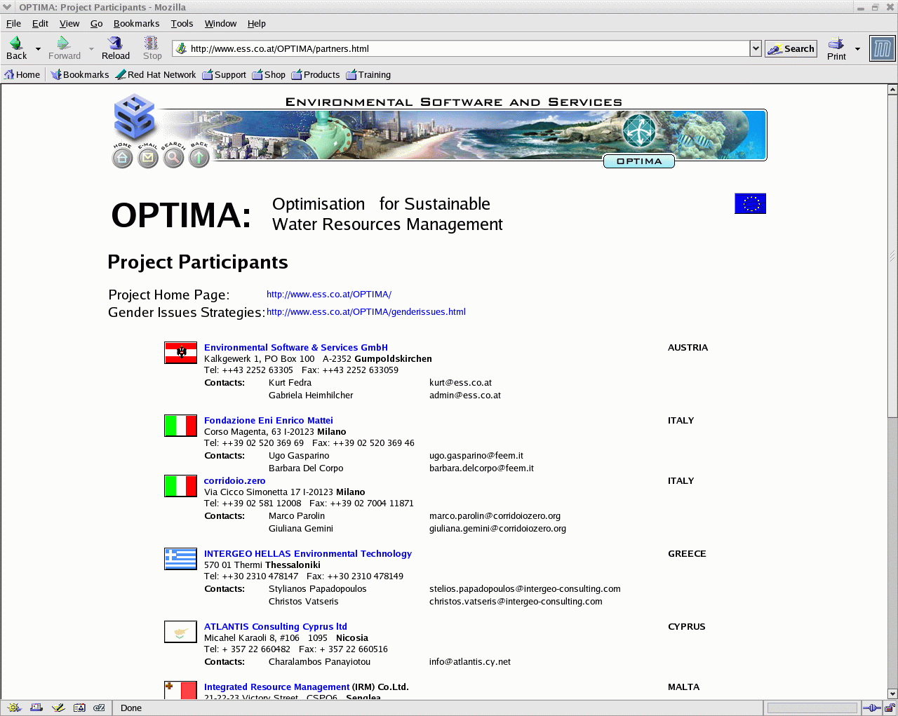
The project brought together 13 partners from 11 countries, and has included case studies in 7 countries, namely Cyprus, Turkey, Lebanon, Jordan, Palestine, Tunisia and Morocco around the Southern and Eastern Mediterranean. Details of the project consortium can be found on the project web server at http://www.ess.co.at/OPTIMA/partners.html.

- Fondazione Eni Enrico Mattei, Italy
- Environmental Software & Services GmbH, Austria
- corridoio.zero, Italy
- INTERGEO HELLAS Environmental Technology, Greece
- ATLANTIS Consulting Cyprus ltd, Cyprus
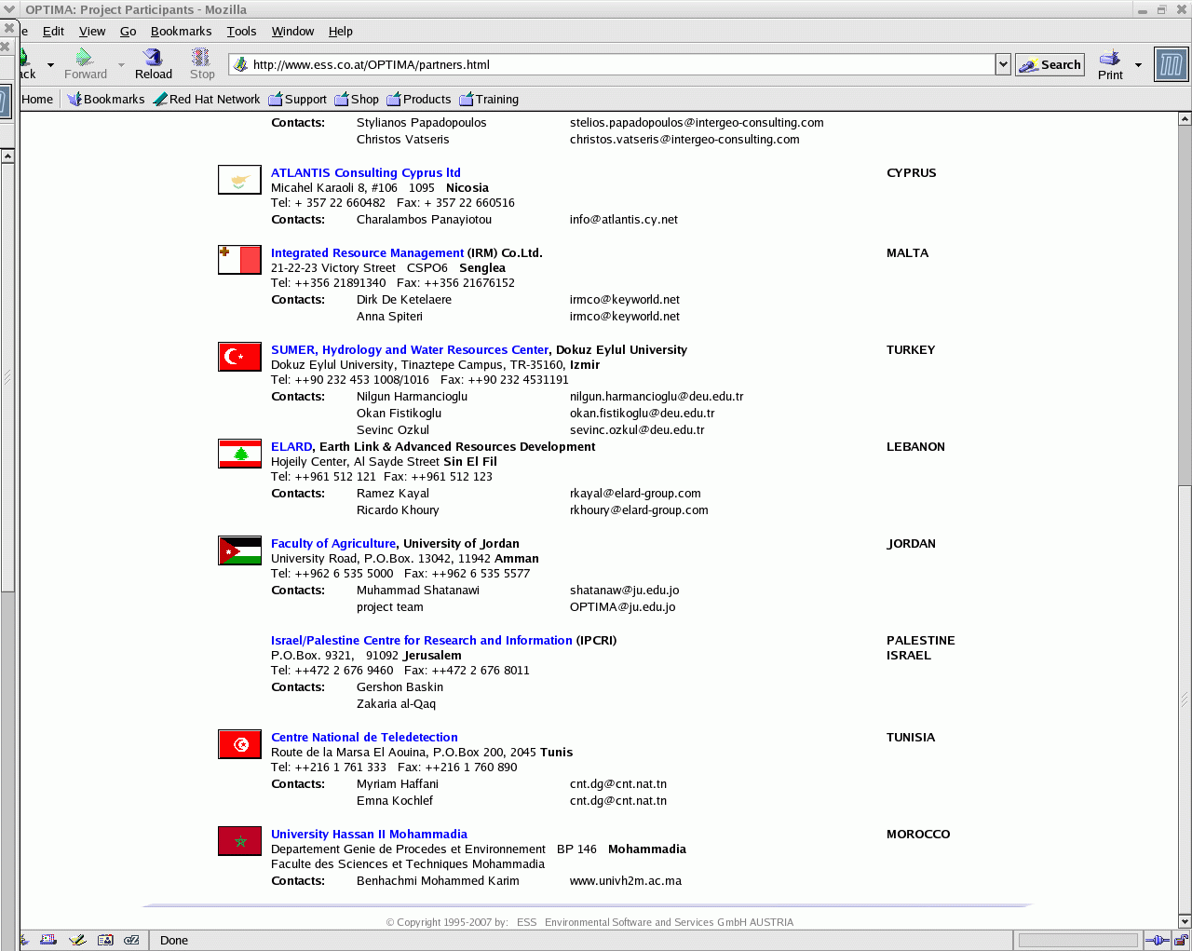
- Integrated Resource Management (IRM) Co.Ltd., Malta
- SUMER, Hydrology and Water Resources Center, Dokuz Eylul University, Turkey
- ELARD, Earth Link & Advanced Resources Development, Lebanon
- NCRS, National Centre for Remote Sensing, Lebanon
- Faculty of Agriculture, University of Jordan, Jordan
- Israel/Palestine Centre for Research and Information (IPCRI), Palestine/Israel
- Centre National de Teledetection, Tunisia
- University Hassan II Mohammadia, Morocco

Work performed
The work plan of the project was structured in four main phases and their associated milestones.
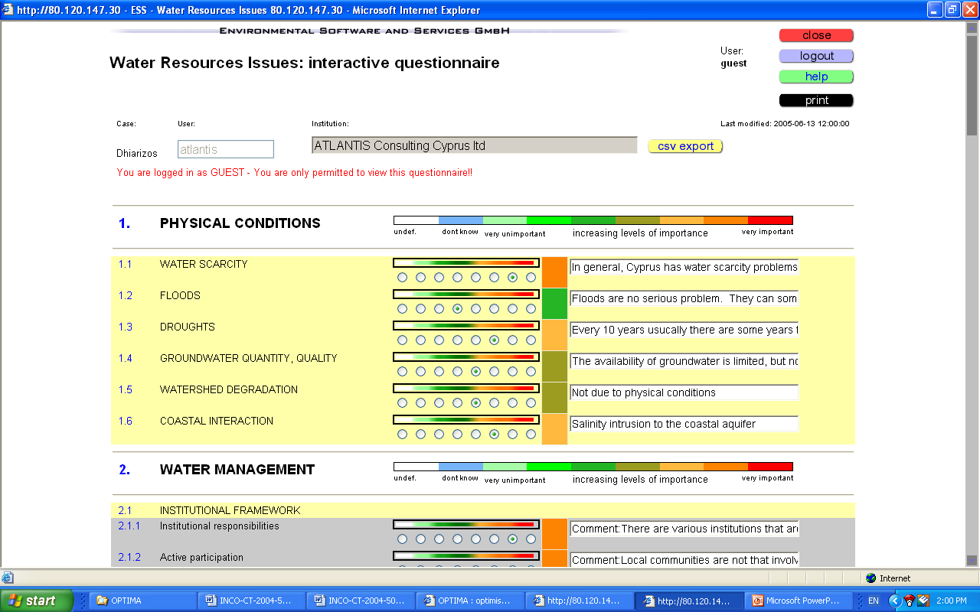
The first, initial phase was dedicated to the analysis of detailed requirements and constraints, the structure of the decision making processes in the case study regions, identification of major actors, analysis of data availability versus data requirements, and the resulting detailed specifications for the basic water resources simulation model. The different physiographical as well as socio-economic and institutional setting of the individual case studies planned has provided a rich set of examples for a truly generic approach across seven parallel Mediterranean case studies covering an accession country, an associated country, and five Mediterranean partner countries for a rich comparative analysis (see also: http://www.ess.co.at/OPTIMA/cases.html). An important aspect for the active involvement of stakeholders at an early phase was the use of on-line questionnaires on water issues as perceived in the individual case studies. More than 120 such questionnaires were collected and are available on-line.

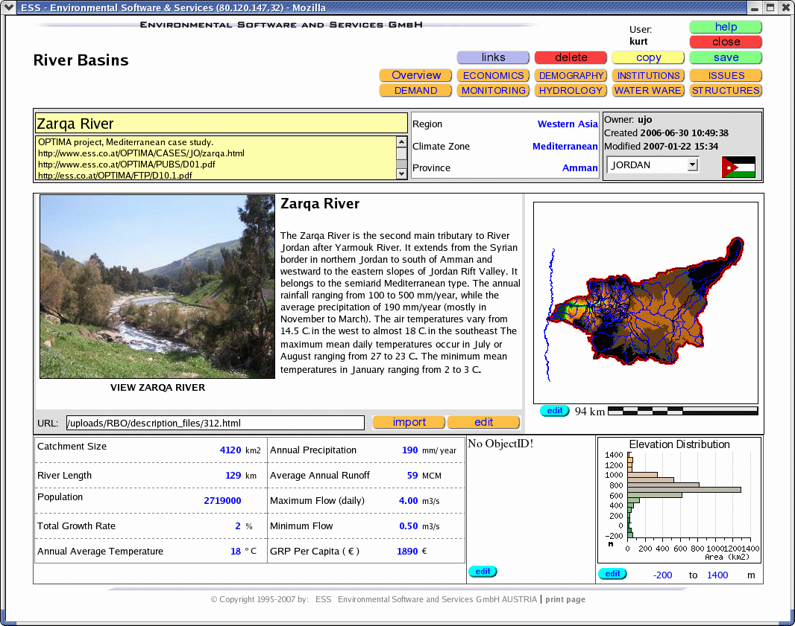
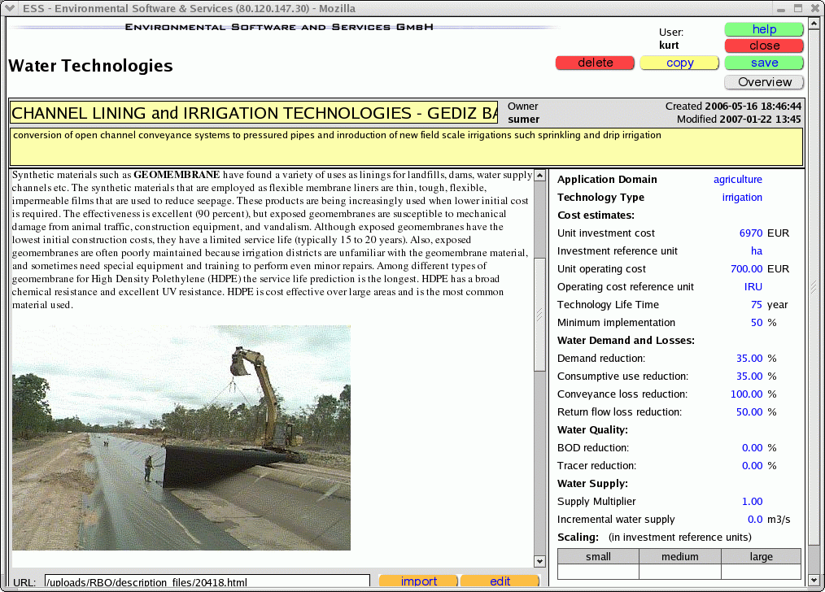
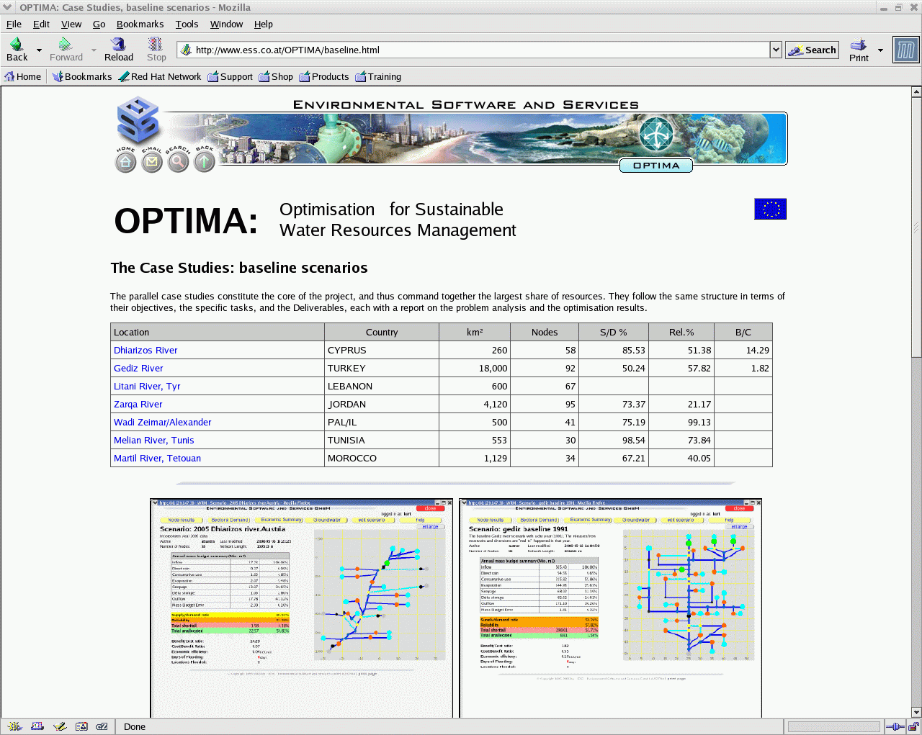
The second phase has concentrated, in parallel, on data compilation and tool development. Based on the specifications evolving from the overlapping first phase, the basic tools (simulation, optimization, assessment) to be used have been adjusted and adapted for the individual case studies. A main element here was the integration of quantitative methods based on simulation modeling and qualitative assessment in the socio-economic domain for a broad multi-criteria approach. Data compilation has also included, as a central task across all case studies, the building of a regional data base of water technologies and associated cost functions (investment, OMR, social costs) as the basis for the optimization, but also as a valuable information resource in its own right. A general important objective will be to achieve enough methodological flexibility to meet the constraints expected in different settings, including the possibility to use generic and default data as a first approximation where necessary. The project will utilise and exploit existing results and ongoing research wherever possible, exploiting the rich set of data from past and present Euro-Mediterranean S&T Cooperation (e.g., from previous INCO-DC and INCO-MED projects). As a specific example, aims to share data for the case studies with SMART (ICA3-CT-2002-10006), which deals with integrated coastal zone management and the management of scarce resources.
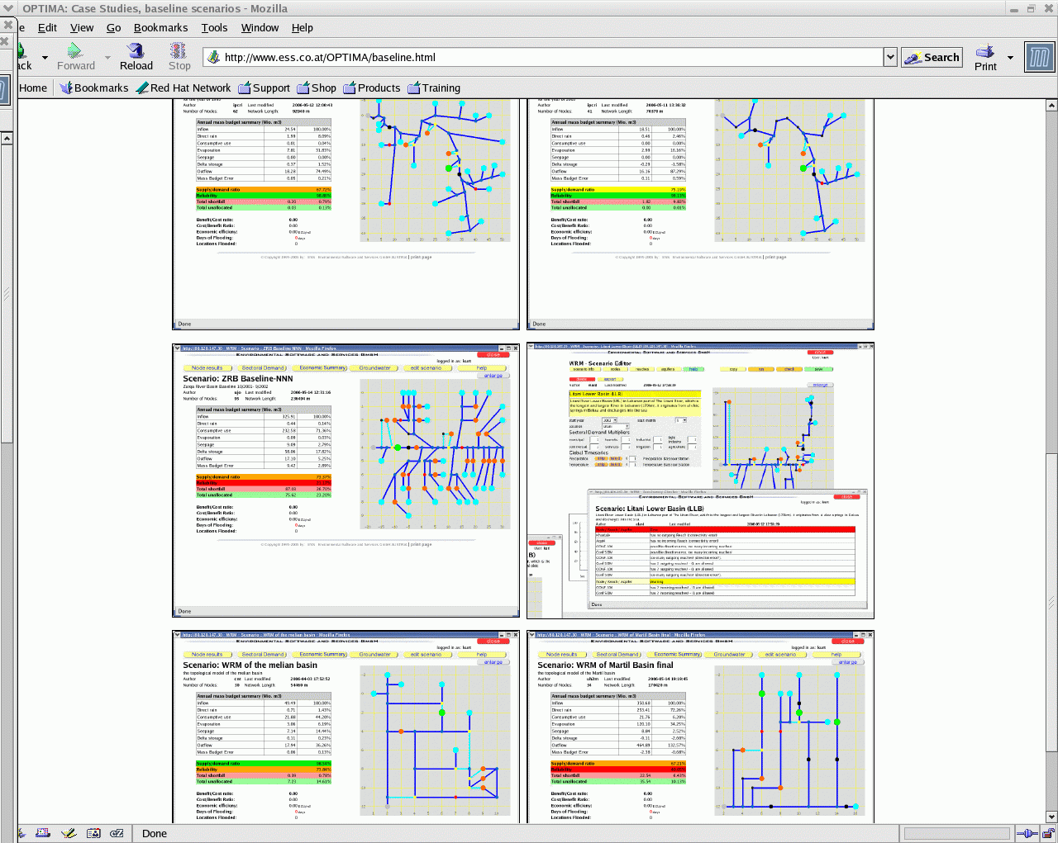
The third and central phase has concentrated on the individual case studies; the emphasis here was on the parallel use and comparative evaluation of the common methodology and tools for a range of regional or local studies with different structural details within the common objective. Parallel with the modeling and optimization tasks, the setup for the intended participatory approach and actor involvement will be prepared and tested. Direct comparability of optimal water management strategies designed and selected with the optimization tools in the individual case studies was supported through the use of a common framework of indicators. Running the case studies in parallel and synchronized as much as possible, as well as the continuous involvement of stakeholders, has guarantee the full exploitation of different experiences in the case studies, leading to more general conclusions but also an effective work style through shared experience with common tools and objectives, leading to the regional dissemination tasks. The case studies problem analyses are described in the corresponding Deliverables, D1.1 to D13.1 (http://www.ess.co.at/OPTIMA/deliverables.htm ).
The fourth and final phase has concentrated on comparative evaluation and dissemination. Technically, this as supported by a discrete multi-criteria DSS tool for the identification of compromise solutions from a set of feasible, non-dominated alternatives. Generalization of the lessons learned, and the dissemination of project results to as wide as possible an audience using a broad range of communication methods prominently including the Internet and project web server were the central activities. On-line reports have supported numerous stakeholder workshops and the final regional dissemination workshop on Malta. The optimization results for each of the case studies are described in D7.2 to D13.2, their comparative evaluation and a best practice report in D15.1 and D15.2, again on-line at http://www.ess.co.at/OPTIMA/deliverables.html.

Methodology and approach
OPTIMA has developed and tested an innovative, multi-step and iterative approach to optimization that extends classical approaches by:
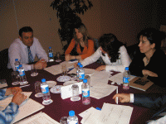
- Direct and repeated involvement of stakeholders throughout the project (see also: http://www.ess.co.at/OPTIMA/stakeholders.html
- Deriving preference structures, issues, criteria, objectives and constraints in an interactive process with active participation with stakeholders and major actors. Wherever feasible, the concepts and questions will be gender specific for a broader social perspective;
- Basing the first step of optimization on the full detail and resolution of a dynamic water resources simulation model embedded in a hybrid genetic programming framework, made possible by the exploitation of more and more powerful yet affordable computer hardware;
- Extending the set of dimensions considered in the optimization by socio-economic and environmental objectives, criteria and constraints into a comprehensive multi-criteria representation;
- By adding a second, participatory and interactive phase that defines the trade-offs to select an optimal solution from the set of feasible, non-dominated alternatives generated in the first step by a discrete, multi-criteria reference point methodology, that facilitates finding trade-offs and compromise solutions and thus defining the concept of optimality for broad acceptance.

Impacts
OPTIMA has involved more than 300 stakeholder institutions across the case study countries and beyond. Several stakeholder workshops have involved more than 300 participants, among them more than to 30% females, see also: http://www.ess.co.at/OPTIMA/genderissues.html
From a technical and water management point of view, OPTIMA has not only demonstrated the possibility to use advanced and detailed quantitative tools within a participatory framework, but could also demonstrate the efficiency of the approach. Potential net (monetized) benefits of the optimized scenarios compared to the baseline runs amounted to several million Euro in most cases on an annual basis, while both demand/supply and reliability of supply as well as the sustainability of solutions could be significantly improved in all cases.

Logo and website

A detailed description of the OPTIMA project, the consortium, all on-line data bases, case study descriptions, data including monitoring data and GIS maps layers, public Deliverables and reports, as well as the on-line model tools that can be explored interactively with an open guest account are publicly available at
http://www.ess.co.at/OPTIMA

2. Dissemination and use
For a compilation of Publishable results and the Final plan for using and disseminating the knowledge, please refer to the Appendix:
INCO-CT-2004-509091_final_dissemination_plan_vs1.doc

