Genomics and Biotechnology for Health – Alternative Testing Strategies
Updated project information sheet – list of headings

1. Project data
Title of project: Innovative ‘cell on chip’ technology to screen chemicals for toxicity, using cultured cells within tiny ‘nanodrops’ of culture fluid

Acronym: TOXDROP

Contract number: FP6- 513698

Project type (ie, Integrated Project, Network of Excellence, STREP or SSA): STREP

EC contribution in euro: 1 615 887.89 €

Starting date (Please use format: 9 May 1950): 1 January 2005

Duration (months): 24 months

2. Project description and results

Background and objectives:

TOXDROP project has the ambition to answer this question: Is it possible to create cheap, rapid and unambiguous toxicological assay screening respecting the Good Cell Culture Practice (ref: Hartung et al (2002) ATLA 30, 407)?
Traditionally, in vitro toxicology assays are performed in Petri dishes or microtiter plates with over 10,000 cells per well. This amount of cells is inadequate if each cell must be wholly phenotyped. To streamline the manipulation of microtiter plates, and reduce the number of cells per assay, we suggest the use of ‘DropChip’ alternative method, where cells are cultured in nano-droplets on a microscope glass slide. Using this method, we expect to undertake multiparametric assays and greatly increase the accuracy in measuring the cell response to toxic addition.
TOXDROP 2 years’ project has allowed successful in vitro toxicological studies using nanodrop cultures, and has placed this innovative concept in the context of the development of “cell on chip” devices.

Approach and methodology:

The drops are maintained on a defined position throughout the experiments using a hydrophilic/hydrophobic interface which enables stabilization and individualization of the drops for high-throughput capabilities. The culture conditions on chip were set so as to obtain approximately 100 cells at fixation time (day4) in the non-exposed cultures, enough to provide statistical analysis significance while avoiding growth inhibition and stress due to excessive cell density. In order to develop a proactive strategy and record the toxicology of various chemicals using Cell on Chip, we have used this reduced number of 100 cells per drop assay and realized high level of cell behavior characterization. Using the metallic mesh embedded in the chip for precise positioning, we performed automated smart capture using IMSTAR´s (partner 5) Pathfinder™ system. The Pathfinder™ imaging platform enables a fully automated capture of the whole chip with intelligent image-data management (IDB, patent n° 01921459.2) for each spot at 0.6µm resolution compatible with multispectral fluorescence single cell detection and multiparametric cellular characterization. Its multiplex capability makes the platform a good tool for complex phenotyping in large scale toxicology.
After image capture, all cells within each spot were automatically segmented thanks to detection protocols integrated in Pathfinder™ system. A set of 3 “proof of concept” compounds was selected: Sodium arsenate (NaAsO2), Cadmium chloride (CdCl2) and Paraquat (Lemaire et al., PLoS 2007). It should be noted that less than 3 micro moles in total of each compound needed be handled by the manipulator on the arrayer platform. We have also set up culture conditions and protocols for cell viability and differentiation of hepatotoxicity for a new human hepatoma cell line HepaRG in drop culture. A new specific fluorescent oxidative stress assay based on EGFP reporter gene induction was engineered in HepaRG cells under the control of the hsp22 promoter; it allows a selective induction of the construct restricted to differentiated hepatocyte colonies and to oxidative stress, especially heavy metal related.

Expected outcome (especially for new or early-stage projects):

Main findings (Significant results, breakthroughs, conclusions if appropriate):

TOXDROP aims at providing an original approach for automated High-Throughput High-Content Screening in toxicity assays using a revolutionary format of cellular nanodrops formed on a glass slide.

Two individual approaches were tested in order to facilitate toxicity analysis within these cellular nanodrops: On the one hand fluorescence microscopy was used to identify fluorescent proteins (fluorimetric assay). On the other hand two- and three-dimensional mass spectrometric analysis of cells was performed (ToF-SIMS analysis). New software tools were developed for the analysis of the images provided by both approaches.

NanoDrops are realised through conventional piezo dispensing or using a a microfluidic device (CellJet) developed through collaboration between partners 1 and 4 (CEA and EPFL). This device is based on impedance detection of cells within the chip and allows ejection of one cell per drop to obtain 100 cells-containing drop-assays. Additionally, specific substrates for the NanoDrops have been engineered.

A fluorometric cell based assays for global toxicity monitoring using the “stress promoter technology” has been developed. For that purpose, several cell lines have been generated by partner 3 (UCBL), chosen as models of organs particularly sensitive to toxic chemicals, such as liver cells (HepG2), lung bronchial epithelium cells (16HBE), keratynocytes (HaCat) and differentiated hepatocytes (HepaRG, in collaboration with partner 2, Inserm), which could express Enhanced Green Fluorescent Protein (EGFP) upon induction of heat shock family stress promoters . Such engineered cell lines are able to respond to the presence of a chemical stress by increasing the expression of the fluorescent reporter protein EGFP (Figure 1).
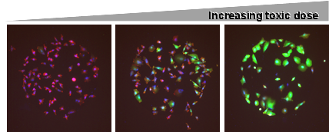

Figure 1: EGFP reporter gene expression is induced in the presence of increasing concentration of toxic chemicals. The Hsp induction is monitored by the green EGFP signal, cell nucleus is stained in blue by Hoechst and actin cell cytoplasm is stained in red by Phalloïdin.

One key development of the “stress promoter technology” is the development of Hepatocytes HepaRG cells. This cell type displays active biotransformation capacities and was transfected by a specific vector by partner 3 (UCBL) and partner 2 (Inserm). Selection of individual clones has been performed 3 days after transfection and 4 days after DMSO treatment. It allows a selective induction of the construct by oxidative stress particularly that relates to heavy metals, restricted to differentiated hepatocyte colonies.

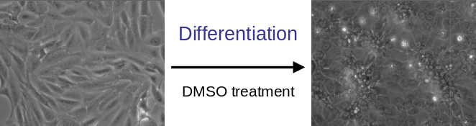

Figure 2: HepaRG. Differentiation appears after 4 days of DMSO treatment.

In order to perform the fluorimetric assay, the engineered cell lines have been provided to Partner 1 CEA in order to set up dispensing conditions, and to allow their culture on Cell on Chip devices. The high level of proliferation allowed us to obtain sufficient cell density to test several chemical stress conditions. A ‘Cell-on-Chip’ device was used to analyse 400 independent nanodrops. Each nanodrop contains 100 individual engineered HepG2 cells and was spiked with an individual species and concentration of a toxic substance. The results obtained show an increasing fluorescence signal upon increasing concentration of the toxic substance (figure 3; published in PLoS).

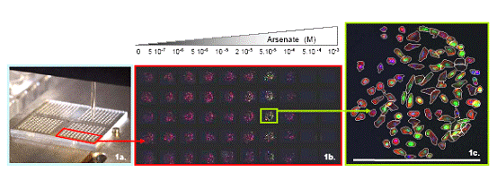
2a
2b
2c

Figure 3: Multiplexed toxicity assay in drops. 2a. Cell dispensing with sciFlexarrayer robot arrayer. 2b. Zoom on the assembled mosaic of images corresponding to HepG2 hsp22-EGFP clone after 6h exposure to ten doses of arsenate in quintuplicate measurements (columns); the Hsp induction is monitored by the green EGFP signal, cell nucleus is stained in blue by Hoechst and cell cytoplasm is stained in red by Phalloïdin. 2c. Heterogeneity in cell response is illustrated by an example of Hsp response to 5.10⁻⁵M arsenate exposure. Scale bar represents 500 μm. Fully automated image capture with a 10× objective and dedicated image analysis were performed using the same detection protocols by IMSTAR Pathfinder™ Cellscan system.

The mass spectrometric assay was performed by ToF-SIMS (Time-of-Flight Secondary Ion Mass Spectrometry). This technology, provided by partner 6 (Tascon), enables the characterization of samples according to the chemical composition of individual cells and cellular compartments either in a two- or in a three-dimensional way. It results in high-resolution images reflecting the distribution of low mass chemical components like e.g. amino-acids on the surface or a z-layer of the cell sample. Using Time-of-Flight Secondary Ion Mass Spectrometry (ToF-SIMS) it was possible to detect the three-dimensional distribution of molecules from both the cell membrane and the cell nucleus without any labelling (submitted to Angew. Chemie Int. Ed.). In addition, a xenobiotic fluorophor could be detected by fluorescence microscopy as well as by ToF-SIMS imaging, thus validating the technique (figure 4, submitted to J. Mass Spec).

Cellular analysis and multiplex phenotypic characterization was performed using IMSTAR (partner 5) Pathfinder™ leading technologies for HCS analysis. Using this patented technology an automated and quick detection of cell borders as well as fluorimetric response of cells was possible. Thus, the enormous amount of data obtained by both, the fluorimetric as well as the mass spectrometric approach developed within the Toxdrop project could be evaluated. Given the large amount of information to process, a shared database was initiated to facilitate data storage and implementation of statistical tools.
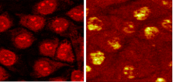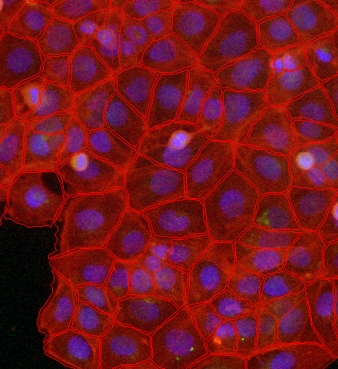

Figure 4: ToF-SIMS assay and application of Pathfinder™ technology: Detection of a fluorophor on an identical sample position by fluorescence microscopy (left) and ToF-SIMS Imaging (middle). Cell border detection by IMSTAR Pathfinder™ technology on a fluorimetric assay nanodrop (right).

Pathfinder™ technology created a bridge between these two approaches in order to finally provide a comprehensive platform integrating all characterization data with a full compatibility and transparency for the user, although the physical nature of image fluorimetry and mass spectrometry is very different. It is to highlight that IMSTAR developed an integration software to make Pathfinder™ technology to be able of reading Tascon mass spectrometry data and to organize them within Pathfinder™ database.

In summary, TOXDROP project demonstrated its ability to integrate a number of new analysis tools, which may be of important added value for an evolving commercial platform.

The partners have benefit from counselling provided by ECVAM (partner 8).

3. Major publications (Please list up to 5-7 of the most significant publications resulting from the project, mentioning author names and article title in citation. Patents may also be mentioned.)
- Mandon et al. BBRC 2005 335(2):536-44, Chemical stress sensitive luminescent human cells:molecular biology approach using inducible Drosophila melanogaster hsp22 promoter
- Mandon et al. , Dithiocarbamate fungicide thiram detection: comparison of bioluminescent and fluorescent whole-cell bioassays based on hsp22 stress promoter induction.Mnadon et al. J Biotechnol. 2006 Jul 13;124(2):392-402. 2006
- Lemaire et al. PLOS 2007 High Content Toxicity Assays in Nanodrops Reveals Individual Cell Behavior
- Advanced semiconductor technologies for above THZ high-frequency, broadband amplifiers, Scientific American 12/2005, pp.1-10
- Transdifferentiation of hepatocyte-like cells from the HepaRG cell line through bipotent , Hepatology, 2007-01-26
- Patent: A new HepaRG cell line carrying a marker of hepatic oxidative stress French and english

4. Partners and contact
Project website address (if applicable): www.toxdrop.vitamib.com

Coordinator of project (Name, institution, address, e-mail) Béatrice Schaack; laboratoire Biopuces, CEA, bat 40-20, 38054 Grenoble, cedex 9; CEA; beatrice.schaack@cea.fr

Scientific coordinator (Name, institution, address, e-mail), if different to above.

Partners (Name of scientist, institution, town, country)
Code | institutions | Names  Email addresses | Town,  Country
CO01 | CEA | B Schaack | Grenoble, France
P02 | INSERM | C Guillouzo  christiane.guillouzo@univ-rennes1.fr | Rennes, France
P03 | UCBL - Ezus | A P Arrigo  arrigo@univ-lyon1.fr | Lyon,  France
P04 | EPFL | P Renaud  philippe.renaud@epfl.ch | Lauzanne,  Switzerland
P05 | IMSTAR | F Soussaline  fs@imstarsa.com | Paris,  France
P06 | TASCON GmbH | B Hagenhoff  birgit.hagenhoff@tascon-gmbh.de | Munster,  Germany
P07 | VITAMIB | O de Bardonnèche  odebardonneche@vitamib.com | Meylan,  France
P08 | JRC | S Coecke  sandra.coecke@jrc.it  maurice.whelan@jrc.it | Ispra, Italy

5. Photos, diagrams and project logo. To accompany the text please send us a few good quality photos or diagrams (with captions) illustrating some aspect of the project, and the project logo if you have made one. Please use JPG files (Bmp accepted). EPS files are also welcome. High resolution files: 300 dpi real size. No screen prints, no PPT, no word files. Assignation of rights (copyright).


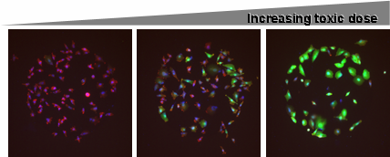

Figure 1: Engineered cell lines able to respond to the presence of increasing concentrations of a chemical stress by increasing the expression of the fluorescent reporter protein EGFP

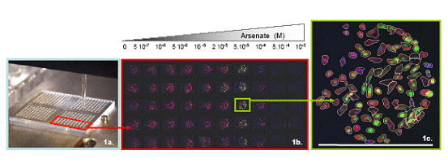
2a
2b
2c

Figure 2: Multiplexed toxicity assay in drops. 2a. Cell dispensing with sciFlexarrayer robot arrayer. 2b. Zoom on the assembled mosaic of images corresponding to HepG2 hsp22-EGFP clone after 6h exposure to ten doses of arsenate in quintuplicate measurements (columns); the Hsp induction is monitored by the green EGFP signal, cell nucleus is stained in blue by Hoechst and cell cytoplasm is stained in red by Phalloïdin. 2c. Heterogeneity in cell response is illustrated by an example of Hsp response to 5.10⁻⁵M arsenate exposure. Scale bar represents 500 μm. Fully automated image capture with a 10× objective and dedicated image analysis were performed using the same detection protocols by IMSTAR Pathfinder™ Cellscan system.

