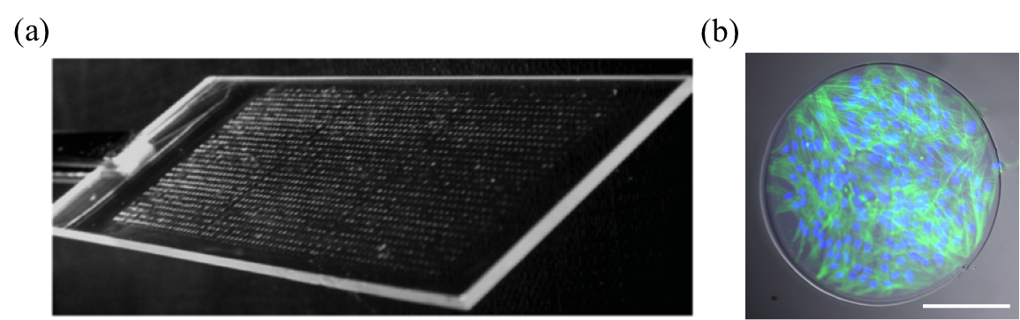

Figure 1. (a) Polymer microarray and (b) a single biomaterial from the microarray with adhered DPSCs. scale bar: 100 μm.

Physicochemical data was acquired and combined with biological data to determine mechanisms of DPSC attachment, proliferation and differentiation in response to the synthetic dental biomaterials. Specifically, quantitative polymerase chain reaction (qPCR) was used to determine genetic changes in DPSCs that had been exposed to different synthetic materials (Figure 2). This revealed that the regenerative polymers provide a supportive niche for DPSC attachment, proliferation and differentiation by maintaining Collagen I expression (Figure 2a). Conversely, commercial dental materials such methacrylates upregulate non-natural collagen genes (Figure 2b and c) and genes associated with cell stress (Figure 2d-f). Furthermore, DPSCs require integrin-β1 to attach to the triacrylates dental biomaterials (data not shown).
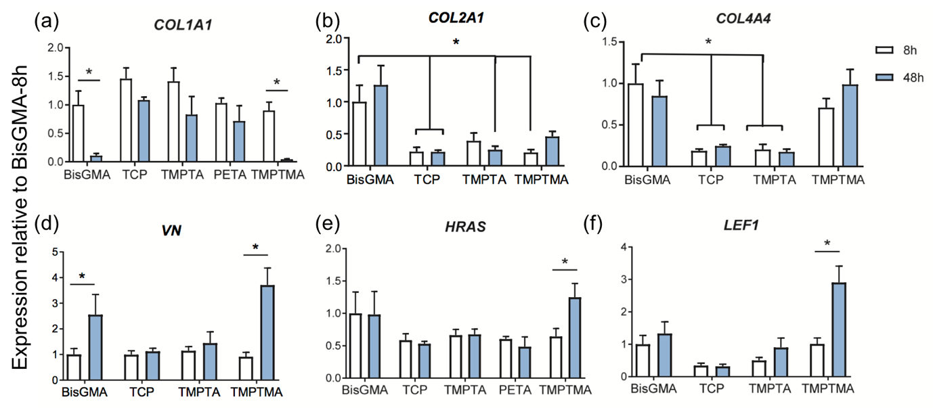

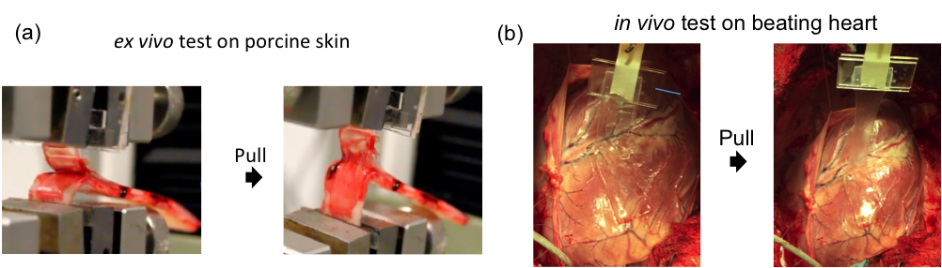
Figure 3. Strong adhesion on wet biological tissues. (a) ex vivo porcine skin and (b) in vivo beating heart.

