Deliverable D6.6.2 Project website
Goal of the eINTERASIA website as a dissemination tool is to facilitate the widest diffusion of the project objectives and to promote the transfer of European research know-how and solutions to the target region. The use of a multimedia online platform will support the dissemination of the project achievements to the relevant stakeholders within the partner target region.

The project website layout is structured into four parts: the header, the page content area, the sidebar and the footer.

Header
Over the header the visitor has access to project-specific public information via a menu bar and is able to browse through the different pages of the website. By selecting the eINTERASIA logo the visitor is always directly reaching the home page of the project website.

Page content area
This area contains all public information of the selected menu item of the header. On the home page of the project website the visitor is conducted to the eINTERASIA project and is linked to the website of the European Seven Framework Programme via FP7 logo. The menu item “Project” is structured into the project overview, its objectives and downloadable content for the public. Under “Partners” the visitor can get short descriptions of each partner, contact information and links to the partner websites via logo click. “News and Events” offer information about past project meetings and upcoming events. Public deliverables, publications and public relation activities can be found under “Results”.

Sidebar
The sidebar contains a search function for specific website content, links to the newest posts of the website as well as a tag cloud and a linkage to the password protected workspace of the project consortium.

Footer
In the footer the visitor can find the imprint and the statement of the data protection policy.

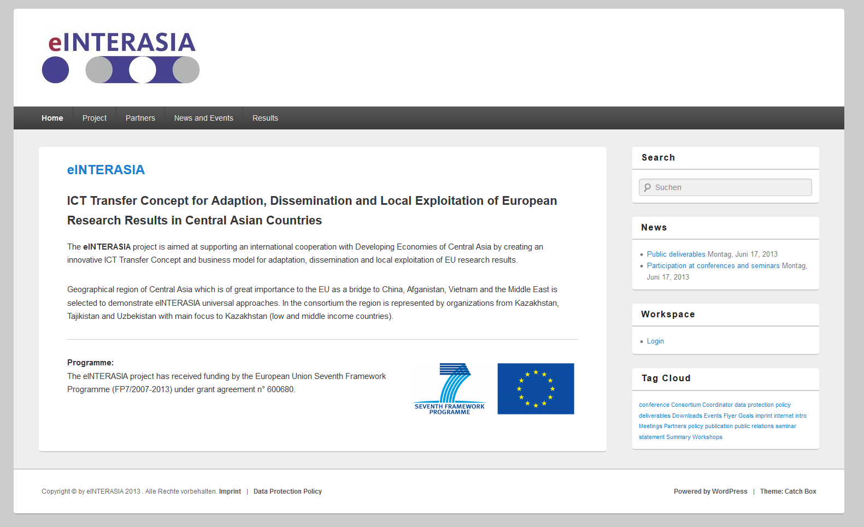
Figure 1: Homepage of the eINTERASIA website

Please find enclosed the URL of the project website: http://www.einterasia.eu

