
EUROPEAN COLLECTED LIBRARY OF ARTISTIC PERFORMANCE
http://www.ECLAP.eu

The richness and value of the European performing arts heritage is unquestionable. Even though these collections are now being digitized and published online, they remain scattered, and coordination is lacking between digital libraries and the performing arts field; however, there is a high demand for access to this content. ECLAP (European Collected Library of Artistic Performance) fills this gap by creating a considerable, and hitherto missing, online archive (with about 1 million of content items: document pages, images, audio, video segments) for all the performing arts in Europe, and providing solutions and tools to help performing arts institutions to enter the digital Europe by building a network of important European performing arts institutions and archives and publishing content collections on Europeana, the European Digital Library. Europeana http://www.europeana.org collects cultural heritage metadata coming from several institutions, universities, foundations, museums, schools of art that represents a cultural heritage of the huge European history. ECLAP is creating a best practice network, making use of advanced database and delivery tools for the production and dissemination of the rich multilingual European heritage. This will result in cultural enrichment and promotion of European culture, and in improvements in learning and research in the field of performing arts. ECLAP is co-funded by the European Union ICT Policy Support Programme as part of the Competitiveness and Innovation Framework Programme, Theme CIP-ICT-PSP.2009.2.2, Grant Agreement N° 250481. All interested institutions and stakeholders are invited to register, and to see the Affiliation Agreement also accessible on the ECLAP portal.

ECLAP Major objectives
- Bring together Europe’s most relevant performing arts institutions (UNIROMA, CTFR, IKP, UVA, BELLONE, ITB, MUZEUM, ESMAE-IPP, OSZMI, BEELD EN GELUID, UG, UCLM) to provide their content on Europeana;
- Make accessible via Europeana a large amount of performing art material: theatre performances, theatre lessons, master classes, theatre teaching material, etc. in the forms of videos, audio, documents, images, and cross media, etc.;
- Create a stable best practice network in order to connect European performing art institutions;
- Provide solutions and services to performing arts institutions to bridge the gap between them and Europeana via published guidelines and ready to be used technical solutions;
- Provide solutions and services to final users (teachers, students, actors, researchers, and performing arts lovers for edutainment, infotainment and entertainment) to access content never before accessible via the Internet and to satisfy their needs;
- Create a virtuous self-sustainable mechanism to provide continuously access to the content and to increase the number of online materials, providing revenues for those institutions that need them, in order to maintain and improve the service, increasing both functionalities and the quantity of materials available.
- Promote the ECLAP services via dissemination. This will be performed by promoting the project services within the major performing arts institutions and by organising open workshops, tutorial training days, conferences and producing dissemination material, video clips, tutorials, booklets, guidelines, etc.
- Contribute to the clustering activities organised by the EC, comparing solutions and integrating them with the Europeana general view.

ECLAP infrastructure and tools
ECLAP is setting up a Best Practice Network and service portal, making use of advanced social network semantic solutions and delivery tools for the aggregation and distribution of rich multilingual performing art content. This will result in cultural enrichment and promotion of European culture, and in improvements in learning and research in the field of performing arts. The activity performed in ECLAP is focussed on setting up an infrastructure (http://www.eclap.eu ) for integrating multi-lingual metadata and content coming from several European Institutions in Europe, and it is open to other partners via the Affiliation. On ECLAP, users can provide and aggregate content files and metadata. Several metadata formats and modalities are supported. A large set of different metadata formats can be ingested. To this end, a metadata mapper tool has been developed, and the mapping goes towards the ECLAP ingestion semantic model. Once the metadata area ingested, an intelligent content processing back office (based on AXCP media grid) is capable of collecting and automatically repurposing content for distribution via pc and mobiles, coping with more than 500 digital file formats.

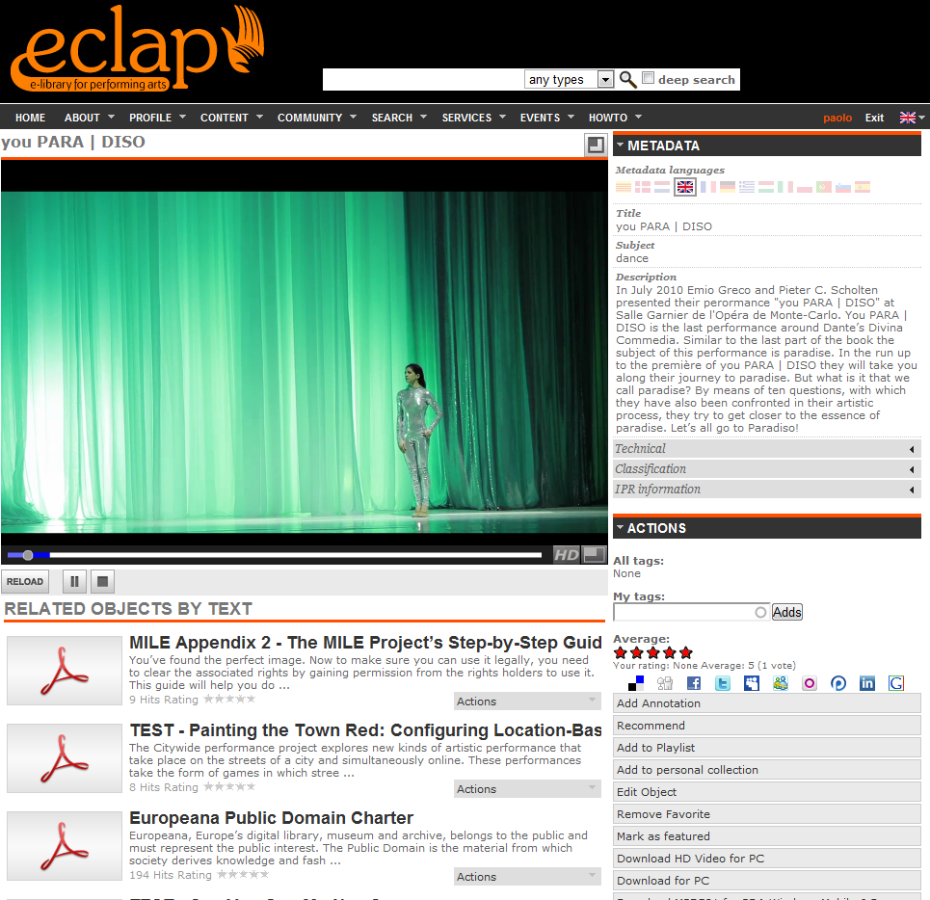

The ECLAP portal is capable of handling a large range of different media kind: video, audio, images, document, slides, crossmedia (e.g., smil, mpeg-21, html, eBooks as epub), animations, pdf, blog, groups, comments, news, playlists, collections, annotations, forum, archive, tools, excel, etc. In the ECLAP, portal it is also possible to create content collections, playlists, aggregation for e-learning and audiovisual annotations via the MyStoryPlayer tool ( http://www.mystoryplayer.org ).
Through ECLAP, users are able to: search, retrieve and play extensive high quality multilingual content via a semantic model with fuzzy support; enrich, validate and contextualize metadata for a large set of content types; aggregate content in play lists, collections and e-learning courses; upload and share multilingual content; receive suggestions and recommendations for similar content, on ECLAP and on Europeana; comment, annotate, tag, rate and vote on content; register and network with others colleagues; create discussion groups and distribution channels; upload digital resources for professional and user generated content; use tools to solve IPR issues with an IPR Wizard, to regulate content access; access all content via different devices such as PCs, tablets and smartphones.

The aim of the ECLAP workflow is to ingest content and metadata in a range of formats and to bring them to reach a high quality level of metadata completion to provide them to Europeana. To this end, collaborative ECLAP tools (for ingestion, metadata enrichment, editing and validation, IPR definition) have been studied and developed. Once the metadata are enriched, ECLAP is providing semantically enriched metadata by mapping them from ECLAP semantic model to Europeana in EDM semantic model via an OAI-PMH ECLAP server.

ECLAP provides to registered users and partners many functionalities and facilities, such as:
- Search, retrieve and play extensive high quality multilingual content;
- Enrich and contextualize, annotate, comment, rate, aggregate content;
- Upload and share multilingual content;
- Register and network with others;
- Create discussion groups and forums;
- Upload digital resources for professional and User Generated Content;
- Use tools to solve IPR issues;
- distribution and access all content via different devices such as PCs, tablets and smartphones.
- publication of metadata to Europeana, to conquer more visibility at your content.
- usage and exploitation of e-learning facilities.
ECLAP best practice networking
ECLAP is creating a set of best practice guidelines covering performing art key areas, such as metadata and content modelling, mapping metadata standards, semantic enrichment, IPR management tools, business models, ingestion and integration of end-user contributions, education and leisure tools, digital libraries tools. To this end, ECLAP work is going to organize international workshops, conferences, via working groups on:
- Intellectual Property and Business Models for performing art Content
- Education and Training tools for performing art
- Tool for performing art Digital Libraries

ECLAP actively participates on clustering and groups identified by the European Commission and Europeana, such as Europeana Project Share. ECLAP placed at the disposal of the Europeana community several solutions and analyses such as: procedures for massive content management, content transcoding, metadata and content processing, semantic computing for social networking, mobile tools, etc.
ECLAP Partners
ECLAP Consortium brings together European leading national performing arts institutions, universities and research institutes. The partners belong to thirteen countries, and combine their expertise and scientific minds to achieve the ECLAP goals see partners' page on the portal:
Content Providers:
- UNIROMA, Centro Teatro Ateneo, University of Rome La Sapienza, Italy
- CTFR, Dario Fo & Franca Rame Archive, Italy
- ITB, Museu de les Arts Escèniques Institut del Teatre de Barcelona, Spain
- UVA, Department of Theatre Studies, University of Amsterdam, The Netherlands
- ESMAE-IPP,Escola Superior de Música e das Artes do Espectáculo do Porto, Portugal
- UCLM,Universidad de Castilla La Mancha,Spain
- FIFF, Festival International de Films de Femmes de Créteil, France
- OSZMI, Hungarian Theatre Institute, Hungary
- TIN, Theatre Institute Nederland, The Netherlands
- BELLONE, La Maison du Spectacle, Belgium
- MUZEUM, Muzeum, Slovenia
- IKP, The Institute of Polish Culture University of Warsaw, Poland
- UCAM, Museum of Archaeology & Anthropology, University of Cambridge, UK
- UG, Department of History of Art at the University of Glasgow, UK
Technology Providers:
- DSI, Department of Systems and Informatics, University of Florence, Italy, Technology provider, technical coordinator and project coordinator
- Beeld en Geluid, (Sound & Vision) ,The Netherlands, content provider and technology provider
- NTUA, National Technical University, of Athens, Greece, Technology provider
- AXMEDIATECH, Axmediatech Srl, Italy, Technology provider
Networking partners:
- FRD, Fondazione Rinascimento Digitale, Italy, dissemination and networking, UG management
Affiliated partners:
- Braille Music, Italy
- Fondazione Fabbrica Europa, Italy

Join the ECLAP community
ECLAP also organises workshops and conferences, to actively fostering networking and strengthening links among the performing arts institutions throughout Europe and at an international level. The ECLAP is developing best practice guidelines. All interested institutions and stakeholders are invited to register, to use and to be an active part of the ECLAP programme and collaboration framework. Any interested institution or company to exploit ECLAP services and tools may get affiliated with ECLAP . For any question or to get more information please contact ECLAP coordinator by sending an email to info@eclap.eu or visiting the ECLAP website at http://www.eclap.eu/ .

ECLAP Main Results of first year
The results produced in the first year of work by ECLAP can be summarized as follow:
- Identification of requirements.
- Set up and management of ECLAP social service portal and tools, covering the 98% of requirements identified, among the major features:
  - Social support: groups, forum, newsletters
  - User profiling and computing
  - Taxonomical classification of content
  - Automated back office for content and metadata processing
  - Multilingual metadata editor and workflow management
  - IPR wizard tools, IPR model definition
  - Draft mobile tools for content access and management
- Setup and management of a user group community on the portal of more than 200 registered users.
- Setup and management of working groups: organizing the first workshops, publication of the registrations and slides of the workshop as content on the ECLAP portal;
- Starting the collection of metadata and content and processing/bringing them accessible on the portal.
- Affiliation of two additional content partners;
- production of dissemination materials: portal, flyers, slides, etc.
- dissemination of ECLAP on indexing engines, mailing lists, social networks, conferences, etc.
- contact of a number of institutions that potentially may be get affiliated with ECLAP;
- Production of papers and publication of some conference papers about ECLAP;
- acceptance of ECLAP demonstrator at DMS 2011 and NEM 2011 international conferences to provide demonstrations.

Expected Final Results
The expected final results of ECLAP project are:
- create best practice guidelines on: theatrical metadata and content modelling, semantic enrichment for performing art content, IPR management for that content, performing art tool for accessing and using digital content for education and entertainment purposes.
- Create and consolidate tools for the gathering, preparation and posting of content and metadata.
- providing to Europeana and promoting performing art content items, collections, of never posted content on Europeana and items never accessible to public via online, and managing the IPR;
- performing networking among the most relevant European performing art institutions, via a set of working groups, workshops, conferences.
- Organising workshops and conferences to make performing art institutions in European and outside aware about the ECLAP activities and huge valuable advantages of having content on European and ECLAP;
- ECLAP Social Services Portal: set up and make it functional a social portal for collecting content, supporting enrichment and contextualisation, repurposing of content according to the requirements of Europeana, posting content on Europeana, etc.;
- Making content accessible and thus distributing content from ECLAP to Europeana Performing art institutions to demonstrate that a central collection can be of large benefit for them for Educational, entertainment and leisure applications.
- Disseminate and promote activities performed in ECLAP and its related benefits for the performing art institutions, including the access to wider collection via Europeana and ECLAP Services.

Expected Impact:
- Higher quantity of quality content available through Europeana regarding performing art institutions. More than 1 million of content items will be posted for example regarding Dario Fo, Sophocles, Terence, Shakespeare, Calderon, Molière, Pirandello, Beckett, Brecht.
- High quality and Content Selection methodology to compare heterogeneous objects from across the EU in a way that is meaningful for the user groups.
- Raising awareness of the value and potential use of Europeana: with a strong push of performing art institutions that presently are not motivated to go on Europeana for the lack of content related to their activity.
- Establishing networking among leading European performing art institutions to define best practice guidelines and examples, to have the critical mass of leveraging and stimulating all the other institutions to post their content on Europeana.
- Define business models and evaluate them in the Education and Leisure markets
- ECLAP is going to offer tested components and documentation of practices to Europeana

Presently
ECLAP with its social service network has published on the web for PC and Mobile more than 35000 files for about 120.000 items (document pages, video, audio, images, cross media, epub, quiz, courses, slides, etc.). 24 active groups are working on ECLAP to prepare and aggregate them to reach about 1 million content items available on ECLAP and accessible via Europeana. Affiliated partners are joining ECLAP.

Project cooordinator name: Paolo Nesi, prof.
University of Florence, UNIFI DSI
Tel: +39-055-4796523, Fax: +39-055-4796363, Email: nesi@dsi.unifi.it, info@eclap.eu
Project web site: http://www.eclap.eu

