Annex – Methodology

The methodology employed for this document involved the merging or contrasting of two very different information sources. On the one hand there was a comprehensive review of different sources of the available literature - ranging from project deliverables to consultancy reports to academic papers to NextMedia reports from other work packages. On the other hand questionnaires were distributed to recognised experts and scientists in the fields of internet and media technologies. Special care was taken to ensure that a significant proportion of these experts represented industry, both in Europe and in USA, Japan and Korea. A total of 26 high level experts took part.

The literature review served as the basis for establishing the framework and content of the questionnaire for the experts (extracting the areas which were presented to the experts as potentially relevant/important), and the comparison between areas was done according to the replies received. The experts thus refined the classification and analysis of the areas and to have a more focused view. The final Roadmap was on the basis of the derived classification and with the literature review as well as the expertise within the NextMedia comsortium.
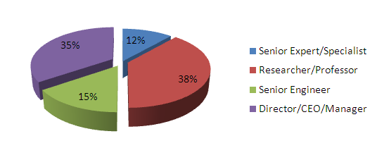
Position of the Experts
The basic purposes of the literature review were of course to get insights into the current and future situation of research in the area of the Future Media Internet but also to ensure that the questionnaires given to the chosen experts asked the right questions.
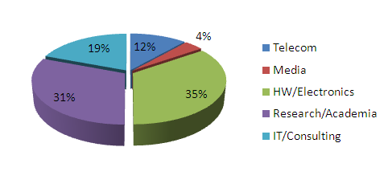
Sector of the Organisations of the Experts
One of the flaws of a standardised questionnaire such as the one used here is that it may not contemplate some possibilities that the experts foresee for the future and thus these possibly unorthodox views are not reflected. To allow for this contingency, once the questionnaires had been filled in by the experts and received back a number of follow up exchanges were carried out.

Finally, a basic statistical analysis of the questionnaires was done including the grouping of responses by region or country and sector (academic or industrial). The results of this analysis were then compared with the results that were obtained from the literature review.
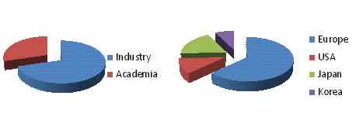
Sector and Country/Region of the Experts

Literature Reviewed
The literature and reports reviewed for the production of this document are of following different types:
- Commercial consultancy reports (Gartner, Forrester, ATOS, Yankee Group) – both publicly available and confidential
- EU publications
- FIA reports
- R&D project deliverables (both public documents and confidential reports when available)
- NEM reports (SRA, Research Challenges)
- FISA standardisation reports
- Academic papers
- NextMedia expert group reports (FCN, Think Tank, Task Force)

Annex – Expert Questionnaire

