Contract no. 224306

**LABONFOIL**

Laboratory Skin Patches and SmartCards based on foils and compatible with a Smartbiophone

INSTRUMENT: Large-scale integrating project (IP)

Publishable Summary 3rd Period

Due Date of Deliverable: NA

Completion Date of Deliverable: NA

Start date of project: 1-5-2008 Duration: 31-4-2012

Responsible partner for deliverable: IKERLAN-IK4 Revision: v1.0

|  |  |  |
| --- | --- | --- |
| Project co-funded by the European Commission within the 7th Framework Programme | | |
| Dissemination Level | | |
| PU | Public |  |
| PP | Restricted to other programme participants (including the Commission Services) |  |
| RE | Restricted to a group specified by the consortium (including Commission Services) |  |
| CO | Confidential, only for members of the consortium (including Commission Services) |  |

**Project coordinator**: IKERLAN-IK4 S. Coop.

**Project partners**:

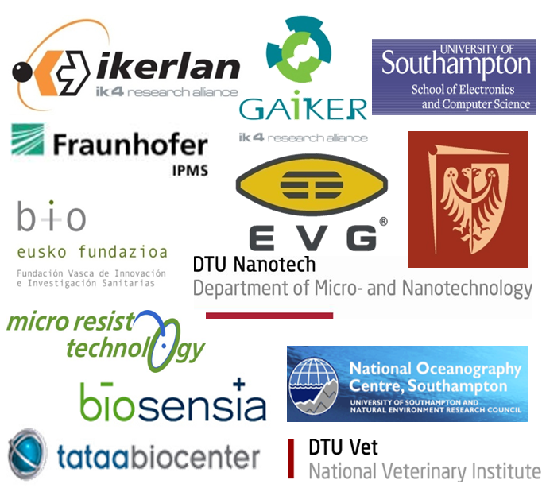

|  |
| --- |
| **Partners** |
| Ikerlan-IK4 S.Coop. |
| Fundación Gaiker |
| University Of Southampton |
| Natural Environment Research Council |
| DTU Nano and DTU Vet |
| BIOEF and Hospital de Cruces |
| Politechnika Wroclawska |
| Fraunhofer IPMS |
| Biosensia Limited |
| Tataa Biocenter Ab |
| E V Group E. Thallner Gmbh |
| Micro Resist Technology Gmbh |

TABLE OF CONTENTS

1. Project Summary 4

2. Results 5

3. Summary 8

4. Future work: Validation and Exploitation 9

5. WEb AND MORE 10

# Project Summary

The objective of the LabOnFoil project is to develop ultra-low-cost laboratories on chips without compromising time response, sensitivity or simplicity of use. The user will obtain the test results using a very popular interface (a smartphone) and a set of Labcards and skin patches, where the sample preparation and detection take place. The project will validate the developed devices in four applications:

* Labcard for marine algae analysis, climate, CO2 sequestration, and toxic blooms.
* Labcard for Salmonella and Campylobacter typing in slaughter houses and farms.
* Labcard for Colorectal Cancer monitoring using blood.
* Skin Patch for cocaine consumption testing of professional drivers.

The future mass production of these novel diagnostic components will be guaranteed by the development of manufacturing equipment. This will provide, in the end, a standardised solution to manufacture truly ultra-low-cost Lab-on-a-chip microsystems. The dramatic costs reduction will be based on the use of large films instead of wafers substrates.

In order to explain the third year achievements, let´s first put in perspective the technical work carried out during the whole project. The first year work focused on the applications definition, design of the devices together with the development of the reactions in tube. The second year main technical actions were: (i) to transfer the tube reactions to one chamber reactors, (ii) to design labcards, skin patch, and readers; and (iii) to verify the design by performing a complete biological assay compatible with the labcard applications and SkinPatch (demos at the review).

Figure 1: Objectives and Plan following ISO9001-2008 Product Design Standard. This validation will consist of 250 labcards (110 labcards for CRC, 70 for Food, 70 for environment ) and 100 SkinPatches for Cocaine test.

# Results

This third year work consisted of: (i) Finalising the verification of the designs by taking and test the prototype in the bio partners labs; (ii) Creating the components of the labcard fabrication tool by EVGroup; (iii) Fabricating the final Labcards using the mentioned tool integrating a successful gelification of reagents by EVGroup; (iv) Fabricating the final SkinPatch design; (v) Fabricating the 3 labcard readers and the SkinPatch reader (see Figure 2); and (vi) Verifying the fabricated devices by a hardware and biological pre-validation plan.

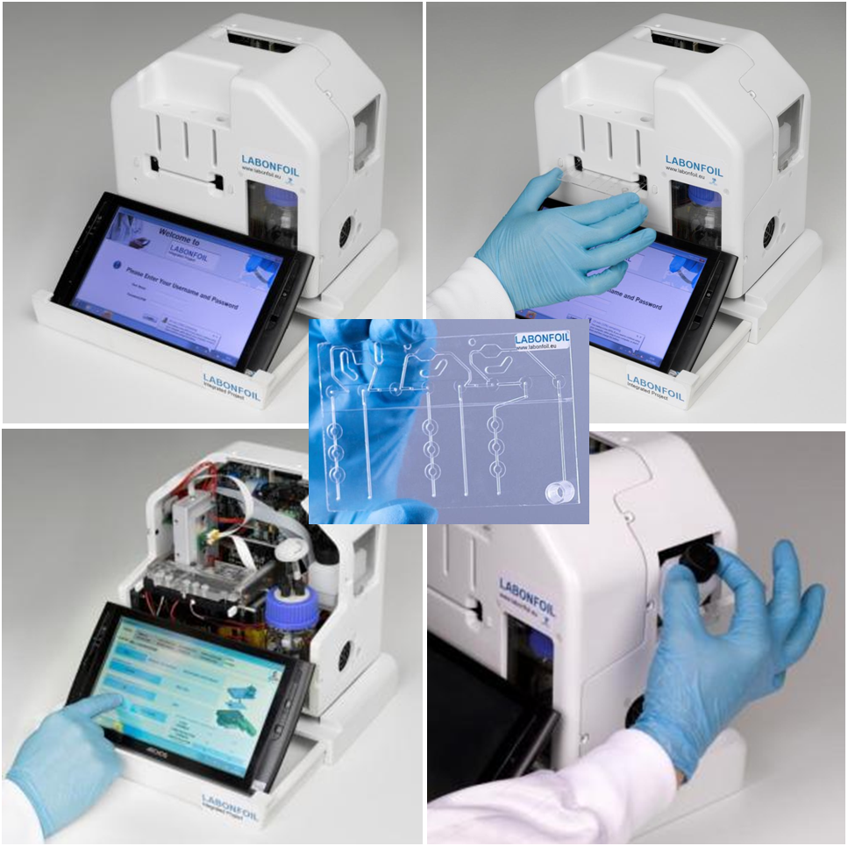

Figure 2. LabCardReader prototype pictures. Ikerlan-IK4 pictures. In the middle it can be seen the picture of the labcard.

In year 3, the SkinPatch group’s activities were strongly focussed on integration, verification and preparation for final validation (see Figure 3). The SkinPatch reached its final generation. Biosensia sourced all raw materials and initiated a pre-manufacture of 40 SkinPatches packages and 500 assay strip.

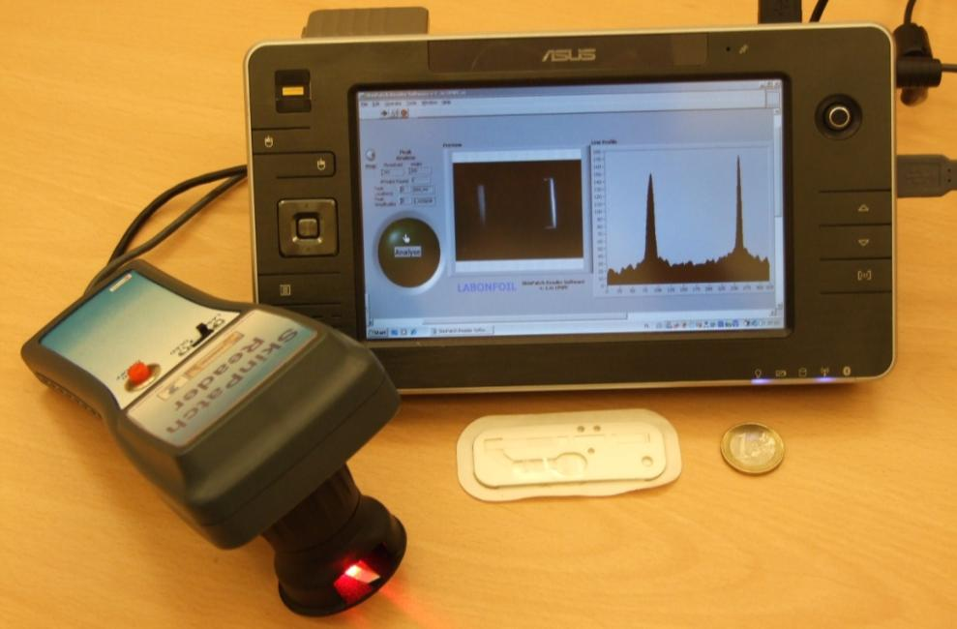

Figure 3. Final generation integrates all key components as outlined in the definition. Biosensia pictures.

The labcard fabrication equipment is over. The conclusions are three fold: (i) we have fabricated the tools needed for the labcard fabrication; (ii) the fabrication including the gelification has been demonstrated in several labcards fabrication at EVG, and (iii) the reagents and labcard have been biologically tested in the three applications not showing inhibition effects.

LabonaChip fabrication for labcard and SkinPatch is finished. These Labcards and SkinPatches have been an important core of the third year since they were thoroughly verified to obtain the expected performance. During the second year we demonstrated the proof of principle of three applications: concentration, washing, elution, transport and amplification with gelified reagents. This third year, we had to verify the Labcard through 3 visits of Ikerlan to the Biological partners places (see Figure 4).

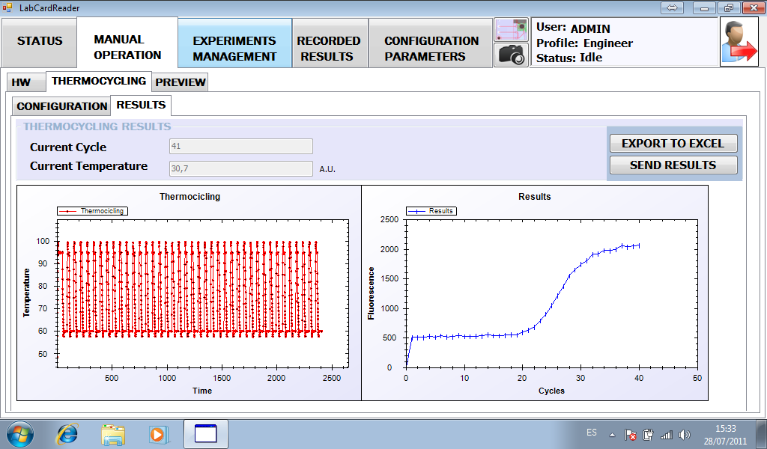

Figure 4. Screen shot of one amplification result carried out with the labcard reader and the experiment management. Ikerlan picture.

In order to reach this level of certainty in such distributed project, many face-to-face experiments and discussion have been needed (see Figure 5). This strategy has demonstrated to be very efficient since it simplifies and speed up the solution of experiment difficulties. This leaves the fourth year as planned for the design and development of the validation of the 4 applications.

Due to the thorough and intense work carried out during the third year, we will start the 4th year with a First stage validation and training carried out at Ikerlan with visits during a 3 weeks period from all bio partners (one week per application). This first stage will make use of a first batch of 10 labcards per application fabricated at EVG (including gelified reagents). This means that apart from the 280 agreed experiments, we will carry out an extra 30 labcard experiments plus 40 more SkinPatches as a part of the validation.

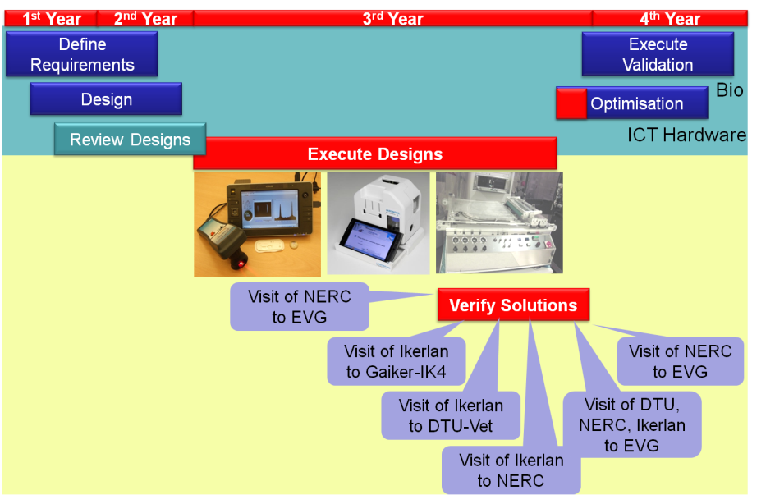

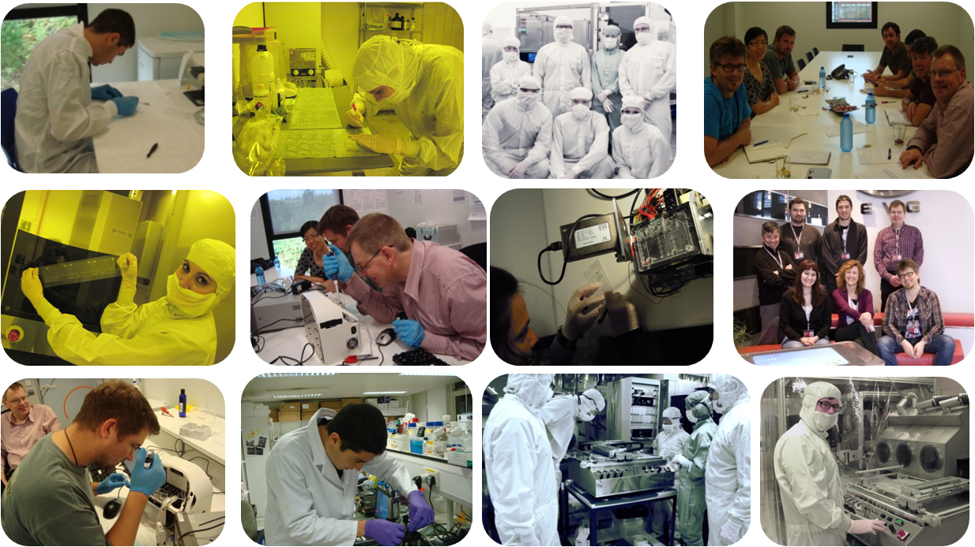

Figure 5. Labonfoil plan with an emphasis in the 3rd year activities. It can be seen that this year demanded a high level of working together face to face. Pictures of Labonfoil researchers during visiting workshops within this third year.

# Summary

* SkinPatches and reader ready for validation. It has been demonstrated:
* System sensitivity below 10ng Cocaine in sweat.
* 80% inhibition at legal cut off concentration.
* In situ analysis in 10 min.
* Three LabCardReaders fabricated, calibrated and functionally validated. Each of them includes:
* User friendly software controlling the platform.
* Robust LabCard interface hardware (heating system, valves, etc.)
* Selectable dual optics (spot or surface measurement).
* Remote operation via a 3G smartphone.
* Automated experiments (sample preparation and detection).
* 1st level validation of the labcard readers carried out:
  + CEA assay performed successfully.
  + Food assay performed successfully.
  + Environmental assay performed successfully.
* The labcard readers will be sent in October to bio partners.
* The 220 labcards will be sent in November.

# Future work: Validation and Exploitation

At this moment of the project, these activities are crucial in order to exploit the results. We have divided the team in two groups: SkinPatch and Labcards exploiters. Our purpose is to demonstrate a good performance during the validation in order to endure the interest of companies. Biosensia, as a company, is going to lead the SkinPatch development to the market. The following figure represents our goal.

Figure 6. Representation of the Labonfoil activities carried out during the last year (fabrication and verification) and the planned work for the last one: Validation.

The Labcard product consists of a preloaded syringe; a labcard with gelified reagents and a reader (see following Figure).

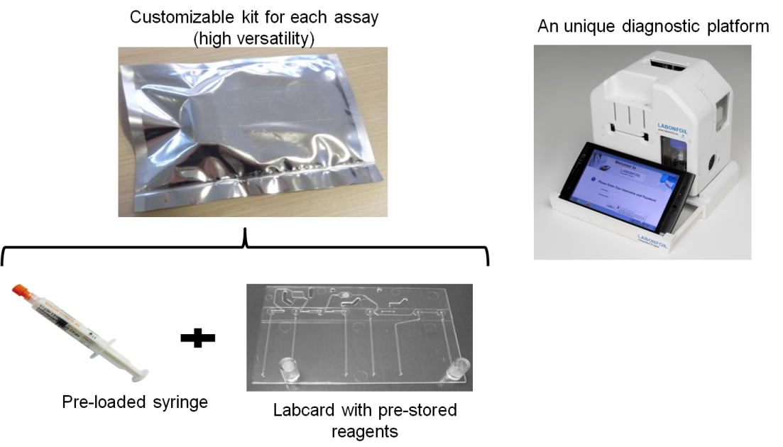

Figure 7. Components of the Labcard product.

In parallel, Ikerlan has promoted a start-up company: POC MicroSolutions. Their main goal is to commercialize the scientific and technological developments in the field of "lab on a chip" (LOC) that has been generated through the various research programs supported by the Basque Government, the European Framework Programs etc., and internal research projects of the Ikerlan Microsystems group. POC MicroSolutions is a company that designs, manufactures and integrates customized platforms for Molecular In Vitro Diagnostics (IVD), with the focus to generate solutions for POC diagnostics (Point of Care).

# WEb AND MORE

Do not hesítate to contact us for further information. Please, come and visit [www.labonfoil.eu](http://www.labonfoil.eu) to see our way to disseminate our project.

Figure 8. Topics and videos mentioned in the media link of the Labonfoil web.