D2.2 - eCall systems functionalities’ specification

|  |  |
| --- | --- |
| Version number: | Version 1.0 Final |
| Main author: | Tomáš Tvrzský |
| Dissemination level: |  |
| Lead contractor: | ERTICO – ITS Europe |
| Due date: |  |
| Delivery date: | 10th November 2011 |
| Delivery date updated document |  |

**Control sheet**

|  |  |  |  |  |
| --- | --- | --- | --- | --- |
| **Version history** | | | | |
| **Version** | **Date** | | **Main author** | **Summary of changes** |
| 0.1 | 22.6.2011 | | Tomáš Tvrzský | Draft of the structure |
| 0.2 | 24.6.2011 | | Tomáš Tvrzský | Draft of the document |
| 0.3 | 4.7.2011 | | Vladimir Velechovsky | Document update (chapter 1 and 3) |
| 0.4. | 15.7.2011 | | Tomáš Tvrzský | Updated part for Germany and Netherlands |
| 0.5 | 31.7.2011 | | Vladimir Velechovsky | Updated part for Czech republic PSAP and MNO |
| 0.6. | 30.8.2011 | | Tomáš Tvrzský | Updated inputs from Italy and Greece |
| 0.9 | 25.9.2011 | | Tomáš Tvrzský | Updated inputs from Italy |
| 1.0 | 3.10.2011 | | Tomáš Tvrzský | Consolidated remarks from review |
|  | **Name** | | | **Date** |
| Prepared | Tomáš Tvrzský | | | 25.9.2011 |
| Reviewed | Stefan Gotte, Vladimír Velechovský | | | 3.10.2011 |
| Reviewed | Andy Rooke | | | 6.10.2011 and 13.10.2011 |
| Authorized | Andy Rooke | | | 10th November 2011 |
| **Circulation** | | | | |
| **Recipient** | | **Date of submission** | | |
| Project partners | | 10th November 2011 | | |
| European Commission | | 10th November 2011 | | |

****Table of contents****

1 Terms and abbreviations 8

1.1 Terms 8

1.2 Abbreviations 11

2 Introduction 14

2.1 Purpose of Document D2.2 functional specification 14

2.2 Structure of Document 15

2.3 HeERO Contractual References 15

3 List of standards 17

4 Functional architecture and specification for each pilot country 18

4.1 Sweden 18

4.1.1 Introduction 18

4.1.2 eCall functions overview 19

4.1.3 PSAP Support of eCall 19

4.1.4 Networks functions 20

4.1.5 In Vehicle System functions 25

4.2 Finland 26

4.2.1 Introduction 26

4.2.2 Specifications of eCall Functionalities 26

4.2.3 eCall test service management 28

4.2.4 Operational cases 30

4.3 Croatia 32

4.3.1 eCall system architecture 32

4.3.2 System functionalities 38

4.3.3 Standard operating procedures in case of traffic incidents in Croatia 45

*4.4* *Germany* 50

4.4.1 Introduction 50

4.4.2 eCall functions overview 50

4.4.3 PSAP Support of eCall 51

4.4.4 Networks functions 54

4.4.5 In Vehicle System functions 55

*4.5* *The Netherlands* 56

4.5.1 Introduction 56

4.5.2 The eCall chain 56

4.5.3 Actors in the eCall chain 57

4.5.4 Explanation of the high-lever architecture 57

4.5.5 Call Information Service 58

4.5.6 Third Party Services 59

4.5.7 High-level eCall Handling Process 59

*4.6* *Czech Republic* 63

4.6.1 General overview 63

4.6.2 Mobile network 63

4.6.3 IVS 66

4.6.4 PSAP 67

*4.7* *Romania* 72

4.7.1 Technical solution overview 72

4.7.2 Basic component of the solution (roles and functions) 80

4.7.3 Description of eCall operating 83

*4.8* *Greece* 86

4.8.1 Introduction 86

4.8.2 PSAP functions 86

4.8.3 Network functions 88

4.8.4 In Vehicle System (IVS) functions 90

*4.9* *Italy* 91

4.9.1 Introduction 91

4.9.2 Italian eCall Pilot functionalities 92

4.9.3 Italian eCall Pilot: on field activities 95

4.9.4 Italian eCall Pilot: specification 96

5 Literature 104

**Figures**

**Figure 1: Structure of deliverables** 14

**Figure 2: End-to-end eCall system extended with conformance test system** 18

**Figure 3: Telenor coverage** 21

**Figure 4: Coverage of TeliaSoneras GSM network in Sweden** 22

**Figure 5: HeERO Finnish pilot system functionalities** 26

**Figure 6: Cross borders tests using the Finnish pilot system eCall sender and receiver parts** 28

**Figure 7: eCall test service management** 30

**Figure 8: eCall Finnish pilot system – functional architecture** 31

**Figure 9: eCall system within the cellular system architecture** 33

**Figure 10: eCall IVS data modem overview** 34

**Figure 11: eCall PSAP data modem overview** 35

**Figure 12: eCall Service chain** 39

**Figure 13: End to end timing proposal** 40

**Figure 14: SOP for traffic incidents on highways** 46

**Figure 15: German Call chain with the main subsystems** 50

**Figure 16: eCall data flow** 51

**Figure 17: German eCall Server system overview** 53

**Figure 18: IVS overview** 55

**Figure 19: German HeERO partners and their parts in the project** 56

**Figure 20: The architecture necessary to handle eCall messages** 56

**Figure 21: High-level eCall Handling Process (Scheme A)** 61

**Figure 22: High-level eCall Handling Process (Scheme B)** 62

**Figure 23: eCall pilot architecture** 63

**Figure 24: Principle of eCall discriminator qualified routing** 65

**Figure 25: In Vehicle System** 66

**Figure 26: The architecture of testing PSAP** 67

**Figure 27: eCall data and voice transmission** 72

**Figure 28: The generic scheme for eCall at subsystems level** 73

**Figure 29: Detailed scheme of the network** 75

**Figure 30: eCall interfaces** 76

**Figure 31: The sequence of eCall messages** 78

**Figure 32: The IVS modem** 81

**Figure 33: The eCall modem** 82

**Figure 34: Tree service operating eCall** 84

**Figure 35: Diagram of upgraded PSAP to support eCall** 86

**Figure 36: eCall handling procedure** 87

**Figure 37: eCall routing** 89

**Figure 38: IVS functional blocks** 91

**Figure 39: eCall Service chain** 93

**Figure 40: bCall Service chain** 94

**Figure 41: Interaction with the RTTI Centre Service chain** 95

**Figure 42: DENSO testing kit** 97

**Figure 43: ACTIA board** 97

**Figure 44: NXP board** 98

**Figure 45: bCall use case** 99

**Figure 46: eCall during bCall use case** 99

**Figure 47: Integration with RTTI Centre** 103

**Tables**

**Table 1: eCall Finnish pilot system functions** 30

**Table 2: eCall chain** 57

**Table 3: Handling the eCall in the 1-1-2 PSAP** 58

**Table 4: TS12 description** 88

**Table 5: Emergency Service Category bits** 89

# Terms and abbreviations

## Terms

|  |  |
| --- | --- |
| **TERM** | **DEFINITION** |
| **112** | single European emergency call number supporting Teleservice 12 (ETSI TS 122 003) |
| **call clear-down** | termination of call and freeing up of line (usually achieved by hanging up the receiver or pressing ‘end call’ or similar on screen) |
| **cellular network** | *wireless communications network* consisting of multiple adjacent access points (cells) with the capability of homogeneous transfer of a communications session instance to an adjacent cell without significant interruption to the session |
| **CSC** | Customer Service Centre |
| **E112** | emergency communications service using the single European emergency call number, 112, which is enhanced with location information of the calling user TS12 |
| **eCall** | emergency call generated either automatically via activation of in-vehicle sensors or manually by the *vehicle occupants*; when activated it provides notification and relevant location information to the most appropriate *Public Safety Answering Point*, by means of *mobile wireless communications networks*, carries a defined standardized *minimum set of data* (MSD) notifying that there has been an incident that requires response from the emergency services, and establishes an audio channel between the occupants of the vehicle and the most appropriate *Public Safety Answering Point* |
| **eCall generator** | occupant of a vehicle or equipment within a vehicle that has cause to trigger an *eCall* transaction by automatic or manual means |
| **eCall discriminator or identifier** | one of two information element bits (flags) included in the emergency call set-up message that may be used by the mobile network to filter and route automatically and manually initiated *eCall* to a designated PSAP |
| **eCall In-band Modem (eIM)** | Modem pair (consisting of transmitters and receivers at IVS and PSAP) that operates full-duplex and allows reliable transmission of eCall Minimum Set of Data from IVS to PSAP via the voice channel of the emergency voice call through cellular and PSTN networks. |
| **eCall service** | end-to-end emergency service to connect occupants of an affected vehicle to the *most appropriate PSAP* via an audio link across a PLMN together with the transfer of a *minimum set of data* to the PSAP |
| **eCall transaction** | establishment of a *mobile wireless communications session* across a *public wireless communications network* and the transmission of a *minimum set of data* from a vehicle to a *public safety answering point* and the establishment of an audio channel between the vehicle and the PSAP |
| **eCall trigger** | signal emanating from within the vehicle to the eCall in-vehicle equipment which requests to start an eCall transaction |
| **eIP** | eCall Implementation Platform |
| **emergency control centre** | unit which deals with emergency calls and which has the capacity to consider professionally the need for response, and which has the provision to mobilize the needed resources to deal with the emergency in question |
| **eSafety** | European Commission-sponsored forum to improve safety for European citizens |
| **in-vehicle equipment** | equipment within the vehicle that provides or has access to in-vehicle *data* required for the *minimum set of data* and any other *data* that is to be sent as part of or complementary to the *minimum set of data* to effect the *eCall transaction* via a *public mobile wireless communications network* providing a link between the vehicle and a means of enacting the *eCall service* via a *public mobile wireless communications network* |
| **in-vehicle system (IVS)** | *in-vehicle equipment* together with the means to trigger, manage and effect the *eCall transaction* |
| **Minimum Set of Data (MSD)** | standardized *data concept* comprising *data elements* of relevant vehicle generated *data* essential for the performance of the *eCall service*  [EN 15722:2011] |
| **most appropriate PSAP** | PSAP defined beforehand by responsible authorities to cover emergency calls from a certain area or for emergency calls of a certain type |
| **network access device (NAD)** | device providing communications to a *mobile wireless communications network* with homogeneous handover between *network access points* |
| **public safety answering point (PSAP)** | physical location working on behalf of the national authorities where emergency calls are first received under the responsibility of a public authority or a private organisation recognised by the national government |
| **service provider** | physical and functional component responsible for providing telematics based services to its subscribers |
| **Teleservice 12** | emergency service supported by PLMNs |
| **TPSP** | third Party Service Provider |
| **TPS-eCall** | Third Party Services supporting eCall. In these cases, the vehicle dials a private number to contact a call centre, which filters the call and transmits the MSD and the call to the Public Safety Answering Points in case of emergency. |
| **vehicle manufacturer** | entity which first assembles the vehicle and provides *eCall* equipment as part of its specification and subsequently sells the vehicle directly or via an agent |
| **VIN** | vehicle Identification Number |
| **vehicle occupant(s)** | person(s) inside the vehicle |

## Abbreviations

|  |  |
| --- | --- |
| **TERM** | **DEFINITION** |
| **3G** | Third generation mobile telecommunication system |
| **3GPP** | Third generation partnership protocol |
| **ACK** | Acknowledgement |
| **AIeC** | Automatic Initiated eCall |
| **AMR** | Adaptive_Multi-Rate |
| **ARQ** | Automatic Repeat Request |
| **AT** | Attention (part of modem instruction to dial as specified in ETSI TS 127 007) |
| **BCD** | Binary coded decimal |
| **BER** | Basic encoding rules (ASN.1) |
| **BS** | Bearer Services |
| **CAN** | Controller-Area Network |
| **CRC** | Cyclic Redundancy Check |
| **CTM** | Cellular Text telephony Modem |
| **eIM** | eCall In band Modem |
| **ETSI** | European Telecommunications Standards Institute |
| **FEC** | Forward Error Correction |
| **GIS** | Geographic Information System |
| **GMSK** | Gaussian minimum shift keying (modulation) |
| **GNSS** | Global Navigation Satellite System |
| **GSM** | Global System for Mobile communications |
| **HGV** | Heavy Goods Vehicle |
| **HLR** | Home Location Registry |
| **HMI** | Human Machine Interface |
| **HPLMN** | Home Public Land Mobile Network |
| **IAM** | Immediate Alert Message |
| **IMEI** | International Mobile Equipment Identity |
| **IMSI** | International Mobile Subscriber Identity |
| **IND** | Indication |
| **IVS** | In-Vehicle System |
| **LAN** | Local Area Network |
| **LTE** | Long Term Evolution (of 3G UMTS access network) |
| **MIeC** | Manually Initiated eCall |
| **MSC** | Mobile Switching Centre |
| **MNO** | Mobile Network Operator |
| **MSISDN** | Mobile Subscriber ISDN (integrated services digital network) |
| **MSD** | Minimum Set of Data (EN 15722) |
| **NACK** | Negative Acknowledgement |
| **NAD** | Network Access Device (e.g. a GSM or UMTS module) |
| **NRN** | Network Routing Number |
| **PAN** | Personal Area Network |
| **PER** | packed encoding rules (ASN.1) |
| **PLMN** | Public Land Mobile Network |
| **PSAP** | Public Safety Answering Point |
| **REQ** | Request |
| **SIM** | Subscriber Identity Module (GSM/3GPP) |
| **SUT** | System Under Test |
| **TPS** | Third Party Service |
| **TPSP** | Third Party Service Provider |
| **TS12** | Teleservice 12 ETSI TS 122 003 |
| **UML** | Unified Modelling Language (ISO 15901) |
| **UMTS** | Universal Mobile Telecommunication System |
| **USIM** | User Service Identity Module |
| **VLR** | Visited Location Register |
| **WGS** | World Geodetic System |
| **WGS 84** | World Geodetic System; issue 1984 (last revised 2004) |

# Introduction

## Purpose of Document D2.2 functional specification

This document will focus on functional architecture and specification of all parts of the future public eCall service chain which means the in-vehicle system equipment, telecommunication infrastructure (specifically 112/E112 related parts) and PSAP infrastructure for each pilot country.

Implementation of eCall service has to fulfil requirements for interoperable eCall system as is described in Deliverable D2.1 and as is one of the main goals of HeERO project. It is responsibility of each member state to prepare their implementation with respect to all required standards as is described in D2.1 and also in Annex 1 of this document.



**Figure 1: Structure of deliverables**

## Structure of Document

There is a simple structure to D2.2, where after the introduction there follows list of mandatory standards related to eCall. Then the main chapter is dedicated to concrete descriptions of the required development and system architecture for each pilot country.

The last part of D2.2 is a table with matrix of standards which will be used in each pilot site to ensure that the consortium is able to reach interoperable system status across different test sites.

## HeERO Contractual References

HeERO is a Pilot type A of the ICT Policy Support Programme (ICT PSP), Competitiveness and Innovation Framework Programme (CIP). It stands forHarmonised eCall European Pilot.

The Grant Agreement number is 270906 and project duration is 36 months, effective from 01 January 2011 until 31 December 2013. It is a contract with the European Commission, DG INFSO.

The principal EC Project Officer is:

***Emilio Davila-Gonzalez***

EUROPEAN COMMISSION

DG INFSO

Office: BU 31 – 4/50

B - 1049 Brussels

Tel: +32 296 2188

E-mail: [Emilio.Davila-Gonzalez@ec.europa.eu](mailto:Emilio.Davila-Gonzalez@ec.europa.eu)

Two other Project Officer will follow the HeERO project:

* Eva Boethius   
  ([eva.boethius@ec.europa.eu](mailto:eva.boethius@ec.europa.eu))
* Pierpaolo Tona   
  ([Pierpaolo.TONA@ec.europa.eu](mailto:Pierpaolo.TONA@ec.europa.eu))

Address to which all deliverables and reports have to be sent:

***Emilio Davila-Gonzalez***

EUROPEAN COMMISSION

DG INFSO

BU 31 – 4/50

B - 1049 Brussels

Tel: +32 296 2188

by mail: [Emilio.Davila-Gonzalez@ec.europa.eu](mailto:Emilio.Davila-Gonzalez@ec.europa.eu)

Any communication or request concerning the grant agreement shall identify the grant agreement number, the nature and details of the request or communication and be submitted to the following addresses:

**European Commission**

**Information Society and Media Directorate-General**

**B-1049 Brussels**

**Belgium**

by electronic mail: [INFSO-ICT-PSP-270906@ec.europa.eu](mailto:INFSO-ICT-PSP-270906@ec.europa.eu)

# List of standards

**Mandatory technical standards:**

* Technical Specification Group Core Network and Terminals; Mobile radio interface Layer 3 specification; Core network protocols; Stage 3 (Release 10) 3GPP TS 24.008 V10.0.0 (2010-09)
* In-band modem solution; General description (Release 10) 3GPP TS 26.267 V10.0.0 (2011-03)
* In-band modem solution; Conformance testing (Release 10) 3GPP TS 26.269 V10.0.0 (2011-03)
* In-band modem solution; ANSI-C reference code (Release 10) 3GPP TS 26.268 V10.0.0 (2011-03) + 26268-a00_ANSI-C_Source_Code.zip
* Intelligent transport systems – eSafety – eCall minimum set of data (MSD) EN 15722, June 2011
* Intelligent transport systems – eSafety – ECall high level application requirements (HLAP) prEN 16062, Date: 2010-09
* Intelligent transport systems – eSafety – Pan European eCall - Operating requirements EN 16072, Date: 2011 -07

**Optional technical standards:**

* PrEN 16102 - Intelligent transport systems – ECall – Operating requirements for third party support

# Functional architecture and specification for each pilot country

## Sweden

### Introduction

The proposed European Standard for eCall defines the general operating requirements and intrinsic procedures for in-vehicle emergency call (eCall) services in order to transfer an emergency message from a vehicle to a ’Public Safety Answering Point’ (PSAP) in the event of a crash or emergency, via an ’eCall’ communication session and to establish a voice channel between the in-vehicle equipment and the PSAP.

The eCall is composed of three distributed main subsystems, see below.



**Figure 2: End-to-end eCall system extended with conformance test system**

The In-Vehicle System (IVS) is provided by the car manufactures Volvo in cooperation with ACTIA Company.

The Transport Network is provided by the Mobile Network Operators (MNO’s) Telenor Sverige AB.

The Public Safety Answering Point (PSAP) equipment is, in Sweden, handled by CoordCom.

### eCall functions overview

Under normal circumstances, the stages of the Pan European eCall transaction that provide the service can be described as comprising 9 steps.

1. Procedures following power-up of the in-vehicle system.
2. Activation (of system).
3. Call set-up (including identifying call type, make call, network selection and registration, authentication, cell localization (by network), establish audio connection to PSAP modem server).
4. MSD transfer (including disconnect microphone and speaker in vehicle from the line, send call tone, synchronize, request MSD, send MSD, error check), and link layer ACK (including stop MSD transmissions).
5. Application layer ACK.
6. Establish Audio link (including check audio link to vehicle occupants, MSD visualization).
7. PSAP interview if possible, and acts on information.
8. Incident resolution.
9. Call clear-down.

### PSAP Support of eCall

CoordCom includes functionality to support the PSAP Operator to:

1. Receive eCalls
2. Automatically create an eCall Case
3. Route the Case to Inbox of an PSAP Operator
4. Update the Vehicle Information Block in the Case with data from Minimum Set of Data as soon the data are received and verified
5. Show the vehicle location on a digital map
6. Show the Incident area from Mobile Positioning
7. eCall in band: Automatically set up the voice connection between the Operator and the In-Vehicle System as soon as the MSD is received or flagged unavailable
8. Do call-back to the IVS if needed
9. Automatically reconnect call from the IVS to ongoing Case

Note that CoordCom can provide the VIN number to the operator as a part of the Vehicle Information Block, but the VIN number is not, and it is supposed will not, be used in the PSAP or by the rescue service in Sweden.

### Networks functions

#### Telenor Networks functions

Telenor Network consists of MSC’s and MSC-Servers supplied by Nokia Siemens Networks (NSN). Telenor is running on latest software. eCall functionality has been commercially available from NSN from beginning of 2010, in order to support the eCall trial this just needs to be packaged for Telenor and installed in the MSC’s. This update will be installed as a patch and not included in a maintenance release to secure the delivery time.

After installation the following coverage can be expected:

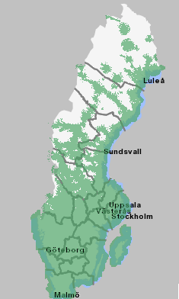

**Figure 3: Telenor coverage**

#### MSC configuration changes

The Mobile Core Network will implement support to receive additional Emergency Service Category Information (ESCI) from the mobile device. “Automatically initiated eCall”, “Manually initiated eCall”. ECA/ECM

ESCI is not currently used for unique routing within the Mobile Core Network. In case no additional configuration is done, the eCalls will be directed in the same way as regular 112 calls to the PSAP’s.

The new categories ECA/ECM needs to be associated with a new service type since the default service type 0 can’t be used or the call will go to normal PSAP’s. Each cell is associated with a routing zone. The routing zone and service type in combination translates the B-number of the eCall into the right PSAP. For the test a local national B-number in the normal Stockholm area will be used.

#### Rollout time

1. Software release test in NSN facilities.
2. Software rollout can be scheduled after confirmed delivery to Telenor. Due to service level agreement with customers, Telenor has a notification delay from decision to rollout.
3. Rollout in one Live MSC, including one week of live operation. Verification of PSAP configuration in case eCall terminal is available.
4. Rollout in remaining MSC (SLA relevant nodes) can be done two weeks after notification. Rollout time for changes of this size is to be expected over night, pending local on call resource availability, and other scheduled network updates. This could take longer time.
5. Configuration of installed software.

Unrushed delivery is approximately less than 5 weeks from available software. However if we catch a testing slot for the software at week 14 it seems we should be able to facilitate a timely delivery without any rush implementation.

#### TeliaSonera network

All MSC´s in the TeliaSonera network in Sweden run the same software, supplied by Ericsson. After a standardized step by step qualification procedure for software updates the patch with the eCall flag will be implemented in the network. The software will receive manual and automatic eCall´s and route them to phone numbers in SOS Alarm´s reference call centre in Stockholm.

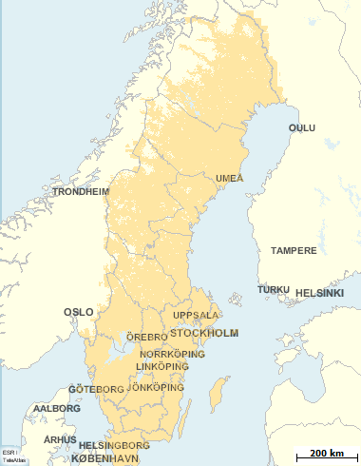

**Figure 4: Coverage of TeliaSoneras GSM network in Sweden**

#### MSC update proposal for in-band

Release MSC R13.2 CM211 + TPC CNI

This part of the eCall functionality contains three files:

* ecLoadPart1_R13.2.cor
* ecActivatePart1_R13.2.cor
* ecRemovePart1_R13.2.cor

The following blocks are modified:

* MCCMH 7PJA/CAAZA 107 2318/MQVAA R1A03
* MTACC 7PJA/CAAZA 107 2259/MQVAA R1A04
* MTA 7PJF/CAAZA 107 1977/MQVAA R1A07

ECV - Emergency Category Value

IVS - In-Vehicle System

PSAP - Public Safety Answering Point

SIM - Subscriber Identity Module

When this is loaded and activated, a manually or an automatically initiated IVS eCall (112,) with a SIM card is made possible, in such a way, that the emergency category information element bits are mapped into unique end-of-selection codes. For more details see information below. For IVS in-band eCall functionality, this is the only modification needed in MSC.

To verify this functionality a tool or an IVS device is needed to set the ECV bits accordingly.

The meaning of the emergency category value, received in the DTAP emergency setup message, is derived from the following settings in MSC:

* bit 0 - police
* bit 1 - ambulance
* bit 2 - fire brigade
* bit 3 - marine guard
* bit 4 - mountain rescue
* bit 5 - manually initiated eCall (hexadecimal value #20)
* bit 6 - automatically initiated eCall (hexadecimal value #40)
* bit 7 - is spare and set to "0"

The meanings of the used End-Of-Selection codes are as follows:

Existing EOS

* 2290 MTA Emergency call made with Subscriber Identity Module (SIM) card, emergency category value all other bit combinations than bit 5 or bit 6 set to one. Recommended task: F, M redirection to emergency centre (PSAP).

New EOS

* 2291 MTA Manually initiated IVS eCall with Subscriber Identity Module (SIM) card, emergency category value only bit 5 is set to one. Recommended task: F, M redirection to emergency centre (PSAP).
* 2292 MTA Automatically initiated IVS eCall with Subscriber Identity Module (SIM) card, emergency category value only bit 6 is set to one. Recommended task: F, M redirection to emergency centre (PSAP).

ANESP:ES=2290;

ANESP:ES=2291;

ANESP:ES=2292;

#### MSC update for eSMS

APZ IP on CP is used and MSC needs to have a defined IP address.

Example 1:

* IHIFP;
* IHIFI:VIF=ETHA-304;
* IHIFC:VIF=ETHA-304,NETMASK=255.255.255.0,ARP=YES,ADD,IP=10.42.226.74;

New blocks BODY and SKIN1 needs to be loaded, activated and size increased.

Example 2:

* SAAII:SAE=500,BLOCK=BODY,NI=100;
* SAAII:SAE=500,BLOCK=SKIN1,NI=100;

End-to-end UDP/IP socket connection to PSAP needs to be defined with new commands.

Example 3:

* APPL VALUE RANGE 1-7 characters application ECALL
* FNC VALUE RANGE 1-7 function code 1
* LDOMAIN VALUE RANGE 1-31 char local fully qualified domain name, local host
* LIP VALUE RANGE "A.B.C.D" IPV4 local IP address
* LPN VALUE RANGE 1-65535 local port number
* PROT VALUE RANGE 1-31 char protocol UDP
* RDOMAIN VALUE RANGE 1-31 char remote fully qualified domain name, remote host
* RIP VALUE RANGE "A.B.C.D" IPV4 remote IP address
* RPN VALUE RANGE 1-65535 remote port number
* SOCKET VALUE RANGE 1-31 socket number

USER VALUE RANGE 1-7 characters socket user block SKIN1

* IPSOI:SOCKET=1,PROT=UDP,LIP="10.42.226.74",LPN=5678,USER=SKIN1,FNC=1;
* IPSOC:SOCKET=1,APPL=ECALL;
* IPSOC:SOCKET=1,LDOMAIN="MSC300.NW01.STP";
* IPSOC:SOCKET=1,RDOMAIN="PSAP001.ENW01.COM";
* IPSOC:SOCKET=1,RIP="164.48.133.38",RPN=6789;
* IPSBE:SOCKET=1;
* IPSOP:SOCKET=1;

### In Vehicle System functions

The Volvo OnCall OBU contains the following main function blocks:

* Network Access Device NAD, GSM/GPRS
* GNSS: GPS receiver (positioning)
* Host CPU (host for Telematics Services including eCall application)
* Antenna system interfaces (NAD and GPS)
* Vehicle interfaces (CAN, eCall trigger, push buttons etc.)
* Audio interface (microphone and speaker)

In order to ensure functionality also when the vehicle has been involved in a severe crash the OBU contains backup power (battery), backup NAD antenna and backup audio.

Volvo OnCall eCall service is currently supported in 15 European countries. At countries where the OnCall eCall service are not is supported by a call centre, the OBU launch a 112 emergency call at an initiated eCall to the PSAP (no data).

In the HeERO project the existing IVS hardware will be used as this hardware supports all features required for Pan European eCall.

The existing OBU SW platform will be used, adoption of eCall application and introduction of in-band modem will be made in order to be compliant with the ETSI and CEN eCall standards, and in addition the OBU also supports TPS eCall based on MSM.

## Finland

### Introduction

This report is prepared as a part of the HeERO project describing the basic functionalities of the planned eCall pilot in Finland. The report is intended to be the basis for the implementation plan.

### Specifications of eCall Functionalities

The following figure illustrates the basic functionality of the planned HeERO Finnish pilot system to be implemented.

**Figure 5: HeERO Finnish pilot system functionalities**

#### eCall clients

Different eCall clients will be used in the pilot, both eCall client simulators and/or in-vehicle clients (if available). Clients include functionality for generating and sending standard eCall MSD (Minimum Set of Data) messages.

The clients include functionality for generating and sending standard eCall MSD (Minimum Set of Data) messages.

A client simulator will be implemented. It will also include a user interface for configuring of eCall messages to be sent. The eCall client simulator software will run on a PC or/and mobile device.

The client will use the eCall standardized in-band modem data transfer for sending messages. The generated MSD data will be encoded for the data transfer. The messages (opened voice call) are targeted to the configured phone number (other than 112 for testing purposes) of the eCall receiver side (eCall testbed).

PSAP1 (a trusted party) will combine the eCall data to be sent to the PSAP2.

#### eCall MSD message encoding, decoding and validation in PSAP simulator (eCall testbed)

eCall MSD message will be implemented according to the specifications.

The software module will enable the encoding, decoding and validation of MSD messages. It will be used and integrated both with the eCall client simulator and the eCall receiver software (within eCall testbed).

#### eCall data transfer

eCall data transfer functionality will be implemented using the eCall in-band modem solution (3GPP TS26.267). In the implementation the ANCI-C reference code (3GPP TS 26.268) will be used.

Interfaces for both the message sending software (eCall client simulator) and receiving software (eCall testbed) will be implemented.

#### MSD message receiving and verification in PSAP1 and PSAP2

The eCall receiver software will be implemented as a module in the eCall test-bed. It provides the functionality to receive and validate eCall messages. It will extract and decode MSD data from incoming eCall phone call. Then, it validates the data. MSD acknowledgement is generated. Also the receiving software will provide logs of received messages and errors.

The voice flow will be treated as a regular emergency 112 call, but other phone number used for test purposes.

In addition, in the pilot it will be studied how to direct the MSD and voice call onto the same Emergency Centre Operators desk.

#### eCall message interface to PSAP2 system

The PSAP simulator (eCall test-bed) will transfer the decoded eCall data to the PSAP2 system (ELS). ELS is the National Emergency call E112 system in Finland, first implemented in 2002 which handles over four million calls per year.

An interface will be implemented for the eCall testbed that enables the eCall message transfer to the ELS. The SOAP (Simple Object Access Protocol) interface of the ELS system will be used.

#### Cross borders activities

Cross borders activities are planned to take place with one or two consortium partners.

In practice, tests may be accomplished, for example, so that Finnish eCall Testbed is used as an eCall receiver (PSAP) and/or the eCall client simulator (part of Finnish eCall pilot) used as an eCall sender (in vehicle).

**Figure 6: Cross borders tests using the Finnish pilot system eCall sender and receiver parts**

### eCall test service management

There will be a special Web user interface for managing the operation of the testbed (see Figure 7). It will provide configurations for the test users (e.g., registering phone of their eCall IVS device) as well as system administration functionalities. It will also provide views to result logs.



**Figure 7: eCall test service management**

### Operational cases

#### General functionalities for eCall

In this section, general eCall related functions and connections between different stakeholders related to the HeERO first phase Finnish eCall pilot system are considered.

|  |  |  |
| --- | --- | --- |
| No | Function | Stakeholder |
| 1.0 | Manual or automatic activation of eCall | eCall client simulator |
| 1.1 | MSD message generation | eCall client simulator |
| 1.2 | MSD encoding | eCall client simulator (MSD encoder) |
| 1.3 | Call to test number, opening voice connection and transmission of MSD | eCall client simulator (software modem) |
| 1.4 | Acknowledgement of MSD | PSAP simulator, eCall testbed (software modem) |
| 1.5 | MSD extraction, decoding and validation | PSAP simulator, eCall testbed |
| 1.6 | eCall data complementing request | PSAP simulator (PSAP1 API) |
| 1.7 | eCall data complementing and verification | PSAP1 |
| 1.8 | Generation of event creation command | PSAP simulator, eCall testbed (PSAP2 API) |
| 1.9 | Reception of event creation command | PSAP2 (ELS SOAP interface) |
| 1.10 | Presentation of the data event | PSAP2 (ELS Workstation) |
| 1.11 | Risk assessment | PSAP2 (by a human user) |

**Table 1: eCall Finnish pilot system functions**

In the following figure, basic functional architecture of the Finnish eCall pilot system is outlined and data flows visualized.



**Figure 8: eCall Finnish pilot system – functional architecture**

## Croatia

### eCall system architecture

#### eCall in-band modem architecture

It is a challenging task to transmit data over the mobile voice channel as required of an in-band modem since speech codecs used in digital cellular systems are optimized explicitly for speech signal compression. Therefore, modem signals may incur heavy distortion after passing through the effective transmission channel consisting of speech codec, possible degradations on the radio channel, and speech decoder with error concealment. Furthermore, in digital cellular communications frame losses occur regularly and increase the burden of data recovery by the in-band modem.

CTM was developed in 3GPP for transmitting text data for text telephony. It was evaluated as a potential solution for eIM in the technical report (3GPP TR 26.967 [4]) and found not able to meet eCall requirements.

The present eIM solution consists of an IVS data modem and a PSAP data modem, employing signals that have been designed to pass through modern speech codecs with only moderate distortion, yet providing sufficiently high data rates for quick MSD transmission.

The overall cellular system architecture, including the IVS and PSAP data modems, is given for information in a simplified diagram below.

After an emergency voice call has been (automatically or manually) established, the IVS modem receiver constantly monitors the incoming signal from the speech decoder output. When prompted by a request from the PSAP operator for MSD, the IVS connects the IVS data modem transmitter to the input of the speech coder and mutes any speech from the motorist for the duration of MSD transmission to prevent it from interfering with the eCall data transmission. Alternatively, it can be the IVS that may trigger the MSD transmission. In this case, the IVS asks the PSAP to request an MSD transmission.

The first operation mode shall be referred to as the pull mode whereas the latter one is the push mode. Essentially, push mode is realized by a request from the IVS to the PSAP to pull the MSD.

The requirement about the modem to be configured in either push or pull mode is beyond the scope of this specification. Refer to clause 4.2 for a reproduction of eCall service requirements. In general, the microphone has to be detached from the signal path whenever the eCall modem is actively transmitting.

The operational principles of the IVS and PSAP modems within the environment illustrated in next figure are further explained in the following.



**Figure 9: eCall system within the cellular system architecture**

#### Principle operation of the IVS data modem

The main components of the IVS data modem are illustrated below. The MSD information input into the IVS transmitter is first appended with CRC information. These bits are then encoded in the hybrid ARQ (HARQ) encoder using FEC coding to reduce the susceptibility to transmission errors. The HARQ encoder employs a powerful state-of-the-art turbo encoding scheme with incremental redundancy added for each retransmission. The signal modulator converts the encoded data into waveform symbols which are especially suitable for transmission through speech codecs employed in present mobile systems, including the GSM Full-Rate (3GPP TS 46.001 [5]) and the various modes of AMR codecs (3GPP TS 26.071 [7]).

The IVS receiver continues to monitor the feedback messages from the PSAP data modem. As long as the received feedback messages are NACK messages, retransmissions of the MSD with incremental redundancy are automatically continued until an ACK message set (containing a link-layer ACK message and a compressed higher-layer ACK message from the application layer) is received by the IVS, or operation is terminated by the PSAP. After the transmission of the MSD information and the higher-layer ACK message is completed, the eCall modem transmitters in both the IVS and PSAP return to idle state and the signal paths from the transmitters are switched off to avoid interference with the normal voice call.

In *push* mode, the IVS reuses the downlink message format for requesting the PSAP to *pull* the MSD. Request messages are transmitted until the IVS receiver detects Sart messages from the PSAP or a timeout occurs. Upon detection of the Start messages the IVS continues as if it was in *pull* mode.

This document only specifies the eCall modem for the transmission of one MSD of length 140 bytes. Messages shorter than 140 bytes are assumed to have been padded, e.g., with zeros before being fed to the IVS transmitter. Longer message lengths would require a packet segmentation mechanism as well as adaptations to the transmission protocol, which are out of scope for this document.



**Figure 10: eCall IVS data modem overview**

#### Principle operation of the PSAP data modem

The main components of the PSAP data modem are illustrated below. After having triggered the IVS data modem for transmission of MSD, the eCall PSAP receiver continuously monitors the incoming signal from the PSTN. When the eCall data signal is detected and synchronized, the signal demodulator demodulates the incoming data symbols. The HARQ decoder soft-combines the first MSD transmission with any retransmissions of the information and decodes the FEC to determine the information bits, i.e. its estimate of the CRC protected MSD information. If a CRC error is detected in the decoded MSD, the PSAP receiver returns NACK and thereby prompts the IVS transmitter to provide retransmissions with incremental redundancy. Otherwise, the MSD information is provided to the PSAP operator and the IVS transmitter is notified with link-layer ACK messages that retransmissions are no longer required. To conclude the MSD transmission sequence, a compressed higher-layer ACK message (received from the application layer) is repeatedly transmitted from the PSAP to the IVS.

In *push* mode, the PSAP monitors the received signal for a trigger from the IVS. Upon detection of a trigger it transmits a request for MSD transmission as it would do in *pull* mode and continues as described above.

The incoming speech path is switched off when the PSAP transmitter needs to use the voice channel for feedback messages. Once the MSD is correctly received and the compressed higher-layer ACK message is transmitted, the speech path is un-muted to avoid interference with the normal voice call.



**Figure 11: eCall PSAP data modem overview**

#### Performance Requirements

The following text defines point by point the (Service) Performance Requirements for an eCall candidate. They have been taken directly from 3GPP TS 22.101 [1].

1. The data may be sent prior to, in parallel with, or at the start of the voice component of an emergency call.
2. Should the PSAP request additional data then this may be possible during the established emergency call.

This service requirement is considered in the selection as follows:

"The eCall candidate algorithm shall allow the PSAP to request additional data at any time during the established emergency call."

1. The realization of the transfer of data during an emergency call shall minimize changes to the originating and transit networks. This service requirement is considered in the selection as follows: "The introduction of the eCall data transfer feature should have minimal (ideally no) impact on any existing mobile and transit network (in Europe), i.e. it should not require (major) changes nor impose (major) restrictions to future evolutions of the networks."
2. Both the voice and data components of the emergency call shall be routed to the same PSAP or designated emergency call centre.
3. The transmission of the data shall be acknowledged and if necessary data shall be retransmitted. This service requirement is considered in the selection as follows: "In the case of errors detected by the candidate algorithm in the received data, a retransmission shall be requested by the candidate algorithm."
4. A UE configured only to transfer data during emergency calls (e.g. eCall only UE) shall not generate signalling to the network besides what is needed to place an emergency call. This service requirement does not need to be considered in the selection.
5. With the exception of the following specific requirements, considered necessary for the satisfactory operation of the eCall service, all existing TS12 emergency call requirements shall apply. This service requirement does not need to be considered in the selection.
6. An eCall shall consist of a TS12 emergency call supplemented by a minimum set of emergency related data (MSD). This service requirement does not need to be considered in the selection.
7. An eCall may be initiated automatically, for example due to a vehicle collision, or manually by the vehicle occupants. This service requirement does not need to be considered in the selection.
8. The Minimum Set of Data (MSD) sent by the In-vehicle System (IVS) to the network shall not exceed 140 bytes. This service requirement is considered in the selection as follows: "The whole 140 Bytes of the MSD shall be made available to the PSAP."
9. The MSD should typically be made available to the PSAP within 4 seconds, measured from the time when end to end connection with the PSAP is established. This service requirement is considered in the selection as follows: "In optimal conditions (error-free radio channel, GSM FR codec and FR AMR 12.2 kbit/s mode) the eCall candidate procedure shall be able to transmit the whole 140 bytes of the MSD reliably within 4 seconds, measured from the time when the transmission from the IVS to the PSAP begins (after a trigger from the PSAP has been detected)."
10. Should the MSD component not be included in an eCall, or is corrupted or lost for any reason, then this shall not affect the associated TS12 emergency call speech functionality.  
    This service requirement does not need to be considered in the selection.
11. A call progress indication shall be provided to the user whilst the MSD transmission is in progress. This service requirement does not need to be considered in the selection.
12. In addition to the above Service Requirements, the following Performance Requirements shall apply to an eCall candidate solution.
13. Installation of eCall equipment in a vehicle shall not affect an emergency call to a PSAP which is not upgraded to receive eCall data, i.e. the eCall candidate algorithm shall not send the eCall data unless the PSAP requests that it do so.
14. The MSD shall be transmitted reliably to the PSAP. An MSD transmission is considered reliably terminated, if a cyclic redundancy check (CRC) of at least 28 bits, applied to the entire MSD, detects no errors.

#### Performance Objectives

Performance Objective 1: The overall average transmission time should be as small as possible.

Performance Objective 2: Under all test conditions, a candidate should be as good as or better than the proposed eCall_via_CTM* (see 3GPP TR 26.967 [4]) would be.

Performance Objective 1 is explained in detail in the following:

* For any particular test condition (specified by speech codec plus radio channel error condition), the observed transmission time of the 140 bytes of the MSD may vary depending on the parameters of the channel simulation and the specific contents of the MSD. Therefore each MSD transmission may be regarded as one trial *k* in a random experiment, where the observed transmission time, *Tk*, is the random variable of interest. For each particular test condition *C,* the MSD transmission is repeated with different, randomly generated MSD data for at least 100 times (*k*= 1, 2, ..., *n*, where *n*≥100) to get enough statistical significance.
* To ensure a practical limit on the time required for testing a candidate, the observed value of *Tk* must have a reasonable upper bound. This upper bound, *tUB*, is fixed at a value of 200 seconds for one trial for all test conditions. Any value of *Tk* that is observed to be greater than *tUB* will be classified as a transmission failure and will be assigned the value of *tUB*.
* Each particular test condition *C* gives an observed sample distribution *T1*, *T2*, ..., *Tn*. The statistic of interest is the average value, *C* = (*T1* + *T2* + ... + *Tn*) / *n*.
* The Figure of Merit (FoM) over *all* test conditions is calculated by un-weighted averaging of *C* over all particular test conditions *C1*, *C2*, ..., *Cm*. A low Figure of Merit is – obviously - better than a higher Figure of Merit. The candidates will be ranked by their Figures of Merit.
* The following assumptions are made for the measurement of *Tk*.
  + The starting time of the transmission with respect to speech codec audio frames is uniformly distributed.
  + The channel error condition is modelled by an error pattern obtained from offline simulations. The following radio conditions will be tested:
* GMSK Full Rate radio channel at C/I values of 1, 4, 7, 10, 13, 16 dB, and error free; with ideal frequency hopping, with the Typical Urban profile and with slow vehicle speed. These channel conditions will be applied in both directions (uplink and downlink) symmetrically.
* GMSK Full Rate radio channel at RSSI value -100 dBm with no other interferer. This channel condition will be applied in both directions (uplink and downlink) symmetrically.
* The following speech Codecs will be tested: GSM_FR and FR_AMR (12.2, 10.2, 7.95, 7.4, 6.7, 5.9, 5.15, 4.75 kbps). DTX will be enabled in both directions.

### System functionalities

#### Basic Service chain

1. The eCall Generator initiate the eCall by sensors triggered and/or manually, send the in-vehicle triggered eCall to a PSAP. The eCall consists of two elements: a pure voice (audio) telephone call based on 112 and the minimum set of data (MSD)
2. The eCall (data + voice) carried through the mobile network, is recognized by the mobile network operator (MNO) as a 112 emergency call, and is first handled by the MNO. Based on the 112 handling the MNO enrich the call with the CLI (caller line identification), and at the same time, according to the USD and the E112 recommendation, add the best location available (based on the best effort principle11). After the 112 handling, the telecom operator delivers the 112-voice together with the CLI, mobile location and the eCall MSD to the appropriate PSAP.
3. The PSAP transmits an acknowledgement to the eCall Generator specifying that the MSD have been properly received. [14]

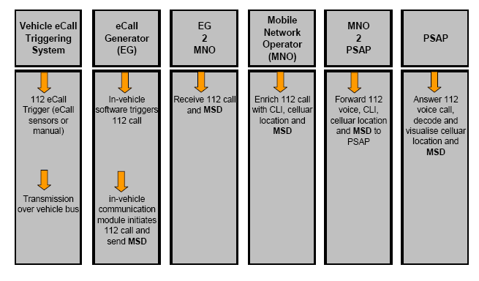

**Figure 12: eCall Service chain**

#### Timing proposal

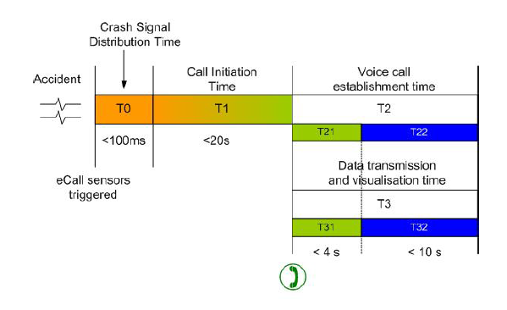

**Figure 13: End to end timing proposal**

#### System requirements II

With the exception of the following specific requirements, considered necessary for the satisfactory operation of the eCall service, all existing TS12 emergency call requirements shall apply. An eCall shall consist of a TS12 emergency call supplemented by a minimum set of emergency related data (MSD). The MSD e.g. vehicle identity, location information and other parameters, is defined by CEN.

An eCall may be initiated automatically, for example due to a vehicle collision, or manually by the vehicle occupants;

An IVS, or other UE designed to support eCall functionality, shall include in the emergency call set-up an indication that the present call is either a Manually Initiated eCall (MIeC) or an Automatically Initiated eCall (AIeC).

The Minimum Set of Data (MSD) sent by the In vehicle System (IVS) to the network shall not exceed 140 bytes;

The MSD should typically be made available to the PSAP within 4 seconds measured from the time when end to end connection with the PSAP is established;

Should the MSD component not be included in an eCall, or is corrupted or lost for any reason, then this shall not affect the associated TS12 emergency call speech functionality.

A call progress indication shall be provided to the user whilst the MSD transmission is in progress.

To reduce the time taken to establish an eCall an IVS whilst in eCall only mode may receive network availability information whilst not registered on a PLMN.

PLMNs should make use of eCall indicators, received in the emergency call set-up, to differentiate eCalls from other TS12 emergency calls.

The MIeC and AIeC should be used by the serving network to filter and route eCalls to dedicated, eCall equipped, PSAPs.

Where the eCall indicators are not supported by the serving network, the time needed for the PSAP eCall modem to differentiate between eCalls and other TS12 calls, before routing the call to an operator, shall not exceed 2 seconds from when the IVS receives notification that the PSAP has answered the call.

The PSAP shall be given an indication that the incoming call is an eCall, Croatian pilot will fully support the eCall flag and indication means that PSAP operator will have a notification which will differentiate eCall from ordinary emergency call.

Throughout the duration of the emergency call and following receipt of the MSD by the PSAP

It shall be possible for the PSAP to send a confirmation to the IVS that the MSD has been acted upon.

It shall be possible for the PSAP to request the IVS to re-send its most recent MSD.

It shall be possible for the PSAP to instruct the IVS to terminate the eCall.

#### Requirements received from European bodies

The following requirements are identified in a Liaison Statement received from ETSI MSG:

* To send a fixed data block (MSD, Minimum Set of Data), which will not exceed 140 bytes, from the vehicle to the PSAP, at the same time that the emergency call is placed.
* The data needs to be acknowledged, hence there will be a return channel.
* The voice call need not be active during the transmission of the data
* The MSD shall be delivered to the interface to the PSAP within a maximum of 4 seconds from when the MSD is available in the terminal.
* The acknowledgement shall be carried out at the transport layers and not the application layers, so that the system is compatible with a PSAP that has not yet implemented the eCall functionality.
* The terminal shall be dual mode GSM/GPRS and UMTS (WCDMA) in order to ensure full European coverage during the lifetime of the car.
* The solution shall seek minimal impact on all nodes involved in the transfer of information, that is, in the mobile network and the fixed network possibly used between the mobile network and the PSAP node.
* 3GPP should aim at including any required specification changes within the 3GPP Release 7 set of specifications.
* The solution shall work on all European 3GPP networks (pan European solution, full roaming capability) SIM/USIM shall be present owing to the fact that the SIM/USIM presence is already mandatory is several EU countries for Emergency Calls.
* The eCall MSD is to be provided to the PSAP in addition to the location and other information associated with an E112 call as currently specified in 3GPP Technical Specifications.
* Normal E112 functionality shall be available in the event of failure of the eCall function.
* Supported by IP Multimedia Subsystem and UMTS Terrestrial Radio Access Network and Evolved UMTS Terrestrial Radio Access Network
* Solution should require minimal changes to 3GPP Technical Specifications for a satisfactory design
* Include facility to disable MS ISDN and/or SIM/USIM when vehicle is deregistered or destroyed
* As an additional clarification the source of the information in the MSD will be the vehicle, the content and the method for obtaining this information is outside of the scope of this study. The mobile network will simply provide means of transferring the data. Other aspects of emergency calls are not expected to be modified.

#### eCall Discriminator table

Service State, eCALL INACTIVE - When in state MM IDLE and service state eCALL INACTIVE, the mobile station shall:

* not perform periodic updating;
* not perform IMSI detach;
* reject any requests from CM entities for MM connections except for emergency calls and calls to a non-emergency MSISDN for test and terminal reconfiguration services;
* not perform normal location updating; and
* not respond to paging.

#### eCall inactivity procedure

The eCall inactivity procedure is applicable only to an eCall only mobile station (as determined by information configured in USIM). The procedure shall be started when timer T3242 or timer T3243 expires or is found to have already expired in any MM Idle state except NO IMSI, NO CELL AVAILABLE or PLMN SEARCH. The mobile station shall then stop other running timers (e.g. T3211, T3212, T3213) and shall perform the IMSI detach procedure if required by the serving network and if the update state is U1. The mobile station then enters MM Idle eCALL INACTIVE state and the mobile station shall delete any LAI, TMSI, ciphering key sequence number stored in the SIM/USIM and set the update state to U4 Updating Disabled.

While in eCALL INACTIVE state, the mobile station maintains awareness of a potential serving cell in a potential serving network but initiates no MM signalling with the network and ignores any paging requests.

The mobile station shall leave eCALL INACTIVE state only when one of the following events occurs:

* if the SIM or USIM is removed, the mobile station enters the NO IMSI state;
* if coverage is lost, the mobile station enters PLMN SEARCH state;
* if the mobile station is deactivated (e.g. powered off) by the user: the mobile station enters the NULL state;
* if there is a CM request for an emergency services call: the MS uses the MM and CM procedures to establish the emergency call; or
* if there is a CM request for a call to an HPLMN designated non-emergency MSISDN for the purpose of accessing test and terminal reconfiguration services: the mobile station attempts the IMSI attach procedure if required by the serving network or otherwise attempts normal location updating. Once this is complete, further MM and CM procedures are used to establish the non-emergency call.

#### Map accuracy

In the case of an emergency call, one critical phase is to locate precisely on a map the position of the caller from GNSS coordinates provided in the MSD and to derive a location which can be sent to the emergency service vehicle.

The recommended performance criteria for the mapping accuracy are:

* Road geometry
* Completeness of the road geometry down to the lowest local level;
* Accuracy of the road geometry is precise to 15 meters
* Road naming
* In Artery category 1 to 4: 99.9% must have a name;
* In Artery category 5: 97% must have a name; and
* Each road name must be the correct.
* When possible the DG eCall recommends that the PSAP’s use a map-matching tool in order to prevent
* Potential “errors”, and thereby increase the accuracy.

#### eCall Certification

In order to ensure the end user that the eCall service meet the performance criteria outlined in this document a certification procedure has been proposed by the standardization sub-working group (ST.4) under the DG eCall.22

In relation to certification of eCall the DG eCall recommends that:

* The vehicle manufactures should be responsible for the certification of the eCall generator using existing certification procedures;
* Mobile Network Operators should be responsible for the certification of their network;
* The PSAPs should be responsible for the certification of the PSAP system along with the PSAP operators’ procedures for handling an eCall.

#### PSAP structure

Furthermore DG eCall recommends that interoperability testing is done with the involvement of all stakeholders in the eCall chain with the objective to ensure that the eCall service performs according to the overall performance criteria.

* DG eCall recommends that PSAPs across Europe implement eCall as soon as possible. It is also recommended that Member States investigate the possibility to potentially revise the current PSAP structures e.g. through public/private partnerships in order to minimize the necessary investments.
* The work within DG eCall has identified a number of possible 112 structures across Europe and it has seen that various possibilities exist depending on national laws and regulation and political organizations. The following examples are given on how Member States could build their emergency call structure.
* Acknowledging that many more would be possible: Two levels of PSAPs, or PSAP1 and PSAP2 served by the same Public body Public operated PSAP1.
* Service provider operating as PSAP1 under the control of a Emergency Agency/Public Authority

### Standard operating procedures in case of traffic incidents in Croatia

The system supports the predicted course of receiving, processing and forwarding of emergency call to related emergency management agency’s (police, fire brigade, and medical emergency) and other stakeholders in the road traffic process and according to standard operating procedures (SOP).

In those cases we have following standard operating procedures[1]:

#### The 112 centre standard operating procedure in case of highway incident

* These Standard Operating Procedures govern the way in which the 112 Centre responds upon receipt of an emergency call involving a highway incident.
* Actors in case of a highway incident are the following:
* Ministry of Health and Social Welfare; Ministry of the Interior; Ministry of Environmental Protection, Physical Planning and Construction; Ministry of Regional Development, Forestry and Water Management; Ministry of Sea, Transport and Infrastructure; Ministry of Defence; National Protection and Rescue Directorate; competent legal entity for highway management and maintenance; Emergency Medical Service; fire fighting units etc.



**Figure 14: SOP for traffic incidents on highways**

OPERATION INSTRUCTIONS SUMMARY

1. The Country 112 Centre (hereinafter referred as: the Centre) receives the information on the incident requiring the following data:
2. WHERE did the incident happen (which section of the highway, direction and vicinity of which town/village)?
3. WHAT happened (short description of the incident, who is involved)?
4. IS ANYONE INJURED (how badly, is it possible to reach the injured, can they be taken out of the vehicle)?
5. Is any vehicle on fire and how many?
6. The Centre immediately notifies of the incident the following:
7. Emergency Medical Dispatcher of the Emergency Medical Service,
8. Operational Communications Centre of the Police Administration,
9. Operational centre of the legal entity in charge of maintenance and management of the highway section on which the incident happened,
10. Competent fire fighting unit.
11. When the forces in the field cannot cope with the situation, they may require additional teams either through their internal communications or through the Centre.
12. If it is necessary to engage the Armed Forces of the Republic of Croatia, the communication with the Headquarters is carried out through the National 112 Centre.
13. In case of road incidents involving a large number of fatalities, victims and major damage, the Centre notifies local self-government units while the National 112 Centre notifies national authorities.
14. Emergency services notify the Centre of the course and end of the operation, as well as consequences of the incident. The Centre sends the comprehensive report to local self-government units and to the National 112 Centre, which in turn notifies national authorities within its regular or extraordinary reports.

#### The 112 centre standard operating procedures in case of other road incidents

These Standard Operating Procedures govern the way in which the 112 Centre responds upon receipt of an emergency call involving an incident on national, local and unclassified roads (hereinafter referred to as: roads).

Actors in protection and rescue operations in road incidents are the following:

Ministry of Health and Social Welfare; Ministry of the Interior; Ministry of Environmental Protection, Physical Planning and Construction; Ministry of Regional Development, Forestry and Water Management; Ministry of Sea, Transport and Infrastructure; Ministry of Defence; National Protection and Rescue Directorate; physical and legal persons charged with regular road maintenance, Emergency Medical Service, fire fighting units etc.

OPERATION INSTRUCTIONS SUMMARY

1. The Country 112 Center receives the information on the incident from a citizen who has been involved in the incident, other road user or other physical person and gathers the first data on the incident:
2. WHERE did the incident happen (the nearest town or village, road number, section number and the kilometer)?
3. WHAT happened (short description of the incident, who is involved)?
4. IS ANYONE INJURED (how badly, is it possible to reach the injured, can they be taken out of the vehicle)?
5. Is any vehicle on fire and how many?
6. WHO IS CALLING (name and last name, telephone or cellular phone number of the caller)?
7. The Center immediately notifies of the incident the following:
8. Emergency Medical Dispatcher of the Emergency Medical Service,
9. Operational Communications Center of the Police Administration,
10. Competent firefighting unit,
11. Legal or physical person in charge of regular road maintenance.
12. As appropriate, rescue operations team leaders arrange for additional teams or means together with the action coordinator.
13. If it is necessary to engage the Armed Forces of the Republic of Croatia, the communication with the Headquarters is carried out through the National 112 Center.
14. In case of road incidents involving a large number of fatalities, victims and major damage, the Center notifies local self-government units while the National 112 Center notifies national authorities.
15. Emergency services notify the Center of the course and end of the operation, as well as consequences of the incident. The Center sends the comprehensive report to local self-government units and to the National 112 Center, which in turn notifies national authorities within its regular or extraordinary reports.

#### The 112 centre standard operating procedures in case of tunnel incidents

These Standard Operating Procedures govern the way in which the 112 Centre responds in case of a tunnel incident from the moment it receives the information on the incident until the end of protection and rescue operation (communication path) and obligations of participants in the protection and rescue operation.

Actors in protection and rescue operations in tunnel incidents are the following:

Ministry of Health and Social Welfare; Ministry of Defence or; Ministry of Defence; Hrvatske autoceste d.o.o.; Hrvatske ceste d.o.o.; Bina – Istra d.o.o.; Autocesta Rijeka – Zagreb d.d.; Autocesta Zagreb – Macelj d.o.o.; professional fire fighting units; National Protection and Rescue Directorate.

OPERATION INSTRUCTIONS SUMMARY

1. The 112 Center receives the information on a tunnel incident and requires the following data:
2. Exact location in the tunnel (at the entrance, in the middle or at the end of the tunnel), short description of the incident and people involved,
3. Direction, section of the road and/or the name of the tunnel,
4. Name and last name, telephone or cellular phone number of the caller.
5. The 112 Center notifies the legal person in charge of tunnel management and maintenance, the nearest police station and the Emergency Medical Service, as appropriate.
6. Upon the receipt of the information firefighters of the legal entity in charge of tunnel management and maintenance start the operation. Their commander is the coordinator of the whole operation.
7. As appropriate, rescue operations team leaders arrange for additional teams or means together with the action coordinator.
8. If it is necessary to engage the Armed Forces of the Republic of Croatia, the communication with the Headquarters is carried out through the National 112 Center.
9. In case of road incidents involving a large number of fatalities, victims and major damage, the Center notifies local self-government units while the National 112 Center notifies national authorities.
10. Emergency services notify the Center of the course and end of the operation, as well as consequences of the incident. The Center sends the comprehensive report to local self-government units and to the National 112 Center, which in turn notifies national authorities within its regular or extraordinary reports.

## *Germany*

### Introduction

The proposed European Standard for eCall defines the general operating requirements and intrinsic procedures for in-vehicle emergency call (eCall) services in order to transfer an emergency message from a vehicle to a ’Public Safety Answering Point’ (PSAP) in the event of a crash or emergency, via an ’eCall’ communication session and to establish a voice channel between the in-vehicle equipment and the PSAP.

The eCall is composed of four distributed main subsystems, see below.

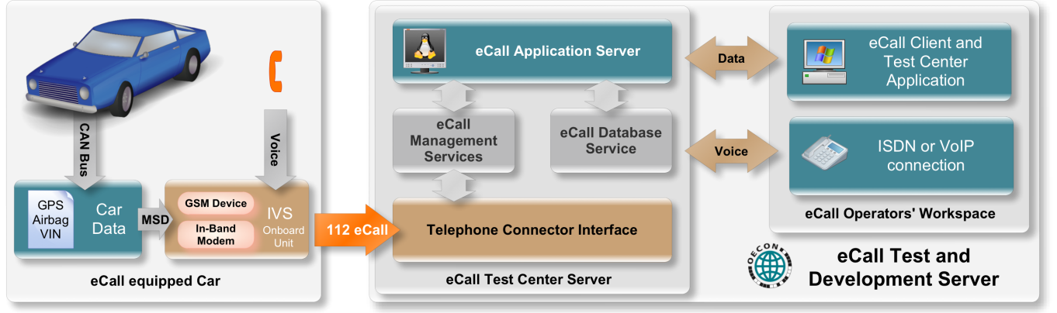

**Figure 15: German Call chain with the main subsystems**

The In-Vehicle System (IVS) is provided by the car manufactures.

The Transport Network, in the picture drawn as an orange arrow, is provided by the German Mobile Network Operators (MNO’s).

For Germany, the Public Safety Answering Point (PSAP) equipment is handled by the rescue services in Braunschweig and Oldenburg.

### eCall functions overview

Under normal circumstances, the stages of the Pan European eCall transaction that provide the service can be described as comprising 9 steps.

1. Procedures following power-up of the in-vehicle system.
2. Activation (of system).
3. Call set-up (including identifying call type, make call, network selection and registration, authentication, cell localization (by network), establish audio connection to PSAP modem server).
4. MSD transfer (including disconnect microphone and speaker in vehicle from the line, send call tone, synchronize, request MSD, send MSD, error check) and link layer ACK (including stop MSD transmissions).
5. Application layer ACK.
6. Establish Audio link (including check audio link to vehicle occupants, MSD visualization).
7. PSAP interviews if possible, and acts on information.
8. Incident resolution.
9. Call clear-down.

The following picture illustrates the data flow during the several operational steps.

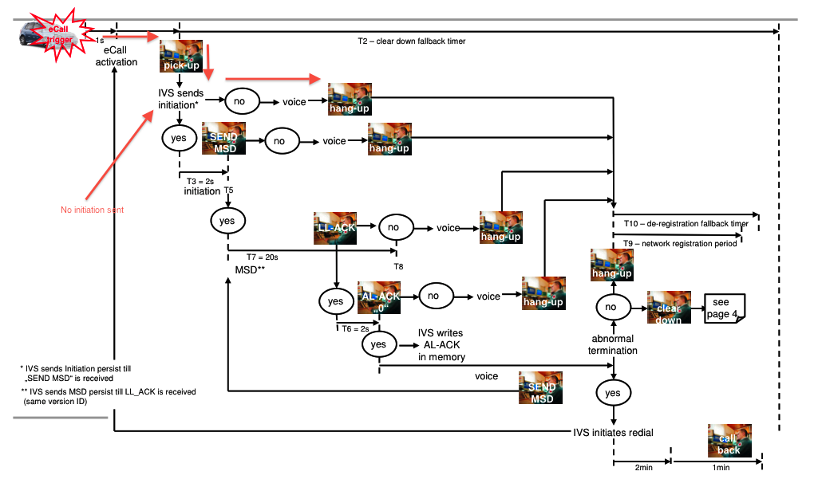

**Figure 16: eCall data flow**

### PSAP Support of eCall

The rescue services in Braunschweig and Oldenburg will include eCall PSAP systems into their operational infrastructure.

To meet multi user requirements the German eCall PSAP server uses client-server architecture. The server is Linux based and uses a few existing open source software components. Asterisk is a software private branch exchange (PBX). It takes care of all ISDN call handling so that no CAPI programming is necessary in the development of new system components. Furthermore Asterisk provides an advanced rule based call forwarding system so it is possible to transfer calls to nearly arbitrary locations. That means it is possible to use either ISDN or IP phones for operator workstations. It is even possible to use mobile phones, though not recommended for obvious reasons.

There are three components that have to be developed to make the system work. The eCall test centre client is running at every operator’s workstation. It represents the main user interface to the whole system. The client gets all data from the server and sends all requests to the server as well. Main tasks are display of MSD values and configuration of test cases. The client is not responsible for the voice call. That means the transmission of audio data is completely delegated to either an actual hardware telephone or a soft phone running on the operator’s computer. This is one of main differences between the eCall test centre and the eCall demonstrator where one software component handled everything.

The other two components are called eCall-Master and eCall-Worker and are running on the server. The master is the system’s main component. When started it spawns a number of eCall-Worker processes that are responsible for call handling and operation of the eCall in-band modem. Each worker handles only one call at a time. So for *n* calls at least *n* worker processes are required.

The master maintains an inter process communication channel to each worker it has started. This channel is used in both directions. For instance the master can send a request to a worker to establish a MSD transmission from an IVS while a call is active after the operator gave the order by clicking a button in the test centre client. The worker on the other side primarily sends status updates concerning the current call that the worker is handling.

Besides taking care of the worker processes the master communicates with one or more test centre clients. A message passing system is used for this purpose. It is provided by RabbitMQ which is an open source implementation of the AMQP specification.



**Figure 17: German eCall Server system overview**

Below the usual sequence of events from call begin to hang up is described. Depending on error conditions, system configuration and / or user interaction the sequence of events may vary.

1. IVS dials number of test centre server.
2. The call gets answered by Asterisk.
3. Asterisk transfers the call to a worker process that is not busy with another call at the moment.
4. The worker starts his eCall in-band modem to initiate MSD transmission process. Whenever a significant event happens the worker sends a status update to the master.
5. The master uses the status updates to save call state in the database which contains the protocols of every call. In addition the master generates a message which is passed to a connected test centre client.
6. The operator sitting in front of the test centre client is able to follow the course of events and is therefore informed that a MSD transmission is in progress.
7. After the MSD transmission is complete the MSD gets transferred from worker to master to test centre client where it gets decoded and is displayed to the operator.
8. Retrieve data from the VIN-Decoder (National and EUCARIS)
9. Simultaneously the worker establishes a new call to the operator phone through Asterisk. Note that the flow of audio data still includes the worker because according to the eCall HLAP it must be possible to request another MSD transmission any time while the call is active.
10. The operator’s phone rings and after picking up the operator is able to talk to the vehicle passengers.
11. The call is terminated when either the operator or the IVS hangs up.

Currently, German laws do not allow a permanent access to the National VIN Database. But there is a special agreement with the Kraftfahrzeugbundesamt in Flensburg to get access to the VIN data of the HeERO test fleet.

The complete PSAP server documentation is described in the document [German eCall Test Centre Server - Software Specification 0.8.pdf], which is available on ProjectPlace.

### Networks functions

In Germany, four Mobile Network Operators provide their services for mobile phones and data access:

* T-Mobile (Deutsche Telekom AG) with about 38% market share
* Vodafone (Vodafone Deutschland GmbH) with about 35% market share
* e-plus (KPM) with about 15% market share
* O2 with about 12% market share

Currently, the situation for eCall is still unclear. Vodafone will be the first partner to implement the eCall flag in its test centre in Düsseldorf. However, fully eCall flag implementation should not be expected earlier than 2013. The other MNOs currently do not participate in the HeERO actions. The German team hopes to bring at least one of them on board.

### In Vehicle System functions

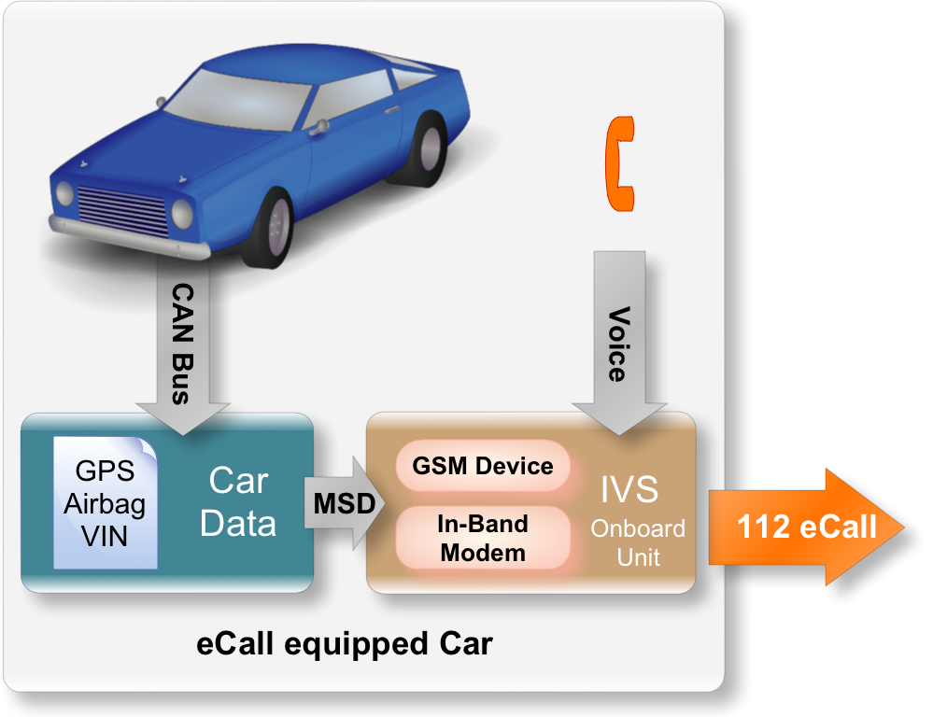

**Figure 18: IVS overview**

The IVS from Continental, S1nn and NXP contains the following main function blocks:

* Network Access Device NAD, GSM/GPRS
* GNSS: GPS receiver (positioning)
* Host CPU (host for Telematics Services including eCall application)
* Antenna system interfaces (MN and GPS)
* Vehicle interfaces (CAN, eCall trigger, push buttons etc.)
* Audio interface (microphone and speaker)

The systems will all be built into cars from “Flughafentransfer Hannover”, a company that offers transport services for airport passengers arriving or departing from Hannover. The fleet mainly consists of Volkswagen cars, but uses other models too.

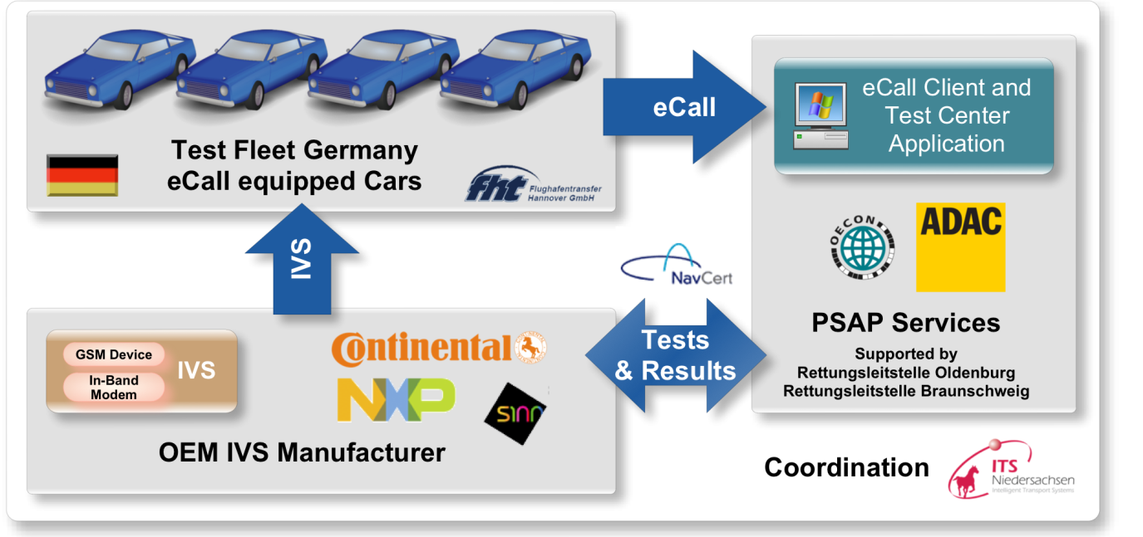

**Figure 19: German HeERO partners and their parts in the project**

## *The Netherlands*

### Introduction

In this chapter we describe the high-level architecture and process-description of handling eCalls in the Dutch pilot. For a detailed description we refer to the document: ‘Pilot Afhandeling van eCalls in de eCall Afhandelingsketen’.

### The eCall chain

The following graph describes from a high-level perspective the architecture necessary to handle eCall messages by the different actors who together make the eCall chain.

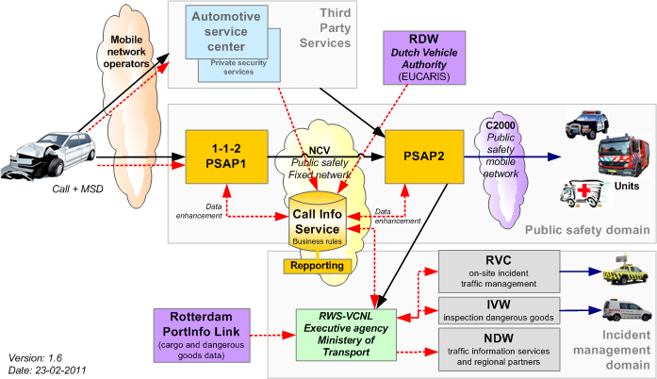

**Figure 20: The architecture necessary to handle eCall messages**

### Actors in the eCall chain

The eCall chain comprises the following (organizational) actors:

|  |  |
| --- | --- |
| Actor | Description |
| Emergency Help Chain | Consists of the national PSAP 1-1-2 and the regional emergency rooms (PSAP2) |
| Incident Management | Is done by different parts of Rijkswaterstaat (Ministry of Transport, Public Works and Water Management):   * VCNL (Verkeerscentrale Nederland) – receives the incoming messages for RWS * RVC (Regionale Verkeerscentrales) – perform traffic management activities * IVW (Inspectiedienst Verkeer en Waterstaat) – for inspection of dangerous goods * NDW (Nationale Databank Wegverkeersgegevens) – forwarding of traffic information to third parties end regional partners |
| Third Party Services | Consist of organisations like:   * PAC’s (private emergency rooms): i.e. ANWB, Mondial Assistant, Securitas * Automotive Service Centers: i.e. BMW, Mercedes, Volvo, Peugeot etc) |
| Other Information Providers | Consist of the following organisations:   * RDW (Rijksdienst voor Wegverkeer) – for the management of car and driving license data in EUCARIS * VGS Register – for collecting data on cargo * PortInfoLink – for collecting data on cargo from the Port of Rotterdam (during the HeERO pilot the possibility to collect data from other parties will be investigated) |

**Table 2: eCall chain**

### Explanation of the high-lever architecture

#### Phase 1 – Establishing an eCall

The eCall will be initiated from a car. This can be a Manually Initiated eCall (MIeC) or an automatically Initiated eCall (AIeC). The eCall will be routed through the mobile network of a telecom provider (i.e. KPN, T-Mobile and Vodafone) to the 1-1-2 PSAP, based on the so called *eCall flag* (= Call Set-up Service category information element, emergency Service category Value: bit 6 = 1 for MIeC and bit 7 = 1 for AIeC)

**Attention**: the mobile network routes the eCalls to a different geographical number (= called party number, CdPN) on the 1-1-2 PSAP then the 1-1-2 calls done by telephone.

#### Phase 2 – handling the eCall in the 1-1-2 PSAP

After receipt of the eCall the following actions are performed in the 1-1-2 PSAP:

|  |  |
| --- | --- |
| # | Description |
| 1 | The 1-1-2 PSAP takes the eCall. After setting up a voice path the vehicle sends its MSD (Minimum Set of Data). The MSD comprises at least the VIN (Vehicle Identification Number) and the location of the vehicle |
| 2 | The Call Information Service of the 1-1-2 PSAP can request EUCARIS (RDW) to send the related vehicle data based on the VIN |
| 3 | The Call Information Service of the 1-1-2 PSAP can (when necessary) request an external source for additional information on hazardous goods |
| 4 | The Call Information Centre of the 1-1-2 PSAP notifies the Incident Management process of Rijkswaterstaat, who will notify the relevant Incident Management sub-processes |
| 5 | Dependant on whether it is a MIeC or an AIeC, there are two scenarios:   * MIeC: the eCall is assigned to a 1-1-2 operator who handles the emergency call. After (positive) validation by the 1-1-2 operator, and a possible manual application to EUCARIS and VGS data, the eCall will be connected to a regional emergency room (police, fire, ambulance) (PSAP2) * AIeC: the eCall is directly routed to a regional emergency room (PSAP2), based on the vehicle location information from the MSD. The eCall is assigned to a PSAP2 operator who will handle the call |

**Table 3: Handling the eCall in the 1-1-2 PSAP**

#### Phase 3 – Handling the eCall in the emergency room (PSAP2)

At the handover of the eCall to the PSAP2, all the relevant information is handed over by the Call Information Service of the 1-1-2 PSAP. After receipt the PSAP2 operator will organise the deployment of the emergency services. When needed the PSAP2 operator can connect the call to the emergency room of Rijkswaterstaat (Incident Management).

During the handling of the eCall the different actors can provide feedback on the status or progress of their actions by sending information to the Call Information Service.

### Call Information Service

The Call Information Service is part of the 1-1-2 PSAP but acts as a central medium for the storage and exchange of information between the different actors of the eCall chain. The Call Information Service stores during the eCall process all the relevant data and provides them on request to an actor and/or notifies actors of changes of these data. Based on the business rules of the actor he can start up or adjust their emergency service processes.

A second functionality of the Call Information Service is recording (statistical) information on the eCall handling in the whole eCall chain for reporting purposes.

### Third Party Services

In case Third Party Services are going to play a role in the handling of eCalls their processes can be connected to the emergency help chain. The Call Information Service will provide the necessary ‘connectors’ through which information can be exchanged.

### High-level eCall Handling Process

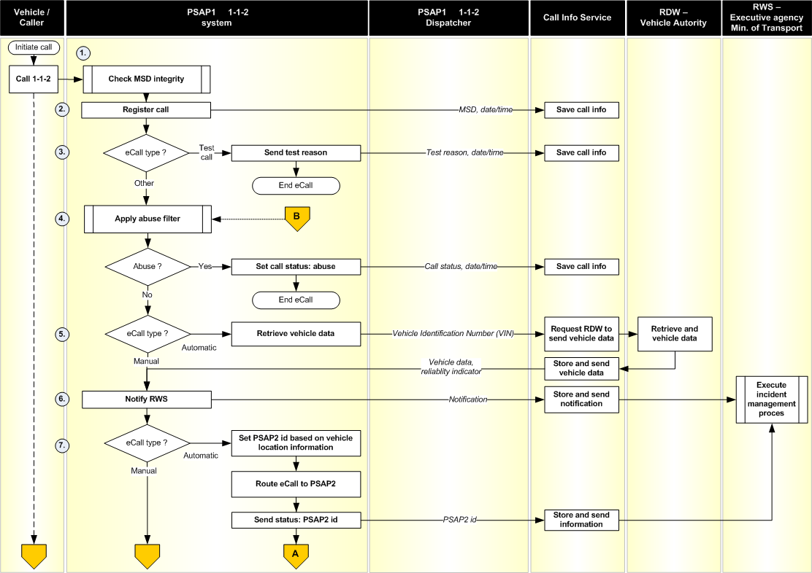

**Figure 21: High-level eCall Handling Process (Scheme A)**

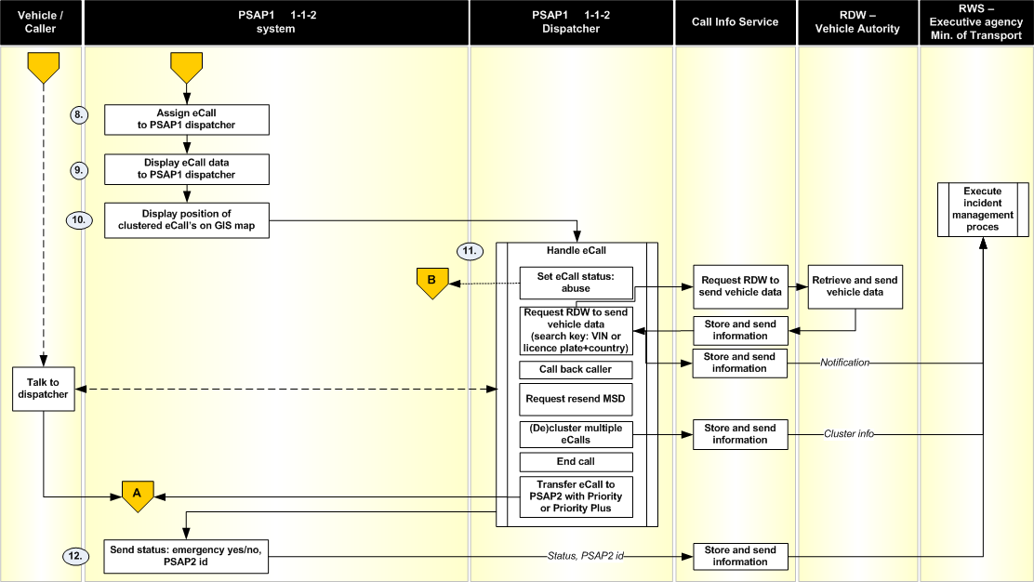

**Figure 22: High-level eCall Handling Process (Scheme B)**

## *Czech Republic*

### General overview

HeERO pilot project will test IVS from two vendors, transmitting eCall through Telefónica Mobile Network specially adjusted by eCall Flag functionality and eCall reception will be realised in the first phase on PSAP “testing platform” whereas it is planned that subsequent pilot implementation will be carried out on one production PSAP. PSAP testing which truly simulates the PSAP 112 operating system and is usually used for the new PSAP SW / functions verification. TPS interface as well as data flow towards Traffic mgt system will be tested.



**Figure 23: eCall pilot architecture**

### Mobile network

There are three most significant mobile network operators in Czech Republic - Telefónica Czech Republic, T-Mobile and Vodafone. In HeERO pilot we decided to implement eCall flag only in Telefónica network. Nevertheless we are ready to discuss during the project a necessary network modification with any other operator.

#### E112 routing

Generally, applicable to all MNOs in Czech Republic, emergency calls 112 are routed to the appropriate PSAP based on caller location at the time of emergency set up activation - origin dependent routing. Basic routing parameter is so called Network Routing Number (NRN). NRN is generated by origin mobile exchange that handle emergency set up of the caller and it corresponds to the region where the caller is located and appropriate PSAP centre should receive and handle the call. From this point of view Czech Republic is divided into 14 regions.

Based on NRN, 112 call is routed via mobile and fixed network to the local exchange, where the PSAP is connected via ISDN 30 link. NRN is further used by PSAP CCD (Call Centre Distribution) for automatic E112 call distribution to the call taker in respective region.

The same principle of routing will be applied for public eCall with this difference, that special NRN will be used to differentiate eCall and ordinary E112 call.

Enhanced 112 in Czech Republic use a push method for improved caller localisation. Caller location is transferred via network as coded information in the suffix of called party number. Complete structure of B-number in case of emergency set up 112 looks like this:

**NRN 112 YXXXX** *(location suffix)*

PSAP application part is able to decode suffix and caller location is than immediately displayed on GIS during the conversation with the caller. This basic principle will be also used for eCall.

#### eCall flag implementation

Basic adaptations to be done in mobile network within eCall pilot project are as follows:

* detection of Emergency Service Category Value in the MSC
* differentiation between eCall 112 and speech only 'Teleservice 12' emergency calls from mobile terminals
* new NRN (eCall) assignment
* proper eCall routing to the testing PSAP

As a very first step in our implementation plan there is a verification of eCall flag functionality in our MSC SW in the mobile network test lab. Once we successfully prove a Service Category based routing in the MSC SW, we will initiate a respective modification in our real mobile and fixed voice network. All MSCs will have to detect Service Category and based on AIeC or MIeC bit =1 they will have to ensure a setting up of respective eCall NRN. This routing information is then transferred into the fixed network which will route eCall to the testing PSAP.



**Figure 24: Principle of eCall discriminator qualified routing**

### IVS

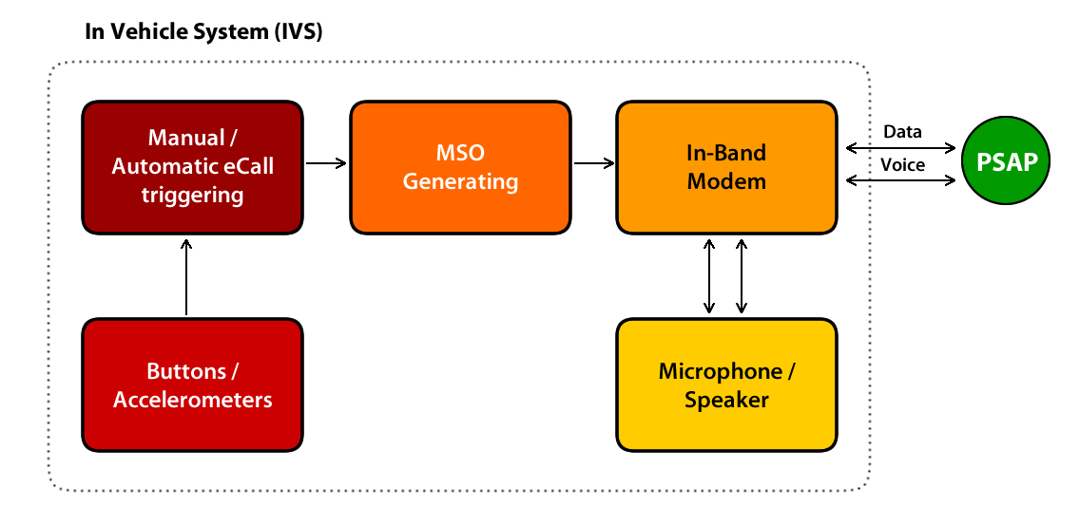

**Figure 25: In Vehicle System**

There will be used two prototypes of eCall IVS, one from Secar and other from Telematix production. All these OBUs are based on common fleet management equipment, where some extra features for eCall will be added. these are:

1. In-band modem implementation

IVS’s In band will be in accordance with following norms and specifications:

1. In-band modem solution; General description (Release 10) 3GPP TS 26.267 V10.0.0 (2011-03)
2. In-band modem solution; Conformance testing (Release 10) 3GPP TS 26.269 V10.0.0 (2011-03)
3. In-band modem solution; ANSI-C reference code (Release 10) 3GPP TS 26.268 V10.0.0 (2011-03) + 26268-a00_ANSI-C_Source_Code.zip
4. Intelligent transport systems - eSafety - eCall minimum set of data (MSD) EN 15722, June 2011
5. Intelligent transport systems - ESafety - ECall high level application requirements (HLAP) EN 16062, Date: 2010-09
6. Intelligent transport systems - ESafety - Pan European eCall - Operating requirements EN 16072, Date: 2010 -09

2. Implementation for sending MSD - Intelligent transport systems - eSafety - eCall minimum set of data (MSD) EN 15722, June 2011

There is other supported functionality/specification:

* only common SIM card will be used (not only eCall dedicated)
* optional support for the mobile networks (3G) by IVS.
* in case of resend MSD IVS should provide PSAP with the actual position of the car
* support for VIN decoding
* optionally User Assistance Call
* Autonomous operation with embedded antenna and battery

### PSAP

Following picture describes overall architecture of testing PSAP where eCall service will be implemented. Upgrade will concern both Call Centre and application part of the PSAP system.



**Figure 26: The architecture of testing PSAP**

Basic changes to be realized during pilot project implementation:

A) Call Centre part

* integration of PSAP In band modem into the IVR
* PBX/CCD routing configuration
* Checking and handover of MSD into the application superstructure

B) Application superstructure part

* MSD handling
* presentation and visualization of MSD in call taker application
* visualization of incident location in GIS
* VIN decoder implementation
* transmission of MSD and VIN data to the Emergency Rescue systems (Fire Rescue Service, Police and Ambulance)
* transmission of eCall data into the Traffic Management System
* implementation and testing of TPS interface

#### PSAP modem integration

Design of In-band modem integration into the PSAP is in accordance with following norms and specifications:

1. In-band modem solution; General description (Release 10) 3GPP TS 26.267 V10.0.0 (2011-03)
2. In-band modem solution; Conformance testing (Release 10) 3GPP TS 26.269 V10.0.0 (2011-03)
3. In-band modem solution; ANSI-C reference code (Release 10) 3GPP TS 26.268 V10.0.0 (2011-03) + 26268-a00_ANSI-C_Source_Code.zip
4. Intelligent transport systems - eSafety - eCall minimum set of data (MSD) EN 15722, June 2011
5. Intelligent transport systems - ESafety - ECall high level application requirements (HLAP) EN 16062, Date: 2010-09
6. Intelligent transport systems - ESafety - Pan European eCall - Operating requirements EN 16072, Date: 2010 -09

#### Basic eCall flow

Telefónica fix network delivers the eCall with a special Network Routing Number (NRN) to the PSAP PBX. This NRN is assigned by the mobile network after the eCall flag identification. Called number is analysed in PBX script and if special NRN code is found (it means eCall is identified) then the call is routed to the input CCD eCall pilot and consequently CCD distribution routes the call directly to the processing group of CCIVR. CCIVR application will be in charge to collect MSD from the IVS call, attach all information contained in these data to the call and then route it to an agent group – pilot CCD. CCIVR answers the call and timeout T3 starts.

VPRM module in CCIVR creates the audio channel to the PBX via the NMS board (PCi embedded board for voice processing). Audio channel is shared with speech recognition module. After the call is answered an in band communication begins between IVS and eCall modem which is integrated in CCIVR. The eCall modem is in fact a library developed by ALCATEL-LUCENT based on the STS SDK which will interface the STS and the eCall algorithms. It manages the transmission protocol through eCall Data Transfer module which is a library based on the ANSI-C references code (TS 26.268). This library will return to the CCIVR application a string data containing all MSD information.

Once information has been successfully collected by the eCall PSAP modem, the CCIVR will be able to attach data to the call using a OmniGenesys CCIVR Connector and then transfer the call to an agent. Respective routing uses simple principal Pilot – Queue – Agent group. For a call distribution so called MIT (Maximum Idle Time) mechanism is applied.

When an agent takes the call, call taker application is in charge to get attached data – all information provided in the MSD. The agent will be in audio communication with the occupants of the vehicle. And MSD are displayed on the screen.

#### Resend MSD

As specified in EN16072 (chapter 8.15), after the MSD has been sent and the IVS occupants are in communication with an agent, the system shall continue to response to MSD resend request from PSAP for the duration of the call.

During voice communication with between vehicle passengers PSAP operator can decide to obtain MSD. He or she will use a special “new MSD” button in call taker application. This new feature will transfer the call to a CCIVR application and put the agent in withdrawal status.

When “new MSD” button is pushed, the call is reconnected to the CCD pilot and subsequently to the CCIVR. The operator is in the status called “Withdrawal” which means that the PSAP system cannot assign to the operator other calls than this one which is now reconnected to the CCIVR CCD Pilot. CCIVR sends through eCall modem request „SEND MSD“ to IVS. Reception and KVP actualization is done and the call is immediately returned back to the operator who initiated the reconnection to the CCIVR. The operator continues in the communication with IVS occupants and MSD data are updated.

#### eCall data visualisation

PSAP application superstructure will be upgraded by several functional blocks supporting eCall service as follows:

* eCall data reception
* eCall data distribution
* eCall data visualisation
* VIN decoder
* Resend MSD
* Traffic mgt interface
* TPS interface
* TDS handling

Following chapter briefly describes a basic functionality of respective SW modules that are responsible for a.m. functions.

***eCall Centre***

New component - central manager of eCall processing in application superstructure responsible for:

* eCall data handover to the call taker application
* external data gain request initialization and handover to call taker application
* eCall data handover to the external systems
* eCall distribution to other PSAP

***PSAP Call Agent***

Manager of SW telephony will be upgraded in connection with MSD content and attributes and Resend MSD function.

***PSAP dispatcher***

Basic call taker application will be upgraded in connection with eCall visualization and changes in eCall reception control.

***PSAP GIS client***

Current PSAP module will be upgraded in connection with eCall visualization. Changes in road determination algorithm will be implemented.

***VIN decoder client***

It is a web service responsible for data gaining from external source. In case of communication outages it repeats a data request according to client configuration. VIN data from external system are as follows:

* Vehicle category
* Manufacturer/brand
* Vehicle model
* Year of manufacture
* Model year
* Number of seats
* Number of airbags
* Fuel type
* Car size (length, width, height)
* Weight

***TPSP client***

It is a web service where TPS interface is implemented – client part.

***TPSP Server***

It is a web service where TPS interface is implemented – server part. It receives data from TPSP and hands it over to eCall centre.

***TMS client***

This module – web service – is responsible for a communication towards Traffic management system. Communication request is initiated by eCall centre module. In case of communication outages it repeats a data request according to client configuration.

## *Romania*

### Technical solution overview

#### Introduction

ECall, in terms of concept, system and service, is a European Commission initiative, defined in the eSafety program aiming at increasing road safety.

The system involves fitting out cars with a module that calls automatically or manually the 112 emergency service in case of an incident and endowing the answering emergency centres with equipments to enable reception and associate data type for eCalls (see Figure 27).

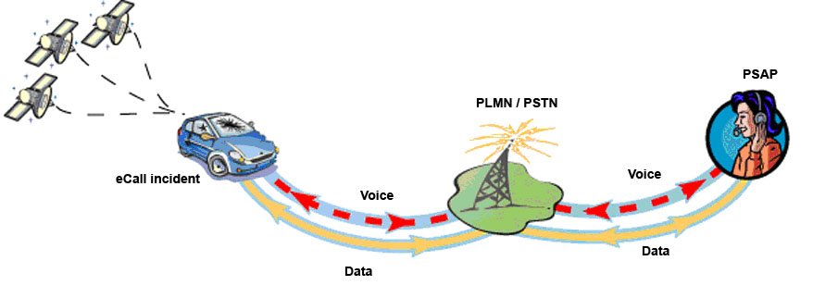

**Figure 27: eCall data and voice transmission**

The current eCall pilot is based on standards defined for this purpose, as follows:

* Intelligent transport systems - eSafety - eCall minimum set of data (MSD) - ver. 15722;
* Intelligent transport systems - eSafety - eCall high level application requirements (HLAP) - ver. 16062;
* Intelligent transport systems - esafety - Pan European eCall - Operating requirements - ver. 16072;
* 3GPP TS 24.008 - ver. V10.0.0;
* 3GPP TS 26.267 - ver. V10.0.0;
* 3GPP TS 26.268 - ver. V10.0.0;
* 3GPP TS 26.269 - ver. V10.0.0.

The proposed solution used for the decoding and processing module will be developed on Microsoft platforms such as: Windows 2008 Server R2, SQL 2008 Server R2, IIS and Silverlight. Only the capture module will use Linux.

#### Generic eCall scheme at subsystems level

Romania eCall pilot is implemented in a centralized manner, all eCalls (data and voice) are forwarded to a central PSAP located in Bucharest, whose operators will process the call and will contact the necessary emergency services (also referred to as “agencies”) for the dispatch. Currently, the 112 Romanian system consists of the following subsystems for the 112 emergency calls management:

* CoordCom ver. P2D (data and VOIP);
* F2CA ver. 1.3 (GIS);
* APD Coordinator 7 (AVLS);
* SL ver. 1.0 (mobile positioning).
* The generic schema for eCall at subsystems level is presented in Figure 28.

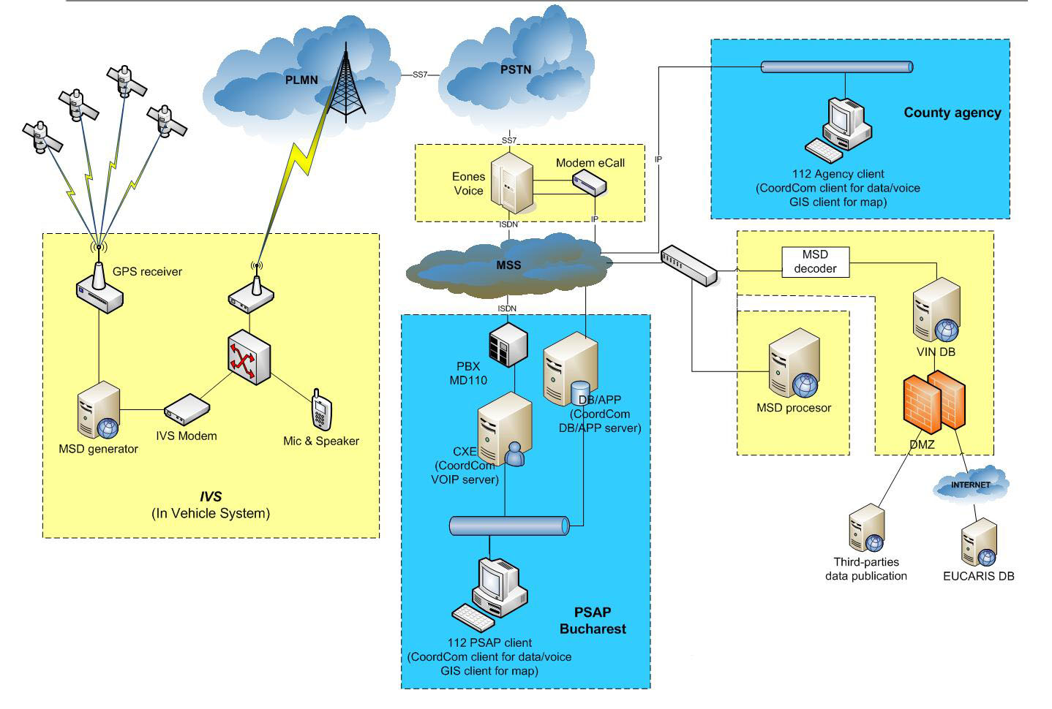

**Figure 28: The generic scheme for eCall at subsystems level**

All the subsystems shown in the figure above are listed below:

1. **GPS receiver** - system for receiving satellite positions (standard updated at every 2 seconds);
2. **MSD generator** (MSD = Minimum Set of Data) - generates MSD based on data collected from the vehicle computer, the car sensors (airbag, etc.) and the GPS receiver;
3. **IVS Modem** (In Vehicle System) - equipment to be installed on the vehicle, which will be responsible for generating the eCall (Manually Initiated eCall = MIeC / Automatically Initiated eCall = AIeC) using the Subscriber Identity Module (SIM) card;
4. **Mic & Speaker** - the microphone and the speaker installed in the vehicle allowing the operator to discuss with occupants or hear what happens in the car (voice);
5. **PLMN / PSTN** - mobile and fixed telephone network which allows the eCall transit;
6. **Eones** - eCall identification equipment (based on eCall flag);
7. **Modem eCall** - equipment to extract the MSD message from eCall;
8. **MSS** - Multiprotocol Switched Services (owned by STS);
9. **MSD decoder** - decoding system data from MSD;
10. **MSD processor** - processing system data from MSD;
11. **VIN DB** - VIN (Vehicle Identification Number) database;
12. **EUCARIS DB** - Eucaris (EUropean CAR and driving license Information System) database wherefrom additional data will be extracted based on VIN; secure access via DMZ;
13. **Third-parties publication** - server to transfer the eCall data to external systems (e.g. National Company for Motorways and National Roads in Romania, insurers etc.); it secure access via DMZ;
14. **PSAP Bucharest** - Public Safety Answering Point for the emergency 112 calls located in Bucharest;
15. **County agency** - 112 emergency agencies (e.g. Ambulance, Police, Fire brigade, SMURD, Gendarmerie etc.) located at county level.

#### Description of the detailed eCall scheme

Centralized solution is based on the submission by the mobile operator of the eCall discriminator ("eCall Flag"). We should mention that in Romania, a regular 112 call (non eCall) is routed to the PSAP at the regional level (county). Without the eCall flag, the eCall will be treated as a regular 112 call because the eCall will not be routed to the eCall modem and it will automatically reach the 112 centre of the county where the eCall was initiated (it basically follows the same route as a regular 112 call). In this case, the data session is not executed.

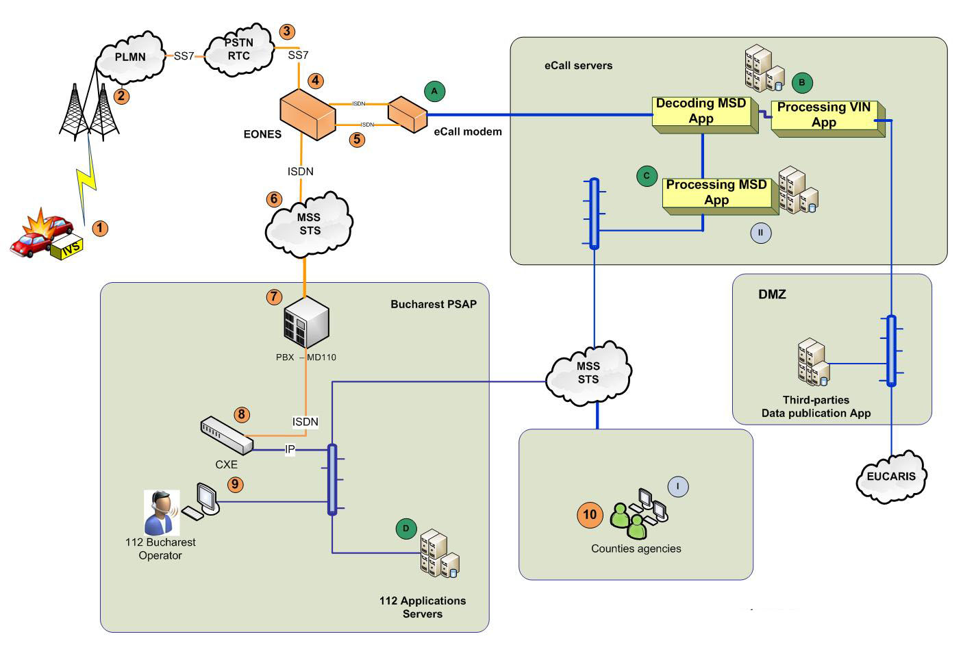

**Figure 29: Detailed scheme of the network**

Therefore, the eCall steps described in Figure 29 are:

1. A trigger in the vehicle (AIeC/MIeC) causes an eCall ordering to the IVS equipment;
2. The call is picked up by the nearest site GSM PLMN and routed further to PSTN (local telecom operator is Romtelecom “RTC”);
3. From the RTC network, the call is routed to Eones equipments (owned by STS – used for mobile phones positioning), which are situated in one of the 7 interconnection points (RTC - STS), based on the eCall flag, the call is routed to the eCall modem;
4. The eCall modem change the B-number of the <112> **CountyCode** into <**21**112> and though the call is prepared to be routed to the Bucharest PSAP (A-number=caller number; B-number=112 emergency service number);
5. The eCall enters the STS central network (MSS) and based on the <**21>** (prefix for Bucharest) will be routed to the Bucharest PSAP;
6. The call is received and distributed by MD110-PBX to the CXE server (CoordCom VOIP server);
7. The eCall is routed to the 112 VoIP network;
8. The call is displayed on the 112 operators console (112 clients):
9. The eCall modem receives and transmits the MSD message to the MSD decoding module;
10. The MSD decoding module decodes the message, extracts the VIN and transmits it to the VIN processing;
11. The MSD decoding module decodes the MSD message and transmits the decoded data to the MSD processing module;
12. The MSD data is processed and inserted into the 112 applications;
13. The 112 operator processes the received data and transmits the case with complete data sheet together with the voice to the responsible agencies operators located in the county from which the eCall was generated based on GPS position and the location of the GSM site:
14. The agency operator requests VIN data from the MSD processing module;
15. The MSD processing module requires VIN data from the MSD decoding module.

#### Detailed internal and external eCall interfaces

Considering the number of subsystems that work with each other, several interfaces are necessary for their connection. There are two types of interfaces: internal and external. The internal ones are bounded by two SNUAU subsystems and the external ones link the SNUAU with other systems.

The necessary interfaces for eCall are shown in Figure 30:

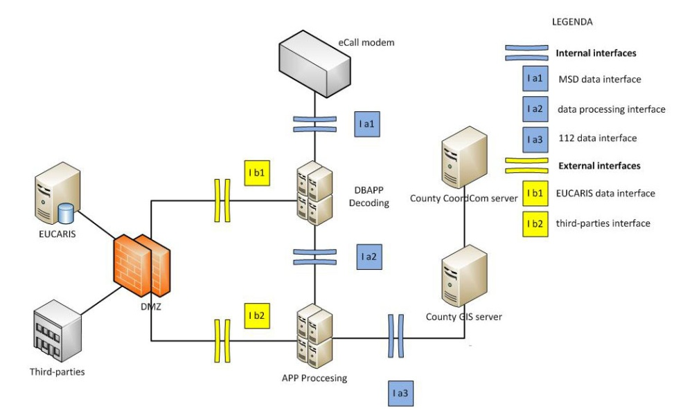

**Figure 30: eCall interfaces**

Types of interfaces:

1. Internal interfaces:

* MSD data interface (placed between the eCall modem and the MSD decoder): it allows the transfer of the captured MSD message;
* Data processing interfaces (placed between MSD decoder and MSD processor): they allow data exchange (MSD and EUCARIS) between the decoding layer and the processing layer;
* 112 data interface (placed between MSD processor and 112 system): it allows the message exchange (MSD and EUCARIS) between the processing layer and the 112 applications;

1. External interfaces:

* EUCARIS data interfaces (placed between MSD decoding and EUCARIS): they allow the message exchange between MSD decoder and EUCARIS DB based on VIN;
* Third-parties (placed between MSD processor and third-parties): they allow transferring the eCall data, or other data related to car incidents, to the authorized institutions.

The technology used for the interfaces will rely on web-services.

#### 4.7.5 The sequence of eCall messages

The sequence of eCall messages can be seen in Figure 31.

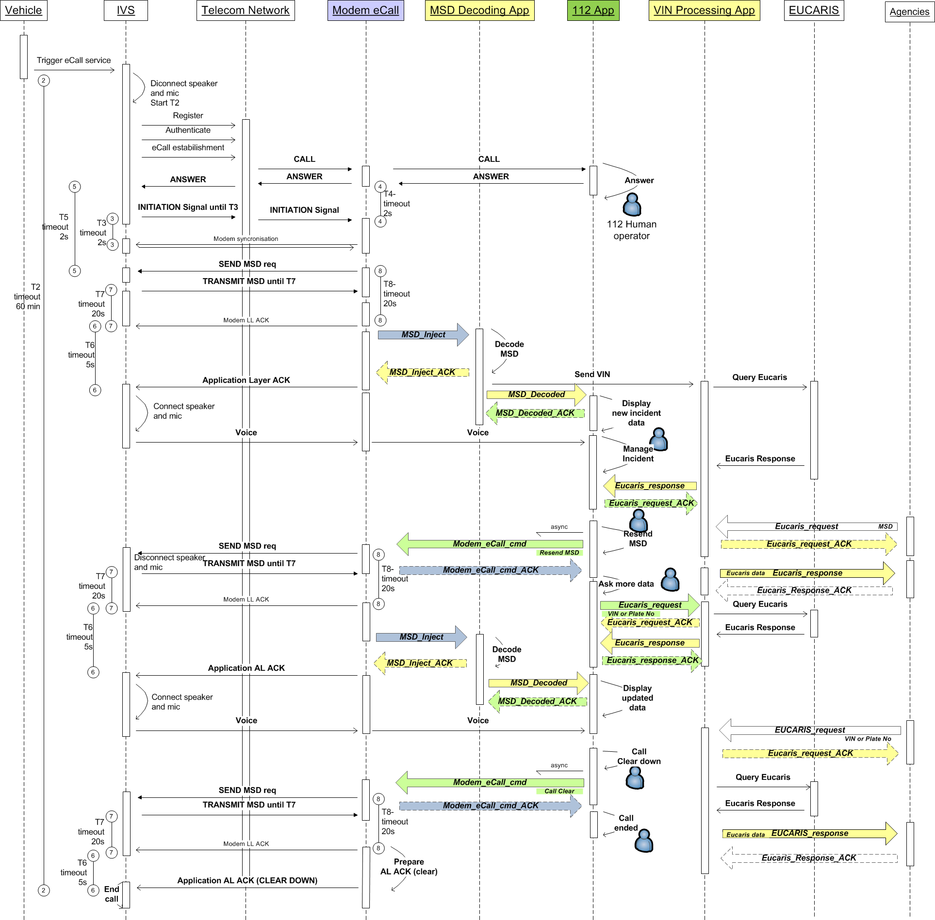

**Figure 31: The sequence of eCall messages**

Description of scheme:

1. An event (“trigger”) inside of the vehicle (AIeC/MIeC) determines the ordering of an eCall transaction to the IVS equipment;
2. At the occurrence of the "trigger", the IVS starts the T2 timer, it makes the authentication in the mobile network corresponding with the cell in which it resides, finally settling up a connection;
3. The call comes in the STS network through the 7 points interconnection with the RTC network, the EONES device routes the call to the eCall modem based on the eCall flag. This changes in the B-number <**21**112> returns it to the EONES equipment to be routed to the Bucharest PSAP; finally, the call generated by the IVS from within the vehicle transits the eCall modem;
4. The 112 operator from Bucharest "sees/hears” the call and answer it; a new form of incident (case folder) is now open in CoordCom Client; the eCall modem starts the T4 timer by waiting for the "signal Initiation" from the IVS modem; the answer is returned by the PLMN to the IVS modem, the IVS modem disconnects the microphone and speakers in the car:
   * Being an eCall, the 112 operator will hear during the data transmission (up to switch to voice of IVS modem) a pre-recorded voice message () information for data transmission;
5. The IVS modem starts the T5 timer. At this time a telephony connection has already been established between the two modems;
6. The IVS modem starts the T3 timer and starts sending the initiation signal); it continues to send this signal until it receives synchronizing messages from the eCall modem or until the expiry of the timer and then stops and waits;
7. Once the synchronization is successful, the eCall modem requires to the IVS modem to send the MSD message (sends "request MSD"); it also starts the T8 timer;
8. The IVS modem receives the "MSD request" message, it sends the MSD message and it starts the T7 timer; the IVS modem continuously sends the message until it receives from the eCall modem the Layer Acknowledgment Link (LL ACK) or until the expiry of the T7 timer;
9. After receiving the MSD message, the eCall modem will respond with LL ACK and send the MSD message to MSD decoding application;
10. The IVS modem receives LL ACK, starts the T6 timer and waits;
11. The MSD decoding application decodes the MSD message and responds with AL ACK having the status "Positive ACK", which means that the message was received and successfully decoded:
    * If MSD cannot be decoded, because it doesn’t comply with the standard content or for other reasons, the MSD decoding application will not respond with AL_ACK; this is the outcome since after the T6 timer expires, the IVS modem enters the voice mode (it connects the car speakers and microphone);
12. The eCall modem will transmit AL ACK to the IVS modem; at this point the IVS modem will connect the speakers and the microphone in the car (allowing voice communication);
13. The MSD decoding application shall immediately transmit the decoded MSD message to MSD processing layer; at the same time, the obtained VIN will be sent to the VIN processing application:
    * 112 App will display the contents of the MSD on the 112 operator screen - the case file created when the call was answered is updated with MSD data;
    * When the IVS modem will connect the speakers and the microphone from the vehicle, the eCall modem will stop the voice message and the 112 operator starts hearing voice/sounds inside the car; also, the 112 operator is heard by those in the vehicle;
    * App VIN processing will query the EUCARIS network and obtain additional data on the vehicle, locally storing it.

### 4.7.2 Basic component of the solution (roles and functions)

The parts involved in the process of generation, reception and handling an eCall are:

**IVS**, to manage data and voice inside of the vehicle; in this pilot we are using an IVS according with 3GPP imposed standards:

1. bringing eCall trigger;
2. reference signal to initiate communication between the modems;
3. send MSD;
4. closing session reference signal voice/data according to agreed work time (since there is no possibility of the modem to stay busy).



**Figure 32: The IVS modem**

**PLMN-PSTN**, a mobile and fixed telephone network through which the eCall passes:

1. the network operators will handle the eCalls as a regular 112/E112, providing information on the identity and location of the caller; eCalls will have the same priority as any other emergency call;
2. the network operators should consider implementing the eCall discriminator ("eCall flag") into the network centres, which will allow differentiation between the regular 112 and the eCall type of calls and also between the eCalls initiated manually and automatically; this feature allows the MNOs to identify and to route the eCall (voice and data) to the appropriate PSAP (in our case Bucharest PSAP);
3. the network operators must reach an agreement regarding the implementation plan for the eCall discriminator;
4. the network operators should work with vehicle manufacturers to find the best way to implement the eCall SIM cards, including to consider providing value-added services.

**eCall modem** (it detects an eCall and acts like a bridge between the IVS and 112 eCall applications)**:**

1. change the B-number of <**CountyCode**112> into <**21**112>;
2. listen the line (voice channel);
3. captures and transmits the MSD message to the decoding module;
4. request for MSD retransmission;
5. running voice message at the 112 operator during MSD transmission.



**Figure 33: The eCall modem**

**EONES:**

1. discriminates a 112 call non-eCall from an 112 eCall based on "eCall Flag";
2. routes the eCall to the E1 port on which is connected the eCall modem;
3. receives the call from the eCall modem on another E1 port and routes it to the MSS STS network.

**MSS** (Multiprotocol Switched Services owned by STS used for eCall transport between IVS, Bucharest PSAP and emergency agencies from counties):

1. based on B-number routes de call to PSAP Bucharest.

**MSD decoding unit:**

1. decodes the MSD message;
2. requests EUCARIS data based on VIN or license plate;
3. sends decoded MSD data to the processing module;
4. sends EUCARIS data to the processing module.

**MSD processing unit:**

1. process MSD data;
2. sends MSD data to the GIS server;
3. sends request for EUCARIS data to the decoding module;
4. sends EUCARIS data to the GIS server.

**GIS server:**

1. receives MSD data;
2. sends MSD data to the GIS client;
3. sends EUCARIS data to GIS client;
4. sends request for EUCARIS data to the processing module.

**GIS client:**

1. displays MSD data to the operator client console;
2. displays EUCARIS data to the operator client console;
3. requests for EUCARIS data to the GIS server;
4. sends MSD data to the CoordCom Operator (CoordCom client);
5. closes the session between the IVS modem and the eCall modem (call clear down)

**CoordCom client:**

1. answers to the eCall;
2. sets the position of the incident on the map (GIS client) to fill the case folder with MSD data using the existing interface between CoordCom client and the GIS client;
3. transfers the eCall (voice and data) to the specialized emergency agencies of intervention.

**EUCARIS**: a unique system that provides opportunities to countries to share their car and driving license registration information**.**

**Third-parties**: external systems that need to receive eCall data according with national laws and protocols - e.g. National Company for Motorways and National Roads in Romania, insurers, etc.

**Others services:** archiving/logging/playback/backup/monitoring for eCall service.

### 4.7.3 Description of eCall operating

The handling of eCalls requires a series of procedural changes and additional activities, such as:

* eCall operational procedures for handling special cases (in cases where, e.g. the voice connection is not possible with the vehicle passengers);
* training courses for PSAP operators;
* protocol implementation for data transmission on the incident by the operators of roads/traffic management centres;
* eCall Handling Procedures in border areas;
* eCall service must provide the same data protection security as the regular 112 system.

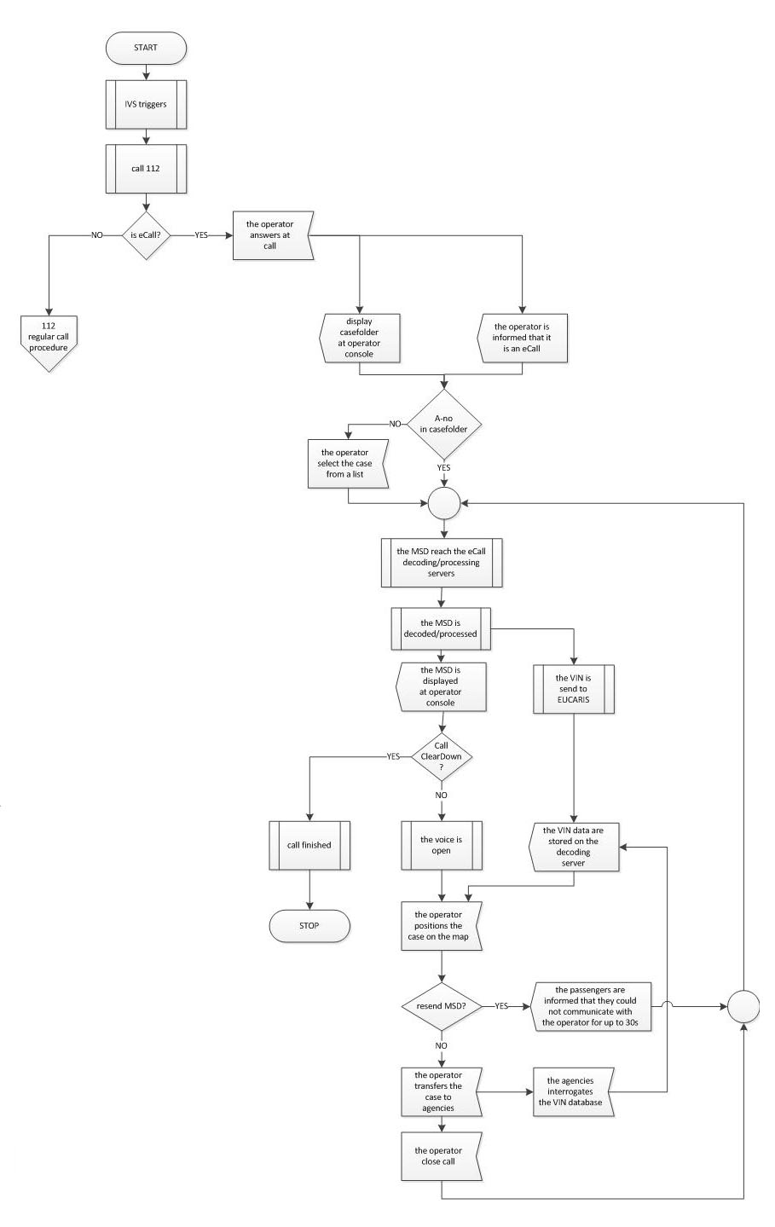

**Figure 34: Tree service operating eCall**

Data flow and operating procedures related to an eCall contains:

* an automatically or manually generated eCall from a vehicle equipped with IVS;
* the eCall is presented to all 112 operators from the Bucharest PSAP, log into the system with 112 receiver role or with dedicated eCall role in the inbox from application CoordCom Operator;
* one of the 112 operators takes the eCall;
* in CoordCom Operator application the case folder automatically displayed is generated and completed with the phone number assigned to the IVS equipment; if the case folder is not filled in with the phone number, the operator can select it from a list of current eCalls available from the GIS client; after selecting it in the list the data is automatically transferred to the CoordCom Operator;
* existing case data (case folder id, an index level 1 named like " eCall" selected manually by the operator 112, telephone number) is transmitted automatically to the associated GIS client with the operator position who took the eCall;
* the eCall modem receives the signal "Initiation" generated by the IVS equipment and starts the synchronization/transmission session of MSD data;
* the 112 operator hears during the synchronization / transmission session of MSD data a default voice message, being unable to communicate with people in the vehicle;
* also, during the session data the operator will not end the call from the client CoordCom and the "ClearDown" button from GIS client will not be active;
* after the session synchronization / transmission session of data the voice session is restored and the 112 operator is available in the GIS client to the MSD dataset decoded and processed in the lower layers;
* the operator initiates in the CoordCom client the action for positioning the case on the map; the MSD dataset decoded and processed is displayed in the CoordCom application acting like a response to the positioning action;
* after setting all necessary data (resend MSD etc.), the system will transfer the case to the responsible agencies via the CoordCom application;
* the dispatcher from the agency is able to query the EUCARIS database using the VIN to request additional data;
* the eCall is completed only by clicking "ClearDown" button available in GIS client.

## *Greece*

### Introduction

In the following sections the main functionalities of the PSAP, the network and the IVS for the support of eCall pilots are presented.

### PSAP functions

The main functional blocks of the eCall enabled PSAP that will be used for the pilots of the HeERO project is presented in **Error! Reference source not found.**.

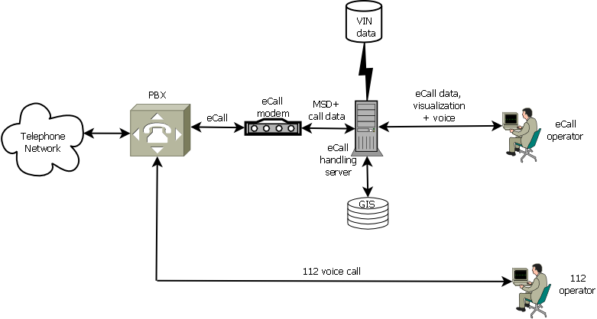

**Figure 35: Diagram of upgraded PSAP to support eCall**

Incoming eCalls are routed from the telephone network to the PSAP. The eCalls are forwarded to the eCall modem for the establishment of the communication link. Following link establishment the Minimum Set of Data (MSD) is sent by the In-Vehicle-System (IVS) to the PSAP. The MSD provides the VIN number of the vehicle, timing, direction and location of the incident from which, with the assistance of a VIN decoder, precise vehicle model details can be obtained and visualization of the incident location. A voice (audio) link is then established with the eCall operator.

The normal procedure for handling ‘112’ voice calls will be modified in order to support eCall. The procedure that will support the handling of eCall is presented in **Error! Reference source not found.**.

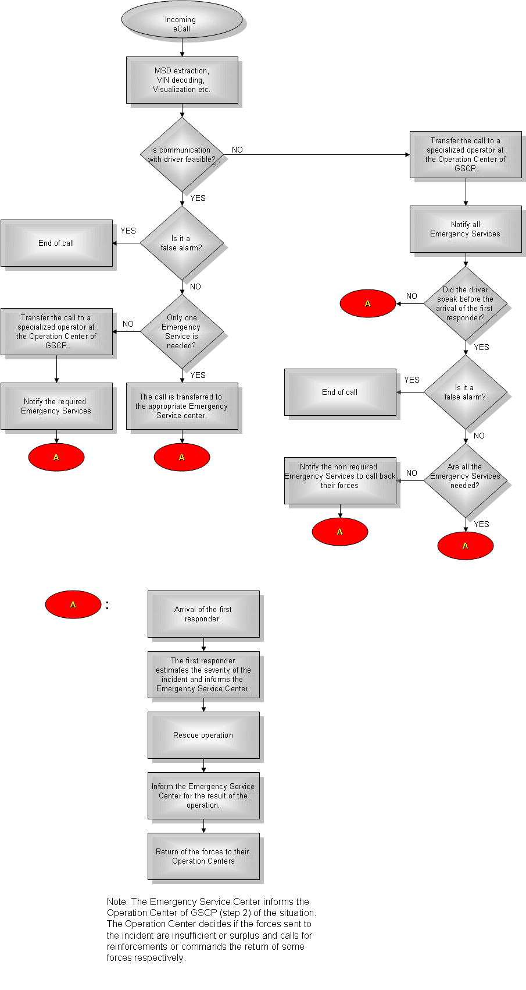

**Figure 36: eCall handling procedure**

### Network functions

An eCall, from the network point of view, is a manually or automatically initiated emergency call (TS12) from a vehicle, supplemented with a minimum set of emergency related data (MSD). The description of a TS12 emergency call from 3GPP TS 22.003 is given in **Error! Reference source not found.**:

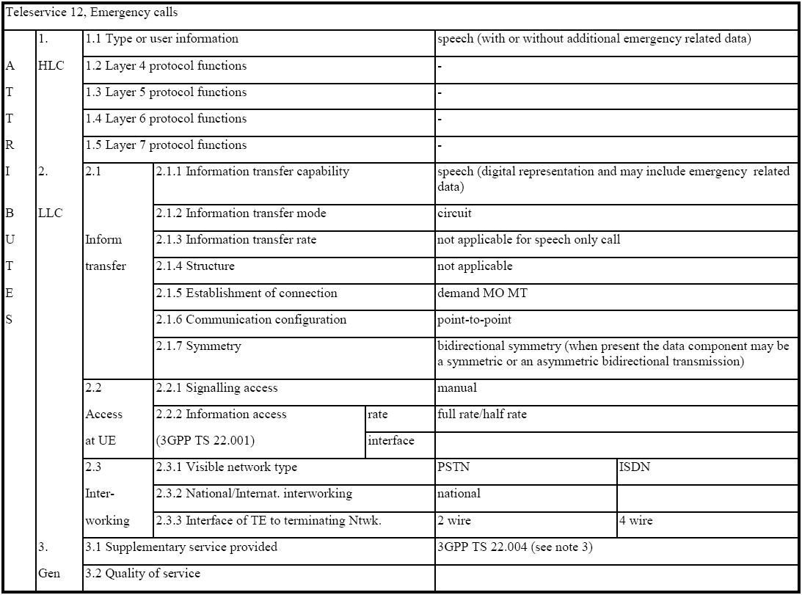

**Table 4: TS12 description**

The eCall includes data transmission along with voice transmission. Hence additional requirements have been identified in 3GPP TS 22.101 for the data transmission through the PLMN:

The ‘service category’ information element, defined in 3GPP TS 24.008, contains in its third octet the field ‘Emergency Service Category Value’. The size of the ‘Emergency Service Category Value’ is 7 bits and the meaning of each bit presented in **Error! Reference source not found.**.

|  |  |
| --- | --- |
| **Emergency Service Category** | |
| **Bit number** | **Meaning** |
| 1 | Police |
| 2 | Ambulance |
| 3 | Fire Brigade |
| 4 | Marine Guard |
| 5 | Mountain Rescue |
| 6 | manually initiated eCall |
| 7 | automatically initiated eCall |
| 8 | spare and set to "0" |

**Table 5: Emergency Service Category bits**

The Mobile station may set one or more bits of the ‘Emergency Service Category Value’ to "1". If more than one bit is set to "1", according to the standard routing to a combined Emergency centre is required. If the MSC cannot match the received service category to any of the emergency centres, it shall route the call to an operator defined default emergency centre. If no bit is set to "1", the MSC shall route the Emergency call to an operator defined default emergency centre. A mobile station initiating an eCall shall set either bit 6 or bit 7 to “1”. The network may use the information indicated in bit 6 and bit 7 to route the manually or automatically initiated eCall to an operator defined emergency call centre.

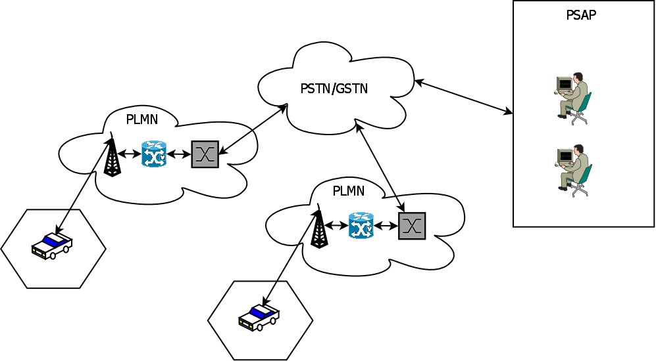

**Figure 37: eCall routing**

In Greece there is one central ‘112’ PSAP, operated by the General Secretariat of Civil Protection (GSCP). The PSAP dispatches the emergency calls to the Fire Brigade, Police etc. according to each case specific requirements. The eCall is implemented as a voice band modem call terminating at the PSAP. The 112 call is routed to the single 112 PSAP, where the modem call will be terminated and the data part will be extracted and processed. Bits 6 and 7 of the ‘Emergency Service Category Value’ will not be used for the routing of the call through the network since every eCall will be routed to the single 112 PSAP which operates in Greece as it is depicted in **Error! Reference source not found.**. Since in the test bench the eCall indicators are not supported by the serving network, the time needed for the PSAP eCall modem to differentiate between eCalls and other TS12 calls, before routing the call to an operator, shall not exceed two seconds from when the IVS receives notification that the PSAP has answered the call.

### In Vehicle System (IVS) functions

The eCall IVS according to the standards provides the following functionality:

* Automatic (vehicle collision) or manual (cabin button) initiation of eCall.
* Initiation of the communication with the PSAP through the PLMN.
* Transmission of the MSD to the PSAP and activation of the voice channel.
* Both voice and data components are routed to the same PSAP. Data may be sent prior to, in parallel with, or at the start of the voice connection of the emergency call, as specified in 3GPP TS 22.101. If the MSD component is corrupted or lost for any reason, the eCall speech functionality process shall not be affected.
* PSAP is allowed to request for additional data or if necessary, request data retransmission in the case of errors detected.
* The MSD is considered reliably transmitted to the PSAP, if the cyclic redundancy check (CRC) detects no errors.

The functionalities of the IVS are expected to be implemented by a microprocessor use based on hardware/software combination. The main functional blocks of the IVS are:

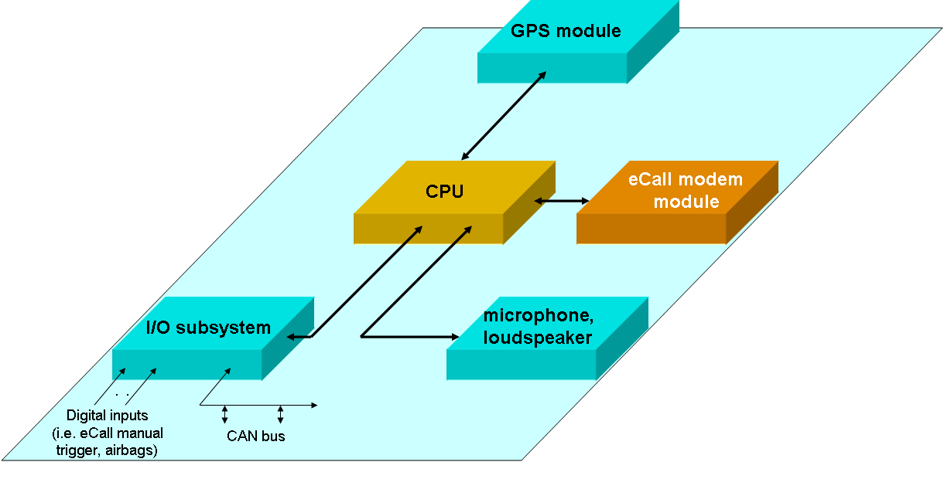

**Figure 38: IVS functional blocks**

* **CPU**: The role of the microprocessor is to supervise and control the IVS subsystems. It implements the algorithms that are necessary for the activation of eCall, the communication with PSAP, the transmission of the data part etc.
* **eCall modem**: The eCall modem block provides the means for the communication of the IVS with PSAP though the PLMN. It consists of the digital part and the analogue front end.
* **GPS**: The GPS block receives the signals from the satellites and provides the current coordinates of the IVS to the CPU for further processing. It also informs the CPU for the validity of the coordinates.
* **I/O subsystem**: The I/O subsystem block interfaces the IVS to the various systems of the vehicle that are required for the operation of IVS such as airbag status info, manual eCall trigger button, CAN bus if it supported by the vehicle etc.
* **microphone, loudspeaker**: This block interfaces the IVS to a microphone and to a loudspeaker that are required for the voice communication of the driver with the PSAP operator.

## *Italy*

### Introduction

In this section, general eCall related functions and their implementation for the Italian pilot will be described. The final aim of the pilot activity, being in line with the scope of the project, will be testing the complete chain of the eCall. The Italian pilot is also willing to demonstrate additional services to the basic eCall.

### Italian eCall Pilot functionalities

The national pilot will include the European eCall and an advanced breakdown call service (shortly bCall), enabling the handling of geo-referenced breakdown calls to a commercial service provider. Finally, the pilot will include the communication between the PSAP and a simulated “Real Time Traffic and Travel Information Centre” (RTTI Centre) for a quicker information service to the road users.

#### Basic Service chain: eCall

When a serious incident occurs, the on-board sensors trigger the start of an automatic eCall. The additional possibility of a “Manually originated” eCall is also provided by the IVS. Once triggered, the on-board vehicular system (IVS) establishes an automatic emergency communication (E112) over the public mobile network with the Public Safety Answering Point. Before actually enabling the voice connection, the IVS transmits the Minimum Set of Data (MSD) to the PSAP.

The eCall (MSD data + voice) carried through the mobile network, is recognized by the mobile network operator (MNO) as a 112 emergency call thanks to the “eCall discriminator” (a.k.a. “eCall flag”) and is handled accordingly. The MNO processes only the signalling of the incoming eCall by adding the suitable processing of the eCall discriminator to the usual processing of an E112 emergency call (which already includes the forwarding of the CLI for possible location request by the PSAP). The voice channel is routed transparently (MSD included) to the fixed network.

The Fixed Network Operator receives the incoming eCall by a MNO and forwards the voice call (MSD included) over ISDN connection. The related signalling includes the CLI originally provided by the MNO as well as the OpId identifying the MNO who received the eCall (Remark: only a single MNO is actually involved in the Italian HeERO Pilot). CLI and OpId (MNO Identification), if needed, may be used by the PSAP to request a best effort call location to the originating MNO.

The PSAP transmits an acknowledgement to IVS specifying that the MSD have been properly received.



**Figure 39: eCall Service chain**

#### Added Service chain: bCall

When a “Manually originated” bCall is activated, the on-board vehicular system (IVS) sends the bCall data to the relevant call centre, through a SMS or through http connection. The call will include geographic coordinates and telephone number of the SIM present in the OBU.

The private call centre will be able to perform the reverse geo-coding of the identified location (translation into an address) and to display the data associated with the call; the private call centre will be able to call back the OBU’s SIM.

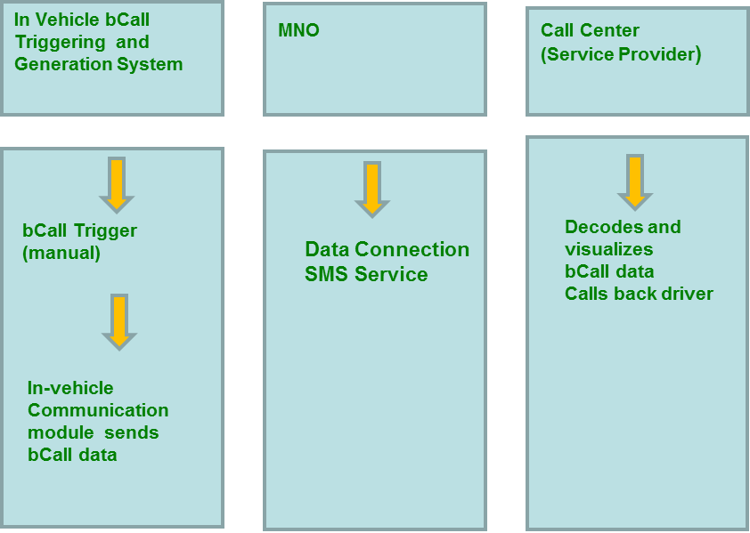

**Figure 40: bCall Service chain**

#### Added Service chain: Interaction with the RTTI Centre

Since the beginning, the introduction of the eCall has been considered as one of the most promising technology aimed at reducing not only the heavy death toll deriving from the road fatalities, but also the indirect costs linked to the congestion generated by road incidents. Indeed a quick alert about the occurred incidents would not only save lives but also help to inform the affected road users more quickly, enabling them to change their routes and thus avoiding congestion.

The proposal will simulate the interaction between the 1st level PSAP and the relevant RTTI Centre, through an exchange of xml files (one by the PSAP derived from the MSD, one as acknowledgment by the RTTI Centre). Each eCall will be then reported to the RTTI Centre, as an "eCall event", so as to allow the specific handling (validation) of this type of events, compared to those coming from the traditional sources.

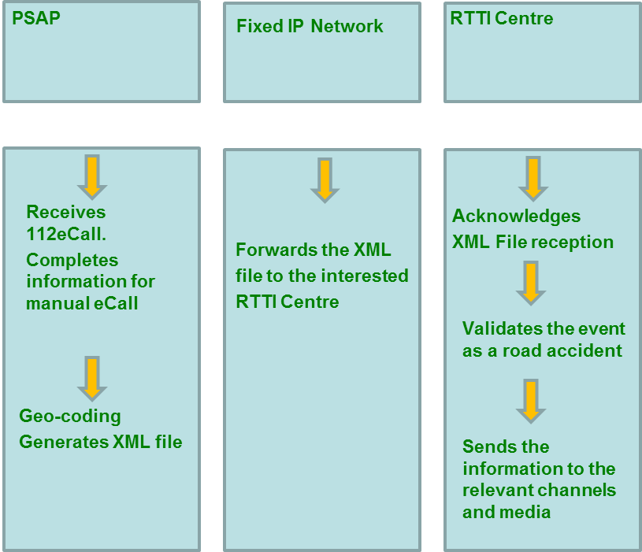

**Figure 41: Interaction with the RTTI Centre Service chain**

### Italian eCall Pilot: on field activities

The activities on the field will be carried out using telematic boxes installed on the following vehicles:

Fiat demonstrator vehicles (provided by CRF)

Cars belonging to premium ACI (Automobile Club Italia) customers

For each set of vehicles and user categories specific targets have been defined.

* For the Fiat demonstrators vehicles, the pilot activities aims at testing the integration of the telematic box inside the car and the automatic eCall function (via a simulated air bag explosion on the CAN bus).
* ACI cars will be used to test the manual eCall function and value added services which can be provided by the eCall telematic box, such as the breakdown and road assistance call.

The geographic area used as test bed is being identified based on the actual radio coverage provided by the base stations involved in the tests and will be the area supported by the Varese NUE 112 emergency call service, provided by the Varese PSAP. This PSAP today receives an average of 3 calls per day related to crash incidents compared to a total of 1150 emergency calls per day.

During the test period they will be generated a much bigger number of eCall showing the capability of the complete system to cope with the real needs.

### Italian eCall Pilot: specification

#### Fiat Cars Specification

CRF will provide Fiat demonstrator vehicles equipped with eCall devices; each vehicle will have the capability to activate both manual and automatic triggered eCall. This will allow to test the boards in the so called OEM-integrated configuration and to compare the two different types of activations.

The activity in the pilot will be finalized to verify the all eCall chain with IVSs from different suppliers in order also to get a general idea about some specific aspects:

* possible mounting positions of the board on the vehicle;
* the performance of the ECall platform in relation to its position;
* absolute performance in realistic contexts;
* comparative tests with a reference positioning system.

Three different FIAT vehicles will be used in the Italian Pilot:

* FIAT 500 (B segment)
* FIAT Bravo (C segment)
* Alfa Romeo Giulietta (D segment)

The IVSs used in FIAT vehicles are:

* ACTIA: Connect Unit “ACU” Generation 1;
* NXP: ATOP 2.5G Telebox Mini 3.0 (board used for test);
* DENSO: DCM (Data Communication Module) Suitcase;

At present the IVSs provided are prototypes, not commercial products, and in this sense not all the eCall features are already available or cannot yet be tested also due to the lack of infrastructure.

During the test phase in the Italian pilot, key performance indicators will be evaluated in all the IVSs according to the specification in D4.1 deliverable in order to provide comparable results.

At present the DENSO Board is composed by 3 subsystems:

* DCM module (Data Communications Module as IVS)
* External Antenna (to install inside the car)
* EE-bench as interface to test DCM

The housing is a mix between plastic (the antenna) and metal (DCM and EE-bench).

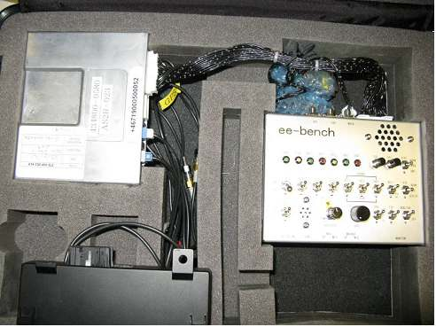

**Figure 42: DENSO testing kit**

The ACTIA Board is composed by a single device, shown in the figure below.

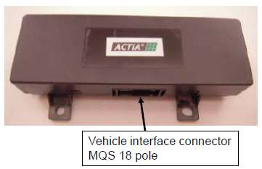

**Figure 43: ACTIA board**

The GPS and GSM antennas are integrated and placed inside a plastic box.

The NXP board is composed by a single device (it has not been provided with a protection case) and the antennas are not integrated.

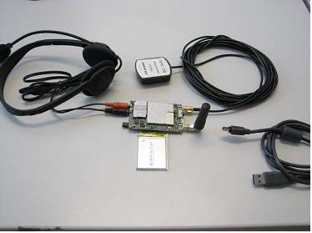

**Figure 44: NXP board**

#### ACI Cars Specification

The on board eCall solution, provided by Magneti Marelli, is based on two components:

* Telematic Control Unit providing
* GPS Functionality
* Cellular Network connectivity
* Integration with vehicle network (not implemented in HeERO project)
* Backup Battery
* Emergency Media Unit to manage User Interface

The break down call service to be implemented for testing added-value services will be integrated in the same application logic as the eCall. First of all, this kind of service requires a specific user interface. So the emergency media unit must be equipped with the following features:

* one dedicated button for eCall with associated pictogram
* one dedicated button for bCall with associated pictogram
* microphone and speaker

The strategy of bCall activation follows the same logic as the eCall, the main difference is that:

* while a bCall is active the system is still listening for eCall event (the user can initiate an eCall while in a bCall, in this case the bCall will be aborted)
* while in a bCall the system can still use the car battery to power the board



**Figure 45: bCall use case**



**Figure 46: eCall during bCall use case**

Summarizing, the bCall is not taken into account as a “Safety” function but as assistance calls. For this reason, the system does not enter a “safe” mode where all the functions other than the modem are disabled and the car battery is not used (to avoid fire and sparks after an incident).

Beside these safety aspects, coming to the actual implementation of the bCall service, the main difference from the eCall is that:

* no in-band modem technology is used
* either MSD over SMS or HTTP protocol are used
* phone call could be started by the assistance centre and not by the car

The choice of not using the in-band modem for bCall services is mainly because this kind of service is usually provided beyond the payment of a service fee thus we assume that a SIM card will be installed in the telematic box.

The in-band modem technology is well suited and conceived for transmitting a small amount (140 bytes) of data, while bCall could require more information or, at least, the level of information must be customizable by the service provider. Under this point of view is it likely that the parameters sent to the service centre will exceed the size of the MSD.

The transmission mechanism can be either the SMS or the HTTP depending upon the structure of the service centre.

Furthermore, for the bCall the use of the eCall flag is not required in any case.

At the end of the transmission of the data, the service centre could immediately call the user (this is a different scenario as the eCall where the call is started by the car itself). This happens because, in this way, there is the certainty that the service provider has received the notification and is handling it. However this is service provided specific and can be customized.

#### The Telecommunication Network for the Italian Pilot

The telecommunication network used for the pilot is provided by Telecom Italia and is a part of the real operation network available in the district of Varese which has been selected for the national pilot campaign.

The telecommunication network to be used in order to allow the delivery of the MSD and the vocal connection originated by the vehicle located in the Varese area to the designated PSAP consists of the mobile access and core networks providing public operational service to the specific geographical area and additional fixed network transits to properly route the incoming call to the designated PSAP

In addition, in order to be able to communicate with the relevant 2nd layer PSAP’s and additional external servers or providers, additional fixed network links (typically ISDN) will be needed. Most of them have been already deployed and are used by the current E112 PSAP, but it is likely that additional links will have to be made available, depending on the selected testing scenarios to be considered in the HeERO pilot.

The availability of access to the real operational mobile network is of course already guaranteed in the Varese area and is not at all subject of the HeERO Pilot.

The incoming eCall signalling (eCall discriminator) is designed to transits transparently through the Base Station (BS) and to be delivered and processed by the MSC(‘s) serving the interested geographical area in order to route the incoming eCall to the designated eCall PSAP. The number of BS’s involved in the end-to-end eCall testing campaign depends of the actual geographical area to be considered the pilot and the relevant analysis is already on-going. The current assumption is to be able to test the eCall service in a significant portion of the Varese metropolitan area. In any case, no impact related to the number of BS’s potentially used is expected on the eCall end-to-end service performance.

As a consequence, the relevant SW patch including the eCall discriminator processing will have to be made available by the provider of the MSC system installed in the Varese area and properly installed and tested by network operator by following the standard upgrade procedures required for the operation & maintenance of any public mobile network. To this aim, preliminary contacts are being established between Telecom Italia and its system provider.

Additional adaption/configurations will have to be provided in the fixed network in order to properly route the eCall “test calls” generated during the trial to the designated PSAP lines.

#### PSAP

AREU has set up and is managing a PSAP 1 in Varese since 21st Jun 2010. This Centre is collecting all the emergency calls (public safety, fire brigade and healthcare) for the Varese Province (about 1,100,000 citizens).

The technological infrastructure of the PSAP is composed by the following blocks:

* A Redundant PABX connected to the PSTN via 6 PRIs
* A fault-tolerant back-end server managing all the PSAP data
* A VPN connecting the PSAP to the second level specialized PSAPs (public safety, fire brigade and healthcare) and to the Italian Operating Centre for telecommunication localization and identification
* A specialized SW application devoted to the emergency call management and dispatching
* operators workstations dedicated specifically to the first level response and 3 spare workstations available in case of big disasters

The present infrastructure seems to be adequate to the eCall handling with the exception of:

* The in-band modem needed to decode the MSD
* An application software upgrade to be developed to fulfil the need to acquire the data coming from the in vehicle box and to be forwarded to the applicable PSAP 2
* An additional VPN connection allowing the communication between the PSAP and the Ministry of Transport Operating Centre aimed to receive data about the vehicle sending the eCall message (both national vehicles and EU vehicles via EUCARIS network).
* A connection to a Traffic Management Centre allowing the PSAP to communicate casualties’ data needed for public information.

As a direct consequence, all the operator procedures will be emended to include the new functionalities and the specific handling of this particular call.

All these procedural modifications will be agreed with the Italian Interior Ministry.

#### ACI services provider

The bCall service will include the treatment envisaged for the ACI Premium membership (ACI Gold Card):

* A basic technical support during the voice connection, in order to better address the customer needs and to provide first assistance tips;
* The on-site technical breakdown service aimed firstly at the on-site depannage service, if possible;
* The towing service to the chosen destination (private address, garage).

With this system the breakdown service would be certainly enriched by the accurate GPS location of the customer and to the voice connection established with the call centre.

Besides the breakdown assistance benefits other location based information services might also be provided to those who activate the service. However, it seems reasonable to limit the national pilot only to bCall service.

#### RTTI CENTRE

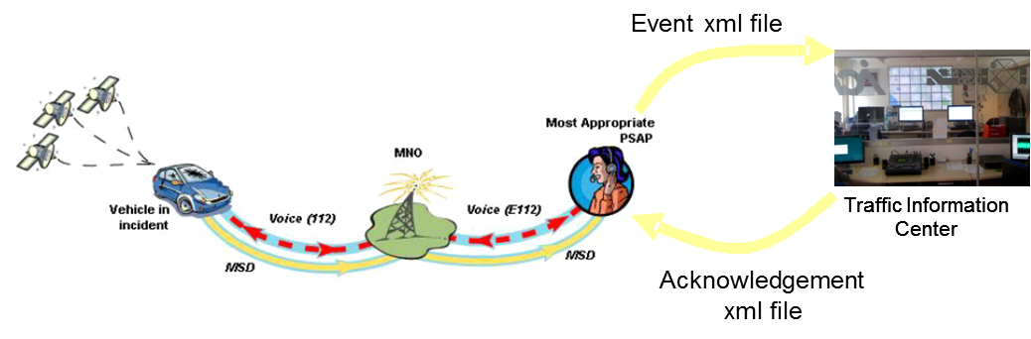

**Figure 47: Integration with RTTI Centre**

The proposal is based on the interaction between the 1st Level PSAP (AREU - Varese) and a Real Time Traffic Information (RTTI) Centre virtually simulated during the tests. This interaction envisages an exchange of files between the two structures, through an internet connection (i.e. through the opening of a VPN, to guarantee security).

At the reception of each eCall, based on the information included in the MSD and using the street address already decoded by the PSAP, the PSAP will generate a properly structured xml file, enabling the generation of a specific event on the RTTI platform. The event will be reported to the operators of the centre itself, as an "eCall event ", so as to handle with this specific type of events, compared to events coming from traditional sources.

Once the xml file has been received, the RTTI Centre sends an acknowledgment through an xml file always acknowledgment, in confirmation of receipt.

In the case of "manually" triggered eCall, the xml file will be generated by the 1st level PSAP operator, following the voice call outcome, as planned for the eCall procedures.

Once received the xml file, the RTTI Centre will send an acknowledgment through an xml file and will include the event within the internal procedures of validation and distribution to the relevant channels and media.

# Literature

[1] The eCall Program: Overview and Design Considerations, Sierra Wireless, 2010.

[2] “ERA GLONASS” Project, JSC «Navigation –Information Systems», Federal Network operator of navigation services, 2010.

http://www.eu-russia-industrialists.org/ru/documents/AsafievNIS.pdf

[3] ETSI TS 126 267 V8.0.0

http://www.etsi.org/deliver/etsi_ts/126200_126299/126267/08.00.00_60/ts_126267v080000p.pdf

[4] 3GPP TS 22.135 Multicall; Service description, 2007

http://www.quintillion.co.jp/3GPP/Specs/22135-700.pdf

[5] ETSI TR 122 967, Transferring of emergency call data, v9.0.0., 2010

[6] 3GPP TS 22.101 V10.3.0 (2010-06) Technical Specification, Service aspects; Service principles (Release 10), 2010

http://www.3gpp.org/ftp/specs/html-info/22101.htm

[7] 3GPP TS 24.008 V9.3.0 (2010-06) Technical Specification 3rd Generation Partnership Project; Technical Specification Group Core Network and Terminals; Mobile radio interface Layer 3 specification; Core network protocols; Stage 3

(Release 9)

[8] 3GPP TS 26.268 V9.1.0 (2010-06), Technical Specification, 3rd Generation Partnership Project; Technical Specification Group Services and System Aspects; eCall Data Transfer; In-band modem solution; ANSI-C reference code(Release 9)

http://www.3gpp.org/ftp/Specs/html-info/26268.htm

[9] 3GPP TS 26.269 V9.0.0 (2009-12), Technical Specification, 3rd Generation Partnership Project; Technical Specification Group Services and System Aspects; eCall Data Transfer; In-band modem solution; Conformance testing, (Release 9)

http://www.3gpp.org/ftp/Specs/html-info/26269.htm

[10] 3GPP TR 26.969 V9.0.0 (2009-12), Technical Report, 3rd Generation Partnership Project;, Technical Specification Group Services and System Aspects;, eCall data transfer; , In-band modem solution; , Characterization report (Release 9)

http://www.3gpp.org/ftp/Specs/html-info/26969.htm

[11] eSafety Forum eCall Driving Group: "European Memorandum of Understanding for Realisation of Interoperable In-Vehicle eCall", May 2004.

http://ec.europa.eu/information_society/activities/esafety/doc/esafety_library/mou/invehicle_ecall_mou.pdf

[12] Qualcom eCall whitepaper, v 1.5, 2009.

http://www.qualcomm.com/common/documents/white_papers/eCall.pdf

[13] eSafety Forum: "Clarification Paper – EG.2 , High level requirements for an eCall in-vehicle system, Supplier perspective", March 2006, Version 1.0.

http://www.esafetysupport.org/download/ecall_toolbox/Reports/Appendix_11.pdf

[14] eSafety Forum: "Recommendations of the DG eCall for the introduction of the pan-European eCall", April 2006, Version 2.0.

http://www.ecall.fi/Position_papers_DG_eCall_v2.pdf

1. Only the most important parts of the Standard Operating Procedures have been outlined. They were adopted on above mentioned dates after the regular procedure of agreement among all participants in each part of the respective SOP. Standard Operating Procedures have been adopted and applied in all of the 112 Centres in the Republic of Croatia.