D4.2 KPIs, test specification and methodology Final

|  |  |
| --- | --- |
| Version number: | Version V1.0 |
| Main author: | NavCert GmbH, Germany |
| Dissemination level: | PU |
| Lead contractor: | ERTICO – ITS Europe |
| Due date: | 31st October 2011 |
| Delivery date: | 12th February 2012 |
| Delivery date updated document |  |

Page left intentionally blank

**Control sheet**

|  |  |  |  |  |
| --- | --- | --- | --- | --- |
| **Version history** | | | | |
| **Version** | **Date** | | **Main author** | **Summary of changes** |
| V1.0 | 31.01.2012 | | Stefan Götte | First draft version |
|  |  | |  |  |
|  |  | |  |  |
|  |  | |  |  |
|  |  | |  |  |
|  |  | |  |  |
|  |  | |  |  |
|  |  | |  |  |
|  | **Name** | | | **Date** |
| Prepared | Stefan Götte, NavCert GmbH | | | 03.02.2012 |
| Reviewed | Thom Verlinden (KLPD) , Anders Fagerholt (ERIC)  Andy Rooke Project Coordinator | | | 03.02.2012 |
| Authorized | Andy Rooke | | | 11.02.2012 |
| **Circulation** | | | | |
| **Recipient** | | **Date of submission** | | |
| Project partners | | 12.02.2012 | | |
| European Commission | | 12.02.2012 | | |

**Table of contents**

1 Terms and abbreviations 9

2 Introduction 10

2.1 Purpose of Document 10

2.2 Structure of Document 10

2.3 HeERO Contractual References 10

3 Definition of Key Performance Indicators (KPIs) 12

3.1 General requirements for the KPIs 12

3.1.1 Requirements from standards 12

3.1.2 Requirements from DoW 13

3.2 General definitions 15

3.2.1 Definition of phases and significant instants within the eCall process 15

3.2.2 Overview of KPIs 17

3.3 Definition and description of the KPIs 19

3.3.1 KPI_001a: Number of automatically initiated eCalls 19

3.3.2 KPI_001b: Number of manually initiated eCalls 19

3.3.3 KPI_002a: Success rate of completed eCalls using 112 19

3.3.4 KPI_002b: Success rate of completed eCalls using long number 20

3.3.5 KPI_003: Success rate of received MSDs 20

3.3.6 KPI_004: Success rate of correct MSDs 20

3.3.7 KPI_005: Duration until MSD is presented in PSAP 21

3.3.8 KPI_006: Success rate of established voice transmissions 21

3.3.9 KPI_007a: Duration of voice channel blocking 21

3.3.10 KPI_007b: Duration of voice channel blocking: automatic retransmission of MSD 22

3.3.11 KPI_008: Time for call establishment 22

3.3.12 KPI_009: Accuracy of position 22

3.3.13 KPI_010: Number of usable satellites 23

3.3.14 KPI_011: Geometric dilution of precision (GDOP) 23

3.3.15 KPI_012: Time between successful positioning fixes 23

3.3.16 KPI_013: Success rate of heading information 23

3.3.17 KPI_014: Success rate of VIN decoding without EUCARIS 24

3.3.18 KPI_015: Success rate of VIN decoding with EUCARIS 24

3.3.19 KPI_016: Time for VIN decoding with EUCARIS 25

3.3.20 KPI_017: Dispatch time of incident data to rescue forces 25

3.3.21 KPI_018: Time to activate rescue forces 25

3.3.22 KPI_019: Dispatch time of incident data to TMC 25

3.3.23 KPI_020: Success rate of presented incident data in TMC 26

3.3.24 KPI_021: Number of successful call-backs 26

3.3.25 KPI_022: Success rate of call-backs 26

3.3.26 KPI_023: GSM network latency 27

3.3.27 KPI_024: 112 National network latency 27

3.3.28 KPI_025: 112 Operator reaction time 27

3.3.29 KPI_026: Time for acknowledgement of emergency services 27

3.3.30 KPI_027: Total response time 28

3.3.31 KPI_028: Number of cross-border tests 28

4 Test specifications and methodologies 29

4.1 General requirements for the test specifications and methodologies 29

4.1.1 Requirements from DoW 29

4.2 Summary of test specifications and methodologies 30

4.2.1 Test methodologies for KPI measurements 30

4.3 Evaluation of network characteristics 49

4.3.1 KPI_network_001: Voice channel disturbance 49

4.3.2 KPI_network_002: Weak radio signal behaviour 49

4.3.3 Test procedure: Voice channel disturbance 50

4.3.4 Test procedure: Weak radio signal behaviour 51

5 Annex I – Member States test characteristics 53

5.1 Croatia 53

5.1.1 In General 53

5.1.2 Testing environment 54

5.1.3 Country specific matters in Croatia 58

5.2 Czech Republic 59

5.2.1 In General 59

5.2.2 Testing environment 59

5.2.3 IVS testing 59

5.2.4 Test purpose for the IVS 60

5.2.5 Selection of conformance points for the PSAP equipment 61

5.2.6 Test purpose for the PSAP equipment 61

5.2.7 Test environment description 62

5.2.8 GNSS simulator 63

5.2.9 Country specific matters in Czech Republic 73

5.3 Finland 74

5.3.1 In General 74

5.3.2 Testing environment 76

5.3.3 Country specific matters in Finland 79

5.4 Germany 80

5.4.1 In General 80

5.4.2 Testing environment 80

5.4.3 Country specific matters in Germany 80

5.5 Greece 83

5.5.1 In General 83

5.5.2 Testing environment 83

5.5.3 Country specific matters in Greece 84

5.6 Italy 85

5.6.1 In General 85

5.6.2 Testing environment 87

5.6.3 Country specific matters in Italy 89

5.7 Romania 90

5.7.1 In General 90

5.7.2 Testing environment 90

5.7.3 Country specific matters in Romania 92

5.8 Sweden 93

5.8.1 In General 93

5.8.2 Testing environment 93

5.8.3 Country specific matters in Sweden 94

5.9 The Netherlands 95

5.9.1 In General 95

5.9.2 Testing environment 97

5.9.3 Country specific matters in the Netherlands 100

6 Annex II – Overview of result sheets for evaluation 101

6.1 Sheet: Summary 101

6.2 Sheet: Results per IVS 102

6.3 Sheet: Results per PSAP 103

6.4 Sheet: Example for results of IVS tests 104

6.5 Sheet: Real Life – Test conditions 105

**Figures**

Figure 1: Relationship of timing issues 16

Figure 2: eCall schematic 38

Figure 3: Croatian test scenarios 54

Figure 4: Croatian eCall pilot architecture 55

Figure 5: Czech laboratory configuration 62

Figure 6: Real environment configuration 62

Figure 7: GNSS simulator 63

Figure 8: Geometric configuration of the GNSS satellites 64

Figure 9: Satellites position and movement over time 65

Figure 10: Display of received signal levels 65

Figure 11: Display of setting concerning signal levels 65

Figure 12: Testing scheme 66

Figure 13: Multipath scenario 67

Figure 14: Multipath signal reception 68

Figure 15: Manual multipath settings 68

Figure 16: Ground reflection principle 69

Figure 17: Ground reflection settings 69

Figure 18: GNSS signal obscuration I 70

Figure 19: GNSS signal obscuration II 70

Figure 20: GNSS signal path hemisphere 71

Figure 21: Reception in a vehicle antenna 71

Figure 22: Antenna model I 72

Figure 23: Antenna model II 72

Figure 24: Moving objects profile settings 73

Figure 25: Sensor model 73

Figure 26: HeERO Finnish pilot system architecture outline 74

Figure 27: Pilot eCall testing in Finland 78

Figure 28: Cross borders tests using the Finnish pilot system eCall sender and receiver parts 79

Figure 29: ECall Service chain in the Italian Pilot 86

Figure 30: HeERO and Dutch project phases 96

**Tables**

Table 1: eCall standards for HeERO 13

Table 2: KPIs to be evaluated by Member States Pilot Sites 18

Table 3: KPIs and applicable test procedures 32

Table 4: KPIs evaluated in Germany 81

Table 5: Overview of Greek laboratory test scenarios 83

Table 6: Overview of Greek real traffic test scenarios 83

Table 7: Overview of Swedish test activities 94

Table 8: Overview of Dutch project phases 96

Table 9: Dutch test per project phase 97

Table 10: Dutch test scenario 1 98

Table 11: Dutch test scenario 2 98

Table 12: Dutch test scenario 3 98

Table 13: Dutch test scenario 4 98

Table 14: Dutch test scenario 5 98

Table 15: Dutch test scenario 6 99

Table 16: Dutch test scenario 7 99

Table 17: Dutch test scenario 8 99

Table 18: Dutch test scenario 9 99

Table 19: Dutch test scenario 10 99

Table 20: Summary of Dutch test scenarios 100

# Terms and abbreviations

**Abbreviation Definition**

3GPP Third Generation Partnership Project

ACI Automobile Club d'Italia

CAN Controller Area Network

CEN Comité Européen de Normalisation

CIP Competitiveness and Innovation Framework Programme

DoW Description of Work

DOP Dilution of precision Description of Work

EC European Commission

EGNOS European Geostationary Navigation Overlay System

ENT Ericsson Nikola Tesla

ETSI European Telecommunication Standards Institute

EUCARIS EUropean CAR and driving License Information System

GDOP Geometric dilution of precision

GIS Geographic Information System

GLONASS Globalnaja Nawigazionnaja Sputnikowaja Sistema

GNSS Global Navigation Satellite System

GPS Global Positioning System

GPRS General Packet Radio System

GSM Global System of Mobile telecommunications

ISO International Standardization Organization

IVS In-Vehicle System

KPI Key Performance Indicator

MNO Mobile Network Operator

MSD Minimum Set of Data

MSISDN Mobile Subscriber Integrated Services Digital Network Number

NIST National Institute of Standards and Technology

NMEA National Marine Electronics Association

PLMN Public Land Mobile Network

PSAP Public Service Answering Point

SBAS Satellite Based Augmentation System

SIM Subscriber Identity Module

TPS Third Party Service

TMC Traffic Management Centre

UMTS Universal Mobile Telecommunication System

USB Universal Serial Bus

VAS Value Added Services

VIN Vehicle Identification Number

VPN Virtual Private Network

**Term Definition**

Process The method of operation in any particular stage of development of the material part, component or assembly involved.

# Introduction

## Purpose of Document

The purpose of this document is to define a common base to allow the evaluation of the achieved results of all participating member states. This document will provide the basis for discussions and consolidation. Thus the document describes the Key Performance Indicators (KPIs) to evaluate the performances of the different eCall implementations of the Member States in a comparable way. This requires that test scenarios and test methodologies are defined in such a way to allow implementation in all participating member states. In addition due to the variety within the Member States, processes and procedures on European level will be complemented at a national level. It should be noted that the elements relating to the Greek Pilot Site are minimal as the site has yet to complete the procurement process for IVS and PSAP equipment. The result is that there will be an up-rated version of this deliverable to reflect the actions for the Greek test site once equipment and testing requirements can be established.

## Structure of Document

The document is structured into three main sections, one concerning the definition of the KPIs and one related to test scenarios and test methodologies. The last section (annex) provides details on methodologies and procedures per member state if necessary. For the KPI section there is a list of all identified KPIs with one definition. Each participating member state selects the KPIs which are applicable to its national pilot, multi-country or ERA GLONASS tests. In the second section, test scenarios and methodologies are described. In addition, national methodologies and testing procedures are if necessary provided as annex per member state to reflect the different set up of the national pilots.

## HeERO Contractual References

HeERO (Harmonised eCall European Pilot) is a Pilot type A of the ICT Policy Support Programme (ICT PSP), Competitiveness and Innovation Framework Programme (CIP).

The Grant Agreement number is 270906 and project duration is 36 months, effective from 01 January 2011 until 31 December 2013. It is a contract with the European Commission, DG INFSO.

The principal EC Project Officer is:

***Emilio Davila-Gonzalez***

EUROPEAN COMMISSION

DG INFSO

Office: BU 31 – 4/50

B - 1049 Brussels

Tel: +32 296 2188

E-mail: [Emilio.Davila-Gonzalez@ec.europa.eu](mailto:Emilio.Davila-Gonzalez@ec.europa.eu)

Two other Project Officer will follow the HeERO project:

* Eva Boethius   
  ([eva.boethius@ec.europa.eu](mailto:eva.boethius@ec.europa.eu))
* Pierpaolo Tona   
  ([Pierpaolo.TONA@ec.europa.eu](mailto:Pierpaolo.TONA@ec.europa.eu))

Address to which all deliverables and reports have to be sent:

***Emilio Davila-Gonzalez***

EUROPEAN COMMISSION

DG INFSO

BU 31 – 4/50

B - 1049 Brussels

Tel: +32 296 2188

by mail: [Emilio.Davila-Gonzalez@ec.europa.eu](mailto:Emilio.Davila-Gonzalez@ec.europa.eu)

Any communication or request concerning the grant agreement shall identify the grant agreement number, the nature and details of the request or communication and be submitted to the following addresses:

**European Commission**

**Information Society and Media Directorate-General**

**B-1049 Brussels**

**Belgium**

by electronic mail:

[INFSO-ICT-PSP-270906@ec.europa.eu](mailto:INFSO-ICT-PSP-270906@ec.europa.eu)

# Definition of Key Performance Indicators (KPIs)

## General requirements for the KPIs

### Requirements from standards

Within the HeERO project, several standards have to be taken into account, to build up a running and compatible system in every country without having difficulties caused by non-interoperability of different components. The following table shows the applicable standards, which are also referred to in the DoW for HeERO.

|  |  |  |
| --- | --- | --- |
| **Description** | **Reference** | **Title** |
| **eCall requirements for data transmission** | 3GPP TS 22.101 10.0.0  ETSI TS 122 101 | 3rd Generation Partnership Project; Technical Specification Group Services and System Aspects Service aspects; Service principles (Release 10) |
| **eCall Discriminator Table 10.5.135d** | 3GPP TS 24.008 10.0.0  ETSI TS 124 008 | 3rd Generation Partnership Project; Technical Specification Group Core Network and Terminals; Mobile radio interface Layer 3 specification; Core network protocols; Stage 3 (Release 10) |
| **eCall Data Transfer - General Description** | 3GPP TS 26.267 10.0.0  ETSI TS 126 267 | 3rd Generation Partnership Project; Technical Specification Group Services and System Aspects; eCall Data Transfer; In-band modem solution; General description (Release 10) |
| **eCall Data Transfer - ANSI-C Reference Code** | 3GPP TS 26.268 10.0.0  ETSI TS 126 268 | 3rd Generation Partnership Project; Technical Specification Group Services and System Aspects; eCall Data Transfer; In-band modem solution; ANSI-C reference code (Release 10) |
| **eCall Data Transfer – Conformance Testing** | 3GPP TS 26.269 10.0.0  ETSI TS 126 269 | 3rd Generation Partnership Project; Technical Specification Group Services and System Aspects; eCall Data Transfer; In-band modem solution; Conformance testing (Release 10) |
| **eCall Data Transfer – Characterisation Report** | 3GPP TS 26.969 10.0.0  ETSI TS 126 969 | 3rd Generation Partnership Project; Technical Specification Group Services and System Aspects; eCall Data Transfer; In-band modem solution; Characterisation Report (Release 10) |
| **eCall Data Transfer – Technical Report - Characterisation Report** | 3GPP TR 26.969 10.0.0  ETSI TR 126 969 | 3rd Generation Partnership Project; Technical Specification Group Services and System Aspects; eCall Data Transfer; In-band modem solution; Characterisation Report (Release 10) |
| **eCall minimum set of data** | CEN EN 15722 Date: 2010-11 | Road transport and traffic telematics – eSafety – eCall minimum set of data - Draft EN 081018 |
| **Pan European eCall Operating Requirements** | CEN EN 16072 Date: 2010-9 | Intelligent transport systems – eSafety – Pan European eCall - Operating requirements |
| **High Level Application Protocols** | CEN EN 16062 Date: 2010-9 | Intelligent Transport Systems – eCall – High Level Application Protocols |
| **Data registry procedures** | ISO/EN 24978:2009 | Intelligent transport systems - ITS Safety and emergency messages using any available wireless media - Data registry procedures |

Table 1: eCall standards for HeERO

These standards form the basis of the KPIs’ that have to be developed, to evaluate the capabilities of the eCall system components in order to fulfil the requirements of these standards. In particular the following elements are of prime importance:

* the timings within the communication process between IVS and PSAP.
* the use of the eCall flag (Service Category) in the emergency call setup procedure.
* the correct generation coding, transmission of the MSD
* decoding and presentation of the MSD.

On one hand this may lead to further development activities in terms of non-conformant system components, on the other hand, the results of this pilot project may lead to refinement/changes within the specifications if it is obvious that a requirement cannot be fulfilled at all or is contradicting another standard.

### Requirements from DoW

The objectives of HeERO, as written in the Description of Work, for the definition and selection of KPIs are to:

• Validate requirements of eCall standards and specifications

* Identify measurable parameters which are comparable between Member and Associated States, independent of organizational structure

• Analyze the complete process chain from initiation of a call to dispatch of rescue forces

To analyze the suitability of eCall for a Pan European deployment, it is necessary, to define KPIs measuring the above mentioned objectives.

## General definitions

### Definition of phases and significant instants within the eCall process

Due to the fact, that many of the defined KPIs are based on timing issues and a clear common understanding within the project is essential, the following was defined:

* The point of time, where the IVS starts the process to get in contact with the PSAP is called “call connection initiation”,
* the corresponding phase is called “call establishment”
* where the transmission of the MSD happens is called “data transmission”
* where the voice communication happens is called “voice transmission”

In addition, the following significant instants are defined with respect to the module where the measurement takes place (IVS, PSAP, emergency service)

* T0-IVS: IVS initiated the eCall (start of phase “call establishment”)
* T1-IVS: IVS starts the MSD transmission (start of phase “data transmission”)
* T2-IVS: End of phase “data transmission”
* T0-PSAP: Initiated eCall is indicated at PSAP
* T1-PSAP: Start of MSD reception at PSAP
* T2-PSAP: Start of phase “voice transmission”
* T3-PSAP: Start of dispatching information about incident to emergency services
* T4-PSAP: Start of dispatching information about incident to TMC
* T3-ES: Start of confirmation about incident handling to PSAP
* T4-ES: Start of dispatching rescue forces

The next page depicts a diagram showing the relationship between the timing issues specified here

PSAP

Public Service

Answering Point

RF

Rescue Forces

TMC

Traffic Management Center

ES

Emergency Service

IVS

In-Vehicle System

eCall initiation

t0

T0-IVS

T0-PSAP

**Call establishment phase**

Start MSD transmission

T1-IVS

T1-PSAP

**Data transmission phase**

End MSD transmission

T2-PSAP

T2-IVS

**Voice transmission phase**

ES

T3-PSAP

T3-ES

PSAP

**PSAP eCall processing phase**

TMC

T4-PSAP

RF

T4-ES

t0+Δt

Figure 1: Relationship of timing issues

### Overview of KPIs

The following table gives an overview which part of the eCall-system will be evaluated via a KPI in which country as committed by the Member States within the DoW (**X** = will be tested, **(X)** = will be tested if possible, **--** = will not be tested) or between member states for cross border respective ERA GLONASS tests.

The table describes all KPIs which are applicable in any of the participating member states. Every member state has selected those KPIs which are appropriate for each single Member State to be evaluated according to their original planning and resource calculation for the HeERO project.

|  |  |  |  |  |  |  |  |  |  |  |  |  |
| --- | --- | --- | --- | --- | --- | --- | --- | --- | --- | --- | --- | --- |
| ID of KPI | Name of KPI | Member States, where KPI is evaluated | | | | | | | | | | |
| **Croatia** | **Czech Republic** | **Finland** | **Germany** | **Greece** | **Italy** | **Romania** | **Sweden** | **The Netherlands** | **Cross border** | **ERA GLONASS** |
| KPI_001a | Number of automatically initiated eCalls | X | X | -- | X | -- | X | X | X | X |  |  |
| KPI_001b | Number of manually initiated eCalls | X | -- | X | X | X | X | X | X | X |  |  |
| KPI_002a | Success rate of completed eCalls using 112 | X | X | -- | (X) | X | X | X | X | X |  |  |
| KPI_002b | Success rate of completed eCalls using long number | X | -- | X | X | -- | -- | X | (X) | X |  |  |
| KPI_003 | Success rate of received MSDs | X | X | X | X | -- | X | X | X | X |  |  |
| KPI_004 | Success rate of correct MSDs | X | X | X | X | X | X | X | X | X |  |  |
| KPI_005 | Duration until MSD is presented in PSAP | -- | X | -- | X | X | X | X | (X) | X |  |  |
| KPI_006 | Success rate of established voice transmissions | X | X | -- | X | X | X | X | X | X |  |  |
| KPI_007a | Duration of voice channel blocking | X | -- | -- | X | -- | -- | X | (X) | (X) |  |  |
| KPI_007b | Duration of voice channel blocking: automatic retransmission of MSD | -- | (X) | -- | -- | -- | -- | X | X | -- |  |  |
| KPI_008 | Time for call establishment | X | X | -- | (X) | X | X | -- | -- | X |  |  |
| KPI_009 | Accuracy of position | X | X | -- | X | -- | -- | -- | -- | X |  |  |
| KPI_010 | Number of usable satellites | X | X | -- | -- | -- | -- | -- | -- | -- |  |  |
| KPI_011 | Geometric dilution of precision | X | X | -- | -- | -- | -- | -- | -- | -- |  |  |
| KPI_012 | Time between successful positioning fixes | X | (X) | -- | -- | -- | -- | -- | -- | -- |  |  |
| KPI_013 | Success rate of heading information | -- | -- | -- | X | -- | -- | -- | -- | X |  |  |
| KPI_014 | Success rate of VIN decoding without EUCARIS | X | X | X | -- | -- | -- | X | -- | -- |  |  |
| KPI_015 | Success rate of VIN decoding with EUCARIS | -- | -- | -- | (X) | -- | X | X | -- | X |  |  |
| KPI_016 | Time for VIN decoding with EUCARIS | -- | -- | -- | -- | -- | -- | X | -- | X |  |  |
| KPI_017 | Dispatch time of incident data to rescue forces | X | X | -- | -- | -- | X | X | -- | -- |  |  |
| KPI_018 | Time to activate rescue forces | -- | X | -- | -- | -- | -- | X | -- | -- |  |  |
| KPI_019 | Dispatch time of incident data to TMC | -- | (X) | X | -- | -- | -- | X | -- | X |  |  |
| KPI_020 | Success rate of presented incident data in TMC | -- | (X) | -- | -- | -- | -- | X | -- | X |  |  |
| KPI_021 | Number of successful call-backs | -- | X | -- | -- | -- | X | X | -- | -- |  |  |
| KPI_022 | Success rate of call-backs | -- | X | -- | -- | -- | X | X | -- | X |  |  |
| KPI_023 | GSM network latency | -- | X | -- | -- | -- | -- | X | -- | -- |  |  |
| KPI_024 | 112 National network latency | -- | (X) | -- | -- | -- | -- | X | -- | -- |  |  |
| KPI_025 | 112 Operator reaction time | -- | -- | -- | -- | -- | -- | X | (X) | -- |  |  |
| KPI_026 | Time for acknowledgement of emergency services | -- | X | -- | -- | -- | -- | X | X | -- |  |  |
| KPI_027 | Total response time | -- | X | -- | -- | -- | -- | X | X | -- |  |  |
| KPI_028 | Number of cross-border tests | -- | (X) | -- | -- | -- | (X) | X | X | -- |  |  |

Table 2: KPIs to be evaluated by Member States Pilot Sites

## Definition and description of the KPIs

A KPI measures the quality of specified services during a period of time. In order to allow a qualification of the achieved results thresholds are defend to indicate what is regarded as poor, acceptable, good or excellent achievement. Within HeERO however the goal is not to measure the quality of the implementation or operation of eCall in the member states. Instead the KPIs will provide guidance on the suitability of eCall (protocol, procedures, parameters, etc) for later deployment. For this reason there is no necessity to allocate thresholds to the KPIs to allow measurement of success. Based on the evaluation of the achieved KPIs for the second phase specific adjustment might be required to improve overall performance of the system.

### KPI_001a: Number of automatically initiated eCalls

This KPI measures the total number of automatically initiated eCalls

Unit: unit-less

Definition: Every automatic initiation of an eCall is counted up to get an overview of the total number of automatically initiated eCalls.

### KPI_001b: Number of manually initiated eCalls

This KPI measures the total number of manually initiated eCalls

Unit: unit-less

Definition: Every manual initiation of an eCall is counted up to get an overview of the total number of manually initiated eCalls.

### KPI_002a: Success rate of completed eCalls using 112

This KPI describes the relation between the number of initiated eCalls at a given period of time versus the number of successful completed eCalls while the 112 is used as telephone number for the emergency call.

Unit: [%]

Definition: eCall success rate = successful eCalls / all initiated eCalls * 100 %

Successful eCalls = initiated eCalls - failed eCalls

General definition of successful eCall: Voice call path was established, MSD data transfer was done and MSD content was shown at operator’s desk.

Initiated eCall: eCall triggered by IVS

Failed eCall: Either no establishment of a voice path connection at all, or no stable connection at all, or no voice call possible or no MSD transmission or faulty MSD transmitted

### KPI_002b: Success rate of completed eCalls using long number

This KPI describes the relationship between the number of initiated eCalls at a given period of time versus the number of successful completed eCalls while the long number of a PSAP is used as telephone number for the emergency call.

Detailed description: See KPI_002a.

### KPI_003: Success rate of received MSDs

This KPI describes the relationship between the number of initiated MSD transmissions versus the number of successfully presented MSD content at the operator’s desk. This is not an arbitrary assessment, if the content itself is correct or not for those cases where the eCall was not successfully completed e g. voice communication not established or not possible.

Unit: [%]

Definition: MSD success rate = successful MSDs / all initiated MSDs * 100 %

Successful MSDs = initiated MSDs - failed MSDs

General definition of successful MSD: Content is presented at operator’s desk in PSAP

Initiated MSD: Start of MSD-transmission in push mode (comes from IVS)

Failed MSD: No MSD data transmission or faulty transmission: voice call started without content of MSD is presented at operator’s desk in PSAP or MSD transmission is not successfully completed.

### KPI_004: Success rate of correct MSDs

This KPI describes the correctness of the coding, transmission, decoding and presentation of the MSD.

Unit: [%]

Definition: MSD correctness rate = correct MSDs / all received MSDs * 100 %

correct MSDs = received MSDs - incorrect MSDs

General definition of correct MSD: The decoded MSD presented to the operator in PSAP has the same content as the one sent by the IVS.

Incorrect MSD: The content decoded and presented in PSAP is not the same sent by IVS.

### KPI_005: Duration until MSD is presented in PSAP

This KPI describes the duration from the initiation (automatically or manually) of an eCall to the presentation of the MSD content in the PSAP.

Unit: [s]

Definition: MSD presentation time = point of time of presentation of MSD at operator’s desk in PSAP (T2-PSAP) - point of time for IVS initiated the eCall (T0-IVS)

### KPI_006: Success rate of established voice transmissions

This KPI describes the relation between the number of initiated voice transmissions versus the number of successfully established of voice transmissions between the vehicle and the PSAP.

Unit: [%]

Definition: Voice transmission success rate = successful voice transmissions / all initiated voice transmissions * 100 %

General definition of successful voice transmission: operator in PSAP and passenger in vehicle can talk, which means speaking to and hearing from each other is possible at both sites.

### KPI_007a: Duration of voice channel blocking

This KPI represents the time the transmission of MSD blocks the voice channel. The time the voice channel is blocked can be defined as a time between successful call setup (“connected” is reported by the network) and the opening of voice communication in both directions after the MSD has been transmitted successfully or the MSD transmission has been abandoned (after time out) and the voice communication has been opened on both sides in both directions.

Unit: [ms]

Definition: Duration of voice channel blocking = start of phase “voice transmission” (T2-PSAP) - IVS starts MSD transmission (T1-IVS)

The "voice connection established" signal can be defined as the point of time when the IVS and the PSAP have both opened the voice communication channel after the transmission of MSD.

Completion of call setup can be defined as a point of time when the IVS attached to a GSM or UMTS PLMN moves from state "alerting" to state "call established" or “connected”.

### KPI_007b: Duration of voice channel blocking: automatic retransmission of MSD

Referring to KPI_008, this KPI evaluates the duration of the voice channel blocking if an automatic retransmission of the MSD is initiated by the IVS.

### KPI_008: Time for call establishment

This KPI refers to the observed time difference between the time of the eCall initiation (automatic and manual) and the time of the eCall reception at PSAP. The value of this KPI is to be determined by the two event logs comparison, as follows:

Unit: [s]

Definition: Time for call establishment = start of eCall reception at PSAP (T0-PSAP) - point of time for IVS initiated the eCall (T0-IVS)

### KPI_009: Accuracy of position

This KPI describes the differences between the reported position by IVS and the actual position of the vehicle. As it can happen under difficult environmental conditions, that the amount of visible satellites in not sufficient for a proper fix of the position, this KPI should give also an impression if the usage of only GPS is enough to get a correct position information or if further GNSS (like Galileo) are needed.

Unit: [m] if reference system with reliable accuracy is used. Otherwise “acceptable”,

“not acceptable” depending on the distance

Definition: Accuracy of position = reported position - actual position measured by reference system or “acceptable”, if reported position is close to reported position in voice communication / “non-acceptable”, if reported position is more than 100 m away from communicated position

### KPI_010: Number of usable satellites

This KPI collects the number of actually visible satellites in operation in every particular case of position estimation.

Unit: unit-less

Definition: Number of visible and operational satellites, as reported by the satellite navigation (GPS) receiver

### KPI_011: Geometric dilution of precision (GDOP)

This KPI refers to the estimate of position estimation error due to spatial distribution of satellites used for position estimation.

Unit: unit-less

Definition: GDOP, as reported by satellite navigation (GPS) receiver

### KPI_012: Time between successful positioning fixes

This KPI refers to duration of time interval between two consecutive successful positioning fixes, thus defining the estimation of position estimation uncertainty at the certain vehicle velocity due to the age of position estimates.

Unit: [s]

Definition: Time between successful positioning fixes = time stamp of nth position estimation - time stamp of nth-1 position estimation

### KPI_013: Success rate of heading information

This KPI describes the accuracy of the heading information of the vehicle. To get this value, the last three positions are evaluated and integrated in the IVS. This information is especially needed if the vehicle has a collision on the motorway and the rescue forces need to know in which direction the vehicle drove to take the correct ramp onto the motorway.

Furthermore, it has to be evaluated, if the last three positions can give a more reliable statement about the direction of the car than the MSD data concerning “vehicle direction” (Direction of travel in 2°-degrees steps from magnetic north (0 - 358, clockwise)).

Unit: [%]

Definition: Heading information success rate = correct heading information / all reported heading information * 100 %;

“Correct” if degree is within 75 degree concerning the direction of the vehicle on the road, or compass point is between neighbouring directions of N, NE, E, SE, S, SW, W, NW.

“Incorrect”, if above mentioned parameters do not fit at all.

### KPI_014: Success rate of VIN decoding without EUCARIS

This KPI will show the correct encoding and decoding of the vehicle identification. The information about the vehicle having a collision can be very important for the rescue forces as they will know beforehand, which type of car has a collision and which tools might be useful to take with.

Unit: [%]

Definition: VIN success rate = correct reported information about vehicle by database / all requests at database * 100 %;

“Correct” if provided VIN is identical and presented data fits to type of vehicle (interface to database is correctly implemented), otherwise “Incorrect”.

### KPI_015: Success rate of VIN decoding with EUCARIS

Another possibility to get information about a vehicle is from the EUCARIS database. This database is used in the EU for the exchanges data concerning vehicles and driving licenses between Member States. After the decoding of the VIN by the PSAP, a connection to EUCARIS will be established, to secure information about the vehicle. This KPI describes how many requests at this database lead to the correct information provided by EUCARIS.

Unit: [%]

Definition: VIN EUCARIS success rate = correct reported information about vehicle by EUCARIS / all requests from PSAP for information at EUCARIS * 100 %

### KPI_016: Time for VIN decoding with EUCARIS

This KPI describes the time required for a successfully established connection and the transfer of data and will provide an overview about the duration of the complete process.

Unit: [s]

Definition: EUCARIS decoding time = point of time the decoded VIN is presented on operator’s desk - point of time the request was initiated by PSAP

### KPI_017: Dispatch time of incident data to rescue forces

This KPI represents the time required, until the PSAP starts to dispatch all necessary information to associated emergency services.

Unit: [s]

Definition: Needed time until information dispatch = start of dispatching information to rescue services (T3-PSAP) - point of time for IVS initiated the eCall (T0-IVS)

The “information dispatched” signal has to be defined before data collection or evaluation can start. One possible definition for “information dispatched” signal is the moment when PSAP has sent information about the event to relevant field units.

### KPI_018: Time to activate rescue forces

This KPI represents the mean time required for activation of rescue forces for sufficient number of processed tests. Time is measured from the reception of the eCall by the PSAP until the rescue forces are dispatched (exit the garage etc.).

Unit: [s]

Definition: Rescue forces activation time = point of time the rescue forces are dispatched (T4-ES) - point of time the eCall was indicated at PSAP (T0-PSAP)

### KPI_019: Dispatch time of incident data to TMC

This KPI refers to the time it takes to inform the TMC operators after the collision

Unit: [s]

Definition: Required time until incident data is presented = point of time of presentation of incident data at operator’s desk in TMC - point of time for IVS initiated the eCall (T0-IVS)

### KPI_020: Success rate of presented incident data in TMC

This KPI refers to the relation between the number of initiated eCalls versus the number of successful received cases in the TMC

Unit: [%]

Definition: Successful presented incidents in TMC = received incidents in TMC / all initiated eCalls * 100 %

### KPI_021: Number of successful call-backs

This KPI refers to the number of successful call-backs from PSAP to IVS.

Unit: unit-less

Definition: Every successful call-back is recorded, to get an overview of the total number of successful call-backs.

Note: A Call-Back is only possible, if the IVS has established (or attempted to establish) an eCall to the PSAP. Between the termination of the initial eCall and the initiation of a call-back the PSAP shall wait at least [20] sec to allow the network to perform “housekeeping”, otherwise the IVS may be reported as “not reachable”.

### KPI_022: Success rate of call-backs

This KPI refers to the number of successful call-backs from PSAP to IVS, compared with the number of attempted call-backs.

Unit: [%]

Definition: call-back success rate = successful call-back / all initiated call-backs * 100 %

Successful call-backs = initiated call-backs - failed call-backs

Failed call-back = The PSAP Operator cannot confirm bi-directional voice connection during call-back.

Initiated call-back = The PSAP Operator has confirmed bi-directional voice connection for the initial call and has initiated a call-back after sending CLEARDOWN to the IVS.

### KPI_023: GSM network latency

This KPI will measure the time it will take a call to pass through the GSM network before reaching the 112 national networks.

Unit: [s]

Definition: GSM network latency = point in time when the call enters the 112 national network - point of time for IVS initiated the eCall (T0-IVS)

### KPI_024: 112 National network latency

This KPI will measure the time it will take a call to pass through the 112 national networks before reaching the PSAP.

Unit: [ms]

Definition: 112 network latency = point in time the call reaches the PSAP - point in time the call reaches the 112 network

### KPI_025: 112 Operator reaction time

This KPI will measure the time it takes an operator to answer a call once it is presented with a visual or audio notification.

Unit: [ms]

Definition: 112 operator reaction time = point in time the operator answers the call - point in time the operator is notified about a call

### KPI_026: Time for acknowledgement of emergency services

This KPI will measure the time it takes the emergency services to acknowledge the information sent by the 112 PSAP.

Unit: [ms]

Definition: Emergency services availability = point in time the emergency services acknowledge the call (T3-ES) - point in time the 112 PSAP dispatches the necessary information (T3-PSAP)

This KPI should be measured separately for every emergency service alerted by the 112 PSAP operators.

### KPI_027: Total response time

This KPI will measure the total response time for the whole operational flow from the time of the collision until the emergency resources reach the incident scene.

Unit: [s]

Definition: Total response time = point in time the emergency resources reach the incident scene - point of time for IVS initiated the eCall (T0-IVS)

### KPI_028: Number of cross-border tests

This KPI will measure the number of tests that have been carried out with a foreign IVS.

Unit: unit-less

Definition: Every test carried out with a foreign IVS is counted up to get an overview of the total number of tests done with foreign equipment.

A “foreign” IVS is defined as:

* a “national” IVS with foreign SIM card (testing the roaming)
* a “non-national” IVS with national SIM card
* a “non-national” IVS with foreign SIM card,

where a “national” IVS is used as standard equipment in the respective member state and where a “non-national” IVS is not used as standard equipment in the respective member state.

Note: This KPI does not include cases, where an IVS is situated in one country near the borderline and the eCall is received in a PSAP in a “foreign” country.

# Test specifications and methodologies

## General requirements for the test specifications and methodologies

All tests are performed in test sets. A set is differentiated from the other one by modified prerequisites. Typically a new set will be initiated with the installation of a new version of software, hardware and/or firmware or by setting new parameters. It will not be necessary to specify all these conditions per test but only per set of tests. This allows later on a detailed evaluation based on specific issues like dependency from 3GPP version and MSD transmission time.

### Requirements from DoW

The main target of the HeERO project is the validation that the defined eCall standards are mature enough for deployment.

In the evaluation of the system it is essential to compare the implemented solutions of the eCall pilot systems during the different test phases in such a way that the achieved results are comparable across all participating member states. This comparison makes only sense, if the test methodologies used will provide comparable results. The test scenarios will be defined in such a way that they can be executed by every project partner with a common understanding of the underlying requirements and challenges.

Furthermore, all recorded data have to be evaluated in the same way using the same statistical evaluation procedures e. g. to identify outliers or to determine a standard deviation.

In addition, all preconditions have to be defined to assure, that the different tests are based on the same test requirements, for example in terms of analyzing specific timings, that the clocks of IVS and PSAP are synchronized in a proper way.

## Summary of test specifications and methodologies

### Test methodologies for KPI measurements

One test procedure will allow the test of several KPIs simultaneously. As such the number of procedures is less than the number of the defined KPIs. The procedures to perform the evaluation are described in such a way that they are independent of any specific characteristics of the used equipment as IVS or in the PSAP.

Each member state will define based on these procedures more detailed ones taking into account features of the equipment deployed and especially available interfaces for logging of specific events.

The description of the procedures assumes that the intended accuracy for timing is only on the level of seconds and not for fraction of seconds. This permits a comparability of the measured data on a European level to compare pears with pears and apples with apples only. In some cases it might be necessary to calibrate the measured data to allow a direct comparison of the achieved results.

As a magnitude of data will be produced in all member states, templates are provided in Annex II with an overview about the excel sheets used for later evaluation and comparison of the test results.

However it is not required nor recommended to collect in the member state data in a specific format nor with a specific application. It is only important to provide collected data on European level in a specific format to allow consolidation.

The table below provides a mapping between KPI and applicable procedure.

|  |  |  |
| --- | --- | --- |
| ID of KPI | Name of KPI | Applicable test procedure |
| KPI_001a | Number of automatically initiated eCalls | Test procedure 1 |
| KPI_001b | Number of manually initiated eCalls | Test procedure 1 |
| KPI_002a | Success rate of completed eCalls using 112 | Test procedure 1 |
| KPI_002b | Success rate of completed eCalls using long number | Test procedure 1 |
| KPI_003 | Success rate of received MSDs | Test procedure 2 |
| KPI_004 | Success rate of correct MSDs | Test procedure 3 |
| KPI_005 | Duration until MSD is presented in PSAP | Test procedures 2 and 12 |
| KPI_006 | Success rate of established voice transmissions | Test procedure 1 |
| KPI_007a | Duration of voice channel blocking | Test procedures 5 and 12 |
| KPI_007b | Duration of voice channel blocking: automatic retransmission of MSD | Test procedures 5 and 12 |
| KPI_008 | Time for call establishment | Test procedure 12 |
| KPI_009 | Accuracy of position | Test procedure 9 |
| KPI_010 | Number of usable satellites | Test procedure 6 |
| KPI_011 | Geometric dilution of precision | Test procedure 7 |
| KPI_012 | Time between successful positioning fixes | Test procedure 8 |
| KPI_013 | Success rate of heading information | Test procedure 9 |
| KPI_014 | Success rate of VIN decoding without EUCARIS | Test procedure 4 |
| KPI_015 | Success rate of VIN decoding with EUCARIS | Test procedure 4 |
| KPI_016 | Time for VIN decoding with EUCARIS | Test procedure 4 |
| KPI_017 | Dispatch time of incident data to rescue forces | Test procedure 12 |
| KPI_018 | Mean time to activate rescue forces | Test procedure 12 |
| KPI_019 | Dispatch time of incident data to TMC | Test procedure 12 |
| KPI_020 | Success rate of presented incident data in TMC | Test procedure 10 |
| KPI_021 | Number of successful call-backs | Test procedure 11 |
| KPI_022 | Success rate of call-backs | Test procedure 11 |
| KPI_023 | GSM network latency | Test procedure 12 |
| KPI_024 | 112 National network latency | Test procedure 12 |
| KPI_025 | 112 Operator reaction time | Test procedure 12 |
| KPI_026 | Time for acknowledgement of emergency services | Test procedure 12 |
| KPI_027 | Total response time | Test procedure 12 |
| KPI_028 | Number of cross-border tests | Test procedure 1 |

Table 3: KPIs and applicable test procedures

Test procedure 1

For: KPI_001a: Number of automatically initiated eCalls

KPI_001b: Number of manually initiated eCalls

KPI_002a: Success rate of completed eCalls using 112

KPI_002b: Success rate of completed eCalls using long number

KPI_006: Success rate of established voice transmissions

KPI_028: Number of cross-border tests

General definition of test procedure: It shall be tested, how often the eCall will be established successfully.

Preconditions: 1) Vehicle

IVS with microphone and loudspeaker for communication with the PSAP

Possibility to initiate an eCall manually or automatically

2) Mobile network

eCall-flag and dialling E112, otherwise long number of the PSAP

3) PSAPs

In-band modem installed

Decoding MSD possible

Voice connection possible

Test sequence: The eCall is initiated at a variety of locations. The locations will be selected in such a way to reflect different environmental conditions. Here especially urban canyons, valleys and mountains, or open plain field should be considered depending on the national geography.

Measurement: Documentation

1) Vehicle

Log with time stamp of eCall initiation per participating vehicle

Log with time stamp of end of eCall

Usage of eCall-flag or long number

2) Mobile network

Nothing

3) PSAP

Log with time stamp of received eCall

Log with indication of MSD received

Log with indication of bi-directional voice communication

Log with time stamp of end of eCall

#### Test procedure 2

For: KPI_003: Success rate of received MSDs

KPI_005: Duration until MSD is presented at PSAP

General definition of test procedure: It shall be tested, how often a MSD will be presented successfully at the operator’s desk at the PSAP.

Preconditions: 1) Vehicle

Possibility to initiate an eCall manually or automatically

Use GPS time or synchronization of clock with accuracy of 1 second with PSAP

2) Mobile network

eCall-flag and dialling E112, otherwise long number of the PSAP

3) PSAPs

3GPP modem installed

Use GPS time or synchronization of clock with accuracy of 1 second with IVS

Decoding and presentation of MSD possible

Test sequence: Required:

The eCall is initiated at a variety of locations. The locations will be selected in such a way to reflect different environmental conditions. Here especially urban canyons, valleys and mountains, or open plain field should be considered depending on the national geography.

Complimentary:

The behaviour of coding, transmission, decoding and presentation of the MSD is tested in laboratories, where dedicated tests with erroneous MSDs, different timings, “incompatible” or different modem versions, etc. are possible.

Measurement: Documentation

1) Vehicle

Log with time stamp of MSD transmission initiation per participating vehicle

Usage of eCall-flag or long number

2) Mobile network

Nothing

3) PSAP

Log with indication of MSD received

Log with time stamp of MSD presented

#### Test procedure 3:

For: KPI_004: Success rate of correct MSDs

General definition of test procedure: It shall be tested, how often a MSD will be coded, transmitted, decoded and presented correctly.

Preconditions: 1) Vehicle

Possibility to initiate an eCall manually or automatically

2) Mobile network

eCall-flag and dialling E112, otherwise long number of the PSAP

3) PSAPs

3GPP modem installed

Decoding and presentation of MSD possible

Use GPS time or synchronization of clock with accuracy of 1 second with IVS

Test sequence: Required:

The eCall is initiated at a variety of locations. The locations will be selected in such a way to reflect different environmental conditions. Here especially urban canyons, valleys and mountains, or open plain field should be considered depending on the national geography.

Complimentary:

The behaviour of coding, transmission and decoding of the MSD is tested in laboratories, where dedicated tests with erroneous MSDs, different timings, “incompatible” or different modem versions, etc. are possible.

Measurement: Documentation

1) Vehicle

Log with time stamp of MSD transmission initiation per participating vehicle

Log with MSD content used in this test

Usage of eCall-flag or long number

2) Mobile network

Nothing

3) PSAP

Log with time stamp of MSD presented

Log with MSD content presented

#### Test procedure 4

For: KPI_014: Success rate of VIN decoding without EUCARIS

KPI_015: Success rate of VIN decoding with EUCARIS

KPI_016: Time for VIN decoding with EUCARIS

General definition of test scenario: It shall be tested, how often VIN data can be received correctly from the EUCARIS database and how long it takes to get the information.

Preconditions: 1) Vehicle

None

2) Mobile network

None

3) PSAPs

Link / Interface / Access to EUCARIS database

Exemplarily VIN data

Test sequence: The PSAP establishes a link to the EUCARIS database transmits the VIN and shall receive the stored data according to the VIN which was transmitted.

Measurement: Documentation

1) Vehicle

Nothing

2) Mobile network

Nothing

3) PSAP

Log of time stamp when request is initiated by PSAP operator

Used VINs for the test

Data sets received from EUCARIS

Log of time stamp when data is presented at operator’s desk

#### Test procedure 5

For: KPI_007a: Duration of voice channel blocking

KPI_007b: Duration of voice channel blocking: automatic retransmission of MSD

General definition of test scenario: It shall be tested, how long the voice channel is blocked at the beginning of an eCall due to transmission of the first MSD.

Preconditions: 1) Vehicle

IVS for communication with the PSAP (microphone and loudspeaker are not required). The IVS shall be able to initiate an eCall automatically with predefined intervals (1-5 minutes).  
The IVS must be able log and store events as described in test procedure,

2) Mobile network

eCall-flag and dialling E112, otherwise long number of the PSAP

3) PSAPs

In band modem installed

Decoding MSD possible

The PSAP must be able log and store events as described in test procedure

T0 T4 T7 T10i T13 T30 T36i T39

MSD(1)

AL-ACK

CLEARDOWN

MSD(2)

Voice channel exists T7 - T39

Figure 2: eCall schematic

This regular eCall schematic assumes that the IVS triggers an eCall at T0 and the eCall is terminated at T39. The radio channel is good, the resources are unlimited and the voice path is "clean" (the 90% case). At T4 the PSAP gets the voice call at its ISDN-input, alerting starts. At T7 the voice path is through-connected and the Operator could talk to the IVS-occupants (if no In-band Modem). In case of In-band transmission the MSD (1) is at the PSAP at T10i and at T13 the voice communication is OK. The voice channel is typically blocked for 5…6 seconds, at maximum for 20 seconds: (T13-T7) <20sec. At T30 the Operator decides to terminate the eCall and to send the CLEARDOWN command via In-band. With In-band the PSAP needs to spend typically 5…6 seconds more, at maximum 20 seconds. The CLEARDOWN is not mandatory in In-band due to that reason. At T39 the voice path is free for new eCalls. The PSAP-voice channel is blocked between T4 and T39. The PSAP-modem-pool is used two times in this case, in total between 10 and 40 sec. The IVS is not allowed to send an updated MSD spontaneously via In-band, but only on request by the PSAP. The PSAP voice channels are typically quite limited in number; therefore the blocking time is of importance.

Measurement: Documentation

1) Vehicle

Log with time stamp according to test procedure

2) Mobile network

Nothing, but the IVS logs several important data about the mobile network that can be used to understand reasons for failed eCalls.

3) PSAP

Log with time stamp according to test procedure

#### Test procedure 6:

For: KPI_010: Number of usable satellites

General definition of test procedure: This test collects the number of actually visible GPS satellites in operation in every particular case of position estimation.

Preconditions: 1) IVS

A GPS receiver is required. Utilization of a SBAS / EGNOS-enabled or combined GPS+EGNOS / GLONASS receiver is an advantage.

Access to NMEA data stream using a dedicated application, or access to internal NMEA stream log is needed.

2) Mobile network

None

3) PSAPs

None

Test procedure: Collect the number of actually visible satellites in operation in every particular case of position estimation. Number of usable satellites is a number reported by satellite navigation receiver for every particular case of position estimation in NMEA-0183 sentences. The record of the numbers of actually visible satellites is considered the result of the T&V procedure.

Measurement: Documentation

1) Vehicle

Internal log of NMEA stream

2) Mobile network

None

3) PSAP

None

#### Test procedure 7:

For: KPI_011: Geometric Dilution of Precision

General definition of test scenario: This test examines the Geometric Dilution of Precision (GDOP) and refers to the estimate of position estimation error due to spatial distribution of satellites used for GPS position estimation.

Preconditions: 1) IVS

A GPS receiver is required. Utilization of a SBAS / EGNOS-enabled or combined GPS+EGNOS / GLONASS receiver is an advantage.

Access to NMEA data stream using a dedicated application, or access to internal NMEA stream log is needed.

2) Mobile network

None

3) PSAPs

None

Test procedure: Estimate of position estimation error due to spatial distribution of satellites used for position estimation. GDOP is a measurable parameter reported by satellite navigation receiver for every particular case of position estimation. GDOP observables are reported by GPS receiver in the NMEA-0183 sentences. The records of observed GDOP values are considered the result of the T&V procedure.

Measurement: Documentation

1) Vehicle

Internal log of NMEA stream

2) Mobile network

None

3) PSAP

None

#### Test procedure 8: Time between successful positioning fixes

For: KPI_012: Time between successful positioning fixes

General definition of test scenario: This test refers to the duration of time interval between two consecutive successful positioning fixes, thus defining the estimation of position estimation uncertainty at the certain vehicle velocity due to the age of position estimates.

Preconditions: 1) IVS

A GPS receiver is required. Utilization of a SBAS / EGNOS-enabled or combined GPS+EGNOS / GLONASS receiver is an advantage.

Access to NMEA data stream using a dedicated application, or access to internal NMEA stream log is needed.

2) Mobile network

None

3) PSAPs

None

Test procedure: Measure the duration of time interval between two consecutive successful positioning fixes, thus defining the estimation of position estimation uncertainty at the certain vehicle velocity due to the age of position estimates. The record of time stamps of successful position estimates is considered the result of the T&V procedure.

Measurement: Documentation

1) Vehicle

Internal log of NMEA stream

2) Mobile network

None

3) PSAP

None

#### Test procedure 9

For: KPI_009: Accuracy of position

KPI_013: Success rate of heading information

The existing eCall standardization calls for the sole utilization of the GPS system for position estimation. The GPS position determination process comprises the position uncertainty estimation algorithm that provides a fair estimation of horizontal, vertical and timing error. Those estimates are available in real-time via standardized NMEA-0183 interface, applied in modern GPS receivers.

Preconditions: 1) IVS

A GPS receiver is required. Utilization of a SBAS / EGNOS-enabled or combined GPS+EGNOS / GLONASS receiver is an advantage.

Access to NMEA data stream using a dedicated application, or access to internal NMEA stream log is needed.

2) Mobile network

None

3) PSAPs

None

Test procedure: Position uncertainty estimates (estimates of horizontal GPS positioning error) reported by GPS receiver via NMEA-0183 sentences at the regular time intervals (usually every 2 s) are to be recorded, along with the GPS position estimates reports.

Measurement: Documentation

1) Vehicle

Internal log of NMEA stream

2) Mobile network

None

3) PSAP

Log of MSD content (containing last two positions and heading)

Within the post processing and evaluation process, the correctness of the heading information will be validated.

#### Test procedure 10

For: KPI_020: Success rate of presented incident data in TMC

General definition of test procedure: It shall be tested, how often the incident data will be presented successfully within the TMC.

Preconditions: 1) Vehicle

IVS with microphone and loudspeaker for communication with the PSAP

Possibility to initiate an eCall manually or automatically

2) Mobile network

eCall-flag and dialling E112, otherwise long number of the PSAP

3) PSAPs

In-band modem installed

Decoding MSD possible

Voice connection possible

Connection to TMC established

Test sequence: The eCall is initiated at a variety of locations. The locations will be selected in such a way to reflect different environmental conditions. Here especially urban canyons, valleys and mountains, or open plain field should be considered depending on the national geography.

Measurement: Documentation

1) Vehicle

Nothing

2) Mobile network

Nothing

3) PSAP

Log with MSD content presented

Log with incident data sent to TMC

4) TMC

Log with incident data presented at TMC

#### Test procedure 11

For: KPI_021: Number of successful call-backs

KPI_022: Success rate of call-backs

General definition of test procedure: This procedure will test the Call-back function after a call has been ended by PSAP operator.

Preconditions: 1) Vehicle

IVS with microphone and loudspeaker for communication with the PSAP

Possibility to initiate an eCall manually or automatically

Possibility to receive call-back

2) Mobile network

eCall-flag and dialling E112, otherwise long number of the PSAPs.

3) PSAP

Microphone and loudspeaker for communication with the IVS

MSD decoding capability

Possibility to initiate call-back

Test sequence: Required:

1. IVS initiates an eCall
2. PSAP Operator answers the call and confirms bi-directional voice connection
3. PSAP Operator hangs up (CLEARDOWN will be sent to the IVS)
4. PSAP operator initiates call-back
5. PSAP Operator confirms bi-directional voice-connection
6. PSAP Operator hangs up again (CLEARDOWN will be sent to the IVS again)

In the case the call drops before the PSAP Operator will initiate call-back (step 4) the results of the test will not be taken into consideration and that call will not be counted as a failed call-back.

Complimentary:

The PSAP Operator will attempt a resend MSD request. This will be helpful considering that, in case of call-back; the MSD won’t be transmitted at the beginning of the call.

Measurement: Documentation

1) Vehicle

Internal log

2) Mobile network

Nothing

3) PSAP

Log with indication of bi-directional voice communication both during the initial call and during call-back

Note: According to the standards, after the IVS will receive CLEARDOWN from the PSAP it will remain registered in the network for 60 minutes. In addition to testing the call-back capability it should be tested that the IVS won’t accept a call-back after this period of time has passed.

#### Test procedure 12

For: KPI_005: Duration until MSD is presented in PSAP

KPI_007a: Duration of voice channel blocking

KPI_007b: Duration of voice channel blocking: automatic retransmission of MSD

KPI_008: Time for call establishment

KPI_017: Dispatch time of incident data to rescue forces

KPI_018: Time to activate rescue forces

KPI_019: Dispatch time of incident data to TMC

KPI_023: GSM network latency

KPI_024: 112 national network latency

KPI_025: 112 operator reaction time

KPI_026: Time for acknowledgement of emergency services

KPI_027: Total response time

General definition of test procedure: This procedure will allow the measurement of different time related KPIs.

Preconditions: 1) Vehicle

IVS with microphone and loudspeaker for communication with the PSAP

Possibility to initiate an eCall manually or automatically

2) Mobile network

none

3) PSAPs

In-Band Modem

MSD decoder

Microphone and loudspeaker

Possibility to log the events presented in the measurement section

Possibility to transfer the case to the emergency agencies

Test sequence: Not all the tests will follow the whole sequence and not all the mentioned KPIs must be measured during one test. Only the first 2 steps are mandatory. All the other steps are required according to the number of KPIs that will be measured. After the first 2 steps the test may be stopped at any time.

1. IVS initiates the eCall
2. The eCall travels through the MNO network and national 112 network and reaches the PSAP
3. The eCall is being presented to the operator
4. The operator answers the call
5. The MSD reaches the PSAP
6. The MSD is decoded
7. The MSD is presented to the 112 operator
8. The case is transferred to the emergency agencies
9. The emergency agencies dispatch their resources
10. The resources reach the incident scene

Measurement: Documentation

1) Vehicle

Log with time stamp of eCall initiation (T0-IVS)

Log with start of MSD transmission (T1-IVS)

Log with end of MSD transmission (T2-IVS)

2) Mobile network

Nothing

3) PSAP

Log with time stamp of eCall indicated at PSAP (T0-PSAP)

Log with time stamp of MSD reception (T1-PSAP)

Log with start of voice transmission (T2-PSAP)

Log with time stamp information dispatch to emergency services (T3-PSAP)

Log with time stamp information dispatch to TMC (T4-PSAP)

Log with time stamp of eCall entering the national 112 network

Log with time stamp of eCall being answered by the 112 operator

4) Emergency agencies

Log with time stamp of acknowledging the information sent by the PSAP (T3-ES)

Log with time stamp of dispatching resources to the incident scene (T4-ES)

Log with time stamp of resources arriving at the incident scene

## Evaluation of network characteristics

Do get an impression about the quality of the mobile network paths that are used and especially the behaviour of the in-band modem under these conditions, the following KPIs and test procedures have been defined to evaluate the different characteristics of the network and their influences on the eCall with in-band modem.

### KPI_network_001: Voice channel disturbance

The purpose of this KPI is to evaluate both the eCall standards and the implementation from a human communication perspective.

It is unavoidable that sometimes small parts of the in-band modem signal will be heard in the loudspeaker / head set at both sides, within the IVS and within the PSAP.

It is unavoidable that the voice path is blocked for some time. Not optimal implementations may block the voice path in one direction, but not in the other. This may cause confusion among the communication, as no one can be sure that his/her words had been heard on the receiving side.

It will be measured during test drives in real networks by a manually triggered eCall with real voice communication and MSD. Subjective evaluation will be made by:

a) Driver in the car

b) Operator in the PSAP

It is a subjective evaluation of voice path blockade:

a) due to the PUSH of MSD at call setup (delayed voice call, long muting)  
b) especially during PULL of MSD during the call (long voice path blockade, parts of the modem signal audible)

* Human judgment on a 5 point scale:
  + Voice path blockade: 1 (very annoying) - 5 (not noticeable)
  + Modem-left-over: 1 (very annoying) - 5 (not noticeable)
  + Communication confusion: 1 (very annoying) - 5 (not noticeable) (Half-duplex communication)

### KPI_network_002: Weak radio signal behaviour

The purpose of this KPI is to evaluate the behaviour of the eCall systems under poor conditions concerning the mobile network. During drive tests in real networks we may find weaknesses of the eCall standard and specific implementations but it will be difficult to pin point the root cause. This KPI is a test under controlled laboratory conditions and will have to be preformed according to the means and equipment available in each country (GSM radio test equipment and set ups). Transmitting eCall over cable with varying attenuation, fading and interference but with maintained voice call will detect if the eCall standard and its implementation is correct and where limitations are (regarding radio signal strength, interferences, retransmissions, time out’s, etc.)

### Test procedure: Voice channel disturbance

Due to the nature of In-band Transmission, the Sender of an In-band signal (e.g. IVS) may block the local audio channels (Microphone and Loudspeaker) immediately when starting sending. The Receiver of an In-band Signal (e.g. the PSAP) has, however, first to detect the In-band signal, before it can block its local audio channels. Therefore a short period of the PUSH signal (termed also “SEND”-burst in 3GPP and “Initiation” in CEN will be audible at PSAP side in PUSH mode; respectively a short period of the PULL signal (also termed “START”-burst in 3GPP and “SEND MSD” in CEN will be audible at IVS side in PULL mode. It depends on implementations skills how much will be audible and how much of the voice communication is cut out. It should be avoided to open the voice channel in one direction only (half-duplex communication).

Preconditions: 1) Vehicle

IVS for communication with the PSAP (microphone and loudspeaker are required). Manual triggered eCalls possible.

2) Mobile network

eCall-flag and dialling E112, otherwise long number of the PSAP

3) PSAPs

In band modem installed. A skilled PSAP operator takes the manual eCall according the procedures and has a voice communication.

Test sequence: Measured during drive tests at different locations to get a reasonable variation in network signal path and radio conditions. Both PUSH from the IVS and PULL form the PSAP shall be evaluated. The IVS shall be able to initiate manual eCalls. Voice communication is established between the driver and PSAP operator. Directly after the call the voice channel disturbance is evaluated.

Measurement: Documentation

Testing people shall fill questionnaires containing value scales with their feelings about the connection.

### Test procedure: Weak radio signal behaviour

Preconditions: 1) IVS box for laboratory environment

2) Mobile network

GSM radio channel simulating equipment (depending on local conditions)

3) PSAPs

A PSAP simulator or a test-PSAP

Test procedure: eCall transmitted (over cable) with bad radio conditions and varying attenuation /fading of the signal.

eCall transmission (over cable) with bad radio conditions due to interferences (at high level).

eCall transmission (over cable) with handover conditions.

The same types of test cases that are used for voice channel testing are applicable.

An analysis of how the system breaks down and recovers at the sensitivity edge including retransmissions and timeouts shall be performed.

Target: System shall perform according to the specifications (not get stuck, but be able to recover)

MSD shall be transmitted when signal conditions are good enough.

System behaviour shall not confuse or disturb involved people.

Evaluation: subjective in a test report.

Here is a list of typical tests that are performed on machine to machine communication devices and mobile phones, whereas some will be automated and some not. A relevant subset of these can be tested:

* Test basic function and terminal signalling
  + Normal operation test
  + Telenor OTA update
  + Deactivated in HLR
  + SIM function test
  + Coverage loss and return
  + Coverage changes
  + Power loss and return
* Random attach to the network
* Handover Tests (HO)
  + 2G Nokia, Intra MSC, Intra BSC, Intra BTS.
  + 2G Nokia, Intra MSC, Intra BSC, Inter BTS.
  + 2G Nokia, Intra MSC, Inter BSC, Inter BTS.
  + 2G Nokia Inter MSC, Inter BSC, Inter BTS.
* 2G Roaming: MSC2/ BSC KAR2- Roaming MSC, Roaming BSC.
* Congestions Tests
  + Blocking, Circuit Switch Traffic (CS). 28
* Sensitivity Tests
* Mobile Sensitivity Test
  + Terminal overload test
* Network Error Tests
* Operation stop, BTS.
* Operation stop, BSC.
* Interference Tests
* Channel Interference GSM
* Remote Device management
  + Terminal control functions

# Annex I – Member States test characteristics

## Croatia

### In General

The primary aim of the Croatian eCall Pilot is to test and validate the eCall performance and operation throughout the eCall chain, from both technological and Standard Operation Procedures' (SOPs) aspects. The Croatian eCall testing scenarios comprises the following testing scenario groups:

* eCall components and chain laboratory testing and verification (T&V) scenarios
* eCall communication performance and operation testing and verification (T&V) scenarios in real network
* eCall SOPs testing and verification (T&V) scenarios
* position estimation for eCall testing and verification (T&V) scenarios

Detailed description of testing scenarios expected to be deployed within the Croatian eCall Pilot is given in the tables below.

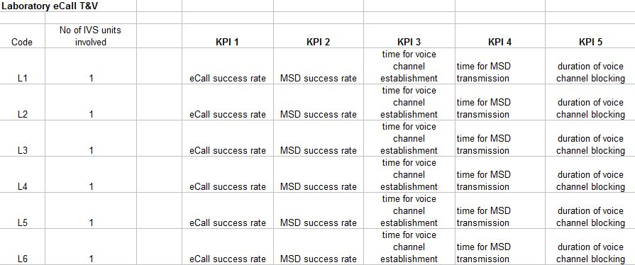

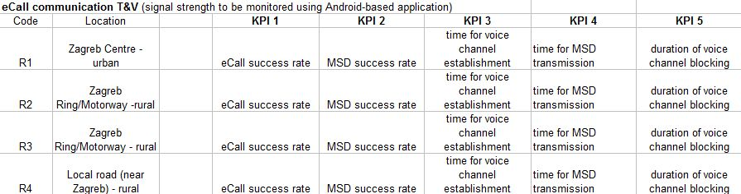

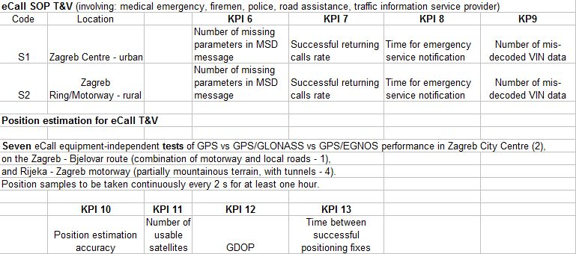

Figure 3: Croatian test scenarios

### Testing environment

The over-all eCall chain will be tested in the Ericsson Nicola Tesla (ENT) eCall laboratory. The necessary pre-requisite is the full component compliance with the eCall standards. The eCall initiation will be performed according the particular scenario set-up, as outlined earlier in this document. All Group 1 KPIs (KPI1 - KPI5) will be measured and observed simultaneously during the T&V procedure. Measurement procedures for the related KPIs are outlined below. They apply to planned scenarios L1 - L7.

The overall eCall chain will be tested in real environment, following the scenario specifications outlined above. The necessary pre-requisite is the full component compliance with the eCall standards. The eCall initiation will be performed according the particular scenario set-up, as outlined earlier. All Group 2 KPIs (KPI1 - KPI5) will be measured and observed simultaneously during the T&V procedure, or post-processed using the records in the event logs. Measurement procedures for the related KPIs are outlined below. They apply to planned scenarios R1 - R4.

The eCall SOP will be tested in real environment, following the scenario specifications outlined earlier in this document. The necessary pre-requisite is the full component compliance with the eCall standards. The eCall initiation will be performed according the particular scenario set-up, as outlined earlier in this document. All Group 2 KPIs (KPI1 - KPI5) will be measured and observed simultaneously during the T&V procedure, or post-processed using the records in the event logs. Measurement procedures for the related KPIs are outlined below. They apply to planned scenarios S1 - S2.

The Croatian eCall Pilot architecture is presented in Figure 4 below.

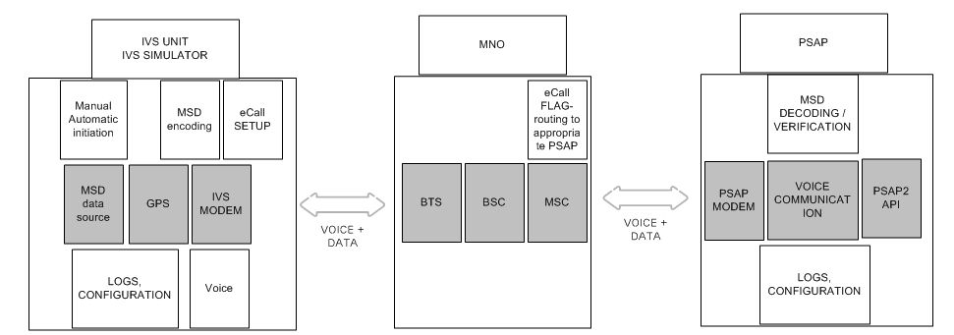

Figure 4: Croatian eCall pilot architecture

General preconditions for KPI measurements in Croatia

Preconditions:

1) IVS

- Compliance with in-band modem eCall rev 10.0.0 outlined in 3GPP TR 26.969 v 10.0.0 (March 2011) and the other standards and specifications listed in WP2 reports should be maintained.

- Support for CAN Bus is not required for Group 1, but is an advantage for Group 2.

- The internal IVS event logger (the application within the IVS that collects time and description of events involving IVS) with the feature of Internal log content transfer to PC (preferably via USB) is required. Time synchronization with GPS reference time frame is required.

- Support for both manual and automatic eCall initiation is required. Manual eCall initiation should be performed by pushing a dedicated button. Automatic eCall initiation should be performed as a result of a dedicated algorithmic processing of the observables of the IVS-embedded accelerometers (MEMS devices), accompanied by airbag sensor readings (if available).

- SBAS/EGNOS-enabled GPS receiver is required. Utilization of combined GPS+EGNOS/GLONASS receiver is an advantage.

- The eCall IVS should support fixed-length (140 bytes) eCall MSD messaging.

- Utilization of 2G (GSM/GPRS) SIM card is required. The Croatian eCall Pilot partners will provide domestic SIM card and SIM card in roaming.

- Power adapter is required, especially for laboratory testing. Utilization of battery + charger package should be considered, and the necessary accessory should be provided by the IVS manufacturer. In Group 2 T&V scenarios, a standard cabin 12 V-socket will be utilized for power supply, for which the necessary accessory should be provided by IVS manufacturer.

- The eCall IVS unit should be pre-configured for utilization in 2G network by manufacturer. The Croatian eCall Pilot will provide a specific PSAP telephone number for pre-configuration, for Group 1 T&V. Standard 112 number is to be pre-configured for Groups 2 and 3 T&V.

2) Mobile network

- Croatian eCall Pilot will assess the eCall performance through utilization of Ericsson PLMN equipment. Laboratory T&V will be conducted on Ericsson PLMN equipment pre-configured in order to emulate existing Croatian eCall Pilot MNO partners' environment, with the addition of the eCall flag support, in accordance with related eCall-related CEN, ETSI and 3GPP standards listed in WP2 report.

3) PSAPs

- The PSAP system should support the PSAP eCall modem communication according to relevant CEN, ETSI and 3GPP standards listed in WP2 report, and in particular the latest revisions of: ISO/EN 24978:2009, CEN WI 00278243, CEN WI 00278220, CEN TS 15722, 3GPP TS 22.101, 3GPP TS 24.008, 3GPP TS 26.267, 3GPP TS 26.268, 3GPP TS 26.269, 3GPP TS 26.969.

- A dedicated landline phone number, reachable through international call, should be provided.

- Minimum Set of Data (MSD) parsing application should be provided, based on the standards listed in WP2 report, and in particular the latest revisions of: ISO/EN 24978:2009, CEN WI 00278243, CEN WI 00278220, CEN TS 15722, 3GPP TS 22.101, 3GPP TS 24.008, 3GPP TS 26.267, 3GPP TS 26.268, 3GPP TS 26.269, 3GPP TS 26.969.

- Call and data PSAP event internal log feature should be deployed and operational. The PSAP event Internal log should record the following parameters: unique call ID, caller MSISDN number, call data, call time, modem session duration, total call duration, *data received* flag (1 = received, 0 = not received), non-parsed content of received MSD. A web-based application should be deployed t display and transfer the PSAP event log.

- PSAP should support an *activity monitor* feature, under which the following parameters should be displayed if activity monitoring is requested by user: unique call ID, caller MSISDN number, connection status, data transfer/reception status, modem session duration, total call duration, (parsed) MSD content, map with position indication.

- PSAP should support a *internal log browser* feature, under which a user can request to browse the Internal log for a pre-selected time period, and after that to be presented with the list of the following parameters: unique call ID, caller MSISDN number, call date, call time, modem session duration, total call duration, *data received* flag (1 = received, 0 = not received).

- PSAP should support a *data parser* feature, to be invoked by selection of a line from one line in the list provided by *internal log browser* feature. Using *data parser* feature, a user can request to display the contents of selected line of the Internal log record, and after that to be presented with the list of the following parameters: unique call ID, caller MSISDN number, call date, call time, modem session duration, total call duration, *data received* flag (1 = received, 0 = not received), (parsed) MSD contents.

- PSAP should maintain time-frame synchronization using GPS, or (optionally) a dedicated atomic clock web-based time synchronization service (such as NIST Internet Time Synchronization, available at: http://1.usa.gov/9vR3Tc).

### Country specific matters in Croatia

Country specific matters are already described in the paragraphs before.

## Czech Republic

### In General

The goal of testing and validation of eCall system in the Czech Republic is to validate technological and functional properties of the system. Testing is divided into 2 parts:

* Laboratory testing
* Testing in real environment

For laboratory testing there will be used GNSS Simulator Spirent GSS 8000 where there is possible to set up properties and simulate limit conditions which are not possible to achieve in real environment. The limit conditions are predicted in eCall system operations so this approach is very important.

As a second step after laboratory testing there will be performed tests in real environment to validate correct functionality and technology readiness of the eCall system.

### Testing environment

Tests will be performed based on test scenarios for the cases described in table 3.

### IVS testing

IVS testing will follow requirements based on ISO 16062 Intelligent transport systems - eSafety - eCall high level application requirements (HLAP).

Conformance points for the in-vehicle system:

* Activation of pan-European eCall
* Call set-up
* MSD transfer
* Application layer ACK
* No receipt of application ACK
* Request “Send MSD”
* Check audio link to vehicle occupants
* Call clear-down
* eCall session termination
* PSAP Call back
* MSD not transmitted correctly
* PSAP modem failure before link layer LLACK is sent
* PSAP modem failure after link layer LLACK is sent
* IVS does not receive a clear-down

### Test purpose for the IVS

* To verify that the eCall equipped IVS has the capability to be initiated via an external interface with the fix data values required for the building of the MSD.
* To verify that upon vehicle ignition, the IVS has the capability to achieve some self test and be ready to start an eCall session in both test and operating mode.
* To verify that the eCall equipped IVS has the capability to react appropriately according to whether it is in operating mode or test.
* To verify that the eCall equipped IVS has the capability to start an eCall session in conformity to EN 16072.
* To verify that the eCall equipped IVS has the capability to generate a well formatted MSD in conformity to EN 15722.
* To verify that the eCall equipped IVS has the capability to initiate an E112 call with its associated relevant flags.
* To verify that the eCall equipped IVS has the capability to disconnect its microphone and loudspeaker from the telephone line and send the formatted MSD to the PSAP when the 112 link is established.
* To verify that the eCall equipped IVS has the capability to send the latest MSD version under a PSAP request during any phase of an eCall session.
* To verify that the eCall equipped IVS has the capability to connect its microphone and loudspeaker to the telephone line and maintain an audio call with the PSAP as soon as a MSD application layer acknowledgement has been received.
* To verify that the eCall equipped IVS has the capability to terminate the 112 link when receiving a clear-down indication from the PSAP.
* To verify that the eCall equipped IVS has the capability to terminate an eCall session after T9 (IVS NAD minimum network registration period) following the last received clear-down from the PSAP.
* To verify that, following the reception of a PSAP call back, the IVS has the capability to reconnect its audio equipment to the line and ensure audio exchange between vehicle occupants and PSAP/Rescue team operator.
* To verify that the IVS has the capability to recover in case of a call clear-down failure.
* To verify that the IVS has the capability to switch to TS12 mode in case of non eCall equipped PSAP or PSAP failure.

### Selection of conformance points for the PSAP equipment

* E112 call management
* Cell position and caller ID presentation
* Test call received
* Received MSD management
* PSAP operator HMI
* Audio exchange
* Calling back the vehicle
* Request send MSD
* PSAP call clear-down
* PSAP unable to receive MSD

### Test purpose for the PSAP equipment

* To verify that the eCall equipped PSAP application layer has the capability to receive an MSD, decode it, check its error free and verify its conformity to EN 15722.
* To verify that the PSAP application layer has the capability to display the MSD content and some other elements, e.g. caller ID, cell position, decoded VIN to the PSAP operator as required.
* To verify that the eCall equipped PSAP application layer has the capability to automatically request to its link layer the transmission of an “AL-ACK” response to the IVS.
* To verify that the eCall equipped PSAP application layer has the capability to request its link layer to transmit a “Send MSD” request to the IVS at any time during the eCall session.
* To verify that the eCall equipped PSAP application layer has the capability to request its link layer to transmit a “clear-down” request to the IVS at any time after the reception of an MSD while the E112 call stays present.
* To verify that the eCall equipped PSAP application layer has the capability to connect the audio system of the PSAP operator to the receiving line. Then verify that a bi-directional audio communication is achievable between the PSAP operator and the vehicle occupants.
* To verify that the eCall equipped PSAP application layer is behaving as expected when receiving a test call, e.g. generating a “clear-down” request to its link layer or forwarding the call to a test PSAP.
* To verify that the eCall equipped PSAP application layer has the capability to send a “call back” request to its link layer for the purpose of re-establishing an audio liaison between the PSAP operator / rescue team and the occupants of the vehicle (RPSAP 09).
* To verify that the eCall equipped PSAP application layer has the capability to request a new MSD.

### Test environment description

#### Laboratory



Figure 5: Czech laboratory configuration

#### Real environment



Figure 6: Real environment configuration

### GNSS simulator

It is possible to use laboratory testing of GNSS part of HeERO project, although this laboratory does not cover part for GSM communication.

The core function of the laboratory testing is the ability to simulate the GNSS signals as inputs for testing ITS applications to be aware of all the entry conditions and low system parameters and ITS applications could be statistically validated on a sufficient number of measurements.

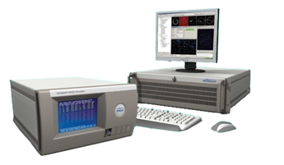

Figure 7: GNSS simulator

Czech consortium could use the GNSS Simulator Spirent GSS 8000. Its main advantage is the ability to simulate up to 10 satellites simultaneously and simulate the GNSS-defined route. In addition, GNSS signals can be simulated in many ways to model and simulate the boundary conditions. This includes the following parameters, which can be modelled:

* Satellite distribution - in a different constellation of GNSS satellites for various time periods (based on almanac file);
* Satellites transmission power;
* Multipath signal reception (multipath);
* Signal ground reflection;
* Signal obscuration;
* Atmospheric effects on signal;
* The impact of receiver antenna (model) - various parameters of the antenna, different antenna positions in the vehicle, or more antennas, etc;
* Vehicle parameters - the maximum speed, maximum acceleration, maximum angular velocity, maximum angular acceleration, etc.;
* Vehicle sensors inputs modelling.

#### Satellite distribution

Precision positioning using GNSS technology depends on the accuracy of pseudo-range measurements the one hand and the geometric configuration of the available satellites on the other hand. Integer value is called DOP (Dilution of Precision, accuracy variance). There are used a few sub-DOP parameters:

* GDOP: Geometric DOP (position in space, including time-shift);
* PDOP: Spatial DOP (position in space);
* HDOP: Horizontal DOP (position in the horizontal component);
* VDOP: Vertical DOP (vertical component of position);
* TDOP: Time DOP (time accuracy).

When visible satellites are close together in the sky, the geometry is weak and the DOP value is high. When the satellites are far apart, the geometry is strong and the DOP value is low. Low DOP value represents the greater accuracy of position.

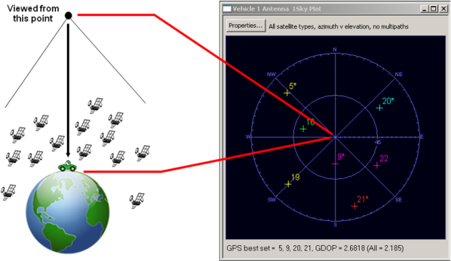

Figure 8: Geometric configuration of the GNSS satellites

Value of the HDOP varies with geographic location only a little, VDOP value is changing a lot with geographic latitude. The latitude of ± 56 ° VDOP reaches its minimum and with latitude increasing VDOP significantly increases. This error increase at higher latitudes is due to the fact that after crossing the latitude, which is equal to the track inclination, already below the overhead satellites, culminating in increasingly lower elevations. Three-dimensional positioning error almost follows track of the dominant height error.

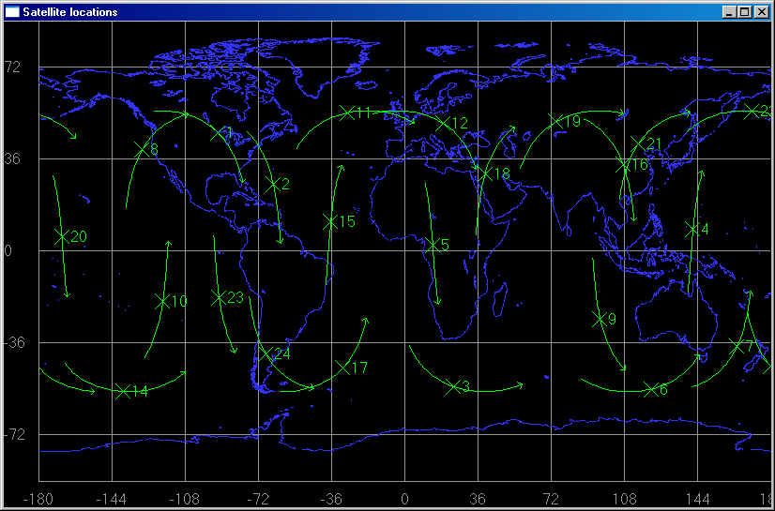

Figure 9: Satellites position and movement over time

Using simulation tools there is possible to model various geometric distribution of satellites typical example for different latitudes. There is possible to simulate conditions of high and low levels of DOP indicators. For each of the satellites there is possible to simulate the signal level, or to switch off the satellite which leads to a situation of broadcast only n satellites. The combination of these settings allows assembling many different test scenarios for testing GNSS signal reception, depending on the constellation of satellites.

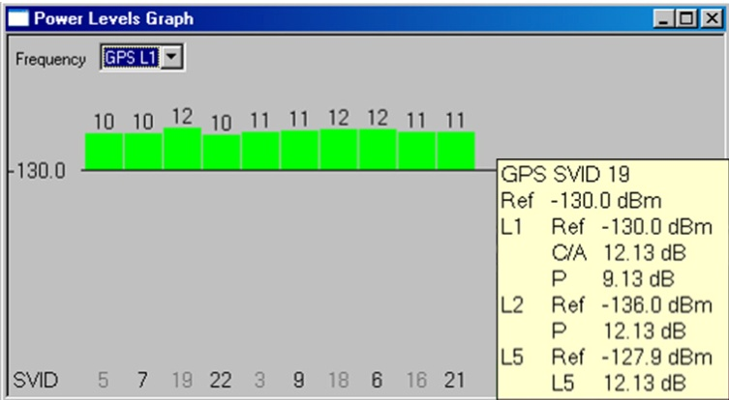

Figure 10: Display of received signal levels

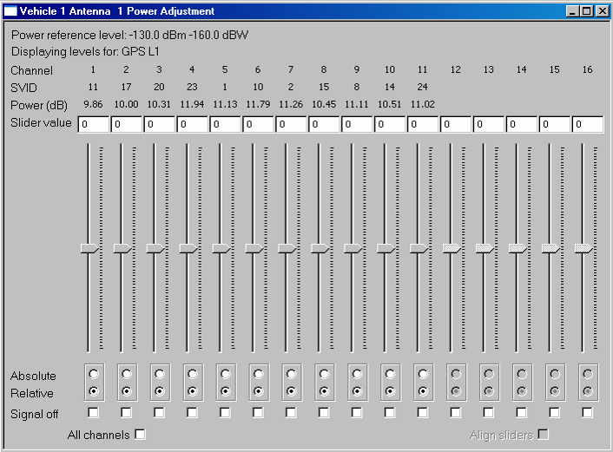

Figure 11: Display of setting concerning signal levels

This feature can also be used to simulate a particular constellation of GNSS satellites in the defined period of time in the past. This includes re-induction (replay) of the situation that leads to the application or device error. This is possible for the GPS signal, which is governed by the so-called GPS weeks. For each GPS week almanac generated file that defines the current position of the GPS satellites. This information is freely available in the internet. This file is imported into the simulation software tools and the position of the satellite after that corresponds to the required time.

#### GNSS signal emulation

Process through the generation of GNSS signal in the simulator is processed in several steps (and is shown on the picture below):

Operator in the simulation program sets the course route (manually or pre-prepared set of positional data, such as NMEA data) and all parameters of the generated signal (e.g. number of available satellites, their output level, a constellation of satellites, signal reflections, near ground relief, etc. - the parameters are defined below), depending on the kind of test.

Proprietary data is sent to the GNSS signal generator which generates a defined signal and this is broadcasted into the environment via antenna.

Test equipment with the application is located within range of the generated signal and the personal device / application is tested.

Data recorded during the tests will be analyzed later on (e.g. comparing the log of the NMEA in Simulator and NMEA log recorded in the test equipment).

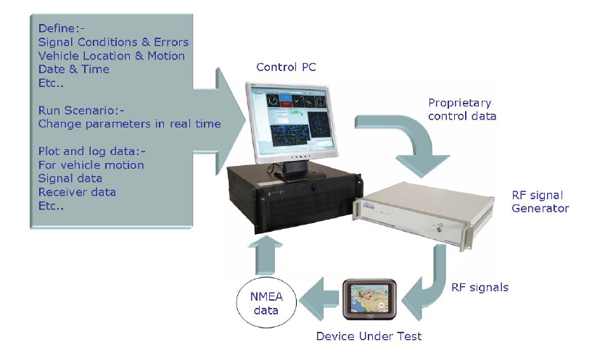

Figure 12: Testing scheme

#### Error test conditions simulation

Simulation technology allows simulate signal induced error conditions that may occur in real situations and also absolutely unrealistic situation. Based on the simulated signal with defined error conditions GNSS devices and applications are tested to verify their response. For example this scenario verifies that navigation device in the vehicle which does not receive any GNSS signal already using only data from sensors in the vehicle.

##### Multipath signal reception

Multipath is the effect of influencing the accuracy of positioning using GNSS. It is a fact that the satellite signal is reflected from buildings or other obstacles, including land and water. Reflections coming into the receiver travelled a greater distance from the satellite for a longer time. This influence pseudo range determination and thus the exact position.

The problem of multipath signal reception occurs mainly in the so-called urban canyons. Illustration can be seen in Figure 13.

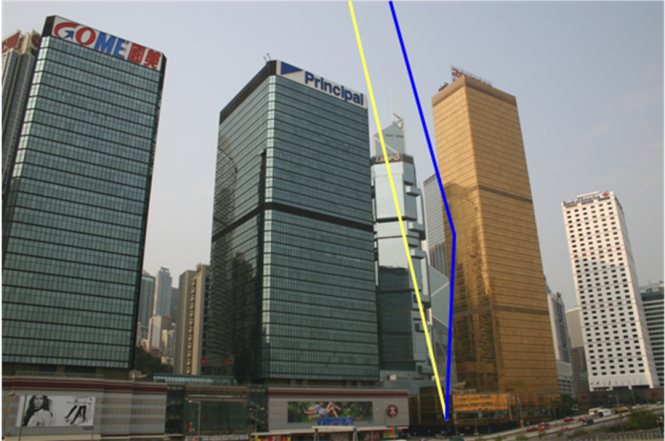

Figure 13: Multipath scenario

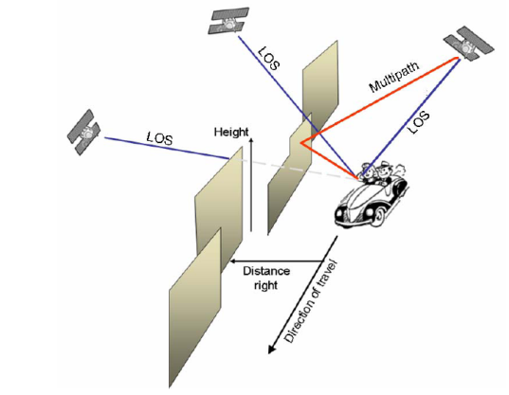

Figure 14: Multipath signal reception

The receiver has no way to distinguish incoming signals and, therefore, considers all the resulting signals together. To reduce the inaccuracies is the better design of the antenna. Some advanced receivers solve multipath by making use of only the first detected signal (which is considered to be one that spreads directly from satellite), then any delayed signals involved.

Using simulation tools to model for any multipath signals independently of their distribution (i.e. separately). There can be set the signal spread in the direct line of sight, or without. For each such signal there can be determined the level of the reflected signal, and possibly influence the signal on a sufficient channel. The reflections can also set the parameters for the Doppler signal shift, the phase signal shift, the signal points of the receiver antenna, and more detailed parameters.

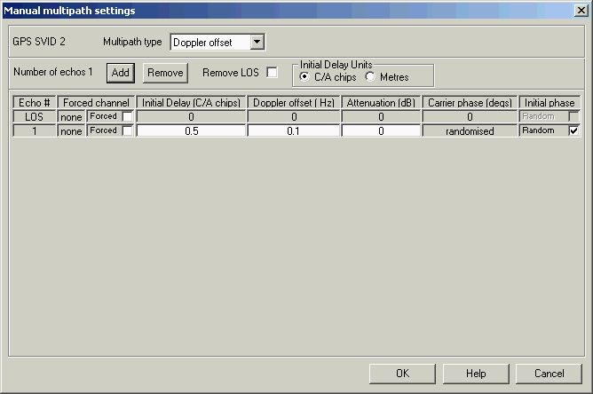

Figure 15: Manual multipath settings

##### Ground reflection

As already mentioned in the multipath, the signal reflections may occur from the ground or from water. Ground reflection is one of the types of multipath propagation of signals. The following picture is suggested by the principle of such reflection.

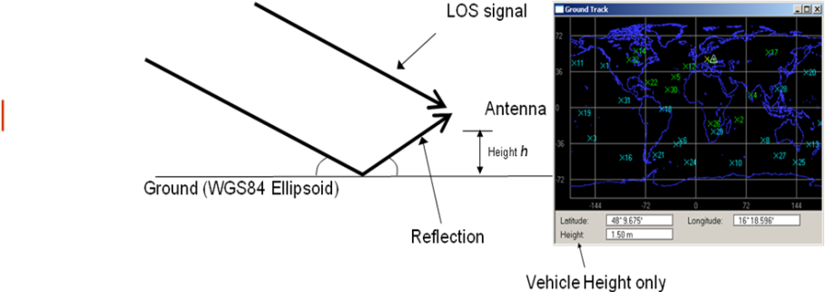

Figure 16: Ground reflection principle

Antenna located at a certain height, also receives the signals reflected from the ground, assuming that the ground is flat. The receiver then receives multiple signals from the line of sight, which leads to inaccuracies in determining the exact position.

Using simulation tools allows creating simulations of ground reflections. Here you can set the level of each signal and its influence on a particular channel.

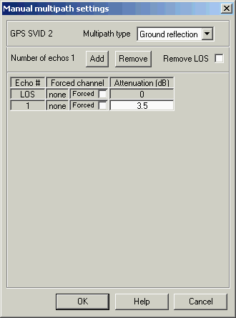

Figure 17: Ground reflection settings

##### Obscuration

Obscuration is a phenomenon where the direct signal from the satellite is shielded by an obstruction, or when a narrowed view of the available satellites. The receiver will only receive signals from satellites above a certain cut-off angle.

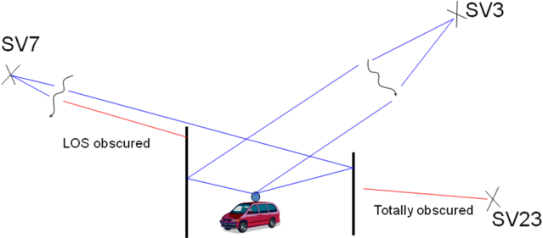

Figure 18: GNSS signal obscuration I

Sources of geographic obscuration are i.e. mountains and buildings.

Sources of local obscuration are i.e. aircrafts, trees or other effects.

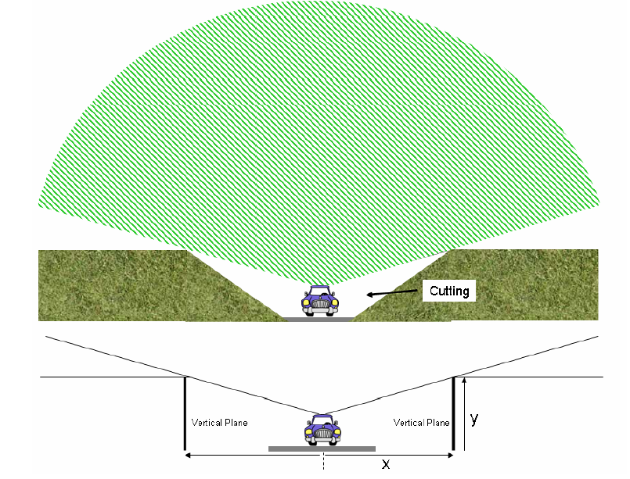

Figure 19: GNSS signal obscuration II

Using simulation tools allows modelling various types of obstacles to obscure signal. Ground obstacles can be modelled as high buildings, trees or bridges. There can be also modelled as well as geographic objects interfering with the signal, such as hills, mountains, valleys, canyons, etc. Each set of objects can be modelled fairly in detailed editor, including the length of the obstacles, the height and location of the simulated route. Objects can be grouped into different scenarios for easy reuse.

##### Atmosphere models

While passing the GNSS signals through the atmosphere there are generated relatively large inaccuracies in determining position. Ionospheric and tropospheric errors are caused by changes in velocity of propagation through the atmosphere. Ionospheric refraction can be eliminated by measuring at two frequencies, because the passage of the signal through ionosphere is frequency-dependent. Passing GNSS signals through the troposphere resulting signal variations due to changes in temperature, pressure and humidity.

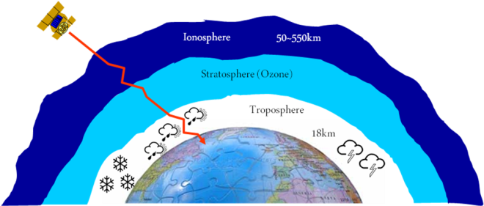

Figure 20: GNSS signal path hemisphere

Tropospheric and ionospheric refraction can be modelled quite accurately and in detail. There can be set different widths for different layers of satellite position, there can be also set different rates of dry gas, which reflects the signal or can modify humidity and other parameters.

It must be said; however, that simulation of these effects on the signal is very complex and requires a fairly deep knowledge of the subject. Currently, this method of influencing the GNSS signal is not widely used.

##### Receiver antenna influence

Receiver antenna also has an impact on the overall positioning. Among its features include gain, directivity and the possibility of phase measurements. If there is used a surveying instrument with precision antennas, with the phase measurement with a larger number of channels, etc., we get more accurate results than using an ordinary low-cost handheld receivers.

Simulation allows us to set the exact parameters of the antenna for a particular type allows modelling of different obstacles in the signal path (e.g. the roof of the vehicle, etc.). We can also make simulations for multiple antennas to one receiver.



Figure 21: Reception in a vehicle antenna

For the precise parameters of the antenna there is available a 3D modelling environment that enables to set the parameters according to the actual antenna radiation patterns.

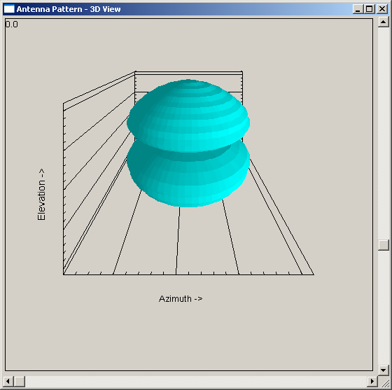

Figure 22: Antenna model I



Figure 23: Antenna model II

##### Vehicle parameters

For each modelled vehicle there can be defined the characteristics and dynamics. Movement of vehicles can be restricted according to different personal profiles. Limits can be specified to represent special examples. So there are possible to model aircraft (such as Boeing 747) or a road vehicle (small vehicle or F1).

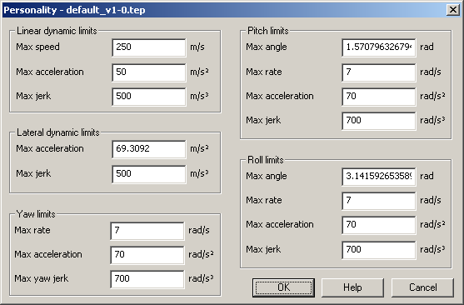

Figure 24: Moving objects profile settings

##### Vehicle sensors

With hardware and simulation tools there is possible to model parameters except the parameters of GNSS also sensors in the vehicle, such as gyroscope, speedometer, wheel speed sensors, temperature sensors, etc. These sensors can be set in detail in cooperation with the setting parameters and testing of GNSS signals and receiving equipment (e.g. dynamic navigation, which uses input data from sensors in the car) on the one hand and the behaviour modification in the event of a vehicle's internal sensors and their possible combinations on the other hand.

Signals from sensors in the vehicle are then transmitted via 4 analogue and 8 digital outputs that can be connected to the receiver (or to the rotate table, which simulates the movement of the vehicle).

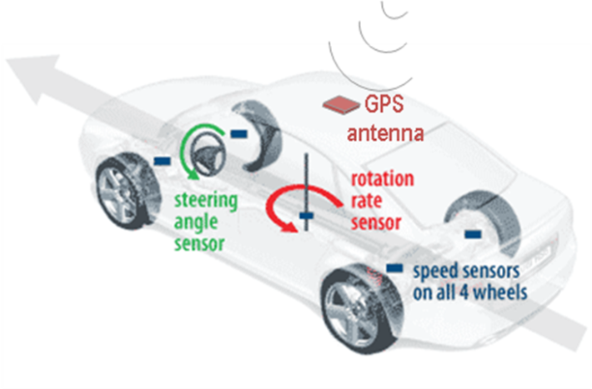

Figure 25: Sensor model

### Country specific matters in Czech Republic

Country specific matters are already described in the paragraphs before.

## Finland

The goal of testing and validation of eCall system in Finland is to validate technological and functional properties of the system. The testing environment to be implemented will cover the whole service chain from the eCall IVS to a simulated PSAP. Cross-border tests to be carried out in Finland will be very similar to tests carried out in the Finnish eCall pilot.

### In General

The following figure outlines the HeERO Finnish pilot system to be implemented, and its basic components (see D2.3 Finnish pilot implementation plan).



Figure 26: HeERO Finnish pilot system architecture outline

The main parts of the system include:

* eCall client simulator (eCall IVS)
* PSAP simulator, which consists of eCall test bed system, PSAP1 service and PSAP2 test system.
* eCall pilot system control and administrator’s UI.

#### eCall client simulator (IVS)

The eCall client (IVS) simulator to be implemented will include functionality for generating and combining eCall message data content, encoding the message data for data transfer, opening phone call and using in-band modem for sending eCall messages.

It will include a user interface for configuring and generating MSD (Minimum Set of Data) messages.

The generated MSD data will be encoded for the data transfer according to the standard CEN EN 15722 (eCall minimum set of data).

The client will use the eCall standardized in-band modem data transfer for sending messages.

The messages (opened voice call) are targeted to the configured phone number of the eCall receiver side (PSAP simulator). For testing purposes, the number is other than 112.

#### PSAP simulator

The PSAP simulator part of the system will consists of eCall test bed, PSAP1 service and PSAP2 test system. These components together constitute the eCall pilot system eCall message receiver side.

#### eCall test bed

The eCall test bed is the eCall message receiver part of the system. It includes functionality for handling incoming eCall phone calls. It receives and decodes eCall message data, includes interfaces for PSAP1 and PSAP2 subsystems, provides logs for analyzing results and includes facility for configuring the operation of the system.

A test phone number (other than 112) is configured for test bed to receive eCall phone calls. The test bed uses the standardized in-band modem to extract eCall data from the call.

The incoming MSD messages are assumed to be encoded according to the standard CEN EN 15722 (eCall minimum set of data). The test bed decodes and validates MSD messages. For analyzing results, there will be a log facility included into the system. It will provide information about received messages and error cases. In particular, it will be used to validate the operation of the system as well as eCall clients. The report “D2.4 System test cases and verification report” will later specify the system verification scenarios. The logs generated by the test bed have a particular importance in validation of the system operation.

### Testing environment

#### Test scenario 1: Successful eCall

This is the main test scenario of the Finnish eCall pilot. This test scenario will cover the following KPIs: 1a, 1b, 2, 3, 4, 5, 6, 7, 8 and 9.

Preconditions: 1) Vehicle

IVS with microphone and loudspeaker for communication with the PSAP.

Possibility to initiate an eCall manually.

Possibility to configure VIN to be transmitted to PSAP.

eCall client simulator will be used in tests as an IVS.

2) Mobile network

GSM or UMTS mobile network, call to an ordinary E.164 phone number used for testing purposes.

3) PSAPs

3GPP modem installed

Decoding and visualisation of MSD possible

Voice connection possible

System used to receive eCalls in the Finnish eCall pilot consists of an eCall test bed connected to ELS (PSAP information system, see figure 26 and chapter 5.3.1.3 for detailed descriptions of the PSAP side infrastructure).

Test procedure: eCall is initiated manually at a variety of locations. The locations will be selected in such a way to reflect different environmental conditions. Tests will be carried out at least two types of locations: densely built urban area and on a main road outside city centre. From 20 to 50 test calls are expected to be initiated.

eCall is received by eCall test bed connected to ELS. Data logging on the PSAP side will be performed automatically by the eCall test bed and manually by a human user. A human user will answer the calls at the PSAP side, record the point in time when the contents of the MSD are presented and verify the status of the voice connection.

Measurement: Documentation

1. Vehicle

Log file collected by the eCall client simulator used as an IVS.

The log file will contain information about various types of events such as activation of the IVS, opening of the GSM call to a test number, beginning of the transmission of MSD, end of the transmission of MSD and end of eCall. Information available about each documented event will include at least the type of event and time stamp.

An ordinary E.164 phone number will be used for testing of eCall instead of emergency number 112.

1. Mobile network

No data logging is performed by the mobile network.

1. PSAP

The PSAP simulator used to receive the test calls will collect log files about various events related to incoming test calls. At least the following events will be logged by the PSAP simulator for each test call:

- opening of test call

- start of MSD transmission

- end of MSD transmission (transmission of link or application layer ACK)

- voice channel established

- closing of test call

Information about an event will include the type of event, timestamp and possible supplementary data such as contents of the MSD.

A human user will answer the test calls at the PSAP used for testing and record the point in time when the contents of the MSD is presented, status of the voice connection and results of VIN decoding.

eCall testing during the pilot will be accomplished as illustrated in the following figure:



Figure 27: Pilot eCall testing in Finland

In addition to the eCall client simulator several other eCall clients may be used during the pilot. They may include both eCall client simulators and/or in-vehicle clients (if available).

The clients used should include functionality for generating and sending standard eCall MSD (Minimum Set of Data) messages via the standardized in-band modem solution to the test number configured to the PSAP simulator (eCall test bed)

During the tests, a Web user interface for managing the operation of the test bed will be used (see Figure 27). It will provide configurations for the test users, possibility to register the eCall clients (e.g. client phone numbers) used in the tests. Also, the pilot system operation can be managed via the user interface. It will also provide views to result logs.

The log facility of the test bed will provide information about received messages (e.g. call time, modem session, duration, MSD information, warnings) and error cases. In particular, it will be used to validate the operation of the system as well as eCall clients.

The eCall pilot system can be directly used in cross borders activities that are planned to take place with one or two consortium partners. Also, eCall cross border tests with Russia (eCall compatibility, ERA GLONASS system) are planned.

In practice, tests may be accomplished so that Finnish eCall Test bed is used as an eCall receiver (PSAP) and/or the eCall client simulator (part of Finnish eCall pilot) used as an eCall sender (in vehicle).



Figure 28: Cross borders tests using the Finnish pilot system eCall sender and receiver parts

### Country specific matters in Finland

At present, Finnish PSAPs have access to national databases of registered vehicles and driving licenses, and Finland is not exchanging information with the EUCARIS system. For that reason, KPIs 15-16 (Correctness of VIN decoding with EUCARIS and Time for VIN decoding with EUCARIS) will not be measured in the Finnish eCall pilot.

## Germany

The goal of testing and validation of the eCall system in Germany is to validate technological and functional properties of the system and to detect possible weaknesses or problems due to complex infrastructural conditions. The testing environment to be implemented will cover the whole service chain from the eCall IVS provided by several manufacturers to simulated and/or real implemented PSAPs. Cross-border tests to be carried out in Germany will be very similar to the other tests and are foreseen at least with Czech Republic and Italy.

### In General

The modules for testing will be placed on the dashboard of cars of Flughafentransfer Hannover GmbH (FHT GmbH). 12V power will be arranged by plugging the modules into the cigarette lighter jack. Five modules per involved IVS manufacturer will be prepared for the testing phase. A possibly needed re-configuration of the modules will be done via SMS-commands during test activities.

### Testing environment

KPIs will extract information about the quality and performance. To reach comparable data it is necessary to know the position of the vehicle initiating an eCall. During the field test phase, eCalls will be performed in determined periods of time without having real collisions. For the HeERO field test the samples will not be integrated into the car. As a result a series production process, performance indicators like shock resistance and backup battery availability without main power supply, will not be available. All parameters necessary for the evaluation of the listed KPIs will be logged in the IVS and the PSAPs.

### Country specific matters in Germany

The following table gives again an overview about the KPIs which shall be evaluated in Germany. To do so, several test scenarios must be defined.

|  |  |  |
| --- | --- | --- |
| KPI_001a | Number of automatically initiated eCalls | X |
| KPI_001b | Number of manually initiated eCalls | X |
| KPI_002a | Success rate of completed eCalls using 112 | (X) |
| KPI_002b | Success rate of completed eCalls using long number | X |
| KPI_003 | Success rate of received MSDs | X |
| KPI_004 | Success rate of correct MSDs | X |
| KPI_005 | Duration until MSD is presented in PSAP | X |
| KPI_006 | Success rate of established voice transmissions | X |
| KPI_007a | Duration of voice channel blocking | X |
| KPI_008 | Time for call establishment | (X) |
| KPI_009 | Accuracy of position | X |
| KPI_013 | Success rate of heading information | X |
| KPI_015 | Success rate of VIN decoding with EUCARIS | (X) |

Table 4: KPIs evaluated in Germany

Concerning the crosses in brackets, the following statements are valid at the moment:

KPI_002a: No eCall-flag is available at the moment in Germany. The German Federal Ministry of Transport, Building and Urban Development leads the initiative to implement the eCall-flag in all mobile networks but it is still unclear if when this KPI will be measured.

KPI_008: It is possible to measure this KPI, but as long as no E112 calls are possible, the measured times will not reflect the later reality. Furthermore the current used test IVS are always connected to the mobile network.

KPI_015: EUCARIS implemented just a small test data base with a few test data sets for our test purposes. So, success rate will always be 100% and access times won`t reflect the reality.

Automatic test scenarios

To get a big amount of data for later statistical analyses, to a huge extend automatic tests will be initiated.

At the beginning there will be a number of manual tests to verify the correct functionality of the system. Later each IVS will initiate eCalls automatically once per hour. All required data to evaluate the above KPIs will be logged both by IVS and PSAP. The caught data is described in the annex of this document. It is planned to increase the frequency of initiated eCalls on the one hand to get more data for statistical analysis and on the other hand to get an impression about the performance of the PSAP system.

Manual test scenarios

Concerning manual test scenarios, two different scenarios are defined:

1) Dedicated test sessions

To verify certain functionalities or to react on erroneous behaviour, dedicated test sessions will be executed. These test sessions will be initiated by the manufacturers of the IVS systems directly to have additional control of the activities within the eCall. This is necessary at least to test the voice communication between driver of test vehicle and PSAP. It might also be necessary at difficult locations, where the environmental conditions are not optimal for GPS or GSM connections. If locations and/or other problems are identified during the automatic test sessions, further manual tests have to be done to clarify the reason for the problem. There will be a close team work between IVS manufacturer, PSAP operator and test fleet manager to coordinate dedicated test sessions.

2) Additional eCalls during test drives

In addition to the automatic tests, the driver of the test vehicle is asked to initiate eCalls whenever he wants. Mainly, these eCalls shall be initiated, when the vehicle is not moving, to get reasonable values concerning the heading and positioning information. These tests must be done to reflect realistic eCall scenarios in the future in which after an incident the vehicle came to a final stop.

## Greece

### In General

The objective of the Greek eCall Pilot is to assess and evaluate the eCall system performance in Greece from IVS to PSAP, end-to-end. The testing scenarios are shown below.

### Testing environment

|  |  |  |  |  |
| --- | --- | --- | --- | --- |
| **Code** | **Number of IVS units involved** | **Number of IVS units in roaming** | **eCall initiation** | **Number of tests** |
| **L1** | 1 | 0 | M | ??? |
| **L2** | 1 | 1 | M | ??? |

Table 5: Overview of Greek laboratory test scenarios

|  |  |  |  |  |  |
| --- | --- | --- | --- | --- | --- |
| **Code** | **Location** | **Number of vehicles involved** | **Number of vehicles in roaming** | **eCall initiation** | **Number of tests** |
| **H1** | Attiki Odos Arterial Highway of Attiki | 2 | 2 | M | 100 |
| **H2** | E65 highway,  Athens - Korinthos | 2 | 2 | M | 100 |
| **U1** | Urban roads,  Athens city centre | 2 | 2 | M | 100 |
| **R1** | Rural road,  Rafina – Oropos | 2 | 2 | M | 100 |

Table 6: Overview of Greek real traffic test scenarios

* **Preconditions**: 1) Vehicle equipment

IVS and voice communication to the PSAP

Manual initiation of the eCall

2) Mobile network

Dialling E112

3) PSAP

3GPP modem installed

Decoding and visualizing MSD content possible

Voice connection to the vehicle possible

* **Test Procedure**: The driver manually initiates an eCall at various positions; in different traffic environments (see Table 4 above). At several selected locations along the road, representative of the area and with possible low GPS coverage, the driver stops the vehicle at the roadside and manually activates eCall. Log files are stored in the vehicle and in the PSAP and both the driver and the PSAP operator complete a subjective questionnaire containing a standardized value scale for the evaluation after the end of each eCall.
* **Measurement**: Documentation

1. Vehicle

Log with time stamps of eCall initiation, MSD sending, end of eCall.

Log with MSD content.

Subjective questionnaire completed by driver.

1. PSAP

Log with time stamps of eCall reception, MSD reception, MSD display, voice call start, end of eCall.

Log with MSD content.

Subjective questionnaire completed by PSAP operator.

### Country specific matters in Greece

Currently Greece is not in synchronization with the other pilot sites owing to procedural difficulties with the procurement of equipment.

Greece is fully committed to the project, but it is not currently in a position to provide full test details as equipment is still to be procured.

In light of this the Greek test site will provide a full test suite in Deliverable 4.2 as a revision to the document as the equipment is yet to be purchased, although the procurement specifications have been defined,.

## Italy

The goal of testing and validation of eCall system in Italy is to verify all chain functionalities in a scenario as much as possible compliant to the expected pan-European requirements and standards. Vehicles will be mounted with IVSs, both in OEM and aftermarket configurations, Italian telecom operator will manage the eCall discriminator for 112 calls and Italian PSAP in Varese will integrate eCall in the existing call centre.

### In General

The activities on the field in the Italian Pilot will be carried out using telematic boxes installed on the following vehicles:

* Fiat demonstrators vehicles (provided by CRF)
* Cars belonging to premium ACI (Automobile Club Italia) customers

For each set of vehicles and user categories specific targets have been defined.

* For the Fiat demonstrators vehicles, the pilot activities aims at testing the integration of the telematic box inside the car and the automatic eCall function (via a simulated air bag activation on the CAN bus).
* ACI cars will be used to test the manual eCall function and value added services which can be provided by the eCall telematic box, such as the breakdown and road assistance call.

The geographic area used as test bed is being identified based on the actual radio coverage provided by the base stations involved in the tests and will be the area supported by the Varese NUE 112 emergency call service, provided by the Varese PSAP.

During the test, a high number of eCalls will be generated to demonstrate the capability of the complete system to cope in an operational mode.

During test period incidents will be simulated; the on-board sensors trigger the start of an automatic eCall and the additional possibility of a “Manually originated” eCall is also provided by the IVS. Once triggered, the on-board vehicular system (IVS) establishes an automatic emergency communication (E112) over the public mobile network with the Public Safety Answering Point. Before actually enabling the voice connection, the IVS transmits the Minimum Set of Data (MSD) to the PSAP. The eCall (MSD data + voice) carried through the mobile network, is recognized by the mobile network operator (MNO) as a 112 emergency call thanks to the “eCall discriminator” (a.k.a. “eCall flag”) and is handled accordingly. The MNO processes only the signalling of the incoming eCall by adding the suitable processing of the eCall discriminator to the usual processing of an E112 emergency call (which already includes the forwarding of the Calling Line Identification (CLI) for possible location request by the PSAP). The voice channel is routed transparently (MSD included) to the fixed network.

The telecommunication network used for the pilot is provided by Telecom Italia and is a part of the real operation network available in the district of Varese which has been selected for the national pilot campaign.

The Fixed Network Operator receives the incoming eCall by a MNO and forwards the voice call (MSD included) over ISDN connection. The related signalling includes the CLI originally provided by the MNO as well as the Operator ID (OpID) identifying the MNO who received the eCall (Remark: only a single MNO is actually involved in the Italian HeERO Pilot). CLI and OpID (MNO Identification), if needed, may be used by the PSAP to request a best effort call location to the originating MNO.

The PSAP transmits an acknowledgement to IVS specifying that the MSD have been properly received.



Figure 29: ECall Service chain in the Italian Pilot

The PSAP will be integrated with additional VPN connection allowing the communication between the PSAP and the Ministry of Transport Operating Centre, connected to EUCARIS network, to receive data about the vehicle sending the eCall message (both national vehicles and EU vehicles) via EUCARIS network.

### Testing environment

During tests, the time stamp clock of the data recorded in log files will be synchronized using GPS received time, both in the vehicle and in the PSAP. Log files will be produced in vehicles IVSs and in the PSAP to provide data for the HeERO Key Performance Indicators (KPIs) calculation in order to perform a common evaluation within the projects national pilots. Log files will be agreed among Italian Pilot Partners according to HeERO KPIs’ requirements agreed by all partners. All IVSs used in the vehicles fleet in Italy however will adopt the same log file format.

The accuracy of the reported position versus actual position (dedicated IVS tests, not performed during pilot tests in Varese. These tests will be performed with reference positions acquired also by a GPS receiver with differential correction (Real Time Kinematic)) will also be evaluated.

Time stamps and data to be logged for KPI:

* **IVS**, for each initiated eCall:
  + ID number (incremental counter) of the eCall
* Manual/automatic trigger activation
* T0_IVS – incident detected
* T1_IVS – IVS start sending the eCall
* MSD contents
* Transmission attempts
* T2_IVS – Voice channel is active and driver and operator communication established
* T3_IVS – Voice connection is ended
* eCall communication OK/NOK
* **TELECOM OPERATOR**
  + T0_MNO – the eCall reaches the 112 telecom operator network
  + T1_MNO – the eCall flag is managed
* **PSAP VARESE**
  + T0_PSAP – the eCall reaches the PSAP
  + T1_PSAP – the MSD reaches the PSAP
  + T2_PSAP – the processed MSD is being presented to the PSAP Operator
  + T3_PSAP – voice channel is active and operator can communicate with the driver
  + T4_PSAP – VIN has been decoded with EUCARIS tool
  + T5_PSAP – the PSAP alerts (is ready to alert) the emergency agencies

KPI- Analysis on MSD transmission time:

* Minimum, Maximum and Average transmission time for the MSD correctly received at PSAP
* Distribution of the MSD transmission time
* Number of non-successful MSD transmission attempt (longer than [20 sec] maximum)

Start time for MSD transmission: when the IVS starts to send the SYNC signal

End time: when the CRC has been detected as correct by the PSAP modem

Target: 90% of all MSD transmission times shall be below 15 sec

KPI-Analysis on voice channel and disturbance/blocking

* Duration of voice connection (IVS, PSAP)
* Individual description of disturbance in voice communication (due to In-band Transmission during Manual/automatic triggered eCall with real voice and MSD), Judgments by:
  + Driver in the car
  + Operator in the PSAP

Subjective evaluation of voice path blockade: Human judgment on a 5 point scale.

### Country specific matters in Italy

At present there aren’t any country specific matters in Italy.

## Romania

The main goal of testing in Romania is to observe the impact that eCall will have on the existing national E112 system. The tests will help determine how the upgrades for the PSAP, both at technical level (hardware and software) and at procedural level, will affect the overall response time. At the same time, the tests will put into perspective different scenarios for the implementation of eCall flag at national level. The cross-country tests with other countries participating in HeERO and Russia (ERA-GLONASS) will ensure that the newly upgraded PSAPs will be compatible with foreign cars travelling in Romania in the scope of delivering a pan-European eCall service.

Other important functionalities of the eCall service chain that will be tested are the interfaces for querying the EUCARIS database and for sending incident data to the Traffic Management Centre.

### In General

The following paragraphs show the testing activities within Romania.

### Testing environment

1. **Testing the eCall reception**
   1. Test the PSAP modem

All the following tests will analyse the performance of the PSAP modem and its behaviour in different scenarios.

* with or without the eCall flag

These tests will show how the system will handle calls with or without the eCall flag. As the implementation of the eCall flag is the responsibility of the MNOs, we are not sure when we’ll be able to test this feature.

* for standard eCall (the IVS calls the PSAP)

These tests will provide information about the normal dataflow for eCall.

* IVS redial

These tests will be performed to observe the behaviour of the system when the IVS attempts a redial after the connection has been interrupted.

* Call-back (the PSAP calls the IVS)

These tests will analyse how the system behaves in case of a call-back. The call-back function will be used in case an on-going call is interrupted for various reasons. After the call is interrupted, the IVS will try to establish a connection with the PSAP and if the IVS won’t be able to so, the operator will have to use the call-back feature.

* Redundancy

We will test the redundancy of the PSAP modem and different failover strategies.

* Test more calls coming at the same time

These tests will analyse the behaviour of the PSAP modem in case of more eCalls at the same time.

* 1. Test the voice connection with the operator

These tests will concentrate on the eCall voice path characteristics from the 112 operator’s point of view. These tests will include, but won’t be limited to: answering a call, transferring a call, ending a call.

* 1. Test the call-back feature from the operator’s point of view

These tests will analyse the call-back functionality from the 112 operator’s point of view. These tests will observe the minimum and maximum wait time before attempting call-back.

* 1. Evaluate the defined KPIs

We will evaluate all the defined KPISs using the data gathered during the tests for eCall reception.

1. **Test the MSD reception from the point of view of the operator**
   1. Evaluate the usability of the operator interface

This evaluation will help analyse if the proposed operator interface is user friendly.

* 1. Test the reception of the MSD in the 112 application

We will test to see if the MSD is being decoded correctly and if the information is being presented to the operator.

* 1. Test the “resend MSD” functionality

These tests will analyse the behaviour of the system in case the operator asks for a MSD resend. We will test different scenarios: resend MSD during a normal eCall, resend MSD during a call-back, consecutive resend MSD during the same call etc.

* 1. Test the automating positioning of the incident

This will test the automatic positioning of an incident on a GIS map, based on the GPS coordinates from the MSD. We will evaluate the best representation method for presenting the recent vehicle position before the incident and the vehicle direction.

* 1. Evaluate KPIs

We will evaluate all the defined KPIs using the data gathered from the MSD reception tests.

1. **Test the EUCARIS query**
   1. Evaluate the usability of the operator interface

This will help define a user-friendly interface for the EUCARIS query for the emergency agencies operators.

* 1. Test the EUCARIS query

We will test the interface with EUCARIS based on different criteria: VIN coming from an eCall MSD, registration plate etc.

* 1. Evaluate the need for VIN associated information

We will evaluate what emergency agencies are in most need of data associated with the VIN.

* 1. Evaluate KPIs

We will evaluate all the defined KPIs using the data gathered from the EUCARIS query tests.

1. **Evaluate the information needed by the agencies**

We will try and determine what information is most needed by the emergency agencies from the MSD and VIN.

1. **Evaluate the response time of the agencies**

We will evaluate the response time of some of the emergency agencies (only Police, Ambulance and Fire Rescue) based on the defined KPIs.

### Country specific matters in Romania

At present there aren’t any country specific matters in Romania.

## Sweden

The Swedish eCall pilot is focused on validation of the technical functionality of the eCall transmission and identification of related technical issues in IVS, Networks and PSAP. Due to the high technical competence inside the pilot partners, extra attention is paid also to the aspects of timing, reliability and robustness of the MSD and 112 signalling. The rescue procedures in Sweden already uses mobile phone positioning of 112 calls so eCall will not change the procedures, just give a better accuracy in the position and a faster incident reporting. Thus there is no need to do a lot of testing of the whole rescue chain.

### In General

Sweden will run trails with 2-5 cars equipped with SIM cards from Telenor or TeliaSonera. In the automatic mode 20 to 30 thousand eCalls will be generated and analyzed. All calls will go the Ericsson test/reference PSAP (Coordcom) in Mölndal, Sweden. When testing voice channel disturbance the calls will be manual triggered and evaluated by a professional PSAP call taker. The weak signal behaviour will be tested at Telenor´s test enter in Karlskrona, Sweden and or at Ericsson in Göteborg, Sweden. For further details refer to table 6 on the next page.

### Testing environment

More detailed test plans and procedures will be part of the test preparations.



Table 7: Overview of Swedish test activities

### Country specific matters in Sweden

The Swedish team has (thanks to Volvo “OnCall”) huge experience of TPS eCall development and testing. We have experienced IVS and PSAP producers in the team as well as telecom network experts (vendors and operators). For that reason we already have a lot of data logging features that will be used in the trial. The Swedish trial will focus on the technical aspects of eCall. The operational aspects of eCall (alerting rescue forces to a position, connection to TMC etc) are standard procedures in the daily operation of SOS-Alarm in Sweden. ECall will add a GPS position (mobile networks already are capable of providing a position for 112 calls) the direction of the vehicle, VIN number etc. and these are easily added to the incident log for the PSAP operator.

## The Netherlands

The primary aim of the Dutch eCall pilot is to test and validate the eCall performance and operation throughout the eCall chain, form both technological and standard operation procedures’ (SOP’s) aspects.

Testing is divided into two parts:

* Laboratory testing
* Testing in real environment (also cross border)

The focus is on end-to-end testing

* Testing the performance to get a quantitative statement about the system
* Looking to add value for PSAP and TMC compared to the current processes
* To get a qualitative statement with regard to comprehensibility and usability

In the Dutch pilot there are no IVS suppliers or MNOs involved as consortium partners. As a consequence a basic assumption is that the technology of IVS and mobile networks etc. will work. The system tests are performed by the manufacturers and suppliers. Of course we will verify that an initiated eCall reaches the PSAP (success rate and duration).

### In General

The system tests are performed by the manufacturer and suppliers. The focus is on end-to-end testing. The performance is tested to get a quantitative statement about the system. Looking to add value for PSAP and TMC compared to the current processes, to get a qualitative statement with regard to comprehensibility and usability.

The HeERO project consists of the following project phases:

|  |  |
| --- | --- |
| **Project phase** | **Project scope** |
| **1** | “Core functionality”:   * Handling eCalls up to PSAP2; notification of PSAP2 Intake process * Notification of Rijkswaterstaat * Processing of EUCARIS data * Hazardous substances in optional data part of the MSD * Routing without eCall flag (to separate telephone number) |
| **2** | * Advanced ‘1-1-2 GIS application’ in PSAP1 regarding agents * Functionality ‘1-1-2 GIS function – automatic routing’ * Involvement of an additional ‘veiligheidsregio’ * Processing results operational tests |
| **3** | * GMS / NMS * Hand-over of collected information to the police cars * Processing results operational tests * Interfacing to Third Party Services (TPS) eCalls |
| **4** | * Routing based on eCall flag * Hazardous substances: external database * Processing results operational tests |
| **5** | * Deployment to production environment |

Table 8: Overview of Dutch project phases

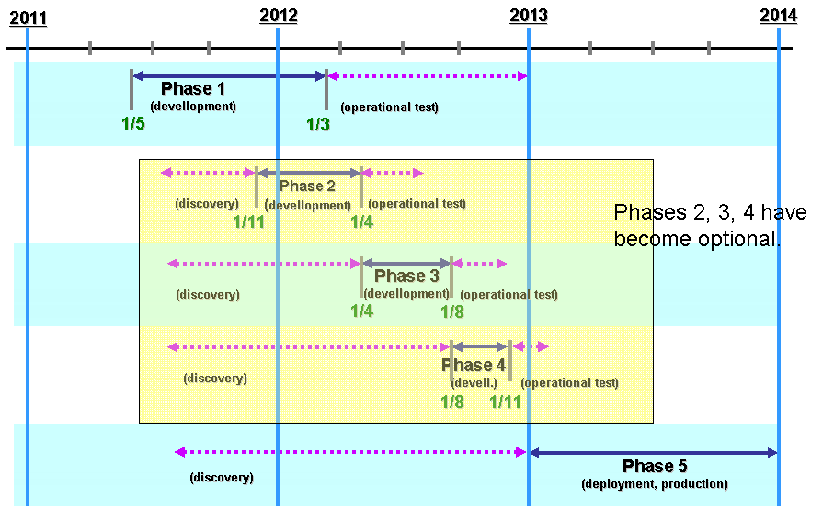

Figure 30: HeERO and Dutch project phases

Phase 1 corresponds with HeERO WP2 (implementation), phases 2, 3, 4 correspond with WP3 (operation), phase 5 corresponds with WP 4 (operation).

### Testing environment

For each project phase the following tests are performed (in given order):

|  |  |  |
| --- | --- | --- |
| **Order** | **Test type** | **Characteristics** |
| **1.** | System tests | * During the system test phase the separate system components are tested; the components are regarded as stand-alone, independent components. The following system components are distinguished:   + Vehicle (IVS modem)   + GSM / UMTS network   + Stand-alone PSAP modem   + Alarmcentrale 1-1-2 (PSAP1), with an integrated PSAP modem   + Interface Alarmcentrale 1-1-2 / Rijkswaterstaat   + Interface Alarmcentrale 1-1-2 / EUCARIS   + Meldkamercentrale (PSAP2) * Testing of the component ‘Vehicle (IVS modem)’ is entirely on responsibility of the IVS modem supplier. Testing of the component ‘GSM / UMTS network’ is entirely on responsibility of the network providers (MNO’s). * System tests are performed in the lab environment (i.e. fully controlled environment), meaning that no operational users are involved. Tests are strictly related to the technical working of the equipment. |
| **2.** | Integration tests | * During the integration tests phase focus is placed on the end-to-end working of the connected system components and the ‘functionality’. * Integration tests are performed in the lab environment, meaning that no operational users are involved. Tests are strictly related to the technical working of the equipment. |
| **3.** | Performance tests | * During the performance tests phase focus is placed on the process of handling an eCall. Attention is paid to following aspects: usability and performance criteria. * During the performance tests the eCall test fleet is involved in drive testing. Performance tests are performed by operational users. * The key performance criteria that are used during the performance tests phase are:   + Percentage of success (also known as ‘Success rate’) with variation in signal strength, caused by variation in clutter density   + Duration as defined by the time table |

Table 9: Dutch test per project phase

Tests are always based on a predefined set of test scenarios. Each set of test scenarios is defined before a particular test cycle is started.

Next to the system tests, integration tests and performance tests in a laboratory environment testing by driving a pre-defined route will be done. The emphasis is on testing realistic combinations of eCalls under different circumstances. The eCalls will be generated in the field, all at a time. Emphasis is also on the processes in PSAP and TMC with the information generated by the eCall. In every scenario all the KPIs will be taken into account.

The following different test scenarios will be tested:

|  |  |
| --- | --- |
| **Title of scenario** | **Rear-end collision 2 passenger cars** |
| **Environment** | Highway |
| **Type of eCall** | 2 automatic eCalls |
| **Dangerous goods involved** | No dangerous goods |

Table 10: Dutch test scenario 1

|  |  |
| --- | --- |
| **Title of scenario** | **Passenger car crashes into tree** |
| **Environment** | Rural |
| **Type of eCall** | 1 automatic eCalls, 4 manual eCalls |
| **Dangerous goods involved** | No dangerous goods |

Table 11: Dutch test scenario 2

|  |  |
| --- | --- |
| **Title of scenario** | **Collision passenger car and pick-up truck** |
| **Environment** | Highway |
| **Type of eCall** | 2 automatic eCalls |
| **Dangerous goods involved** | Dangerous goods present in pick-up truck |

Table 12: Dutch test scenario 3

|  |  |
| --- | --- |
| **Title of scenario** | **2 Passenger cars, side impact** |
| **Environment** | Rural |
| **Type of eCall** | 1 automatic eCall |
| **Dangerous goods involved** | No dangerous goods |

Table 13: Dutch test scenario 4

|  |  |
| --- | --- |
| **Title of scenario** | **Passenger car, heart attack** |
| **Environment** | Urban |
| **Type of eCall** | 1 manual eCall |
| **Dangerous goods involved** | No dangerous goods |

Table 14: Dutch test scenario 5

|  |  |
| --- | --- |
| **Title of scenario** | **Truck runs into passenger car, second truck tries to avoid Collision and runs into barrier** |
| **Environment** | Highway |
| **Type of eCall** | 2 automatic eCalls, 16 manual eCalls from cars passing by |
| **Dangerous goods involved** | Dangerous goods in second truck |

Table 15: Dutch test scenario 6

|  |  |
| --- | --- |
| **Title of scenario** | **Rear-end collisions passenger car and truck** |
| **Environment** | Highway |
| **Type of eCall** | 2 manual eCalls |
| **Dangerous goods involved** | Dangerous goods in truck |

Table 16: Dutch test scenario 7

|  |  |
| --- | --- |
| **Title of scenario** | **Chain collision 6 passenger cars, 1 pick-up. After 3 minutes a second incident on opposite lane with 2 passenger cars** |
| **Environment** | Highway |
| **Type of eCall** | 8 automatic eCalls, 3 manual eCalls after 1st collision.  1 automatic eCall, 3 manual eCalls after 2nd collision. |
| **Dangerous goods involved** | Dangerous goods in pick-up truck |

Table 17: Dutch test scenario 8

|  |  |
| --- | --- |
| **Title of scenario** | **Truck with flat tire on hard shoulder** |
| **Environment** | Rural |
| **Type of eCall** | 2 manual eCalls by cars passing by |
| **Dangerous goods involved** | No dangerous goods |

Table 18: Dutch test scenario 9

|  |  |
| --- | --- |
| **Title of scenario** | **Passenger car crashes into lamppost** |
| **Environment** | Urban |
| **Type of eCall** | 1 automatic eCall |
| **Dangerous goods involved** | No dangerous goods |

Table 19: Dutch test scenario 10

|  |  |  |  |  |  |
| --- | --- | --- | --- | --- | --- |
| Position  Type eCall | Rural | Highway | Urban | Total of scenarios | Dangerous goods in scenario |
| Manual |  |  | 1 | 1 |  |
| Automatic | 1 |  | 1 | 2 |  |
| Multi manual | 1 | 1 |  | 2 | 1 |
| Multi automatic |  | 2 |  | 2 | 1 |
| Combination manual/ automatic | 1 | 2 |  | 3 | 2 |
| TOTAL | **3** | **5** | **2** | **10** | **4** |

Table 20: Summary of Dutch test scenarios

**Current situation**

To refer the future situation with eCall to the current situation it will be necessary to map the current situation. This is why a pre-pilot measurement is being carried out. The baseline will be a quick-and-dirty measurement. The idea is to monitor for 1 or 2 days all incoming reports into the national 112-PSAP (PSAP 1), the regional PSAPs (PSAP 2) and TMC, and to describe in an exact way the tracking, timing and procedures. It should be clear what messages are actually sent to the TMC and how much time the different procedures take to complete. During the eCall pilot such measurements also will be carried out. At the conclusion of the tests it will be possible to draw conclusions about the effects of eCall on the incident duration, the different phases of incident management and the success rate.

**Further actions:**

* In one or more scenario’s a foreign car(s) must be involved
* Detailed planning of the scenario test must be done
* Test duration and frequency must be discussed
* Test registration must be discussed

### Country specific matters in the Netherlands

Country specific matters are already described in the paragraph before.

# Annex II – Overview of result sheets for evaluation

The following sheets are exemplarily and still under discussion. Due to first test experiences, the layout may change completely.

## Sheet: Summary



## Sheet: Results per IVS



## Sheet: Results per PSAP



## Sheet: Example for results of IVS tests



## Sheet: Real Life – Test conditions



< End of document >