Publishable summary

Objectives
The objectives of the TeleFOT project are to assess the impacts of functions provided by aftermarket and nomadic devices in vehicles and raise wide awareness of their traffic safety potential. In particular, TeleFOT investigates how retrofitted equipment, such as navigators and smart phones that are not in all cases originally designed for in-vehicle use, can support the driver and the detailed effects of the information produced for this purpose on the driving task. These devices can provide different types of driver support functions and almost nothing is known about their safety and other impacts yet.
The project also aims at speeding up the penetration of systems able to "see" beyond drivers’ field of vision in conditions where good situation awareness is needed.
TeleFOT provides opportunities to test the impacts of similar functions future cooperative systems will provide after their development challenges have been solved in the coming years. In fact, aftermarket and nomadic devices provide an alternative to some important cooperative driving and ADAS functions for many years ahead. The concept comprises of creating three European test communities: Northern, Central and Southern. About 3 000 drivers participated in the tests.

The main focus
The market penetration of portable navigators and smart phones is exploding today, therefore the timing for the project is ideal. The functions to be tested cover two broad areas: Functions promoting (i) safe driving and (ii) economic and fuel efficient driving. These are Speed information, Traffic information, Road weather information and “Green driving” support. The impacts are assessed on levels ranging from usability; behaviour & incidents; safety; Green Driving and efficiency; to the impacts on the transport system. Attention will be also paid to possible negative impacts, since especially smart phones are not originally designed for vehicle use and navigators may have problems in fixing and positioning in the cockpit. Business models are also studied.

Field Operational Tests
Field Operational Tests developed in TeleFOT are aimed at a comprehensive assessment of the efficiency, quality, robustness and user friendliness of in-vehicle systems, such as ICT, for smarter, safer and cleaner driving. FOTs are organized in three test communities in Northern (Finland, Sweden), Central (Germany, UK, France) and Southern (Greece, Italy, Spain) Europe.

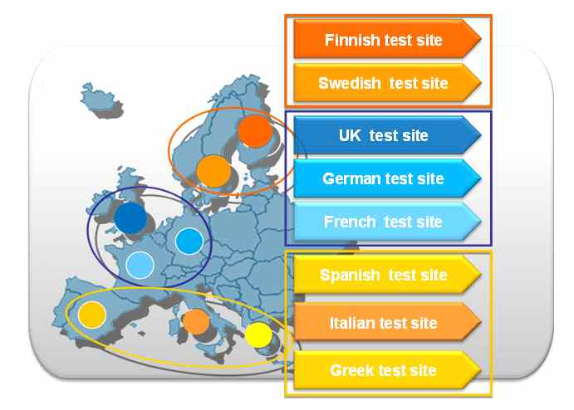
Figure 1: TeleFOT test sites
The tests are planned in two phases: first, short and long term testing are performed with a large number of vehicles. In the second phase, detailed testing with a limited number of subjects with instrumented cars are carried out. In the tests, drivers have access to smart phones and navigators and the effects of the services they provide to support driving are tested. Prior to any field operational tests, the usability and safety of the devices and services are studied carefully in laboratory conditions.

The consortium and the work plan

The Consortium:
The project Consortium is composed by Research Institutes, Universities as well as representatives from the European automotive industry, equipment manufacturers, road maintenance, and service operators.
TeleFOT is led by VTT Technical Research Centre of Finland and Mr Petri Mononen is the project Coordinator. In addition to VTT, the project partners are: Adac, Blom, BroadBit, Centro Ricerche FIAT, CERTH/HIT, Chalmers, CIDAUT, Destia, Emtele, Electronic Trafic S.A., Institute for Communication and Computer Systems, RWTH Aachen - Institut für Kraftwahrwesen, Logica Suomi Oy, Loughborough University, Magneti Marelli, Metasystem, MIRA Ltd, Navteq, Universite de Technologie de Belfort-Montbeliard (joined during 2nd project year), Rücker Lypsa, Swedish Road Administration, and University of Modena and Reggio Emilia.

The Workplan:
As a Large Scale Project, TeleFOT is divided into five Sub-Projects:
In SP1 (Coordination) management procedures are used to ensure shared and clear decisions among the partners, receiving support from the Core Group and the EU team.
In SP2 (FOT Framework) a detailed TeleFOT operational framework will be created to guide the activities, firstly based on FESTA general handbook, then, constantly updated when new knowledge is accumulated and data is collected.
SP3 (Field Tests) coordinates three Test Communities (in Northern, Central and Southern Europe) to collect the data of the introduction of nomadic devices to the vehicle environment. Data collected are analysed in SP4.
SP4, Evaluation and Assessment ensure an appropriate analysis of data collected, in order to identify the impacts of aftermarket and nomadic devices/functions.
In SP5 Dissemination, user awareness and exploitation activities are coordinated by UNIVERSITA, also supporting liaison among all subprojects and raising awareness of its goals and results since the earliest phases of its activities.

Potential impacts
The project will speed up the penetration of systems able to support drivers’ field of vision in conditions where good situation awareness is needed. The collected sizable database will be useful and valuable also after the project completion.

Key results after the last reporting period
First year key results: These include the major steps taken in defining the general framework for running the novel type of research project – a challenging exercise that has involved input from more or less everyone working in the project. The major outcome of this work was the selection of functions to be tested and the associated framework from the functions to the research hypothesis, through research questions and performance indicators up to the data logger specifications. Also, steps were taken in the planning and practical preparations for the numerous national test sites.
Second year key results: The main weight of the activity during the second project year have been i) the final preparations for the FOT test site launches, incl. the preceding technical validation and pilot phases and ii) defining the evaluation framework in the form of assessment domain specific data analysis plans.
Third year key results: The main defining characters of the activity during the third project year have been i) the FOT test site launches, incl. the rest of the pilots; ii) full FOT data flowing in the project and iii) testing the evaluation framework in the form of preliminary data analysis and results for each assessment domain.
Final reporting period: These are reported in D1.15 Final report.

The main results
These are reported in D1.15 Final report.

www.telefot.eu
Detailed information on the project results and the consortium are available on its website http://www.telefot.eu

