

ETICS Draft Detailed specification of the inter-carrier service delivery system

Deliverable: D5.6

Date: 21/11/2012

Version: 1.0





Editor: | Zied Ben Houidi (ALBLF)
Deliverable nature: | R
Dissemination level:  (Confidentiality) | RE
Contractual Delivery Date: | 31/07/2012
Actual Delivery Date | 21/11/2012
Suggested Readers: | ETICS partners, European Commission
Total number of pages: | 70
Keywords: | Architecture, specification, Service discovery, service composition, control plane

Abstract
The goal of ETICS is to enable inter-carrier ASQ paths: data connectivity services with quantified quality that span multiple Network service providers. This deliverable is a draft detailed specification of an inter-carrier service delivery system that enables such inter-carrier ASQ paths. Prior deliverable D5.2 described the functional building blocks of such a delivery system and specified how they interact together. This deliverable goes more into the details of each building block.

DISCLAIMER
This document contains material, which is the copyright of certain ETICS consortium parties, and may not be reproduced or copied without permission. All ETICS consortium parties have agreed to full publication of this document. The commercial use of any information contained in this document may require a license from the proprietor of that information.
Neither the ETICS consortium as a whole, nor a certain party of the ETICS consortium warrant that the information contained in this document is capable of use, or that use of the information is free from risk, and accept liability for loss or damage suffered by any person using this information.
This document does not represent the opinion of the European Community, and the European Community is not responsible for any use that might be made of its content.

IMPRINT
Full project title: Economics and Technologies for Inter Carrier Services
Inter-carrier high level technical architecture for end-to-end network services
Document title: ETICS Draft Detailed specification of the inter-carrier service delivery system
Editor: Zied Ben Houidi (ALBLF)
Workpackage Leader: Isidro Cabello Medina (TID)
Project Co-ordinator: Nicolas Le Sauze, Alcatel-Lucent Bell Labs France
Technical Project Leader: Richard Douville, Alcatel-Lucent Bell Labs France
This project is co-funded by the European Union through the ICT programme under FP7.

Table of Contents
1. Introduction 5
2. ETICS High level picture 6
2.1. Inter-carrier ASQ paths that need to be implemented by ETICS 6
2.1.1. More “compleX” PoI to Region ASQ 8
2.2. ETICS user guide 8
2.3. ETICS Internal Work Flow 9
3. ETICS Functionalities specification 11
3.1. ETICS Service Access Point 11
3.1.1. State of the Art: EuQoS SAP 11
3.1.2. Available Information 12
3.1.3. Available actions 13
3.1.4. Traffic identification negotiation 13
3.2. Offers/Capabilities representation 13
3.2.1. Offers representation (Push Model) 13
3.2.2. Capabilities representation (Pull Model) 19
3.3. protocols for Capabilities/Offers Exchange 23
3.3.1. Offers Exchange and storage (push model) 23
3.3.2. Capabilities exchange (pull model) 23
3.4. Algorithms for offers computation/NSP chain computation 24
3.4.1. Algorithms for offers computation/negotiation 24
3.4.2. Algorithms for NSP chain computation 38
3.5. Network path computation 39
3.5.1. From An inter-carrier ASQ path offer to an inter-Carrier ASQ network path 39
3.5.2. From an NSP chain to an inter-carrier ASQ network path 43
3.6. Inter-Carrier ASQ path Provisioning 43
3.6.1. What is the right traffic identification scheme? 44
3.6.2. Enforcing the traffic identification scheme: A distributed end-to-end signaling mechanism (RSVP overlay) 52
4. Deployment of ETICS functionalities 55
4.1. Centralized (and Per-NSP centralized) deployment scenario 55
4.2. Distributed pull deployment scenario 56
5. Conclusion 58
6. Annex: Tunable QoS-Aware Network Survivability 59
6.1. Introduction 59
6.2. Model and problem formulation 60
6.3. Algorithmic Solutions and Results 61
6.4. References 61
7. References 63

Introduction
The goal of the ETICS architecture is to enable and implement inter-carrier ASQ paths that are paths, with quantified and assured network performance characteristics, and that span multiple Network Service Provider (NSP) networks. This document is a draft detailed specification of such an Inter-Carrier Service delivery system.
This document follows the guidelines of Deliverable D1.6 (technical roadmap of the ETICS project) and partly updates it. It also updates Deliverable D5.2, which is the first draft detailed specification of components of the ETICS architecture.
First, while deliverable D5.2 focused mainly on specifying the interactions between the different building blocks (and how they are affected by the different deployment scenarios), this deliverable further goes into the details of these different building blocks.
Second, while deliverable D5.2 focused on the single-NSP PoI to PoI “transit” services, this deliverable deals also with the association of these services to the ETICS customers by taking into account also region offers.
Finally, this deliverable provides a first input to the path provisioning (traffic identification) problem.
This document is organized as follows.
First, Sec.2 presents the high level picture ETICS by separating three components: the inter-carrier ASQ paths that need to be implemented/enabled by ETICS, the “user guide” to request and order such ASQ paths, and finally the ETICS internal workflow. The latter concerns the way the different NSPs in a community “collaborate” in order to provide inter-carrier ASQ paths, as well as the different functional blocks involved in this task.
Second, Sec.3 goes through these different functional blocks of the ETICS architecture and further specifies them. Finally, Sec.4 describes the two particular deployments scenarios of these functionalities, that will developed for prototyping.

ETICS High level picture
This section reminds the ETICS high level architecture. We ask the reader to refer to deliverable D1.6 [ref-D1.6] for the most recent high level picture of ETICS and for getting familiar with the terminology used in this document.

Inter-carrier ASQ paths that need to be implemented by ETICS
Figure 1 summarizes and provides an abstraction of the inter-carrier ASQ paths that need to be offered by the ETICS community and to be implemented by the ETICS solution (the ETICS targeted final architecture). The ETICS community is a set of NSP that have implemented the ETICS specifications and that collaborate in order to offer and realize the inter-carrier ASQ paths as ordered by the ETICS customer. The order from the ETICS customer is directed to the (primary) supplier NSP, which can in principle be any of the involved NSPs for the particular ASQ path or even a 3rd-party virtual NSP, like a broker. This abstracted inter-carrier ASQ path is applicable to and covers all the types of actors in the ETICS ecosystem, except may be business enterprise customers, for which the ASQ paths are currently being defined, and will be left for further deliverables.
An inter-carrier ASQ path is a Point of Interconnect (PoI) to a region assured quality connectivity service. From the point of view of the primary NSP supplier it contains mainly two parts: a PoI to PoI part and a PoI to region part. The current core-system architecture development takes as an assumption that the first part the traffic is aggregated and follows the same path in terms of Points of Interconnect. This part results from the concatenation of one or multiple single-NSP PoI to PoI ASQ paths. In the second part of the ASQ path, the traffic is split at the level of the last PoI to reach different destinations hosts.
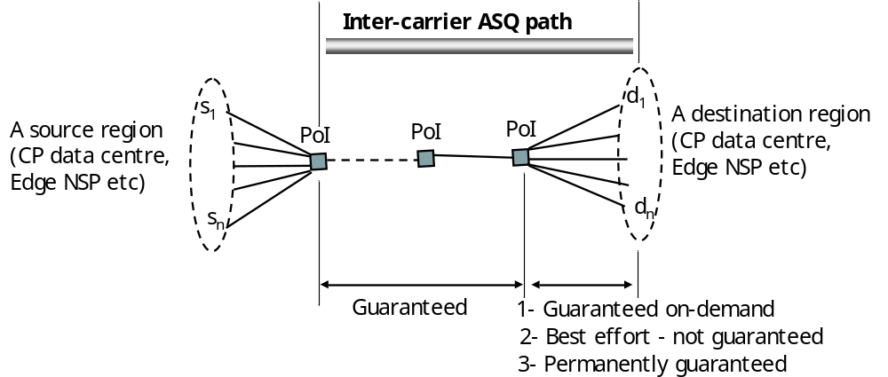
Figure 1 INTER-CARRIER ASQ PATHS THAT NEED TO BE IMPLEMENTED BY ETICS
The PoI to PoI part of the ASQ path is always guaranteed (e.g. Bandwidth, delay estimation and possibly more parameters). However, as described in D1.6 [ref], the PoI to region part of the ASQ path can be either best effort or guaranteed. Moreover, if it is guaranteed, then different types of guarantees can be described. Deciding on the types of guarantees of the PoI to region part of the ASQ path is still under discussion within the consortium. We present in this deliverable the latest taxonomy as described in the D1.6 deliverable. This reflects therefore the current state of thinking and is subject to evolution in the future. The PoI to region part of the ASQ path can be:
- Best effort: The access provider responsible for the region does not provide guarantees on the traffic delivery. It can however give hints on the quality of the best effort service.
- Permanent guarantees: The access provider guarantees and describes for each host in the region what guarantees it can provide on the traffic delivery.
- On-demand guarantees: The access provider can provide guarantees on the traffic delivery but any customer that wants to use them needs to explicitly ask for it. In this case the access provider:
  - Describes in a high level way what kind of guarantees it will provide.
  - Provides a mechanism that the customer can use to demand guarantees to individual connectivity sessions (traffic related to a particular end host). This mechanism is one of the roles of the SEFA (Service Enhancement Functional Area) that was described in deliverable D4.3 [ref-D4.3].
In order to clarify this process and the origin of the taxonomy of PoI to region services introduced first in Deliverable D1.6, we provide a diagram that describes the interaction between an end user within a region and an ETICS customer (here a content provider). The diagram, described in Figure 2, shows the viewpoint of the content provider and how it can use the PoI to region ASQ path. It starts with the end user connecting to the content provider’s web page.
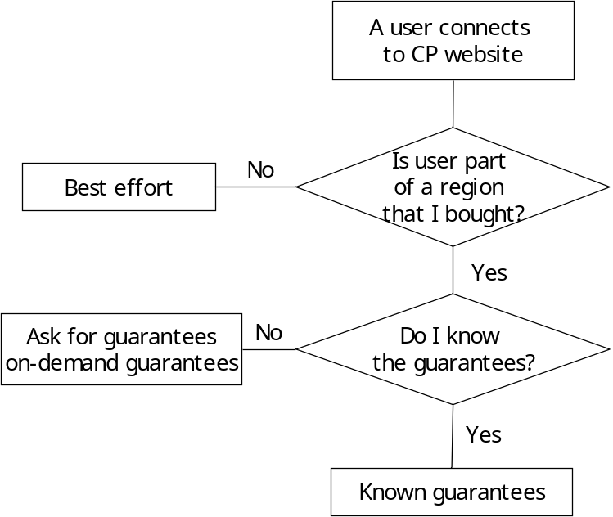
Figure 2 INTER-CARRIER ASQ PATHS THAT NEED TO BE IMPLEMENTED BY ETICS
Once the content provider receives the request, it checks whether the user is part of a region for which it bought a contract. If it is not the case, the communication between the CP’s server and the end user will go best effort. Now if the user belongs to a region for which the CP has bought a contract, there are two possibilities, the first is that the CP does not know the guarantees. This implies that the PoI to region contract does not specify the guarantees that a given user can get. The CP needs therefore to explicitly ask in order to know which guarantees it can obtain. It needs also eventually to explicitly request the edge NSP responsible on the region to set up these guarantees. This is what we called “on-demand” guarantees.
Finally, the last case is when the content provider knows already, when it purchases the PoI to region contract, about which guarantees the edge NSP provides. In this case, the PoI to region part can be:
- Permanently guaranteed: In this case, the ETICS customer has an idea on the guarantees it has for each destination host in the destination region. It needs not therefore to ask for further clarifications about these guarantees.
- Best effort: Although we acknowledge the fact that best effort is not a guarantee, the CP has the possibility to purchase an ASQ path that serves a region, with the sole guarantees on the transit part of the ASQ path, i.e. from the first PoI till the last PoI at the edge NSP connecting the region.
We will provide later in this deliverable further information about this taxonomy when providing a first detailed description of the PoI to region ASQ path.

More “compleX” PoI to Region ASQ
The Inter-Carrier ASQ path described previously pre-supposed that a destination Region is owned by the same Operators and belongs to the same AS. Nevertheless, in some cases this rule could not be guaranteed:
- This could be the case of an Operator that owns several ASes in different regions/countries and would like to serve all its eyeballs within a single ASQ path offer.
- It could also be that inside the ETICS Community, some Operators would join their efforts to negotiate an offer to an over the top player for all their respective eyeballs.
In these particular scenarios, it is not possible to use as is the PoI to Region described previously. It is necessary to decompose the problem during the service composition phase.
First, the service composition must determine which part of the ASQ path is shared between the different Regions. Once this path has been determined, a first PoI to PoI ASQ path is requested. Then, as many as necessary PoI to Region ASQ path offers are requested. All the ASQ paths are then grouped under the same identifier for management purpose. The ETICS system will then store two identifiers: an individual identifier and a group identifier. Only the group identifier is provided to the requester.
This scenario has been proposed as an example of what combination of PoI to PoI and PoI to Region ASQ path is possible to manage in order to form more complex ASQs. For example, we could envisage a PoI to Multi-PoI as P2MP ASQ with a similar decomposition. What it is important to remember is that ETICS should be able to support complex connectivity scenarios through two basics ASQs without major modification in its architecture. Only the service composition algorithm must be enhanced to support future and more complex ASQ paths like the one introduced in this subsection.
An additional complexity can also appear when a region is served by different offers (full or partial overlap of offers‘regions) with similar QoS parameters and starting from different PoIs. In this case it is often difficult to determine, without explicit region definition or without an additional request method procedure addressed to the owner of the regions, the real total number of end-users (union of the regions but taking into account their intersection) that can benefit from guarantees whatever if the offers are permanent or on-demand guarantees.

ETICS user guide
We now show, in a fully automated setting, how an ETICS customer can request an inter-carrier ASQ path from the ETICS community. We use Figure 3 to illustrate how it should work. We remind that an ETICS customer is any actor that triggers the ETICS community to compute an inter-carrier ASQ path.
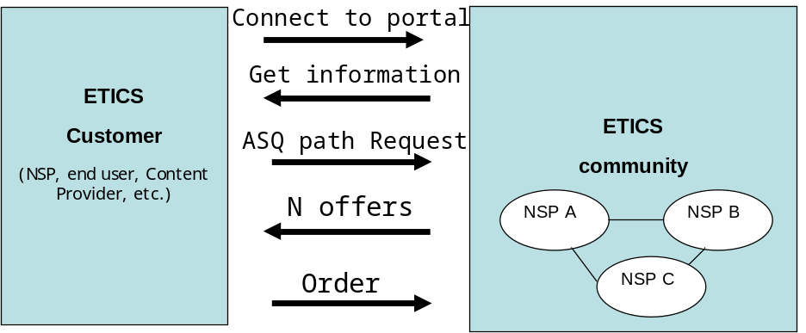
Figure 3 Requesting INTER-CARRIER ASQ PATHS From ETICS (When the ETICS customer does not do the service composition)
According to Sec.2.1, the ETICS customer needs an inter-carrier PoI to region ASQ path. The customer first connects to the ETICS portal, an ETICS interface that contains information about the regions and the points of interconnect that are served by the ETICS community. This first step allows the customer to discover the ETICS community and know whether the latter can satisfy its needs. If it is the case, the ETICS customer formulates an inter-carrier ASQ path request to the ETICS community. The ETICS system is then responsible of finding one or multiple inter-carrier ASQ paths that can satisfy the customer’s request. If the customer is satisfied with one of the offers, it can order it from the ETICS community. The latter is then responsible for provisioning the ASQ path for the customer. Note that the arrows in the figure do NOT necessarily mean message exchange, but actions that the ETICS customer performs.

ETICS Internal Work Flow
The ETICS architecture is governed by different processes that must follow a given work flow. The goal of this work flow is to implement the inter-carrier ASQ paths described in the previous section. Figure 4 below shows the different steps that govern the life cycle of an inter-carrier ASQ path. These steps could be grouped by means of phases in the ETICS work flow (these phases were first summarized in Deliverable D1.6[D1.6]:
- Step 1 corresponds to an initialization phase in which the NSPs of a community get ready to receive inter-carrier ASQ path from ETICS external customers.
- Steps 2 to 5 that correspond to the Invocation phase where an ETICS customer requests an inter-carrier ASQ path,
- Steps 6 to 8 design the phase where NSPs are enforcing the inter-carrier ASQ path in their respective networks,
- Step 9 simply designs the monitoring and management phase of the ASQ IC including its termination.
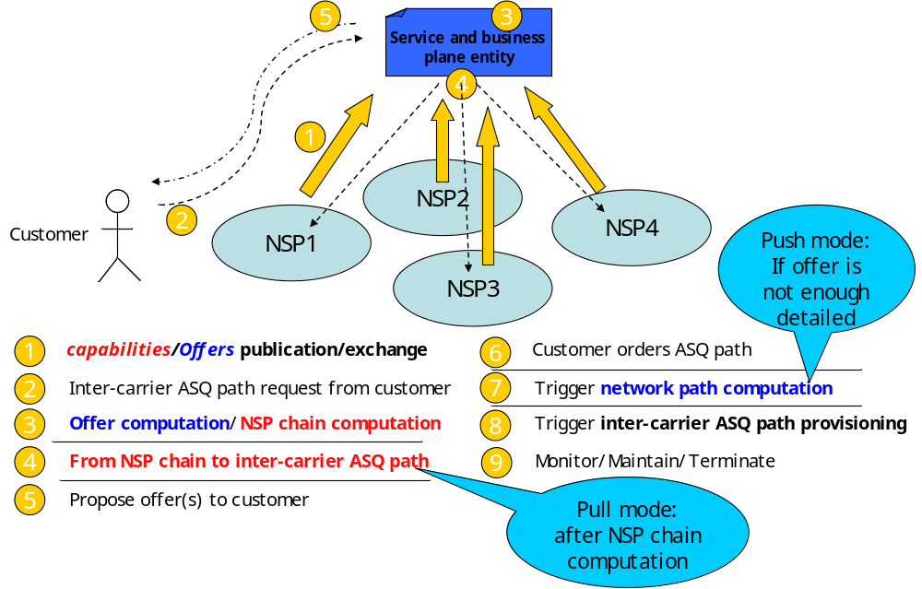
Figure 4 ETICS WORK FLOW
In a bit more details, the first step (1) is to get the service and business plane aware of the different network capabilities or ASQ path offers of the different NSPs of the ETICS community. This is covered by the capabilities/offers publication/exchange functionality. This functionality is detailed in Sections 3.2 and 3.3.
Then, the ETICS system is triggered by an ETICS customer inter-carrier ASQ path request (step2). This will trigger first an Offer computation in the push mode and an NSP chain computation in the pull mode. This is covered by the Offer computation/NSP chain computation and detailed in section 3.4 .
Next, in the pull mode, the next step (4) is to go from the NSP chain to a precise inter-carrier ASQ path. In the push mode, the Offer computation has already determined an inter-carrier ASQ path. This functionality is covered in section 3.5.2.
Once we have one or multiple inter-carrier ASQ path(s), we offer it to the customer (5). If the customer accepts the offer, it orders it (6). If the inter-carrier ASQ path is not enough detailed, an extra step is needed (7) (detailed in section 3.5.1). This is what we called the network path computation.
Once the network path is computed, the next step (8) is to provision the inter-carrier ASQ path. This functionality is covered in section 3.6.
During the life of the inter-carrier ASQ path, the ETICS architecture needs to monitor and maintain the ASQ path (step 9). A first description of this functionality was covered in prior deliverables. It will be subject to further refinements and specifications in the next deliverables D4.4 (final architecture) and D5.8 (final detailed specifications).
Finally, the last step is then to terminate the service once the contract takes end.

ETICS Functionalities specification
Deliverables D5.2 [RefD5.2] and D1.6 [RefD1.6] identified a set of basic functionalities that need to be specified and implemented in order to have a fully working ETICS solution. This section details these functionalities.

ETICS Service Access Point
This section describes the interface between the ETICS external customer and the ETICS architecture. Thanks to this interface, the user can discover ETICS services, request and order inter-carrier ASQ paths.

State of the Art: EuQoS SAP
One of the main achievement of the IST/FP6 EuQoS project is the definition of a Service Access Point (SAP) that enable a common API for applications that would reserve some resource in the network. What is important to retain from the EuQoS SAP is the way that the problem has been decomposed. Indeed, the EuQoS SAP is composed by actions on data. These parameters are then divided into 4 mains categories:
- Scope: The scope precises on which part of the network will carry the reservation i.e. the beginning and the end. The scope is composed by:
  - Source: where the reservation start as an IP or realm address
  - Destination: where the reservation end as an IP or realm address
- QoS Specification: The Qspec (similar to what have been standardized in Y.1541, RSVP-TE …) describes which kind of QoS the requester expected. The Qspec is composed by:
  - Class of Traffic: A name that designs a set of parameters (see below). For example, Interactive, Conversational, Streaming, Background …
  - Class of Service: Could be a name (CT0, CT1 …) or a type (EF, AF1 …) or Traffic Specification that explicitly fixes parameters. For example, delay, jitter, loss … Exceed treatment could be also mention in this category.
  - Bandwidth
  - Priority
- Flow Specification: The FSpec specifies which packets will receive the QoS mention in the QSpec. The FSpec take various forms, but could be formalized as a:
  - Marker (Type, Value) that specifies a one field identification of a flow or micro flow. For example it could a an ATM VCC, a IPv6 flow label, an (G)MPLS tunnel label, a DSCP …
  - Ends Point Identification that used a multi-field combination to determine which packets belong to that FSpec. It is more or less similar to what is used for the Forwarding Equivalent Class (FEC) identification used by Label Edge Router (LER) in MPLS. In general FSpec uses the IP source and destination address with or without mask (so host or prefix IP addresses), port or range of port source and destination and protocol number.
- Time Specification: TSpec finally determines the when the QoS will be applied. TSpec could be an interval or duration with or without a repeatability schema. In all case, TSpec is also used as graceful release timer in case of failure.
So, the mandatory parameters of the EuQoS SAP determine precisely where in the network (Scope), when (TSPec), on which packet (FSpec) and what level of Qos (QSpec) will be applied belonging to that reservation.
The functions provided by the API are as follow:
- Reserve( Scope, (FSpec, QSpec)+, TimeSpec): returns a ReservationIdentifier and reserves network resources for ensuring QoS (specify by the QSpec) guaranty for flow (specify by the FSpec) between two nodes. The QoS corresponding to this reservation will be enforced by the "Commit" function,
- Commit( ReservationIdentifier, (FlowId, QSpec)+ ): this function is called to enforce QoS parameters belonging to the reservation that has been initialized by the "Reserve" function (with the "ReservationIdentifier" parameter returned by the Reserve function). The initial resource profile will be restored in two ways: by explicitly calling "Stop" or implicitly when the "ActiveDuration" associated to the "TimeSpecification" parameter expires,
- ReserveCommit( (Scope, FlowId, QSpec)+, TimeSpec) returns ReservationIdentifier. Combine the Reserve and Commit function into the same call,
- Modify (ReservationIdentifier, (old_FlowId, old_QSpec)*, [old_TimeSpec], (new_FlowId, new_QSpec)*, [new_TimeSpec]) this function is able to modify the parameters that were initialized by a previous reservation. ReservationIdentifier is mandatory,
- UnCommit( ReservationIdentifier, (FlowId, QSpec)+) to un-enforce the reservation inside the network. This stops the reservation activated by the "Commit" function. It is needed for reservation which have repeated schedule,
- Stop( ReservationIdentifier, (FlowId, QSpec)+ ) stops the reservation and re-establish initial/default network configuration parameters.
Compared to the need of the ETICS ASQ IC service, the EuQoS SAP is more or less well adapted to the ETICS need. Indeed, the functions of EuQoS SAP could be use as is and parameters just need some adaptation. In particular for the scope where instead of source and destination ETICS need to identify the Point of Interconnect and where the price is missing. But, from a technical point of view, this API is well adapted to our needs.

Available Information
This interface should offer the following information to an ETICS customer:
- The regions that can be reached within the ETICS community together with the capabilities associated to these regions. The different region offers are described in Sec.3.2.1.3.
- The points where it is possible to offer point to point (multipoint) network services such as business connectivity services. This part is work in progress. The development focus has been so far centered around region services.
- Optional: One can imagine a configuration in which the ETICS customers could as well have access to single-NSP ASQ path offers.

Available actions
An ETICS customer can have one of two actions:
- Request an ASQ path offer: In return, the ETICS interface returns an offer.
- Order an ASQ path offer: If the offer satisfies the customer, the latter can order it.

Traffic identification negotiation
During the ordering phase, the ETICS customer and the ETICS community need to agree on the way customer traffic is identified at the entry of the ASQ path. This implies agreeing on the content of a similar table that specifies the traffic that needs to be matched at the entry of the ASQ path:
Interface | IP source range | IP destination range | VLAN id | DSCP |  | etc...

The PoI from which the ASQ path starts contains multiple network interfaces. The first step is to agree on which interface the traffic will be coming from. Then, a flow specification field must be agreed on. The flow specification field identifies which traffic should profit from the ASQ path. Traffic that does not correspond to this identification will not profit from the ASQ path.

Offers/Capabilities representation

Offers representation (Push Model)
Automating the trading of ASQ paths between the different ETICS actors goes through a detailed description of the ASQ path parameters. This is the goal of this section.
The parameters describing an ASQ path can be divided into the following classes:
- Technical parameters: all the parameters describing the guarantees of the ASQ path, as well as how it can be provisioned.
- Business parameters: any business related information like the price or the validity of the offer.
- Administrative parameters: like the boundaries of the ASQ paths.
An inter-carrier ASQ path is as we saw a PoI to a region path. It is composed of one or multiple single-NSP ASQ paths. An SLA offer request of an ETICS external customer is therefore an inter-carrier ASQ path offer request.
Deliverable D5.2 [D5.2] performed a first round of Offer descriptions refinement. This was done within the SLA refinement section of this deliverable (Sec.3.1). The work, which was seeking to be generic classified metrics, not in terms of what they mean for the network or the user, but rather in terms of how their composition is done. They were as such split into additive, multiplicative, concave or probabilistic metrics. In this deliverable, and in order to get closer from prototypes, we take a more practical and short-term approach by specifying a set of metrics and parameters that are meaningful to the network, and easily understandable by the customers (i.e. with a relative easy mapping in an application QoE level according to the usage of the connectivity service by a specific application).

A lesson from prototyping
We learned from our experiences during the prototyping part of ETICS project that we neglected to clearly specify the importance of the creation of different PoI instances in a PoP even between the same ASBRs and to enforce Traffic Delivery Point (TDP) rules (choice of exit ASBR or entry ASBR) to all PoIs of an ETICS community and not per-PoI. For example we reproduced the case where an Edge NSP was the destination of offers from its neighbours and also the initiator of offers to their neighbours. The problem came when the composition process unintendedly stitched these two types of offers, due to the fact that some of them were sharing a common PoI. But in our scenario the Edge NSP didn’t want to participate to any kind of transit product. Therefore, in this document, we enhance the definition/usage of PoI to avoid such behaviour.

PoI to PoI ASQ path offers specification

Technical parameters

Guarantees:
All the following technical guarantees are expressed with a confidence interval.
Bandwidth in Mbits/s: This parameter defines the guaranteed rate of the data traffic handled by the ASQ service.
Note that traffic policing mechanism is deployed at the head end(s) of the ASQ path (where the different traffics are taken by the first ETICS NSP in the ASQ path) ensuring that the transmitted data is compliant with the SLA. Either traffic shaping, excess traffic discarding or non-compliant packet marking techniques will be enforced to ensure that customer data traffic respects the contract. By default, packets violating the contract will be dropped to not introduce jitter, or impact other ASQ services taken in charge by the community of NSPs. By this strategy the ETICS community does not oblige to deploy such mechanism at each PoI when the ASQ path spans several NSPs.
Delay in ms: represents the maximum time of transmission of data between the ingress PoI and the egress PoI.
“Jitter” in ms: This parameter could be considered as optional for software applications due to the fact that the delay parameter represents a maximum value but to the technical specification limitations of some devices used by end-users this parameter is often required. The typical example is the limited buffering size of mobile devices (at network protocol stack and/or application levels) that do not allow a predictable quality of experience. Thus some applications relying on the streaming of data can be degraded even if all data have been received under the required delay constraint. For this reason we define a Jitter parameter that represents the maximum delay variation in ms between two successive packets.
Loss: expressed as a percentage of lost packets.
Availability: expressed as a percentage of availability time of the connectivity service. More complex representation of the availability (for example taking into account minimum time between two failures, maximum time to repair…) could be proposed but the composition of a richer parameter between different operators is considered too complex for a rapid adoption of the ETICS solution by different actors (operators, customers…).
Establishment delay in ms: represents the maximum delay to establish the connectivity service from the reception by the provider of an order of the service sent by the customer.

Related to provisioning and traffic identification (optional)
This part will be further refined once we converge on the final inter-carrier ASQ path provisioning and traffic identification solution. This part is two-fold, the first is related to how the boundaries of ASQ paths are described, and the second is related to traffic identification and path provisioning.

Boundaries of the ASQ path:
First, the ASQ path takes place between an entry point and an exit point. These points need to be defined in the ASQ path offer. As such the double (ingress PoI, egress PoI) needs to be part of the offer. Now, as far as the PoI naming is concerned, there are mainly two directions.
The first is to base the naming on the IP addresses of AS border routers (ASBRs) and how they connect together. As such, a PoI would be a couple of ASBRs belonging to two different NSPs, and that are interconnected and ready to participate together in building inter-carrier ASQ paths.
The second is to create a new namespace to name PoIs. A PoI can be for instance the name of the Point of presence (PoP) where NSPs interconnect (e.g. PariX IXP). This approach has the drawback of assuming that all the NSPs that are present in the PoP are fully meshed, and therefore are willing to do “ETICS business” with each other. This approach has, on the other side, the advantage of being more scalable for the offers computation.
As a first step, we opt for a restricted version of the second approach relying on a new namespace to name ETICS PoIs. In our solution, we limit the creation of PoIs between NSPs only if they are effectively fully meshed. We assume that NSPs are fully meshed in a PoI if each NSP has at least one interconnection link (between ASBRs) with each of all other NSPs in the PoI. It is obvious that link properties between NSPs of a PoI have to be homogeneous (similar length, traffic identification capabilities…). That’s why when a NSP is not physically located by its ASBRs in a POP but only interconnected to other NSPs by mean of a longer links coming from another POP then it is mandatory to create a set of PoIs, each of them dedicated to a bilateral interconnection between this remote located NSP and each of locally present NSPs that is interconnected to it. When NSPs agree on the creation of a PoI, they have to respect the following rules for the TDPs (Traffic Delivery Points) of all their network connectivity services terminating or starting at this PoI :
- Network services of an NSP terminating at a PoI terminate at the ingress ASBR of the neighbour NSPs in this PoI.
- Consequently, network services of an NSP starting at a given PoI starts at its ingress ASBR.
This choice has to be respected by all the NSPs at all PoIs. PoI naming convention, preserving name collision, has to be used. For example, it can be the aggregation of the name of the PoP and an integer identifier value incremented for each of the new PoIs created at the PoP.
More important the number of NSPs joining a PoI is, dramatically less important is the (network services) graph of an ETICS community, and consequently in a push model the number of network service offer publications. In an ideal case, if a single PoI is sufficient for each PoP in the world then the size of the graph can be reduced by several orders of magnitude (cf analyses of scalability studies in WP4). Moreover in a push model, when an NSP would like to add/upgrade an ASBR at a PoI, this action will not modify the current network service offers of NSPs concerned by this PoI. Identically, when a NSP would like to join an already existing PoI (then respecting the rules/characteristics of the PoI), the other NSPs do not have to modify their already published network service offers.

Identifying the traffic that flows within the ASQ path
The traffic that goes within the ASQ path from a PoI to a PoI needs to be identified at the ingresss ASQ path. There are several identifiers (belonging to different technologies) that allow a router to identify the traffic (IP addresses, DSCP field, MPLS header, VLAN id etc).
Second, such field might be needed to express the capabilities of the PoI to PoI ASQ path in terms of traffic identification. On which traffic identifiers is the ASQ path able to handle traffic? Can it be MPLS labels? Or only IP addresses? Etc.

Business parameters:
Price: The main price model for each connectivity service is based on a flat rate (not reflecting the real consumption of the service, i.e. not reflecting the real sent data traffic) depending of the duration of the service. The idea is not to impose measurement at each boundary of the offers. Another model relying on the volume based (e.g. 95th percentile) could be considered only when the composition of the service is limited to a selection of a service offer, i.e. only between a customer and a single NSP for a single offer. Then this last exception of the usage of a volume based model can be consequently also used to build connectivity services requiring single or multi-transit connectivity services only if the resulting offer composition has been build by successive (in cascade) bilateral contracts, each time requiring only a selection of one offer by an NSP that will compose internally with one of its own offer and then resell the composition to its own customers). This type of indirect service construction (terminology more adapted than composition that is limited to the building of end-to-end offers in a single process) requires to measure traffic volume at each boundary of each cascaded contracts.
To also provide a comprehensive illustration, we describe in the following an example of pricing model for an ASQ IC :
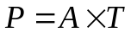
Where  is the final price that will be charged to the customer,  is a price coefficient depending of the required bandwidth for the connectivity service,  is the total duration of the service.
Duration: this parameter represents the couple of minimum and maximum duration of the connectivity service in ms ones the service is purchase. Note that the maximum component of the duration parameter can be optional. But this maximum value allows some NSPs to not have network configuration never released even if not used thanks to the termination phase of ETICS services that automatically triggers this unconfiguration action.
Validity of the offer: when an offer is provided to a potential customer (resulting from a service offer composition (push or pull model) or simply published in the push model), the offer includes an expiration date (that can also include a specific time). If the customer would like to obtain the service described by the offer then it has to order the service before the expiration date. It is important that the provider which emitted the offer is responsible to provide the service if a customer asked it before the expiration date. Thus if the provider can’t for any reasons then penalties should be provided in order to avoid abuse and a loss of confidence in the tenders. According to ETICS community rules, penalties can be shared between different actors. Note that in push model, emitted offers have to provide minimum validity duration between the date of their emissions and the expiration dates to avoid potential scalability issues (too many frequent publications…) and often a less confidence in offer value in business market.

Administrative parameters
Administrative parameters inform about the administrative entity that issues the ASQ path. This contains the following parameters.

Administrative authority
NSP name: Who owns the ASQ path offer.
AS number: The Autonomous System number of the NSP that is issuing the ASQ path.

Boundaries of the ASQ path and PoI naming:
The boundaries of an ASQ path are determined by the pair (ingress PoI, egress PoI).

Resulting PoI to PoI ASQ path description:
Ingress PoI | Egress PoI | Traffic id | Bandwidth | Delay | Jitter | Loss | Availability
Establishment delay | Price | Duration | Validity | NSP | ASN

PoI to Region ASQ path offers
Concerning the PoI to region ASQ path offers, there are as we saw in Sec.2.1 three types of offers. We give in this deliverable a first elaboration of the PoI to region ASQ path offers according to these three types of offers.
Like for the PoI to PoI ASQ paths, we divide the specification into (1) technical, (2) business and (3) administrative parameters. We further divide technical parameters into those that define guarantees, and those that help in the provisioning of the path. Administrative parameters are further divided into administrative authority and administrative boundaries

Best effort PoI to region description

Technical parameters

Guarantees
N/A

Related to provisioning
Ingress PoI: ingress Point of Interconnect where the region starts (same naming as PoI to PoI ASQ path above)
Region naming: This defines the set of hosts that are “reachable” through the PoI. This can be an:
<IP prefix>: A contiguous IP range: A range of IP addresses that cover the hosts of the region. It can be encoded as an IP prefix expressed in the CIDR notation.
<List IP> An explicit list of IP host addresses: Unlike IP routing where the CIDR was introduced to enhance scalability by allowing finer-grained aggregation, in our case, we don’t need to necessarily use the CIDR notation. In fact, the region naming is not necessarily intended to be used for routing. In practice, the list of IP hosts can be made available at the ETICS portal. ETICS customers can simply download it.
<Hybrid list>: A list of both IP prefixes and lists of IP addresses: This can be seen as a generalisation of the above two region addressing schemes. A region can be therefore defined as a list of zero or multiple IP prefixes and zero or multiple IP lists.

Business parameters
The accounting/pricing part of this subsection is left for future work as this would depend on the business model adopted for such service. We instead focus on a different characterization of this service.
N_user: number of active users: This number is a good indicator for ETICS customers to estimate the market they can target (when the IP addresses space defined earlier does not allow to infer the number of customers). Note that this number of active users represents first the number of active destination hosts (number of Internet Access Service contracts) but may also be completed by additional profiling information describing the number and quality (age, sex…) in an anonymized fashion to respect the privacy of the potential users behind all the contracts.
Duration
Validity of the offer

Administrative parameters

Administrative authority
NSP: NSP name
ASN: AS number

Administrative boundaries
From the ingress PoI to each host in the region.

Resulting PoI to region offer description
A PoI to region best effort ASQ path can be therefore one of the following:
Ingress PoI | IP prefix | N_user | NSP | ASN
or
Ingress PoI | IP list | N_user | NSP | ASN
Or in the hybrid case:
Ingress PoI | IP prefix(es) | IP list(s) | N_user | NSP | ASN

Permanent guarantees PoI to region description

Technical parameters

Guarantees
The guarantees can be either “soft” or “hard”.
“Soft” guarantees: The guarantees can either relate to the entire region or only to a subset of a region. An example of such soft guarantees is the use of Diffserv to serve the region for instance.
“Hard” guarantees per host (or set of hosts): Note that the following parameters are the same as for the PoI to PoI offers.
Bandwidth in Mbits/s
Delay in ms
“Jitter” in ms
Loss
Availability
Establishment delay in ms
The above technical parameters deal with the global parameters of the network connectivity service for all the region at an aggregated level. But a technical guarantees has to be specified for all the individual hosts in the described region:
- The minimum access rate of individual hosts of the region that can benefit from the above described guarantees. This access rate that can benefit from QoS can differ from the global acces rate of the host. For example this is currently the case for operators’managed services in some edge ISPs. Note that no bandwidth guarantee is provided to benefit to this minimum access rate (or a part of it) without any other additional mechanism (such as SEFA) due to the competition between applications on the available bandwidth. Consequently the bandwidth tie break between applications requiring the common end-user network resources have to be done by the end-user of the applications itself. Despite all this information (hard guarantees technical parameters) gives to the potential customers , such as OTT, an indication of a potential market for some application services.

Related to provisioning
Ingress PoI: ingress Point of Interconnect where the region starts (same naming as PoI to PoI ASQ path above)
Region naming: This defines the set of hosts that can be served through the PoI. Since permanent guarantees are defined for the region, we divide the region into subsets (sub-regions) that have an equal treatment in terms of guarantees. A region is therefore defined as the union of these sub-regions.
Sub-regions can be addressed/represented by:
<IP prefix>: A contiguous IP range: A range of IP addresses that cover the hosts of the region. It can be encoded as an IP prefix expressed in the CIDR notation.
<List IP> An explicit list of IP host addresses: Unlike IP routing where the CIDR was introduced to enhance scalability by allowing finer-grained aggregation, in our case, we don’t need to necessarily use the CIDR notation. In fact, the region naming is not necessarily intended to be used for routing. In practice, the list of IP hosts can be made available at the ETICS portal. ETICS customers can simply download it.
<Hybrid list>: A list of both IP prefixes and lists of IP addresses: This can be seen as a generalisation of the above two region addressing schemes. A region can be therefore defined as a list of zero or multiple IP prefixes and zero or multiple IP lists.

Business parameters
Number of active users
Pricing: Either flat rate per bandwidth/capacity pricing, either volume based (e.g. 95th percentile) pricing or a mixture of both could be applied on this type of offer. As for PoI to PoI offers, it is easier to apply a flat rate pricing model.
Duration
Validity of the offer

Administrative parameters

Administrative authority
NSP name
ASN: AS number

Administrative boundaries
From the ingress PoI to each host in the region.

Resulting PoI to region offer description
A PoI to region permanent guarantee ASQ path defines for each sub-region the following information:
Guarantees are expressed in Sec.3.2.1.3.2.1.1
Ingress PoI | Sub-region identifier | N_user | NSP | ASN | Guarantees
Sub-region identification is described in Sec.Error: Reference source not found

On-demand guarantees PoI to region description

Technical parameters

Guarantees
On-demand: Aggregated guarantees are described. One could offer individual guarantees in terms of capabilities, but real individual guarantees need to be asked on demand by the ETICS customer for each host..
Bandwidth in Mbits/s: As for precedent offers the bandwidth concerns the aggregated level of the offer.
Note to complement the description in the specific case of “Region to PoI”: The traffic policing mechanism has to be deployed on each network element that is directly linked to a host which is a traffic source of on demand connectivity service. For example, in a residential region, we can imagine that operators which deployed home gateway in their customer homes can enforce traffic shaping and/or traffic discarding techniques directly in this network element. This type of deployment strategy enables a scalable approach to maintain guaranteed bandwidth among on-demand connectivity sessions in an ASQ IC.
Delay in ms
“Jitter” in ms
Loss
Availability
Establishment delay in ms
The precedent parameters deal with the global parameters of the network connectivity service at the aggregated level but for on demand individual connectivity session other individual technical parameters are also required. In individual connectivity session case, a sub or the total part of the global bandwidth of the ASQ IC offer can be dedicated to reach a specific host in the region. Then due to this specificity of this offer, some additional parameters are required:
- The offer has to provide the information of the maximum number of parallel on demand individual connectivity sessions that can be provided at the same time through the offer,
- The maximum and the minimum allowed bandwidths (peak) for each on demand individual connectivity session,
- The authorized bandwidth step between the precedent minimum and maximum bandwidths,
- the maximum delay in ms to establish an on demand individual connectivity session from the reception of its demand,
- the maximum delay in ms to release the individual connectivity session from the reception of this operation request sent by the customer. This parameter is important when the number of current established sessions in parallel is near to its maximum authorized value.

Related to provisioning
Ingress PoI: ingress Point of Interconnect where the region starts (same naming as PoI to PoI ASQ path above)
Region naming: This defines the set of hosts that are “reachable” through the PoI for this On-demand ASQ path. The region naming is the same as in the best effort case. It can be:
<IP prefix>: A contiguous IP range: A range of IP addresses that cover the hosts of the region. It can be encoded as an IP prefix expressed in the CIDR notation.
<List IP> An explicit list of IP host addresses: Unlike IP routing where the CIDR was introduced to enhance scalability by allowing finer-grained aggregation, in our case, we don’t need to necessarily use the CIDR notation. In fact, the region naming is not necessarily intended to be used for routing. In practice, the list of IP hosts can be made available at the ETICS portal. ETICS customers can simply download it.
<Hybrid list>: A list of both IP prefixes and lists of IP addresses: This can be seen as a generalisation of the above two region addressing schemes. A region can be therefore defined as a list of zero or multiple IP prefixes and zero or multiple IP lists.

Business parameters
The accounting/pricing part of this subsection is left for future work as this would depend on the business model adopted for such service. This should be ideally reported to the WP3 workpackage.
The establishment of each on demand individual connectivity session often requires each time costly additional network configurations and checking operated by the NSP. To provide incentives to NSPs to provide such kind of enhanced services it is reasonable to reflect these operations in the charging. Then we foreseen that a global connectivity service offers should integrate a direct additive part in its price model, compared to a PoI to PoI offer one for example, according to the usage of the service. Moreover the duration of these individual connectivity sessions may be also considered in the pricing model. The different requested bandwidths for each of the individual connectivity sessions may be also taken into account. But here either flat rate per bandwidth/capacity pricing, either volume based pricing or a mixture of both could be applied on these individual connectivity sessions.
To also provide a comprehensive illustration, we describe in the following an example of pricing model for an ASQ IC allowing the triggering of on demand individual connectivity that could be provided in the offer:
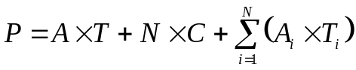
Where is the final price that will be charged to the customer, is a price coefficient depending of the required bandwidth for the aggregated connectivity service, is the total duration of the service,  is the total number of on demand established individual connectivity sessions during all the duration ,  is the operational price for each establishment of an individual connectivity session, 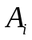 is the price coefficient depending of the i^{th} individual connectivity session required bandwidth, 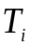 is the duration of the i^{th} individual connectivity session.

Instead of the price model, a number of other parameters can be described in such type of offers. Examples include:
Number of active users: Number of users that can profit from the on demand individual connectivity session part of the offer.
Duration
Validity of the offer
Specific parameter for on demand individual connectivity session:
- An individual connectivity session duration parameter can also be required if decouple for the global connectivity service. In this case then a minimum and maximum component of this authorized duration (in ms) is also provided for each individual connectivity session that could be triggered.

Administrative parameters
The administrative parameters are the same as for the previous types of region services.

Administrative authority
NSP name
ASN: AS number

Administrative boundaries
Similarly to the previous services, the administrative boundaries start from the ingress PoI and go to reach each host in the region.

Resulting PoI to region ASQ path:
Ingress PoI | Sub-region identifier | N_user | NSP | ASN | Possible Guarantees description
Or:
Ingress PoI | IP prefix(es) | IP list(s) | N_user | NSP | ASN | Possible Guarantees description

Capabilities representation (Pull Model)
Compared to the Push Model, the Pull Model is based on the exchange of network capabilities between the different NSP. Then, from these network capabilities, ASQ are computed on demand based on what the different networks have previously announced and the requested parameters.
As already described in previous deliverables (D4.3, D5.3 and D5.2), the Pull Model uses a standard Interior Gateway Protocol (IGP) with Traffic Engineering capabilities to convey the network capabilities. In our implementation, we have chosen OSPF-TE even if Network Operators mostly use IS-IS. This choice was driven by the ease of deployment of OSPF, but could be easily transposable to IS-IS. Of course, mostly for scalability but also for confidentiality issues, the network capabilities are not exchanged at the standard level and the IGP-TE is not running between ASBR. Indeed, the IGP-TE runs at a higher hierarchy level i.e. on an abstract view of the different networks. Named Hierarchical Traffic Engineering (H-TE), the OSPF implemented for the Pull Model runs between dedicated servers in an overlay mode (See figure below). These specific machines are named Autonomous System Virtual Router (ASVR). Finally, you could consider the interconnection of the different networks (at the AS level) that formed the ETICS community, as a simple network formed by the interconnection of ASVR. Thus, we could simply apply the same TE rules and Tool Box on the set of ASVRs as we manage a standard network. The challenge is that instead of a single network administrator, we must face with one network administrator per ASVR that must coordinate them to ensure a proper configuration of the ASVR and thus a coherent configuration.
The next sub-sections describe the different parameters exchanged by ASVRs and which kind of offers is proposed when ASVRs are solicited.

Network Capabilities Parameters
First of all, by using a standard IGP-TE protocol, we could convey between ASVRs the standard TE parameters:
- TE metric: A TE administrative weight,
- Bandwidth in bytes/s: Multiple bandwidths could be announced. The Maximum, Maximum Reservable, the Unreserved (one for each of the 8 classes supported by standard TE).
In addition to these standard values, the support of draft-ietf-ospf-te-metric-extension allows us to advertise these complementary parameters:
- Available and Residual bandwidth in bytes/s,
- Delay in µs with the possibility to advertise anomalous value (particular useful in case of problems),
- Jitter in µs,
- Link loss in % with, like delay, the possibility to advertise the anomalous case too.
Complementary to the technical parameters, we support also the price information. Two options are possible:
- Through the addition of a new TLV parameter to convey the Link price in cents/Mbit/s,
- By using the TE Metric field. In this case, all operators within the ETICS community must agree to use the TE Metric to describe the Link price.

PoI to PoI ASQ path offers
There are no proper ASQ path offers in the Pull Model. ASQs are built on demand from the computation of the shortest path on top of the network capabilities exchange between ASVRs. This means that not only TE parameters need to be exchange between ASVRs, but also path, network prefix in the same manner of a standard routing protocol.
As already said, mostly for scalability and confidentiality purposes, ASVRs do not exchange all the details of the network topology. In fact, only a subset i.e. an abstract view of the real network topology is announced between the ASVRs. The aggregation method is up to the NSP i.e. the algorithm that computes the abstraction model. For example, we could refer to [WH07]. But the network schema announced by each NSP remains more or less the same: ASVRs announce through the H-TE area two kinds of information:
- Pseudo-Links for which attached TE parameters describe the network capabilities,
- And Pseudo-Nodes that advertise the node of the abstract network topology.
In this way (see figure below), the network could be seen as a black box where only entry/exit points (i.e. the PoI) are announced and the TE parameters that represent the performance of the network when crossing this black box from one PoI to another one. More precisely, the pseudo nodes that correspond to:
- The ASVR itself that corresponds to the nucleus (N1 and N2 in our example below) in the abstract view of the network. It could be considered as the barycentre of the network,
- The different ASBRs that connect the AS to its neighbour ASes (ASBR₁₁ and ASBR₂₁ in the figure below).
The nodes are interconnected by the pseudo-links (in red in the figure below) which are of two types:
- Inter-AS TE links: By using the RFC 5392, the IGP-TE could collect precisely the TE parameters of the Inter-AS link that connect it to the remote AS i.e. the link between the ASBR that run BGP (the link between ASBR₁₁ and ASBR₂₁ in the figure below). These information are redistributed between the ASVRs in the H-TE area ,
- Intra-AS TE Link: 2 new pseudo-links (PL_{ASBR11N1} and PL_{ASBR21N2} in the figure below) are advertised to describe the TE parameters to go to/from the nucleus from/to an ASBR.
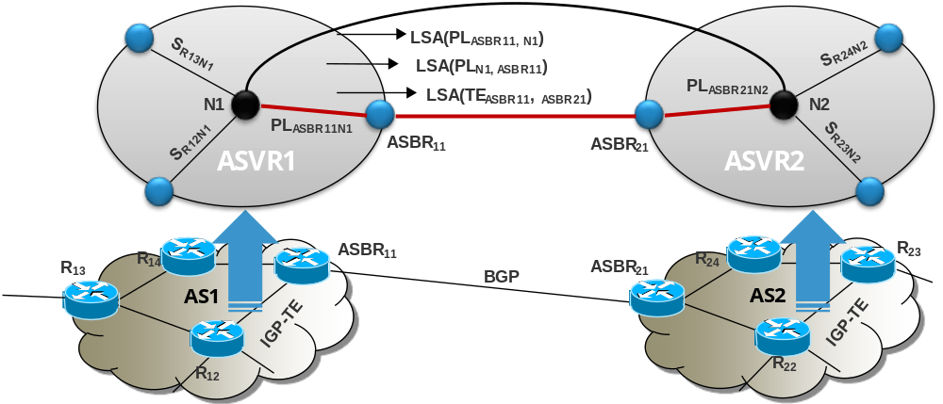
Figure 5 Topology abstraction for H-TE
In addition, network prefixes are also announced in order for each ASVR to localise the region (i.e. to determine which AS owns a given prefix). This is optional as the information could be extract from the BGP table. In our case, only own network prefix are announced by the ASVR to complete the H-TE topology. We see in the next subsection how regions can be taken into account.
Finally, the PoI is described by the knowledge of the pair of ASBRs and the inter-AS link that connected these two ASBRs. Of course, a PoI could contain more than two ASBRs. If this has some advantages (i.e. a precise knowledge of TE parameters of the Inter-Carrier links inside the PoI) this has also a drawback: it is impossible to determine or name precisely a PoI. Only inter-AS link and connected ASBR are known in the Pull Model. However, during the path computation (i.e. service composition,) the Pull Model will use the precise topology information of the PoI (i.e. the inter-AS link and connected ASBR capacities) instead of the PoI itself. Then, the PoI is automatically selected as during the second phase of the service composition (when the PCE uses the BRPC algorithm), it is possible to impose which ASBR that must be used, and so not only the PoI, but also the inter-AS link located in this PoI.
When requesting an inter-carrier ASQ path, the client could precise the scope (i.e. where the ASQ starts and stops) in two ways:
- Directly by providing the IP address of the Ingress and Egress node IP addresses. These node could be located inside the PoI, e.g. by providing the loopback IP address of the ASBR, or outside if the ASQ start, respectively end, from respectively to the middle of the network,
- Indirectly by giving the source and destination IP addresses in the form of decimal dot notation followed by a slash and the size of the mask e.g. 10.1.2.3/32. This way, it is also possible to ask for network prefix instead of IP address. Then, the service composition will retrieve from its topology database where the source and destination are connected, and so the Ingress and Egress node of the ASQ.

Taking into account regions
Like mentioned previously for the PoI to PoI ASQ path offers, the region are taken into account during the service composition following the Inter-carrier ASQ path request. For that purpose, it is mandatory to request one or more network prefix instead of a simple IP address.
For that purpose, the ASVR must not only be aware about the inter-carrier TE topology (even if it is abstracted). They also need the knowledge of network prefix that are reachable by the different ASes. More exactly, they need to determine which network prefix are directly attached, or served by the different ASes i.e. the own network prefix of the ASes as well as the networks that are directly connected to them (in case the prefix is not assigned by the AS). Two ways are available to obtain such information:
- By learning the BGP routing tables and extract from the whole Internet routing table which ones are suitable for the ASVR,
- By advertising also the network prefix into the H-TE area.
If the first solution doesn’t need to add extra protocol, it suffers from a higher degree of complexity and dependency. Indeed, the service composition module must maintain a mapping table between the network prefixes and the ASBR. This not only require to search in the BGP database the network prefixes that are attached directly to a given AS, but also to maintain up to date the mapping table each time BGP announce a modification. It is not trivial and with a risk to not learn all networks prefixes if a BGP router has decided to aggregate several network prefixes. In the second solution, we simply use the native OSPF features to convey the network prefix like OSPF does in the standard. The main difference is that the ASVR must select which network prefix it wants to advertise to its neighbours. By using a non backbone area for the H-TE one, OSPF process automatically summarize the network prefix in learnt in the backbone area (i.e. the real network) and advertise them into the H-TE area. In addition export filters could be used to fine tune this export of summarized table.

protocols for Capabilities/Offers Exchange

Offers Exchange and storage (push model)
This section specifies how to exchange offers between NSPs and between NSPs and the centralized server. This include the technology used (web services) as well as the main types of messages/actions (Publish offer, remove offer, order etc). A single design has been created to support all ETICS centralized push model scenario, i.e. per-NSP centralized or fully centralized (see section 4.4 and 4.5 of ETICS deliverable D5.2). The provided sequence diagrams precise at a higher level the different states and main information exchanged between entities and their principal block functions. The section 6.2 of D5.2 provides in a global picture the different steps and protocols used during the different sequences.
Our service plane relies on a SOA (Service Oriented Architecture) based on Rest (mainly using post, and get of HTML protocol in our case). Two main software applications are used:
The “NSP service server” which creates offers, send them for publication to one or several “Facilitator servers”, requests connectivity service offer propositions (under QoS constraints) to one of the potential “Facilitator servers”, orders offers to one of the potential “Facilitator servers”.
The “Facilitator server” which receives offers from one or different “NSP service servers”, sent end-to-end offer based on a composition process to “NSP service server” who requested an offer, requests connectivity service offer propositions (under QoS constraints) to one of the potential other “Facilitator servers”.
The different deployment scenarios of these two software applications allow the representation of the different push scenario.
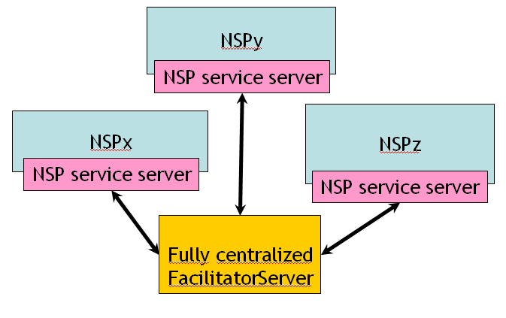
Fully centralized facilitator scenario
In the above example of the “fully centralized scenario”, each NSP of the ETICS community has its own instance of the software application “NSP service server” that interacts with only a single instance of the software application “Facilitator server” for all the ETICS community. Note that this “Facilitator server” can be either hosted on an independent device managed by the community or hosted and possibly managed by one of the NSP of the community.
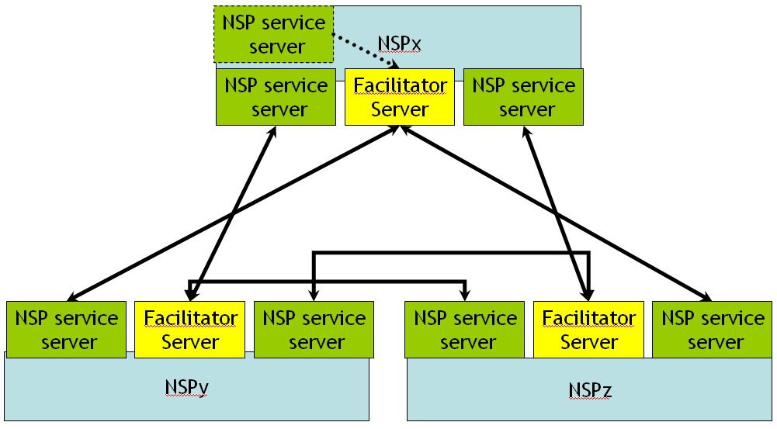
Per-NSP facilitator scenario
In the above “Per-NSP facilitator scenario”, a different instance of the “facilitator server” is hosted and managed by each NSP of the ETICS community. In this case, each NSP can have different instances of the software application “NSP service server” that allow the usage of different policies for the publication process according to the targeted NSPs. In addition each NSP should have, such as illustrated in dash lines for the NSPx, another instance of “NSP service server” to publish its own local others to be able to compose by it-self end-to-end offers taking into account its own possibilities.
Of course a mix of these deployment scenarios is possible and does not require an adaptation of the two software applications.
To complete

Capabilities exchange (pull model)
In the Pull Model, we have chosen to use a standard IGP-TE protocol to convey the network capabilities. Two choices are possible: OSPF-TE or IS-IS-TE. Even if IS-IS-TE is mostly used by NSP, we decided to select OSPF-TE for a practical implementation point of view (for prototyping). In fact, the Quagga stack that we intend to extend for the ETICS prototype, supports both OSPF and IS-IS. However, it provides a stronger support of TE inside OSPF compared to IS-IS. In addition, OSPF-TE proposes an API that allows us to connect directly the PCE in order for the latter to automatically learn the network topology.
The network capabilities necessary to the Pull Model are conveyed through the Opaque LSA type 10 (Area flooding) and Type 11 (AS flooding). In all cases, they respect the OSPF standard:
- RFC3630: This is the base for OSPF-TE. It allows us to transport all TE parameters on the intra-links, and in particular the links between the nucleus (ASVR) and the border nodes (ASBR). In addition, the draft-ietf-ospf-metric-extensions was also supported in order to complete the standard TE metrics by the delay, the jitter, the loss, the available and residual bandwidth on the advertised link. All these parameters use an Opaque LSA Type 10 with a TLV = 1 (Traffic Engineering).
- RFC5088: This RFC allows the ASVR to advertise itself as a PCE as well as corresponding capabilities in term of Path Computation. It also provides support to advertise to which neighbours it is connected. With this RFC, the PCE is then capable to automatically discover its peers, and setup corresponding PCEP connexions for the BRPC algorithm (See Service Composition in Sec. 3.4.2). All parameters use an Opaque LSA Type 10 (or 11) with a TLV = 4 (Router Information).
- RFC5292: In addition to intra-links TE information, we need also to learn the inter-AS link TE parameters. The RFC5392 does exactly this job. It allows any BGP router to advertise the TE parameters on the inter-AS links as well as the remote IP address of its peer BGP and the remote AS number. In complement of the RFC5088, the PCE knows exactly with which peers it is connected and what AS is controlled by a given PCE. All parameters used an Opaque LSA Type 10 (or 11) with a TLV = 6 (Inter-ASv2 TE).
- RFC5787 and draft-ietf-ccamp-rfc5787bis: These two last standards allow the ASVR to announce in the H-TE area the BGP routers as pseudo-node as well as the TE link between the ASVR and the BGP routers as pseudo-links according to the aggregation principle specified in Sec.3.2.2. All these parameters used an Opaque LSA Type 10 with a TLV = 1 (Traffic Engineering), but compared to the RFC3630, with new sub-TLV. As there is no real interface nor IP addresses between the ASVR and the ASBR, we use the Link Local/Remote Identifier (RFC4203) combine to the Local and Remote Router TE ID (RFC5787 and draft-ietf-ccamp-rfc5787bis) to describe this pseudo link.
In the implementation of the prototype, two restrictions will be imposed between the standard area and the H-TE area:
- All LSA announced in the H-TE area are never flooded in the other areas, even if the LSA flooding scope is AS wide e.g. Opaque LSA type 11. For that purpose, and in particular for the RFC5392 and RFC5088, the LSA Opaque Type 10 (area flooding) is preferred.
- In the other direction, the LSAs advertised in the different areas are filtered and flooded in the H-TE area if necessary even if the LSA flooding scope is only Area wide e.g. Opaque LSA type 10. In particular, Inter-As links learned in a given area (through the support of RFC5392) will be flood as is in the H-TE area.
- Links between ASVRs and between the ASVR and the real network are not announced as TE link but only as adjacency link.
The behaviour of the OSPF-H-TE is similar to a diode or a FireWall in the sense that it passes all LSA to the H-TE area and blocks all LSA that comes from the H-TE area.

Algorithms for offers computation/NSP chain computation

Algorithms for offers computation/negotiation

Inter-carrier ASQ Path Computation/NSPs selection
Some of the algorithms presented in this section have been previously described in [Del3.3]. In this deliverable, we provide a specification of these algorithms for an implementation purpose. Hence, some models have been refined and some choices have been made on the basis of the simulation results provided in [Del5.4].

Operational modes
In a centralized architecture the problem of negotiating occurs especially under the push option. In the pull option the central entity does not chooses the offers but the NSPs does. The problem is thus repeated at the NSP level. Hence, we rather focus on the centralized push and consider how a central entity can both optimize the NSPs revenues while satisfying customers.

Centralized push operational mode
The Service Facilitator retrieves offers and associated prices from one or several repositories it can access to and which are fed by the NSPs. The Service Facilitator is the entry point for customer requests and treats them according to their arrival time. The whole negotiation process can be summarized as follows:
- A customer makes a request at time t which consists in the selection of a normalized QoS profile and a source/destination couple.
- The Service Facilitator identifies the feasible offer chains and selects one following a criterion (e.g. the chain of maximal benefit).
- The Service Facilitator negotiates each offer with each corresponding NSP: each NSP checks that its network is able to support the selected offer.
- All NSPs confirm or infirm their offer availability.
- A commercial offer (e.g. a price) is made to the customer who decides to accept it or not. If yes, the offer chain is instantiated.
This scenario describes the ideal sequence of events of a negotiation; alternative scenarios are not considered here. The problem faced by the Service Facilitator is to maximize the ETICS community revenues while making a proposal that fits the customer expectations.

Distributed operational mode
The problem for a NSP in a dsitributed architecture is very different than in a centralized one where only one entity centralized the choices with partial information (especially on NSP capacities) but also more complete ones (on the possible NSPs paths). In a distributed architecture a NSP is facing two choices:
- To which neighbor NSP - allowing reaching the target - should the remaining request be propagated?
- Which offer to select for the request s.t. the remaining request succeeds and gives the highest revenue?
For the first decision, the NSP knows, through the capability disclosure, its neighbors and which NSPs they are a gateway to. For the second question, the NSP must compute, for each identified next NSP, which of its available offers are suitable for the customer request.
Figure 6 describes the distributed process involving a learning algorithm in a distributed pull mode. This process is composed of two phases:
- a choice phase, highlighted in yellow,
- an observation phase, highlighted in red, where the NSP observe the results of its choices.

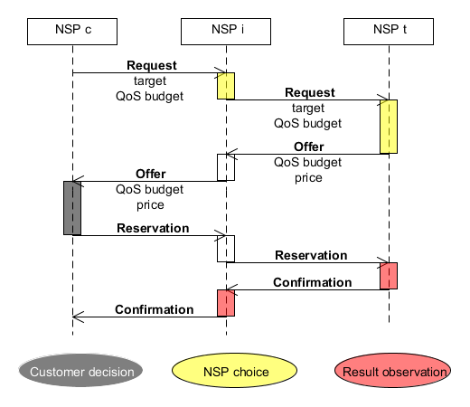
Figure 6 - Distributed framework for ETICS pull option
Figure 7 illustrates the process of a distributed negotiation in a push architecture: offers are disclosed as well as some indicators about the availability of offers. The NSP is thus facing two slightly different choices:
- Which published offers to aggregate to its own ?
- Which request to satisfy and with which aggregated offer (assuming that an aggregation of QoS could actually lead to several aggregated offers) ?
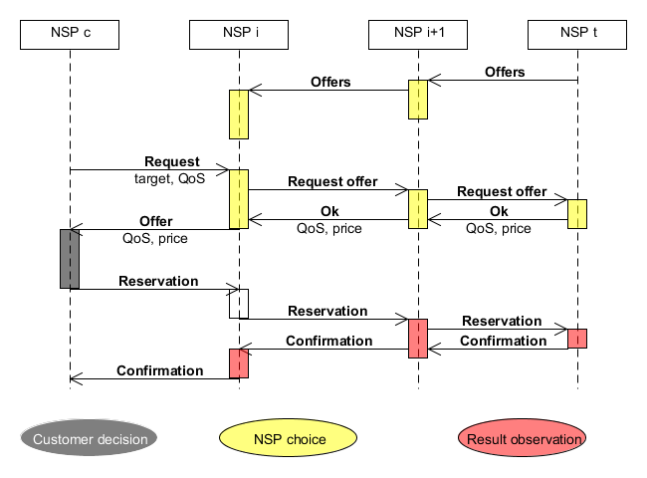
Figure 7 – Distributed framework for ETICS push option

Optimization Algorithms
In previous works, the problem of combining several QoS offers has often been studied as an optimization problem for one customer demand.

Model specification in optimization approaches
In a centralized model, the problem can be formulated at a Multi-Choice Multi-Dimensional Knapsack Problem (MMKP) for each NSP chain. Such chains are determined by the graph of NSPs. The MMKP can be built as follows: the NSPs being the classes of items and each item being a multi-dimensional offer.
In a distributed pull mode, the exploration is quite particular and described in Sec. 3.4.1.2.
In a distributed push mode, the optimization is quite limited and the function to optimize must endeavor to track both the economic and the technical interest of offers. For these reasons, we have not considered such an application.

Optimization algorithms
The problem being NP-Complete due to the multi-dimensionality of QoS [WC96] and to the fact that in the worst case all NSP chains should be explored, different approaches have been considered by various authors:
- Deterministic algorithms: enumeration, branch-and-bound, dynamic programming [DP09] which benefits from some space reduction if the published offers are similar, graph-based approaches [XB05].
- Meta-heuristic algorithms: genetic programming [HG06], ant colony optimization [DP09].
We have implemented such algorithms in the platform for the centralized push mode. The whole process consisting in 1) transforming the published into the solution space of an MMKP and 2) Applying one of these algorithms.

Implementation Specification
Figure 9 illustrates the class diagram of the data model required to apply optimization algorithms in a centralized push operational mode as this mode has been chosen for the prototypes. This specification use the refinement of the SLA offer specifications provided in [Del5.2] and recalled by Figure 8. The class diagram from [del5.2] is recalled to stress the importance of composition, decomposition and comparison operations over offers. As shown by Figure 8, a generic class called QoSVector allows instantiating objects of multiple QoS parameters having different mathematical properties. The aforementioned operations are also associated to this class and their detailed specification provided in [Del5.2].
The various algorithms shown on Figure 9 inhereting from the abstract class Algorithm are inspired by the algorithms mentioned in the section 3.4.1.1.2.2 and use the composition, decomposition and comparison operations over QoSVector objects of the class SLAOffer. Figure 9 also illustrates the simplicity of the mapping to realized between the ETICS data model including NSP, SLAOffer and QoSVector objects and the MMKP object representing the Multi-Choice Multi-Dimensional Knapsack Problem.
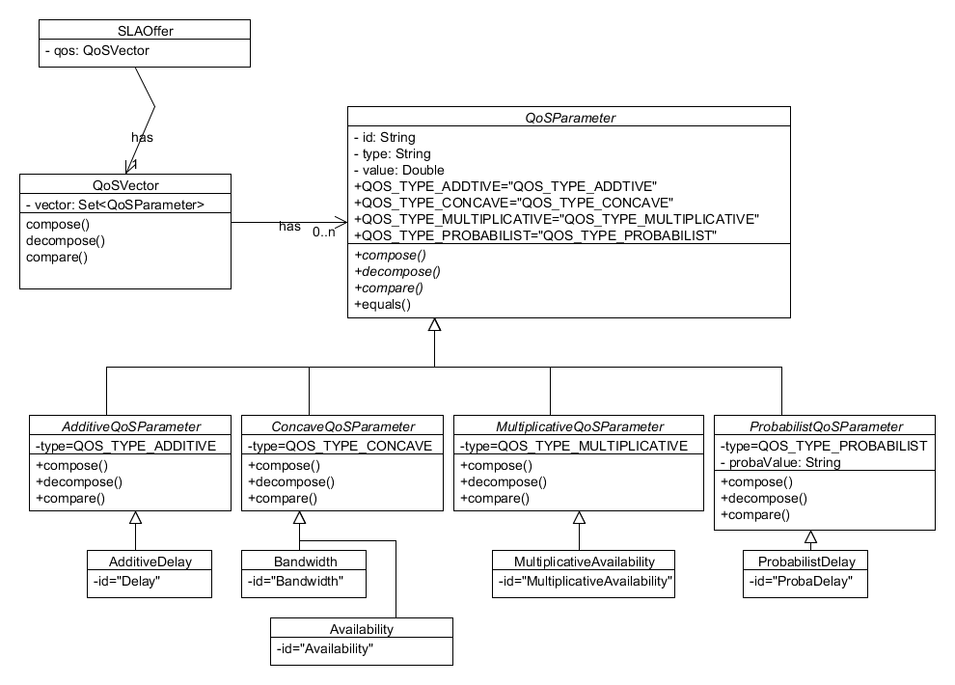
Figure 8 - Class Diagram for offer extracted from [Del5.2]
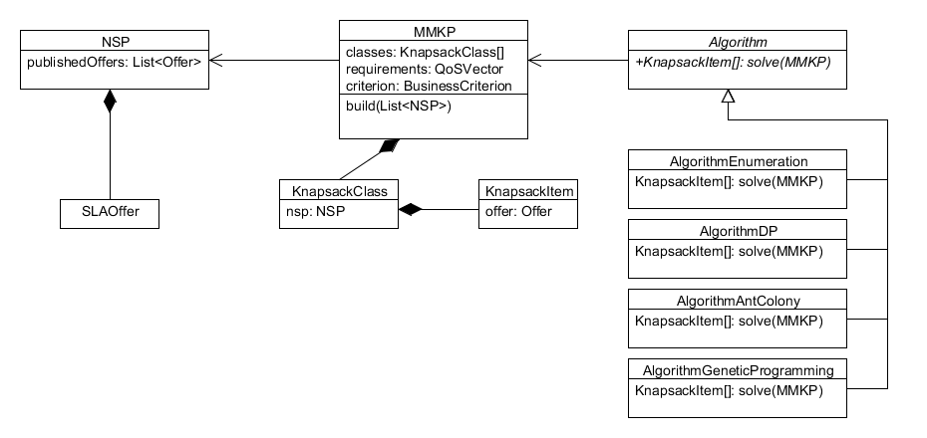
Figure 9 - Class Diagram of Optimization data model applied in a centralized push operational mode

Learning Algorithms
Optimization approaches are adapted to treat one request. But extending them to treat several requests simultaneously would lead to very complex and unadapted solutions. Furthermore, it would impose to queue requests until they are treated. This might be adequate for specific contexts, but with respect to the business and real-time context we consider, we opt for Reinforcement Learning (RL) techniques.

Model Specification for reinforcement learning algorithms
Reinforcement Learning techniques are based on Markov Decision Processes whose description for the specific problem of NSP/offer selection have been described in [Del3.3]. In this section, we specify the application of these models to the different modes decribed in the previous section.
A Markov Decision Process (MDP) is tuple (S,A,R,P) modeling the environment of a learning agent where S is the set of states of the environment, A is the set of actions the agent can choose, R (s,a) is the reward function defining the gain the agent can have using an action a at a state s and P (s,a,s’) is the transition function giving the probility to be in a state s’ when applying an action a at state s. The function P verifies the markov property.
In the centralized push mode, the learning agent is the Service Facilitator. The corresponding MDP should be defined as:
- Each state is couple (requested QoS, success/failure) where the requested QoS is the one of the request at decision epoch t and success/failure tracks the success of the proposed end-to-end offer at epoch t-1,
- Each action is a combination of NSPs’ offers,
- The reward function is equivalent to the price of the combined offers if both the customer accepts and by the NSPs acknowledge the availability of their offers,
- The transition function is a combination of: the customer likeliness of acceptance, the customers’ request law of arrival and the NSPs acknowledgement probability.
In the distributed pull mode, two models have been studied: in a first model, labeled Comb-NC, both choices are realized jointly and in a second model, labeled Sep-NC, choices are done separetely to keep an exploration of several NSP path. So, in the Comb-NC model only one path is explored. It appears, as illustrated in [Del5.4], that the convergence of the algorithm does not suffer from this lack of exploration which is, on contrary, beneficial from a runtime point of view. The corresponding MDP of this approach is defined as:
- Each state is couple (next NSPs, locally chosen QoS, network availability) where the network availability is a discrete indicator of the network available resources (e.g. 0=congestioned, 1=80% used, 2=less than 80% used),
- Each action is a locally chosen QoS satisfying the requested QoS and the choice of the next NSP,
- The reward function is equivalent to the price of the proposed QoS if the end-to-end QoS offer respects the requested QoS and the customer accepts the proposal,
- The transition function is a combination of: the customer likeliness of acceptance, the customers’ request law of arrival and the next NSP capacity to succeed.
In the distributed push mode, we modeled only the choice of acceptance of a request and the selection of the adequate combination of offers. Hence the MDP is quite similar to the one of the distributed pull mode except that the locally chosen QoS is replaced by the aggreated offer and the network availability by the aggregated availability.
In RL, when the transition function of an MDP is unknown, so-called “model-free” algorithms should be prefered.

Reinforcement Learning Algorithms
Even if they have different properties, RL algorithms have a common framework detailed by algorithm 1. The scheme has three main steps within a finite or infinite loop. The choice and observation phases are highlighed using the same colors as on the previously commented figures.
Algorithm 1 Generic learning algorithm
Initialize learning parameters
At each decision epoch
Select an action according to a formula
Observe reward and new state
Update decision data according to a formula
Update learning parameters

We focus on the Q-learning and Sarsa algorithms because of their "model-free" ability which make them particularly adapted to the inter-NSP offer negotiation where many behaviors are untractable.
The Watkins' Q learning algorithm [WD92]to learn optimal Q-values of each couple (state, action) at each decision epoch according to a “Q-based” policy. The Q-value function is defined as ensued:
This recursive definition of the function is exploited by the Q-learning algorithm [WD92] to build a Q-table, without knowing the transition probabilities, but using the observed reward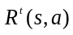:
where is a learning rate determining the trade-off between exploration and exploitation. This latter also evolves at each decision epoch and the way it is actualized particularly impacts the convergence property of the algorithm.
Various kinds of "Q-based" policies explore the state/action space in order to learn the optimal policy. The recursive equation allows the system to reach a deterministic optimal policy. So, by definition the Q-learning have to be modified to learn an optimal mixed policy, equivalent to the mixed NE.
The SARSA (State-Action-Reward-State-Action) algorithm also uses the state-action function described above. It differs from Q-Learning algorithm in the update of the Q-values, and more specifically in the consideration of the future action. Q-values are updated as follows: . The value used for the actualization is not the one of the action maximizing the future reward but the one of the "real" next action. This suggests some smooth modifications in Algorithm 2 to keep in memory the past action and reward when the update is performed.
Convergence. The Q-Learning algorithm is proven to converge to optimal Q-values under two assumptions, as demonstrated in [WD92] all couples (state, action) must be visited infinitely, and 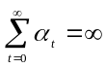, 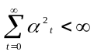. This suggests that, in a finite-horizon MDP, the algorithm has been "trained" prior to its execution. The authors of [DM03] refined this proof demonstrating the existence of an upper bound according to how the learning rate is updated: if it is updated using a polynomial function then the convergence time is polynomial, if it is updated using a linear function then the convergence time is exponential.
The authors of [SJLS00] provided a proof of convergence of the SARSA algorithm under the following assumptions: i) All couple (state, action) must be visited infinitely, and ii) the Q-based policy to choose actions is greedy at the limit (when ).

Learning Policies for NSP Choices
A Q-based policy is the way to select an action based on Q-values. Such policies must allow exploration of the environment (trying several actions to learn Q-values) but also exploitation (choosing frequently actions that maximize the expected reward). Initially, the agent has to learn, so the exploitation has priority. After convergence, Q-values are precise enough to be exploited, so exploitation has priority.
Greedy policy. The greedy policy selects always the action having the highest Q-value, such as 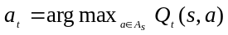.
-Greedy policy. This policy selects the action having the highest Q-value with a probability 1-, and a random action with probability . is initialized to a high value in order to encourage exploration. It decreases as Q-values become more precise. The policy is greedy at the limit.
Softmax policy. The softmax policy, defined as 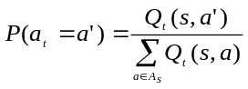 , selects an action with a proportional probability to its Q-value. This policy is not necessarily greedy at the limit.
Boltzmann policy. The Boltzmann policy selects an action using formula 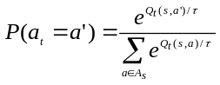, where 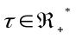governs the lag between action probabilities. When lags between probabilities tend to 0 and the policy is nearly random and uniform. When 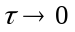lags between probabilities increase and the policy is nearly greedy. Usually, is initialized to a high value to encourage exploration, then it is decreased to tend to a greedy policy.

Implementation specification
This section provides a specification of the data model of the learning algorithm in order to be applicable either in centralized push or distributed push and pull. This specification illustrated by Figure 10 uses the genericity paradigm of object-oriented programming representing the State class as “S” and Action as “A”’. The implementation of specific classes for states and actions is illustrated by the class diagram of Figure 11.
As shown by Figure 10 , only one type of learner can be implemented for both Q-learning and SARSA algorithms as such algorithms use the same objects. The difference between both algorithms lies in the use of the updateQValue function. With the parameters (S,A, double, S, A) the function holds for SARSA – as indicated by the parameters corresponding to the SARSA accronym State-Action-Reward-State-Action, the reward being typed by a real value. And with the parameters (S,A,double, S, A[]) the function holds for the Q-learning algorithm as it needs to browse all the potential next actions.
Figure 10 illustrates also that the policies used in the choice of actions (the class ExplorationPolicy <S,A> ) or for updating the values of some learning rates (the class CoeffPolicy <S,A>) can also be quite generic.
The genericity is a choice driven by the lack of theoretical results assessing the convergence of some policies, which can, however, be experimentally proven to perfom better than the -greedy policy. Hence, depending on the observed performance of the process, the use of a policy remains as a choice of execution.
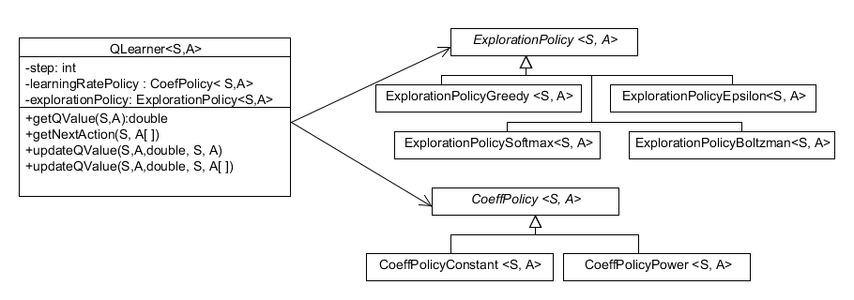
Figure 10 - Class Diagram for RL algorithms
Figure 11 provides a class diagram illustration of the specification given in Sec.3.4.1.1.3.1.
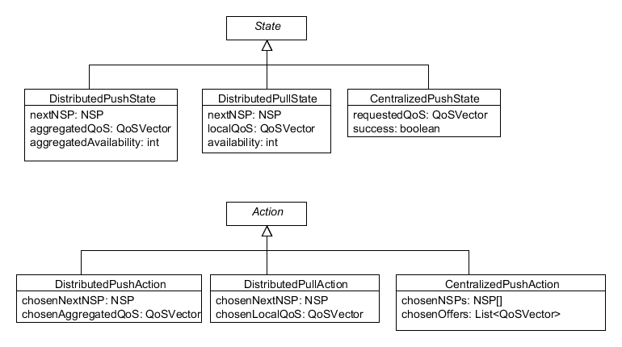
Figure 11 - Class Diagram for states and actions in different operational modes

Multi-Path Computation
Computing inter-NSP Multiprotocol Label Switching Traﬃc Engineering Label Switched Path (MPLS-TE LSP) through a pre-determined sequence of NSPs is quite straight as each Path Computation Element (PCE), using the Backward Recursive PCE- based Computation (BRPC), knows who is the next to be contacted in order to continue the computation. The optimality of the MPLS-TE LSP inter-NSP path depends strongly on the choice of the pre-determined sequence of NSPs on which the calculation works. We propose a noval procedure allowing a forward discovery of multiple inter-NSP sequences and the computation of optimal MPLS-TE LSP inter- NSP path(s) over these NSPs sequences. The discovery operation and the constrained path computation phase are performed simultaneously starting from the source to the destination. Experimental evaluation shows that the proposed sheme is eﬀective in terms of Traﬃc Engineering solution and protocol efficiency.

Problem definition
The multi-constrained inter- NSP path computation over multiple NSP routes problem can be deﬁned as ﬁnding paths that obey to the constraints vector C[j] (where C[0] is the bandwidth constraint and the other weight components are the QoS additive metrics) and respect the non-dominance rule, from the source node s to the destination node t over a set of inter- NSP routes S. When an optimal path is required, an optimization can be performed in order to identify the optimal path Ps,t . The selection of such path is done through an objective function Z(Ps,t ).This function can take several forms according to the policy adopted by participant NSPs (e.g. path cost, generated proﬁt, remainder bandwidth, etc.). This is known as the Mult-Constrained Optimal Path problem (MCOP). In our inter- NSP context we call this problem, Inter-NSP Multi-Constrained Optimal Path Over Multiple NSP Routes (ID-MCOP-MNR) problem. Consequently, the ID-MCOP-MNR problem can be expressed as follow:
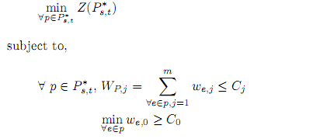
The ID-MCOP-MNR problem is a MCOP problem which is classiﬁed as NP-complete.The only diﬀerence between our problem and the MCOP one is the context of solving the problem, i.e. constraints that force us to solve the problem by parts (per-NSP); if there were no conﬁdentiality constraints or management restrictions between NSPs and if a centralized entity (that would have a global vision of all networks resources and their states) exists, it will be exactly the same as a MCOP problem in one NSP.

Algorithm
In the following we detail the meta-code of the ID-MCOP-MNR algorithm. The request is to compute one or more paths from a source node s to a destination node t, subject to a constraint vector Cj , where j = 0, ..., m, that minimize a cost function Z(Ps,t ). Other input parameters are recovered locally, such as the network graph of the source NSP Ds and the set of neighboring NSP’s path segments PathSegs_{i−1}. The procedure starts initializing previous path segments to φ and then calls the subroutine ID-MCOP-MNR, described by Algorithm 1, to trigger the computation over diﬀerent inter-NSP routes. A timer is activated until reception of potential non-dominated paths through the diﬀerent inter-NSP routes. Once the timer expires, subroutine Compute_GlobalOptimumPath (Algorithm 2) performs a global optimization (in our case, minimization of Z(Ps,t )).
The subroutine ID-MCOP-MNR (Algorithm 1) contains two diﬀerent treatments: one is achieved by intermediate NSPs, another by the target NSP Dt. Intermediate NSP processing is exhibited by lines 1 to 7 of Algorithm 1. It begins with the concatenation of previous path segments (initially empty) to the present network graph (line 2 of algorithm 1). Each path segment starts with the source node s and ends with a border node. The concatenation allows the computation of constrained segments, still, from the same node s to an ingress border node of a next NSP. Ingress border nodes are extracted by the function IngressNodesOfDownstreamDomains, that uses as an input (using the function Next(Di , Dt , t) in line 3) downstream NSPs, which are able to reach the target t. The set Ω of ingress border nodes, is then used at line 4 by subroutine Compute_Non-dominatedPaths to compute non-dominated path segments within the current NSP, which are transmitted to neighbor NSPs that could reach the destination, at lines 5-7. The second part, illustrated between lines 8 and 13, diﬀers from the ﬁrst one by replacing the ingress nodes of next neighbor NSPs by the target node t (line 10) and by sending back the path segments to the source NSP (line 12) - instead of to neighbors - in order to perform a global optimization.
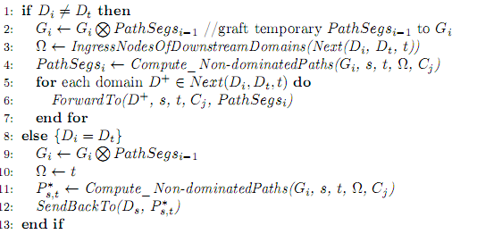
Algorithm 1 - ID-MCOP-MDR(Gi , s, t, Dt , Cj , P athSegsi−1 )
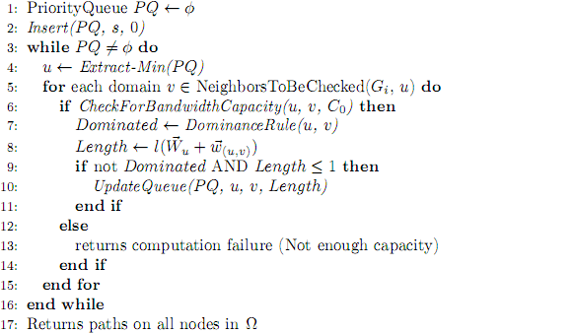
Algorithm 2 - Compute_Non-dominatedPaths(Gi , s, t, Ω, Cj )

Specification of a Multiple Path Exploration Protocol
In order to tackle some of the issues inherent to the BRPC procedure, we investigated another approach where several inter-NSP routes are explored and the pre-comutation of those inter-NSP routes (as is done with BRPC) is avoided, in order to identify the e2e resources that would be meet customer QoS requirements. In this approach, each NSP’s PCE has to select one or more PCEs of neighbor NSPs, able to reach the destination, to transmit the path computation request according to the QoS contraints and potentially other considerations: speciﬁc agreements, success rate of previous demands, expected QoS revenue, etc. The selection of next PCEs has also the role of ﬁltering (to not ﬂood all the neighbors PCE) for each service requests. By this way, several sequences of NSPs are examined in parallel and paths results are compared between them.
The basic idea of the FDPC procedure for computing constrained paths for an MPLS-TE LSP over multiple inter-NSP routes from a source node to a destination node comprises:
- A request for an inter-NSP MPLS-TE LSP is sent by a PCC to a particular PCE (called source PCE) of its NSP, to trigger the exploration mechanism and to compute LSP(s) from a source node to a destination node. The PCC can be the source node.
- A Session ID ﬂag is added to the PCE request to identify the same path computation process with the same couple source/destination. In this speciﬁc case (PCE-based computation) we propose to reuse the Request ID ﬁeld used in the PCEP standard protocol.
- We propose to add a PCE Path ﬁeld, transmitted in the PCE request message and completed (PCE address or PCE id appending) during the message transmission. The role of the PCE Path could be twofold: 1) Optimization of loop detection mechanism (section 4.3): each PCE only enters the loop detection algorithm when it ﬁnds its address (or id) in the PCE Path of a received PCE request message and 2) PCE path to the PCE source: in case of stateless PCEs, this allows the destination PCE to send the optimal path(s) back to the source PCE following the reverse path of the PCE Path.
- The source PCE identiﬁes the next PCEs and computes the VSPT (a set of optimal path segments) from the source node to every entry border nodes of next PCE neighbors, involved in the computation scheme.
- A coloring mechanism is applied in order to distinguish between the sub-tree for the receiver PCE, and the other sub-trees sent to other PCE neighbors. The white color means that the node is under the scope of the PCEs which are in the PCE Path and the black one means that the mean. Let takes a focus on three PCE neighbors; PCEi , PCEi+1 and PCEi+1 as illustrated by Figure 12. PCEi computes the VSPT from s to concerned entry border nodes of the NSP’s PCEi+1 and NSP’s PCEi+1 . Before sending the VSPT to PCEi+1 , PCEi applies the coloring rule on this VSPT by stamping end nodes of the VSPT: 1) Nodes that corresponds to concerned entry border nodes of NSP’s PCEi+1 are stamped with white color, in order to indicate to PCEi+1 that this sub-tree (source node and white nodes) corresponds to computed constrained path segments within NSP’s PCEi . This sub-tree should be merged with the network graph of NSP’s PCEi+1 to continue the computations, 2) the other nodes of the VSPT are stamped with black color in order to inform PCEi+1 that there is another VSPT sent to a second PCE capable capable also to reach the same destination.This stamping operationslead to construct V SP Ti . Similarly, V SP Ti∗ is constructed and sent to PCEi+1 .
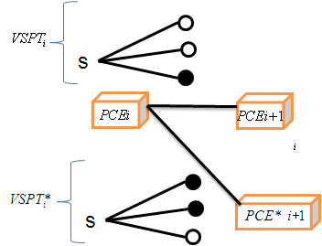
Figure 12 - Coloring mechanism

- We propose to reuse the ﬁeld Include Route Object (IRO) of PCE request message in the same way that the Explicit Route Object (ERO) is used in the PCE reply message to transport the VSPT for the BRPC procedure.
- When one or more VSPTs are received by an intermediate PCE, this last one grafts the VSPT(s), according to the black and white nodes, to its graph that models the network topology of the NSP. Note that, links connecting the source node to black nodes are not concerned by the path computation. Once the merge is done, the PCE trigger the computation process within the new network graph (from the source node to entry border nodes of the involved downstream NSPs).
- When a PCE sees that a data path of the VSPT cannot further satisfy the QoS constraints, it should prune this data path (under its responsibility) without sending extra control messages to the destination PCE. The latter will know that the data path is pruned thanks to the node color, which is white in this case (uncompleted data path with white nodes means pruned data path and uncompleted data path with black nodes means actual enhanced PCE for Inter-NSP Service Delivery Under Multiple QoS Constraints uncompleted data path). Such a pruning in the forward direction allows for limiting the ﬂooding of messages.
- At the level of the destination PCE, the colouring mechanism is used to synchronize the diﬀerent VSPTs. The ﬁrst received VSPT indicates if more VSPTs could be received through alternative inter-NSP routes. This information is extracted from black/white nodes contained in the received VSPT. In this case the PCE destination must wait for the other VSPTs before making a decision. To avoid the inﬁnite waiting time, a timer (Target PCE Waiting Timer or TPWT) is armed by the PCE destination once the PCE request message with a new Session ID (ﬁrst VSPT related to a Session ID) is received.

Algorithms for NSP chain computation
In the Pull Model, NSPs exchange network capabilities in the form of Traffic Engineering routing information. Thus, each ASVR is capable of reconstituting the whole topology (at the hierarchical aggregate view) of the ETICS community formed by the different NSPs. Once this LSDB is built, it is easier to run on top of the topology a standard CSPF (Constraint Shortest Path First) algorithm to determine the optimal path based on the requested parameters.
As already mentioned, the ASVR not only embeds the OSPF-H-TE protocol, but also provides PCE functionalities. This particular PCE, in addition to the BRPC support, is based around two kind of Traffic Engineering Database (TED):
- The standard TED is filled by learning the underlying network topology through the IGP-TE (here, OSPF-TE),
- The Hierarchical TED (H-TED) is fed by learning the inter-carrier topology through the OSPF-H-TE protocol.
When performing the Service Composition for the Pull Model, the PCE runs two different phases depending of the parameters sent by the Path Computation Client (PCC):
- If the AS path is explicitly mentioned in the request (under the form of an Include Route Object – IRO), the PCE just executes the BRPC algorithm by following the AS path mentioned in the IRO. For that purpose, it sends the request to the PCE in charge of the next AS. This process is iterated at each hop till the destination. The last PCE starts the path computation and sends its results to its predecessor. This process is iterated at each hop (PCE) till the result reaches the source. As such, AS by AS, the path is computed and the first PCE provides the final answers. During the BRPC computation, each PCE could select precisely which BGP routers (ASBRs) will be used inside the PoI. It is also possible to precise the BGP routers used in PoI by providing their respective IP addresses in the IRO. This corresponds to the case where the PCE is triggered by the Service Composition acting in Push mode.
- If the AS path is not provided in the request, the PCE must first determine it. For that purpose, the PCE will use its H-TED and executes a CSPF on the hierarchical topology to determine the optimal AS path regarding the requested parameters. Once the AS path is computed, the first PCE will run the standard BRPC as described previously. Again, depending on the network capabilities provided by the different NSPs, the AS path computation could result into a more or less detailed vectors. In its simplest form, it could be composed only by the AS numbers, letting each PCE choose the PoI and the BGP routers inside the PoI.
Note that instead of letting the first PCE compute the AS path, it is also possible to fully distribute the computation on a hop by hop basis. In this scenario, each PCE only compute the optimal next AS in the chain in order to determine next PCE to which the initial request must be send. Then, the standard BRPC algorithm takes place. Note that in this way, the PoI could not be selected as well as the BGP routers inside the PoI. From a business perspective, it could be preferable to completely distribute the AS path selection. Nevertheless, from a technical point of view, the probability of rejection may increase when the AS path selection is done on a hop by hop basis with local criteria for the selection and without global objective of success.
CSPF algorithms have been extensively studied and numerous proposals are available today. However, the main principle consists to path a tree where arcs are normalized with TE parameters. For that purpose, the CSPF algorithm starts to determine where the beginning and the end (ingress and egress nodes) are. Then, the CSPF search the optimal path on the tree by first pruning all paths that don’t match the criteria and then on the remaining paths selects the best one. In the case of PCE, it is possible to specify which criteria (e.g. bandwidth, delay, price …) must be optimized in the whole set of requested parameters through the PCEP protocol. This is possible for the PCC by precising the objective function in the PCEP request.
As usual, each NSP is free to use / implement the CSPF that satisfy its criteria (both technical and business ones). Some CSPFs are more power full that other ones, often at the expense of performance. So, as it is part of the PCE, the CSPF algorithm for the AS path selection is not specified. A basic and standard CSPF will be implemented for the prototype. What must be taken into account for the CSPF selection is the number of constraints i.e. the number of TE parameters used for the path tree selection that influence the SPF computation. Again, by announcing several objective functions, the PCE provides a way for the PCC to choose which TE parameters is predominant in the path computation.
An interesting and innovative approach for selecting the chain of NSPs can utilize the tunable survivability scheme that is described in section 6. The tunable survivability scheme explores the tradeoff between the standard SLAs (e.g., the percentage of time the network is operational from the customer point of view), and QoS parameters (e.g. packet delay). Tunable survivability provides a quantitative measure for specifying the desired level of survivability (0%-100%(, along with bottleneck and additive QoS parameters (e.g., bandwidth and packet delay, respectively), and thus offers flexibility in the choice of the routing paths.
Utilizing that concept, user can specify two parameters, and identify an optimal route that maximizes a third parameter. For example, user can specify that a connection between two end points needs to be operational for 99.9% of the time, and provides end to end packet delay of at most 200ms. The tunable survivability algorithm can identify the route that provides the highest bandwidth possible. User can specify any of the two parameters, and the algorithm finds the route that optimizes the third parameter. This optimization problem is NP-Hard, but our algorithms demonstrate near polynomial complexity.
This scheme can be used for NSP chain computation. Once the desired parameters of the ASQ are published, each NSP identifies one or more appropriate routes between its border routers (by employing the tunable survivability scheme within its network). Each NSP is then treated as one node in the tunable survivability scheme. The algorithm identifies one or multiple chains of NSPs that satisfies the need, and can point to the most optimal chain of NSPs.

Network path computation
This section now details the specification of network path computation functionality: given an NSP chain, or a loose inter-carrier ASQ path, how to compute the inter-carrier (detailed) network path. This section is therefore two-fold, the first deals about how to go from an inter-carrier ASQ path offer (containing a loose path) to an inter-carrier ASQ network path that is ready to be provisioned.

From An inter-carrier ASQ path offer to an inter-Carrier ASQ network path
In the push model (centralized and per-NSP centralized), the outcome of the service composition phase, performed by the service and business plane, is an inter-carrier ASQ path. This path is loose for it does not specify the network path: which exact router or exact interface will be used. The role of the functionality described in this section is to determine this path.

Contract Identifier and PCE server address
As an outcome of the offer computation described in Sec.3.4.1 , a contract identifier is provided to compute the inter-carrier ASQ network path. This contract identifier represents an instance of an offer within the scope of a SLA.
Although the contract identifier could be unique globally, it seems easier from an implementation point of view to have a less constrained approach and to have a unique value within the scope of an NSP. This approach avoids the need to find an agreement between the NSPs to share the pool of the contract identifier values. So an instance of an inter-carrier ASQ path offer composition is associated with a suite of contract identifiers.
During the path offer composition, each NSP provides not only a contract identifier but a PCE server address. The PCE server is responsible for the ASQ network path computation.
As introduced in [Del4.2], in a multi-AS and multi-NSP environment a single PCE server has not enough information on the network topology to compute the optimal end-to-end network path. A sequence of PCEP requests between the NSPs is needful along with the “Backward-Recursive PCE-based Computation Procedure” (BRPC) [BRPC] to find this optimal path.

Overview of the solution
The contract identifier is used to retrieve different pieces of information needed to compute the end-to-end path (these pieces of information have been provisioned by the service and management plane when building the inter-carrier ASQ path offer):
- acceptance criteria to check the validity of the path request. The policies can be different per NSP and are applied at the ingress NSP domain node.
- TE parameters: the traffic engineering parameters have to be taken into account during the path computation to select a path compliant with these constraints. Such a parameter can be the required bandwidth for instance or the delay or the jitter or other QoS parameter. These TE parameters are the TE parameters declared when the NSP publishes its offers. When a PCE server receives a path request with TE-parameters it must checks that these latter TE-parameters are compatible with the ones associated with the offer.
- Autonomous System Boundary Routers (ASBRs) in the local domain: an NSP can restrict the list of ASBRs eligible for the inter-carrier ASQ path. The path computation process will select the ingress and the egress ASBRs among these ASBRs only.
- Next PCE server: the address of the next PCE server to which the path computation request is to be sent.
- Next Autonomous System (AS): the number of the next AS in which a path computation has to be performed to provide the complementary part of the path.
- Next contract id: the contract identifier value associated with the next NSP in the inter-carrier ASQ path offer.
To compute the optimal end-to-end path, the “Backward-Recursive PCE-based Computation Procedure” (BRPC) is selected. Once the PCE server associated with the ingress domain receives a network path computation requests, it extracts the contract identifier and queries a server to obtain the above mentioned information. If the request is accepted and if the PCE server is not able to compute the path to the destination it sends the path computation request downstream to its next PCE server mentioning the next AS and the next contract identifier value. When the server is the last in the chain, it computes the different paths eligible according to the PCEP request TE parameters and sends back to its upstream PCE server these possible paths and this recursively up to the upstream PCE server.
In addition, in order to keep the domain topologies confidential, the Path Key Segment (PKS) procedure is activated to exchange keys representing path segments instead of the path segments themselves.
The PCE server can be implemented in many ways. For the prototype 2, a RESTful architecture has been agreed to achieve the correlation between the contract id and PCEP parameters.

Sequence diagram
For the sake of simplicity, the diagram of Figure 13 below depicts an inter-carrier network path computation between two NSPs only, each with a single AS.
The topology is as below:
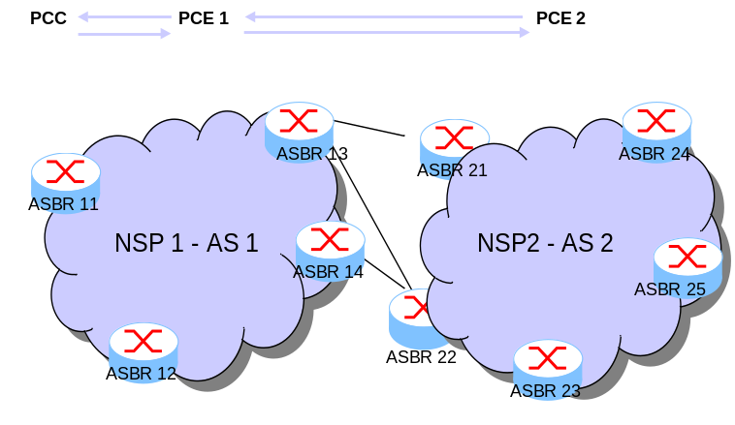
Figure 13 – an Inter-carrier netowrk path computation between Two NSPs
The Service and management plane has computed an inter-carrier ASQ path offer and it now requests the computation of an inter path between ASBR11 and ASBR25 for the contract id whose value is Cx1.
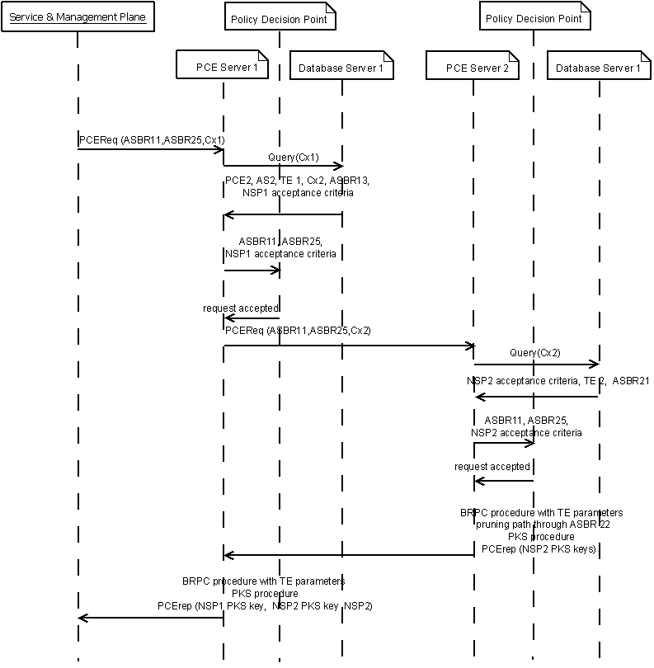
Figure 14 – GIVE ME A TITLE Too

PCEP extensions
A way to carry out the contract identifier value in the path computation request has been specified in the draft “draft-leroux-pce-contract-id-01.txt » .
The purpose of the draft is to describe the structure of a new optional object in the PCE request message so that to specify a contract identifier. For the time being the contract identifier value is a 128 bit field encoded as a Universally Unique IDentifier (UUID).
This draft could be enhanced after the outcome of the Etics prototypes to get IETF standard status.
Another option is to encode the contract identifier as a proprietary constraint as per the IETF draft draft-ietf-pce-vendor-constraints-05.txt.

From an NSP chain to an inter-carrier ASQ network path
Like in Push Model described above, the same mechanism based on PCE BRPC is used to determine the inter-carrier ASQ path. The main difference is that the NSP chain computation, as described in section 3.4.2, could result in a pre-selection of BGP routers inside the PoI. In this case, the BRPC, and so each PCE, are constrained to explicitly use these particular BGP routers (even if this wouldn’t have been their initial choice. It is important to understand that the NSP chain computation done by the CSPF on top of the hierarchical topology tries to achieve a global (i.e. end to end) optimal path computation instead of a local path computation that only stratify local criteria / strategy of a NSP and not the whole ASQ. Therefore, to be sure that this global optimal strategy will be followed by each NSP, we force the PoI and BGP routers selection during the BRPC process. This will be a constraint that the BRPC process needs to respect.
The main benefit regarding the Push model, is that the NSP Chain is passed to the PCE through the Include Route Object (IRO). Indeed, the NSP chain output by the Hierarchical CSPF contains the list of IP address of BGP routers in complement of the AS numbers. One can use a relaxed BRPC computation. In this case, only the AS number list is passed to the next PCE through the IRO. If we prefer to use a strict computation, the IRO passed to the next PCE will contain the list of the IP addresses of the BGP routers. So, it is not necessary to modify the PCEP protocol to convey a contract-id. This has also the advantage of speeding up the algorithm.
As a major drawback, this results into a single answer instead of a bundle of offers like it is proposed in the Push Model. To remedy to this problem, the ETICS portal that triggers the PCE, must request, not only one computation, but several ones. The portal can do so by releasing one constraint at once e.g. asking first to minimize the delay, then to maximize the bandwidth, then to minimize the price and so on. The ETICS portal retrieves in this configuration several propositions that it could present to the ETICS customers.
Alternatively, the tunable survivability scheme, described in section 6 and utilized in section 3.4.2 for NSP chain computation, can also be used for selecting the full ASQ path. Each NSP in the chain provides the set of possible ASQ routes between its border routers. A network that consists of all NSPs in the chain is formed, each with its border routers that can satisfy the required ASQ connection (and only with these border routers). The properties of the links between the border routers are recorded (within the NSP network, and between NSPs in the chain). The tunable survivability algorithm can now compute the optimal ASQ path in near polynomial complexity.

Inter-Carrier ASQ path Provisioning
The previously described blocks of the ETICS architecture return an inter-carrier ASQ path to the ETICS customer. If the customer accepts the inter-carrier ASQ path, it needs to be provisioned. Provisioning means enforcing a traffic identification scheme at the border routers involved in the PoIs of an ASQ path. This is exactly the scope of this section. In its current status, this section does not provide a fully working final solution but rather reports our progress on this issue.
The section is two-fold. First, it deals with how the traffic can be identified at the border routers. It second deals with how such a traffic identification scheme can be enforced at the data plane level.

What is the right traffic identification scheme?

Why do we need a traffic identification scheme? and what are the challenges?
ETICS proposes a way to reach destinations according to specific needs. This proposed architecture implies that several flows to the same destination may follow different paths. From that consideration, an ETICS router must be capable to recognize the different flows in order to make them follow the correct path.
Figure 15 present an example of such an issue. The red and blue flows have the same destination but do not follow the same path. As a consequence, the classical “simple” destination-based routing identification scheme is not enough anymore for our needs.
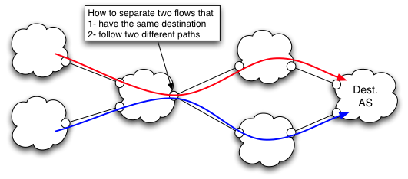
Figure 15 Flow differentiation for a common destination

Now, an efficient identification scheme needs to be insensitive to the following points/issues:
- Forwarding scalability: the current Forwarding Information Base (FIB) in the Internet DFZ is about 450 000 lines (for destination-based routing). The chosen identification scheme must not lead to scalability issue at the FIB level.
- Policy compliancy: the identification scheme must not allow a domain to use a path that is not compliant with the path proposed by its neighbors or to steal (free ride) an ASQ path that is destined to another domain. We illustrate later in this section a global identification scheme that is not policy compliant.

What are the possible identification schemes?

Input to the traffic identification problem
The input to the traffic identification problem is given during the phase in which the customer orders the inter-carrier ASQ path. During this phase (See the Service access point in Sec.3.1), the ETICS customer and the ETICS interface agree on the way the traffic is identified at the first point of interconnect. This results in a set of traffic identifiers that uniquely identify the traffic (e.g. a set of source IP addresses belonging to the customer and a set of destination IP addresses that the inter-carrier ASQ path needs to reach). We call this identification the original headers identification.

Possible identification schemes
An inter-carrier ASQ path enforces a network path that the packets identified by the original headers identification need to follow. Any traffic identification scheme should ensure that these packets follow this network path. Different ways are possible to ensure this goal.

Re-identification at each intermediate PoI (using original headers)
A naïve approach is to use the original headers as traffic identifiers along the entire path. In this configuration, the routing decision is taken, at each PoI, based on the original header identification. That means that, at each PoI, the router will match the packets against the original headers identification and take the routing decision to enforce the route (and the QoS) accordingly.

Indirect identification: path identification:
This approach consists in using a path identifier instead of routing based on the original headers. The original headers are only used at the entry of the ASQ path (the first PoI). The traffic is then tunneled (encapsulated) and is routed according to the tunnel/path identifiers. We distinguish between two extreme cases: End-to-End flat labelling and source-label stacking.

End-to-end flat labelling
In this case, the path from stub to stub is identified by the path identifier.
We have evaluated the number of potential routes available towards all the domains in Internet. Addressing all the paths of Internet (toward destination ASes) a domain can use, the number of paths is of the order of magnitude of 10^7.

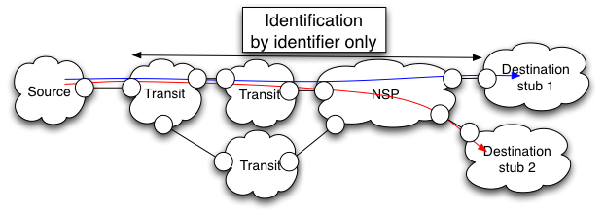
Figure 16 – Flow Aggregation

Source identifier stacking
In such an identification scheme, each domain aggregates all the flows that need to be carried to a common next domain. We must highlight that these scheme is an example, which we consider not being applicable in the Etics context. Nevertheless it is a good way to underline issues that can be encountered.
Figure 18 presents an example of such a scheme. The source (or its provider) adds to the original packet a series of identifiers. Each identifier identifies one domain of the path. For instance, NSP-1 forwards the packets according to the external identifier (i.e. C) only and stripe off this identifier at its exit ASBR, just before forwarding the packet to the next AS (i.e. NSP-2). NSP-2 then receives the packets and forwards it according to the external identifier (i.e. B) only and so on.
This process is very close to the source routing [RFC791] but applies at the AS level.

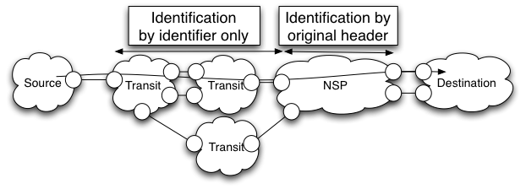
Figure 17 – Example of source identifier stacking
This type of scheme resolves the FIB scalability issue as each AS would only need the same number of routes than the number of its neighbors.
For instance, an AS having 1 000 neighbors would only need 1 000 entries in its FIB.
Despite the fact that it is insensitive to the FIB scalability issue, this type of schemes encounters non-negligible issues:
- All the identifiers are inserted into encapsulation header(s) therefore increasing the payload of the packets.
- If formats of identification were not the same among the crossed domains (e.g. NSP-1 is MPLS based whereas NSP-2 is LISP based), the source domain would be obliged to deal with all these formats.
A domain may potentially use paths its neighbors did not advertise to him. An example of policy violation is shown in Figure 18.

- By knowing the blue and the green path (and their associated identifiers), the source AS, which could either be the real source or a transit AS, is able to deduce the red path, even if it has not been advertised. In order to prevent such type of violation, packet filtering associated to deep label inspection is necessary. This type of filtering would need to be performed at the entrance of each domain and is very costly (in term of computational cost). Therefore, this scheme is not usable.

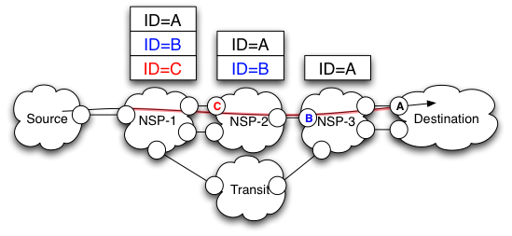
Figure 18 – Policy violation example
Finally, for both indirect identification mechanisms, nearby the destination, at the exit of the aggregated part of the ASQ path, identification may be performed based on the original header of the packets (potentially taking into account extra fields, such as DSCP…).

Hybrid stacking:
This approach lies in the middle of the design space between end-to-end flat labelling and source stacking. In the transit networks, where the scalability issue is most likely to take place, there is substantial potential for the aggregation of different paths in common path subsections. Such aggregation may be performed thanks to an extra header. We will see in the next sections how aggregation could be performed.

Which approach is better for ETICS?
Re-identifying the traffic using the original headers in not suitable for ETICS because of the high number of rules (Policy based routing) that this would imply on the border routers. Today’s core routers mainly perform destination-based routing or label switching. Therefore, ETICS should better focus on the indirect traffic identification scheme.
Therefore, the tempting approach for ETICS relies therefore on the following key points:
- Packets encapsulation: packets are encapsulated to enforce their path till an intermediate PoI, which lies on the chosen/alternative path. Original packets are not modified and an alternative path may be compound by several PoIs. From that consideration, the PoIs must be capable to recognize the different flows in order to make them follow the correct path (cf. Figure 15). Nevertheless, the destination addresses of the original packets are not anymore sufficient to separate the individual flows following a path as the different paths potentially have the same destination prefix but nevertheless need to follow different paths.
- Flow identification: in addition to the inner destination address, an identifier must be used for specifying the route, which is to be followed. We name that identifier a flow Identifier (Flow-ID) and each encapsulated packet carries its Flow-ID. For scalability reasons, the value of this identifier must be local to each hop. However, at the same time, path-ID values must be aligned all along a path in order to assure end-to- end path coherence. In practical terms, intermediate routers must be able to swap incoming identifiers with the appropriate outgoing path identifiers.
Already existing labels or identifiers can be used as Path Identifiers. For instance, MPLS encapsulation path enforcement can use MPLS labels (20 bits per incoming/outgoing router interface) as Flow-ID whereas IP encapsulation path enforcement can use the IPv6 Flow Label (20 bits) or the 64 lowest-order bits of /64 IPv6 addresses and LISP path enforcement [Citation ?] the LISP Instance ID [Citation ?] (24 bits). All these possibilities must only impact the extra header and not modify the user packet (including the original/inner header).

Traffic identification at the different parts of the ASQ path
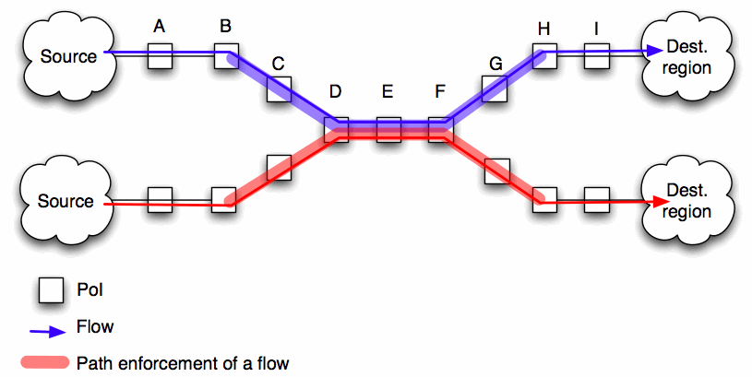
Figure 19 Where to identify the traffic
Figure 19 illustrates an ETICS path enforcement and the principal points of interest of the traffic identification process. The traffic can be identified at the following points:

At the entry of the ASQ
In order to identify the path a flow has to follow, the system has to identify flows, at Point B, and deduce the path it is to be forwarded to. This identification takes place at the point B in Figure 19. This point is located at the frontier between the two following areas:
- The part of the network where packets are forwarded thanks to the routing protocol only (according to the destination IP address).
- The part of the network where packet path is enforced thanks to encapsulation. In this area, the flows are not always following the path provided by the underlying routing protocol.
As the traffic is not yet encapsulated this identification can only take into account the original packet fields, for instance:
- Destination/source prefix/IP/port(s)
- DSCP field
- Vlan identifier/VRF -> in that case, an upstream box must separate the QoS flows from BE flows in to them in the correct vlans/VRFs
Therefore, this router must know the association between the fields of the original header (e.g., address, port, DSCP, etc.) and the Path-ID that will be used to forward the packets till the end of the ASQ path. MPLS [9] uses the same type of association thanks to the Forwarding Equivalent Class (FEC). In our context, we use the same term for clearer descriptions and explanations. The number of entries in the FEC depends on both the number of prefixes and the number of recorded paths per prefix. The Internet routing table currently contains 450 000 entries. Allowing each entries to have X paths would make the number of FEC entries increase by a factor of X, which is not acceptable, regarding the current prefix number. By placing router B close to the source network, it is be possible to minimize the impact of this issue. Indeed, a single source network hardly needs a lot of routes for all prefixes but would potentially need some specific alternate routes for a subset of prefixes. In that case, each domain can negotiate with its provider the characteristics of the entries of the FEC (i.e., amount of entries, types, etc.). On the contrary, placing the router B far from the source network would advance it to being shared between several source networks. Consequently, this would induce a substantial increase of the FEC due to the addition of the routing requirements of all the source networks.

At the intermediate PoIs
At each hop of the ASQ path (i.e., Points C till G) must be performed path identification.
Point B (the FEC) can be placed near the source network, which would make the number of entries in the FEC reduce due to the limited number of services a single source domain needs (e.g., reach a small subset of prefixes). Contrary to the FEC, points C till G are far from it. Intermediate PoIs are therefore used by a great number of source domains, thereby aggregating their resource needs (potentially reaching all the prefixes in earth), and need to address a large proportion of the Internet prefixes. Prefixes can hardly be aggregated in bigger prefixes in the Internet. Therefore taking forwarding decisions by taking into account IP destination prefixes (in addition to other fields) of packets is not scalable. It would make the number of entries into the FIB be multiplied by the number of path per prefix.
Forwarding packets thanks to the path-ID only may have some limitations. A 20 bit field allows the router to identify, at most, 1 048 576 paths. The BGP routing table of a router in the default free zone already contains 450 000 or so lines. A 20 bit identifier would then limit between 2 and 3 the number of different paths per prefix. Whereas 2 or 3 paths seem to be sufficient for fast recovery purpose, it becomes very limited if NSPs want to provide advanced services. Nevertheless, using only Path-ID to forward traffic proposes a good level of aggregation. A Path-ID may be used to identify a path to a domain (or a set of domains), instead of a prefix. There are currently around 60 000 or so domains. Therefore, by taking into account only the size of a label, this solution would coarsely provide (on average) 17.46 paths per destination domain. This type identification would therefore lead to a good aggregation ratio. With this method, the number of Path-IDs is not anymore proportional with the number of prefixes but with the number of regions/domains addressed by the ETICS architecture, which increase is far slower than the one of the number of prefixes.

Aggregation of ASQ paths
Several ASQ paths may be aggregated, into a single and bigger ASQ path, by intermediate ETICS partners.
The Figure 20 illustrates such an aggregation.

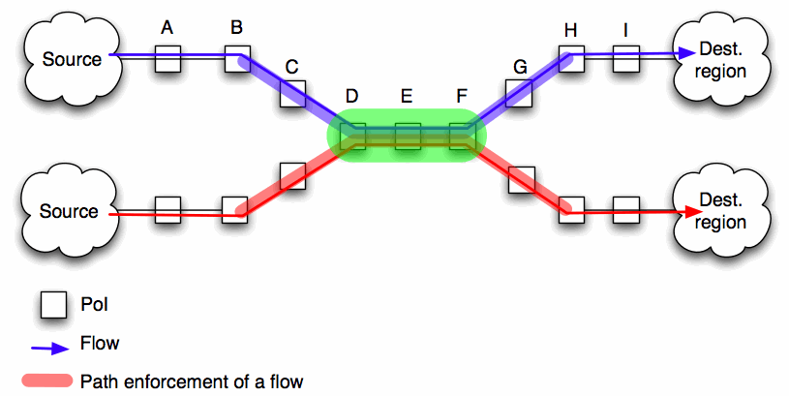
Figure 20 ASQ path aggregation
More traffic identification points are used to aggregate ASQ paths:
- Point D: At the aggregation point of ASQ paths. This aggregate is another ETICS ASQ path. It must therefore identify the flows, which are to be forwarded into this aggregate, and deduce another outgoing path-ID (i.e., Path-ID_ag). This identification is performed thanks to a FEC, which is comparable to the one at point B. This identification may be performed based on the already existing Path-ID (i.e., the one inserted by the PoI B) and/or on the original packet IP destination address. Taking into account the original IP destination address cannot be performed as it leads to scalability issues, as underlined earlier. We assume that all the flows following an ASQ path are aggregated in the same aggregate. Therefore it is possible to identify the corresponding ASQ paths by only taking into account the associated path-ID. Packets are then encapsulated another time and the Path-ID_ag is inserted into the extra header in order to forward the packet till the exit of this ASQ path aggregate.
- Point E: This point only has to forward the traffic to the next PoI and is therefore equivalent to the previously analyzed points C and G. It is therefore better to identify the path based on the external path-ID (i.e., Path-ID_ag) only, which is used for the aggregation.

The following table summarizes the different identifications that could be used in the ETICS architecture:
 |  |  |  | ETICS ASQ AGGREGATION
 |  | ETICS ASQ |  |  |  |  | ETICS ASQ
 | IP forwarding |  |  |  |  |  |  |  |  | IP forwarding
 | Point B | Point B | Point C | Point D (aggregation) | Point E | Point F  (end of aggregation) | Point G | Point H |  | Point I
Type of identification | IP destination | Flow identification based on original packet. | Path identification based on Path-ID in extra header. | Flow identification based on Etics header (Path-ID). | Path identification based on the Path-ID_ag in extra header. | Path identification based on the Path-ID. | Path identification based on the first Path-ID. | Path identification based on the destination IP address. |  | IP destination
Action(s) | 1/ Forward to next hop (B) | 1/ Encapsulate packet  (with a path-ID)  3/ Forward to next PoI (C) identified thanks to the Path-ID | 1/ forward to next PoI (D) identified thanks to the Path-ID | 1/ encapsulate packet with a second Etics header (with a second path-ID, the Path-ID_ag).  3/ Forward to next PoI (E) identified thanks to the Path-ID_ag | 1/ Forward to next PoI (F) identified thanks to the Path-ID_ag | 1/ De-capsulate packet.  2/ Forward to next PoI (G) identified thanks to the Path-ID | 1/ forward to next PoI (H) identified thanks to the first Path-ID | 1/ De-capsulate packet.  2/ Forward to next router (I) identified thanks to the original destination IP address. |  | 1/ Forward to next hop
incoming header(s) | IP | IP | IP+Etics | IP+Etics | IP+Etics+Etics | IP+Etics+Etics | IP+Etics | IP+Etics |  | IP
Outgoing header(s) | IP | IP+Etics | IP+Etics | IP+Etics+Etics | IP+Etics+Etics | IP+Etics | IP+Etics | IP |  | IP

Enforcing the traffic identification scheme: A distributed end-to-end signaling mechanism (RSVP overlay)
This section deals about how the traffic identification schemes described in the previous section could be enforced on the network.
Mostly for security reasons, only the BGP protocol is allowed, today, at the Peering Points. It is not thus possible to use other signalling protocols to set up routes that enforce the traffic identification scheme on the border routers. In fact, in the case of a connection oriented scenario, RSVP-TE could not be used at the Peering Point to stitch or nest the DiffServ-TE tunnels. To overcome this limitation, one might think about setting up IPsec tunnels between BGP routers in order to let RSVP-TE cross inter-domain boundaries. Unfortunately, this only could work if all the NSPs are homogenous: this does not work if at least one NSP is not supported MPLS or MPLS-TE.
So, exactly like we propose to use an IGP-TE in overlay mode (distributed pull), we propose to use RSVP-TE the same way. After endowing the ASVR with the PCE functionality, we need to augment it with the RSVP-TE support too. As a result, the ASVR is more or less a complete MPLS-TE router with all the TE features: IGP-TE, MPLS-TE, RSVP-TE and PCE. Like other RSVP-TE routers, the ASVR could be triggered to setup a TE tunnel. But, this time, instead of creating the TE tunnels into the real network, the TE tunnels will be setup between the ASVRs.
In a standard router, the RSVP-TE path message determines the route of the tunnel, or simply follows the path provided in the Explicit Route Object (ERO) e.g. the one computed previously by the PCE. Each router that receives the path message checks if resources are available and marks them as pre-reserved before forwarding the path message to the next router. Once the egress router i.e. the tail end of the TE tunnel, receives it, it sends back the resv message to confirm the resource reservation and indicate which label the previous router must use. Hence, Hop by hop, every router receives the reservation confirmation and the inner label. It finishes configuring its routing LSP table and confirming the resources reservation. In case of failure, the router that does not have sufficient resources available sends back a path error message. From this point, the source sends periodically RSVP path messages to maintain the TE tunnel up.
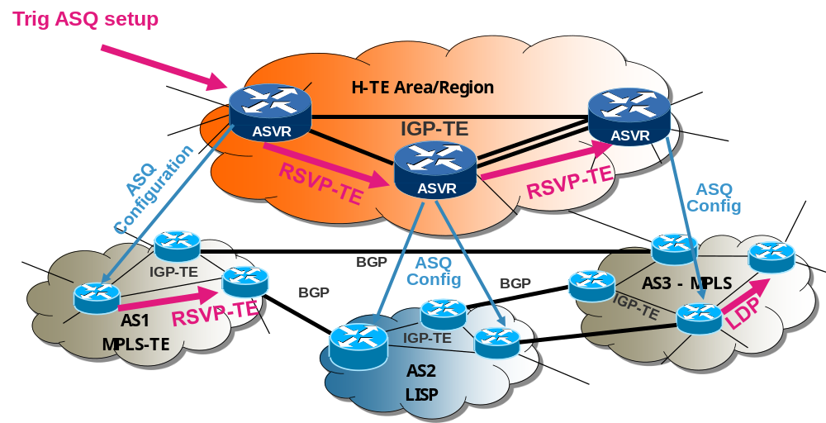
Figure 21 – RSVP-TE in overlay mode through ASVR
In the particular case of the pull scenario, instead of looking to its local resources (which has no sense as it has no data plane), the ASVR will trigger the ASQ enforcement into the underlying network. This configuration depends on the underlying technology used by the Operator. It could be a DS-TE tunnel, MPLS, MPLS-BGP-VPN, LISP, simple DiffServ router configuration etc. Regardless of the intra-NSP technology in use for ASQ path enforcement, the ASVR will forward the initial RSVP-TE path message to its neighbour NSP (ASVR) only once the part of the ASQ path is correctly configured into the network it controls. So, from the H-TE overlay network perspective, we would use RSVP-TE the same way as in a standard network. The modification is purely internal to the ASVR: instead of looking to some internal resources, the ASVR will trigger the underlying network to check resources availability and enforce the QoS. Again, standard mechanisms are available for that purpose like Netconf or proprietary protocol could be used like OSS/BSS of the equipments provider. In case of failure, a path error message is sent back advertising the problem to the previous ASVR that could release their respective configurations. In case of success, the last ASVR sends a resv message to its predecessor with the Traffic Identifier that must be used at the PoI between the BGP routers. Several cases could occur:
- MPLS continuity: Disregarding if tunnels are TE or DS-TE aware or not, we could use an MPLS label between two BGP routers (more precisely between the interfaces of the two BGP routers) to identify the traffic at the PoI. So, the ASVR could transmit this label avoiding an end-to-end RSVP-TE message that performs the stitching or nesting of the different MPLS tunnels. We solved the problem mentioned previously and also save one step (i.e. the stitching or nesting is done after all sub MPLS tunnels are setup with another particular RSVP-TE message).
- Non MPLS to MPLS domain: In this particular case, the ASVR that controls the MPLS domain will send back a label that will not be usable by the non MPLS domain. In fact, the BGP router must be considered as the Ingress Label Edge Router (LER) for the TE tunnel. So, it must be configured with a Forwarding Equivalent Class (FEC) that identifies the incoming traffic in order to label the correct IP packets i.e. the ones which must follow the ASQ path. To avoid impact on performance, we recommended using only the DiffServ Code Point (DSCP) as traffic identifier in conjunction to IP address prefix (source and/or destination). In all cases, the ASVR of the MPLS domain must be aware that the previous domain is not MPLS aware and so, could not provide traffic identified by a label. A Router Information LSA could be used to advertise what technology the underlying network is supporting.
- MPLS to non MPLS domain: This time, the ASVR has no label to propagate to the previous one. So, it is easier for the previous ASVR to understand that the next domain is not MPLS aware, and so, that the BGP router is the Egress LER of the TE tunnel. The configuration consists simply for the Egress LER to pop the label and deliver a standard IP traffic. Again, to increase performance of traffic identification, we recommend that the BGP router set the DiffServ Code Point of the IP packets output the tunnel before delivery them to the next domain. Then, ASVR could exchange the DSCP value instead the label.
So, by using RSVP-TE between ASVR we solve two problems: Stitching and Nesting of TE tunnels at the inter-domain and support of connection-less technologies. This gives us the possibility to maintain an end-to-end session coherency between the different operators as well as refreshing regularly the ASQ path. Of course, RSVP-TE timers could be largely increased at the ASVR level. We also inherit all MPLS-TE management features like:
- Protection and Fast-Reroute: it becomes easier to coordinate Fast-Reroute and protection between NSPs e.g. add a backup BGP router in the PoI, a backup PoI for the ASQ …
- Management of the ASQ path: Removal, modification will be easier,
- Path Key Sequence (PKS) could be used to protect privacy of NSP,
- Use MPLS OAM to monitor the ASQ even if it not completely composed by MPLS tunnels,
- …

Deployment of ETICS functionalities
We end this deliverable by showing how the above mentioned functionalities can be mixed together to form a working ETICS solution. From the global process picture presented in section §2.2, we remind two of the ETICS deployment scenarios that will be subject to prototyping within ETICS.

Centralized (and Per-NSP centralized) deployment scenario
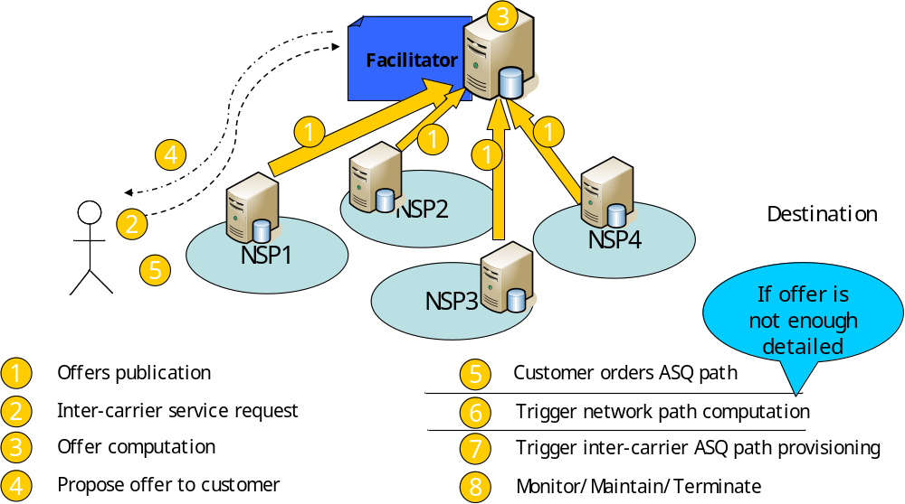
Figure 22 – Fully centralized Push deployment scenario
Figure 22 reminds the different steps involved in the centralized push deployment scenario. The figure shows how some of the functionalities that we described in this deliverable can be used together. These steps have been described in prior deliverables (e.g. deliverable D1.6 [D1.6]).

Distributed pull deployment scenario
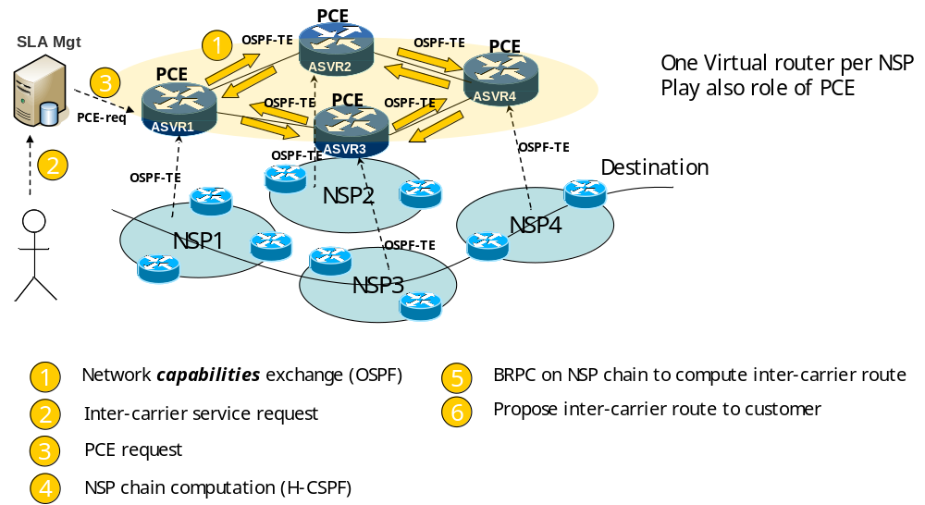
Figure 23 – Distributed pull (H-TE) deployment scenario
Figure 24 reminds the different steps involved in the distributed pull deployment scenario. The figure shows how some of the functionalities that we described in this deliverable can be used together in the distributed pull deployment scenario. These steps have been described in prior deliverables (e.g. deliverable D1.6 [D1.6]).

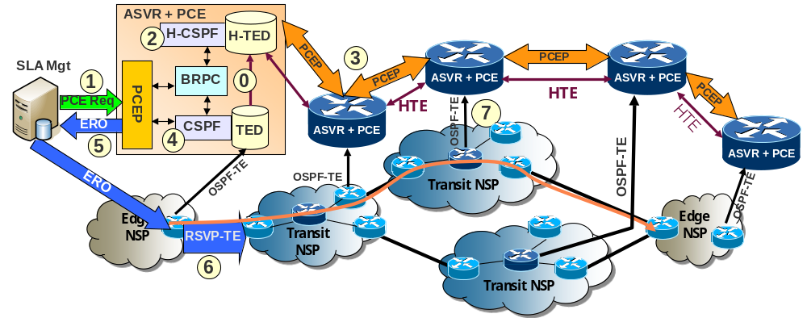
Figure 24 – Distributed pull (H-TE) deployment scenario
In term of deployment, each NSP must setup at least one ASVR in addition to the SLA manager server i.e. the ETICS web portal. Several ASVR could also be deployed for redundancy and load balancing purpose. What it is important is to pay a particular attention to the ASVR configuration like for a BGP router. Indeed, as the different ASVRs cooperate with each together, their respective configuration must follow carefully the ETICS recommendations in order to achieve a running hierarchical routing protocol (OSPF-H-TE).

Conclusion
D5.2 focused on defining the different functional blocks that compose the ETICS architecture, as well as how they interact together. The deliverable used UML modelling to specify these interactions.
This deliverable complements Deliverable D5.2 by specifying the different functional blocks that compose the ETICS fully automated architecture. The deliverable follows the guidelines of deliverable D1.6, and is a bit more focused on two deployment scenarios that are subject to prototyping. These scenarios are the centralized push and the distributed pull.
Further refinements are needed and will be left for future work. These refinements concern mainly the following blocks. First, the service access point, the traffic identification and the region services need to be further refined and aligned. Second, the interaction between the service plane and the control plane for computing the network path needs to be further elaborated. Second, the traffic identification solution needs to be assessed and further developed. This will be the focus of the coming deliverables: The ETICS final architecture deliverable (D4.4) as well as the final draft of specifications (D5.8).

Annex: Tunable QoS-Aware Network Survivability

Introduction
Coping with network failures has been recognized as an issue of major importance in terms of social security, stability and prosperity. It has become clear that current networking standards fall short of coping with the complex challenge of surviving failures.
The literature distinguishes between two major classes of recovery schemes, namely restoration and protection [2]. In restoration schemes, post-failure actions are performed in order to search for a backup path that would avoid the faulty element. In protection schemes, on the other hand, pre-failure actions are performed in order to pre-establish a backup solution for any possible failure. Protection schemes have an obvious advantage in terms of recovery time and are usually achieved by the establishment of pairs of disjoint paths.
The concept of tunable survivability [6] is an attempt to revisit failure recovery methods. Tunable survivability offers major performance improvements over traditional approaches. While the traditional approach is to provide full (100%) protection against network failures through disjoint paths, it was realized in practice that this requirement is too restrictive and demands excessive redundancy. Moreover, a pair of disjoint paths of sufficient quality may not exist, occasionally making the requirement infeasible. Therefore, a milder and more flexible survivability concept is called for, which would relax the rigid requirement of disjoint paths by also considering paths containing common links. Tunable survivability provides a quantitative measure for specifying the desired level of survivability (0%-100%( and offers flexibility in the choice of the routing paths.
Tunable survivability enables the establishment of connections that can survive network failures with any desired probability. Given a connection that consists of two paths between a source-destination pair under the single failure model, only a failure on a link that is common to both paths can disrupt the connection. Accordingly, we characterize a connection as p-survivable if there is a probability of at least p to have all common links operational during the connection’s lifetime.
Quality of Service (QoS) refers to a broad collection of networking techniques that provide guarantees to the capability of a network to deliver predictable results. Elements of network performance within the scope of QoS metrics often include survivability, bandwidth, delay, jitter and cost. Generally, we distinguish between two classes of QoS metrics: bottleneck metrics, such as bandwidth, which are determined by the weakest component in the path, and additive metrics, such as packet delay, which are determined by the sum of the corresponding metrics over the path’s links. Algorithmic schemes that combine the concept of tunable survivability with bottleneck metrics were established in [6]. The important and much more complex class of additive QoS metrics is the subject of this work in the context of ETICS, and is fully described in [7] Technical report. We have just been notified that this research work was accepted to INFOCOM 2013 conference.
Survivability is closely related to SLAs, namely the percentage of time the network is operational from the customer point of view. QoS parameters are also related to upcoming standard SLAs, in which a network connection can have performance guarantees, not only in terms of network availability, but also in terms of the quality of the connection (e.g. minimum guaranteed bandwidth, maximum packet delay, etc.) Our research aims at evaluating the tradeoff between network availability and QoS parameters, and as such, is highly related to ETICS.
This section reports the summary of this research only. The complete research is available at [7].

Model and problem formulation
In our research [7], we formally defined the model. The network is represented by a directed graph of nodes and links. We defined a simple path in the network, in which no loops are possible between a source and a destination node. Each link is attributed with failure probability, which is independent from failure probabilities of other links. Additionally, each link is assigned with a QoS value (e.g. delay).
We adopt the widely used single link failure model. Although multiple failures can occur in the network, ”survivability” under this model aims at handling only single failure events. This model has been the focus of most studies on survivability, e.g., [3] [4] [5], due to its simplicity as well as the fact that protecting against a single failure is a common requirement of various standards, e.g. [1]. Moreover, a common approach for handling multiple failures is to supply protection for the first failure and restoration for any subsequent ones.
A link is classified as either faulty or operational. A given path is operational if it has no faulty links. Survivability is defined as the capability of the network to maintain service continuity in the presence of failures. Thus, we say that a survivable connection of any two paths between source and destination nodes is operational if at least one of these paths is operational. Under the single link failure model, a survivable connection of two paths is operational if and only if the links that are common to both paths are operational. We then defined a p-survivable connection and its p survivability level, considering the failure probabilities of the common links of the two paths forming the connection. When no common links are available in the two paths, the connection is termed 1-survivable connection. Previous work [6] shown that for any network, if there exists a p-survivable connection that admits more than two paths, then there exists a p-survivable connection that admits exactly two paths. Therefore, we can indeed focus on survivable connections with just two paths.
We then defined the QoS value of a survivable connection, adding the QoS values of its links. We consider two variants that sum the QoS value of the common links differently, each appropriate for different QoS metric (e.g. monetary metric Vs. average metric, such as delay). For a source-destination pair, there might be several p-survivable connections, among them we would be interested in those that have the best “quality”, giving rise to several tunable survivability optimization problems.

Algorithmic Solutions and Results
We focus in solutions that optimize an average QoS metric. These solutions are an important class in which the QoS metric represents either an average or aggregate measure over the employed survivable connection, e.g., the average delay over the two paths of the connection. Further, we focus on the critical links, i.e., those links that are common to both paths, and the shortest paths between source and destination, while considering the QoS values.
We proceed to show that, when addressing the optimization problem, the links that may affect the survivability level of the optimal solution are restricted to a (typically small) subset of the network’s links. These findings are, in part, counter-intuitive properties of the optimal solution.
We show that all optimization problems addressed are NP-Hard. However, efficient solution schemes are still possible. Indeed, we established exact solutions of pseudo-polynomial complexity, and near (i.e., ε-optimal) solutions of polynomial complexity, for the considered problems.
We proceed with establishing efficient algorithmic schemes for optimizing the level of survivability under additive end-to-end QoS bounds (looking for best p-survivable shortest path with total QoS value that does not exceed a defined budget). We evaluated the running time of the algorithms proposed
We then conducted a simulation study, evaluating the performance of our algorithms. The description of the simulation environment, its execution, results, as well as its implications for ETICS architecture are already fully reported in ETICS deliverable D5.4.
In summary, we show that, at the price of negligible reduction in the level of survivability, a major improvement (up to a factor of 2) is obtained in terms of end-to-end QoS performance. We expect these findings to be applicable to any additive QoS metric, such as jitter, log(packet loss rate), or monetary cost. In past research [6], the impact of tunable survivability was examined along with bottleneck metric (bandwidth considerations). We therefore, could find the most survivable connection for a given bandwidth requirement. Alternatively, we could find the highest bandwidth available for a given survivability level. The research conducted now [7] adds the QoS considerations (e.g. concluding what is the improvement of QoS metrics and the maximum bandwidth available for any survivability level).
D5.4 further evaluates the dynamicity and scalability issues that are identified by our research, as well as algorithm granularity, as related to the various options of the proposed ETICS architecture.
Finally we applied the results of this research to network design, providing guidance on effective network upgrade from the survivability and QoS point of views (namely, which elements of the network should be upgraded, thereby providing best performance enhancements to the network when investing a given budget).

References
[1] N. Sprecher and A. Farrel, “MPLS Transport Profile (MPLS-TP) Survivability Framework,” RFC 6372, Sep. 2011.
[2] A. Askarian et al., “Protection and restoration from link failures in dwdm networks: A cross-layer study,” in IEEE ICC, 2008.
[3] R. Banner and A. Orda, “Designing low-capacity backup networks for fast restoration,” in IEEE Infocom, 2010.
[4] P. Heegaard and K. Trivedi, “Network survivability modeling,” Computer Networks, vol. 53, no. 8, pp. 1215–1234, 2009.
[5] J. Tapolcai et al., “On monitoring and failure localization in mesh all-optical networks,” in IEEE Infocom, 2009.
[6] R. Banner and A. Orda, “The power of tuning: A novel approach for the efficient design of survivable networks,” IEEE/ACM Trans. Networking, vol. 15, no. 4, pp. 737 –749, Aug. 2007.
[7] J. Yallouz and A. Orda, “Tunable QoS-Aware network survivability,” Comnet, Technion, Israel, Tech. Rep., 2012. [Online]. Available: http://www.ee.technion.ac.il/Sites/People/ArielOrda/Info/Other/YO12.pdf

References
[Del3.3] ETICS Delivarable 3.3 : Financial/Economic Dynamic Analysis.
[Del5.2] ETICS Delivarable 5.2: Draft detailed specification of the inter-carrier service delivery system.
[D4.2] ETICS deliverable D4.2: ETICS architecture and functional entities high level design
[D1.6] ETICS deliverable D1.6: ETICS technical roadmap.
[HB75] E. R. Hilgard and G. h. Bower, Theories of Learning, Prentice-Hall, 1975.
[KLM96] L. Pack Kaelbling, M. L. Littman and A. P. Moore, Reinforcement Learning: A Survey, Journal of Artificial Intelligence Research, 1996.
[SPT94] P. S. Sastry, V. V. Phansalkar and M. A. L. Thathachar, Decentralized Learning of Nash Equilibria in Multi-Person Stochastic Games With Incomplete Information, IEEE Transactions on Systems, Man, and Cybernetics, 1994.
[WD92] C. J.C.H. Watkins and P. Dayan, Technical Note: Q-Learning, Journal of Machine Learning Research, 1992.
[DM03] E. Even-dar and Y. Mansour, Learning rates for Q-learning, Journal of Machine Learning Research, 2003.
[XB05] J. Xiao and R. Boutaba. QoS-aware service composition and adaptation in autonomic communication. IEEE Journal on Selected Areas in Communications, 23, 2005.
[HB06] M. P. Howarth et al. End-to-end quality of service provisioning through inter-provider tra-c engineering. Computer Communications, 2006.
[TJDB06] G. Tesauro, N. K. Jong, R. Das, and M. N. Bennani. A hybrid reinforcement learning approach to autonomic resource allocation. In ICAC '06: Proceedings of the 2006 IEEE International Conference on Autonomic Computing. IEEE Computer Society, 2006.
[DP09] Nabil Bachir Djarallah, Hélia Pouyllau: Algorithms for SLA composition to provide inter-domain services. Integrated Network Management 2009: 460-467
[WC96] Z. Wang and J. Crowcroft, Quality-of-Service Routing for Supporting Multimedia Applications, IEEE Journal on Selected Areas in Communications, vol.14, num. 7, 1996, pages 1228-1234.
[WH07] W. Htira, O. Dugeon and M. Diaz, “An Aggregated Delay|Bandwidth Start Scheme for Admission Control” in proceeding of 12th IEEE International Workshop on Computer Aid Modeling and Design of Communication Links and Network (CAMAD’07), Athens, Greece, September 2007.
[BRPC] JP. Vasseur, R. Zhang, N. Bitar and J.L. Le Roux. “A Backward-Recursive PCE-Based Computation (BRPC) Procedure to Compute Shortest Constrained Inter-Domain Traffic Engineering Label Switched Paths” RFC 5441.

