AtMol deliverable reporting
3D1.4 : Polymerisation of long molecular wires on a passivated semiconductor surface
Unit 3: Atomic scale construction and simple testing | WP3.1: Atomically precise construction by on-surface polymerisation and transfer to other  samples
Lead participant: P10-Krakow | Other participants: -
Person Months (Krakow): 12 | Person Months (other participant): -
Start date: M 12

Planned End date: M 35 | Real end date: M 36

Introduction:
The goal of this section is the growth of (potentially long) molecular chains on a passivated semiconductor surface from individual building blocks. While this concept has been successfully used in the last years by many reseach groups on metals (partners P6 and P7 of the AtMol consortium have published seminal papers), no such study exists on passivated semiconductor surfaces even though they are technically of great interest. For instance, they would not short-circuit any electric current flowing through a molecular wire on the surface which happens for metal surfaces.
P10-Krakow has fully explored the polymerization for various surfaces. While on passivated Si and Ge surfaces no long molecular wires were formed, such a growth process could be achieved successfully for the passivated TiO₂(011)-(2x1) surface where long DBBA (dibromobianthryl) and DITF (diiodoterfluorene) polymeric wires are formed. The molecular building blocks, being deposited under ultrahigh vacuum conditions onto the surface, were provided by partner P7-HU Berlin. DITF molecules are similar to dibromoterfluorene (DBTF) used by P6-FH Berlin to polymerize long molecular chains on Au(111) surface. Bromine atoms of DBTF are exchanged by iodine atoms in DITF. On metals, C-Br bonds are broken at higher substrate temperatures than C-I bonds.
Experimental considerations:
As expected, DBBA or DITF molecules deposited at low coverage on the substrate kept at room temperature prove to be so mobile that stable scanning tunneling microscopy (STM) imaging conditions at room temperature (RT) are hardly achievable. Imaging at liquid nitrogen temperature (LNT) allows to resolve single molecules distributed on terraces and attached to step-edges. There is no trace of polymers on the surface, suggesting that deposited precursors still possess their halogen substituents. The polymerization reaction is triggered thermally at the conditions described below.
Description of the results:
In the last year report we have demonstrated the feasibility of thermally triggered, on-surface polymerization on the TiO₂-(011)-(2x1) surface. A schematic description of the reaction obtained for the molecular precursor: 10,10’-dibromo-9,9’-bianthryl (DBBA) is shown in Fig. 1.
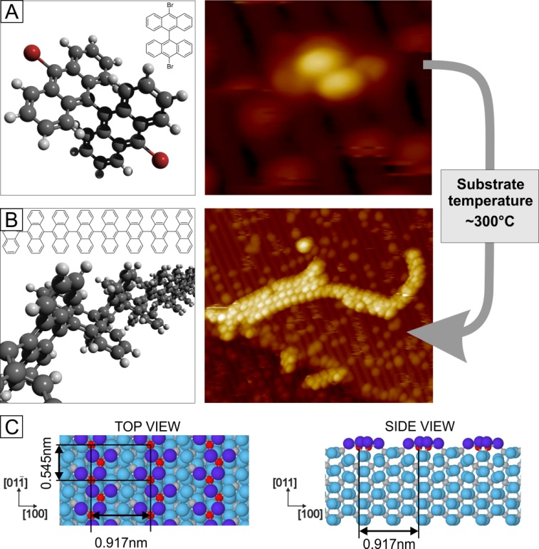
Figure 1. On-surface polymerization of DBBA molecules on a TiO₂ surface. Models and STM images of a DBBA monomer (A) and polyanthrylenes (B); STM images: little bright dots on zigzag rows are ascribed to surface hydroxyl groups. Model of the TiO₂(011)-(2×1) surface (C), top and side views, respectively. Oxygen atoms are marked with blue color (dark blue is reserved for the two-fold coordinated oxygen atoms forming the characteristic double zigzag rows, running along the [01-1]crystallographic direction of the surface). Titanium atoms are marked with grey color; five-fold coordinated titanium atoms are highlighted with red.
This year experimental observations were corroborated by DFT calculations and simulation of the STM images [7]. Our experimental findings are further corroborated with density functional theory (DFT) modelling of the DBBA monomer and dimer adsorbed on the TiO2(011)-(2×1) surface. We used the Viena ab initio Simulations Package (VASP) [9] based on Mermin’s finite temperature DFT[10]. For reliable description of electronic structure of rutile titanium dioxide we employ projector augmented plane wave (PAW) [11] method for description of electron-ion interactions and PW91 GGA exchange-correlation functional as parameterized by Perdew et al. [12]. Additionally, to account for dispersion forces that play important role in adsorption of policyclic molecules on the surface of rutile [13] we used the semi-empirical Grimme extension [14] of the standard DFT method (DFT-D). The performed GGA-DFT-D calculations indicate the presence of very weak molecule-substrate attractive interactions (0.11 eV per molecule) that are dominated by dispersion therm (0.08 eV per molecule). Due to the presence of the bianthryl core in the DBBA molecule (see Figure 1) the adsorption geometry is governed by tendency to keep each anthryl as parallel to the substrate as possible. In contrast, the short C-C bond, connecting anthryls in the bianthryl core do not let the molecule to arrive at flat geometry. Consequently, the adsorbed molecule preserves its gas-phase geometry with 90° dihedral angle between the planes of anthryls. In the optimized geometry the hydrogen atoms, closest to the surface, are 1.8 Å above the topmost ions of the substrate. Additionally, the bromine atoms are 4.95 Å above the topmost ions. These results strongly suggest that no chemical interaction is expected between the molecule and the substrate. Translations along and across surface the zig-zag rows, and rotation with respect to the surface normal change the adsorption energy only by 2-5%. Such observations are in line with the fact that the direction-independent dispersion forces dominate the surface-molecule interactions and suggests that the monomers should be able to diffuse on the surface without any significant distortion of their gas-phase structure. Applying the same calculation scheme for a dimer adsorbed on the (011) face gives coherent result, the dimer adsorption energy is nearly twice the monomer 0.21 eV per molecule. Finally, simulations of STM images were performed as topographs of the constant local density of states within the Tersoff-Hamann theory[15] with additional Gaussian blurring to include tip broadening effects. As can be seen in Figure 2, there is an excellent agreement between the calculated and the measured images.
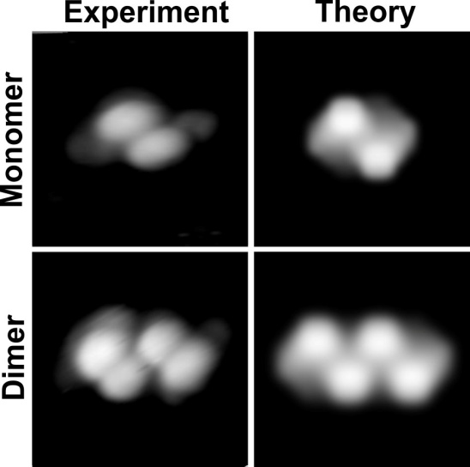
Figure 2. Comparison between experimental and theoretical STM images of DBBA monomer and dimer. The left column: in the experimental images the contrast is set to expose the molecules. The right panel: simulated images with Gaussian blurring mimicking the tip broadening of experimental images. (Both experiment and theory: 3 nm×3 nm, 2 pA, +2 V).
Although, the method of covalent assembly of organic building blocks (namely DBBA molecules) on surfaces has been shown to be applicable for semiconducting materials such as TiO₂, the resulting structures for the particular molecular precursor (DBBA molecules) were polymer bunches rather than long, well aligned molecular wires. Therefore, for this year experimental activities we have chosen DITF molecules, provided by partner P7-HU Berlin. DITF molecules are similar to dibromoterfluorene (DBTF) used by P6-FH Berlin to polymerize long molecular chains on Au(111) surface [4]. Bromine atoms of DBTF are exchanged by iodine atoms in DITF. On metals, C-Br bonds are broken at higher substrate temperatures than C-I bonds.
The substrate was prepared by the standard cleaning procedure in UHV, i.e., through cycles of ion bombardment and annealing [7]. The size of the sample band gap is lowered by this procedure, so that STM imaging is possible even at LN₂ temperature. Furthermore, it is important to emphasize that the as prepared surface contains many hydroxyl OH groups which may play a very important role in dehalogenation process proceeding the polymerisation process, as postulated by us for TiO₂ surface[7] Similarly to the case of DBBA molecules, DITF molecules deposited on TiO₂(011) sample kept at RT do not form any ordered structures. Both post- and during-deposition annealing lead to formation of long, single chain structures well aligned along reconstruction rows of the surface (see Fig. 3). Molecular chains can be nicely resolved indicating that individual fluorene units could rotate around the long axis of the monomer molecule, since they are connected with a single bonds. Consequently, on the reconstructed TiO₂(011) surface the methyl groups appearing in the STM image as bright lobs could have different orientation with respect to the surface. Resulting contrast indicates that single monomers could be represented by different number of lobs from 1 to 3.
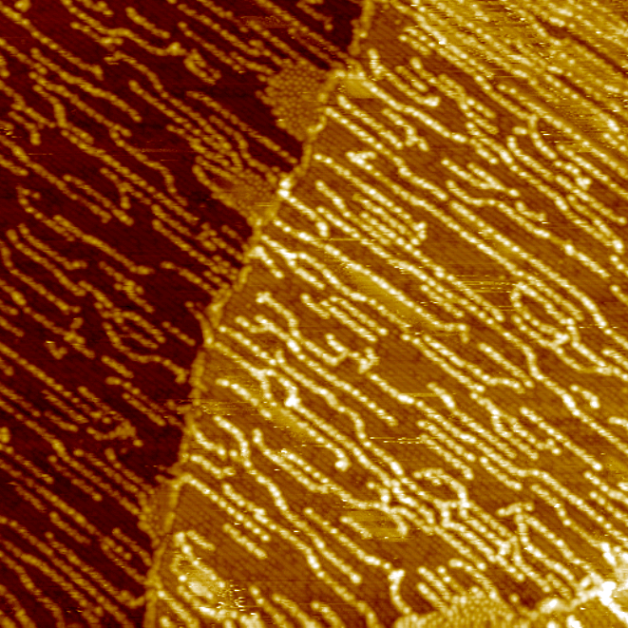
^{100 × 100 nm2}
^{19-1 , 16-05-2013}
^{I=5pA, U= +2 V}
Fig. 3. STM image taken at room temperature for DITF molecules deposited on TiO2 (011) surface and annealed at 300 ºC for 20 min.
The importance of hydrogen passivation of the reconstructed TiO₂(011) surface is demonstrated by our studies on DITF polymerisation as the function of OH group surface density. By heating under O₂ atmosphere we were able to produce surfaces almost free from OH group and we see effectively no polymerisation on such a surface (see Figures 4 and 5). Also for the case of high density of OH groups the polymerisation is quite effective but it is easy to see from the images that all OH groups are "consumed" during the process, so no OH spots are seen on STM images between the polymer chains (see Fig. 6).

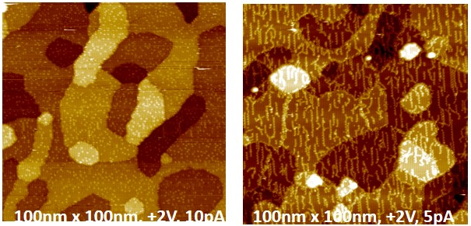
Fig. 4. STM images taken at LN₂ temperature of the reconstructed TiO₂ (011) surface as prepared (left panel) and after deposition of DITF molecules at T≈250°C (resisitive heating) for 5min (right panel). The light dots on the left panel correspond to OH group termination.
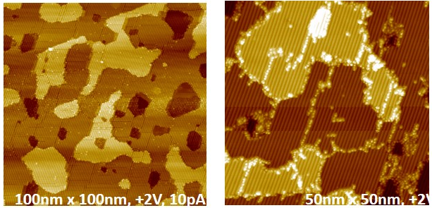
Fig. 5. STM images taken at LN₂ temperature of the reconstructed TiO₂ (011) surface as prepared under partial O₂ atmosphere (left panel, essentially no OH group termination seen) and after deposition of DITF molecules at T≈250°C (resisitive heating) for 5min (right panel). Please, note that only individual DITF molecules are decorating step edges and domain borders but no polymer wires are seen.
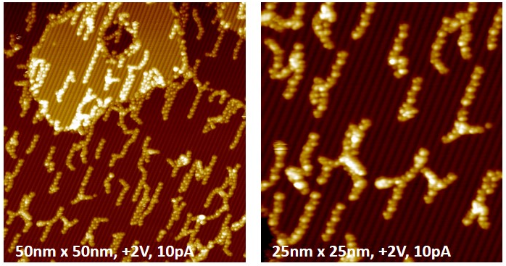
Fig. 6. High resolution STM images of DITF molecular chains taken at LN₂ temperature after deposition of the molecules onto the reconstructed TiO₂ (011) surface kept at T≈250°C (resistive heating) for 5min (both panels). Note the absence of OH groups between the wires!
Conclusions:
In conclusion, we have demonstrated the feasibility of thermally triggered, on-surface polymerization on the TiO2 - (011)-(2x1) surface for both DBBA and DITF molecules. In a broader context, the method of covalent assembly of organic building blocks on surfaces is shown to be applicable for semiconducting materials providing that they have selected surface chemical properties such as OH group termination for rutile. It is expected that the reaction mechanism of polymerization on metal oxide surfaces is different from that reported for metals. Regardless of the differences in the pathways leading to covalently bonded molecular nanostructures, the discussed thermally driven on-surface polymerization appears as more universal and very promising method for constructing miscellaneous molecular devices on substrates with a suitable band gap.

References:
1. Bombis, C.; Ample, F.; Lafferentz, L.; Yu, H.; Hecht, S.; Joachim, C.; Grill, L. Angewandte Chemie-International Edition 2009, 48, (52), 9966-9970.
2. Franc, G.; Gourdon, A. Physical Chemistry Chemical Physics 2011, 13, (32), 14283-14292.
3. Grill, L.; Dyer, M.; Lafferentz, L.; Persson, M.; Peters, M. V.; Hecht, S. Nature Nanotechnology 2007, 2, (11), 687-691.
4. Lafferentz, L.; Ample, F.; Yu, H.; Hecht, S.; Joachim, C.; Grill, L. Science 2009, 323, (5918), 1193-1197.
5. Lafferentz, L.; Eberhardt, V.; Dri, C.; Africh, C.; Comelli, G.; Esch, F.; Hecht, S.; Grill, L. Nature Chemistry 2012, 4, (3), 215-220.
6. Gourdon, A. Angewandte Chemie-International Edition 2008, 47, (37), 6950-6953.
7. Kolmer, M.; Ahmad Zebari, A. A.; Prauzner-Bechcicki, J. S.; Piskorz, W.; Zasada, F.; Godlewski, S.; Such, B.; Sojka, Z.; Szymonski, M. Angewandte Chemie International Edition 2013, doi: 10.1002/anie.201303657.
8. Cai, J.; Ruffieux, P.; Jaafar, R.; Bieri, M.; Braun, T.; Blankenburg, S.; Muoth, M.; Seitsonen, A. P.; Saleh, M.; Feng, X.; Muellen, K.; Fasel, R. Nature 2010, 466, (7305), 470-473.
9. J. Hafner, J. Comput. Chem. 2008, 29, 2044-2078.
10. N. D. Mermin, Physical Review 1965, 137, 1441-&.
11. a) P. E. Blöchl, Phys. Rev. B 1994, 50, 17953-17979; b) G. Kresse, D. Joubert, Phys. Rev. B 1999, 59, 1758-1775.
12. J. P. Perdew, Y. Wang, Phys. Rev. B 1992, 45, 13244-13249.
13. S. Godlewski, A. Tekiel, W. Piskorz, F. Zasada, J. S. Prauzner-Bechcicki, Z. Sojka, M. Szymonski, ACS Nano 2012, 6, 8536-8545.
14. a) S. Grimme, J. Comput. Chem. 2006, 27, 1787-1799; b) S. Grimme, J. Comput. Chem. 2004, 25, 1463-1473.
15. J. Tersoff, D. R. Hamann, Phys. Rev. B 1985, 31, 805-813.

AtMol Ref. Publication:

1) Kolmer, M.; Ahmad Zebari, A. A.; Prauzner-Bechcicki, J. S.; Piskorz, W.; Zasada, F.; Godlewski, S.; Such, B.; Sojka, Z.; Szymonski, M., Polymerization of Polyanthrylene on a Titanium Dioxide (011)-(2×1) Surface, Angewandte Chemie International Edition 2013, 52, 10300.

