The AgeingWell website is a reference point for key stakeholders in the ICT & Ageing Sector. It aims at creating a Community of Actors interested in improving the life of older persons by promoting the market uptake of ICT solutions for Ageing Well.

Why join our community?

 | Receive regular news on the ICT & Ageing Sector
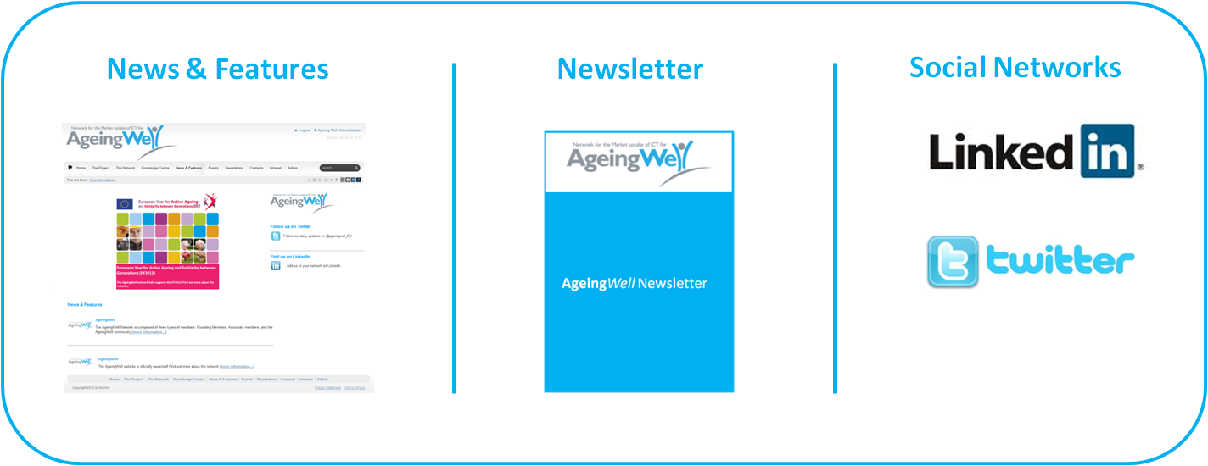
 | Access the information available on our Knowledge Centre
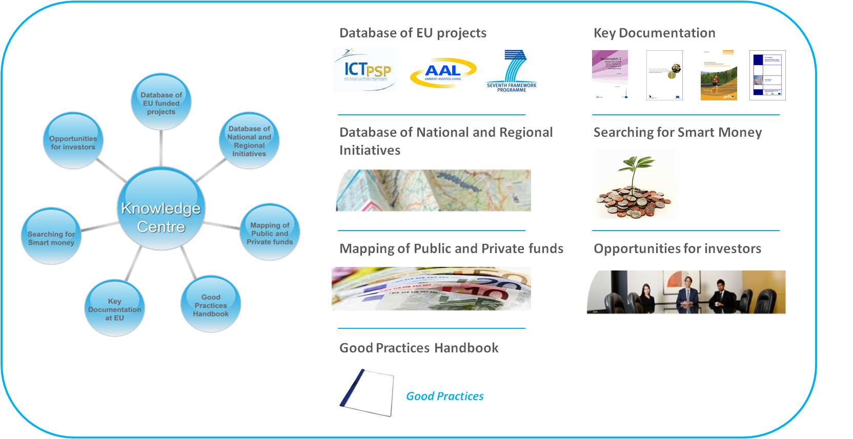
 | Benefit of Networking Opportunities all over Europe
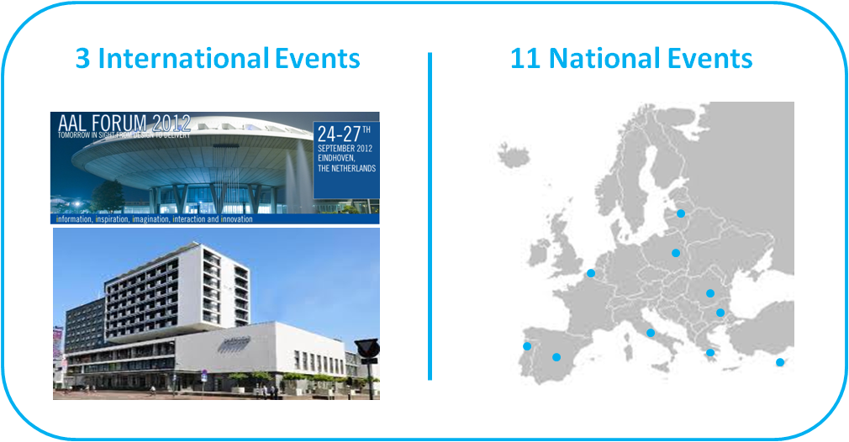

Register now!

