Project Number: 610389
FP7-ICT-2013-10

Development of a low-cost point-of-care test for Tuberculosis detection

Deliverable D7.1: Website online, continuously updated

Due date of deliverable: Feb 1st 2014 (M3)
Actual submission date: Dec 2nd 2013

Start date of project: 2013-11-01 Duration: 3 Years

Organisation name of lead contractor for this deliverable: UGent Revision [1.0]

Project co-funded by the European Commission within the Seventh Framework Programme
Dissemination Level
PU | Public | X
PP | Restricted to other programme participants (including the Commission Services)
RE | Restricted to a group specified by the consortium (including the Commission Services)
CO | Confidential, only for members of the consortium (including the Commission Services)

Description of the website

The website has been online since Nov 6 at http://www.pocket-proj.eu/, and consists of the following parts:

Main page:

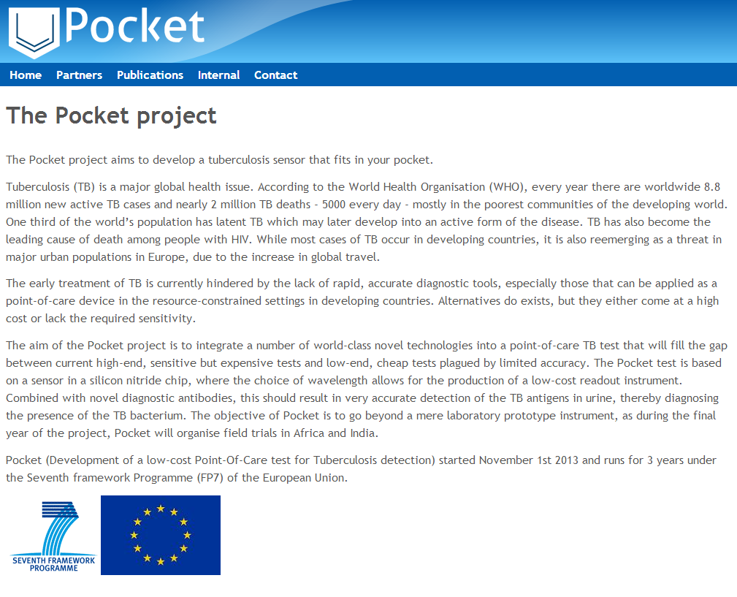

Description of partners:
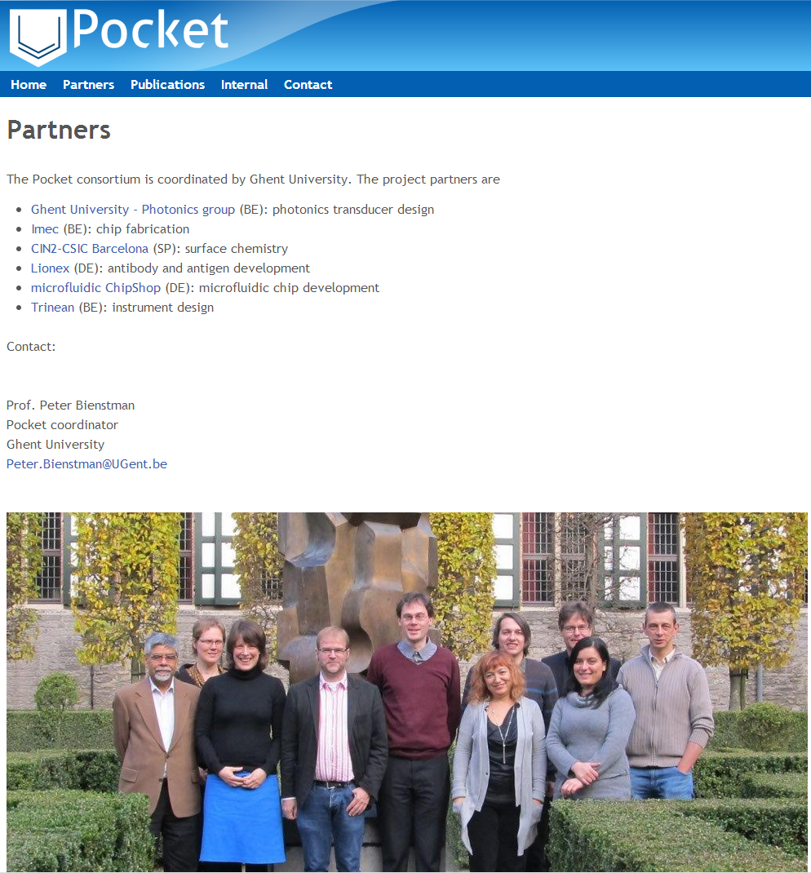

Publications:
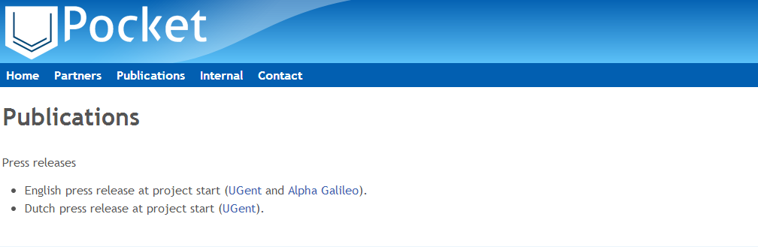

Internal partner area:
