Project Number: 610389
FP7-ICT-2013-10

Development of a low-cost point-of-care test for Tuberculosis detection

Deliverable D7.4a: Press release at project start

Due date of deliverable: Dec 1st 2013 (M1)
Actual submission date: Dec 2nd 2013

Start date of project: 2013-11-01 Duration: 3 Years

Organisation name of lead contractor for this deliverable: UGent Revision [1.0]

Project co-funded by the European Commission within the Seventh Framework Programme
Dissemination Level
PU | Public | X
PP | Restricted to other programme participants (including the Commission Services)
RE | Restricted to a group specified by the consortium (including the Commission Services)
CO | Confidential, only for members of the consortium (including the Commission Services)

Description of the press release
Several press releases have been made, which can be found below. They are also linked on the project website under http://www.pocket-proj.eu/publications.

An English press release by UGent on Alpha Galileo on Nov 5 2013:
http://www.alphagalileo.org/ViewItem.aspx?ItemId=136155&CultureCode=en
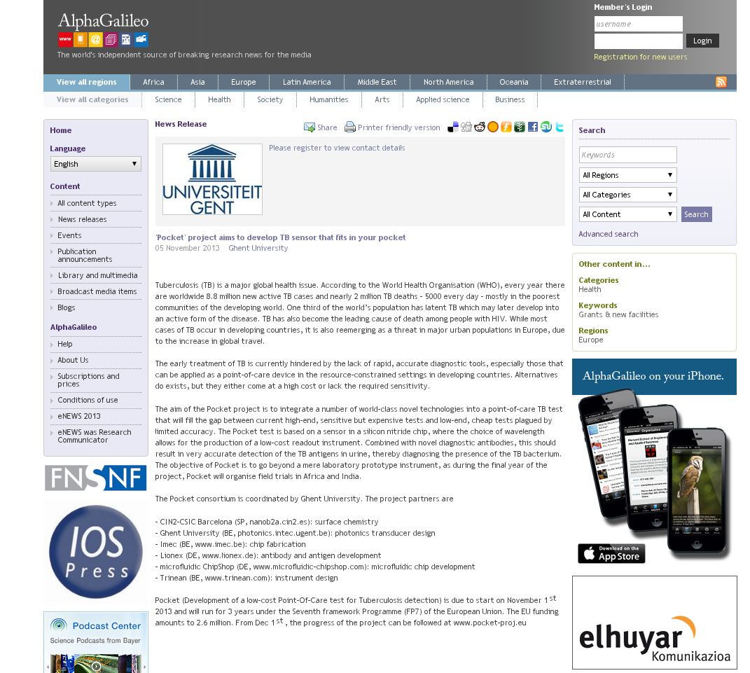

An English press release by UGent on its own website on Oct 31 2013:
http://www.ugent.be/en/news/bulletin/tuberculosis-tb-sensor-pocket.htm
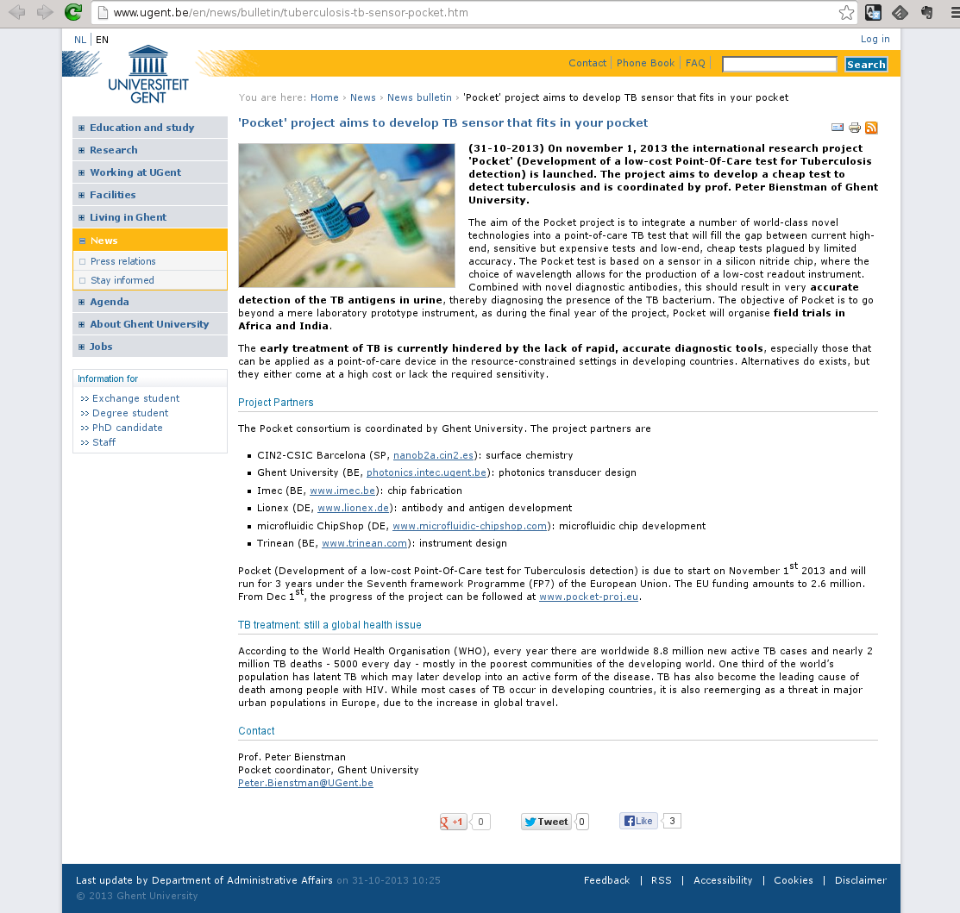

A Dutch press release by UGent on its own website on Oct 31 2013:
http://www.ugent.be/nl/actueel/persberichten/tuberculose-tbc-sensor-it.htm
