FINAL TECHNICAL REPORT (PUBLISHABLE PART)

CONTRACT N° : ENK6-CT-2000-00093

PROJECT N° : NNE5-1999-20166

ACRONYM : IRTMBA

TITLE : Improved Radiation Transport Modelling for Borehole Applications

PROJECT CO-ORDINATOR : C. K. Harris

PARTNERS : Shell International Exploration & Production B.V. (SIEP – Coordinator)
Serco Assurance (SERCO – Contractor)
Imperial College of Science, Technology & Medicine (ICSTM – Contractor)
Delft University of Technology (DUT – Contractor)
Nuclear Research & Consultancy Group (NRG – Contractor)
Institut Jozef Stefan (IJS – Contractor)

REPORTING PERIOD : From 01/12/2000 to 30/11/2003

PROJECT START DATE : 01/12/00 DURATION : 36 Months

Date of issue of this report : 31/12/04

 | Project funded by the European Community under the EESD Programme (1998-2002)

Table of contents Page

Part 1: Executive Publishable Summary 1 1

Part 2: Publishable Final Report 3

2.1. Objectives and strategic aspects 3
2.1.1 Objectives and Problems Addressed 3
2.1.2 Some Technical Background on the State-of-the-Art of Neutron Saturation 3
Log Interpretation
2.1.3 Scientific and Technical Objectives of the IRTMBA Project 6
2.1.4 Socio-Economic Objectives and Contribution to EU Policies Needs 6
2.2. Scientific and technical description of the results 7
2.2.1 Overall Project Work Plan 7
2.2.2 Results Obtained on Improved Nuclear Data for Key Nuclides in the 8
Borehole Environment
Task 1.1 8
Task 1.2 12
Task 1.3 15
Task 2.1 20
Task 2.2 22
Task 2.3 24
2.2.3 Results Obtained on Faster Algorithms for Stochastic Radiation Transport 28
Modelling
Task 3.1 29
Task 3.2 33
Task 3.3 36
2.2.4 Progress in the Development of a Nuclear Data Library Supplement for the 37
Borehole Environment
2.2.5 Progress in the Development of an Enhanced Modelling Tool for Neutron 37
Saturation Logs
Task 4.1 37
Task 4.2 38
2.2.6 Progress on the Remainder of the Work Plan 41
Task 5.1 41
Task 5.2 43
2.3 Assessments of Results and Conclusions 44
2.4 Acknowledgements 45
2.5 References 45

Part 1: Executive Publishable Summary Non Confidential

Contract No: | ENK6-CT-2000-00093 | Reporting Period: | 01/12/00-30/11/03
Title: | Improved Radiation Transport Modelling for Borehole Applications (IRTMBA)
Objectives: The high level aim of this project is to increase the ultimate recovery from producing hydrocarbon reservoirs, at minimal environmental cost, by more effectively pinpointing missed hydrocarbon pockets and thereby enabling appropriate reservoir management strategies for extracting the resources remaining in the reservoirs. To achieve this, the project is focussed on improving the interpretation of the nuclear logging measurements which are used to locate remaining hydrocarbon resources behind casing but away from existing producing zones. This will be done by increasing the accuracy, precision and ease of use of the radiation transport modelling codes available to the petrophysicist interpreting the logs. Greater accuracy will result from the development of improved nuclear data libraries specifically geared to the borehole environment and the type of radiation transport model used, while improvements in the computational efficiency of stochastic codes will yield greater precision for a given computational effort. A front end enabling selection of the most appropriate code for a particular application will render the new neutron log interpretation technology accessible to the practising petrophysicist.
Scientific Achievements: A key milestone was achieved by the end of the IRTMBA project with a demonstration of the value of improved nuclear data in predicting the response of a vendor neutron logging tool. This became possible after the tool vendor provided the IRTMBA consortium with a model of their tool as well as test-pit data. A good match between the predictions and the tool response in test-pit experiments was obtained after performing new evaluations of detector nuclides, incorporating a more detailed formulation of electron transport so as to respect electron balance at the detector edge and using a realistic spread of energies for the neutron source (rather than considering it to be mono-energetic). Other key developments included establishing and validating a neural-network-based approach for rapid optimisation of group structure in group-formatted nuclear libraries, as well as the implementation of the MIDWAY speedup method with the MCBEND and MCNP stochastic codes, entailing the use of optimised group-formatted data developed during the course of the project and the preparation of the special purpose nuclear data library for the oil well logging applications. Most of the interfaces to the various radiation transport codes used and developed during in IRTMBA have been completed in the front-end integrator.
Socio-Economic relevance and policy implications: This three-year project has delivered a tool for achieving the high-level objective stated at the beginning of this summary, and the final year saw a convincing validation of the approach taken in developing the tool. Much of Europe’s hydrocarbon resources are classified as “mature” and therefore appear a promising testing ground for the IRTMBA technology. In the high oil price world that currently prevails, it remains economically attractive to continue to develop these resources, and the technology developed in this project will help the remaining oil to be extracted at a lower environmental cost, since any additional drilling required can be more precisely targeted. In a low oil price world, by contrast, using IRTMBA technology will, through increased extraction efficiency, help lower the threshold oil price below which exploitation of remaining reserves ceases to become economically viable, thus helping to reduce imports and to stabilize the economies of the major oil producers within Europe. The techniques developed during this project have been disseminated to the nuclear engineering community at conferences and workshops and spin-offs are envisaged.
Conclusions: In summary, the project “Improved Radiation Transport Modelling for Borehole Applications” has concluded successfully, with the main deliverables formulated at the beginning of the project being achieved. Following a successful demonstration of the technology developed during this project to modelling the response of an actual neutron saturation logging tool, significant buy-in by oilfield service companies and others to the implementation and further development of the technology is expected. A Technology Implementation Plan has been drawn up and is available on-line.
Keywords: Neutron logging, radiation transport, Monte-Carlo, MIDWAY, EVENT, MCBEND, MCNP, DOORS, SUSD3D

Part 2: Publishable Final Report Non-Confidential

2.1. Objectives and strategic aspects

2.1.1 Objectives and Problems Addressed

The aim of this project is to optimise the recovery of hydrocarbons from existing wells by accurately locating oil and gas deposits behind casing, thus reducing the overall cost of production with minimal environmental impact.

Large amounts of unswept and bypassed hydrocarbon (oil and gas) deposits exist which can be extracted from existing wells if only we knew where to look for it. It is much cheaper and more environmentally friendly to identify and extract these from existing wells rather than drilling new ones. However, once a well has been drilled and casing has been set, conventional logging tools are unable to take measurements through the casing. Until the past two years, which has seen the development of a commercial through-casing resistivity tool [1], a neutron-logging tool [2-7] was the only practical one for determining formation and fluid composition through casing, and is still the most widely used. Improved interpretation of the neutron logging data obtained from cased-hole wells is needed in order optimise the recovery of hydrocarbons from these wells.

Experience both in interpreting neutron logs and in trying to devise improved modelling techniques to aid in this interpretation have helped pinpoint the following two key areas addressed in this project, and the way forward for each of them:

Nuclear Data/Libraries: The current nuclear data libraries contain discrepancies and inconsistencies, and the library data format is often not immediately suitable for use with the modelling techniques available. These problems are addressed in this project in an integrated way, within the framework of a new library supplement dedicated to bore-hole applications. It is aimed that this library supplement will grow to become an industry standard. Much can be done by reformatting and regrouping existing data, and the results of additional but incomplete measurements can be augmented using the latest modelling techniques.
Modelling: At present, radiation transport modelling (RTM) is too slow and not sufficiently accurate for well-logging applications. Techniques have been developed by the participants in this project for both speeding up the traditional stochastic or Monte-Carlo approach to RTM, and in developing deterministic alternatives. These are adapted in this project to treat nuclear borehole logging.

2.1.2 Some Technical Background on the State-of-the-Art of Nuclear Saturation Log Interpretation

This project focuses on improving the interpretation of the nuclear logging measurements which are used to locate remaining hydrocarbon resources behind casing but away from existing producing zones. These measurements make use of a pulsed accelerator source [8] that sends high-energy neutrons into the formation to probe it. Two types of measurements are made (see Figure 2.1), and use different interactions of the neutrons with the formation nuclei to deduce whether the pore space behind the casing contains oil or water.
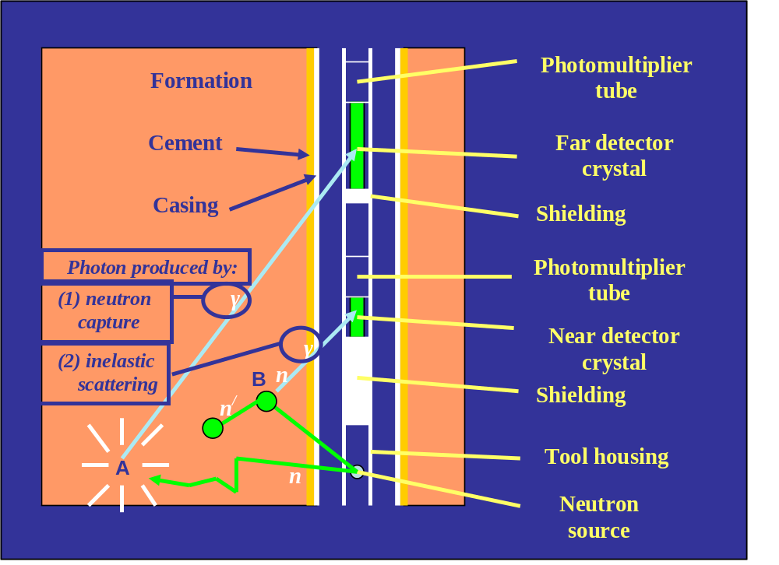
Figure 2.1. Schematic of Generic Nuetron Saturation Logging Tool

The first type, known as spectroscopic or carbon-oxygen (C/O) logging, makes use of the fact that water contains oxygen but not carbon, while the situation is reversed for oil. Point B in Figure 1 is supposed to represent a high energy inelastic interaction of a neutron with a formation nucleus (the latter is not shown). The spectra of the gamma radiation produced by such interactions yield information about the distribution of nuclei in the formation. In particular the spectra of certain common reservoir interactions with carbon and oxygen nuclei have characteristic shapes which, in principle, allow the relative proportions of carbon and oxygen nuclei in the formation to be determined. Knowing the rock type (e.g. sandstone or carbonate), together with the porosity, which is the fraction of the bulk volume of the rock contained in the pore space, allows information to be obtained about the relative proportion of oil in the pore space.

The second type of measurement, called neutron capture or sigma logging, is essentially designed to detect the proportion of chlorine in the formation, an element which is present in reservoir water but not in oil. It involves the detection of gamma radiation produced by capture of neutrons by nuclei after the neutrons have reached thermal energies (less than 0.4 eV: see point A in Figure 1). The decay with time of the gamma radiation detected following the burst reflects the depletion of the neutron population due to capture, and its rate depends on the nuclei present, as the probability that a thermal neutron in the vicinity of a nucleus will be captured, rather than merely undergoing a thermal interaction, strongly depends on the type of nucleus. Of the nuclei commonly present in fluid-bearing rock formations, chlorine is particularly effective in neutron capture, and a relatively fast depletion of the neutron population is often an indicator of its presence in the pore space, in the form of salt in water originally present, or resulting from a salt water drive to produce the oil.

The interpretation of C/O and sigma logging is often not straightforward for the following reasons:
1. In C/O logging, the gamma radiation spectrum is modified by subsequent interactions of the gamma radiation with the environment.
2. In both C/O and sigma logging, the formation response is contaminated by the response from the bore-hole. This contamination is made more severe by the fact that the composition of the bore-hole fluid in the vicinity of the tool during the logging operation is usually unknown.
3. Contamination from the unknown bore-hole fluid poses particular difficulties for reliable sigma log interpretation when the contrast in neutron absorption between oil and water in the pore space is very low. This situation occurs when the formation water or injection water is fresh.

The state-of-the-art in interpreting nuclear saturation logs in the light of items 1-3 above can be divided into two parts according to whether the interpretation involves an in-depth laboratory analysis or a routine field analysis.

In the laboratory, the main technique used to address 1.-3. above is to perform detailed radiation transport modelling to disentangle the effects of multiple interactions and bore-hole effects on the carbon/oxygen ratio or decay curves [7]. Although of some use for in-depth studies, current Monte-Carlo techniques are too slow and too specialised for routine application, and the nuclear data libraries that they use have known deficiencies for neutron-nucleus interactions that are important for bore-hole logging.

In the field, various methods are used to extract the carbon-to-oxygen data from the raw spectra. The near and far detectors (see Figure 2.1) sample the space around the source differently (i.e., they 'see' the bore-hole relative to the formation in a different way). This fact is used to extract out the intrinsic carbon-to-oxygen ratio pertaining to the formation, using a database of measurements carried out under test conditions in which fluids of known composition are contained in the bore-hole and formation pore space [see, e.g. Ref. 9]. The interpretation of sigma logs also uses such a database; the decay curve that results in this case is split up, for instance via a dual exponential fit, into short and long term parts, corresponding to the bore-hole and formation responses, respectively [10]. In summary, the methods used in the field to interpret nuclear bore-hole logging measurements are purely empirical, do not take the detailed physics of the neutron-nucleus interactions into account, and are based on a database of standard configurations that is too limited, especially in view of recent innovations in well completion technology.

2.1.3 Scientific and Technical Objectives of the IRTMBA Project

Scientific objectives

The scientific objectives of this project were designed to circumvent the above problems and enable a step change in our capability to model nuclear bore-hole logging. They are the following:

A. Improved Nuclear Data for Key Nuclides in the Borehole Environment. Comparisons made of RTM for C/O logging using different nuclear data libraries have revealed serious discrepancies in the results. A key project objective is for these discrepancies to be further investigated, documented and publicised, and the best sources of data for individual interactions identified. A further issue addressed in this project is the setting up of optimal group data to enhance the accuracy of deterministic RTM codes.

B. Faster Algorithms for Stochastic Radiation Transport Modelling. Speed-up in radiation transport modelling can be accomplished by an effective combination of weighted sampling techniques and forward and adjoint computations (in an adjoint calculation the expected detector response of a particle is tracked backward to the source of the particle rather than forward). A factor 10-100 increase in computing speed for a given accuracy has been achieved for nuclear reactor calculations (neutron source steady in time), and these techniques have been extended in the present project to treat pulsed neutron sources (time-dependent neutron source).

Technical Objectives

The technical objectives of this project are geared to the implementation phase of the improved nuclear log interpretation technology that will result from achieving the scientific objectives. The two primary objectives are:

1. A Nuclear Data Library Supplement for the Bore-hole Environment. This library is a product of the work carried out in achieving the first of the two scientific objectives listed above. Making it available on licence to industry and academia will facilitate the implementation of ongoing improvements in nuclear data technology.

2. An Enhanced Modelling Tool for the Interpretation of Neutron Saturation Logs. The other primary technical opbjective of the IRTMBA project was the development of a user-friendly front-end, incorporating all the results of the scientific objectives and coupled to all the available modelling techniques. This will be an important enabler for the practical implementation of the new technology developed during this project.

2.1.4 Socio-Economic Objectives and Contribution to EU Policies Needs

Oil and gas produced in Europe (EU plus associated countries) accounts for a considerable percentage of primary energy consumption (though this is difficult to quantify exactly due to oil trading). Although significant new deposits are still being located, much of the production results from maturing fields. Examples are many of the North-Sea fields, onshore oil and gas fields in northwest and southeast Europe, and the Villafortuna field in Italy. In many of these fields additional wells are planned in order to boost production and to extract the remaining hydrocarbon reserves.

Technical success for the IRTMBA project will contribute to European policies in the following ways:

- Economic and social
The technical objectives of the project, detailed above, will improve the efficiency of mature hydrocarbon resource development significantly. This helps lower the threshold oil price below which exploitation of remaining reserves ceases to be economically viable, thereby helping to reduce imports and to stabilise the economies of the major oil producers within Europe. On the scientific side, an important social dimension to the project is that it is in the area of nuclear technology, a discipline which has encountered setbacks in recent years with the reduction or cancellation of national nuclear energy programmes. The cooperation between the participants has a pan-European dimension, with participants stretching across the breadth of the continent.

- Sustainability of reserves
The aim of this project is the improved location of remaining reserves in producing fields, so that they may be extracted more efficiently at a lower environmental cost. Clearly this enhances the sustainability of these fields, since the ultimate productivity is expected to be higher - an additional 5% increase over a five-year timespan does not seem unreasonable. This increased productivity results not only from being able to target the oil that is detected as a result of the work carried out in this project, but also from being able to build better reservoir management models as a result of knowing which regions of a mature hydrocarbon reservoir have been bypassed during production.

- Reduced environmental impact
Instead of having to drill new wells, the new techniques developed in IRTMBA will increase confidence in sidetracking from existing wells to look for bypassed hydrocarbons. Sidetracking reduces the environmental impact of hydrocarbon exploitation as much less waste is produced and existing surface facilities can be used.

- Increased safety
A generally lower level of activity that would result from on-target drilling would automatically lead to increased safety.

Outside the oil and gas industry, spin-offs of the work carried out in IRTMBA could include optimisation of radiation protection. There could also be applications in medical radiation physics. A wider benefit would arise from the application of original optimisation methods in this computationally intensive environment - these should have wide industrial applicability in product design and 'inverse' imaging technology.
2.2. Scientific and technical description of the results

2.2.1 Overall Project Work Plan

The work plan for achieving the scientific and technical objectives of the project is shown in Table 2.I. This version of the work plan was adopted by the consortium after the first project meeting and is a slight revision of the original. The revision was accepted by the Project Officer and the work plan shown in Table 2.I was followed for the remaining project duration.

Table 2.1 Overall Workplan in the form of a Work Package/Manpower Bar Chart
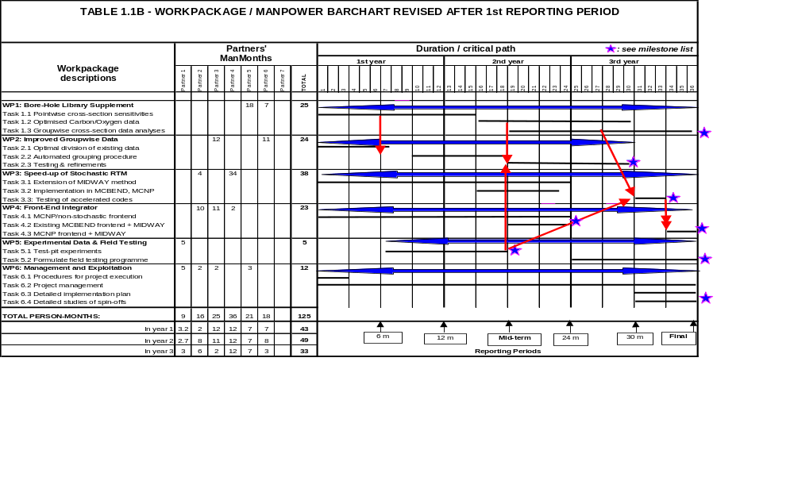

The chart shows how the work required to achieve the scientific and technical objectives listed in Section 2.1.3 of this report was divided into tasks, and how manpower was planned to be divided up among the various tasks including timelines and interrelation with other tasks.

2.2.2. Results Obtained on Improved Nuclear Data for Key Nuclides in the Borehole Environment

This section of the report describes the results obtained on the improved nuclear data that constitutes Scientific Objective A in Section 2.1.3.

The work described in this sub-section covers work packages 1 and 2 , which are described in Table 2.I. They are also listed below, together with their associated tasks and deliverables, in Tables 2.IIA and B (overleaf and on page 17 respectively)

Task 1.1

Under Task 1.1, the Monte Carlo radiation transport modelling code MCNP4C [11] was used to assess the sensitivity of the carbon-oxygen ratio, a quantity determined in nuclear oil-well logs, to underlying nuclear data. The carbon-oxygen ratio is the ratio of gamma radiation due to inelastic scattering of neutrons with nuclei in the formation and borehole received in two energy windows, the so-called carbon and oxygen windows (3.21-4.75 MeV and 4.75-7.05 MeV respectively). The first of these windows contains the main carbon peak, at 4.44 MeV, while the second window contains several oxygen peaks. The measurement is designed to determine the ratio of carbon to oxygen nuclei in the formation, and hence whether the pore space contains oil (carbon but no oxygen) or water (oxygen but no carbon), or a mixture of the two. In a logging run, gamma radiation from capture of thermal neutrons is also measured, but can be extracted out using a separate measurement. In the simulations, capture gammas are excluded by only counting photons arising from interactions involving neutrons with energies greater than 3 MeV.

Table 2.IIA. Detailed Description of Work Package 1
WORK PACKAGE NUMBER 1
Objectives
The objective of this workset is to assess the critical nuclear data pertinent to the bore-hole environment and to improve the related cross sections. The best available data for those elements encountered in typical bore-hole applications will be identified, and is intended to be developed into an industry standard for nuclear borehole logging.

Description of work
Task 1.1 Identification of pointwise cross-section sensitivities for oil-well logging, based on the present ENDF (USA), JENDL (Japan) and JEFF (Europe) nuclear data libraries.
Task 1.2 Optimise nuclear data for the primary inelastic interaction of high energy (10-14 MeV) neutrons with a carbon or oxygen nucleus., the choice depending on the outcome of WP 1.1 The impact of the improved data will be assessed using the calculational scheme of Task 1.1.
Task 1.3 Study the performance of different groupwise cross-section data in the analysis of a benchmark test-pit experiment. Identify the relevant calculational parameters, cross section data and reaction data from a groupwise point of view in order to guide model and data improvements.

Deliverables
D1.1 Report and publication detailing the effect of pointwise cross section sensitivities on the modelled data response.
D1.2 Report and publication on the improved carbon/oxygen data, including the nuclear reaction models employed.
D1.3 Report and publication describing the differences between evaluations and suggestions for improvements on the basis of groupwise sensitivity studies.
D1.4 Launch of borehole data library supplement via on-line advertisement.
Milestones and expected results
Assessment and improvement of most crucial nuclear data for borehole applications.

The evaluated nuclear data libraries used in the sensitivity analyses were JEF-2.2 [12], ENDF/B-VI.5 [13] and JENDL-3.2 [14], and the NJOY nuclear data processing system (developed, like MCNP, at Los Alamos National Laboratory – see Ref. 15) was used to generate nuclear cross-section libraries for MCNP4C. First, the three libraries were used to compute carbon-oxygen ratios in limestone with porosities of 0%, 20% and 40%, and with oil, water and a 50-50 mixture of the two in the pore space. While the data exhibited the expected trends, the carbon-oxygen ratio determined using the JENDL data was 15% lower than for the other two libraries, which agreed with each other within statistical error. To determine which nuclides are responsible for this discrepancy, cross-section libraries were compiled
using the JENDL nuclear data, except for specific nuclides for which the JEF-2.2 evaluation was used. Most of the discrepancy was found to be due to the evaluation of ^{nat}Ca in JENDL, with ¹⁶O also contributing.

Table 2.II: C/O-ratio calculated in limestone and sandstone with the pore space filled with an oil and water mixture (porosity = 0.2)

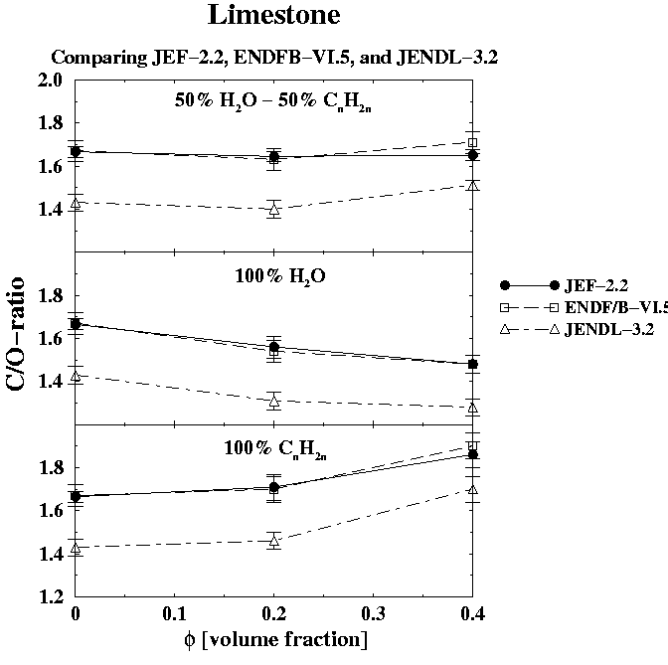 | Nuclear Data | Limestone | Sandstone
 | JEF data | 1.644 ± 0.025 | 1.092 ± 0.016
 | JENDL data | 1.409 ± 0.025 | 1.082 ± 0.019
 | JENDL +  Ca from JEF | 1.576 ± 0.025 | -
 | JENDL +  O from JEF | 1.499 ± .023 | -
 | JENDL + Ca,  O from JEF | 1.615 ± 0.026 | -

Figure 2.2. C/O ratio in limestone

JEF-2.2 was used to carry out the sensitivity analyses, which focused on nuclear cross sections for ^{nat}C, ¹⁶O, ^{nat}Cl, ^{nat}Si and ^{nat}Ca. These are the elements most commonly occurring in the formation. The effect on the carbon-oxygen ratio of varying the neutron and photon production cross-sections per element and per reaction channel was determined. The perturbation option available within MCNP was used to vary the neutron cross-sections. Since the neutron and photon transport calculations are decoupled in the simulations, the effect of varying neutron cross-sections on the carbon-oxygen ratio is limited to the effect that the changed neutron distribution in the formation will have on the produced photons. In fact, for the perturbed total cross-sections, in which a maximum perturbation of 20% for ^{nat}C and ¹⁶O, 50% for ^{nat}Si and ^{nat}Ca and 100% for ^{nat}Cl is applied, the largest change in carbon-oxygen ratio encountered was 0.5%. This change was larger if only the cross-sections pertaining to certain specific reaction channels were changed, up to 3.4% for the primary inelastic scattering cross-section on ¹⁶O.

To modify the photon production cross-sections in the simulations, these were modified directly in the evaluated nuclear data library, and NJOY was used, as before, to generate the corresponding MCNP library. For all elements and reaction channels considered, the photon production cross-sections were doubled. A significant effect on the carbon-oxygen ratio was observed for all the elements except chlorine, with perturbations in the photon production cross-sections for oxygen having the largest effect. The results for specific reactions are shown in Table 2.III, together with the results, referred to above, for the neutron cross-sections.

Finally, the sensitivity of the carbon-oxygen response to angular distributions was investigated by setting distributions of produced photons and elastically scattered neutrons resulting from interactions with ¹⁶O nuclei to isotropic. Only minor effects were observed.

The work under Task 1.1 described above was published in Ref. 16.

Table 2.III Maximum Impact on C/O Ratio by Reaction Channel

Nuclide | Perturbed  Quantity | Applied  Variation  [%] | Impact  C/O-ratio  [%]
Neutron | cross sections
¹⁶O  ^{nat}Si  ^{nat}Ca | (n,n’) formation  (n,α) borehole fluid  (n,n) formation  (n,n’) formation  (n,p) formation  (n,α) formation  (n,p) formation  (n,n’) formation  (n,α) formation | 50  50  50  50  50  50  50  50  50 | +3.4  -0.5  -1.5  -0.3  +0.3  +0.1  -1.0  -0.4  -0.4
Photon | prod. cross section
^{nat}C  ¹⁶O  ^{nat}Ca  ^{nat}Si | (n,n’γ) E_{γ}=4.44 MeV  (n,n’γ)  E_{γ}=6.13 MeV  E_{γ}=6.92 MeV  (n,αγ)  E_{γ}=3.68 MeV  E_{γ}=3.85 MeV  (n,n’γ)  (n,n’γ) | 100  100  100  100  100  100  100  100  100 | +20.0  -37.0  -28.0  -14.0  +23.0  +13.0  +6.0  +10.0  -8.0

Further work was carried out during the second project year on the effect of the differences in nuclear data evaluations in three general-purpose nuclear data libraries on photon production spectra due to the presence of the nuclides C, O, Si and Ca. A generic neutron tool resembling Schlumberger’s RST-A tool [17] was used. This is a slim tool (1¹¹/₁₆ inches OD) designed to be run through production tubing, and differs from the wider-bodied generic tool (resembling Schlumberger’s RST-B tool) that was used in the sensitivity studies and evaluation comparisons reported in Ref. 16. The borehole environment chosen for the simulations was representative of a test-pit configuration, with a 5½” borehole containing a 4⁷/₈” plastic casing filled with fresh water. The formation was chosen to be a 19% sandstone or limestone and the pore space was filled with either fresh water, 150 g/L NaCl brine or oil.

New editions of the general purpose nuclear data libraries had been released since the work reported in Ref. 16 was done, and these were used to perform the comparisons [18]. Specifically, JEF-3.0, ENDF/B-VI.8 and JENDL-3.3 replaced JEFF-2.2, ENDF/B-VI.5 and JENDL-3.2 respectively. Differences between the evaluations resulted in small differences in photon production cross sections due to the presence of carbon, with oxygen producing much larger differences, and calcium and silicon being intermediate between the two. On comparing the prediction of the carbon-oxygen ratio obtained with the evaluations for C, O, Si and Ca in the new editions of the three general purpose libraries used in turn with JENDL-3.2 evaluations of all the other elements, it was found that the widest spread in values occurred when the new Ca evaluations were used, closely followed by O.

Since the O evaluation in ENDF/B-VI.8 is based on recent microscopic experimental data, and is therefore expected to be superior to the evaluations in JENDL-3.3 and JEFF-3.0, it was decided retain it and to perform a new evaluation for all Ca isotopes and incorporate these into new library using ENDF/B-VI.8 evaluations for the other elements. This evaluation thus effectively forms Task 1.2, rather than a new evaluation for either O or C.

Task 1.2

Based on the results of Task 1.1, the decision was made to optimize nuclear data for the various isotopes of calcium rather than for carbon or oxygen. This is because the different evaluations for carbon in the standard general-purpose nuclear data libraries produce negligible differences in the photon production cross-sections due to the presence of carbon, and, while this is not the case for oxygen, the most recent oxygen evaluation, in the ENDF/B-VI.8 data library, is based on recent new data and is expected to be accurate. On replacing the evaluations for C, O, Si and Ca in the JENDL-3.2 library, one by one with newer evaluations from the JENDL-3.3, JEF-3.0 and ENDF/B-VI.8 libraries, the greatest variation in the carbon-oxygen ratio was produced on switching the calcium evaluations (followed by oxygen).

To carry out the optimisation, a new optical model [19] for total cross sections and elastic angular distributions was developed for Ca. This was applied together with other reaction models in NRG’s in-house nuclear reaction code TALYS [20] to obtain a satisfying description of relevant microscopic experimental data.

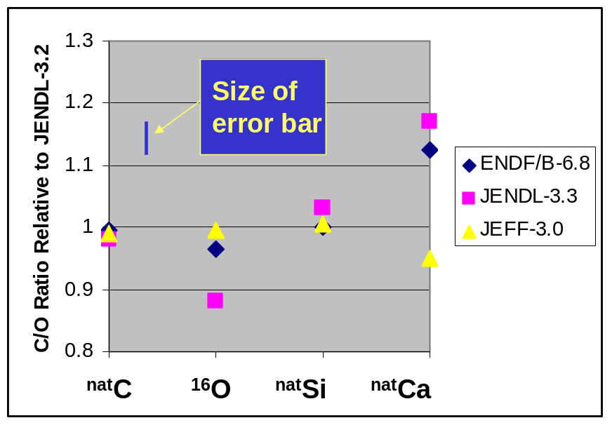

Figure 2.3. Carbon-Oxygen ratio for a generic nuclear logging tool calculated using MCNP when the evaluations for the nuclides ^{nat}C, ¹⁶O, ^{nat}Si and ^{nat}Ca in the latest releases of three general purpose nuclear data libraries are substituted for the base-case value (JENDL-3.2).

The models are used to fill in for higher excited levels for which there is no experimental data. The results are stored in an evaluated nuclear data file which is the subjected to a number of consistency checks before being ported to sn MCNP-ACE library by the program NJOY

During the third project year, NRG added a number of features to the nascent borehole library supplement as well as made refinements to its version of MCNP in order to improve the modelling of a vendor tool, for which a tool model and test-pit data became available at the beginning of project year 3. As explained previously, the new element for which a new evaluation was deemed most beneficial, is Ca, comprising the isotopes ⁴⁰Ca, ⁴²Ca, ⁴³Ca, ⁴⁶Ca and ⁴⁸Ca. The final evaluations for these isotopes have now been performed with TALYS. Additional features include the incorporation of resonance parameters from JENDL-3.3, and the adoption of measured total and capture cross sections from ENDF/B-VI.8. For other key elements in the formation, C, O, Cl and Si, the best existing evaluations have been selected for incorporation in the library. Initial poor results in modelling the response of a vendor tool (see below) prompted NRG to carry out new evaluations for the detector isotopes ^{70, 72, 73, 74, 76}Ge and ²⁰⁹Bi.

NRG’s initial attempts to model the photon response of a vendor tool resulted in under-prediction at low photon energies, over-prediction of the photon response in the oxygen window and overall under-prediction of the carbon-oxygen ratio by up to 30%. The comparison of the predicted and measured photon response for the far detector is shown in Figure 2.4 (note that the logarithmic scale on the y-axis makes the discrepancy appear less serious than it is), and the flux ratio is shown in Figure 2.5
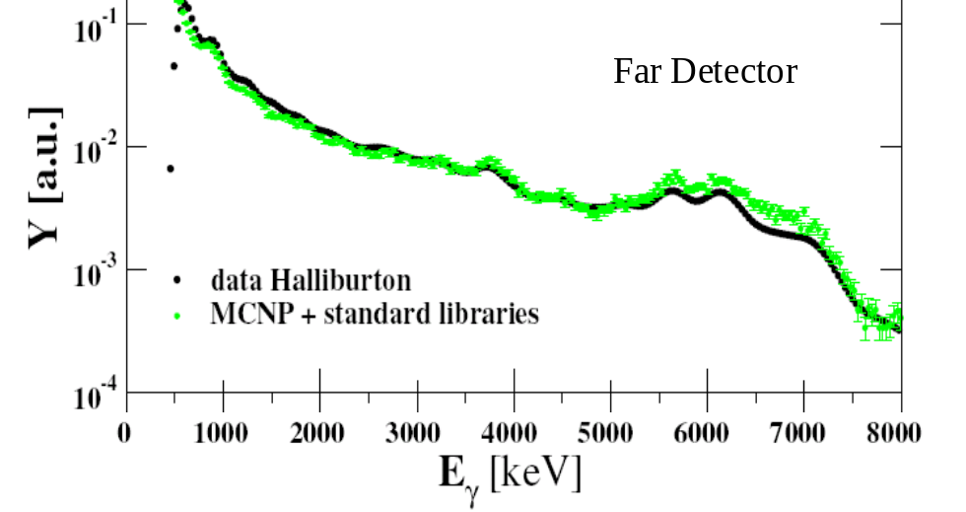

Figure 2.4. Comparison of MCNP predictions of total photon response at the far detector for a vendor tool with results from a test-pit measurement (a freshwater-filled limestone formation with a 12” borehole and 9⁵/₈” casing).
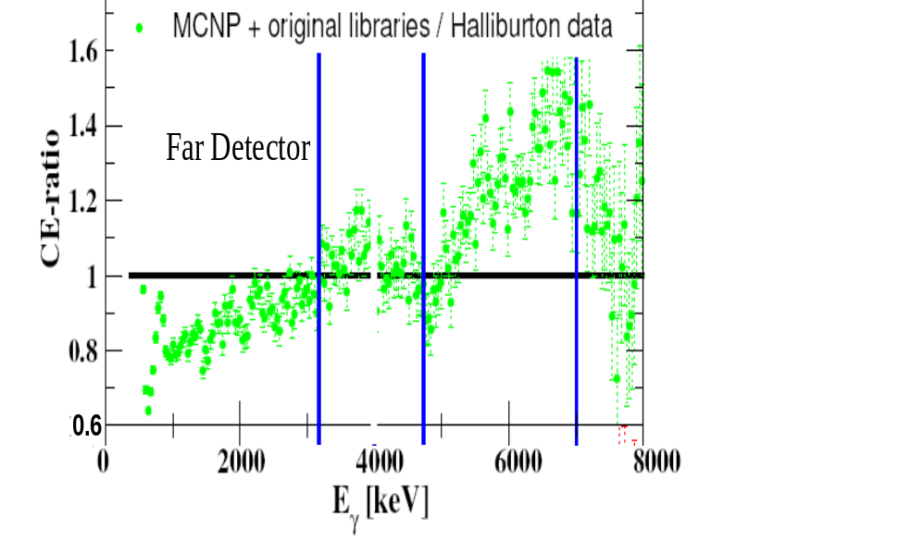

Figure 2.5. Ratio of predicted to experimental photon fluxes computed from the results shown in Figure 2.4. Ratio of predicted to experimental carbon-oxygen ratio is 0.81.

In order to address the above issues, NRG refined its version of MCNP to use a realistic neutron source (i.e. no longer mono-energetic), to treat electron transport in a detailed enough way to respect electron balance at the detector crystal edge, and, to enable time-dependent energy deposition scoring by capturing and postprocessing thermalised neutrons from a previous burst.

In addition, new evaluations of the detector elements germanium and bismuth, described above, were carried out. One such evaluation is compared with experimental data in Figure 2.6. More details are given in Ref. 21.

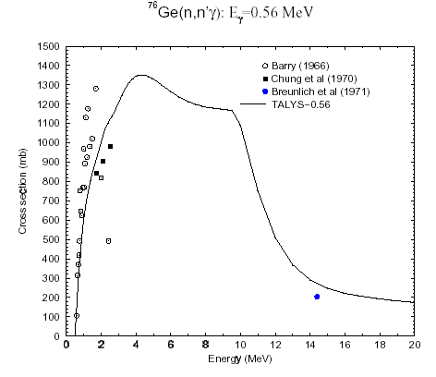
Figure 2.6. New evaluation of the photon production cross-section for the reaction ⁷⁶Ge(n,n’γ) at a photon energy of 0.56 MeV as a function of incident neutron energy: comparison with available nuclear data

The results dramatically improved the capability of the model to describe the vendor test-pit data, which covered limestone and sandstone formations and different borehole and casing sizes. The formation fluid was fresh water in most cases, but test-pit data was also provided by the vendor for an oil-saturated sand. For all cases, the predicted carbon-oxygen ratio for both the near and far detectors agreed to within 1%, while an under-prediction of the ratio by 5% was obtained for the sandstone cases (including the oil sand). Figure 2.7 shows the predicted and measured photon response after incorporation of the new evaluations in the predictions, while Figure 2.8 depicts the ratio of computed to measured photon energy deposition. Finally Figure 2.9 demonstrates the contribution of the new oil-well library in improving the prediction of the carbon-oxygen ratio for both near and far detectors in a selection of formation lithologies, formation fluids and borehole and casing sizes. This work has been reported in Ref. 22.

Task 1.3

IJS analysed experimental oxygen spectra from the FNS/JAERI Liquid Oxygen benchmark [23], in which the angular neutron spectra leaking from a 20 cm liquid oxygen slab, and covering the energy range relevant for oil well logging applications were measured. As for the oil well logging applications, a 14 MeV neutron source was used.

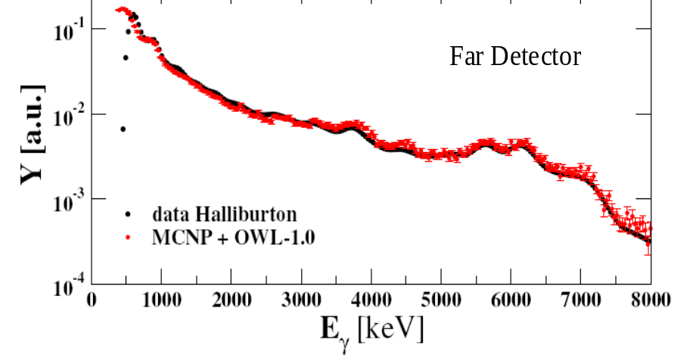

Figure 2.7. Comparison of MCNP predictions of total photon response at far detector for a vendor tool with experimental results after incorporating the new evaluations.(OWL-0.1 and 1.0 for the near and far detectors respectively) .
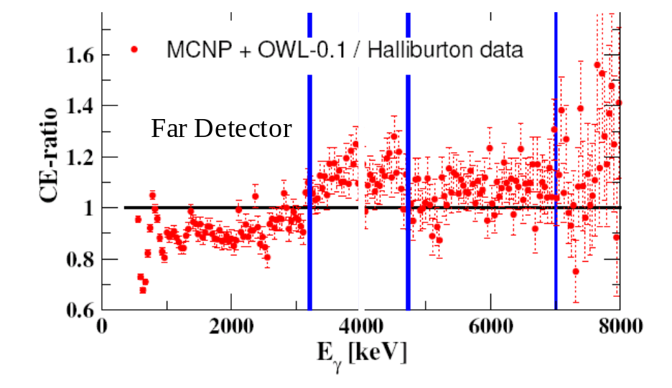

Figure 2.8. Ratios of computed to experimental photon response from the results shown in Figure 2.7 – note improvement in ratio of computed to experimental carbon-oxygen ratio (1.04 v 0.81 – see Fig. 2.9).
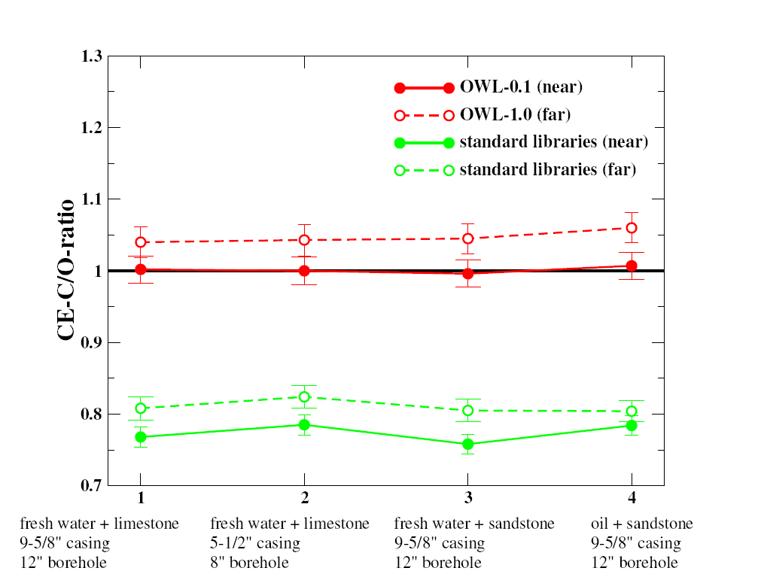

Figure 2.9. Ratio of computed to experimental carbon-oxygen ratio ( ratio of total photon response in thecarbon window to that in the oxygen window). Note improvement obtained on using the new Oil Well Library (OWL).

In order to determine the actual state-of-the-art of the oxygen nuclear data relevant for oil well logging, this benchmark was analysed using the same code system as used for the borehole benchmarks (see WP2). The cross sections for the DORT [24] code were taken from the FENDL-2 library [25]. The data are given in a 175 VITAMIN-J energy structure, with 127 groups above 0.01 MeV. P-5 Legendre expansion was used. Monte Carlo results were obtained using the MCNP-4B [26] code, and the standard ENDF/B-VI library available with the code package. Good agreement was found between the DORT discrete ordinates transport calculations and the measured spectra, as well as the values calculated by the MCNP-4B M/C code. In general the calculations agree with the measurements within ~20 %, DORT performing slightly better than MCNP. Both for DORT and MCNP the C/E values degrade with the increasing angle. At 66.8 degrees the calculations differ by almost a factor of 2 with respect to the experiment, indicating possible problems in the description of the secondary angular distribution of the scattered neutrons. The results are described in detail in Ref. 27.

IJS further developed a special-purpose cross-section library with neutron and photon energy groups selected with the right balance for nuclear oil well logging. This library was tested in the first project year against stochastic calculations for an oil-filled sandstone; and was updated in project year 2 to the latest release of ENDF/B-VI (version 8) The configurations investigated were extended to include limestone, and with fresh or saline water replacing oil in the formation. The library has 175 neutron and 45 photon groups. Nine photon groups span the range of the carbon and oxygen windows, and there are 12 neutron groups in the lower epithermal and thermal ranges (< 5 eV), as well as three up-scattering neutron groups. Comparison of the predictions of the library using the deterministic DORT code with stochastic calculations using MCNP4C for photon fluxes in the carbon and oxygen windows incident on the detectors of a generic tool, centered in the borehole, yielded a maximum difference of about 17% for the 48 cases considered (two windows, two detectors, two lithologies and three formation fluids, inelastic - capture gamma). This agreement can be considered as very good, in particular taking into account that the statistical uncertainties of the Monte Carlo calculations were rather high, up to ~ 10%. Comparing the carbon-oxygen ratio between the stochastic and non-stochastic runs, however, the maximum difference was reduced to ~11 % and was below the level of statistical uncertainty for the stochastic calculations in almost all 48 cases (see Table 2.IV).

On WP 1.3, IJS has carried out further testing of a special-purpose cross-section library with 175 neutron and 45 photon energy groups selected with the right balance for nuclear oil well logging.

The use of the deterministic codes DORT and TORT [24] in conjunction with the gamma and neutron cross-section library ENDF/B-VI.8 formatted into 175 neutron and 45 gamma energy groups yielded the same carbon-oxygen ratios as a stochastic calculation using MCNP-4C with the point-wise library data, to within the statistical accuracy of the Monte-Carlo calculation. The cases considered were 19% porosity sandstone or limestone formations, fresh water, 150 g/L brine or oil in the formation, and a near and a far detector, yielding a total of 24 cases. These results are shown in Table 2.V.

Table 2.IV -Comparison between the C/O ration calculated by the DORT and MCNP codes. The M/C statistical uncertainty (Δ(%))  is also shown.(a) Inelastic + capture response.

Inelastic + capture gamma | 19%H2O |  | 19%H2O, 150gNaCl |  | 19%CH2
Inelastic + capture gamma | DORT/MCNP | Δ(%) | DORT/MCNP | Δ(%) | DORT/MCNP | Δ(%)
SiO2
Near detector | 1.006 | 2.7 | 0.967 | 2.7 | 1.009 | 2.6
Far detector | 1.015 | 6.4 | 0.943 | 6.5 | 1.063 | 6.5
CaCO3
Near detector | 1.002 | 2.7 | 0.964 | 2.7 | 0.992 | 2.7
Far detector | 1.053 | 6.8 | 0.927 | 6.8 | 1.005 | 6.8

Table 2.IV (continued). (b) Inelastic response only
Inelastic gamma  (cutoff E>0.64MeV) | 19%H2O |  | 19%H2O, 150gNaCl |  | 19%CH2
Inelastic gamma  (cutoff E>0.64MeV) | DORT/MCNP | Δ(%) | DORT/MCNP | Δ(%) | DORT/MCNP | Δ(%)
SiO2
Near detector | 0.985 | 3.2 | 0.986 | 3.2 | 0.975 | 3.2
Far detector | 0.967 | 9.3 | 0.923 | 9.4 | 0.952 | 9.3
CaCO3
Near detector | 0.960 | 3.2 | 0.963 | 3.2 | 0.951 | 3.2
Far detector | 0.888 | 9.5 | 0.906 | 9.4 | 0.932 | 9.4

Sensitivity analyses using SUSD3D [28] with DORT were also carried out by IJS as part of Work Package 1 (these require direct and adjoint flux moments to be computed). The ENDF/B-VI.8 nuclear data library, formatted into 56 neutron and 24 gamma groups was used for these calculations, in which sensitivity of the gamma flux in the carbon and oxygen windows to the gamma production reactions from oxygen, carbon, silicon and calcium nuclei was computed. The effect of a new Cl evaluation on the gamma fluxes received at the detectors for a brine-filled formation was also demonstrated.

Table 2.V. Comparison of DORT code using ENDF/B-VI.8 library with MCNP. Ratios of fluxes received in the carbon and oxygen windows, and their quotient, the carbon-oxygen ratio, are shown.
DORT/MCNP  Inelastic gammas (cutoff E_{n}>0.64MeV) |  | 19% H₂O |  | 19% H₂O +  150 g/L NaCl |  | 19% oil (CH₂)_{n}
Sandstone (SiO₂)
 | E (MeV) | Φ_{γ} ratio | Δ % | Φ_{γ} ratio | Δ % | Φ_{γ} ratio | Δ %
Near detector:
Carbon window
Oxygen window
Ratio of C/O ratio
Far detector:
Carbon window
Oxygen window
Ratio of C/O ratio
 | 3.21-4.75 | 1.009 | 2.1 | 1.010 | 1.8 | 1.010 | 2.1
 | 4.75-7.05 | 1.024 | 2.4 | 1.024 | 2.0 | 1.036 | 2.4
 |  | 0.985 | 3.2 | 0.986 | 2.7 | 0.975 | 3.2
 | 3.21-4.75 | 1.090 | 2.7 | 1.081 | 6.3 | 1.066 | 6.2
 | 4.75-7.05 | 1.127 | 2.7 | 1.170 | 7.0 | 1.120 | 6.9
 |  | 0.967 | 3.8 | 0.923 | 6.4 | 0.952 | 9.3
Limestone (CaCO₃)
 | E (MeV) | Φ_{γ} ratio | Δ % | Φ_{γ} ratio | Δ % | Φ_{γ} ratio | Δ %
Near detector:
Carbon window
Oxygen window
C/O ratio
Far detector:
Carbon window
Oxygen window
C/O ratio
 | 3.21-4.75 | 0.999 | 2.0 | 1.006 | 2.0 | 0.989 | 2.0
 | 4.75-7.05 | 1.040 | 2.5 | 1.045 | 2.5 | 1.040 | 2.5
 |  | 0.960 | 3.2 | 0.963 | 3.2 | 0.951 | 3.2
 | 3.21-4.75 | 1.039 | 5.8 | 1.054 | 6.3 | 1.064 | 5.6
 | 4.75-7.05 | 1.170 | 7.5 | 1.163 | 7.0 | 1.142 | 7.6
 |  | 0.888 | 9.5 | 0.906 | 6.4 | 0.932 | 9.4

Table 2.VI. Photon fluxes incident on the near and far detectors for a generic neutron saturation tool in the carbon and oxygen energy windows. Comparison of predictions made using MCNP-4C with the ENDF/BVI.8 and older ENDF/BVI.3 nuclear data libraries. All cases are for a sandstone formation with a water filled pore space at 19% porosity.
MCNP4C |  | ENDF/BV1.3 |  | ENDF/BV1.8 |  | VI.8/VI.3
 | E (MeV) | Φ_{γ} | Δ % | Φ_{γ} | Δ %
Near detector:
Carbon window
Oxygen window
C/O ratio
Near detector:  Carbon window  Oxygen window  C/O ratio | 3.21-4.75 | 1.68×10⁻⁵ | 1 | 1.81×10⁻⁵ | 1.8 | 1.08
Near detector:  Carbon window  Oxygen window  C/O ratio | 4.75-7.05 | 1.52×10⁻⁵ | 1 | 1.77×10⁻⁵ | 2.0 | 1.16
Near detector:  Carbon window  Oxygen window  C/O ratio |  | 1.11 | 1 | 1.02 | 2.7 | 0.92
Far detector:
Carbon window
Oxygen window
C/O ratio
Far detector:  Carbon window  Oxygen window  C/O ratio | 3.21-4.75 | 1.58×10⁻⁶ | 2.7 | 1.89×10⁻⁶ | 6.3 | 1.20
Far detector:  Carbon window  Oxygen window  C/O ratio | 4.75-7.05 | 1.51×10⁻⁶ | 2.7 | 1.89×10⁻⁶ | 7.0 | 1.25
Far detector:  Carbon window  Oxygen window  C/O ratio |  | 1.05 | 3.8 | 1.00 | 6.4 | 0.95

Table 2.IIB. Detailed Description of Work Package 2
WORK PACKAGE NUMBER 2
Objectives
Devise and implement an appropriate methodology for automated multigroup data set generation for non-stochastic numerical modelling of nuclear production logging.

Description of work
Task 2.1 Using existing pointwise nuclear data, devise a strategy for an optimal division of the data into thermal and high energy groups to provide sufficiently accurate and fast sigma and C/O log interpretation using non-stochastic numerical codes.
Task 2.2 Automate the procedure in Task 2.1 for the treatment of revised data.
Task 2.3 Testing and refinements
Deliverables
D2.1 Report and publication describing an automated routine for generating grouped data suitable for nuclear borehole logging applications.
Milestones and expected results
Algorithm for automated grouping of nuclear data into a format suitable for deterministic codes.

Task 2.1

Work carried under Task 2.1 was performed by IJS and ICSTM. The challenge posed by Task 2.1 is to cover both neutron (fast and thermal) and gamma energies sufficiently accurately without having to resort to an inordinate number of groups (which would significantly slow down the matrix calculations in the deterministic codes).
Spectra obtained using the deterministic codes DORT, TORT [24] and EVENT [29] were compared with those resulting from using MCNP-4B on two test problems relevant for nuclear logging applications. These problems were (a) a logging tool offset within a borehole having a square cross-section, taken from Ref. 30, and (b) a generic tool, centred in the borehole, resembling Schumberger’s RST-A tool [17]. The formations used were pure CaCO₃ (calcite) in case (a) and SiO₂ with porosity varying from 20% to 40% in case (b). The boreholes were filled with water in both cases. The motivation for these test problems was, in case (a), to provide a three-dimensional geometry mesh-able using a Cartesian grid and, in case (b), a two-dimensional geometry allowing DORT to be used. To give an idea of the mesh sizes used, 1886 elements were applied in the EVENT discretisation of the geometry.
For the group structure, several cross-section evaluations, processing and self-shielding treatments were used, including the fine group library VITAMIN-B6 (199 neutron/42 gamma groups, Ref. 31), FENDL-2 (175 n/42 γ, Ref. 25), BUGLE-96 (47 n/20 γ, Ref. 32). In addition, a special purpose ENDF/B-VI.7 based library for the oil well logging applications was created using the NJOY-99 [15] and TRANSX [33] processing codes. In the cases of VITAMIN-B6, FENDL-2 and the new ENDF-B-VI.7 based library, the rigorous self-shielding treatment was used, taking into account the actual geometry and material compositions.
An overall good agreement was observed between the volume-averaged gamma fluxes calculated by MCNP and the deterministic codes DORT, TORT and EVENT. The results indicate that, even using the existing special purpose libraries developed for other applications (i.e. fission and fusion), the DORT/TORT calculations agree with MCNP reference solution to within 25% at worst in the energy range of interest (3 MeV ≤ E ≤ 7 MeV) – Table 2.VII. The agreement with the oil well logging special purpose library is excellent, to within 10 %. Further details are provided in Ref. 34.

The 175 n/42γ group calculations were found to require prohibitively long computational times (several days on a PC). The choice of about 50 n / 20γ energy groups seems reasonable. The need to take into account the upscattering effect was pointed out in order to estimate correctly the thermal neutron flux.

The transport calculations were combined with sensitivity analysis in order to determine the importance of various nuclear data in the neutron transport. The SUSD3D sensitivity and uncertainty code package [28], based on the direct and adjoint discrete ordinates transport calculations, was used. SUSD3D can perform one-, two- and three-dimensional sensitivity and uncertainty analysis and has been extensively used for the pressure vessel dosimetry analysis, fusion applications, as well as for
Table 2.VII: Gamma Fluxes in the far and near detectors calculated by different transport codes and nuclear data libraries. Results for the 3-dimensional square cross-section (XYZ) and the generic tool (GENTOOL) benchmarks are presented.
Case | Parameter | Det. | MCNP | TORT/DORT |  |  | EVENT
Case | Parameter | Det. | endfb60 | BUGLE-96 | FENDL-2 | ENDFB6.7 | BUGLE-96
XYZ-NaI  CaCO3(30%) | γ (3-7 MeV) | near | 3.96E-5 (0.51*) | 4.74E-5 | 4.17E-5 | 3.93E-5 | 4.93E-5
XYZ-NaI  CaCO3(30%) | γ (3-7 MeV) | far | 1.15E-6 (2.84) | 1.29E-6 | 1.17E-6 | 1.04E-6 | 1.02E-6
XYZ-NaI  CaCO3(30%) | γ (5-7 MeV) | near | 1.30E-5 (0.81) | 1.55E-5 | 1.29E-5 | 1.27E-5 | 1.79E-5
XYZ-NaI  CaCO3(30%) | γ (5-7 MeV) | far | 4.41E-7 (4.43) | 4.89E-7 | 4.16E-7 | 3.88E-7 | 4.25E-7
XYZ-NaI  CaCO3(30%) | γ (3-5 MeV) | near | 2.66E-5 (0.61) | 3.19E-5 | 2.88E-5 | 2.66E-5 | 3.15E-5
XYZ-NaI  CaCO3(30%) | γ (3-5 MeV) | far | 7.11E-7 (3.57) | 7.99E-7 | 7.55E-7 | 6.54E-7 | 5.92E-7
GENTOOL  SiO2(20%) | γ (3-7 MeV) | near | 3.48E-5 (0.68) | 4.40E-5 | 2.98E-5 | 3.51E-5 | 2.66E-5
GENTOOL  SiO2(20%) | γ (3-7 MeV) | far | 3.45E-6 (1.48) | 4.61E-6 | 2.63E-6 | 3.66E-6 | 3.42E-6
GENTOOL  SiO2(20%) | γ (5-7 MeV) | near | 1.25E-5 (1.05) | 1.59E-5 | 1.03E-5 | 1.28E-5 | 1.05E-5
GENTOOL  SiO2(20%) | γ (5-7 MeV) | far | 1.18E-6 (2.30) | 1.60E-6 | 0.92E-6 | 1.29E-6 | 1.35E-6
GENTOOL  SiO2(20%) | γ (3-5 MeV) | near | 2.23E-5 (0.87) | 2.81E-5 | 1.95E-5 | 2.24E-5 | 1.61E-5
GENTOOL  SiO2(20%) | γ (3-5 MeV) | far | 2.26E-6 (1.85) | 3.02E-6 | 1.71E-6 | 2.37E-6 | 2.07E-6

γ(3-7 MeV) is the gamma flux in the 3-7 MeV energy interval
* standard deviation (1 σ) [%]
benchmark experiment analyses. At this first stage the sensitivity of the gamma-ray fluxes with energy corresponding to the energy window used for oxygen and carbon logging, i.e. roughly between 3 and 7 MeV, with respect to the oxygen cross-sections was studied. Some first results have been obtained that show the sensitivity of the 5-7 MeV gamma fluxes in the generic tool benchmark with respect to the major nuclear reaction types of oxygen contained in the SiO₂ formation. A large effect of high-energy reactions (like inelastic, (n,p), (n,α) was observed. The neutron spectra and gamma fluxes at the near detector were compared for centred and eccentric generic tool configurations. It was found that the neutron spectra were increased by about 15% o using an eccentric tool, while the γ-flux was hardly affected [35]. This could be because the water-filled borehole is relatively transparent to photons but not to neutrons, and is consistent with a recent study showing the insensitivity of natural gamma-ray spectroscopic logging to the location of the tool in the borehole [36].

Task 2.2

Turning now to the progress made on Task 2.2, ICSTM successfully used neural network technology [37] to emulate the EVENT simulations. The advantage of this is that many different variations of a base case can be treated with a very rapid turn-around time. A neural network consists of sets of input and output nodes, linked together via a layer or layers of intermediate nodes. The linkages are non-linear functions which are optimized on operating the network in training mode, so that inputting a set of test data will yield the correct responses at the outputs. The neural network software used is called the Stuttgart Neural Network Simulator (SNNS), and was developed at the Institute for Parallel and Distributed High Performance Systems at the University of Stuttgart [38]. The case (b) geometry, described above, was used for the EVENT simulations and to train the networks. Each network had three inputs, corresponding to the porosity, formation oil saturation and borehole salinity, and a single output, corresponding to a specific energy group. The EVENT simulations were run with the BUGLE96 cross-section library, which has 47 neutron and 20 γ energy groups, so 67 networks were employed, one per energy group. 130 EVENT simulations were carried out and 120 were used for training. The remaining 10 were reserved for testing the networks, and also for an inversion exercise described below.

The performance of the networks using the test data was excellent, and is illustrated in Figure 2.10 below. In addition, an inversion procedure was developed for the trained networks, and then applied to the test data. The results for five of the ten test cases are shown in Table 2.VIII.
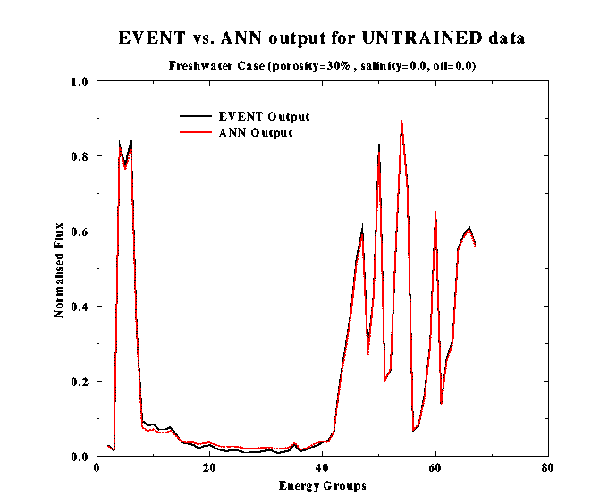  (a) | 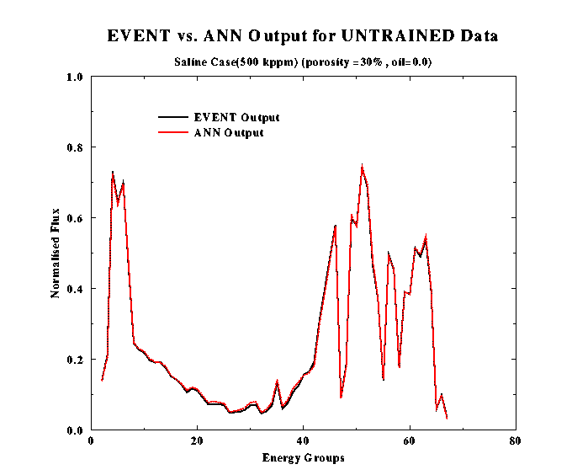  (b)

Figure 2.10. Comparison of EVENT and neural network predictions of normalised energy flux incident on the detector per channel – (a) Fresh water in the formation, (b) salt water in the formation

Table 2.VIII Test set values of porosity φ, formation water salinity S_{a} and formation oil saturation S_{O}, versus predictions derived from the inversion procedure.

 | Test Case Parameters |  |  | Inversion procedure results
Case # | φ | S_{a} (kppm) | S_{O} | φ | S_{a} (kppm) | S_{O}
1 | 0.35 | 250 | 0.15 | 0.355 | 260 | 0.16
2 | 0.20 | 150 | 0.0 | 0.20 | 160 | 0.02
3 | 0.20 | 50 | 0.0 | 0.20 | 60 | 0.02
4 | 0.25 | 150 | 0.05 | 0.255 | 160 | 0.06
5 | 0.30 | 0 | 0.1 | 0.30 | 0 | 0.1

The results shown in Figure 2.10 and Table 2.VIII are described in more detail in Refs. 39 and 40.

The next step was for ICSTM to implement the neural network approach described above to reduce the number of neutron and photon energy groups from an initial large value to a desired level. This is done automatically so as to minimize the loss of accuracy at each step. The procedure uses a neural network forward model to generate neutron and photon fluxes for each of the original energy groups incident on the near detector of a generic neutron saturation logging tool, placed in a borehole in a hydrocarbon-bearing formation. The formation and borehole parameters that can be varied are the formation porosity, formation hydrocarbon saturation and the borehole salinity. The neural networks have been trained to mimic the response of the EVENT non-stochastic radiation transport code with a high degree of accuracy and they are run for a grid of values spanning the range of formation and borehole parameters.

Next a pair of adjacent energy levels are combined or collapsed, which means that information relating to the individual fluxes in the original energy levels is lost, and they are recalculated using the combined flux, appropriately weighted according to the widths of the original energy groups (see schematic in Figure 2.11 for more details).

The final step involves running the inversion routine, using the collapsed and uncollapsed energy fluxes, and assessing the difference in the predicted formation and borehole parameters. The measure of the difference that is used is the sum of squares of the differences in the three parameters (porosity, hydrocarbon saturation and borehole salinity – suitably normalized). The largest such difference seen for the entire parameter space grid is recorded. The optimum pair of energy levels to collapse (for the N_{γ} photon and N_{n} neutron energy groups there are N_{γ} -1 and N_{n} -1 possible collapses, respectively) is the one for which this largest difference is minimized.

The entire process is repeated until the desired number of groups is reached. By monitoring how the deviation in the predicted formation and borehole parameters increases with the number of collapsing steps, the method can also be used to determine an optimal trade-off between the reduced accuracy and increased computational speed resulting from the smaller number of groups. Starting from the 47 neutron and 20 photon groups of the BUGLE-96 library, such a trade-off was reached on collapsing down to 13 neutron and 14 photon groups. The details of successive collapses are illustrated in Figure 2.12.

Having obtained a fast automated procedure for optimally subdividing nuclear data into energy groups, it was validated by running EVENT calculations for each of the merging stages and selecting the optimal pair to merge based on applying the inversion procedure to these calculations. The sequence of merged pairs obtained using this procedure can then be compared with that obtained using the neural networks The results are shown in Figure 2.13. While not completely identical, very similar merged structures are obtained, validating the neural network approach, which is orders of magnitude faster. This work has been reported in Ref. 41.

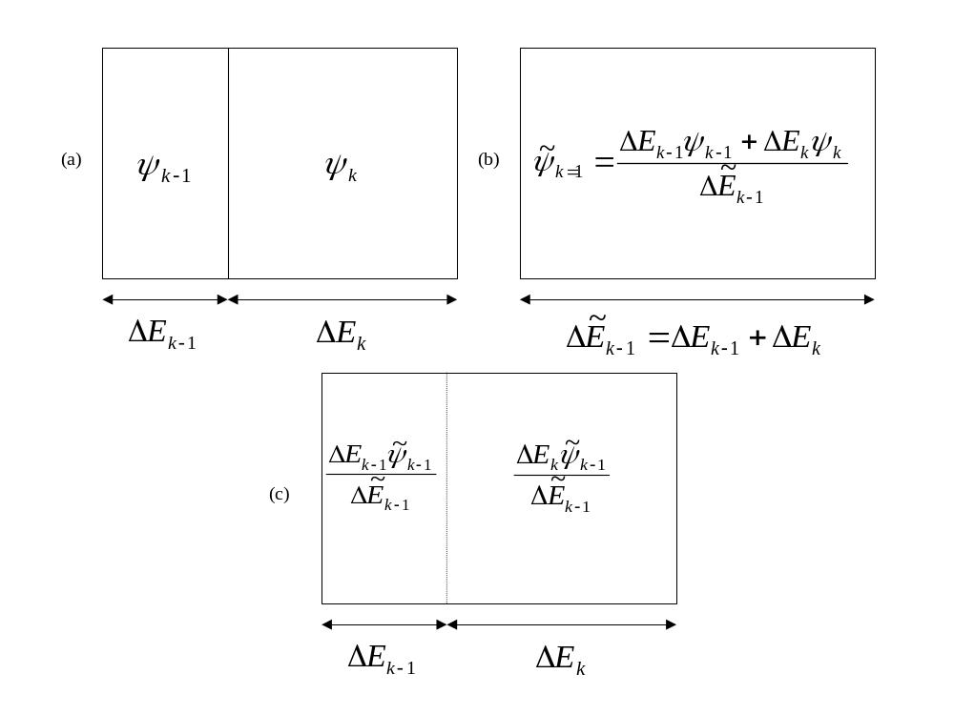
Figure 2.11. Schematic showing how the neutron or photon fluxes in adjacent energy bins are combined when the bins are merged or collapsed, and how the combined flux is partitioned into the original bins.

Task 2.3

Work on Task 2.3, which focused on accelerating the computations performed using the special purpose cross-section library described under Task 2.1, was performed mainly by IJS, with DUT and SERCO also contributing. The effect of removing the three up-scattering groups – which means that only a single iteration is needed to calculate fluxes – was investigated, as well as further reducing the number of groups to 56 neutron and 24 photon groups. The results are shown in Tables 2.IX and 2.X for centered and ex-centered tools respectively.

More details are given in Refs. 42 and 43. While removing up-scattering and collapsing the group structure hardly affects the flux counts received in the carbon and oxygen windows, and hence the carbon-oxygen ratios, significant reductions in computation time result. This is especially true for the ex-centered case, where the removal of up-scattering and the use of fewer groups yields a reduction in computation time of a factor of almost 60.

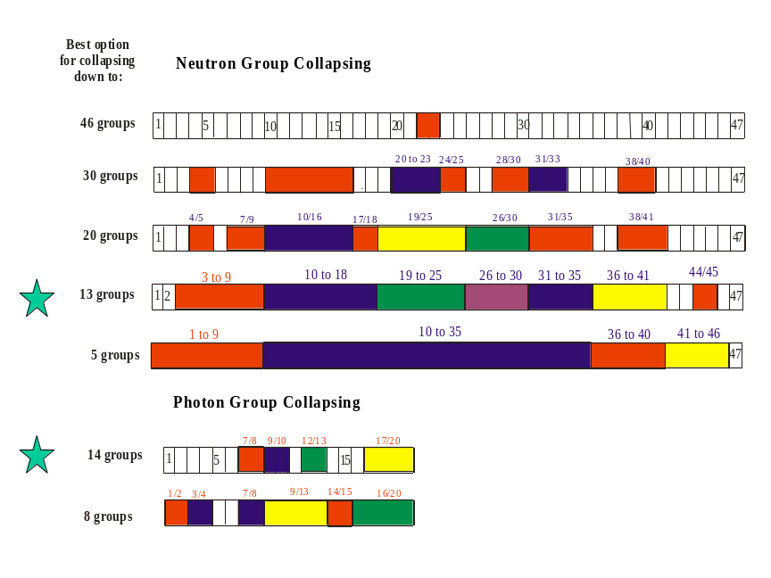

Figure 2.12. Schematic showing stages in the collapse of the 47 neutron and 20 photon groups in the BUGLE-96 nuclear data library. The green stars represent an optimum beyond which the accuracy of inversion routine shows a sharp decline.

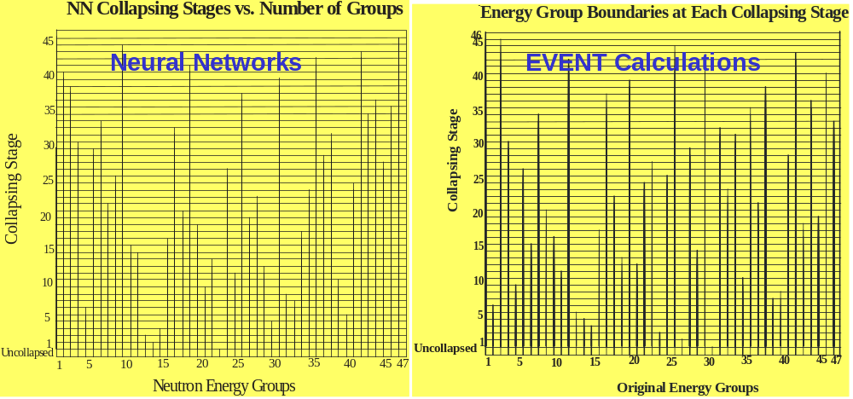
Figure 2.13. Merging of energy group structure using neural networks (left) versus EVENT radiation transport calculations (right)

The final form of the multi-group library, dedicated to nuclear bore-hole logging, contains the following nuclides: ¹H, ¹²C, ¹⁶O, ²³Na, ^{nat}Mg, ²⁷Al, ^{28,29,30}Si, ^{nat}S, ^{35,37}Cl, ^{nat}K, ^{nat}Ca, ^{54,56,57,58}Fe, ¹²⁷I and ^{nat}W. These nuclei are present in one or more components of the bore-hole environment – the formation matrix and fluids, the steel casing, the cement, the borehole fluid and the logging tool housing and internals. The above set of nuclides is appropriate for a tool with a sodium iodide detector, such as Baker-Atlas’s RPM tool [44]. The library is based on the latest release of the ENDF/B-VI.8 evaluated nuclear data files. The group structure has been adapted to the requirements of both sigma and carbon-oxygen logging, and has 175 neutron groups, including 12 groups below 12 eV and 3 upscatter groups. Of the 45 gamma groups, nine cover the energy range 3.21-7.05 MeV, encompassing the carbon and oxygen windows. All the nuclides were processed using the NJOY software [15]. To prepare the data for deterministic codes like DORT and TORT the TRANSX code [33] was used. This code can also produce the cross-sections in a reduced group structure. For a more detailed description see Ref. 45.

Table 2.IX- Photon Fluxes, Carbon-Oxygen Ratios and Computation Times for the Special Purpose Cross-Section Library with and without Up-scattering, and with a reduced Number of Groups – Axisymmetric Calculations for a Neutron Logging Tool Centered in the Borehole.
Gamma Fluxes  Detector 1  (Detector 2) | Carbon Window  3.21-4.75 MeV | Oxygen Window  4.75-7.05 MeV | Carbon-Oxygen  Ratio | CPU Time
SiO₂ formation, centered generic tool using DORT
175n/45γ groups  up-scattering | 1.6747 x 10⁻⁵  (1.7174 x 10⁻⁶) | 1.6316 x 10⁻⁵  (1.6944 x 10⁻⁶) | 1.026  (1.014) | 150 min
175n/45γ groups  no up-scattering | 1.6554 x 10⁻⁵  (1.6938 x 10⁻⁶) | 1.6130 x 10⁻⁵  (1.6704 x 10⁻⁶) | 1.026  (1.014) | 21 min
56n/24γ groups  up-scattering | 1.6667 x 10⁻⁵  (1.6998 x 10⁻⁶) | 1.6230 x 10⁻⁵  (1.6766 x 10⁻⁶) | 1.027  (1.014) | 9 min
56n/24γ groups  no up-scattering | 1.6668 x 10⁻⁵  (1.6999 x 10⁻⁶) | 1.6231 x 10⁻⁵  (1.6767 x 10⁻⁶) | 1.027  (1.014) | 7 min
CaCO₃ formation, centered generic tool using DORT
175n/45γ groups  up-scattering | 1.6854 x 10⁻⁵  (1.6294 x 10⁻⁶) | 1.5720 x 10⁻⁵  (1.5810 x 10⁻⁶) | 1.072  (1.031) | 250 min
175n/45γ groups  no up-scattering | 1.6658 x 10⁻⁵  (1.6079 x 10⁻⁶) | 1.5541 x 10⁻⁵  (1.5599 x 10⁻⁶) | 1.072  (1.031) | 21 min
56n/24γ groups  up-scattering | 1.6763 x 10⁻⁵  (1.6131 x 10⁻⁶) | 1.5630 x 10⁻⁵  (1.5643 x 10⁻⁶) | 1.072  (1.031) | 9 min
56n/24γ groups  no up-scattering | 1.6763 x 10⁻⁵  (1.6131 x 10⁻⁶) | 1.5631 x 10⁻⁵  (1.5643 x 10⁻⁶) | 1.072  (1.031) | 7 min

Another code, CRSRD [46] was used to prepare the data for use with the Monte Carlo code MCNP. In addition, a library format conversion to allow the library to be used with SERCO’s MCBEND [47, 48] code was implemented. Photon fluxes received by the detectors in the carbon and oxygen windows, and the carbon-oxygen ratio, were compared for a centred generic tool using DORT, multigroup MCNP, multigroup MCBEND and pointwise MCNP. Sandstone and limestone formations with 19% porosity and fresh water, brine or oil as the formation fluid were treated. The results for the carbon-oxygen ratio obtained at the near detector are shown in Figures 2.14.
Table 2.X - Photon Fluxes, Carbon-Oxygen Ratios and Computation Times for the Special Purpose Cross-Section Library with and without Up-scattering, and with a reduced Number of Groups – Three-Dimensional Calculations for an Ex-Centered Neutron Logging Tool.
Gamma Fluxes  Detector 1  (Detector 2) | Carbon Window  3.21-4.75 MeV | Oxygen Window  4.75-7.05 MeV | Carbon-Oxygen  Ratio | CPU Time
SiO₂ formation, ex-centered generic tool using TORT
175n/45γ groups  up-scattering | 1.5688 x 10⁻⁵  (1.4959 x 10⁻⁶) | 1.5097 x 10⁻⁵  (1.4598 x 10⁻⁶) | 1.039  (1.025) | 81 hr
175n/45γ groups  no up-scattering | 1.5684 x 10⁻⁵  (1.4904 x 10⁻⁶) | 1.5102 x 10⁻⁵  (1.4551 x 10⁻⁶) | 1.039  (1.024) | 5 hr
56n/24γ groups  no up-scattering | 1.5794 x 10⁻⁵  (1.4938 x 10⁻⁶) | 1.5190 x 10⁻⁵  (1.4578 x 10⁻⁶) | 1.040  (1.025) | 83 min

To treat an eccentrically located tool, TORT [24] was used, with the circular borehole cross-section being approximated by a series of staggered rectangles in the Cartesian mesh required to use TORT. The BOT-3P pre-processor [49] was used to prepare the geometry, with several degrees of approximation being studied before settling on the grid depicted in Figure 2.15. A comparison of the TORT results for the carbon-oxygen ratio with multigroup MCNP and multigroup MCBEND is shown in Figure 2.16. More detailed results, including fluxes, are given in Ref. 50.
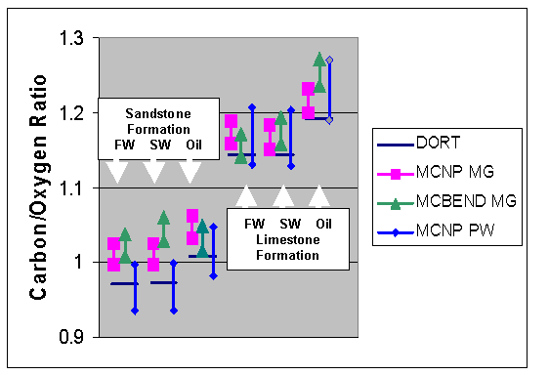
Figure 2.14. Comparison of the carbon-oxygen ratio calculated at the near detector using various codes for a centred generic tool. The codes used are DORT, MCNP MG (Multigroup MCNP) and MCBEND MG (Multigroup MCBEND), all with appropriately formatted versions of the new multigroup library dedicated to the borehole environment. The results of a pointwise (PW) calculation using MCNP are also shown. The computations were carried out for sandstone and limestone with 19% porosity and with fresh water (FW), salt water (SW – 150 g/L NaCl) and oil as the formation fluids.The spread in values for the Monte-Carlo calculations reflect the statistical error bar.

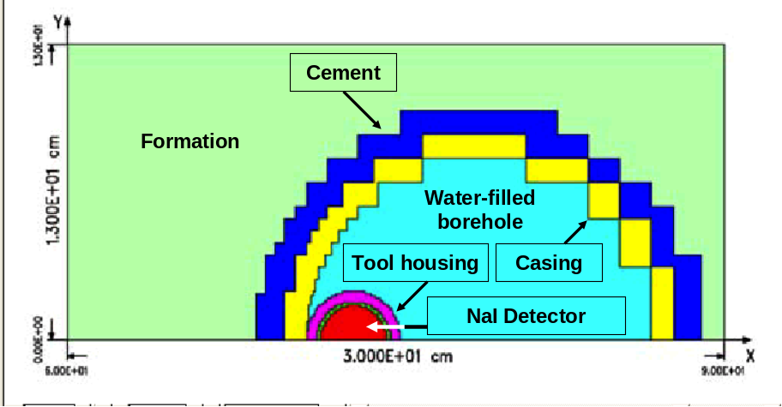

Figure 2.15 Mesh used to grid the eccentric generic tool geometry for TORT. The different colours correspond to different borehole components which are labelled in the diagram.

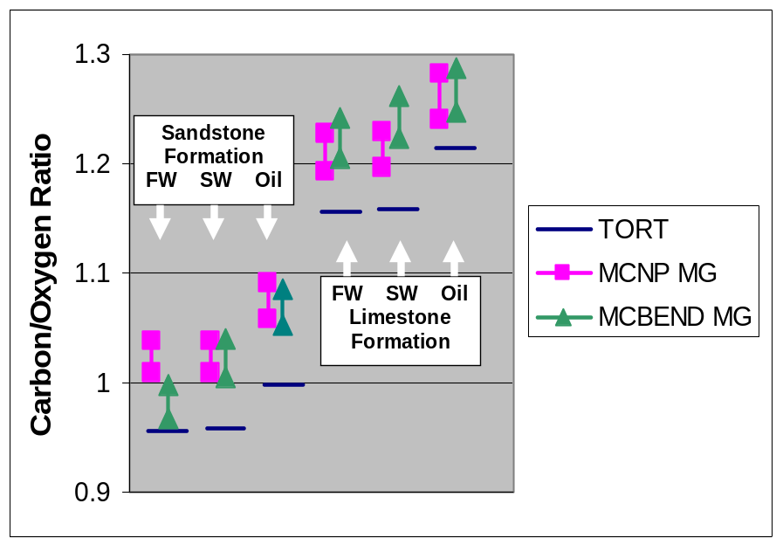

Figure 2.16 Comparison of the carbon-oxygen ratio calculated at the near detector using various codes for the eccentric generic too depicted in Figure 2.14. See caption to Figure 2.13 for details of the codes used and cases run.

2.2.3 Results Obtained on Faster Algorithms for Stochastic Radiation Transport Modelling

The development of faster algorithms for stochastic radiation transport modelling of neutron logging tools constitutes Scientific Objective B in Section 2.1.3. The work plan for achieving this forms Work Package 3, which is described in detail in Table 2.XI.

Table 2XI. Detailed Description of Work Package 3
WORK PACKAGE NUMBER 3
Objectives
Extend hybrid forward/adjoint schemes, already developed for stochastic radiation transport modelling of systems with steady sources, to the non-steady case. Write routines to implement the extended schemes into the standard stochastic radiation transport modelling codes MCBEND and MCNP.

Description of work
Task 3.1 Extend the existing MIDWAY method incrementally to time dependent sources and more complex geometries.
Task 3.2 Implement extended MIDWAY, via FORTRAN routines, into the stochastic radiation transport modelling codes MCBEND and MCNP.
Task 3.3 Test speed-up and accuracy of extended MIDWAY by benchmarking with respect to non-optimised MCBEND and MCNP.

Deliverables
D3.1 Report and publication on the work performed in Task 3.1
D3.2 Delivery of benchmarked stochastic radiation transport modelling codes incorporating extended MIDWAY.
Milestones and expected results
Extension of existing method to speed up stochastic radiation transport modelling codes in non-steady cases.

Task 3.1

The work carried out on this work package was largely performed by DUT. In addition, SERCO provided DUT with an MCBEND licence and meetings were held in order for SERCO to explain the structure of the code.

The MIDWAY method [51] is a general variance reduction technique for stochastic shielding (source-detector) calculations. The MIDWAY method combines an adjoint and a forward Monte Carlo simulation and couples the results to calculate the detector response, resulting in a much higher efficiency of the simulation. It was developed and implemented within MCNP several years ago by DUT. In a shielding calculation, the aim is to calculate a response which is a convolution of a flux characterizing the transported radiation with a detector response function. It has been known for a long time that the same response can also be calculated using a convolution of a source response function with the adjoint flux, and that, in a Monte Carlo calculation, the latter procedure is much more efficient for an extended source and localized detector. The theory behind MIDWAY is that this response can also be computed using the product of the flux and its adjoint and integrating over all phases, energies and directions, on a closed surface enclosing the detector and not the source (or vice-versa). Such a procedure, implemented stochastically, enables significant gains in the efficiency of the calculation when both the source and detector are localized.

Prior to the commencement of this project, MIDWAY was implemented into MCNP-4A, and later on into a subsequent version MCNP-4B2. The most challenging feature of the implementation is the requirement to segment the phase space on the surface and is complicated by the fact that, in MCNP, only a multigroup capability exists for the adjoint flux. In addition, the implementation was limited to steady-state radiation transport calculations. For a time dependent application, the integration over the MIDWAY surface includes a convolution over time, that is, to obtain the response at time t, the flux at time t/ and adjoint flux at time t – t/ is integrated over the surface, and then a time integration over t/ is performed. Since the adjoint flux at time t – t/ is readily obtained from a knowledge of the adjoint flux at all times, we see that only a single simulation to obtain the forward and adjoint fluxes is required.

The first attempt to implement time-dependent MIDWAY was by modifying the existing steady-state implementation, using time binning along with spatial segmentation. The time dependent feature of the surface tally increases the memory requirement dramatically, limiting applicability. Once the contributions to the flux and its adjoint were obtained for each phase-space segment and time bin, they were coupled to obtain the time-dependent response in an external program.

A generic nuclear logging tool comprising a source, near detector and far detector mounted centrally in a cased borehole was used to compare the new MIDWAY implementation with an unoptimised MCNP simulation. To compute the near detector response, the MIDWAY surface was chosen to be a plane situated between the neutron source and detector. For the far detector response, it was situated just below the far detector shielding. A comparison between the MCNP-MIDWAY and MCNP results for the total gamma response received at the near detector is shown in Figure 2.17a. The results are good, except at small times where there is a systematic discrepancy. The improvement in efficiency resulting from using MIDWAY varies with time bin, but, roughly speaking, is between 10 and 20. For the far detector, it is around 40, increasing to 100 at the largest times. The efficiency is gain is computed by taking the ratio of the figures of merit (FOMs) for the MIDWAY and forward runs, the figure of merit being a ratio of statistical accuracy to computational run time. An illustration of the gain achieved for the far detector is shown in Figure 2.18, in which the size of the error bars shows the statistical accuracy for the forward and MIDWAY calculations. More details are provided in Ref. 52.

A second implementation of MIDWAY was then carried out that was virtually independent of the MCNP architecture. This method writes particle track files created by MCNP to disk during one of the runs, bins them in an external program, and couples the binned data with the directly scored fluxes obtained from the second run. In this case, the segmentation specification for the MIDWAY surface does not have to be entered into the MCNP input deck, and can be freely chosen. Furthermore, the memory allocation to store the scores is set at a time when the particle transport code is not active. This is offset by the need to write large amounts of data to disk. Results for the near detector response, comparing this implementation of MIDWAY with un-optimised MCNP, is shown in Figure 2.17b. We see that the discrepancy seen in Figure 2.17a has disappeared, presumably because of a more appropriate segmentation of the MIDWAY surface.

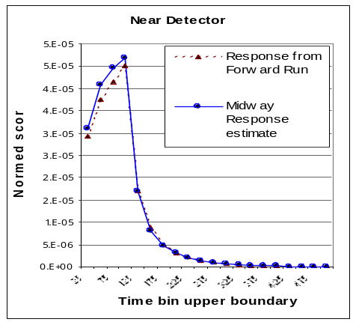 | 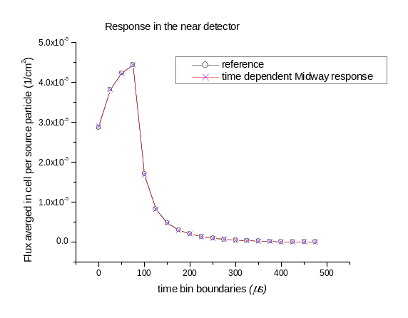
(a) (b)

Figure 2.17. Comparison of Un-optimised MCNP Simulations against MIDWAY runs for Total Gamma Response at the Near Detector. (a) – 1st Implementation of MIDWAY, (b) – 2nd Implementation of MIDWAY.

The next stage of the work carried out by DUT under Task 3.1 focused on combining MIDWAY with standard variance reduction techniques to obtain further speed-up, and on how to incorporate the detailed detector response within the MIDWAY framework. Progress was also made on developing a continuous energy forward-adjoint algorithm coupling for MIDWAY (the current implementation requires energies to be grouped into bins) – see Ref. 53.

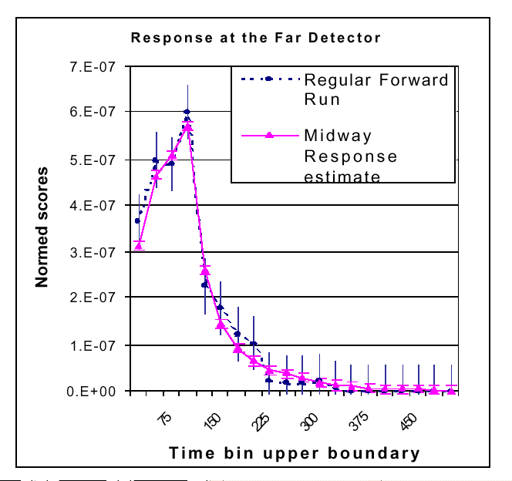

Figure 2.18. The far detector response computed using un-optimised MCNP (regular forward run) and MCNP with MIDWAY. Note increase in precision on using MIDWAY.

One of the standard techniques for variance reduction is the use of weight windows, which can be optimized with respect to time or energy. For a forward run using MCNP, the greatest improvement in the figure of merit (FOM - ratio of statistical accuracy to computation time) resulted when the optimization was performed with respect to energy – optimization with respect to time not yielding a significant improvement. On combining this optimization technique with the MIDWAY method, the extra computational effort involved actually resulted in a decrease in the FOM with respect to pure MIDWAY – however a simplification of the calculation in which angular binning of the adjoint and forward flux estimates on the MIDWAY plane was omitted, and the resulting simplified response functions were used for the iteration of the weight window generator for the next run, resulted, for weight windows optimized with respect to energy, in a doubling of the FOM over the pure MIDWAY calculation (see Figure 2.19)

As a further incremental extension of extended MIDWAY, the problem of how to incorporate the detector response into a MIDWAY formulation was addressed. This is related to the energy deposited in the detector crystal, and is not simply equivalent to the photon flux incident on the detector volume, as illustrated in the schematic shown in Figure 2.20.

The carbon-oxygen ratios determined from the flux incident on the detector and the energy deposited in it are quite different, as shown in Figure 2.21. The problem of finding an adjoint Monte Carlo solution for the pulse height tally, the measure relating to the energy deposited in the crystal, was solved in a simplified case and was demonstrated to give the same pulse height distribution as a forward calculation for a spherical source and spherical sodium iodide detector.

Finally, some preliminary work was done on the use of multiple MIDWAY surfaces. It was shown that for a medium that is optically thick to the radiation transport, efficiency improvements of 10-15 over using a single MIDWAY surface could result [54].

Considerable effort was expended under Task 3.1 in improving the segmentation needed at the MIDWAY surface to calculate the convolution of the forward and adjoint fluxes. A large number of segments increases accuracy but also increases statistical error for a finite number of samples. DUT’s practice to date for the time-dependent MCNP calculations using MIDWAY has been to use about 10⁷ bins and about the same number of particles, yielding a poor MIDWAY response, especially at large times. Tests were carried out using larger numbers of particles than bins and the use of Legendre polynomials, with samples contributing to coefficients in expansions of the forward and adjoint fluxes, identified as a promising alternative to segmenting the convolution directly [54]. However, the efficiency of the calculation decreases rapidly on increasing the number of Legendre coefficients used.

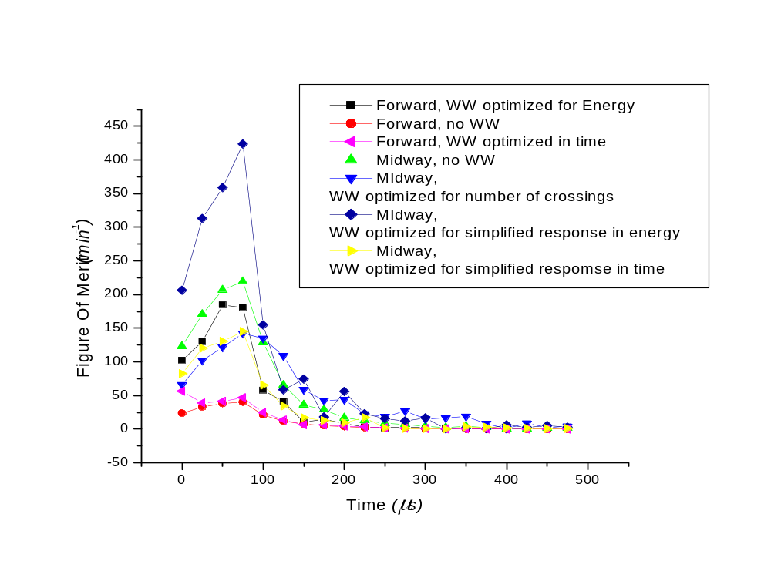

Figure 2.19. Comparison of forward and forward-adjoint (MIDWAY) computations with and without weight windows applied in various ways. The best results are obtained using MIDWAY in conjunction with weight windows optimized according to a simplified response in energy.

Task 3.2

Task 3.2 is concerned with the implementation of extended MIDWAY into the stochastic radiation transport modelling codes MCBEND and MCNP. Extending the technique incrementally, which formed Task 3.1, involved the use of MCNP, so there is some overlap between the present task and the previous one in the work package. The MIDWAY acceleration method currently requires nuclear data to be formatted into groups and DUT used the group structure selected by IJS and converted it the format required by the Monte-Carlo codes MCNP and MCBEND – see Ref. 50 Virtually identical results for the neutron flux at the near detector were obtained for the two codes, as shown in Figure 2.22.

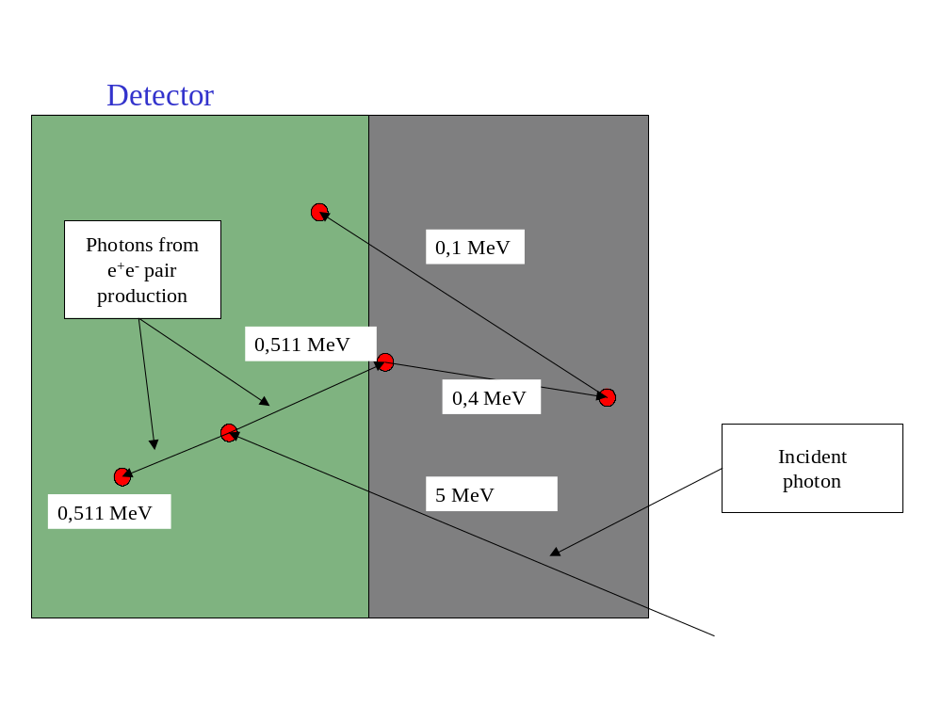

Figure 2.20. Schematic showing how electron-positron pair creation and annihilation can result in only part of the energy of an incident photon being deposited in the detector crystal.

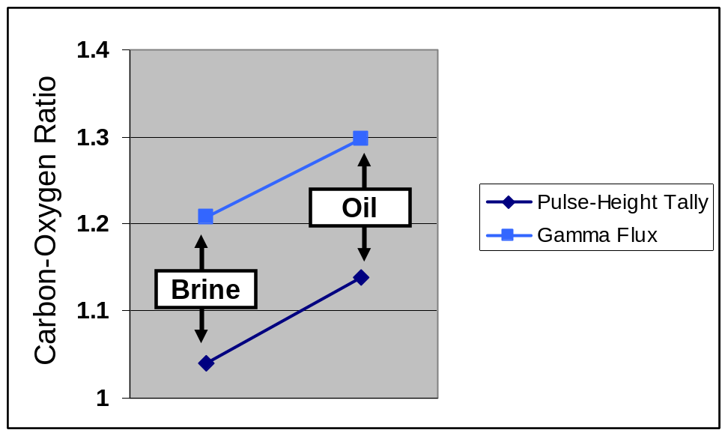
Figure 2.21. Comparison of carbon-oxygen ratios computed using the gamma flux incident on the detector and the energy deposited in it (the pulse-height tally).Results are shown for a brine-filled and an oil-filled formation

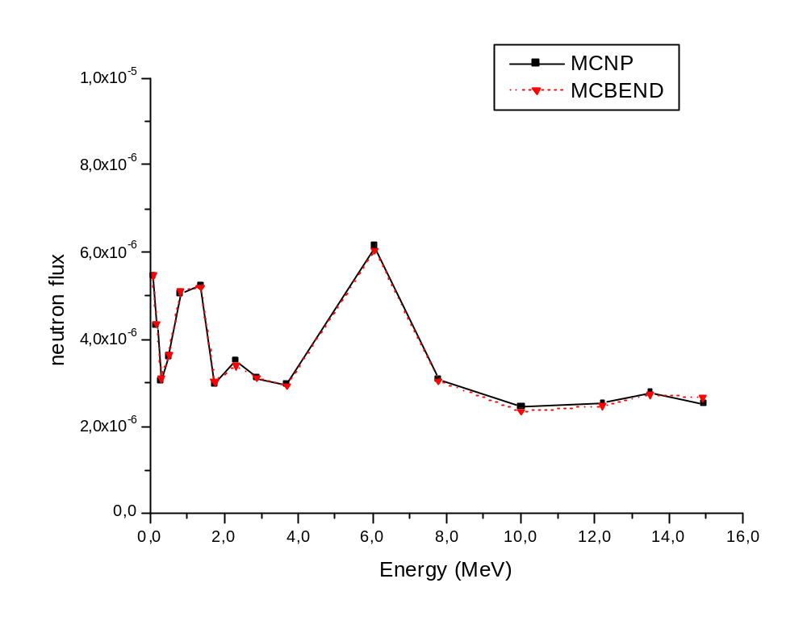
Figure 2.22. Comparison of neutron fluxes at the near detector on using IJS energy group structure formatted for MCNP and MCBEND.

The importance map calculation in MCBEND, which determines the expected contribution to the score in the detector, and can be used to remove the particle if the expectation is below a certain threshold, or divide it into multiples for more accurate scoring if it is high (a technique known as Russian Roulette and splitting), was converted to MCNP format so that it could be applied to the MCNP calculation. This resulted in the figure of merit (FOM) increasing by a factor of 7.4 over the un-optimised calculation compared with 8.4 when the importance map calculation available in MCNP was used. (The figure of merit is a measure of the tradeoff between accuracy and computational speed).

The implementation of time-dependent MIDWAY in MCNP was finalized by the end of the project and DUT, together with SERCO, made significant progress in the implementation of MIDWAY into MCBEND.

This implementation involved a number of developments of the MCBEND code, which were tested in a sequence of tests on a notional well logging problem. For evaluation and optimization of the MIDWAY implementation, MCBEND-MIDWAY was installed on a PC at Delft University.

The final implementation of the MIDWAY method in MCNP involves no changes to MCNP, but uses a stand-alone coupling program to process track files recording all crossings of particles with the MIDWAY surface. Three MCNP runs are performed – a forward calculation and two adjoint calculations, one for each detector. The Legendre coupling approach identified during the previous period is now working correctly for the general borehole logging problem, and is available, together
with the segmentation method, as an option to the coupling program. Figure 2.23 shows an example calculation for the photon fluxes received at the near and far detectors following a neutron burst in which MCNP with MIDWAY applied is compared with unoptimised MCNP.

After SERCO implemented the MIDWAY method in MCBEND, and after some initial problems encountered on using the coupling program with MCBEND which were solved with SERCO’s help, DUT were able to run a neutron-gamma coupled problem in MCBEND-MIDWAY.

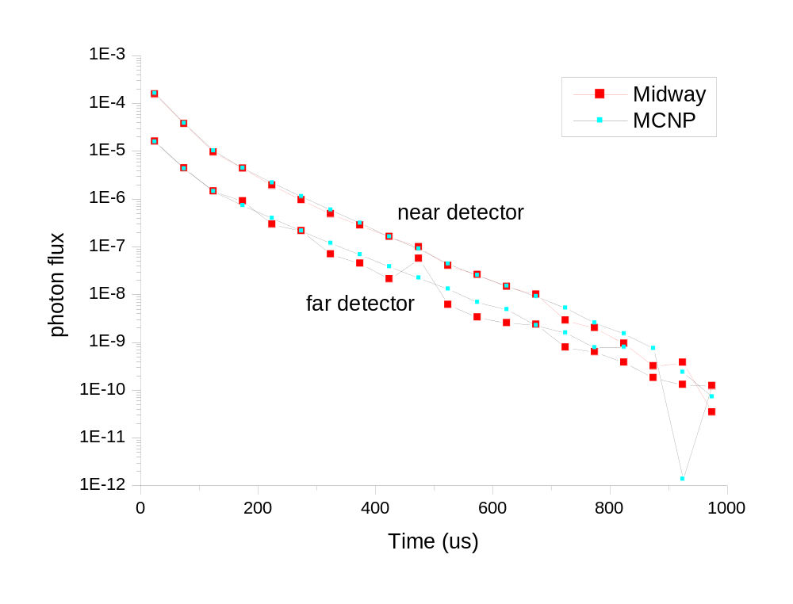
Figure 2.23. Photon flux versus time received at the near and far detector of a generic nuclear logging tool. Comparison of MCNP-MIDWAY against un-optimized MCNP.

Task 3.3

Task 3.3 is to test the speed-up and accuracy of extended MIDWAY by benchmarking with respect to non-optimised radiation transport modelling codes. This was accomplished in the process of carrying out Tasks 3.1 and 3.2 and is reported above.

2.2.4 Progress in the Development of a Nuclear Data Library Supplement for the Borehole
Environment

Detailed reporting of the development of the nuclear data library supplement is contained in Section 2.2.2. To summarise here:

Concerning point-wise (non-grouped) cross-section data, this includes new evaluations of the formation element calcium, comprising the isotopes ^{40,42,43,46,48}Ca, and the detector elements germanium (^{70,72,73,74,76}Ge) and bismuth (²⁰⁹Bi). The new evaluation for calcium, which was performed using the TALYS [19] software, also incorporates resonance parameters from JENDL-3.3 and total and capture cross-sections from ENDF/B-VI.8. For the remaining primary formation elements, carbon, oxygen, chlorine and silicon, the best existing evaluations were selected. Validation of this special-purpose data library using the response of a real tool yielded good results and is reported in Ref. 11.

For multi-group formatted nuclear data, dedicated to the borehole environment, formatting was carried out for nuclei present in the formation, cement, casing and bore hole. This encompasses the following nuclides: ¹H, ¹²C, ¹⁶O, ²³Na, ^{nat}Mg, ²⁷Al, ^{28,29,30}Si, ^{nat}S, ^{35,37}Cl, ^{nat}K, ^{nat}Ca, ^{54,56,57,58}Fe, ¹²⁷I and ^{nat}W. Processing was carried out using NJOY [5] and the group structure chosen to match the requirements of both sigma and carbon-oxygen logging.

2.2.5 Progress in the Development of an Enhanced Modelling Tool for Neutron Saturation Logs

The development of an enhanced modelling tool for neutron saturation log interpretation forms Technical Objective 2 in Section 2.1.3. The work programme designed to achieve this is contained in Work Package 4, which is described in detail in Table 2.XII.

Task 4.1

SERCO was the lead implementer for this work package, and worked closely with ICSTM and DUT for the EVENT and MIDWAY implementations of the front end. As reported under Task 3.2, modifications were made to MCBEND to allow it to be run using the MIDWAY speed-up algorithm and these have been tested. These modifications affect the MCBEND program itself and not the GUI. Changes have been made to the GUI in order to facilitate the running of the code on a remote host using the GUI. In particular, the process and results manager are now separate programs and will sit on the remote host together with the main program. This overcomes the limitations of the current original set up in which the disks of the local and remote hosts are assumed to be shared (as is usually the case for compatible UNIX systems belonging to the same network). Schematics comparing the original set up for running MCBEND on a remote host with the revised one are shown in Figures 2.24 a & b.

Table 2.XII. Detailed Description of Work Package 4
WORK PACKAGE NUMBER 4
Objectives
Build graphical user interfaces to speeded-up stochastic and non-stochastic codes to serve as a front end for a suite of new neutron log interpretation software.

Description of work
Task 4.1 Extend existing 'PUNDIT' graphical user interface for MCBEND to include MCBEND with MIDWAY
speed-up
Task 4.2 Build PUNDIT-based graphical user interfaces for MCNP and EVENT.
Deliverables
D4.1 Incrementally unroll graphical user interface for fast Monte-Carlo and non-
stochastic codes.
D4.2 Delivery of fast well-head interpretation system with graphical user interface.
Milestones and expected results
Wrap-up of scientific and technical milestones into user-friendly interpretation software package to locate oil behind casing.

In addition the PUNDIT GUI was ported to Windows PC (from UNIX) and exhibits full functionality on Windows 2000 and Windows NT.

Task 4.2

Turning now to Task 4.2, which is to build front-end graphical user interfaces for MCNP and EVENT, we report first on the incorporation of EVENT into the Front End. The GEM program serves as both input and run interface and PLOTTER is the visualisation interface. The schematic for running EVENT remotely using the GUI is shown in Figure 2.25.

When running the radiation transport model on a remote host, the GUI on the local host
communicates with the process and results managers using Sockets (analogous to UNIX
pipes), implemented in TclTK, which means that no assumptions are made about the operating systems of the local and host computers. A beta version of the PUNDIT-EVENT interface was installed at Imperial College.

Further developments are that the PUNDIT GUI has been rewritten so that it is object oriented – the need for this became clear during the course of the project. Modifications to the materials library available to PUNDIT have also been made – this library comprised segments of MCBEND input data and is now stored in a generic way, allowing conversion to a format accessible to the radiation transport model being used. PUNDIT also now scans a “Tools” directory for subdirectories that will eventually house files containing vendor tool specifications.

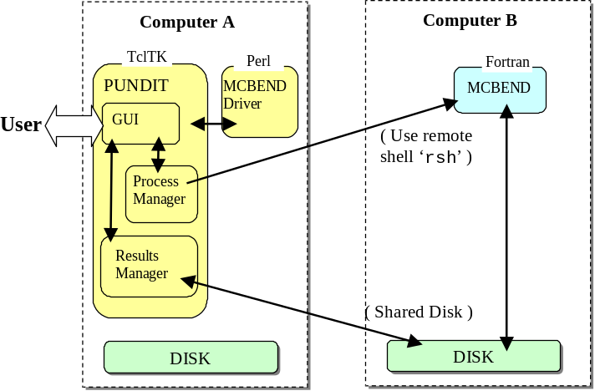

(a)

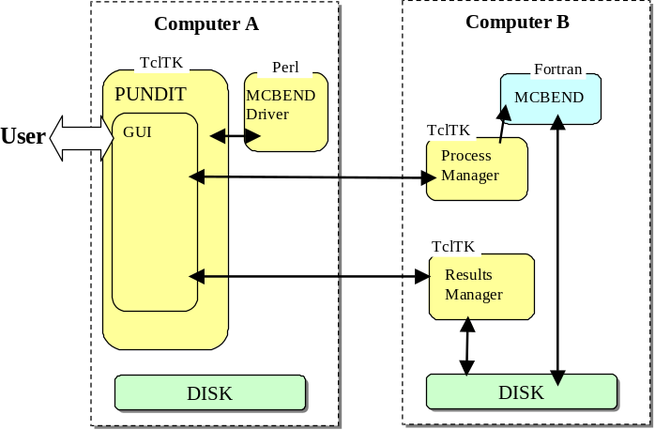
(b)

Figure 2.24. Comparison of (a) old scheme of running MCBEND on a remote host using PUNDIT with (b) new scheme, which does not require the remote and local hosts to share a disk.

Looking to the future, the changes made to PUNDIT make it suitable for use within a secure company network.

SERCO has implemented a generic pulsed neutron logging tool into PUNDIT for testing purposes, and MCBEND templates have been created for capture (sigma) and carbon-oxygen logging modes.

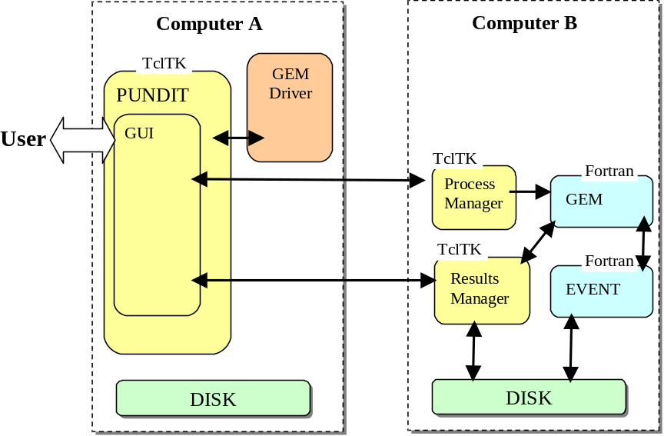

Figure 2.25. Schematic for running EVENT remotely using the PUNDIT GUI.

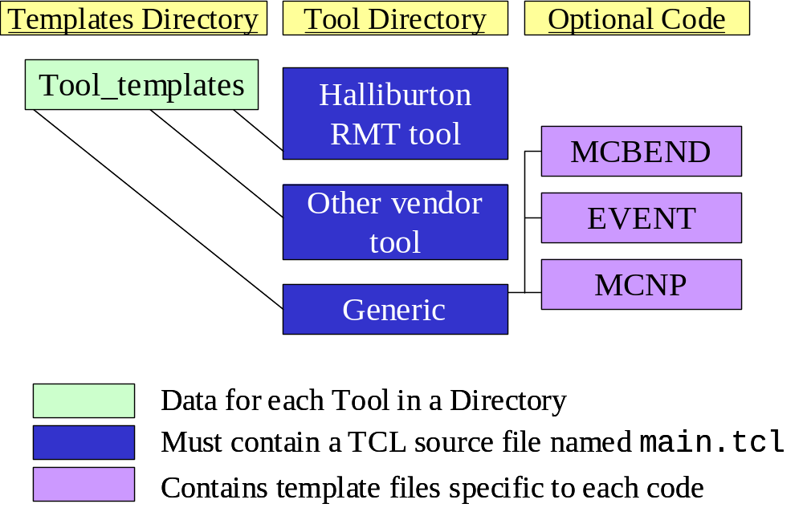
Figure 2.26. Schematic illustrating link between tool templates, radiation transport modeling codes and GUI processing.

A number of issues have been addressed concerning the incorporation of vendor tool models into PUNDIT. The original program created MCBEND input data by parsing template files substituting numbers directly from the PUNDIT database. The fact that PUNDIT now has to access multiple tool models with different set of parameters and different GUI requirements and has to create input data for different target codes renders this approach unsuitable. Instead, each logging tool added to pundit will be provided with a customized piece of source code to provide GUI processing, create input data and extract results from the output data. This code will be dynamically loaded when PUNDIT starts, obviating the need to modify the PUNDIT program whenever a new tool is added. The relationship between the tool templates, radiation transport modelling and the GUI processing is illustrated in Figure 2.26.

Another issue is that vendor tool models are proprietary, so there is a need for some sort of encryption of the tool models to keep them secure. MCBEND has a secure geometry option that stores sections of the input in encrypted binary files that are decoded and merged with unencrypted input data when the calculation executes, and from which output is suppressed. While it would be desirable to have such a feature in MCNP and EVENT, implementation would be a fairly considerable task requiring expertise in the target source code. An easier option would be to create an additional subroutine that unscrambles the encrypted data prior to passing them to the standard reading routines of the target code, suppressing output in the process.

At the end of the project, EVENT input, run and output interfaces to the PUNDIT GUI were complete. For MCNP including MIDWAY, input and run interfaces are partially complete, while the output interface was not completed. MCBEND input, run and output interfaces to PUNDIT are all complete, but MCBEND with MIDWAY has not been incorporated into the new GUI. The term “partially complete” means that there are currently some restrictions associated with the use of the interfaces. For example, the MCNP input interface does not currently allow cases with tubing to be set up, while there are some problems involving adjoint cases with the run interface.

2.2.6 Progress on the Remainder of the Work Plan

The remainder of the work plan shown in Table 2.I, not covered in sub-sections 2.2.2-2.2.5, is contained in Work Packages 5 and 6. Work Package 6 concerns management and exploitation, which is dealt with in Chapter 3 of this report. A detailed description of the elements of the Work Package 5 is given in Table 2.XIII. It concerns experimental validation of the improvements in nuclear data and modelling software obtained in work packages 1-4, as well as the formulation of a field testing plan of these improvements, as rolled up in the new front-end integrator developed in work package 4.

Task 5.1

The aim of Task 5.1 was to obtain a set of test-pit data for a nuclear production logging tool or tools, which could be used to validate the improvements in nuclear data and modelling software developed under Worksets 1-4 of the IRTMBA project. It was originally envisaged that a set of publicly available test pits owned by the University of Leicester and located at Reeves Wireline’s facility at East Leake [56] would be used to obtain the data, but though formations of different types and porosities were available, the choice of bore-hole fluid was limited to fresh water or air. This is because the test pits are comprised of large blocks, saturated with fresh water, and with holes drilled through them to emulate a borehole, and are stacked in such a way that the holes in the blocks do not align. This precludes the use of a sleeve to prevent an alternative borehole fluid, such as oil or brine (saline water), from entering the formations. The use of the American Petroleum Institute test pits at the University of Houston was considered next – the blocks are aligned allowing the use of sleeves and a variety of borehole fluids. However, only one of

Table 2XIII. Detailed Description of Work Package 5
Objectives
Obtain a set of experimental results in which neutron production logging tools are run in a so-called test-pit - an artificial bore-hole in a well characterised formation containing fluids of known composition in the bore-hole and in the formation. Formulate a field testing programme for the integrated nuclear log interpretation software package.

Description of work
Task 5.1 Carry out experiments, using neutron production logging tools widely applied in the field, in a well-controlled test-pit environment. The experiments will gather both C/O and sigma logging measurements and will be run with various relevant fluid combinations (oil, fresh water and salt water) in the formation and bore-hole. The lithologies treated will be a 17.5% porosity sandstone and a 25% porosity limestone.
Task 5.2 Formulate a field testing programme for the integrated nuclear log interpretation package developed in D4.2

Deliverables
D5.1 Report and publication detailing test-pit results, comparing them with model results obtained by applying the integrated nuclear log interpretation package delivered in Workset 4.
D5.2 Report recommending a field trial programme for application of the new package.
Milestones and expected results
Validation of the integrated nuclear log interpretation package against test-pit data and field testing.

the two pits is available for neutron logging tools (the other is reserved for gamma logging tools), and the formation is limited to a fresh-water saturated limestone. Three limestone layers with differing porosities are available.

Since validation of the work carried out in Worksets 1-4 requires a model, suitable for radiation transport calculations, of a vendor tool, it was decided to request test-pit data as well as tool models from neutron saturation logging tool vendors. A selection of cases studied at Halliburton and Schlumberger’s test pit facilities is shown in Table 2.XIV.

Table 2.XIV: Test-pit data gathered by tool vendors Schlumberger and Halliburton for nuclear tool
characterisation.
Schlumberger:
Hole Size (in) | Lithology-Porosity(%) | Formation Fluid  (salinity kppm NaCl) | Borehole Fluid  (salinity kppm NaCl)
6, 8, 10 | S: 15-20%, 33%  L,D: 0%, 15-20%, | 0, 70, 140, 210 | 0, 25, 50, 100, 200, Air
12 | S: 15-20%, 33%  L: 0%, 15-20%, 38-43% | 0, 70, 140, 210
Halliburton:
Hole Size (in) | Lithology-Porosity(%) | Formation Fluid  (salinity kppm NaCl) | Borehole Fluid  (salinity kppm NaCl)
6, 10 | L: 2%, 12%, 26% |  | FW, SW, Oil
6, 10, 14 | S: 35% | 0 | FW, SW, Oil
6, 10, 14 | S: 36% | Oil | FW, SW, Oil
6, 10, 14 | S: 42% | 150 | FW, SW, Oil
L = limestone, S = sandstone, D = dolomite, FW = fresh water, SW = salt water

Inspection of Table 2.XIV shows that the experiments span a wide range of conditions, including a variety of bore-hole sizes (both the Callisto and API test pits are restricted to a single borehole size – 8 ½ inches). Halliburton provided the IRTMBA consortium with a model of their tool and with test pit data at the beginning of the third year of the IRTMBA project. Although acquired later in the life of the project than originally planned, the model and accompanying data allowed Task 5.1 to be completed before the end of the project.

Task 5.2

During the last year of the project, discussions were held with members of SIEP’s petrophysical community about field testing of the new capabilities incorporated in the nuclear logging interpretation package that is the main deliverable of the IRTMBA project. The capabilities that have been developed to date are the improved nuclear data library supplement, dedicated to the borehole environment, incorporating both new cross-section evaluations and multigroup formats, a user-friendly front-end, currently featuring a generic tool, for running a variety of radiation transport codes, and methodologies for carrying out both Monte-Carlo and deterministic calculations faster without loss of accuracy. As principal end-user, SIEP can make use of these capabilities in a number of ways in the context of a field test.
For sensitivity analyses, to address whether running nuclear saturation logs is worthwhile, the generic model as implemented in the front-end integrator may be used. To treat vendor tools for which Shell has contracted out wireline services (currently either Schlumberger or Baker-Atlas, depending on geographic region), the tool model needs to be made available for incorporation into the front-end integrator. Incorporation of the tool model could be done by the IRTMBA project participants, subject to appropriate agreements. An alternative could be to make the front-end
integrator available to the vendor, allowing vendor staff to incorporate the tool model and run the software themselves. The latter option would not require the vendor to reveal details of their proprietary tool model.

In addition to cased-hole saturation logging in existing wells in mature fields for reservoir management purposes, a relatively new area that is becoming ripe for the application of the technology developed in the IRTMBA project is focused around the desire to perform fluid saturation logs in new wells that have been drilled using casing. This technique is being used in a number of specific geographical areas and potential applications of the IRTMBA technology in these areas are being investigated.

2.3. Assessment of Results and Conclusions
The results delivered at the end of the IRTMBA project, in view of the challenging work programme, were fully in accord with expectations. Highlights of these results include the following:
(1). The demonstration that the differences in nuclear data for calcium nuclides, rather than carbon or oxygen nuclides as had been anticipated, are responsible for the greatest spread in the values of the carbon-oxygen ratio, leading to the conclusion that calcium nuclides were the ones that should be selected for a new evaluation.
(2). The validation that the improved nuclear data, including new evaluations for detector elements as well as the new evaluation for calcium nuclides referred to above, yields much better predictions for detector response for an actual neutron saturation logging tool than when un-optimised data, from standard nuclear data libraries, is used.
(3). The demonstration that, with judicious choice of where they should be concentrated, the number of photon and neutron energy groups in group-formatted data can be reduced so that computation times are significantly shortened, while retaining accuracy in computing parameters that are important for the interpretation of neutron saturation logs, such as the carbon-oxygen ratio.
(4). Delivery of an automated algorithm, based on neural network technology, for performing optimal energy-group reduction for group-formatted nuclear data.
(5). The demonstration of the extension of the previously existing MIDWAY method for improving the ratio of precision to computation time for stochastic radiation transport codes, to time-dependent radiation problems in general and to neutron saturation logs in particular.
(6). The delivery of a front-end that can accommodate new nuclear data and software developed as part of the IRTMBA project, as well as vendor tool models and radiation transport codes, in a way suitable for operations when extensive computer power is not available locally.
As well as direct application of the above in the interpretation of neutron saturation logs, many spin-offs and extensions of the items in points (1)-(6) above are envisaged. Full realisation of the potential of these developments will only take place if the work is effectively disseminated. This process is well under way.

2.4. Acknowledgements
The IRTMBA consortium would like to thank Halliburton, especially Larry Jacobson and Andrew Green, and Gary Simpson and Larry Gadeken, formerly of Halliburton, for their interest in the IRTMBA project and supplying the tool model and data used to validate some of the technologies developed during the course of the project.

2.5. References

Note – References in bold italics indicate that the work was carried out under the auspices of EU sponsorship for the present project

- Aulia, K. et al., 2001, Resistivity Behind Casing. Schlumberger Oilfield Review, Spring 2001, pp 2-25.
- Rabson, W.R., 1959, Chlorine Detection by the Spectral Log. Petroleum Engineer 31, No. 3, B102-B111.
- Dewan, J.T., Stone, O.L. & Morris, R.I., 1961, Chlorine Logging in Cased Holes. Journal of Petroleum Technology 13, No. 6, 531-537.
- Lawson, B.L., Hoyer, W.A. & Pickett, G.R., eds., 1978, Gamma Ray, Neutron and Density Logging. Reprint Volume, The Society of Professional Well Log Analysts. 260 pages.
- Albertin, I. et al, 1996, The Many Facets of Pulsed Neutron Cased-Hole Logging. Schlumberger Oilfield Review, Summer 1996, pp 28-41.
- Jacobson, L.A., Ethridge, R. & Simpson, G., 1998, A New Small-Diameter High-Performance Reservoir Monitoring Tool. Transactions of the Thirty-Ninth Annual Logging Symposium of the Society of Professional Well Log Analysts, held Houston, USA, May 26th–29th, 1998. Paper K.
- Mickael, M.W. et al, 1997, Interpretation of the Response of a New Through-Tubing Carbon/Oxygen Instrument using Numerical Modeling Techniques. Transactions of the Thirty-Eighth Annual Logging Symposium of the Society of Professional Well Log Analysts, held Houston, USA, June 15th–18th, 1997. Paper J.
- Csikai, J., (ed.), 1987, Handbook of Fast Neutron Generators. Vols I & II. CRC Press Inc., Boca Raton, Florida, USA.
- Sanni, M.L. et al, 1999, Effective Pulsed-Neutron Logging in both Tubing and Casing for Brown Fields. Transactions of the Fortieth Annual Logging Symposium of the Society of Professional Well Log Analysts, held Oslo, Norway, May 30th–June 2nd, 1999. Paper KK.
- Steinman, D.K., Adolph, R.A. & Mahdavi, M., 1986, Dual Burst Thermal Decay Time Logging Principles. Paper SPE 15437 presented at the 1986 Society of Petroleum Engineers Annual Technical Conference and Exhibition, held New Orleans, USA, 5th-8th October 1986.
- Briesmeister, J.F., Ed., (2000), MCNP – A General Monte Carlo N-Particle Transport Code Version 4C. LA-13709-M, Los Alamos National Laboratory.
- Nordberg, C. & Salvatores, M., 1994, Status of the JEF Evaluated Data Library. Nuclear Data for Science and Technology, ed. J.F.Dickens (American Nuclear Society, La Grange, IL, USA, 1994).
- Rose, P.F., ed., 1991, Cross Section Evaluation Working Group: ENDF/B-VI Summary Documentation. Report BNL-NCS-17541 (ENDF-201). National Data Center, Brookhaven National Laboratory.
- Nakagawa, T. et al., 1995, Japanese Evaluated Nuclear Data Library. Version 3, Revision 2, J. Nuclear Science and Technology 2, 1259.
- MacFarlane, R.E. & Muir, D.W., 1994, The NJOY Nuclear Data Processing System. Report LA-12740-M, Los Alamos National Laboratory.
- Duijvestijn, M.C., Hogenbirk, A. & Koning, A., 2001, Sensitivity to nuclear data for oil-well logging applications. Presented at the International Conference on Nuclear Data for Science and Technology, held October 2001, Tsukuba, Japan.
- Roscoe, B.A. et al, 1991, A New Through-Tubing Oil-Saturation Measurement System. Paper SPE 21413 presented at the Society of Petroleum Engineers Middle East Oil Show, held Bahrain, 16th – 19th November 1991.
- Duijvestijn, M.C., Hogenbirk, A. & Koning, A.J., 2005, The Role of Fast Neutron-Induced Photon Production Data in the Search for Oil. Submitted May 2003 to Nuclear Science & Engineering. Accepted and scheduled to appear March 2005.
- Koning, A.J. & Delaroche, J.P., 2003, Local and global nucleon optical models from 1 keV to 200 MeV. Nucl. Phys. A713, 231.
- Koning, A.J., Hilaire, S. & Duijvestijn, M.C., 2004, TALYS: Comprehensive nuclear reaction modelling. In Proceedings of the International Conference on Nuclear Data for Science and Technology, to be held Santa Fe, USA, 26th September – 1st October 2004
- Koning, A.J., Duijvestijn, M.C., van de Marck, S.C., Klein Meulekamp, R. & Hogenbirk, A., 2004, New nuclear data evaluations for Ca, Sc Fe, Ge, Pb and Bi isotopes. In Proceedings of the International Conference on Nuclear Data for Science and Technology, to be held Santa Fe, USA, 26th September – 1st October 2004
- Duijvestijn, M.C., Koning, A. & Hogenbirk, A., 2004, Presentation to Special Interest Group on Nuclear Logging, Tuesday 8th June 2004. Held at the 2004 Society of Professional Well Log Analysts Annual Logging Symposium, Noordwijk, The Netherlands, 6th-9th June 2004. A journal publication on this topic is in preparation.
- Oyama, Y., Kosako, K. & Maekawa, H., 1993, Measurement and Calculations of Angular Neutron Flux Spectra Leaking from Slabs Bombarded with 14.8 MeV Neutrons. Nucl. Sci. Eng. 115, 24-37.
- Rhoades, W.A. & Childs, R.L. (1993), TORT-DORT: Two- and Three-Dimensional Discrete Ordinates Transport, Version 2.7.3, RSIC-CCCC-543, ORNL, RSICC, Oak Ridge National Laboratory, TN, USA.
- Herman, M. & Pashchenko, A.B., 1997, Evaluation and Improvement of the FENDL Library for Fusion Applications (FENDL-2). INDC(NDS)-373, International Atomic Energy Agency, Vienna.
- Briesmeister, J.F., Ed., (1997), MCNP – A General Monte Carlo N-Particle Transport Code Version 4B. LA-12625-M, Los Alamos National Laboratory.
- Kodeli, I., 2001, Verification of oxygen cross-section data for oil-well logging applications. Presented at the International Conference on Nuclear Data for Science and Technology, held October 2001, Tsukuba, Japan.
- 28. Kodeli, I., 2001, Multidimensional Deterministic Nuclear Data Sensitivity and Uncertainty Code System – Method and Application. Nucl.Sci.Eng. 138, 45-66.
29. De Oliveira, C.R.E. (1986), An Arbitrary Geometry Finite Element Method for Multigroup Neutron Transport with Anisotropic Scattering. Prog. Nucl. Energy, 18, 227.
- Badruzzaman, A., 1985, A Three-Dimensional Radiation Transport Problem in Well-Logging. Proc. Int. Meeting on Advaces in Nuclear Enginering Computational Methods.
Held Knoxville, Tennessee, USA, 9th – 11th April 1985.
- D.T. Ingersoll et al.: Production and Testing of the VITAMIN-B6 Fine-Group and the
BUGLE-93 Broad-Group Neutron/Photon Cross-Section Libraries Derived from ENDF/B-VI Nuclear Data ORNL-6795, NUREG/CR-6214 (January 1995)
- White, J.E. et al., 1996, BUGLE-96: A Revised Multigroup Cross Section Library for LWR Applications Based on ENDF/B-VI Release 3, ANS Radiation Protection and Shielding Topical Meeting, Falmouth, April 1996.
- MacFarlane, R.E., 1992, TRANSX 2: A Code for Interfacing MATXS Cross-Section Libraries to Nuclear Transport Codes. Report LA-12312-MS, Los Alamos National Laboratory.
- Kodeli, I., Maucec, Aldama, D.L., Aristodemou, E. & de Oliveira, C., 2001, Comparison of Monte Carlo and deterministic sensitivity calculations for nuclear well logging applications. Presented at the International Conference on Nuclear Energy in Central Europe 2001, held Sept. 10th-13th, Portoroz, Slovenia.
- Maucec, M., Kodeli, I. & Aldama, D., 2002, Monte-Carlo and deterministic sensitivity calculations for nuclear oil-well logging. In Proceedings of the 12th Radiation Protection and Shielding Division’s Topical Meeting, held Santa Fe, US, April 14th – 18th 2002.
- Hendriks, P.H.G.M., Maučec, M., de Meijer, R.J., van Hoegaerden, V. & Limburg, J., 2001, Calculation of Bore-Hole Correction Factors for Natural Gamma-Ray Spectra. Proceedings of the 6th Workshop on Borehole Physics, held Hannover, Germany, October 2001.
- Van der Baan, M. and Jutten, C., 2000. “Neural networks in geophysical applications'”, Geophysics, 65, 1032-1047.
38. Stuttgart Ref. Zell, A., et al., 1995, “Stuttgart Neural Network Simulator (SNNS) User manual, version 4.2. Institute for Parallel and Distributed High Performance Systems (IRVR), University of Stuttgart and Wilhelm-Schickard Institute for Computer Science, University of Tubingen, Germany., Report No. 6/95.
39. Aristodemou, A., Pain, C., de Oliveira, C., Goddard, A. & Harris, C., 2003, Subsurface properties determination from nuclear well logging data using neural networks. In Proceedings of the 44th Annual Symposium of the Society of Professional Well Log Analysts, held Galveston, USA, 22nd-25th June 2003.
- Aristodemou, E., Pain, C.C., de Oliveira, C.R.E., Goddard, A.J.H. & Harris, C., 2005, Inversion of nuclear well logging data using neural networks. Geophysical Prospecting 53 (1) 103-120.
- Aristodemou, E., Pain, C.C., de Oliveira, C.R.E., Umpleby, A.P., Goddard, A.J.H. & Harris, C., Energy group optimisation for forward and inverse problems in nuclear engineering: Application to downwell logging problems. Submitted 2003 to Geophysical Prospecting, Revised June 2004.
- Kodeli, I., Aldama, D.L., Maucec, M. & Trkov, A., 2002, Progress in nuclear well logging using deterministic transport codes. In Proceedings of the International Conference on Nuclear Energy in New Europe, held Kranjska Gora, Slovenia, 9th – 12th September 2002.
43. I. Kodeli, D. Aldama, Nuclear Well Logging Modeling Using Deterministic and Monte Carlo Transport Computer Codes, 12th European Symposium on Improved Oil Recovery — Kazan, Russia, 8 - 10 September 2003
44. Gilchrist, W.A. et al., 2000, Initial Field Application of a New 1.7 in. Pulsed Neutron Instrument. Society of Professional Well Log Analysts Annual Logging Symposium Transactions, June 2000.
- Kodeli, I., Aldama, D., Kitsos, S. & Zefran, B., 2003, Nuclear Cross Section Library for Deterministic Oil Well Logging Analysis, International Conference Nuclear Energy for New Europe 2003, Portoroz, Slovenia (Sept. 2003).
- Wagner, J.C. et al., 1994, MCNP: Multigroup/Adjoint Capabilities. Report LA-12704, Los Alamos National Laboratory, NM, USA.
- Wright, G.A., Shuttleworth, E., Grimstone, M.J. & Bird, A.J., 2002, The Status of the General Radiation Transport Code MCBEND. Proc. 5th International Topical Meeting on Industrial Radioisotope and Radiation Measurement Applications. Bologna, Italy, 2002.
- Smith, N.R. et al., 2000, The Current Status and Future Plans for the Monte Carlo Codes MONK and MCBEND. Proc. Int. Conf. on Monte Carlo. Lisbon, 2000.
- Orsi, R., 2002, BOT-3P Version 3.0: The ENEA Nuclear Data Centre Pre-Processors of the DORT, TORT, TWODANT, THREEDANT and MCNP Transport Codes and Post-Procesors of DORT and TORT. Report FS-P129-001, ENEA-Bologna, Italy.
- I. Kodeli, D. L. Aldama, P. F. A. de Leege, D. Legrady, J. E. Hoogenboom, P. Cowan, Generation and Performance of a Multigroup Coupled Neutron-Gamma Cross-Section Library for Deterministic and Monte Carlo Borehole Logging Analysis, PHYSOR 2004 -The Physics of Fuel Cycles and Advanced Nuclear Systems: Global Developments, Chicago, Illinois, April 25-29, 2004, on CD-ROM, American Nuclear Society, Lagrange Park, IL. (2004)
- Serov, I.V., John, T.M. & Hoogenboom, J.E., 1999, A Midway Forward-Adjoint Coupling Method for Neutron and Photon Monte Carlo Transport. Nucl. Sci. Eng. 133, 55-72.
- Legrady, D., Hoogenboom, J.E. & Kloosterman, J.L., 2001, The time dependent Monte Carlo Midway Method for application to borehole logging. Presented at the 2001 American Nuclear Society International Meeting on Mathematical Methods for Nuclear Applications, held Sept. 9th-13th 2001, Salt Lake City, US.
- Hoogenboom, J.E. & Legrady, D., 2002, Coupling of forward and adjoint Monte Carlo calculations for continuous energy by next event estimation. In Proceedings of the Conference on the New Frontiers of Nuclear Technology: Reactor Physics, Safety and High-Performance Computing, held Oct. 7th – 10th , Seoul, S. Korea. 2002.
- Hoogenboom, J.E., 2001, The Monte Carlo Midway Method with multiple Midway surfaces. Presented at the 2001 American Nuclear Society International Meeting on Mathematical Methods for Nuclear Applications, held Sept. 9th-13th 2001, Salt Lake City, US.
- Legrady, D. & Hoogenboom, J.E., 2004, Monte-Carlo Midway forward-adjoint coupling with Legendre polynomials for borehole logging applications. In Proceedings of PHYSOR-2004: The Physics of Fuel Cycles and Advanced Nuclear Systems; Global Developments, to be held Chicago, USA, 25th-29th April 2004.
56. Samworth, J.R. & Lovell, M.A., 2000, Callisto – A New World-Standard Facility for Calibration of Well Logs. Dialog (London Petrophysical Society Newsletter) Vol. 8 No. 3, October 2000.

