ULTRA COMPACT HIGH FLUX GaAs CELL PHOTOVOLTAIC CONCENTRATOR
(HERCULES)

Prepared by: C. Algora, I. Rey-Stolle, V. Díaz, P. Benítez, J.C. Miñano, V. Andreev, S. Saveliev, K.R. Viehmann, G. Smekens and A. Luque

INSTITUTO DE ENERGÍA SOLAR (IES-UPM), Spain
A.F. IOFFE PHYSICO-TECHNICAL INSTITUTE (IOFFE), Russia
PROGRESSIVE TECHNOLOGIES (PROTECHN), Russia
VISHAY SEMICONDUCTORS GmbH (VISHAY), Germany
ENERGIES NOUVELLES ET ENVIRONNEMENT (ENE), Belgium

Contract JOR-CT97-0123

PUBLISHABLE FINAL REPORT

1st June 1997 to 31st May 1999

Research funded in part by

THE EUROPEAN COMMISSION
In the framework of the
Non Nuclear Energy Programme

JOULE III

TABLE OF CONTENTS

ABSTRACT 3
PARTNERSHIP 4
OBJECTIVES OF THE PROJECT 5
TECHNICAL DESCRIPTION OF THE PROJECT 6
WP1 Heat sink, bonding and encapsulation 6
WP2 1000 sun GaAs solar cell 7
WP3 Isotropic Antireflection coating. 9
WP4 Optical concentrator 10
WP5 Assembling 11
WP6 Photovoltaic concentrator testing 13
WP7 Cost Analysis 15
RESULTS AND CONCLUSIONS 18
EXPLOITATION PLANS 19
PHOTOGRAPH, DIAGRAM OR FIGURE TO ILLUSTRATE POTENTIAL APPLICATION OF THE PROJECT 20

ABSTRACT

In this project the technological challenges related with very high concentration levels (1000 suns) have been undertaken and solved. More specifically, the main goals achieved have been:
- Concentrator GaAs solar cells with an efficiency of 25% at 935 suns and 21.9% at 2243 suns whose short-circuit current (25.77 mA/cm²) has been confirmed at Fraunhofer Institute.
- Design and manufacturing of RXI-40 optical concentrators with a current gain of 1110 (geometrical concentration 1256), an acceptance angle of +/- 1.6 degrees for 90% of the maximum value and an aspect ratio of 0.27.
- Temperature drop in operation from solar cell to ambient lower than 32º C.
Several complete concentrator prototypes have been fabricated. Due to the low yield in this experimental phase, which is not a mass production one, no prototype has reached a high efficiency. However, the best experimental values obtained indicate that an efficiency of the whole prototype of 19.3% could be obtained. It is important to stress that this efficiency could be obtained with our present technology because there is no trade-off between the best values reached independently.
The manufacture of the prototype has been done by incorporating several standard processes of Optoelectronics. As a consequence of this, together with the high efficiencies obtained as well as the high concentration level used (1000 suns) a PV plant nominal cost of 2.82 Euros/W_{p} and a cost of the electricity of 0.094 Euros/kWh could be obtained based on a 10 MW_{p} production. If learning is applied, a PV plant nominal cost of 0.81 Euros/W_{p} and a cost of the electricity of 0.030 Euros/kWh could be obtained for the medium term based on a 1000 MW_{p} production.
The prototype is ready for further development oriented towards an industrialisation in order to build commercial flat concentrator modules.

PARTNERSHIP

INSTITUTO de ENERGÍA SOLAR. UNIVERSIDAD POLITÉCNICA de MADRID, IES-UPM (Co-ordinator)
E.T.S.I. Telecomunicación. Ciudad Universitaria 28040 MADRID
Contact Person: Prof. Antonio. Luque (Director)

IOFFE PHYSICO TECHNICAL INSTITUTE, IOFFE
26 POLYTECHNICHESKAYA str. SANKT-PETESBURG, RUSSIA. RU-194021
Contact Person: Prof. Viatcheslav Andreev (Head of the Laboratory)

PROGRESSIVE TECHNOLOGIES, PROTECHN
BUILDING SOSNOVYBOR, LENINGRAD REGION. 188537 RUSSIA
Contact Person: Dr. Sergey Savelyev (Vice-Director)

VISHAY SEMICONDUCTORS GmbH, VISHAY
Theresienstrasse 2. D-74072 Heilbronn
Contact Person: Dr. Heinz Nather (Director R&D Opto)

ENERGIES NOUVELLES ET ENVIRONNEMENT SA, ENE
188 Avenue van der Meerschen B-1150 BRUSSELS
Contact Person: Mr. Guy Smekens (President)

OBJECTIVES OF THE PROJECT

In areas of the world having a high proportion of direct irradiation one important way to reduce costs is to replace solar cells with low-cost optical concentrators. Consequently, the resulting collector to be developed in this proposed project is expected to generate economical electricity through a combination of reduced solar cell area and much higher plant efficiency than has ever been attempted before.
The technological targets to be achieved by the PV concentrator device are the following:
- Conversion efficiency range: around 20% (@ T_{cell}=25ºC),
- GaAs cell efficiency 24-26% (@ 1000 suns and T_{cell}=25ºC) with a cell diameter in the range 0.5-2 mm,
- Optical concentrator with an optical efficiency greater than 85%, a concentrator thickness not greater than 0.5 times its aperture diameter and an acceptance angle of +/- 1.5 degrees.
- Passive heat sink producing a cell temperature not greater than 40ºC above the ambient temperature.
In addition some other technical aspects must be verified, such as the compatibility of the materials surrounding the cell under with high intensity radiation (dielectric, AR coatings, front metal contacts, etc.).
Therefore, the basic project objective is to prove the feasibility of the concept. This is linked with the demonstration that the cost of PV energy can be reduced by the use of the new high concentration optical device, together with high efficiency GaAs cells operating at irradiances above 1000 suns which will be encapsulated according to optoelectronics industry production techniques. Thus, this project is precompetitive.
Demonstrated the success of the manufactured prototypes, an additional effort will be required to have a commercial product. This additional effort will last approximately another three years.

TECHNICAL DESCRIPTION OF THE PROJECT

In the following there is a detailed description of the performed work according to the work package distribution agreed for this project.

WP1 Heat sink, bonding and encapsulation
After a first IES-UPM heat sink design, VISHAY assessed about the best process for bonding and encapsulation of the GaAs solar cell. Two heat sink proposals were defined by VISHAY. From the information and designs supplied by VISHAY, IES-UPM re-designed and manufactured the heat sink -in copper material- by conventional machining.
The design proposed provide the required passive cooling for the cell for operation under concentrated light and it is compatible with controlled temperature measurements. Such a design is adapted to that of the concentrator and therefore allows for an easy method of cell positioning. The entire aforementioned features of the constructed heat sinks make it is simple to eliminate inconvenient unknowns for the final device characterisation.
The assembly process has been done using a laboratory-sized translation of conventional optoelectronic techniques for mass production. The cell is glued to the heat sink with a silver filled epoxy for thermal and back electrical contact. The top contacting has been done by standard wirebonding with an aluminium wedge bonder. However gold-ball thermosonic bonding was also considered in an early stage of the project and could also be used as its yield is only slightly lower.
The thermal performance of the heat sink prototype has been calculated by analytical approximations of the heat-transfer solution to the problem. The model predicts, for a convection coefficient h=15.10⁻⁴ WK/cm² , a cell operation temperature drop of 27.8°C over the ambient temperature (4.2°C corresponds to the drop from cell to heat sink).
The encapsulation has been done by casting a transparent silicone rubber which glues the GaAs cell to the PMMA of the concentrator. This encapsulation method, based on elastomerers, is currently used for some commercial Si modules in the PV field, replacing the more conventional EVA, and also for some high-efficiency LEDs in optoelectronic industry. The selected silicone rubber has a high UV stability, needed for the 1000 suns light intensity near the cell. The light concentration outside the silicone volume (in the PMMA) is not problematic, because it is smaller than 50 suns by design. The silicone rubber stands up to 350°C, which is convenient to avoid damages of the prototypes in case of an eventual bad thermal contact.

WP2 1000 sun GaAs solar cell
The aim of this task was the fabrication of 1000 sun GaAs solar cells specifically designed for this project.
This general goal includes several specific tasks such as the optimisation of the semiconductor structure of the solar cell (intrinsic design); its extrinsic design (size, shape, grid design) and the development and/or modification of the technological processes needed for its fabrication.
The optimisation of the whole GaAs concentrator solar cell considering both the semiconductor structure and the front metal grid has been carried out in the same process of the solar cell area optimisation.
A new software tool capable of both predicting optimum structures and simulating them providing the evolution of the characteristics parameters of a GaAs solar cell has been designed and developed at IES-UPM. A multievaluation process starts then, trying to find (by numerical routines) the optimum combination of semiconductor thickness, doping levels, and solar cell area among others. Specific variables for this project as angle of incident of light and illumination under a cone of homogeneous light has been considered for the evaluation of the better structure. This simulator also supports different front grid patterns and anti-reflecting layers materials.
MOCVD Cell T84YX: One Sun Short-Circuit Current Determination

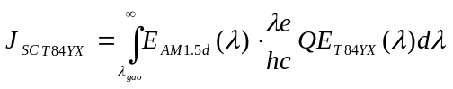

J_{SC T84YX} = 25.774 mA/cm²

MOCVD Cell T84YX: Characterisation under Concentrated Light
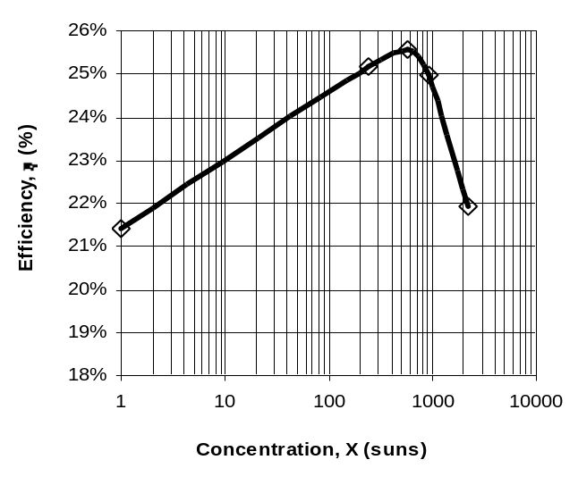

X (suns) | V_{OC} (mV) | FF (%) | η (%)
1 | 991 | 83.0% | 21.4%
248 | 1.144 | 85.4% | 25.2%
578 | 1.166 | 85.1% | 25.6%
935 | 1.178 | 82.2% | 25.0%
2243  η vs. X | 1.194 | 71.3% | 21.9%

FF vs. X
V_{OC} vs. X

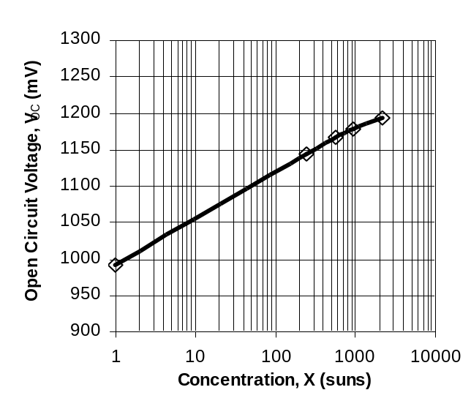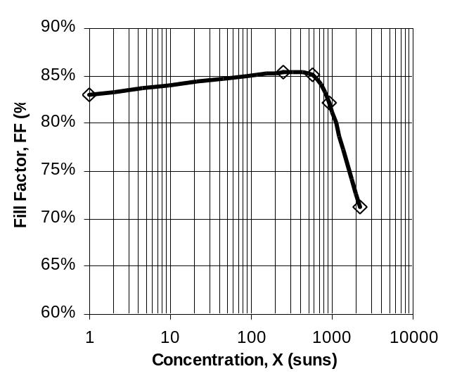

Figure 1: Best MOCVD Cell Characterisation Summary
An inverted square front metal grid with a finger width of 3 μm and a shadowing factor of 7.2% was obtained after several approaches. The solar cell size (inside busbar) determined by the photomasks was 1 mm².
Over the structures supplied by both IOFFE and ENE a lot of technological processes were developed at IES-UPM to manufacture high-efficiency concentrator solar cells. The determination of the optimum set of processes required a lot of experimental work.
The importance of an optimised p-type metalisation technology was clearly assessed in our work. The optimised technology produced contacts in the range of 10⁻⁴ Ω·cm² resulting in devices with an efficiency of 25% at 1,000 suns without prismatic covers (see Fig. 1).

WP3 Isotropic Antireflection coating.
A design of an antireflection coating (ARC) for almost isotropic illumination of the GaAs solar cell has been conducted. A new theoretical model based on the étendue concept for the performance of solar cells when the light impinging on them is in the shape of a cone was taken into account. The model has been applied successfully to concentrator heteroface GaAs solar cells for a cone angle ranging between 0 and 90 degrees.
Several materials have been theoretically evaluated to adapt the refractive index of silicone rubber (used to encapsulate the solar cell to the optical concentrator) to the AlGaAs/GaAs one. Zinc sulphide (ZnS) appears as the optimum material as single antireflecting coating. Among the double layers both the SiO₂/ZnS and ZnS/TiO₂ couple appear as the most suitable.
Experimentally, the three different systems of antireflecting coatings were deposited over the manufactured solar cells. The deposition method applied for both SiO₂ and TiO₂ (evaporation in a partial atmosphere of O₂) suggested the possibility of depositing different materials than desired ones, mainly due to the presence of O₂ at the process. As a consequence, there were unknowns regarding the exact composition of the coatings (that means unknowns at the oxide compositions). After the evidence of different refractive indexes, a new theoretical evaluation of the optimum thicknesses was performed. As a result, it can be concluded that the double system ZnS/TiO_{x} seems to be the best for the GaAs solar cells working inside the RXI. The increment in solar cell short circuit current is in the range of 22-25% with air as incident medium (n=1)

WP4 Optical concentrator
IES-UPM has designed the RXI concentrator. Several parameters are optimised during the design (acceptance angle, aspect ratio, cell position, losses by shadowing) and some other are fixed (geometrical concentration, cell size, refractive indices).
The data of both designs were transferred to PROTECHN for the manufacturing of high-accuracy samples of PMMA. The design of the instrument for moulding was made on the base of the following requirements on RXI concentrator:
- Optical surfaces form accuracy 2 μm
- Linear decentering 4 mm
- Angular decentering 30 angular seconds
- Linear dimensions accuracy 5 mm
The resulting accuracy of the manufactured concentrator has been very high (peak-to-valley error below ±15 microns), but the surface roughness has been higher than expected.
On the other hand, a series of low-cost moderate precision RXI-40 concentrators have been manufactured by PMMA injection moulding. The profiles of the concentrator have been measured with a contact profilometer. There is a hole on the centre of the mirror surface to put the cell inside of the concentrator. The radio of this hole is 3.5 mm.
The optical performance of the PMMA injected RXI-40 has been simulated by computer ray-tracing software developed by IES-UPM for such purpose. The input parameters of the program are the actual concentrator profiles (measured on some pieces, showing a peak-to-valley error below ±30 microns) and the material parameters (absorption, mirror reflectivity, etc).
From the simulation with normal incidence light, we deduce that the main effect of the manufacturing errors of the profiles is not in transmission drop, but on the acceptance angle.Also, from computer simulation we can obtain the irradiance target of light over the cell. Light is concentrated on the centre of the receiver. In this point, irradiance gain could be greater than 20,000. However, this calculation is pessimistic (the actual value should be lower), as in this case the analysis do not consider optical losses nor dispersion at the optical surfaces (see figure 2).
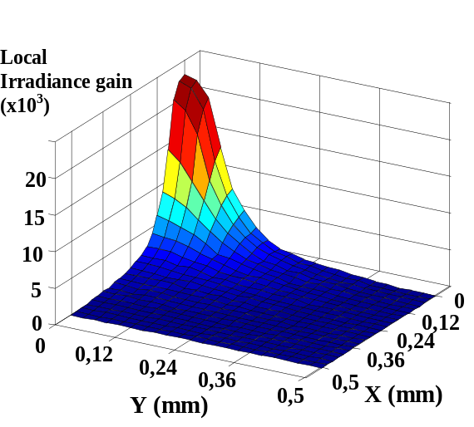
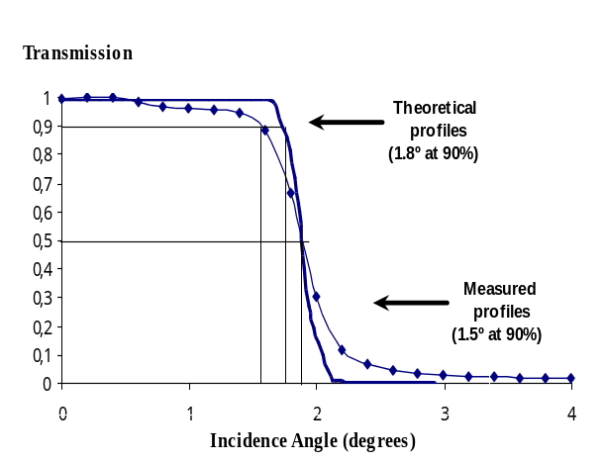

Figure 2. Results of the ray-tracing simulation of the performance of the PMMA injected RXI-40. The angular transmission degrades slightly due to the profile errors (left). Irradiance pattern on a quarter of cell surface inside of RXI (right).

WP5 Assembling
Several attempts for the final assembling of cell and heat sink have been carried out. Epoxies and solder for the contact set-up have been considered.
The devices designed in the frame of this project are small area solar cells (1 mm²). These devices are clearly in the size range of optoelectronics and therefore demand new strategies for contacting similar to those traditionally used in LEDs (i.e. wirebonding). In the following subsections the results of a study on the applicability of the most extended wirebonding techniques (i.e. aluminium wedge bonding and thermosonic gold ball bonding) on our GaAs solar cells are presented.
If during the wirebonding process a slight damage is produced the low concentration performance of the cell will be spoiled but a gradual improvement will be observed when going up in concentration. In some cases the damage influence at high concentrations may be completely negligible. Conversely, if significant damage is produced under the bond region the cell performance will be ruined for all concentration ranges. At this point it should be noted that minor damage during bonding is considered to be a main cause for unexpected failure of electronic devices. Therefore, although it does not seem to be critical for solar cell performance at high concentration it is strongly recommended to avoid any damage in order to guarantee a long and reliable lifetime for the device specially when high currents flow.
Aluminium wedge bonding seems to be the most appropriate technique as it produces better results (a 78% vs. a 69% yield) for all the two substrate growing techniques considered (LPE and MOCVD).
Several attempts for the final assembling of cell and heat sink have been carried out. Epoxies and solder for the contact set-up have been considered. The epoxy thickness, which is an important parameter from the thermal point of view, has been measured for several prototypes, resulting in the range of 50-140 microns. This is acceptable for the thermal performance, as shown by the simulation done by a finite elements resolution.
The procedure of accurate positioning of the cell inside the concentrator has been developed. It consists of the following steps: the concentrator hole where the cell is to be placed is filled with the silicone rubber, the cell is forward polarised, and its infrared emission thought the concentrator is collected by a CCD camera, whose objective is focused to infinity. The image on the CCD represents the angular transmission of the device (although operating in reverse way), and it is used, simultaneously digitalised, as the merit function for the positioning. When the optimum is found (that providing maximum IR light intensity and more abrupt angular transmission), the mechanical assembly between the concentrator and heat sink is fixed, and the silicone rubber is cured.

WP6 Photovoltaic concentrator testing
The process followed for solar cell characterisation has been divided into two stages. Firstly, a measurement process addressed to fully characterise the semiconductor structures was developed. The set of measurements performed over the samples included:
- Raman-Scattering Spectroscopy: to determine free carrier concentration distribution in graded emitters (structures made by LPE)
- SIMS Profiles: to determine the impurity profile (Al, O₂, Mg, Zn and Ge content) of the emitter and Window
- Hall Effect Measurements: to determine effective free carrier concentration and mobility of the emitters of both MOCVD and LPE samples.
Once the semiconductor structures were thoroughly characterised, devices were fabricated over them. The characterisation of high concentrator solar cells is a complex task that involves a great number of different measurements. The process was as follows:
- Dark I-V Curve Measurements.
- Specific Contact Resistivity
- One sun preliminary measurement:
- Quantum Efficiency Measurement and I_{SC} Accurate Determination:
- Characterisation under Concentrated Light: this was the final target of the whole test and characterisation process.
With regard to the Optical concentrator characterisation the angular transmission of the low-cost RXI-40 concentrators has been measured, showing a 90% acceptance angle of ±1.5° in the best injection series. This agrees with the ray-tracing simulation made using the measured profiles.
Optical efficiency, η_{opt}, of a concentrator is usually defined as the fraction of power incident on concentrator aperture that reaches the receiver’s surface.
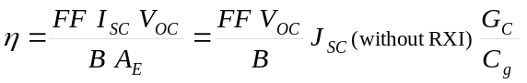If we consider global electrical efficiency, η, of the device as output electric power between power incident on aperture entrance, it can be decomposed as follows:
(1)

where B is the beam irradiance, A_{E} is the concentrator entry aperture area, V_{oc}, I_{sc} and FF are the open circuit voltage, short circuit current and fill-factor of the whole device. The best values obtained for the parameters in the expression are given in Table I:

Table I: Best values obtained for the parameters in the expression (1)
Parameter | FF  (at Isc = 191-195 mA) | V_{oc} (V) | Jsc(without RXI)  (@100 mW/cm²)  mA | Gc/Cg | η (%)  (expected)
Value | 0.77 | 1.15 | 24.2 | 0.902 | 19.3
Device | T8478, 1-3000 | Dis7, 1-3000 | T8322 | T84x8 | -

It is important to stress that the best values for these parameters could be obtained in a device of IES-UPM present technology (there is no trade-off between them). The reason why no single device which such efficiency has been found is that the yield of the complete process, which is not a mass production one, is low.
The fill factor degradation is the main cause to limit the efficiency. The value of 0.85 has been measured with uniform illumination (of the flash lamp equipment), but 0.77 is the best one measured with an RXI concentrator. This is due to the non-uniform illumination produce by the RXI on cell surface. The light is concentrated producing a spot of high local irradiance gain.
This non-uniform illumination could not be predicted with enough accuracy before the real manufacturing of the device (it is very sensitive to the concentrator profile errors and surface scattering). Nevertheless, this low fill factor can be improved by re-designing the cell structure and the front grid.

WP7 Cost Analysis
Cost analysis constitutes a difficult topic very dependent on assumptions. Anyway, a rather detailed analysis including several concepts whose costs are extracted from the experience of several partners has been conducted.
Germanium substrate wafers as those used in spatial industry for manufacturing GaAs solar cells have been considered. These wafers having 115 mm in diameter (that is, 103.8 cm²) have a cost of 125 Euros each one. A rounded down area of 100 cm² is considered for the calculations leading to 1.25 Euros/cm². In this analysis, square centimetre has been preferred before square meter to be used as unit due to the low size of solar cells. The cost of growing the semiconductor structure (1.75 Euros/cm²) includes the depreciation of epitaxial reactor, labour, gases and overheads. The metallization of both sides, the mesa etching, the deposition of antireflecting coatings, and the on-wafer-checking of the solar cell have been considered in the fabrication cost.
After this, an 80% of the solar cells comply with the specifications and therefore, the cost of the individual solar cells diced with an active area of 1 mm² will be 12.5 Euros/cm² (this means, 0.2 Euros each solar cell, that is the cost of GaAs LEDs, Light Emitting Diodes, of the same size).
Finally, the cost of each solar cell must be divided by the concentrator level (1000 suns) giving a cost of 0.0125 Euros/cm² and highlighting the dramatic influence of such a high concentration for really reducing cost. A problem associated with a small concentrator size, as the one proposed here, is the assembly cost. The formula 1600/N^{0.5}+0.027N (optics cost + encapsulating cost in Euros/m²) refined after years of experience has been recently fitted to real data of optoelectronic products. N is the number of optical concentrators per m². The optimisation of the formula gives N=957 what means a concentrator unit of 32x32 mm² and solar cell size of about 1 mm². The corresponding cost is 0.0052 Euros/cm² for the Optics and 0.0026 Euros/cm² for the encapsulation. To these costs, that of passive cooling based on finned heat exchanger (0.0030 Euros/cm²) has been added.
In order to obtain the cost of the PV field, the cost of the EUCLIDES concentrator (0.0096 Euros/cm²) for assembling the panels, their mounting on metallic structure, tracking and DC wiring has been increased to 0.0110 Euros/cm² in order to consider a two-axis tracking based on published data. Finally, the cost of 0.0040 Euros/cm² for the land and its preparation (again taken from the EUCLIDES results) has been considered. The addition of all the above costs produces 0.0383 Euros/cm² for the PV field.
The power supplied by the PV field (0.0186 W/cm²) is based on a module efficiency of 18.6% at standard conditions derived from the multiplication of the GaAs solar cell efficiency (24%) by the optics efficiency of (80%) and by the module interconnection efficiency (97%). The two first efficiencies have been already reached in IES-UPM previous EC funded project.
The cost of the PV plant (0.0420) is obtained by adding to the cost of the PV field (0.0383) the cost of the inverter transformers and electric equipment (0.0037). This last is obtained by multiplying the figure of 0.2 Euros/W_{p} obtained in the EUCLIDES experience by the power supplied by the PV field (0.0186 W/cm²). The cost of the PV plant is incremented in a 25% of commercial profit up to reach 0.0525 Euros/cm². Finally, the nominal cost of the PV plant is obtained by dividing the price of the PV plant (0.0525 Euros/cm²) into the power supplied by the PV field (0.0186 W/cm²) what gives 2.83 Euros/W_{p} .
Throughout HERCULES project the increase of both the efficiency and the reliability of GaAs solar cells has received a great effort. This increase of efficiency has an impact by itself in the cost (second column) consisting of the decrease of the nominal cost up to 2.62 Euros/W_{p}.
In the long run, we have applied the historic learning rate of the PV modules to all the process and components for a cumulated production of 1,000 MW_{p} with the exception of encapsulation, cooling and optics for which a more restricted cumulated production of 100 MW_{p} has been considered. It must be pointed out that there is no reason to expect that the utilised 17.5% historic learning curve for modules (mostly of silicon) will be the same for concentrators. As a reference, the learning rate of Microelectronics and Optoelectronics (that are closer to the product here proposed) is estimated to be of 32 %. At this respect, an increase of the yield from the present 80% to 95% (typical in Optoelectronics) has been assumed. In addition, small increase in the efficiency of solar cells (from 26 to 27%) and optics (from 80 to 83%) would be expected. All these considerations would drive to a cost of 0.81 Euros/W_{p}.
Therefore, for the long term the learning rate will have a dominant effect. Nevertheless, when this will happen, a generation of concentrator multi-junction III-V solar cells will be probably ready for commercialisation with efficiencies ranging 35-40%. Given that the ultra-flat concentrator module technology described in this proposal is able to incorporate such a very high efficiencies solar cells, a cost reduction up to 0.6 Euros/W_{p} is envisaged (as it has been already published) and therefore, it will completely satisfy the goal of 1 Euro/W_{p} for modules by 2010.

RESULTS AND CONCLUSIONS

In this project the following achievements have been obtained:
- Specific design of concentrator GaAs solar cell optimisation with a size of 1 mm². Theoretical analysis and experimentation of several related aspects as series resistance, antireflecting coatings for isotropic illumination under wide cones of light, and influence of solar cell size in its performance. Best device has reached 25.0% of efficiency at 935 suns and 21.9% at 2243 suns of light concentration. The short circuit current of 25.77 mA/cm² was calibrated at Fraunhofer Institute of Solar Energy (Freiburg) facilities.
Contractors involved: IES-UPM, ENE, IOFFE
- Design and manufacturing of optical RXI-40 concentrator with low-cost injection moulding technology and silver mirror by evaporation. Accuracy of optical surfaces: 20-60 μm (peak to valley).
Contractors involved: IES-UPM, PROTECHN
- Design and manufacturing of the heat sink prototype on copper by direct machining. The temperature drop in operation has been 28ºC from cell to ambient.
Contractors involved: IES-UPM, VISHAY
- Assembling results: bonding of the GaAs solar cell to the heat sink by a silver conductive epoxi. Front contact by wire bonding. Encapsulation by casting a transparent silicone ribbon.
Contractors involved: IES-UPM, VISHAY
- A cost study has been realised. By introducing some values known during the project execution, the analysis confirms the viability of the achievement of electricity at 0.1 ECU/kWh. An important conclusion is that this cost level can be only reached with solar cells sizes ranging from 0.5 to 1 mm².
Contractors involved: IES-UPM, ENE, IOFFE, VISHAY, PROTECHN

EXPLOITATION PLANS
This project aims at developing a PV concentration system able to lead to an electricity cost competitive with the conventional electricity. This may not be achieved in the very first moment but we think that the project has potential for it in particular when tandem cells operating at 1000 suns will be developed. Obviously niche markets should be covered previously. For it a system as modular as possible should be sought.
Main innovative aspects that support our ambitious final goals are: the use of high efficiency GaAs cells, and in the future of tandem cells operating at concentrations above 1000X (to allow for the high cell cost), the invention of novel compact optics, with unusually high acceptance angle able to both, allow for optoelectronic assembling (low cost because of the huge advancement of the sector) and low cost tracking structure due to the wide acceptance angle (allowing low stiffness and low tracking requirements).
Potential barriers for European development are the almost total exclusion of III-V and tandem cells R&D from the 4th FP although in the 5th FP there was no specific exclusion. This field is very active and well developed in Japan and USA.
Obviously the use of moving elements is an additional barrier that excludes our solution from certain niche markets, and sometimes produces rejection feelings. This barrier has to be overcome, but the bet of BP Solar for concentration may help to it.

PHOTOGRAPH, DIAGRAM OR FIGURE TO ILLUSTRATE POTENTIAL APPLICATION OF THE PROJECT

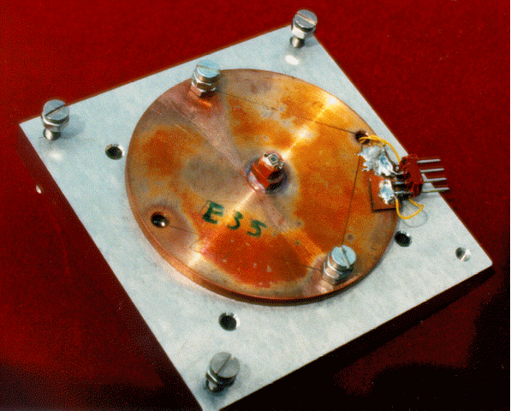
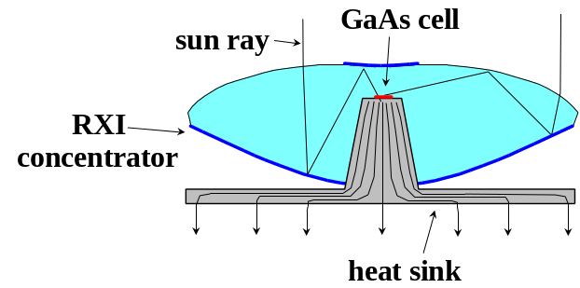
PV concentrator prototype including heat sink, RXI optical concentrator and 1 mm²-sized GaAs solar cell (left). Heat flow from cell to ambient across the heat sink (right). A slight modification of such prototype will lead to commercial flat concentrator modules.

