

Project no: CA 013983

EFONGA

European Forum on New Glass Applications

COORDINATION ACTION

PRIORITY 3

Nanotechnologies and nanosciences, knowledge based

multifunctional materials, new production processes and devices – ‘NMP’

Periodic Activity Report

Period from 01/06/2008 to 31/05/2009 Date of preparation: 15/09/2009

Start date of project: 01/06/2005 Duration: 4 years

Project coordinator: René Vacher
Coordinator organisation: Centre National de la Recherche Scientifique
Table of Contents

Summary…………………………………………………………………………. 3

1- Project objectives and major achievements during the reporting period… 6

2- Workpackage progress of the period…....................................................... 11
2.1- Workpackage 1- Micro- and nanostructure of glasses................... 11
2.2- Workpackage 2- Nano-structure based glass applications............. 21
2.3- Workpackage 3- Glass processing mechanisms and modelling..... 33
2.4- Workpackage 4- Surface and interface phenomena....................... 56
2.5- Workpackage 5-Communication, dissemination and education... 67

3- Consortium management……………………………………………………. 70

A1- Plan for using and disseminating knowledge…………………………….. 74

Summary

EFONGA is a Coordination Action in the field of glass science and technology, which aims at co-ordinating all European groups working in fundamental and applied pre-competitive research. The groups involved in the project are already operative and they have co-operated for many years within the framework of the European Group of the International Commission on Glass. EFONGA works in the following fields: basic knowledge of glassy materials, relation structure-properties, setting-up of new methods for the characterisation of glassy materials, preparation of reference materials. Among the most important goals is the development of basic knowledge in the chemistry of glasses, in order to create new glasses and new glasses applications, in particular nano-structured glass materials. Another important goal is the improvement of the chemical composition and production processes of glasses in order to reduce as much as possible the impact on environment. Also, EFONGA will develop the support to the European standardisation bodies at the co-normative and pre-normative level, and will act in the preparation of critical reference materials (CRM).

The three axes of this Co-ordination Action (CA) are:
- Co-ordination of the work performed by the different groups through the organisation of Round Robin tests,
- Organisation of workshops, seminars and meetings in order to promote the exchange of information and define the axes of development at the European scale,
- Diffusion and dissemination of information on the results of the different actions, and co-ordination of education and training at the European level.
Ten contractors co-operate in the EFONGA project:
- Centre National de la Recherche Scientifique (CNRS), France, Laboratoire des Colloïdes, Verres et nanomatériaux, Montpellier
- Consiglio Nazionale delle Ricerche (IFAC-CNR), Italy, Istituto di Fisica Applicata “Nello Carrara”, Florence
- Leibnitz Institute für Neue Materialen (INM), Germany
- Turkiye Sisa ve cam Fabrikalari AS (SIS), Turkey
- Stazione Sperimentale del Vetro (SSV), Italy
- The University of Sheffield (USFD), United Kingdom, Department of Engineering Materials
- Ivoclar-Vivadent (IVO), Liechtenstein
- Saint-Gobain-Recherche SA (SGR), France
- Schott AG (SMZ), Germany, Corporate Research and Technology Department
- Netherlands Organisation for Applied Scientific Research (TNO), Netherlands
The project is co-ordinated by:
René Vacher
Laboratoire des Colloïdes, Verres et Nanomatériaux
Université Montpellier 2, case courrier 069
34095 Montpellier Cedex 5, France

Tél : +33 (0) 4 67 14 34 49
Fax : +33 (0) 4 67 14 34 98
e-mail : rene.vacher@univ-montp2.fr
The main contribution of EFONGA
The main interest of the EFONGA coordination action is that, within this frame, European glass companies become more and more open to co-operation. An excellent example is provided by the panel of experts and research and development managers on the subject: “Glass products for the Future”, which was held at the opening of the XXIst International Congress on Glass. High-level managers from Saint-Gobain (France), Schott (Germany), and Sisecam (Turkey) contributed in an open discussion. A similar round table was organised in 2008 during the 9th Conference of the European Society for Glass Science and Technology in Trencin, Slovakia. In view of the success of such events, it was decided that all Congresses and Annual Meetings of the International Commission on Glass will include one similar Round Table.
Glassmakers were already connected in the International Commission on Glass (ICG) on a voluntary basis. ICG is based on a long –but somewhat frozen-in- tradition, to organise meetings and social events. EFONGA was established on the basis of the European group of the ICG. Thanks to the support in the EFONGA project, we are now able to organise meetings, Round Robin tests, networking, and better communication inside the European glass community. We have now a more independent position, allowing preparing long-term activities. As we do not need external support any more for those coordinating activities, we can organise them independently of any particular interest. We can also think more deeply to the fundamental aspects and the long-term preparation of the future of our material. This allows putting in common non-competitive research activities on major aspects such as environmental impact, bio-applications, nano-structuration, surface properties.

Coordination of scientific and technical work
During this fourth year, four Round Robin tests were completed on: characterisation of integrated optical amplifiers (active waveguides) (WP 2.1), Liquidus Temperature of Soda-Lime-Magnesia-Silica Float Glass samples (WP 3.1), on water content and absorption coefficient (WP 3.2), on combined models for investigating batch blanket models and improvement of glass bath and combustion space modelling and parameters (WP 3.4), on optical measurements for diffusing and patterned glass (WP 4.2). Several are running and new Round Robin tests were started in different domains, from basic glass science to glass production, properties, and glasses for new applications: on NMR spectroscopy and diffraction studies of glass structure (WP 1.1), on thermo-chemical modelling of multi-component glass compositions (WP 3.1), on bubbles from refractory corrosion (WP 3.2), on the characterisation of condensates inside bubbles (WP 3.2), on refractory blisters (WP 3.2), on TV panel pressing (WP 3.5), on gob forming (WP 3.5), on continuous fibre drawing (WP 3.5), on quality of XRD characterization (WP4.3).

Exchange of information
Conferences
The 8th Conference of the European Society for Glass Science and Technology, was held in Trencin, Slovakia, from June 22 to 25, 2008. The recent progresses in all aspects of glass science, technolology, and production were presented in 4 plenary talks, 15 invited talks, 110 oral contributions and 150 posters. Eight meetings of the EFONGA workpackage took place there. The Efonga groups have been very active in the preparation of the American Ceramic Society meeting to be held in Vancouver, Canada, in June 2009.
Workshops
One of the most important results of the EFONGA project is the organisation of top-level expert meetings. Following the success of the expert meeting organized in March 2008 in Brig, Switzerland, on Innovation in Glass Melting Processes and New Functional Materials, by the workpackages 1.2, 1.3 and 3.1, five similar workshops have been held this year. The main outputs of these workshops are roadmaps on important topics for the next ten years. This kind of expert workshops will be developed in the future.
In order to summarize the results obtained during the four years of cooperation in the frame of the EFONGA project, and to define the main lines for future actions, a closing meeting “Current Status and Future of Glass” was organized in Montpellier from May 6 to May 8 in Montpellier. It was attended by more than 50 experts.

Websites
Two websites are operative at the addresses: www.efonga.org and www.efonga.eu. More information on the activity of WP4.2 EFONGA group can be found on www.icg-tc10.org
Publications
This year, the Efonga groups have published more than twenty articles in scientific journals.

Training
Similarly to what was done in previous years, special arrangements were made for students to attend the DGG Annual Meeting in Amberg, May 2009 at low cost. We have given support for a speaker from France to give a presentation at a Workshop on Sol Gel targeted at younger researchers held in Cambridge, UK in September 2008, and also support for a Short Course on Glass Strength organised by the DGG for an international audience in May of this year.
We have organizer a 2 day teaching event in Montpellier under the heading “Glass structure-property relationships”. The workshop attracted 56 students from 12 different European countries plus 3 from the US; they were taught by 11 staff who between them presented 16 lectures.
1- Project objectives and major achievements during the reporting period

1.1- Project objectives

Glass is one of the oldest man-made materials, and at the same time it has a very rich future. Presently glass is used more and more in very different applications such as packaging, building, automotive, tableware and domestic glassware, space communications, optoelectronics, bioapplications, etc. This extremely wide range of uses relies on the one hand on the exceptional physical and chemical properties of this material and on the other hand on its low cost and almost limitless capacity for recycling. Glass is a multifunctional and also, in principle, a fully renewable material. The progress in knowledge of its structure and properties has led in the recent years to a continuous expansion of its application. At the present time many possibilities for further improvements exist in the different domains listed above, and these rely on progress in the basic understanding of glassy materials and developments in glass technology.

Within the framework of the European Group of the International Commission on Glass, the European Forum of New Glass Applications, EFONGA operates in a co-ordinated and co-operative way in many different fields from the basic knowledge of the glassy materials to the optimisation of the industrial production process. The EFONGA activities involve about 200 European Glass Scientists and Technologists from about 50 European Laboratories, from 20 European Union member and associated states, and belonging to industries, Universities and Institutes. EFONGA acts in managing and co-ordinating the research activities of these different groups at the pre-competitive level, and in organising dissemination of knowledge and training activities. The activities involve three main axes:
1) Management and co-ordination: the organisation of Round Robin Tests on key scientific and technical problems in the context of co-normative and pre-normative research according to the needs of the market, of industry and of the standardisation bodies;
2) Dissemination of knowledge: the organisation of regular technical meetings, seminars, workshops and conferences, in order to promote, maintain and update the exchange of information and interactions among glass experts from most of the states of the European Union;
3) Education and training: The Efonga project acts on the one hand by co-ordinating existing glass education and training at a European scale, and on the other by organising specific training courses in the framework of the annual meetings.

The first and automatic goal of EFONGA is the integration of all glass groups from all EU states according to a common axis of development based on the highest level of knowledge. This acts for the homogenisation of the European glass sector and its increased competitiveness with the USA and Japan. Moreover, integration based on common industrial best practice contributes to reduce significantly the environmental impact of the European Glass Industry. Among the most important goals of the EFONGA is the improvement of basic knowledge on the chemistry of glasses in order to create new glasses and new glass applications, in particular nano-structured glassy materials. Another important goal is the optimisation of batch compositions and of the production processes of glass in order to reduce their environmental impact. Also, the continuous support to the European standardisation body, CEN, at co-normative and pre-normative level represents an important aim. EFONGA focuses its activity on: micro and nano-structured glasses and their applications, glass processing mechanisms and modelling, surface and interface phenomena, communication, dissemination and education.

Micro and nano-structure of glasses (this topic includes: Structure investigations and numerical simulations; nano-phase formation, nucleation and crystallisation; biomaterials; and hybrid and nano-composite materials for optoelectronics).
A fundamental understanding of the most important properties for the development of high-tech glasses for specific applications is needed and there are considerable concerns over the lack of sample characterisation.
The following actions have been planned:
- Investigation of the structural aspect of glass nucleation and crystallisation and of glass fracture;
- Preparation of a set of standard glass samples, and reviewing the data analyses procedures used at large international experimental facilities;
- development of detailed TEM studies and analytical characterisation of glass-ceramic microstructures, and studying the possibility of nanophase formation to initiate the nucleation;
- control of surface reactions to promote bone growth, i.e. detailed study of bio-activity;
Current developments in optoelectronics and photonics require that novel or advanced glasses are investigated: flat panel displays and luminescent materials that may be efficiently excited by low cost light sources, metal nanocluster composite glasses for photonic and magnetic devices, hybrid materials for exceptional properties or extended functionality.
Nano-structure based glass applications (this topic includes: coatings made by sol-gel and chemical nanotechnologies; waveguides, optical amplifiers and lasers; coatings on glasses).
Several important issues have to be addressed to improve knowledge of the properties of Ormocer and Nanomer coatings. Among them:
- The characterisation of the substrate/coating interphase and of the surface properties which will be developed by Round Robin Tests.
- A data-base on industrial sol-gel coatings on glass and their physical-chemical structural, biological properties will be set up and published.
- The key goals for waveguides, optical amplifiers and lasers will be the optimisation of materials for 1.55 µm operation, the identification of optimal glass matrices and corresponding optimal rare–earth doping concentration.
An increasing percentage of produced glass is nowadays being functionalised by coatings: low emissivity windows, self-cleaning windows, smart windows, displays, solar cells. At present each glass company is performing its own quality insurance by its own test methods. There is a need for standardised test methods and standards for the European market. With reference to the above need there will be the following actions:
- set up of standards for self-cleaning glass products through Round-Robin Tests on commercially available products;
- benchmarking of Transparent Conducting Oxide (TCO) coatings on glass by measuring and comparing optical and electrical properties of TCO coatings produced by European Company; - setting up of a coated glass internet portal.

Glass processing mechanisms and modelling (this topic includes: properties of glass forming melts; gas solubility in glasses; electrochemical properties of glass melts; modelling of glass melting processes; modelling of glass forming processes.)
Detailed knowledge of the melting process chemistry and of the properties of the molten glass at high temperature in order to achieve the optimisation of the glass production process is the main goal of the above topics.
The various goals dealing with the properties of glass forming melts and the gas solubility in glasses are:
- improved understanding of the knowledge on glass melt properties related to melting and forming processes;
- evaluation of glass melt properties data and measurement techniques;
- exchange of information on glass melt properties and mechanisms of glass melt process (melting kinetics, fining, crystallisation).
To reach these goals:
- Round Robin Tests on measurements of glass properties at high temperature will be organised;
- data on glass melts properties will be collected;
- the results of glass melt property measurement and the measurement methods will be published;
- computer simulation models for estimating thermodynamic properties of glass and glass melts, based on their compositions and temperatures, will be developed and compared;
- Round Robin Tests on measurements of water in glass have been organised and their results are being published;
- Round Robin Tests on the measurements of the glass solubility (gas content) in glass will be organised;
- Certified Reference Materials (glasses) for the determination of water in glass are being identified.
Mathematical modelling studies for the achievement of realistic glass furnace evaluation are in progress and cover mainly the glass bath, furnace atmosphere and batch blanket, and their combined behaviour.
Future studies are already planned on combustion space residence time and particle tracing, and glass quality models.
Computer modelling of the glass manufacturing process is becoming increasingly important to enhance process understanding and optimisation, but appropriate models are not available in commercial software packages and need to be developed. To reach such a goal the activities already planned and in progress are:
- definition and accomplishment of bench mark problems for specified forming processes;
- identification of models requiring enhancement and initiation of development;
- sensitivity studies to identify material properties critical to simulation results;
- definition and accomplishment of experiments for model validation.

Surface and interface phenomena (this topic includes: chemical properties, optical properties, physical characterisation).
The main purpose is to establish the best and most effective methods of characterising the topology, chemical composition and reactivity of the surface and surface near region of glass/glass-ceramic substrate down to the sub-nanometer scale. Also organic contamination in the ppb range, reactions with the environment and chemical inhomogeneities have to be characterised with the same precision. The analytical techniques of suppliers and customers have at least to produce comparable results.
The activities already planned and in progress are:
- revision of current standards on glass chemical durability;
- revision of the European Pharmacopoeia in comparison with ISO 4802;
- preparation of the reference container to assess the efficiency of the testing apparatus for chemical durability measurements;
- determination of the optimal procedure and configuration for the use of FTIR spectrophotometers and recommendations to the standardisation committees;
- Round Robin measurements of the colour of coated flat glass by using portable devices and laboratory spectrophotometers;
- Round Robin characterisation of corrosion phenomena of glass and determination of contamination sources and respective cleaning processes;
- Round Robin characterisation of inorganic/organic thin film multilayers: single layers density, thickness and roughness, chemical composition and gradient;
- comparison of the latest techniques for insulator analysis.

Communication, dissemination, education and training.
The diffusion and the dissemination of information is performed via a web-site, dedicated publications workshops and conference presentations. The interim and final results of the EFONGA collaborative program will also be published in the form of collected volumes of work.
The main task is to set up an appropriate mean of organising committee meetings, workshops, conferences, congresses and studies schools to facilitate the interactions between the different groups involved, to encourage combined activities and to offer training and educational possibilities whether at the level of senior or new research workers. We plan:
- Annual meetings covering the period of the project,
- One or two meetings per year for each working group inside a sub-workprogramme,
- Organisation of one training school every year.

1.2- Major achievements

A great progress has been made in the cooperative investigation of industrial glasses. Four Round Robin tests were completed on: characterisation of integrated optical amplifiers (active waveguides) (WP 2.1), Liquidus Temperature of Soda-Lime-Magnesia-Silica Float Glass samples (WP 3.1), on water content and absorption coefficient (WP 3.2), on combined models for investigating batch blanket models and improvement of glass bath and combustion space modelling and parameters (WP 3.4), on optical measurements for diffusing and patterned glass (WP 4.2).
A highlight of Work-package 5 during the last year has been to organise in May 2009 a 2 day teaching event in Montpellier under the heading “Glass structure-property relationships”. The workshop attracted 56 students from 12 different European countries plus 3 from the US; they were taught by 11 staff who between them presented 16 lectures.
Following the success of the expert meeting organized in March 2008 in Brig, Switzerland, on Innovation in Glass Melting Processes and New Functional Materials, by the workpackages 1.2, 1.3 and 3.1, four similar workshops have been held this year. WP1.3, 3.1 and 3.5 organized a follow-up of the Brig meeting in November 2008 in Eindhoven, The Netherlands on “Conditioning of Glass Melts & Forming of Glass Products”. WP 1.1 and 4.3 organized in February 2009 in Montpellier, France, an expert meeting on “Glass surfaces and stress corrosion mechanisms at the nanoscale”. In the domain of basic glass science, two experts meetings on “Glass and Entropy” were held, the first in Trenčin, Slovakia, June 25-27, 2008 with 36 invited contributions and more than 50 attendees, the second in Aberystwyth, UK, April 22-24, 2009, with 28 invited contributions and more than 40 attendees. The main outputs of these workshops are roadmaps on important topics for the next ten years. This kind of expert workshops will be developed in the future.
Finally, in order to summarize the results obtained during the four years of cooperation in the frame of the EFONGA project, and to define the main lines for future actions, a closing meeting “Current Status and Future of Glass” was organized in Montpellier from May 6 to May 8 in Montpellier. It was attended by more than 50 experts.

2- Workpackage progress of the period

2.1- Workpackage 1- Micro- and nanostructure of glasses

WP 1.1: Basic glass science

- Structure investigations and numerical simulations

ACTIVITIES IN 2008-2009

A round Robin test on structure of borosilicate glasses was started. Eight samples of each of four sodium borosilicate glasses have been prepared and cut at the Otto Schott Institut, University of Jena, and distributed to the laboratories involved. The four glasses have also been characterized at the Otto Schott Institut, and their compositions are summarized in Table 1, together with their glass transition temperatures, Tg, mass densities and thermal expansion coefficients, α100-300°C.

Composition (mol.%)
Sample | Na₂O | B₂O₃ | SiO₂ | T_{g} (°C) | Density (g/cm³) | α_{100-300°C} (10⁷/K)
NBS-A | 12.5 | 62.5 | 25.0 | 415 ± 3 | 2.18 ± 0.01 | 85 ± 2
NBS-B | 3.0 | 48.5 | 48.5 | 380 | 2.04 | 64
NBS-C | 15.0 | 42.5 | 42.5 | 490 | 2.31 | 87
NBS-D | 6.5 | 33.5 | 60.0 | 445 | 2.15 | 53

Table 1 - Standard Sodium Borosilicate Glasses.

All four glasses exhibit subliquidus phase separation, as may be seen from the electron micrographs for samples NBS-A and NBS-D in Figs 1 and 2. In the SciGlass Database, the property measurements in Table 1 will be identified as belonging to WP1.1 standard glasses. Other properties in the SciGlass Database will include their refractive index and Abbe number.

Figure 1. Electron micrograph of sample NBS-A, showing SiO₂-rich droplets in a sodium-borate-rich matrix (Otto Schott Institut).

Figure 2. Connected phases in sample NBS-D (Otto Schott Institut).

Samples have now been distributed to 8 NMR research groups worldwide. Preliminary NMR measurements have been performed in Joe Zwanziger's laboratory, using the NMR techniques summarized in Table 2, and thermodynamic modelling has been carried out by Natalia Vedishcheva, using the model of associated solutions. Some of the results from the thermodynamic modelling are given in Table 3, including the mass density and the fraction of 4-fold co-ordinated boron atoms, x₄. The distribution of SiØnO _{4n} ^{n4} tetrahedral species, denoted Q^{n}, where n is the number of bridging oxygen atoms, Ø, is also shown. However, since all of the glasses have an excess of B₂O₃ over that required to balance the Na⁺ ions, the latter are mainly associated with the more acidic oxide (B₂O₃) and the SiO₂ is almost entirely present as Q⁴ species, as may be seen from Table 3.

Experiments NMR facilities Rotor/ Spinning speed Pulse Relaxation
¹¹B MAS Bruker-700 2.5-mm/20 kHz < 15 º 10-15 s
²⁹Si MAS Bruker-400 7-mm / 5 kHz 30 º 40-90 s
¹¹Na MAS Bruker-400 4-mm / 12 kHz < 15 º 0.5-1 s
¹¹B MOMAS Bruker-700 2.5-mm /25 kHz 3Q/Z-filter 10-15 s
¹¹Na MQMAS Bruker-700 2.5-mm /20 kHz 3Q/Z-filter 0.5-1 s

Table 2 - NMR facilities and experimental parameters used for the measurements performed in Joe Zwanziger's Laboratory.

Sample Density x₄ Q² (%) Q³ (%) Q⁴ (%)
(g/cm³)
NBS-A 2.158 0.201 0.0 0.0 100.0
NBS-B 2.053 0.062 0.0 0.0 100.0
NBS-C 2.302 0.349 0.0 0.4 99.6
NBS-D 2.174 0.193 0.0 0.0 100.0

Table 3 - Results from the thermodynamic modeling.

WORKING GROUP OF WORKPACKAGE 1.1A
Chairman: Prof. Adrian C. Wright (Univ. Reading – U.K.)
Members: Prof. Rui Almeida (Inst. Superior Técnico, Lisboa – Portugal)
Prof. Giuseppe Dalba (Univ. Trento – Italy)
Dr. Doris Ehrt (Otto-Schott-Institut – Germany)
Dr. Ulrich Fotheringham (Schott Glas – Germany)
Prof. Ondrej Gedeon (Inst. Chem. Technol. – Czech Repub.)
Dr. Efstratios I. Kamitsos (Nat. Hellenic Res. Foundation –
Greece)
Prof. Marek Liška (Inst. Inorg. Chem. – Slovak Repub.)
Prof. René Vacher (Univ. Montpellier – France)
Prof. Lothar Wondraczek (Univ. Erlangen – Germany)

- Relaxation phenomena in glasses

SUMMARY

Although the topic has seen significant and continuous progress for more than five decades, the nature of the glass transition remains one of the biggest mysteries in solid-state physics. From the beginning, the topic fascinated not only glass scientists, but also physicists, geologists and chemists – although very often for different reasons.
Understanding relaxation phenomena that occur in glasses, at different timescales and at different pressures and temperatures, was often motivated by immediate applications, be it evolution of refractive index for optical applications, internal strain for mechanical or optical applications or melting behaviour and magma rheology in geophysics and molecular mobility for bio-preservative applications. In recent years, scientists all over the world developed new interest on this field, and came up with new hypotheses, models, and experimental concepts to study hyperquenched glasses, compressed glasses or glasses with very low fictive temperatures, but also polyamorphic transitions, melt rheology, dynamic heterogeneities, potential energy landscape of glass forming melts, etc

ACTIVITIES IN 2008-2009

* The first ”International Workshop on Glass and Entropy” was held in Trenčin, June 25-27, 2008 with 36 invited contributions and > 50 attendees
* A special issue of the Journal of Non-Crystalline Solids was published in April 2009 (L. Wondraczek, R. Conradt (Eds.): Glass and Entropy. J. Non-Cryst. Solids 355, (10-12), Elsevier, Amsterdam (2009) ISSN 0022-3093), including 24 edited papers and an introductory article (Deliverable S8)
* The second “International Workshop on Glass and Entropy” was held in Aberystwyth, April 22-24, 2009, with 28 invited contributions and > 40 attendees
* A press release was published, summarizing major outcomes of both workshops and giving a future prospect (Deliverable S17)
* A session on thermodynamics was organized for the closing workshop of EFONGA in Montpellier, May 6-8, 2009
* A summary of Glass and Entropy workshops was presented (Appendices 1a,1b)
* For future, application-related work, as major topics of interest, glass corrosion and relaxation were identified
* A technical session on one of the focus areas, relaxation in disordered systems, was prepared for an international conference in Vancouver (finally held after the end of EFONGA)

* First preparations of an invited feature article on “Glass and Entropy” in the Journal of the American Ceramic Society were undertaken

- Glass Nanomechanics

SUMMARY

The initiative for a new action on "Glass Nanomechanics" was taken in January 2008 in concomitance with the fourth year extension of the EFONGA project. The mission is to promote cooperative research activity on the comprehension of recent advances in the observations by local scanning probe techniques of the fundamental crack propagation mechanisms acting at the nanoscale in glass and glass-ceramics. We can cite the debated observations on the presence of plastic deformation near the crack tip, as well as the manifestation of stress-induced ion migration in the neighbourhood of the crack tip, but also the subtle details of the diffusion and interaction of water molecules with the glass network. The group joins experts in different domains of the glass community (fracture, physical-chemistry, structural relaxation, surface properties, scanning probe microscopies, numerical simulation) with the aim of discussing how to put together different evidences in order to gain new insights in the relationship between the glass composition, nanostructure and mechanical properties.

PLANS AND DELIVERABLES FOR 2008-2009

- Core physical meeting at MSE2008 (Nuremberg, Germany, 1-4 September 2008) on September 3rd 2008.
- Contributions in the symposium "Towards Ultrastrong Glasses" organized at MSE2008.
- Definitions of priorities for the future actions and research activity.
- Organization of an expert workshop: “Glass surfaces and stress corrosion mechanisms at the nanoscale”

ACTIVITIES in 2008-2009

- A core meeting was held on September 3rd 2008 at MSE 2008 (Nuremberg, Germany, 1-4 September 2008), where a symposium "Towards Ultrastrong Glasses" was organized jointly by TC03 and TC06.
- The symposium animated by Lothar Wondraczek was very stimulating and it was followed by a joint meeting of TC03, TC06 and TC09 concerning a Round Table on the Strength of Glass issue. Three TC09 members were present (M. Ciccotti, A. Cormack and R. Hand) and contributed with oral presentations and active discussion.
- Preliminary discussion were made on the opportunity of organizing a joint TC09 and TC19 workshop on "Glass surfaces and stress corrosion mechanisms at the nanoscale" to be held in February 2009 in Montpellier. This should be an excellent opportunity to make a point of the state of the art in this research topic and settle better plans for future activities of TC09 which are likely to involve extensive cooperation with both TC19 and TC06.
- As a personal action of the chair, Matteo Ciccotti has written a review on the “Stress-corrosion mechanism of silicate glasses” that is in press in the Journal of Physics D: Applied Physics and that is meant to review the stat of knowledge on the subject before the workshop in order to animate discussions. The article can be found on:
http://hal.archives-ouvertes.fr/docs/00/37/23/69/PDF/CICC1223.pdf
- The expert workshop on “Glass surfaces and stress corrosion mechanisms at the nanoscale” was organized in collaboration with Volker Rupertus (responsible for EFONGA WP 4.3) and it was held in February 2009 in Montpellier, France. This action was totally financed by the EFONGA project and has brought together 16 international experts in the glass community in order to present a talk focused on own expertise and to support a roadmap process for surface related phenomena for glass/glassceramics. A web page for this event is created at:
http://w3.lcvn.univ-montp2.fr/~ciccotti/TC09/EFONGAWorkShop2009.html
The report of the meeting is joined (Appendix 2 and Deliverable S13).

PUBLICATIONS AND OTHER CONTRIBUTIONS

- Three contributions were given at the symposium "Towards Ultrastrong Glasses" at MSE 2008 in Nuremberg by M. Ciccotti, A. Cormack and R. Hand.
- As a personal action of the chair Matteo Ciccotti has written a review on the “Stress-corrosion mechanism of silicate glasses” that is under submission and that is meant to review the state of knowledge on the subject before the EFONGA workshop of February 2009 in order to animate discussions. The article can be find on:
http://hal.archives-ouvertes.fr/docs/00/37/23/69/PDF/CICC1223.pdf
- A press release on the main results of the expert workshop “Glass surfaces and stress corrosion mechanisms at the nanoscale” is being prepared, as well as a publication in an international journal.
- The results of the action and the workshop were presented in the EFONGA Final Meeting held in Montpellier in Mai 6-8th 2009.
- Matteo Ciccotti has also contributed to the Spring School held in Montpellier on May 4-5th 2009 with a lecture on “Stress-corrosion mechanisms and AFM studies of glass surfaces”.

WP 1.2. Nucleation and crystallisation, Nanophase formation

- Meeting Hameln, D
A first information was already given in the 2008 report. The meeting focused on showing and discussion the results of the Efonga workshop on materials in Brig, Switzerland 2008 (see WP 1.3). The outcome of the meeting are the powerpoint presentation on the materials groups glasses and glass-ceramics for technical application (specially new energy sources) and biomaterials (for human medicine and dentistry). This meeting included a deep discussion with different leading scientists from Germany. The forum of the discussion is the annual meeting of the German Glass Society. (Appendix 3)

- Meeting Amsterdam, NL
A first information on this meeting was given already in the 2008 report. The meeting was a coordination action of scientists with the focus on crystallization phenomena in Biomaterials. New materials characterization and development will be focused on bioactive materials for bone substitution and dental restoration. One of the deliverable is the first conclusions of the Brig declaration (Efonga Brig meeting/ workshop 2008). This is written in the minutes of the meeting (Appendix 4). More deliverables are shown in the ppt presentations of J. Jones, R. Hill and W. Höland (Appendices 5,6,7).

- Meeting Trencin, Slovakia
A first information on this meeting was given in the 2008 report. The coordinating action was focused on nucleation and crystallization in glass-ceramics. The most important outcome were ppt presentations of leading scientists in that area of glass-ceramic research (Appendix 8).

- Meeting St. Gobain, F
The meeting with leading scientists of St. Gobain and Prof Brow, USA, was the fundamental discussion on the challenges of glass-ceramic materials for different application. The main outcome is a powerpoint presentation on properties of glass-ceramics (Appendix 9).

- Meeting Jena, D
The main focus on that meeting with leading scientists in the glass and glass-ceramic research was the continuation on glass and glass-ceramic research in Germany. This is a result of the Brig workshop 2008. The main results are shown in ppt presentations of leading scientists (Appendix 10).

- Meeting Montpellier 2009
This was the final meeting of the Efonga project. The main results of the WP1.2 and 1.3 were documented in the ppt presentation of W. Höland. This presentation showed the main results of the Brig workshop on materials (technical glasses, glass-ceramics and biomaterials as a road mat to the year 2020) and the coordinating action on toughness in glass-ceramics (as a collaboration between the research groups of: TU Clausthal, D; BAM, Berlin, D.; University Buchs, Switzerland and Ivoclar Vivadent AG, Schaan Liechtenstein) (Appendix 11).

WP 1.3. Biomaterials
- Workshop Brig 2008
This meeting was focused on future directions of materials (glass, glass-ceramics and biomaterials). The main outcome was the creation of a roadmap on materials and the documentation of all the presentation in the J. Europ. Ceram. Society, published as an special issue in April 2009 (a copy of all these presentations is given in Deliverables S10 and S11).
[Remark: this meeting was held in conjunction with the strategy on glass melting/ Prof. Beerkens.]

- Organization meeting in Frankfurt
This meeting was focused on the summary of the activities in 2008 and the directions for 2009. Here, the continuation of the Brig meeting 2008 was planed as Brig 2 held in February 2009 in Schaan Liechtenstein.

- Meeting Berlin
This was a meeting with Dr. Müller `BAM as member of the Efonga group of the research program on strength and toughening of materials, on of the most important outcome of the Brig workshop 2009. Ms. E. Apel and Dr. R. Müller discussed the next activities of this research program as an coordinating action (Appendix 12).

- Workshop in Schaan ( as Brig II meeting on Biomaterials)
This workshop with leading scientists in the area of Biomaterials was focused to work out the next steps of the biomaterials research. The results were summarized by W. Höland in the ppt presentation attached (Appendix 13).

WORKING GROUP OF WORKPACKAGES 1.2 and 1.3

Chairman: Prof. Dr. W. Höland (Ivoclar-Vivadent – Liechtenstein)
Members: J. Deubener (Germany)
I. Donald (UK)
P. James (UK)
J. Jones (UK)
R. Müller (Germany)
W. Pannhorst (Germany)
G. Querel (France)
J. Sestak (Czech Republic)
I. Szabo (Hungary)
G. Völksch (Germany)

WP1.4: Hybrid and nanocomposites materials for optoelectronics

The web site, shared with WP 2.2 and established since January 2006 at the address www.efonga.org, is being regularly updated.[1]

The scientific activity has been concerned with the collection of references in the literature on the subject of laser micro- and nano-structuring of glasses, in view of the preparation of deliverable D15.
This activity was also useful to strengthen existing contacts or to start new ones in this area. Thus, IFAC has been promoting a scientific collaborative activity, involving several laboratories in different countries, on issues concerning the fabrication and characterization of waveguides or periodic structures in glasses.[2-6] The list of collaborating Institutes included: IFAC CNR in Florence, IFN CNR in Trento and Milan, University of Verona and Polytechnic of Bari, in Italy; LASIR – USTL in Lille and University of Le Mans, in France; Forschungszentrum Karlsruhe, IMT, and Universität Karlsruhe, in Germany; Research Institute for Solid State Physics and Optics, Budapest, in Hungary; Kyoto Institute of Technology, in Japan; and University of Hyderabad, in India. Figures 3-5 illustrate this activity.

Figure 3. Schematic diagram of laser direct writing setup used to fabricate grating structures in a modified silicate (Baccarat) glass. The microphotograph of one of the inscribed gratings is shown in Figure 4. [2]

Figure 4. Microscope image of a grating inscribed by fs laser into a modified silicate (Baccarat) glass. [2]

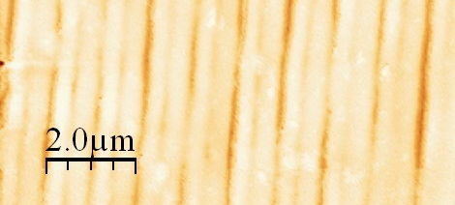

Fig. 5. AFM measurement of the relief grating obtained with an UV irradiation dose of 30 J/cm² and 30 mJ/cm²/pulse fluence. Two superimposed gratings are measured, the one with the same period of the phase mask being the dominant.[3]

References

- A very recent news concerning nanostructured materials, which still has to be reported in the web page, is represented by the publication of the book “Nanocomposite Coatings and Nanocomposite Materials”, A. Öchsner, W. Ahmed and N. Ali, Editors (Trans Tech Publications, Zurich, 2009).
- K. C. Vishnubhatla, S. Venugopal Rao, R. Sai Santosh Kumar, S. N. B. Bhaktha, A. Chiappini, A. Chiasera, J. Laureyns, M. Ferrari, M. Mattarelli, M. Montagna, R. Osellame, R. Ramponi, G. C. Righini, S. Turrell, D. Narayana Rao, Micro-Raman mapping of micro-gratings in 'BACCARAT' glass directly written using femtosecond laser, SPIE Proc. 6881, pp. 688141-1 - 688141-10 (2008).
- Cacciari, S. Pelli, G. Nunzi Conti, S. Soria, G.C. Righini, B.Tiribilli, U. Hollenbach, T. Mappes, J. Mohr, Bragg gratings fabricated by UV-laser irradiation on waveguides in polymethyl Metacrylate, Proc. MOC2008, 14th MicroOptics Conference, Brussels, September 25-27, 2008.
- C. Armellini, S.N.B. Bhaktha, A. Chiappini, A. Chiasera, M. Ferrari, Y. Jestin, P. Feron, E. Moser, C. Duverger Arfuso, B. Boulard, G. Speranza, L. Minati, G. Nunzi Conti, S. Pelli, G.C. Righini, P.T. Huy, Fabrication and Spectroscopic Properties of Glass-Based Erbium Activated Micro-Nano Photonic Structures, Proc. ICTON 2008, pp. 239-243 (2008).
- S. Berneschi, G. Nunzi Conti, I. Cacciari, S. Pelli, G.C. Righini, I. Banyasz, N. Quoc Khanh, T. Lohner, P. Petrik, Z. Zolnai, M. Bettinelli, A. Speghini, L. Mescia, F. Prudenzano, Annealing effect on optical barrier in ion-implanted tellurite glass waveguides , Proc. SPIE vol. 7218, DOI: 10.1117/12.811153 (2009).
- S.N.B. Bhaktha, C. Armellini, F. Beclin, M. Bouazaoui, B. Capoen, A. Chiappini, A. Chiasera, M. Ferrari, Y. Jestin, C. Kinowski, E. Moser, D.N. Rao, G.C. Righini, S. Turrell, SiO₂–SnO₂ glass-ceramics planar waveguides activated by rare earth ions, Proc. SPIE vol. 7212, DOI: 10.1117/12.808277 (2009).

WORKING GROUP OF WORKPACKAGES 1.4 and 2.2

Chairman: G. Righini (Nello Carrara Inst. Appl. Phys., Italy)
Members: P. Kazansky (Southampton Univ, UK)
U. Fotheringham, Schott Glas, Germany
J. Lucas, Univ.f Rennes, France
P. Mazzoldi, Uni di Padova, Italy
F. Nicoletti, Stevanato Group, Italy
L. K Ross, IOT Integriete Optik, Germany
V. P. Veiko, St Petersburg Inst of Prec Mech & Optics, Russia
R. Wyatt, BT, UK.

2.2- Workpackage 2- Nano-structure based glass applications

WP 2.1: Coatings made by sol-gel and chemical nanotechnology

- Objective and description of the work

The objectives were: characterisation of the nature of the substrate/coating interface to improve the adhesion and the abrasion resistance of the coatings.
The basic task pursued was:
- the characterisation of the nature of the substrate/coating interface for a single layer nanocomposite coating made by chemical nanotechnology.
The main techniques used were cross-section TEM and cross-section SEM, XRD, Spectroscopic Ellipsometry, SIMS and XPS with depth profiling.

Results

For the technical report on the nature of the glass/coating interface for a single layer nanocomposite coating made by chemical nanotechnology (corresponding to deliverable 18), it was decided that samples of sol-gel TCO (Transparent Oxide Coatings) on glass substrates (previously utilized for D17) would be used for this study as well. This deliverable, D18, was completed in June 2008.

PLANS FOR 2009

The plans for 2009 included the organization of a meeting in the beginning of 2009 in order to launch new activities, starting with the study of low index nanostructured coatings with tailored high porosity and nanostructured glass coatings for energy savings in buildings, to improve the thermal efficiency of low emissivity coatings on glass windows (Appendix 14).

In June 2008, Rui M. Almeida attended two EFONGA meetings. A meeting in Frankfurt on the 12th and a meeting in Trencin (Slovakia), on the 24th, held during the 9th ESG Conference and Annual Meeting of ICG.

Since September, the main activity has been the preparation of a manuscript based on the work done for deliverable D18, for submission to the Journal of Sol-Gel Science and Technology.

Meanwhile, a paper was published: M.A. Aegerter, Rui M. Almeida, A. Soutar, K. Tadanaga, Hui Yang and T. Watanabe, “Coatings made by sol-gel and chemical nanotechnology”, J. Sol-Gel Sci. Technol. 47 (2008) 203 – 236, summarizing the information compiled in deliverable D16.

The Working group of WP2.1 was involved in two separate conferences in 2009. The EFONGA meeting in Montpellier in May and the organization of a session on Glass science / Nanostructured glasses at the 8th Pac-Rim Conference on Ceramic and Glass Technology in Vancouver (Canada), from May 31 – June 5.

EFONGA meeting in Montpellier from 4-8 May, 2009

The EFONGA project organized in Montpellier (France), between 4 - 8 May, 2009, two consecutive scientific meetings related to glass.

The first one consisted of a Spring School, attended by ~ 65 Ph.D. students from different European countries working on topics involving glass, which took place on 4-5 May at a CNRS Center in Montpellier. This consisted of a series of 18 lectures (~ 45 minutes each), two of which were given by Rui M. Almeida (“Special techniques for glass making” and “Optical effects and crystallization”) and are attached as appendices (Appendices 15,16).

The second activity consisted of a 3-day Workshop, held in the Hotel Golf Club Massane, near Montpellier, from 6 to 8 May. This workshop included a number of different sessions, each one devoted to a particular EFONGA project Workpackage. Workpackage WP2.1, corresponding to the INM partner, was the object of a session on May 6, from 3:30 pm until 5 pm, designated by Nanoglasses. In this session, the main achievements of workpackage WP2.1 were presented, including the three deliverables D16, D17 and D18 and this was followed by two presentations by invited speakers on “Nanostructured germanosilcate glasses” (L.F. Santos) and “Rare-earth doped nano-glass-ceramics for efficient luminescence" (V. Tikhomirov).

OTHER ACTIVITIES

Some measurements were repeated during the 4th year of the EFONGA project in order to obtain additional data for the manuscript in preparation. In particular, XRD and SIMS/RBS.
Two examples are shown below:

Fig. 6. XRD of ITO film.
Incidence angle 3°, mean crystallite diameter evaluated for line broadening using Sherrer equation:
11 nm for both films; phase: cubic In2O3 PDF#712195.

Fig.7. SIMS spectrum of ITO UV sample converted with RBS data.
The detection limit of SIMS is below 10²⁰at/cm³: the background is therefore a measurement artefact. In the case of O, the conversion has been made on the film alone, subtracting the contribution of the substrate.

The activities during the 4th year of the EFONGA project included also the following recent activities.

In Padova:

First attempt to make AZO (aluminum zinc oxide) nanoparticles: ZnO has been obtained by colloidal chemistry at low temperature. ZnO nanoparticles have been successfully doped with Cu, Co and Ni, while problems have been found in doping with Al. From the literature review, it seems necessary to have a calcination step for obtaining AZO particles. Further experiments have been in progress and will be continued in the near future.

In Lisbon:

The preparation of titania films on glass and Si substrates, in order to investigate the possible use of titania-based coatings on glass for photocatalytic and solar control effects.

Fig. 8. Reflectance of TiO₂ films

This latest, more recent work has been done in collaboration with the Institute of Glass and Ceramics (ICV) and the Institute of Materials Science (ICMM), both in Madrid, Spain.

PUBLICATIONS AND OTHER CONTRIBUTIONS

M.A. Aegerter, Rui M. Almeida, A. Soutar, K. Tadanaga, Hui Yang and T. Watanabe, “Coatings made by sol-gel and chemical nanotechnology”, J. Sol-Gel Sci. Technol. 47 (2008) 203 – 236.

WORKING GROUP OF WORKPACKAGE 2.1 (during 4th year of project)

Chairman: Rui M. Almeida, IST/ICEMS, Lisbon, Portugal

Members: Alex Martucci, Univ. Padova, Italy
Sidney Ribeiro, Univ. Araraquara, Brazil
Kiyoharu Tadanaga, Osaka Pref. Univ., Japan
David Levy, ICMM-CSIC, Spain
M. Clara Gonçalves, IST/ICEMS, Portugal
Luís Carlos, Univ. Aveiro, Portugal
Mario Aparicio, ICV, Spain
Yolanda Castro, ICV, Spain
Hui Yang, Zhejiang Univ., China
Jian Xu, Univ. Ningbo, China

WP2.2: Waveguides, optical amplifiers and lasers

In the frame of this Work package the 2008/2009 activity has been mostly focused on the completion of the two planned deliverables, D20 (Round-robin test on the characterization of integrated optical amplifiers) and D21 (Handbook on integrated optical lasers and amplifiers based on glassy materials). Both activities have been performed thanks to national and international collaborations.
The round robin has involved IFAC CNR, Florence and Politecnico di Milano, in Italy; College of Optics, Tucson, in USA; Department of Applied Physics, University of Zaragoza, in Spain; Institute of Photonics and Electronics, Prague, in Czech Republic. Some preliminary results were presented at the XXI Congress of the International Commission for Optics, Sydney (Australia), 6-9 July 2008.[7] As planned in the previous activity report, the round-robin test has been completed with the measurements on a commercial Er-doped glass integrated optical amplifiers, bought from Teem Photonics in a custom format (i.e. without fiber pigtail and pump power laser)
(see Deliverable 20).
For what concerns the D21 deliverable, taking into account that a large amount of relevant references had already been made available in the D19 deliverable (Database of active glasses), it was decided to include in it only four works, namely the dedicated review paper Rare-Earth-Doped Glasses for Integrated Optical Amplifiers, by G.C. Righini and M. Ferrari, and published as Chapter 3 in the book “Physics and Chemistry of Rare-Earth Doped Glasses”[8], two papers on an emerging topic (microlasers based on resonant microspherical cavities) [9, 10], and a paper considering a challenging technical problem (the bonding of doped and undoped glasses for the fabrication of lossless integrated optical components) [11].
At the beginning of 2009, the discussion arose about the organization of the third edition of the Workshop on PHOTOLUMINESCENCE IN RARE EARTHS: PHOTONIC MATERIALS AND DEVICES. The two previous editions were both held in Trento, Italy, in 2005 and 2007, with the sponsorship and support of the TC-20 Committee of ICG and of EFONGA.. Eventually it was decided to postpone the 3rd Workshop to April 2010 and to held it in Florence, Italy. The co-chairs of PRE’10 will be again Maurizio Ferrari, Giancarlo C. Righini, and Setsuhisa Tanabe.
It can be underlined that in July 2009 a Special Issue of the Journal “Optical Materials” will be published, containing selected and peer-reviewed papers from PRE’07.

International Meetings and Conferences

For what concerns EFONGA primary activities, Stefano Pelli participated to the Advisory Board Meetings in Frankfurt in June 2008 and November 2008, as well as to the Montpellier meeting in May 2009.

Moreover, Simone Berneschi participated in the Smart Systems Integration Meeting in Brussels in March 2009, presenting a paper on tin-silicate glass-ceramics as a promising material for smart photonic circuits (especially in terms of the possibility of photostructuring it).[12]

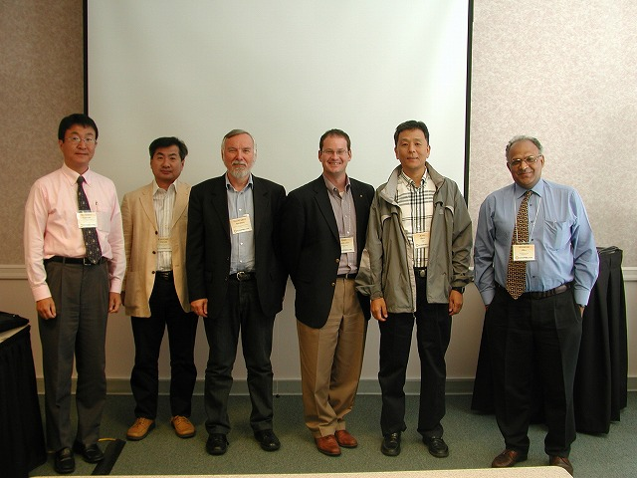
- Photo of members attending the 2008 Annual Meeting in Edmonton -

References

[7] S. Pelli, S. Berneschi, G. Nunzi Conti, G.C. Righini, M.Á. Rebolledo, G. della Valle, P. Laporta, S. Honkanen, F. Ondracek, J. Čtyroký, Round Robin Characterization of Integrated Optical Amplifiers, Proc. ICO 21 (Sydney, Australia, 2008).
[8] G.C. Righini and M. Ferrari, Rare-Earth-Doped Glasses for Integrated Optical Amplifier, in “Physics and Chemistry of Rare-Earth Doped Glasses”, N. Sooraj Hussain and J. Domingos da Silva, Editors (Trans Tech Publications, Zurich, 2008).
[9] G. Nunzi Conti, A. Chiasera, L. Ghisa, S. Berneschi, M. Brenci, Y. Dumeige, S. Pelli, S. Sebastiani, P. Feron, M. Ferrari, and G.C. Righini Spectroscopic and lasing properties of Er3+-doped glass microspheres, Journal of Non-Crystalline Solids 352, 2360-2363 (2006).
[10] G. Nunzi Conti, S. Soria, S. Berneschi, M. Brenci, F. Cosi, S. Pelli, C. Armellini, A. Chiappini, A. Chiasera, Y. Jestin, M. Ferrari, E. Moser, L. Ghisa, S. Trebaol, Y. Dumeige, P. Féron, and G. C. Righini, Glass microspherical lasers, Advances in Science and Technology Vol. 55 (2008) pp 46-55.
[11] Q. Chen, D. Milanese, Q. Chen, M. Ferraris, G.C. Righini, Fabrication and direct bonding of photosensitive multicomponent silicate glasses for lossless planar waveguide splitters, Journal of Non-Crystalline Solids, vol. 354, pp. 1230-1234 (2008).

[12] S. Berneschi, S.N.B. Bhaktha, M. Bouazaoui, B. Capoen, A. Chiasera, M. Ferrari, G. Nunzi Conti, S. Pelli, G. C. Righini, S. Turrell, Tin-silicate glass-ceramics: a promising material for smart photonic circuits, presented at the SmartSystems Integration Conference (SSI 2009), Brussels, 10-11 March 2009.

WP 2.3: Coatings on glasses

1. SUMMARY

Activities
1) Meeting of experts in 2008/09
- Meeting on June 20, 2008 in Veldhoven, The Netherlands;
- Meeting on October 21, 2008, in Gelsenkirchen, Germany;
- Meeting on May 7, 2009 in Lathom, UK
2) Self-cleaning glass test methods & round robins:
- Ongoing activities; Transfer of know-how to CEN TC129
3) Test methods & Round robins of TCO coated glass
- Ongoing activities; First round robin finished, second round robin started
4) Website
- Activities stopped; Information available on www.glassfiles.com
5) International Conference Coatings on Glass
- ICCG7 organized from June 15-19, 2008 in Eindhoven/Veldhoven, The Netherlands
- Short Courses on June 14, Veldhoven, The Netherlands

2. DETAILED INFORMATION WORKPACKAGE 2.3 ACTIVITIES 2008-2009

2.1 Meetings 2008-2009
Three meetings took place in this period, June 20, 2008 in Veldhoven, The Netherlands, October 21, 2008, in Gelsenkirchen, Germany and May 7, 2009 in Lathom, UK. During all meetings part of the meeting was dedicated to Self Cleaning Glass and part on TCO activities.
From June 15-19 an international Conference dedicated to coatings on glass was organised in Veldhoven, The Netherlands, with approximately 400 attendees. Prior to this conference short courses were given on several topics related to coated glass.
In June 2009, Karel Spee was replaced as chairman of ICG, TC24 by Kevin Sanderson, due to a job change. It was agreed that Kevin Sanderson would also lead the technical activities for WP2.3 of Efonga, Karel Spee was available to round off financials and would help assisting with the reports.

2.2 Self-cleaning glass test methods & round robins:
During the meeting updates on self cleaning / glass and reduced maintenance discussions conducted by committee members were presented. The test methods, for self-cleaning and reduced maintenance glass, developed by some of the members of WP2.3, have now been the basis of an activity of CEN TC129. The workgroup TC129 is now working on a new norm for standardisation of self-cleaning glass. The role/approach WP2.3 has been conducting over the last years, has been:
- Wider participation in the project with members from Japan, Europe, N. America all participating in WP2.3
- On going technical evaluation of the standard
- Viewing of the standard in context with other standards
In 2008 the results of studies conducted as part of WP2.3 were communicated to CEN TC129, and a formal agreement has been made with CEN TC129.
A number of areas of discussion following the results and discussions at the meetings of WP2.3 are under debate with CEN TC129:
- Dirt Mixture – The original dirt mixture in the test was developed based on real life build up on glass samples and air monitoring conducted as part of the EU funded Framework 6 project. However, the dirt mixture is a scientific representation of this, containing readily available chemicals to simulate fatty acids, sulphates, metals and other components found in real life. This has led to two different views:-
  - The dirt is a scientific representation of real dirt which can be reproducibly prepared and whilst not a real dirt can be linked back to scientific data in terms of rough content organic, inorganic, sulphates and metals.
  - The dirt is not representative of real life. In particular the high level of water soluble compounds in the dirt is a concern as it results in too much being re-dissolved and washed off during a simulated rainfall part of the test. This results in bare glass performing better on the test than would be expected and does not bring out the dual nature of the films functionality – photoactivity and hydrophilicity. In addition that the hydrophilic action of the coatings is not really represented due to the high solubility of the dirt.
    - Others claim that in real life a similar situation exists with even bare glass showing good cleaning after a heavy rain shower. It is also argued that the test does demonstrate the hydrophilic effect as this is important in aiding rinsing / removal of the dirt from the surface even if solubilised.
- Test Reproducibility – The reproducibility of the test between different labs has been a concern within WP2.3 with an initial round robin conducted as part of WP2.3 involving Cardinal, St. Gobain and the NSG Group. Laboratories have struggled to obtain comparable results at different sections of the tests. It is known that the CEN TC129 are setting up an extended round robin but key areas which need to be included in the round robin include in our opinion are:
  - Test equipment– how sensitive is the test to different manufacturers equipment and the impact of failures e.g. aggregation due to stirrer failure. It is felt additional advice is required in the standard to support statements such as – “The cabinet must be clean and exempt of any contamination source, especially silicone source.” In addition the impact of
  - Haze standardisation – an agreed calibration method is required as part of the test
  - Temperature, humidity, cleanliness and sources of UV. Studies of the impact of these are critical along with guideline figures / clear recommendations are required.
  - The test may be impacted by the initial dirt loading and as such an initial target value should be included in order to ensure the test is within usual parameters.
  - Should the test be applicable to aftermarket coatings, secondary processed glass e.g. toughened samples and how is lifetime of the coating simulated?
    - Some participants feel that in line with other CEN standards e.g. EN1096 the standard should simply apply to as produced samples. However, at a later stage incorporation of the test method following for example EN1096 tests to simulate lifetime may be appropriate
    - Others feel that the standard should cover all coating types and have an accelerated lifetime element to it to simulate the functionality of the coating over the lifetime of a double glazed unit.
- Classification – How do we define what is self cleaning, what is reduced maintenance and what is ordinary glass performance. Additional work on classification levels is felt appropriate.
- Relationship between real life and the accelerated test –
  - Measurement Method - As part of the Framework 6 evaluation an 18 month correlation between real life performance using a panel of observers and haze (evaluation method in accelerated test) was conducted. Additional studies have been commenced which some members of WP 2.3 feel do not show such a correlation between real life performance and haze. It is felt that CEN TC129 need to consider the statistical significance of these studies and as such whether haze is the best evaluation tool.
  - Real Life Evaluation –a discussion on the relationship between consumer perception of the coatings and quantitative values has been raised. Evaluations of the studies with respect to this aspect are felt to be something which the CEN TC129 should consider. Like many products external factors may influence performance e.g. exposure, weather. Whether the impact of these can or should be covered in standard needs to be considered along with manufacturers recommendations on product functionality.

These activities are ongoing and will be continued in ICG TC24 beyond the Efonga project.

Conclusion: WP2.3 has played a crucial role in the development of test methods for the characterisation of self-cleaning and easy maintenance glass. Although the basic test were developed by the members outside of WP2.3, and the set-up of a new norm is being done in CEN TC129, WP2.2 has been able to extend the know-how by the participation of non-European members, by extending the number of glass and glass related companies into the studies, and bringing in their results and opinions, and making comparisons with related products and norms.

2.3 Test methods & Round robins of TCO coated glass

In the beginning of the Efonga project, both TNO as INM have prepared overviews of available methods for the testing of TCO coated glass. An extensive discussion was started, which of the properties and measured by which techniques should be part of an official CEN norm which is the ultimate goal of the work started in Efonga, and being continued after the Efonga project in ICG TC24.

Initial screening by TNO and INM, and intensive discussions to compare with the methods being used in research labs in the glass industry, revealed that quite a number of different techniques are being used to measure quite a lot of different properties. It was decided not to make choices in this phase, but to start with a general first round-robin program. Pilkington provided identical test samples to 8 different WP2.3 participants. Each participant tested the samples with all of the techniques standard used in their labs. In June 2008 and October 2008 the results have been presented and discussed (see Table 4 for a small subset of the results).

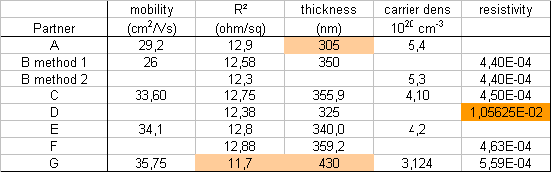

Table 4: Subset of obtained results in first round robin

It became clear from the results that the results showed large deviations, with quite some outliers. Especially it was highlighted that wide variations in thickness and Hall Effect measurements had been identified. The reasons behind these were discussed and it was felt that a key variation was in film thickness measurements and may be due to the multiple layer nature of the film supplied for the round robin. As such it has been agreed to expand the round robin with non commercial single layer samples of a TCO. Furthermore, it was discussed that as different TCO coated glass samples require completely different TCO properties, the work would concentrate on properties needed for Photovoltaic applications, as this will be the most demanding market in near future. Furthermore as TCO for photovoltaic’s have specific demands for its optical properties, the tests will include more detailed and extended optical measurements than performed in the first round robin. These conclusions were drawn after TNO presented two sets of measurements on a range of different samples showing considerable optical differences, which result when used in thin film solar cells in cells with very different efficiencies (see figures 9 and 10).
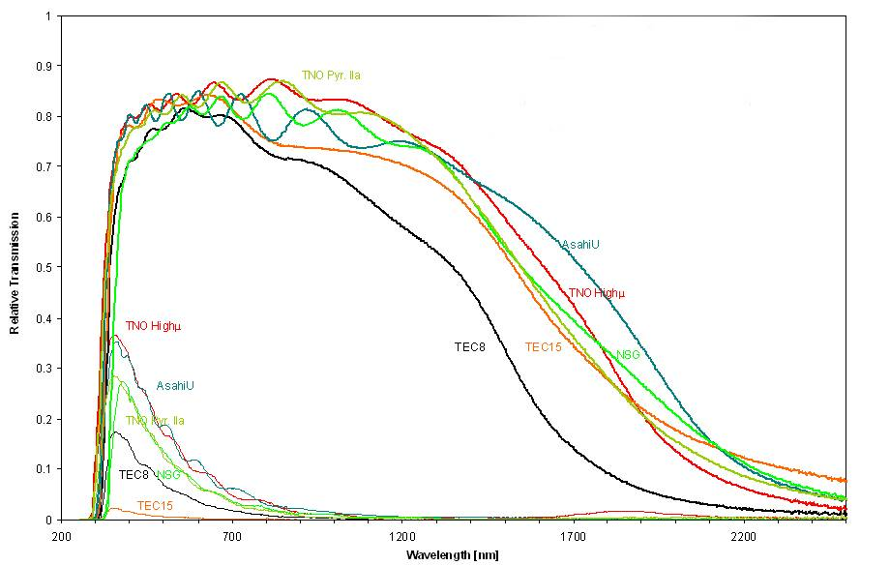
Fig. 9: Haze and total transmission of a number of commercial and laboratory TCO samples

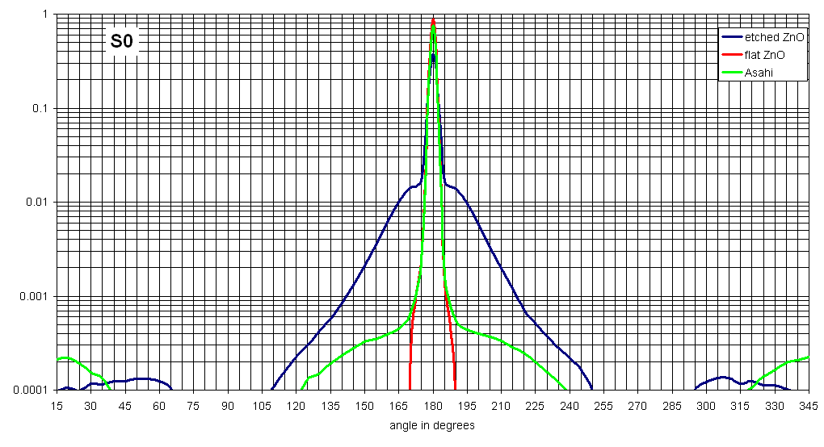
Fig. 10: Reflection measurements on three TCO samples (sputtered and chemically etched ZnO, sputtered flat ZnO and Ashai U-type APCVD F:SnO₂)

New samples have been prepared and are being measured, but the results were not available before the end of the Efonga project. This work will be continued in ICG TC24.

Conclusion: WP2.3 has initiated a collaborative study involving the largest glass companies active on the market of TCO coated glass, to work on obtaining reliable test methods for the testing of commercial TCO coated glass samples. Especially the photovoltaic market, a market which is growing very fast and for which the quality of TCO is of the utmost importance needs a good norm for the characterization of TCO coated glass products. Although the progress in WP2.3 has been slower than originally anticipated, developing good test methods and testing them in round robins is very much in progress, and will be continued beyond the Efonga project.

2.4 Coated Glass internet website
In 2007/2008 most of Efonga task 2.3 members and the underlying TC24 group of ICG went through a considerable member change, inactive members were asked to leave the group, and quite a number of active new members were joining the group. Also the chairman and up to that point the person who had set-up a database and an internet site, and who, with help of the members started filling the site with data in 2008, resigned from the group due to a job change, moving out of the coated glass business. Within the new group, the need for such a site was not felt as important as in the old group, and no one was found to resume the activities for now, so the activities were set on hold. So although the site has been open for a while, it has now been stopped. One of the reasons the interest was diminished was because another internet site, although dedicated to glass in general, also is collecting and disseminating information for the coatings on glass area (www.glassfiles.com). This site is set-up by one of the Efonga members (J. Vitkala), but outside Efonga support, and contains a lot of information also being collected within WP2.3.

2.5 International Conference Coatings on Glass
WP2.3 members have been actively involved in the organisation of the 7th International Conference Coatings on Glass and Plastics (ICCG7), which was very successfully organised in Veldhoven (The Netherlands) from 15-19 June, 2008, with more than 400 participants from 34 countries. There were 7 Technical Sessions with 54 speakers and 55 posters presenting their latest knowledge in the extensive fields from new markets and trends over different technologies for product design as well as technical aspects, safety measures and environmental and economic factors (more info www.iccg7.nl). A special panel discussion with 6 panel members was dedicated to photovoltaic’s one of the hottest topics at the moment in the coatings on glass area. Chairman of the ICCG7 conference was Karel Spee, who was at that time also leading WP2.3 of Efonga.
The next conference will be organised in Braunschweig, Germany. Members of WP2.3 are again actively involved in the organisation.
To boost the student participation to ICCG7, the organisation heavily sponsored the participation of students, bye asking only about half of the normal conference fee, and reducing the fee additionally for students who had either an oral or a poster presentation.

4. PUBLICATIONS AND OTHER CONTRIBUTIONS
- Proceedings of the 7th International Conference on Coatings on Glass and Plastics (ICCG7), June 15-19, 2008, Eindhoven, The Netherlands, ISBN 978-90-5986-281-4
- Thin Solid Films, Vol. 517, 10 (2009), special edition, refereed papers from the ICCG7 conference.

5. WORKING GROUP OF WORK PACKAGE 2.3

Project leader: Kevin Sanderson, Pilkington, UK, Managing technical part
Karel Spee, TNO, The Netherlands, Managing financial part & report.

Members: Ronan Garrec, CDI/Saint Gobain, France
Arne Roos, Uppsala University, Sweden
Tobias Kaelber, Schott AG, Germany
Andy Simpson, Pilkington European Technical Centre, UK
Christian Wagner, Velux A/S – Panes, Denmark
Sigbjørn Christophersen, Velux A/S – Panes, Denmark
Bernhard Goer, Pilkington Deutschland AG, Germany
Dominique Coster, Glaverbel - R&D Centre, Belgium
Jörg Pütz, Carl Zeiss, Germany
Leena Hupa, Åbo Akademi University
David Sheel, CVD Technologies ltd., UK
François Creuzet, Saint Gobain Recherche, France
Jorma Vitkala, Tamglass Ltd. Oy, Finland
Koichi Suzuki, Surftech Transnational Co.Ltd, Belgium
Andre Piers, TNO Quality B.V., Netherlands
Hansjörg Weis, Interpane, Germany
Hüseyin Parlar, Sisecam, Turkey
Peter van Nijnatten, OMT Solution B.V., The Netherlands
Paul Bastianen, Van Noordenne Safety Glass B.V., The Netherlands
Thomas Belgardt, Interpane, Germany
Emmanuel Valentin, Saint Gobain, France
Monika Mitterhuber, ETC-Products, Germany
Joop van Deelen, TNO, The Netherlands

Advisors outside EU: Kari Myli, Cardinal Glass Industries, USA
Michael Andreasen, Vacuum Edge, USA
Klaus Hartig, Cardinal Glass Industries, USA
Makita Kensuke, Central Glass Co, Japan
Masahiro Hirata, Nippon Sheet Glass Co., Ltd, Japan
Susumu Suzuki, Research Center Asahi Glass Co., Ltd., Japan
Kensuki Makita, Central Glass, Japan
Russel Pylkki, Aspen Research Corporation, USA
Fred van Milligen, JDS Uniphase, USA

2.3- Workpackage 3- Glass processing mechanisms and modelling

WP 3.1: Properties of Glass Forming Melts

SUMMARY

Workpackage 3.1 of the EFONGA programme, delivered the following main results:
A final report, on: “Round Robin Test on Liquidus Temperature of Soda-Lime-Magnesia-Silica Float Glass samples”, ready for publication in an European glass journal.
A catalogue was extended, presenting a world-wide list of facilities (laboratories) that perform measurements to determine different glass melt properties (more than 35 different properties).
A new Round Robin test has been defined and has been initiated in March 2008: “Thermochemical modeling of multi-component silicate glass compositions.”
A Website has been launched in August 2008 and can be accessed through: www.icglass.com (ICG website)
An expert meeting on Innovative Glass Melting for the Year 2020 with top specialists from all over the world was organized by WP 3.1 from 26.-29. March 2008 in co-operation with WP 1.2.

a. Meetings of Experts on glass melting & preparation of main project definitions innovative glass melting:
Experts on glass melting met three times to discuss future strategies of innovative glass melting based on the first meeting in BRIG (March 2008). The meetings were held on 24. June 2008 in Trenčín, Slovakia, with 15 participants, in Düsseldorf on 23rd of October 2008, with 20 participants and in Offenbach, Germany on 8. January 2009 with 10 participants. Project plans have been prepared on the 4 main issues of the Glass Melting Innovation Roadmap:
1). Innovative glass melting concepts and furnace designs;
2). Innovative batch processing;
3). Waste heat recovery from flue gases of glass furnaces;
4). Sensors and Advanced Control for Glass Production.

An annual meeting of WP3.1 (and TC18 of the ICG) was organized on 22. June 2008 in Trenčín, Slovakia (see minutes in Appendix 17).

b. Publications:
Five papers (publications) from activities and workshops of this work package have been published in 2008 in two journals (see Appendices 18-22):
Glass Techology: European Journal Glass Science & Technology A,
Beerkens, R.G.C.; Conradt, R.: Round robin test on liquidus temperature of soda–lime–magnesia–silica float glass samples- A technical report of the ICG Technical Committee (TC 18) on Properties of Glass Forming Melts. Glass Tech.: Eur. J. Glass
Sci. Technol. A, October 2008, 49 no. 5 pp. 205-212

Ceramics-Silikaty with 4 papers presented at the 26.-29. March 2008 seminar/expert meeting on “Innovative Glass Melting for the Year 2020” in Brig (Switzerland):
- R. Beerkens: Analysis of elementary process steps in industrial glass melting tanks - some ideas on innovations in industrial glass melting, Ceramics-Silikaty 52 [4] 206-217 (2008).
- M. Kawaguchi, T. Kato, Y. Imamura, N. Yoshida, S. Aoki: Challenge to improve glass melting and fining process, Ceramics-Silikaty 52 [4] 218-224 (2008).
- L. Němec, V. Tonarová: Glass melting and its innovation potentials: bubble removal under the effect of the centrifugal force, Ceramics-Silikaty 52 [4] 225-239 (2008).
- L. Němec, P. Cincibusová: Glass melting and its innovation potentials: the role of glass flow in the bubble-removal process, Ceramics-Silikaty 52 [4] 240-249 (2008).

c. Seminars:
In co-operation with Glass Trend, Work Package 3.5 and Work Package 3.1, a seminar on Conditioning of Glass Melts & Forming of Glass Products 13. & 14. November 2008 at TNO in Eindhoven in the Netherlands was organized with 12 extended papers and an excursion. A CD ROM with the power point presentations and the abstracts has been prepared (Deliverable S14).

A seminar was organized between the work packages (3.1, 3.2, 3.4 and 3.5) from 6 till 8 May 2009 in Montpellier. The activities of work package 3.1 were also discussed during these EFONGA meetings in Montpellier on 6-8 May 2009. See Appendix 23.

A seminar was organized in Montpellier, with a session on Glass Melting, the papers have been collected (power point presentations converted in pdf format), part of Deliverable S12.

The activities and deliverables of work package 3.1 were presented in the St. Petersburg (Russia) meeting on 29. January 2009.

The WebSite (Work Package 3.1 and TC18: http://www.icg.group.shef.ac.uk/TC18/TC18Mission.htm)
has been updated in April 2009.

The catalogue was extended, presenting a world-wide list of facilities (laboratories) that perform measurements to determine different glass melt properties (more than 35 different properties).

In 2008 a new Round Robin test among experts of thermodynamic modeling has been started, but this will be finalized in 2010. This Round Robin test is on Thermodynamic Modeling of Multi-component silicate melts.

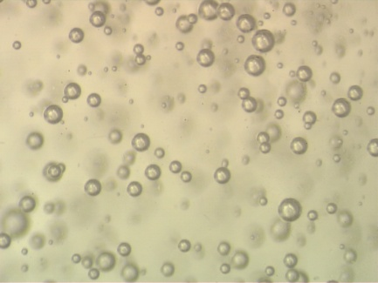 Bubbles in glass

DETAILED INFORMATION WORKPACKAGE 3.1 ACTIVITIES 2008-2009

Meetings 2008-2009
An annual meeting for contributors to work package 3.1 and members of the TC18 (Properties of Glass Forming Melts) of the International Commission on Glass was organized on 22. June in Trenčín. Topics of discussion have been: Progress Round Robin Tests and Proposal for future Round Robin Test (2008-2009), report on BRIG Expert meeting on Innovative Glass Melting, Submission of Paper on Round Robin Test on liquidus temperature analysis of clear float glasses, and the Website.10 participants met here to discuss recent activities on properties of glass forming melts .

During the annual meeting two oral presentations have been given:

Reinhard Conradt: Calculation of Liquidus Temperatures of Multicomponent Glasses -Options and Limits
Lubomír Němec: (Laboratory) Studies on innovative glass melting.

Minutes are given by Appendix 17.

On 6-8 May 2009 a meeting was organized in Montpellier, France, for all EFONGA work packages to report on their activities in the period June 2005 – May 2009. A session has been organized for the Work Packages focusing on Glass Melting: WP3.1, WP3.2, WP3.4 and WP3.5. Presentations have been collected, see Deliverable S12.

The project leader of WP 3.1 participated to the monthly EFONGA telephone conferences and to three EFONGA progress meetings:
24. June 2008, in Trenčín, Slovakia
17. November 2008, in Frankfurt, Germany
29. January 2009, in St. Petersburg, Russia

Activities 2008-2009
Organisation of seminars/conference sessions:
- A 2-days seminar in co-operation with Work Package 3.5 and Glass Trend in Eindhoven, the Netherlands: Conditioning of Glass Melts & Forming of Glass Products on 13 and 14 November 2008, with 12 extended presentations (collected on a CD ROM, Deliverable S14) and an excursion. The seminar was visited by 48 participants.
- A web-site in co-operation with the ICG-TC18 has been revised and updated in April 2009 and is operational: http://www.icg.group.shef.ac.uk/ (link: Technical Committees, TC18).
- A workshop for the Work Packages on Glass Melting & Forming (WP 3) was organized from 6-8 May 2009 in Montpellier, see Appendix 24)
- The catalogue on “Measurement Facilities for Investigations of Glass Melt Properties” (worldwide catalogue with facilities that are available to measure physical, mechanical and chemical properties of molten glasses) was extended. Catalogue can be ordered free of charge from: ruud.beerkens@tno.nl
- A Round Robin on Thermodynamic Modeling of Multi-Component silicate melts has been continues. First results have been delivered by two experts in 2009.
- Five papers have been published in the second half of 2008 as a results of WP 3.1 activities (Appendices 18-22):

Beerkens, R.G.C.; Conradt, R.: Round robin test on liquidus temperature of soda–lime–magnesia–silica float glass samples- A technical report of the ICG Technical Committee (TC 18) on Properties of Glass Forming Melts. Glass Tech.: Eur. J. Glass Sci. Technol. A, October 2008, 49 no. 5 pp. 205-212

R. Beerkens: Analysis of elementary process steps in industrial glass melting tanks - some ideas on innovations in industrial glass melting, Ceramics-Silikaty 52 [4] 206-217 (2008).

M. Kawaguchi, T. Kato, Y. Imamura, N. Yoshida, S. Aoki: Challenge to improve glass melting and fining process, Ceramics-Silikaty 52 [4] 218-224 (2008).

L. Němec, V. Tonarová: Glass melting and its innovation potentials: bubble removal under the effect of the centrifugal force, Ceramics-Silikaty 52 [4] 225-239 (2008).

L. Němec, P. Cincibusová: Glass melting and its innovation potentials: the role of glass flow in the bubble-removal process, Ceramics-Silikaty 52 [4] 240-249 (2008).
Fig. 11

Round Robin Tests running in 2008-2009:
In 2008, a new Round Robin was launched and experts have been invited to participate in a comparison of thermodynamic Modeling of Multi-component Silicate Melts. Three types of glass compositions have been defined and the experts are invited to determine by their mathematical-thermodynamic modeling approaches and databases the chemical activities of the individual oxides in the multi-component glass compositions. The first results of two participants have been reported in Spring 2009.
More results are expected in the second half of 2009 and 2010.

Fig. 12. Mixtures of associated species in sodium silicate melt (from Reinhard Conradt)

Co-operation with groups in the EFONGA project and co-operation in organizing seminars
Follow-up meetings have been organized with experts of WP3.2 and WP3.4 after the BRIG expert meeting on Innovative Glass Melting for the Year 2020 in Brig (26-29 March 2008).
These meetings were organized in:
in Trenčín, Slovakia, 24. June 2008 with 15 participants,
in Dusseldorf on 23rd of October 2008, with 20 participants and
in Offenbach, Germany on 8. January 2009 with 10 participants.
Outcome of these meetings are project plans concerning:
1). Innovative glass melting concepts and furnace designs
2). Innovative batch processing
3). Waste heat recovery from flue gases of glass furnaces;
4). Sensors and Advanced Control for Glass Production.

A joint seminar with WP3.5 and Glass Trend was organized in Eindhoven, the Netherlands (see above) on: Conditioning of Glass Melts & Forming of Glass Products, 13. and 14. November 2008

On 6-8 May, 2009, the work packages met in Montpellier to discuss the highlights and main activities of these work packages in the EFONGA project, period 2005-2009. A session on: Glass Melting was organized on 7. May 2009 in Montpellier (F).

Minutes, presentations and reports can be delivered on request (ruud.beerkens@tno.nl)

Working group WP3.1

Project leader: Ruud Beerkens, TNO, The Netherlands

Vice-Chairs/ Core Group: Reinhard Conradt, RWTH, Germany
Thomas Pfeiffer, Schott AG, Germany

Members: Ulrich Roger, HVG, Germany
Detlef Köpsel, Schott AG, Germany
John Buckett, Pilkington, UK
Kay Karlsson, Abo Akademie, Finland
Marie-Helene Chopinet, Saint Gobain, France
Wilfried Linz, Schott AG, Germany
Marianne Guldberg, Rockwool Int. Denmark
Alexander Flügel, Germany
Advisors outside EU: Edward Boulos, Visteon, USA
Harrie Stevens, Alfred University, NY USA
Phil Ross, USA
Shige Aoki, NEG, Japan
Masataka Kawaguchi, NEG, Japan
Noriyuki Yoshida, NEG, Japan
James A. Shell, Gahanna, Ohio, USA
Oleg Prokhorenko, St. Petersburg, Russia
Oleg Mazurin, St. Petersburg, Russia
Nobuyuki Kido, Asahi Glass Ceramics, Japan
Kenji Oda, Asahi Glass, Japan
Lale Önsel, Şişecam, Turkye
Hande Sengel, Şişecam, Turkye

Fig. 13

WP 3.2: Gas solubility in glasses

SUMMARY

The members of the WP 3.2 work on 3 different problems: (1) the determination of the absolute water content in borosilicate glass in order to derive reliable absorption coefficients for the IR spectroscopic water analysis, (2) the determination of the blistering rate of refractory materials in glass melts and the understanding of mechanisms of blister formation in refractories, (3) the understanding of mechanisms of deposit formation in bubbles in float glass. The work has partially been performed in collaboration with WP4.1.
In 2008 two meetings were held in Trencin during the ESG conference. Furthermore, 3 core group meetings were held at different places (Brussels/Belgium, Lathom/UK, Herzogenrath/Germany), among them one core group meeting together with WP4.1.

PLANS AND DELIVERABLES FOR 2008

a) Water in borosilicate glasses
In addition to measurements undertaken in 2007, the absolute water concentration in borosilicate glasses has been analysed with two additional methods – Karl-Fischer-Titration (KFT) and Elastic Recoil Detection Analysis (ERDA). The KFT method can only be used for glasses with a relatively high water concentration. Therefore, only 3 of the 5 glass compositions could be analysed with KFT. The results on the variation of the absorption coefficient for water in a range of borosilicate glass compositions as determined using the five different methods are summarised in Figures 13 and 14 below. Inspection of the figures shows that within the range of experimental error the NRA, ERDA and KFT techniques agree in the variation of absorption coefficient as a function of glass composition. The VHE technique consistently evolved slightly lower amounts of water and hence afforded a higher water absorption coefficient. It is currently thought that some water from borosilicate glass melts may be evolved as HBO₂ which cannot be quantitatively analysed using mass spectroscopy. Some final experiments are planned to take place at the BAM institute in Berlin in order to verify the problem associated with analysis of HBO₂. After these experiments have been undertaken it is hoped that the work on the measurement of the absorption coefficient of water in borosilicate glasses can be concluded.

Fig. 14: | Absorption coefficient for the band at 2.8μm in borosilicate glasses: 15Na₂O.xB₂O₃.(85-x)SiO₂, determined with 4 different analytical methods

Fig. 15: | Absorption coefficient for the band at 2.8μm in borosilicate glasses: yNa₂O.10B₂O₃.(90-y)SiO₂, determined with 4 different analytical methods

b) Refractory blisters (in collaboration with WP4.1)
The round robin test on the determination of the blistering rate with the dynamic blister test has been repeated twice. The results are summarised in figure 15 below:

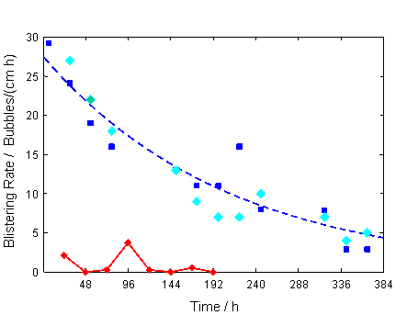

Fig. 16: | Blistering rate determined with dynamic blister test (2 participants)

The red diamonds indicate the first repeat results for participant 1 and the dark blue squares are the repeat results for participant 2. The differences in the results were discussed during the combined TC11 and WP3.2/TC14 meeting held in Brussels. Possible reasons for the big discrepancy were attributed to differences in the preparation of the glass cullet used for the test and differences in the bubble counting procedures. It was decided to repeat the test a 3rd time under absolutely equal conditions. The repeat results for participant 2 are depicted by the light blue diamonds in Figure 15 showing good reproducibility. The data from the second repeat experiment by participant 1 is still being assessed but it is already clear that many more bubbles have been detected. The problem was thought to be largely due to a difference in the optical resolution of the camera systems used by the two participants. It is hoped that in the near future agreement can be reached between the two participants, the test procedure agreed and that other TC11 and WP3.2/TC14 members can participate in further refractory corrosion tests.

In order to understand the mechanisms of blister formation not only the analysis of the gas content of freshly formed blisters at the refractory – melt interface is important but also the analysis of impurities in the refractory. Therefore, it was decided to broaden the focus of this activity by analysing the impurities in the refractory material such as carbon, sulphur and nitrogen (nitrides). Together with WP4.1 three different analytical methods have been identified which should be used for the impurity analysis in the next step.

Additionally, the structure of the AZS refractory was explored using Computer Tomography (CT). The structure of the refractory is shown in Figure 16 below:

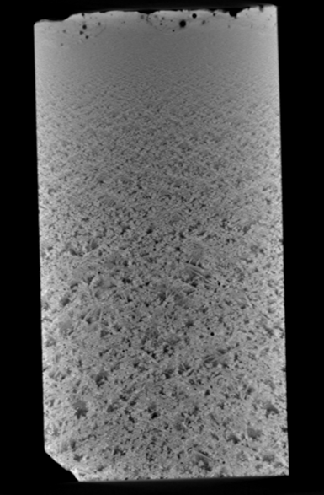

Fig. 17: | CT photograph showing porous refractory microstructure

Inspection of Figure 16 shows that the AZS refractory contains many pores that could potentially be responsible for blister generation when in contact with a glass melt. An initial investigation into the chemistry of the gas trapped in the refractory pores has been undertaken. The results are shown in Table 4 below:

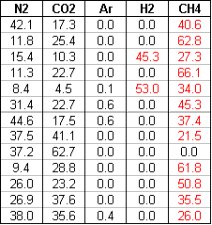

Table 5: | Gas analyses on refractory pores

The initial results are somewhat surprising, showing the presence of reactive gases such as hydrogen and methane. Further information on the gas chemistries of the pores will be afforded following analysis by other TC11 and WP3.2/TC14 members. The results will be discussed at future meetings.

c) Sulphur deposits in bubbles
The gas content of bubbles with deposits and the deposits themselves have been analysed with 2 different methods (SEM/EDX and Raman spectroscopy).
The bubbles contain mainly N₂ and some Ar, SO₂, CO₂ (N₂ > 90%, Ar ≈ 1, CO₂ < 6%, SO₂ < 2%). The deposits consist mainly of sulphur and/or sulphur compounds (SEM/EDX). With the help of Raman spectroscopy sulphate (Na₂SO₄) and sulphur (Fig. 17,18) have been found.

Fig. 18: | Raman spectra of the gaseous species and the deposits at the bubble boundary (float glass, Sisecam, nitrogen peaks not shown)

Fig. 19: | Raman spectra of the gaseous species in a bubble (float glass, Pilkington)

It is assumed that the deposits are formed at the bubble boundary during cooling of the glass samples according to the following reactions:

Reducing conditions:
3n SO_{2(gas)} + 2n Na₂O_{(glass boundary)} 2n Na₂SO_{4(deposit)} + S_{n(deposit)}
(2 ≤ n ≤ 8)

Oxidising conditions
SO_{2(gas)} + Na₂O_{(glass)} + Fe₂O_{3(glass)} Na₂SO_{4(deposit)} + FeO_{(glass)}

It was decided to investigate the influence of the redox conditions on the deposit formation as a next step.

ACTIVITIES in 2008

Meeting | Date | Place | Topics | Participants
Core group meeting + invited refractory experts | 09/04/2008 | Brussels, AGC Flat glass Europe | - Determination of the refractory blistering rate: results of the 1st round  - Discussion of the reasons for the deviations and the actions for the next round | 7
Core group meeting | 18/04/2008 | Lathom, Pilkington | - Presentation of analytical results of the deposits in bubbles  - Discussion of potential mechanisms of deposit formation and next actions  - WP 2.3 website | 6+2 guests
WP 3.2 meeting | 22/06/2008 | Trencin | - Presentation of new results on water in borosilicate glass and discussion of the reasons for the deviations and next steps  - Presentation of analytical results of the deposits in bubbles, discussion of potential mechanisms of deposit formation and next actions | 12
WP3.2 meeting + invited refractory experts | 22/06/2008 | Trencin | - Determination of the refractory blistering rate: results of the 2nd round  - Discussion of the reasons for the deviations and the actions for the 3rd round | 17
Joint core group meeting WP3.2+ WP4.1 | 23/10/2008 | Herzogenrath, St.Gobain | - Presentation of literature data on impurities in refractories  - Discussion of the literature data  - Identification of “best” methods for a following RRT on impurities (C, N, S) in AZS material | 12
WP3.2 meeting | 14-15/05/2009 | Istanbul, Sisecam | - Discussion of new results on water in glass (ERDA)  - Refractory blisters: Discussion of gases in closed pores and next steps (impurity analysis)  - Discussion of joint seminar/session of WP3.2+WP3.4 during the ICG congress in Brazil, 2010  - Condensates in bubbles -next steps: Preparation of synthetic bubbles in order to investigate the influence of redox conditions | 10

PLANS FOR FUTURE WORK

a) Water in borosilicate glasses
Further work to be conducted at BAM in Berlin in order to assess whether HBO₂ can be quantitatively measured using mass spectroscopy

b) Refractory blisters (in collaboration with WP4.1)
The blistering rate has to be determined a 3rd time under absolutely equal conditions. In order to understand the mechanism of blister formation additional investigations have to be undertaken:
- analysis of the gas content of freshly formed blisters
- analysis of the gas content of “pores” in the refractory material
- analysis of impurities in the refractory and their influence on blister formation (support of WP4.1)

c) Sulphur deposits in bubbles
The influence of the redox conditions on the deposit formation has to be investigated. Therefore, bubbles with deposits have to be collected from furnaces running under oxidising and reducing conditions. Additionally, bubbles in a glass with low iron content have to analysed.

d) Preparation of a session/seminar during the next ICG congress in Brazil in 2010
The WP2.3 and WP3.4 decided to prepare a seminar on modelling of bubble formation, bubble behaviour, fining and refining during the next ICG congress in Brazil in 2010.

WORKING GROUP OF WORK PACKAGE 3.2

Chairman: | D. Koepsel | Schott AG, Mainz, Germany
Secretary: | J. Buckett | Pilkington, UK
Members: | R. Beerkens | TNO, Eindhoven, The Netherlands
 | H. Behrens | University Hannover, Germany
 | M.-H. Chopinet | Saint Gobain Recherche, France
 | O. Collart | Glaverbel, Belgium
 | J. Daniels | ZGU Ilmenau, Germany
 | M. Gaber | BAM Berlin, Germany
 | F. Geotti-Bianchini | SSV, Italy
 | K. Heide | Friedrich-Schiller-University Jena, Germany
 | J. Hermans | Philips Lighting, Winschoten, The Netherlands
 | J. Klouzek | Institute of Chemical Technology, Prague
 | F. Kraemer | Retired
 | W.Linz | Schott AG, Mainz, Germany
 | R. Mueller | BAM Berlin, Germany
 | H. Mueller-Simon | HVG, Germany
 | L. Nemec | Institute of Chemical Technology, Prague
 | M .Oran | Sisecam, Turkey
 | J. Ullrich | Glass Service, Czech Republic

WP 3.4 . Modelling of glass melting processes

1. SUMMARY

Studies on WP 3.4. from May 2008 to May 2009 can be summarized in the following items;

- The report for round robin test investigation of a glass furnace with a combined mathematical model is completed (RRT and RRTa). The studies have been carried out to see the effects of
. different batch blanket models and combined modeling and assumptions,
. improvements on dimensions and operation parameters of the
hypothetical furnace,
. properties of batch and glass and
. boundary conditions of glass bath, batch blanket and combustion space.

- Studies on a new round robin test have been made. A furnace from Philips has been proposed by TNO. A presentation introducing the furnace and the available data was prepared. It was agreed to make the new round robin test on this furnace.

2. ACTIVITIES
- Round robin test on combined models for investigating batch blanket models and improvement of glass bath and combustion space modelling and parameters (RRT and RRTa).
The tests have been thoroughly investigated and many evaluations have been done with the members who have participated in the tests. Therefore, it was planned to complete the tests and prepare a report (Deliverable 29). An outline for the report was prepared and each member who has worked on the round robin tests collected their final studies and prepared short information on their glass, batch blanket and combustion space modeling. Outputs from the final study are processed and compared. The studies, modeling information of each member and final results are prepared as a report.

- New study on the furnace application of combined modelling

Studies on new round robin test of combined modelling of an industrial furnace continued. For this new test, an old Philips furnace that has good record of operation data and measurements of temperature along the depth of glass at several points was simulated. Outputs were examined with respect to furnace data and measurements.

3. DELIVERABLES IN 2008-2009

- WP 3.4. Report for May 2008 - May 2009 studies.

- Report for round robin tests RRT and RRTa is completed. The report is completed and the report and outputs of each member are presented as Deliverable 29.

4. WORKING GROUP OF WORKPACKAGE 3.4

Chairperson: Lale Onsel, Sisecam, Turkey

Members: Wolfgang Muschick, Mainz, Germany
Stanislav Kasa, ICT Prague, Czech Republic
Erik Muysenberg, Glass Service, Netherlands
Menno Eisenga, Glass Service, Netherlands
David Martlew, Pilkington, UK
Graham Unwin, Pilkington, UK
Adriaan Lankhorst, TNO, Netherlands
Mathi Roengen, TNO, Netherlands
Gerd Philipp, JSJ-Jodeit, Germany
Otto Hofmann Jena, Germany
Wolf Kuhn, Stein Heurtey, France
Robert Markiewicz, Videocon, Poland
Matthias Lindig, Sorg, Germany
Camille Moukarzel, Stein Heurtey, France
Klaus Jochem, Schott, Germany
Zeynep Eltutar, Sisecam, Turkey
Fabien Bouillet, Saint Gobain , France
Jaydeep Kulkarni, Fluent,UK
Didier Bessette, Fluent,France

WP 3.5 . Modelling of glass forming processes

SUMMARY

The WP3.5 core group met twice in 2008-2009. The first core group meeting took place in Mainz, Germany on May 28th, where the Trenčín meeting was prepared.
The second meeting was held in Eindhoven, NL on August 25 to discuss the Round Robin study (Bench Mark Problem) BMP-I results in detail, to slightly simplify output definitions and to prepare the Eindhoven meeting for November.

The first meeting took place on June 22nd, 2008 in Trenčín, Slovak Republic. The focus of our meeting was the schedule to finalize BMP-I and a discussion of the draft versions for extended Gob (BMP III.2) and Fibre forming (BMPIII.2) bench marks – both new definitions and chosen boundary conditions are now in line with experimental facilities at Emhart (BMPII.2) and Cleveland State University (BMPIII.2) respectively. For the latter, experimental data are already available (ref. to presentations given by Simon Rekhson in former WP3.5 meetings) whereas the set up of Emhart’s experimental facility is ongoing and tests & measurements are scheduled to be completed by beginning of 2009.

The second meeting took place on November 12th, 2008 in Eindhoven, NL. A detailed comparison of BMPI results was presented and intensively discussed. A first résumé is that all of the three codes involved are capable to solve 3d non-isothermal pressing problems with extremely large deformations in acceptable (CPU) times. Not all of the results were in good agreement which might be due to insufficient?? (not well defined exact positions of the monitor points used for comparison?) position of the defined monitor points. For BMPII.2 (Gob) an advanced version of the definitions was presented and discussed and a schedule for next steps has been fixed. For BMPIII.2 (Fiber drawing), a detailed definition/set of boundary conditions with all required information to set up the models is now on hand. But finally it seems that not more than one code would be capable to solve the complete coupled (glass flow / air flow / radiation) problem.

A Seminar on “Conditioning of Glass Melts and Forming of Glass Products” held from November 13th until 14th 2008 in Eindhoven was co-organized by WP3.1 and WP 3.5. The program included 12 papers and an excursion to EMGO, Lommel (Belgium) to visit their glass ribbon process for the production of glass bulbs. The seminar has had about 50 international attendees (Deliverable S14).

MEETINGS in 2008

28.05.2008 Mainz Core Group Preparation Trenčín meeting
22.06.2008 Trenčín WP3.5 Update status of BMP’s
25.08.2008 Eindhoven Core Group Preparation Eindhoven November meeting
Discussion BMP-I results
12.11.2008 Eindhoven WP3.5 Presentation BMP-I results
Presentation & discussion extended BMP
definitions for gob and fibre forming
13./14.11.08 Eindhoven Glass Trend Workshop

PLANS AND DELIVERABLES FOR 2008

Bench Mark Problem I “3D TV-Panel-Pressing”
- Put TNO, Polyflow, NoGrid data together and check consistency; final review of the data by the core group (done)
- Core group: Fix a time schedule to finish BMP I (done)
- The final comparison shall be presented at the next WP3.5 meeting in Trenčín (June 2008); (partly done in November 2008 in Eindhoven, ongoing)
- Dries Hegen & core group: Preparation of a common paper to publish the BMP-I-results. (ongoing)

Bench Mark Problem II “Gob Forming” / Advanced BMP II.2
- Polyflow, NoGrid: provide the required data for the final comparison to Matt Hyre (done)
- TNO: check whether BMP II can be done using software code TNO-GPP and give feedback to Matt Hyre when the data could be provided to him?; (done)
- Put TNO, Polyflow, NoGrid data together and check consistency; final review of the data by the core group; (done, only for Polyflow & NoGrid results)
- Core group: Fix a time schedule to finish BMP II; (done)
- The final comparison shall be presented at the next WP3.5 meeting in Trenčín 2008; (done in November 2008 in Eindhoven)
- Matt Hyre & core group: Preparation of a common paper to publish the BMP-II-results; (cancelled)
- Proposal for BMP II.2 definition & boundary conditions to be discussed in a core group meeting in early 2008. (done)

Bench Mark Problem III “Continuous Fibre Drawing” / Advanced BMP III.2
- Final proposal for BMP III.2 definition to be discussed in a core group meeting in early 2008. (done)
- Contact GS-Improve and 2M as potential candidates for BMP III.2 (done, both will not directly participate, but eventually via Abaqus cooperation)

Plans for further WP3.5 Activities
- Mechanical Contact L.A.M.I.H. / Dominique Lochegnies did already a lot of
investigations on that issue; ask for his recommendations.
(done, no activities planned)
- Thermal Contact Oleg Prokhorenko has developed a software to calculate
thermal contact conditions; a short presentation is planned
for the next meeting. (postponed)
- Radiation Model There were already some investigations at TNO, which
should be checked; a short presentation is planned for
our next meeting. (done, Trencin meeting)
- Residual Stress Might be an issue for the Glass Trend
meeting & seminar: 13 & 14 November 2008, TNO
Eindhoven (no activities)
PUBLICATIONS AND OTHER CONTRIBUTIONS
- Prepare paper of BMP-I results (ongoing)
- Prepare paper of BMP-II results (cancelled)

ACTIVITIES in 2008

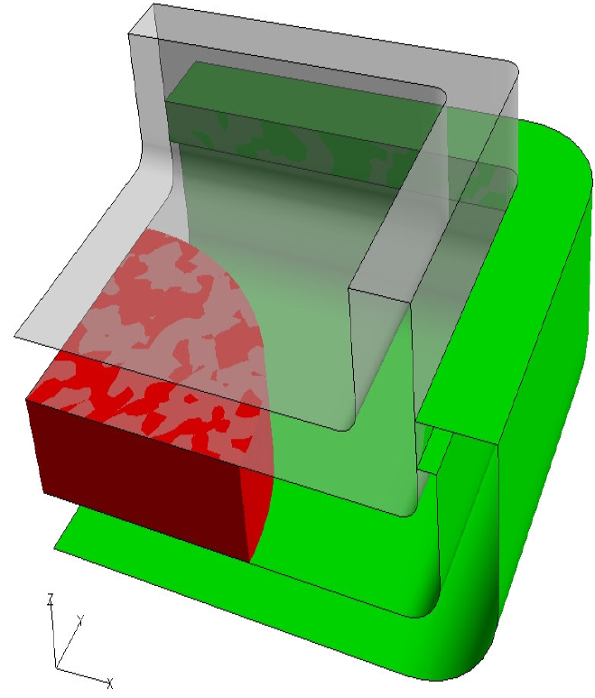
GlassGob
Mould
Ring
Plunger
by: Polyflow
Bench Mark Problem I “3D TV-Panel-Pressing”

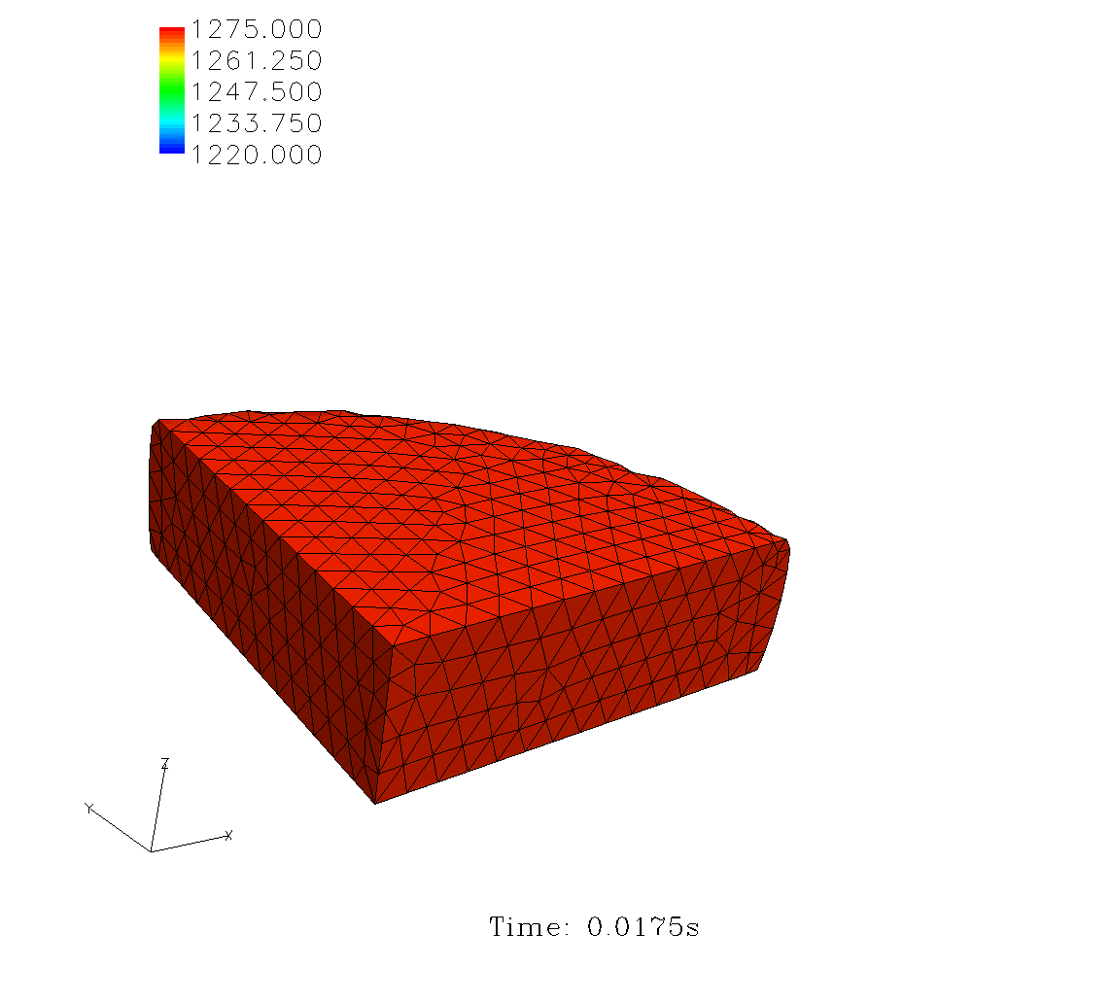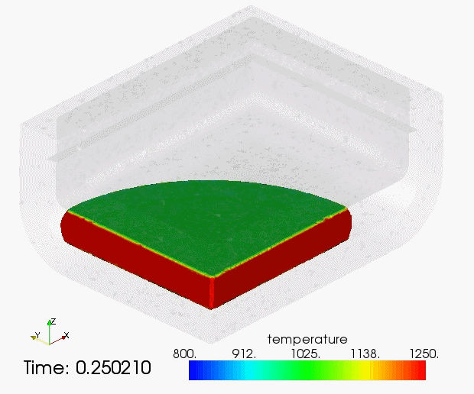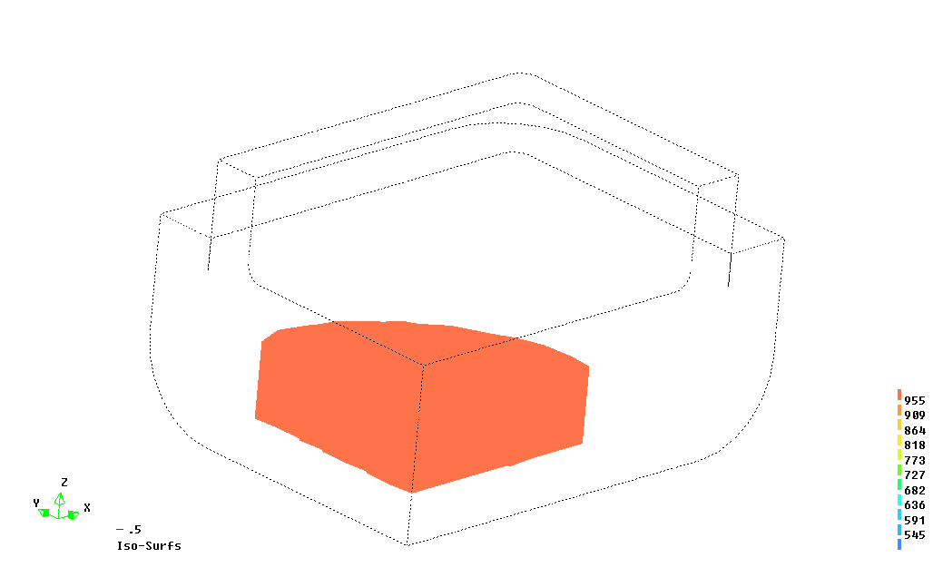For the first time a detailed comparison of BMPI results of TNO, NoGrid and POLYFLOW codes is available now and was presented and intensively discussed at the Eindhoven meeting (November 2008). A first résumé is that all of the three codes involved are capable to solve 3d non-isothermal pressing problems with extremely large deformations in acceptable (CPU) times.

Polyflow

NoGrid

TNO
Fig.20: initial configuration
(T.Marchal / Abaqus)
Fig.21: glass temperature distribution (1st time step of 3D animations)
(T. Marchal /Abaqus, A. Möller /NoGrid, D. Hegen /TNO)
Results of temperatures, velocities and pressures have been compared in 3 different vertical cross sections for 9 fixed time steps. The tracking of the free surface and the velocity results are in good agreement with each other whereas temperature results need further discussion. Only two codes show the typical cold layer in the glass at the glass/solid interface, for the third code this effect becomes visible only at the end.

More detailed inspection of the results can be obtained by monitoring results at precisely fixed coordinates in space (monitor points) with time. For each domain glass, mould and ring respectively 5 monitor points have been defined. Partly, the results of the three codes at these monitor points differ significantly from each other. Two explanations for this have been identified: (1) all of the glass monitor points are at the glass edge – this might cause different treatment in the post processing (extrapolation of cell values to node values and eventually interpolated values between glass/solid edge); (2) mould and ring monitor points might be too insensitive to temperature increases that are encountered after contact with the glass (monitor points don’t “see” temperature increase after 1 cycle due to the distance to the glass interface i.e. in both cases observed temperature differences between the codes might be just due to insufficient positions of the defined monitor points. To solve this post-processing problem it has been agreed to (1) slightly move monitor points to more appropriate positions, (2) add monitor points in the centre of the model, (3) add monitor lines across glass and solid domains to get continuous profiles especially at the glass/solid interfaces.

Bench Mark Problem II “Gob Forming”

Results for a complete non-isothermal run according to the recent BMP definitions are available from NoGrid and Polyflow. A comparison of these results has been presented in Eindhoven in November 2008 (s.Fig. 22).

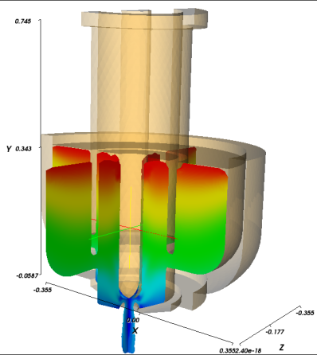
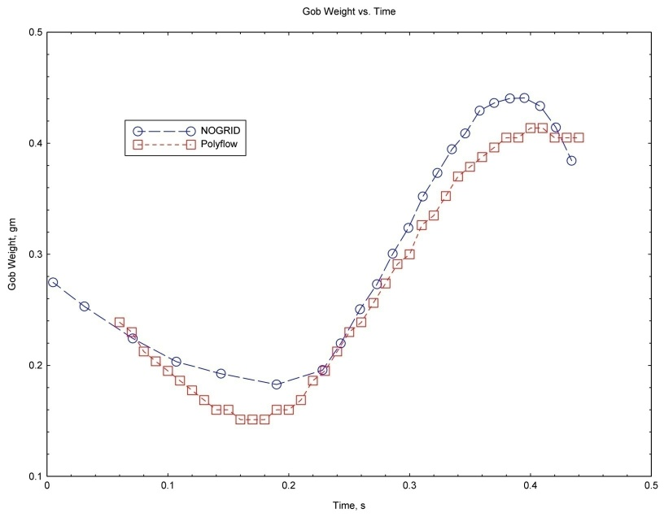
POLYFLOW has used a 2D axi-symmetric model according to the BMP definitions whereas NoGrid provided results of a full 3D model instead of axi-symmetric assumption (s.Fig. 21).

Fig.23: Gob weight - Polyflow vs. NoGrid results
(M.Hyre /Emhart)
Fig.22: 3D-model (A. Möller /NoGrid)

In general both results show a similar behaviour of the gob weight versus time, but the relative error exceeds about 15% which seems to be not really satisfying. Potential reasons have been discussed

1. Definition of the correction motion profile
2. Initial temperature profile led to unrealistic results (gob too short)
3. Surface boundary conditions not realistic
4. Glass flow inlet conditions not realistic
5. 2D-axisymmetric vs. full 3D model
6. Calculation not yet periodic

However, it has been demonstrated in general that POLYFLOW and NoGrid codes are capable to solve these type of gob forming problems. But due to several reasons (lack of experimental data, only two codes involved, etc ) it has been decided to stop BMPII-phase1 and to continue with an extended BMP definition.

For BMP-II.2 an advanced version of the definitions & boundary conditions was presented and discussed and a schedule for next steps has been fixed. At least Polyflow, TNO and NoGrid agreed to the proposal and would be willing to continue BMP-II activities. Participation of further codes (ABAQUS/Simulia, Forming code O.Prokhorenko) will be considered.

The goal of this benchmark BMP-II.2 is to model the weight, shape and tempera-ture of the gob at the time of its delivery to the forming process (at the point of shear cut). As opposed to Phase 1, this problem will be fully three-dimensional. The result should include the volume and length of the gob at the point of shear cut, the vertical position of the point of largest and smallest diameter, the surface area of the gob, and the average temperature of the gob.

It is planned by EMHART to provide the following experimental data for comparison and validation of the modelling results:
1. Gob weight
2. Gob diameter vs. length (through high speed video)
3. Average gob temperature
4. Gob surface temperature vs. length
5. Gob length

The definitions will be completed when the experimental set up at Emhart is finished and all parameters are known.

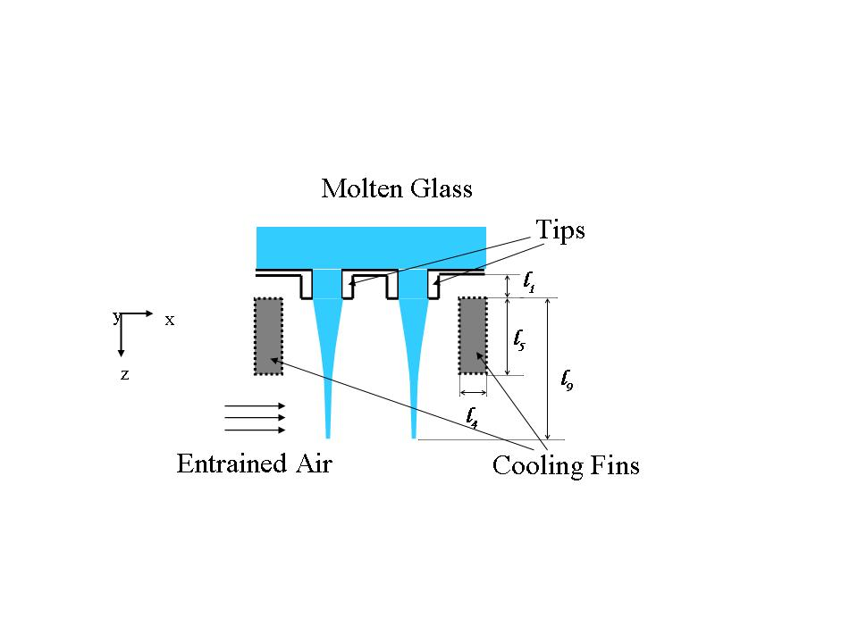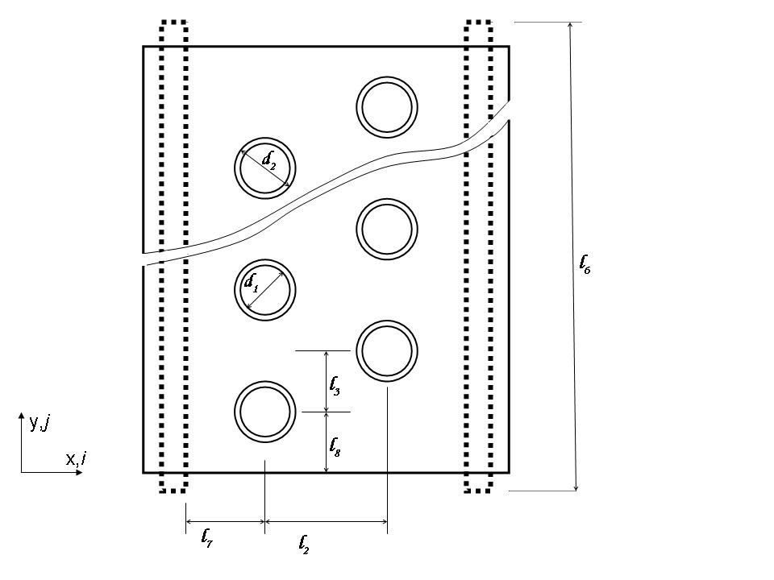Bench Mark Problem III “Continuous Fibre Drawing”
Fig. 24: side and top view of the model geometry (A.Karadag / Sisecam)

For BMP-III.2 a detailed definition with all required information to set up the models is now on hand. WP3.5 members agreed that recommendations given by Simon Rekhson are widely included in the BMP definitions and that BMP-III.2 seems to be realistic enough to attract industrial interest. Furthermore, the complexity of the problem due to the coupling of glass / air flow and radiative interaction between the fibres and the cooling fins has been discussed.

It became apparent that the present BMP-III.2 definition would be a very challenging task and that most of the potential codes in mind would not be capable to solve the entire problem. Present WP3.5 members agreed that BMP-III.2 could be solved only by coupling of at least two codes – e.g. Fluent Polyflow. Hence it has been decided first to check whether other codes / coupling of other codes might be capable to solve the fibre forming problem according to the present definitions or not – otherwise a more simplified definition would be necessary before starting the bench mark and comparing different models.

PLANS FOR FUTURE WORK

Bench Mark Problem I “3D TV-Panel-Pressing”
- Update monitor point and monitor line definitions
- Update TNO, Polyflow, NoGrid results (from new monitor points) for final comparison
- Preparation of a common paper to publish the BMP-I results

Bench Mark Problem II “Gob Forming” / Advanced BMP-II.2
- Final version for BMP-II.2 definition available and distributed
- Contact Abaqus, Prokhorenko, … as potential candidates for BMPII.2
- Commitment of TNO, Polyflow, NoGrid, … to start BMP-II.2
- 1st WP3.5 meeting 2009
- report of first experimental results of Emhart facility
- discussion of first modelling experiences and decision to update BMP-II.2
definitions if necessary
- 2nd WP3.5 meeting 2009
- presentation of first BMP-II.2 results

Bench Mark Problem III “Continuous Fibre Drawing” / Advanced BMP-III.2
- Review of the current BMP-III.2 definitions by all WP3.5 members regarding capability of codes to solve the entire fiber forming problem
- Commitment / Veto of potential candidates
decision to start BMP-III.2 or to simplify definitions
- 1st WP3.5 meeting 2009
- discussion of first modelling experiences OR update of BMP-III.2 definitions
- 2nd WP3.5 meeting 2009
- presentation of first BMP-III.2 results

Meetings
- 1st WP3.5 meeting 2009: probably at ICG annual meeting -Vancouver, June 2009
- 2nd WP3.5 meeting 2009: Fall 2009 - not yet fixed

PUBLICATIONS AND OTHER CONTRIBUTIONS
- Prepare paper of BMP-I results

WORKING GROUP OF WORKPACKAGE 3.5

Chairman | Berndhäuser | Christoph | Schott AG – Germany
Vice-Chair | Lochegnies | Dominique | Univ. Valenciennes – France
Core group | Hegen | Dries | TNO – The Netherlands
 | Hyre | Matt | Virginia Military Institute – USA
 | Karadag | Adnan | Sisecam – Turkey
Members | Aoki | Shigeaki | NEG – Japan
 | Bajart | Christian | ARC International – France
 | Cai | Yifang | Johns Manville – USA
 | Chumley | John H. | Logotec Constr., Inc.- USA
 | de Leede | Gerard | GS Improve – The Netherlands
 | Fontaine de Ghelin | Olivier | AGC FlatGlass – Belgium
 | Koch | Rik | GS Improve – The Netherlands
 | Mal | Olivier | AGC FlatGlass – Belgium
 | Marchal | Thierry | Polyflow – Belgium
 | Martlew | David | Pilkington – UK
 | Matousek | Ivo | University Liberec -
 | Moeller | Alfons | NoGrid – Germany
 | Moravsky | Miroslav | 2M-Consulting – Slovak Rep.
 | Moreau | Philippe | Univ. Valenciennes – France
 | Oda | Kenji | Asahi Glass Company – Japan
 | Penlington | Roger | Univ. of Northumbria – UK
 | Primdahl | Soeren | Rockwool Intl. - Denmark
 | Prokhorenko | Oleg | Lab. Glass Properties - Russia
 | Rekhson | Simon | Cleveland State Univ. -USA
 | Richards | Cheryl | PPG Industries Inc. – USA
 | van Iseghem | Mike | France
 | von der Ohe | Renate | St Gobain Recherche – France
 | Vrabel | Peter | Rona Crystal -
 | Yi | Allen | Ohio State University – USA
 | Youmani | Youssef | Air Liquide – France

2.4- Workpackage 4- Glass processing mechanisms and modelling

WP 4.1 Surface and Interface Phenomena

SUMMARY

The one-year extension of the EFONGA project allowed the finalization of two main issues:

- SAC, Surface Ablation cell : a glass surface study using an innovative wet chemical ablation method assisted by ICP . Results are compared with other surface techniques;
- the publication of the collection: “Handbook of Approved Analytical Methods for Glass” produced by the group over the years

Other activities such as the certification work of a sand sample and a proficiency testing on a slag sample were also finalized .

Meetings:

A core-group meetings was held in Avon in October 2008 to plan the necessary actions in order to accomplish the tasks listed above. Present at the meetings were : Messr E.Guadagnino, P. Sundberg , D. Brochot & O. Corumluoglu

A full meeting was held in Aachen, by the kind invitation of the Saint-Gobain “Research and Development Centre” of Herzogenrath (Germany).
Present at the meeting were: Dr J Simons & Dr D Michiels from Belgium, , Mr D Brochot and Dr Mrs Maria Malheiro from France, Mr D Capon and Mr S Jamieson from UK, Mrs C Strubel, Mrs E Chorus & Dr Kipphardt from Germany, Mrs A Kerestecioglu (Turkey) , Dr P Sundberg (Sweden), Dr Mrs M Scarpa (Italy), Dr R le Clerk and Dr S Smolders (NL).
The report of this meeting is available as doc.: 08-1500

Activity: in 2008, 2nd semester
All collaborative studies were completed successfully (SAC study, certification of a sand sample in collaboration with SGT , a PT on a slag sample, see doc. 08/1490)
The sand is available from the Society of Glass Technology : participation was wide, results were acceptably good , the sand sample was formally certified.
The SAC study was completed, the paper includes the results obtained with SIMS which are in good agreement with wet chemistry values. The profiles for boron and tin oxide obtained by the 2 methods are plotted in the figures below.
A paper is ready to be submitted to the Journal of Glass Technology for publication.
A summary presentation was given in Montpellier (see deliverable S12)

Fig. 25: PT on a slag

The sample “Slag II” was circulated despite analyses performed by Dr Simons had shown an insufficient homogeneity (such kind of samples cannot be highly homogeneous by their own nature). 13 labs provided sets of results according to their routine-methods, a full report is distributed as doc. : TC2/08-1490 .
Each participant will receive a participation certificate with detailed information about the values found by the lab itself, to be compared with the overall mean value for each investigated element.

Handbook of recommended analytical methods (Deliverable S15): an A4 format was chosen which is easy to use in consultation, double side printing of every single sheet, coloured cover with ICG logo, reference to EFONGA financial support.
The title is : “Handbook of recommended analytical methods“, cared by ICG/Technical Committee 2. The front page holds the following ISBN number : 92-95041-01-1.
Every page reports on the top a reference to TC2 and the title of the method , hence every reproduction of the method which is made by the user shall contain the source.
The index is organised per tasks as follows :
- Chloride/Fluoride
- Reducing Components
- Total and sulphide-sulphur
- FeII/FeIII
- Trace elements in glass (Pb, Cd, Hg, CrVI, Se and valence states)
All methods were revised, edited in the same format and integrated with uncertainty and reproducibility data.
The Handbook was published in February 2009 and is available on request at the Deutsche Glastechnische Gesellschaft where booklets are stored.
Printing costs have been fully covered by ICG

The cover page is reproduced in the following page.

Deliverables
Main documents issued were:

ICG/TC2/08-1469 : Minutes of core meeting / Avon February 2008
ICG/TC2/08-1484 : Report from the 89th meeting / Corning May 2008
ICG/TC2/08-1488 : LIBS presentation by Corning US
ICG/TC2/08-1494 : LIBS for cullet sorting ( Pilkington )
ICG/TC2/08-1494 : Minutes of core meeting / Avon October 2008
ICG/TC2/08-1496 : SO3 in glass by combustion/final manuscript
ICG/TC2/08-1500 : Report from the 90th meeting / Aachen October 2008
ICG/TC2/08-1501 : Action sheet arising from the 90th meeting in Aachen
- SAC presentation in Montpellier (ppt)
Minutes of the meetings and documents available on request to:
peter.sundberg@ glafo.se

WP 4.2 Optical Properties of Glass and Coated Glass Products

1. Meetings: The group held two full member meetings during the extension year (4th year) of EFONGA. One core group meetings was held during this period. Places and dates of these meetings are as follows:

- Full membership meeting of the year was held at Fraunhofer Institute for Solar Energy Systems in Freiburg, Germany on September 12th, 2008,
- Full membership meeting of the year was held at STAZIONE SPERIMENTALE DEL VETRO in Murano, Italy on March 27th, 2009
- A core group meeting concerning the angular properties of coated glass products was held in Eindhoven, The Netherlands on the 11th of May.

2. Activities during the extension year:

  - Optical Characterization of highly diffusing and patterned glass

This inter laboratory comparison is intended to resolve the problems of measuring optical properties of highly diffusing and patterned glass. It originated from both the need of the building sector and the need to quantify light impinging on photovoltaic devices. There is a push by the concerned CEN WG for standardization. A similar study several years ago indicated that these measurements were highly dependent on the measurement configuration used. While an instrument independent method has not yet been found, progress has been made into the comprehension of the light scattering phenomena involved. The design of the integrating sphere used for the measurement has been found to be the major factor for these measurements. An interim report will be prepared by the end of June, 2009.

  - Website (www.icg-tc10.org): The website was modified to make updating easier and the site was updated.

  - Determination of the dispersion functions of bare glass substrates

While not a deliverable for the EFONGA project, the group decided to investigate this topic. This study will compare various techniques for the determination of the dispersion functions of bare glass substrates. Spectophotometry, ellipsometry, Brewster angle determination and other techniques as well as combinations of the techniques will be compared to determine the best methods. Dispersion functions are important for optical modelling of coated products. Samples have been distributed and measurements begun.

  - Angular optical properties of glass and coated glass products

Again, not a formal deliverable for the EFONGA project, the group decided that this topic merits investigation. It is becoming clear that there is a necessity to correctly measure angular optical properties of glass and coated glass products. The group will compare the few commercial instruments/accessories together with spectrophotometers built in various laboratories. It is hoped that proper instrument design and measurement procedures will result from this study.

3.0 Deliverables:

D4. Contributions to the final report: this report

Deliverable 32. The website has been developed and is operational. It was a major expense both financially and in term of member’s time.

Deliverable 33. Round Robin test on the determination of the precision of portable spectrophotometer: Final report finished and is in the public section of the website.

Deliverable 34. Interlaboratory comparison on the measurement of the optical properties of diffusing and patterned glass products: This project is in it’s 3rd year. Significant progress has been made in understanding the problems associated with such measurements. An interim report will be made available on the website at the end of June.

WORKING GROUP OF WORKPACKAGE 4.2

Chairman: C. Anderson, Saint-Gobain Recherche, France
Vice-Chairs: J. Roucour, GLAVERBEL R&D, Belgium
P. Van Nijnatten, TNO TPD, NL
Members: F. Akmaz, TURKIYE SISE, Turkey
J. Bretschneider , PILKINGTON, Germany
R.T. Davies PILKINGTON, England
A.V. Dotsenko, CORNING, Russia
G. Flamant, BBRI, Belgium
G. Gagliardi, PILKINGTON, Italy
F. Geotti-Bianchini, SSV, Italy
M.G. Hutchins, SONNERGY,Ltd., England
F.-Th. Lentes , SCHOTT GLASWERKE, Germany
F. Olive, CSTB, France
A. Roos, UPPSALA UNIVERSITY Sweden
G. Rossi, ISTITUTO ELETTROTECNICO, Italy
J. Simons, INISMa, Belgium
Guests: A. Gusarov, SCK.CEN, Belgium
H. Rose Wilson, Fraunhofer Institute, Germany

WP 4.3 Physical Characterization

1. SUMMARY

This workpackage was engaged in one round-robin and the organization of a scientific expert workshop during the 4th period:
- A new round robin dealing with x-ray diffraction (XRD) was planned and samples were spread out to compare the reproducibility of XRD-systems in different laboratories
- An scientific expert workshop was organized in conjunction with WP1.1 on "Glass surfaces and stress corrosion mechanisms at the nanoscale”

2. ACTIVITIES IN 4th year (2008/2009)

The chairman participated in several EFONGA related meetings, which were located in Frankfurt (June 2008), Trencin ( June 2008), Frankfurt (December 2008), Clausthal (February 2009), Montpellier (February 2009) and Montpellier (May 2009).

The major activities of WP 4.3 can be summarized as follows:

2.1. Round robin “XRD”: (Deliverable S16)
The aim of this round robin is the characterization of these two sample types in each participating laboratory with their individual measurement and quality procedures. So the employed different techniques can be compared with their power and their limits.
The results are focused on:
- phase analysis
- quantification of the crystal phase
- crystal size
- lattice parameters
For that task two different sample types were chosen:
Type 1: Commercially available Ceran Suprema glass ceramic (one piece).
Type 2: MAS- (MgO-Al2O3-SiO2) glass ceramic powder, produced with an laboratory melt process.
Sample 1: Ceran Suprema gc

Fig. 26: Lattice parameter
of Sample 1

As can be seen in Fig. 25, the results, obtained in the different laboratories, show a distribution, which has to be proved. Therefore the XRD-round robin is not yet finished and will continue up to the end of 2009 in the TC19 of the ICG.

2.2. Workshop “Glass surfaces and stress corrosion mechanisms at the nanoscale” (Deliverable S13)
On 22. – 25. February 2009, the chairmen of the technical committees "surface diagnostics" and "glass micromechanics" of the ICG organized an expert meeting in the framework of EFONGA (WP1.1 and WP4.3), inviting a selection of international experts on "glass surfaces and stress corrosion mechanisms at the nanoscale", in Montpellier, France. Fifteen international experts with special topics related to surface or strength items in the field of the material glass were invited. The reaction mechanisms on the glass surface become more and more important, especially for subsequent processes like surface conditioning or coating to optimize the properties of the material. Corrosion processes in the nanoscale are well known since many years /1/ but up to now not fully understood. There exist lots of data, experimental results and computer models to describe corrosion and strength related phenomena for special parameters or applications/materials. Especially the mechanisms of crack propagation and driving forces in the nanometer scale are still under discussion.

Therefore, it was the aim of this workshop, to cover the existing knowledge and start a discussion on the future work, which has to be done to a clear understanding of the mechanism on stress corrosion in the nanometer scale, which should be resulting in a task list of items to be solved in the next years called "Roadmap".

Participants and their main topics are listed in the following table:

Carlo G Pantano: | Surface Chemistry Effects in the Strength and Fracture of Silicate Glasses
Russel J Hand: | Silicate glass, hydration, chemistry and defects
Matthieu George: | Local probe investigation of glasses
Tanguy Rouxel: | The incidence of the glass composition on the contact damage behavior - A Vickers indentation study
Etienne Barthel: | Plastic deformation of silicates and tensile strength
Elisabeth Bouchaud: | Scaling properties of fracture surfaces
Minoru Tomozawa: | Fictive temperature of silica glass fracture surface
Giuseppe Pezzotti: | Visualization of highly graded stress gradients in glassy and crystalline materials and in their hetero-structures
Kurt Nattermann: | Lifetime statistics and durability under environment
Walter Kob: | Computer Simulations of Glasses
Alastair N Cormack: | Atomistic Simulations of the Mechanical Properties of Silicate Glasses, and of their Interaction with Water
Sheldon M Wiederhorn: | Dependence of the Strength of glass on Mobile Ions in the Glass Network
René Gy: | Ion Exchange for Glass Strengthening
Uwe Rothhaar: | Durability of and adlayer formation at glass surfaces in “wet” environment
Joachim Deubener: | Enhancement of glass surface quality by sol-gel coatings

A lot of topics were discussed related to the headlines:
- main key challenges related to surface stress corrosion mechanisms
- exceptional success items related to surface stress corrosion mechanisms
- key breakthrough items related to surface stress corrosion mechanisms
- Application items related to surface stress corrosion mechanisms

Details can be found in the Deliverable 13. An example is depicted in Fig. 25, described below:
A Numerical Modelling
- A1 Ab initio simulation of 10 million particles.
- A2 The ability to perform routine classical atomistic simulations of 100,000 atoms or more.
- A3 The ability to perform quantum mechanical simulations on thousands of atoms routinely.

B Surface coatings
- B1 Development of active coatings for healing cracks on glass surfaces (2025).
- B2 Self-healing sol-gel coatings for glass surfaces.
- B3 Implementation of the controlling parameters of crack propagation in glasses by sol-gel coatings (2021)
- B4 Low cost hermetic, hard, lubricious multi-functional coatings (now).
- What is the limit of sol-gel systems in terms of mechanics (does one need high temperature condensation and sintering) ?
- B5 "Active" coating materials with self-healing properties for glass surfaces by sol-gel technology. Localized reactions in the film/glass interface induced by stress corrosion.
- B6 Improvement of surface quality by "passive" protective coatings.

C Surface protection
- C1 Nano-crystalline materials with adequate properties vs. glasses.
- C2 2009…2012: Improving methods for the separation of failure causes by statistical analyses of fracture data ("multimodal fracture").

D Glass Transition structure and composition Prio B

- D1 Understanding the mechanism responsible for the slowing down of glass-forming systems and thus the glass-transition (now). TASK for TC08

E Plasticity and toughness Prio B

- The field of plastic deformation of amorphous systems is very active. The case of silicates is a (small) subset. To support these claims let us mention :
- E1 BMGs (Bulk Metallic Glasses): very different materials but they show the way in terms of plastic deformation in amorphous systems
- E2 Modelling at various length scales of disordered materials. For multi-scale modelling amorphous materials are an opportunity because fewer length scales are involved.
- E3 A number of recent experiments on plastic deformation of silicates
- E4 The opportunity of using new micromechanics tools

F New glasses
- F1 Preparation of oxide glass surface which is immune to water or moisture.

Following this analysis, a roadmap was created:

As a last deliverable a summary of all the activities of WP4.3 are listed and interpreted in Appendix 25.
Standard analysis tools like SEM/EDS or AFM produce meanwhile reproducible and comparable results in most of the participating laboratories. High sophisticated techniques like TOF-SIMS, XPS produce up to now measurement results, which depend strongly on the experience of the operator and the status of the equipment.

WORKING GROUP OF WORKPACKAGE 4.3

Chairman: V. Rupertus, Schott AG, Mainz, Germany
Coworkers: K. Bange, Schott Glas, Mainz, Germany
M. Farnworth, Pilkington Technology, UK
E. Greiner-Wronowa, Univ. of Krakow, Poland
H. Montigaud, Saint Gobain Recherche, France
M. Kopnarski, IFOS GmbH, Kaiserslautern, Germany
H. Kheyrandish, CSMA Ltd, Stoke-on-Trent, UK
A. Helebrant, Inst. Of Chem. Techn., Prague, Czech Republic
Guests N. Tadokoro, Hoya Corporation, Japan
Y. Yamamoto, Asahi Glass Co Ltd, Japan
C. Pantano, Pennsylvania State University, USA
V. Balek, Nuclear Research Inst. Czech Republic

2.5- Workpackage 5-Communication, dissemination and education

SUMMARY

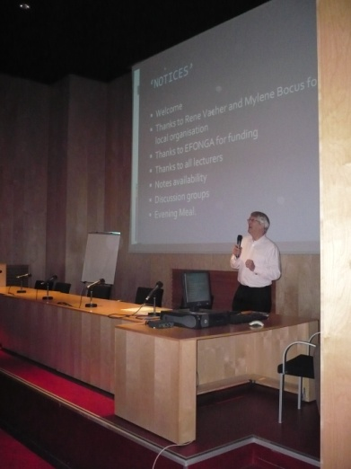
One aspect of the role of information dissemination for WP5 has been to continue to support and encourage workshops organised specifically for young people although there is also an increasing realisation that scientists and engineers from many different backgrounds appreciate and can learn from this structured and more in-depth approach compared with conventional conferences. Examples of our involvement during the last year have included: 1) special arrangements made for students to attend the DGG Annual Meeting in Amberg, May 2009 at low cost, 2) support for a speaker from France to give a presentation at a Workshop on Sol Gel targeted at younger researchers held in Cambridge, UK in September 2008, and 3) support for a Short Course on Glass Strength organised by the DGG for an international audience in May of this year. This trend has continued even after the close of EFONGA with a Workshop on Thermodynamics held in Vancouver alongside an international glass conference during June of this year.

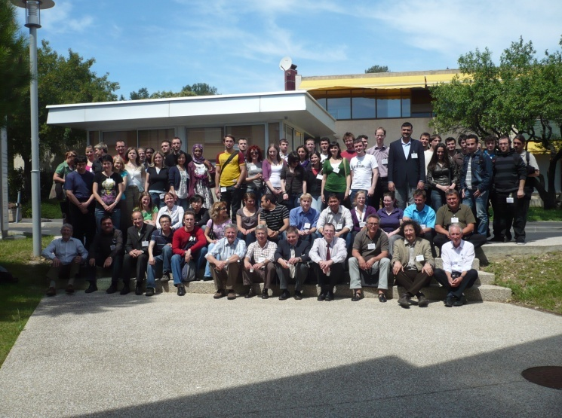
A highlight of Work-package 5 during the last year has been to organise ourselves a 2 day teaching event in Montpellier under the heading “Glass structure-property relationships”. The workshop attracted 56 students from 12 different European countries plus 3 from the US; they were taught by 11 staff who between them presented 16 lectures. We also had group exercises, one of which mirrored the road-mapping exercise mentioned later. The attendees were mostly research students although there were a few undergraduates and also one or two from industry. The social interactions between different groups and with the lecturers were seen as of key importance and the students have now set up a facebook account to encourage links

The DVD reported earlier is being circulated to a wide range of educational organisations with an interest in Glass both to publicise its existence and promote it as an educational aid. Discussions have taken place with schools to discover how the DVD can most usefully be incorporated into class room teaching and the syllabuses being followed. A final outcome of these discussions may be that the content is available in smaller clips as well as a 30 minute continuous showing.

The preparation of a Database on Glass Educational Establishments (D38) was started using an initial database prepared at the offices of the Society of Glass Technology. This database was used to produce a circulation list for the workshop described above. Unfortunately the inclusion of additional information on courses available has proved very difficult because of the wide variations in course structure and content throughout the EU.

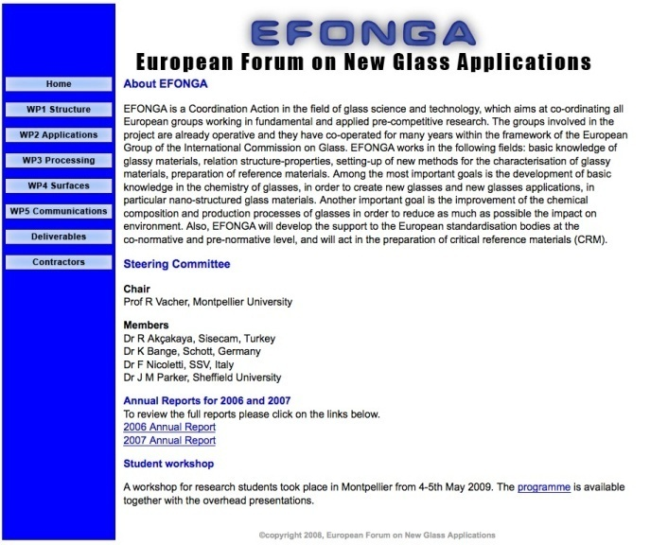
Our web site has undergone a major re-vamp and can be accessed via the new address www.efonga.eu, as well as the previously advertised address. A few other work-packages are generating their own web sites and the aim is that the central web site will offer links to these as well as providing key on formation on deliverables. This project has moved forward at a faster rate as more information has become available in Annual Reports; it will be finally updated after the final report is complete so that the achievements of the project can be fully advertised to the wider glass community.

During the final stages of the EFONGA project, considerable effort was expended on the generation of Road Maps to focus the future directions of research effort within the glass community. Much of this work was organised by other workpackages, but WP5 participated in these discussions and the students at Montpellier were themselves able to have an input, as well as learning what is involved in such processes.

Finally the minutes of the Management and Advisory Board meetings form a key record of the progress of the EFONGA work programme and continue to be written and circulated as part of the activities of this work package.

DELIVERABLES, PUBLICATIONS AND OTHER CONTRIBUTIONS

Web Site (www.efonga.eu)
Minutes of EFONGA advisory and management board meetings (18/08/07, 24/01/08, 06/03/08)
Lecture notes for Montpellier Workshop (www.efonga.eu)

WORKING GROUP OF WORKPACKAGE 5

Chairman: J M Parker, the University of Sheffield, UK
Members: Prof R Condradt, Univ of Aachen, Germany
K Bange, Schott, Germany
E Flygt, Glafo, Sweden
H Schaeffer, Germany
W Schaeffer, Germany
Guests: A Makashima, University of Japan

3- Consortium management

The role of the management is particularly important in a Coordination Action project. With this in mind, we have organised several meetings along this year at different levels:
- The Management Board (5 persons, each of them responsible for one of the main workpackages),
- The Advisory Board, in which all responsibles for workpackages and sub-workpackages participate (about 15 persons) ,
- The Co-ordination of the project. The Co-ordinator, who has been acting all along the year for the management of the project, met with members of the management board for the preparation of the meetings and for discussing important management actions.

List of management meetings
- Advisory board meeting in Frankfurt, June 12, 2008
- Management Board + Advisory board meetings in Trencin, June 25, 2008
- Advisory board meeting in Mainz, November 17, 2008
- Management Board meeting in St. Petersburg, January 30, 2009
- Meeting between K. Bange and R. Vacher in Montpellier, April 16-17, 2009 for preparation of the next annual report

Main management actions

The management has asked all workpackage responsibles to present a precise plan of future actions at the first advisory board meeting of the year. All of them presented their previous results, their plan for the next year, and the present state of their progress to deliverables. Some changes in the original plans have been proposed and accepted. It is important to recognize that, over a period of 4 years, the main interest of industrial groups can change; some of the initial purposes could become obsolete while efforts have to be re-focused over new products. The details of the changes can be found in the report for each workpackage.
To improve the co-ordination inside workpackages, a core group has been defined inside each working group. The core group members must be in contact at least once a month by telephone conference or e-mail, the whole group must meet at least twice a year.
The management has promoted the organisation of cross-links between workpackages. All expert meetings held during this period were organized in collaboration between 2 or 3 different WPs

Information on deliverables
As seen from the list on the next pages, during the whole duration of the project, 8 deliverables planned initially were cancelled, 3 were replaced, 14 new deliverables were added. The changes have been explained in the reports.
Deliverables list

The list has been updated to take into account the real state of the progress and the additions related to the extension of the duration. Deliverables provided are indicated in bold. New deliverables have been added.

Del.  No | Deliverable Title | WP  No | Date due | Actual/  foreseen  deliv. date | Lead  contractor
1 | Annual report 2005-2006 | 6 | 12 | 12 | CNRS
2 | Annual report 2006-2007 | 6 | 24 | 24 | CNRS
3a | Annual report 2007-2008 | 6 | 36 | 36 | CNRS
3b | Final report | 6 | 48 | 48 | CNRS
4 | Report on the Conference « Glass : Past, Present and Future » | 5 | 12 | 12 | USFD
5 | Proceedings of the Conference « Glass Science and Technology », September 2006, Sunderland, UK | 5 | 28 | 48 | USFD
6 | Proceedings of the International Congress on Glass, July 2007, Strasbourg (France). | 6 | 36 | 48 | CNRS
7 | Report on School « Structure and strength of glasses » | 5 | 12 | 24 | USFD
8 | Report on School « Technological Problems in Artistic Glass” | 5 | 24 | Cancelled | USFD
9 | Report on School « Glass structure and surface properties” | 5 | 36 | Replaced (see Sect. 2.5 above)  48 | USFD
10 | Set-up of standard glass samples | 1.1 | 24 | 24 | CNRS
11 | Review and data-base on data analysis from several techniques at large facilities | 1.1 | 36 | Cancelled | CNRS
12 | Web site on materials for optoelectronics | 1.4 | 8 | 8 | IFAC-CNR
13 | Handbook on manufacturing of composite and nanostructured glasses | 1.4 | 18 | 36 | IFAC-CNR
14 | Handbook on characterisation technologies of composite and nanostructured glasses | 1.4 | 28 | 36 | IFAC-CNR
15 | Handbook on laser micro- and nano-structuring of photonic glasses | 1.4 | 36 | 42 | IFAC-CNR
16 | Technical report-data base on sol-gel industrial coating products | 2.1 | 10 | 24 | INM
17 | Technical report on Round Robin tests | 2.1 | 16 | 36 | INM
18 | Technical report on the nature of the glass/coating and coating/environment atmosphere interfaces and its influence on the properties of the coatings | 2.1 | 24 | 36 | INM
19 | Database of active glasses | 2.2 | 18 | 36 | IFAC-CNR
20 | Round-robin test of active waveguides | 2.2 | 22 | 48 | IFAC-CNR
21 | Handbook on integrated optical lasers and amplifiers based on glassy materials . | 2.2 | 30 | 48 | IFAC-CNR
22 | Test method for the characterisation of self-cleaning glass products | 2.3 | 18 | 24 | TNO
23 | Round Robin test results of 1-2 self-cleaning glass products | 2.3 | 24 | 48 | TNO
24 | Benchmarking results of the optical and electrical properties for a number of European produced TCO coatings | 2.3 | 30 | 48 | TNO
25 | Operational internet site: coated glass portal | 2.3 | 36 | Cancelled | TNO
26 | Publication of data on glass melt properties and measuring methods | 3.1 | 18 | 24 | TNO
27 | Round Robin tests on measurements of glass properties: power point presentations of the results and measuring methods | 3.1 | 36 | 36 | TNO
28 | Round Robin tests on voltammetric measurements on glass melts | 3.3 | 24 | Cancelled: see 2^{d}-year report | SMZ
29 | Round Robin test on combined models for investigating the batch blanket models | 3.4 | 30 | 48 | SIS
30 | Technical procedures and related working progress | 4.1 | 24 | 24 | SSV
31 | Preparation of draft International Standards | 4.1 | 30 | 30 | SSV
32 | Round Robin test on the validation of colour | 4.2 | 16 | Replaced  (see report)  48 | SGR
33 | Round Robin test on the determination of the precision of portable spectrophotometer | 4.2 | 22 | 30 | SGR
34 | Round Robin test on the self-assessment of the uncertainty of transmission and absorption measurements over the solar range | 4.2 | 36 | Replaced  by S4 | SGR
35 | Round Robin test on characterisation of thin films | 4.3 | 22 | 36 | SMZ
36 | Directory on research of glass surface | 4.3 | 28 | Cancelled | SMZ
37 | EFONGA web site | 5 | 8 | 8 | USFD
38 | Listing of education and training courses on glass in Europe | 5 | 12 | Cancelled | USFD
39  40 | Periodic progress reports on review and assessment (Consortium management) | 6 | 12  24 | Included in annual  reports | CNRS
41 | Final report on review and assessment | 6 | 36 | Included in final report | CNRS
S1 | Book “Glaskeramik” | 1.2 |  | 24 | IVO
S2 | DVD “Looking Through Glass” | 5 |  | 24 | USFD
S3 | Catalogue of glass melt property measurements: laboratory names, methods, contacts on world-wide scale | 3.1 | 40 | 40 | TNO
S4 | Report on round-Robin test on determination of optical properties of diffusing samples and on patterned glass | 4.2 | 48 | 48 | SGR
S5 | Report on determination of dispersion functions in the visible and near infrared | 4.2 | 48 | Cancelled | SGR
S6 | Report on definition of structural quantities extracted from simulations, comparison between modelling and experiment, and improvement in numerical modelling | 1.1 | 48 | Cancelled | CNRS
S7 | Report on symposium: “The Relationship between Glass Structure and Mechanical Properties” | 1.1 | 48 | (See S13)  48 | CNRS
S8 | Report on workshop: “Glass and Entropy” | 1.1 | 48 | 48 | CNRS
S9 | Proceedings of the congress “Glass – The challenge for the XX1st century” | 5 | 48 | 48 | USFD
S10 | Report on workshop: “Advanced Glass Materials & Innovative Glass Melting Technology in the Year 2020” | 1.2  1.3  3.1 | 42 | 36 | TNO
S11 | Roadmap on Glass Products and Technology for the Future | 3.1 | 48 | 36 | TNO
S12 | Report on closing meeting | 6 | 48 | 48 | CNRS
S13 | Conclusions of the expert meeting on "Glass surfaces and stress corrosion mechanisms at the nanoscale" | 1.1  4.3 | 48 | 48 | CNRS  SMZ
S14 | Expert seminar on “Conditioning of Glass Melts and Forming of Glass Products | 3.1  3.5 | 48 | 48 | CNRS  SMZ
S15 | Handbook of Recommended Analytical Methods | 4.1 | 48 | 48 | SSV
S16 | XRD Round-Robin Test | 4.3 | 48 | 48 | SMZ
S17 | Program and press release on Workshop “Glass and Entropy II” | 1.1 | 48 | 48 | CNRS

A1- Plan for using and disseminating knowledge

The plan for using and disseminating knowledge was organised along the following lines:

a) Websites and databases
In connection with the work program dedicated to communication, a web site has been established. It will be maintained to spread information on the purposes of the project and the main results obtained. This web-site, together with dedicated publications workshops and conference presentations, will ensure the diffusion and the dissemination of information.
In addition to this general website, more dedicated websites and databases start to be established, on data analysis at large facilities, materials for optoelectronics, active glasses, and coated glass.
Deliverables 12, 16, 19, 37, S3, S15

b) Reports and Publications
The interim and final results of the EFONGA collaborative program have also been published in the form of handbooks, public reports, and collected volumes of work.
Deliverables 1, 2, 3a, 3b 13, 14, 15, 17, 18, 21, 26, 36, S1, S2, S11, S13, S14, S17

c) Conferences and schools
In the frame of this project, we acted in organising committee meetings, workshops, conferences, congresses and studies schools in order to facilitate the interactions between the different groups involved, to encourage combined activities and to offer training and educational possibilities whether at the level of senior or new research workers. The main actions were:
- Annual meetings covering the period of the project,
- One or two meetings per year for each working group inside a sub-workprogramme,
- Organisation of one training school every year.
Deliverables 4, 5, 6, 7, 8, 9, S7, S8, S9, S10, S12

d) Preparation of a glass education video
We have produced a glass education video for use by Schools in order to encourage the best students to study engineering and materials subjects at University.

