
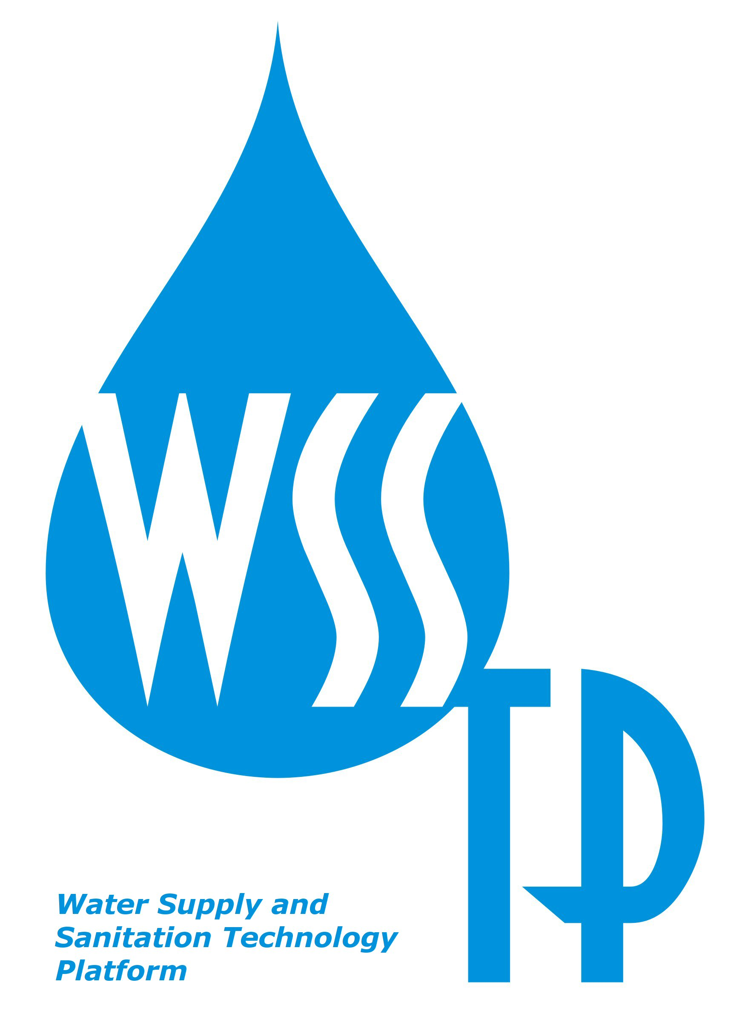

018379

WSSTP

Water Supply and Sanitation Technology Platform

SSA

FP6-2004-GLOBAL-3

FINAL REPORT

Period covered: from 01-11-2004 to 31-05-2005 Date of preparation: 30-11-2006

Start date of project: 01-11-2004 Duration: 19 months

Project coordinator name: Adriana Hulsmann
Project coordinator organisation name: Kiwa Water Research
CONTENTS

1 Publishable final activity report 3
1.1 Project execution 3
1.2 Dissemination and use 10
1.3 Publishable results 18

2. Final plan for using and disseminating the knowledge 19

3. Final Management report 20

4. Final report on the distribution of the Community’s contribution 21

5. Final Science and society reporting questionnaire 22

6. Final reporting questionnaire on workforce statistics 23

7. Final socio-economic reporting questionnaire 24

8. Supplementary final reports 25

9. Residual obligations 26
1 Publishable final activity report

1.1. Project execution
This project concerned a Specific Support Action for the Water Supply and Sanitation Technology Platform. The Consortium responsible for the execution of this SSA provided the organisational, management and scientific support necessary to facilitate the process of the Technology Platform. This support made it possible to produce the three deliverables: Vision Document, Strategic Research Agenda and an Implementation Plan for the water sector in Europe. This was done by the Secretariat, a delegation of members of the WSSTP Board, together with and on behalf of the Board. These three deliverables will, amongst others, be used by the European Commission as input for FP7.

The Consortium involved in the SSA included the following organisations and institutes:
- Kiwa Water Research – Adriana Hulsmann (Coordinator)
- EUCETSA - Lionel Platteuw
- TNO-MEP - Bert Jansen
- UKWIR - Mike Farrimond
- NTNU - Hallvard Ødegaard
- EASA-IoS - Peter Wilderer

The mission of the WSSTP is “to strengthen the competitiveness and the potential for technological innovation of the European water industry, of water professionals and research institutions through the development of a strategic science and research agenda, to meet global challenges and regional demands of ensuring safe, secure and sustainable water supply for human societies and for the environment and sanitation services, within the framework of the available water resources”. In addition, the WSSTP will contribute to the MDG’s of the Johannesburg Summit and the European Union Water Initiative.

The documents produced by the Technology Platform were the results of a merging process of separate documents produced by five highly qualified working groups. The working groups each covered an important water sector:
- TWG 1 Integrated Water Resource Management
- TWG 2 Urban, peri-urban and rural water systems
- TWG 3 Water in Industry (water for industrial purposes)
- TWG 4 Water in Agriculture (water in food and drinks production).
In addition, a horizontal working group covered cross-cutting issues and enabling factors
- HWG Cross-cutting issues.
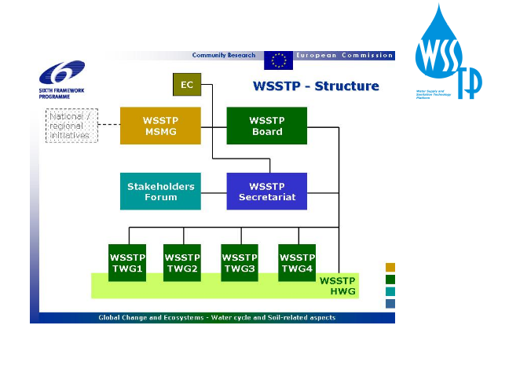

Organisation of the WSSTP

All activities of the WSSTP and various drafts of the documents produced by the working groups were monitored, discussed and finally approved by the Executive Board of the WSSTP. The Board consists of representatives from universities, research networks, technology suppliers, water industry, EUREAU, and the European Commission as observer.
A very important role was foreseen for the Member States Mirror Group (MSMG). The MSMG consisted of regulators and policy makers of the Member States and from R&D Framework Programme associated states, interested in the activities of the platform. The MSMG ensured an appropriate interface between the Platform and Member States/countries, by providing information on policies and programmes in the Member States relevant to the goals and deliverables of the Technology Platform. The MSMG provided representation and input to the WSSTP Board through the chair (NL) and the vice-chair (LUX) and in the working groups.

During the first year the WSSTP had Mrs Pamela Taylor as President, Alain Rousse as Vice-President and Riku Vahala as chair of the Board. After one year both the President and the Chair resigned. The Platform appointed a new Chair Claude Roulet but decided not to appoint a new President.

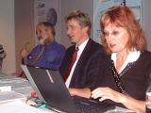

Riku Vahala first chair of the Board

Work carried out within the Specific Support Action:
- Board of the WSSTP: facilitation and organisation of nine Board meetings in the period 01-11-2004 to 31-05-05. The work involved preparation of draft and final versions of the agenda and the minutes, provision of logistic details such as venue, hotel and travel information, identification of additional Board members, sending out invitations and organisation of presentation lists, preparation of the Rules of Procedure for the Board, preparation and coordination of various drafts of meeting documents, setting up and coordination of dedicated teams around ad hoc issues and identification of important upcoming events and informing the Board on such events. An additional eight Board meetings were organised outside the contract period as well as a joint MSMG-Board meeting.
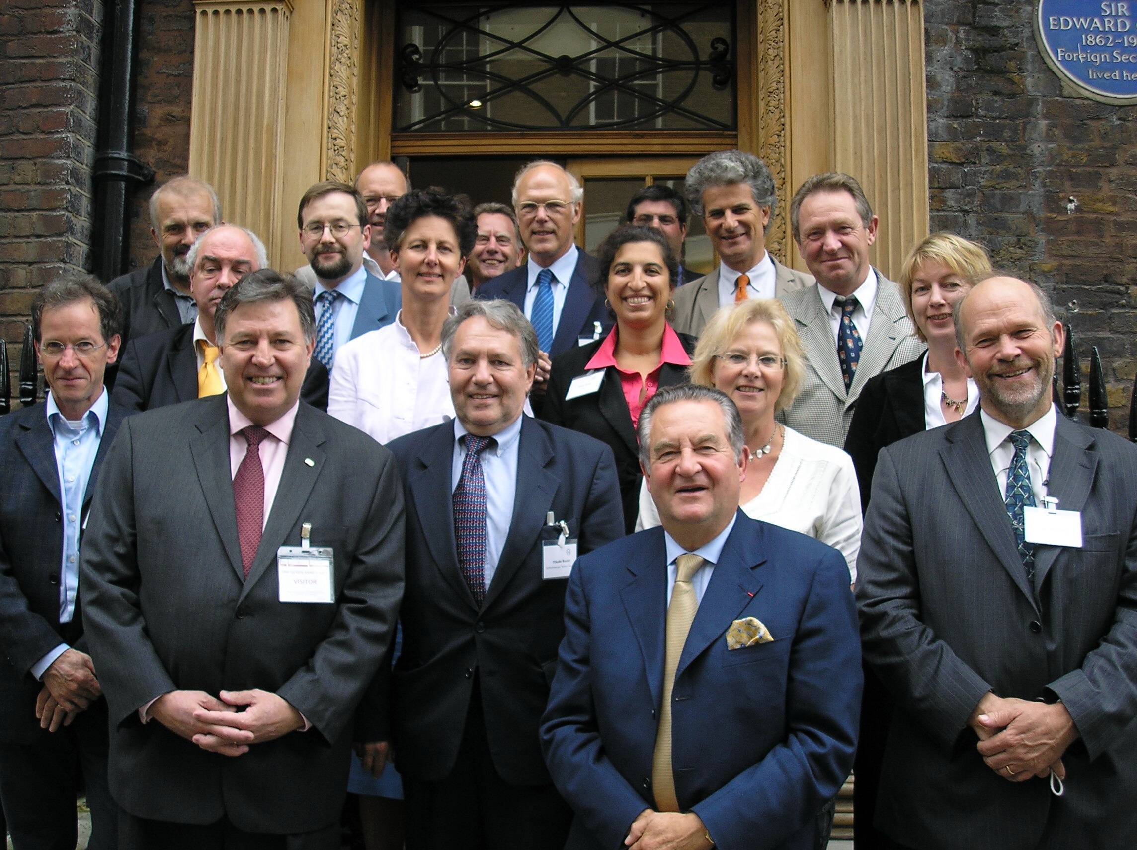
The Board October 2006
- MSMG: facilitation and organisation of five MSMG meetings in the period 01-11-2004 to 31-05-05. The work involved preparation of draft and final versions of the agenda and the minutes, provision of logistic details such as venue, hotel and travel information, identification of additional MSMG members, sending out invitations and organisation of presentation lists and preparation and coordination of various drafts of meeting documents. Specific documents included an overview of national research programmes in the represented Member States and associated countries. Presentations were given on the progress and (planned) activities of the Board of WSSTP. An additional three MSMG meetings were organised outside the contract period, one of which was a joint Board-MSMG meeting.

- Thematical Working Groups and the Horizontal Working Group. A large number of working group meetings were organised and facilitated both inside and outside the contract period:
  - TWG1 five meetings and an additional two outside the contract
  - TWG2 seven meetings and an additional two outside the contract
  - TWG3 five meetings and an additional two outside the contract
  - TWG4 five meetings and an additional two outside the contract
  - HWG four meetings.
The work was very much the same as for the Board and the MSMG, but in addition, the various versions of individual documents (SRA and VD) were produced.

- Stakeholder event. The draft Vision Document and the draft Strategic Research Agenda (individual and merged versions) were produced by the more than 100 experts in the working groups and merged by the Secretariat. The drafts were put out for consultation through the WSSTP website. Comments were assessed and incorporated. To enable a wide-scale presentation and consultation of the deliverables, a European Stakeholder Event was organised. Much time was spent on the organisation of a stakeholder event in Brussels at the Bavarian Building. Due to other commitments of the Commissioner the event was cancelled and a new event had to be organised. The stakeholder meeting eventually took place in Budapest, at the Hungarian Academy of Sciences on the 17th of October 2005. A summary report was produced on the outcome of the Stakeholder Event and the comments were taken into account in the final versions of the deliverables. An analysis was made of the participation in the event in Budapest. The outcome was used to improve representativeness of the platform.

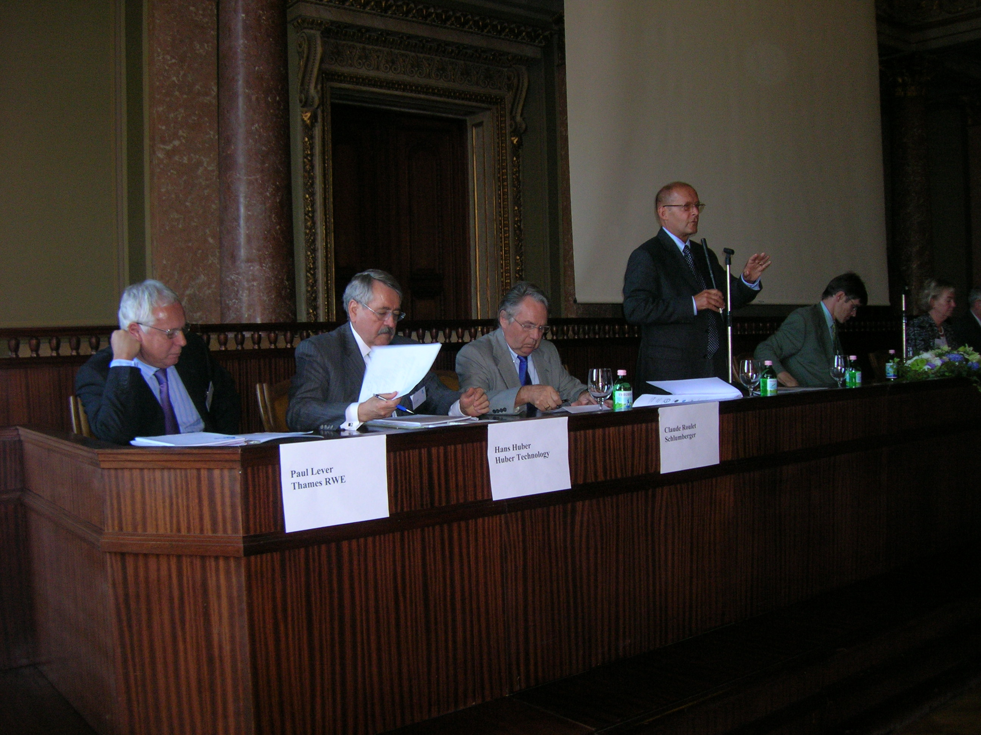
Stakeholder event in Budapest,
the chair Laszlo Somlyody President IWA
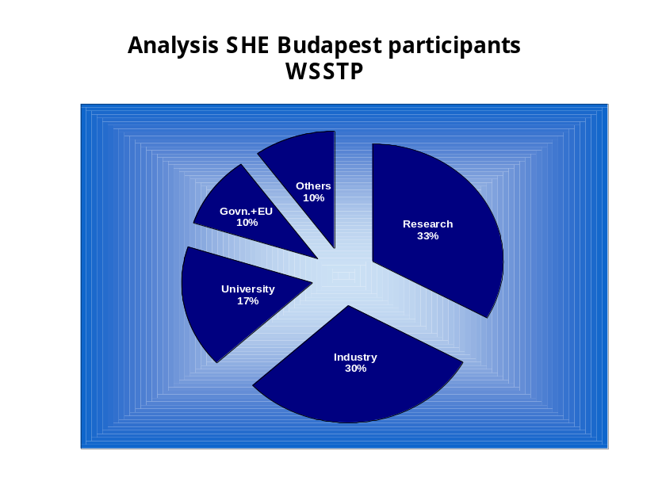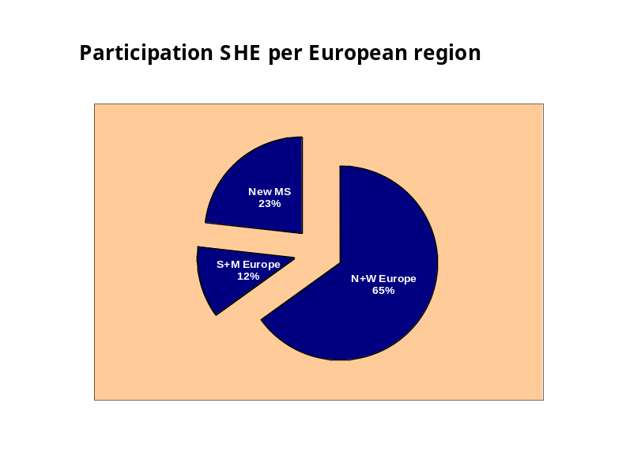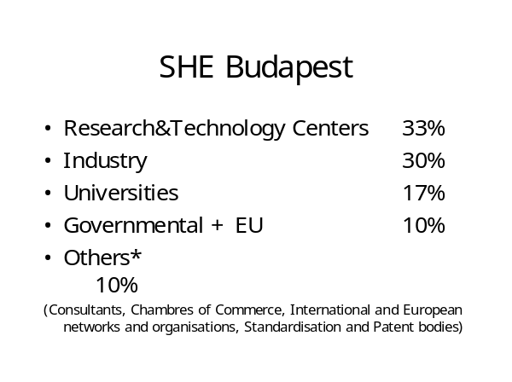

- Secretariats meetings. For the smooth operation of the Secretariat a number of meetings was organised and facilitated. At the start of the project, the meeting frequency was high, as was the case nearer the stakeholder event(s). In addition, regular teleconferences were organised. For the production of the merged versions of VD and SRA and for the production of the Implementation Plan additional meetings were organised by the Secretariat.

- Reimbursement of experts. Within the budget of the SSA, an amount of money was reserved for the reimbursement for a number of participants of the Board, MSMG and working groups that lack the financial resources. A list of criteria was proposed and accepted on the basis of which requests for funding were assessed and allocated. Criteria concerned the additional input from under represented regions or countries and under represented stakeholder groups.

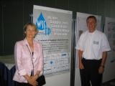
- Attendance national branches TP The Secretariat received many requests from various countries to provide information on the WSSTP to national platforms. Whenever necessary assistance was given to help and set up national platforms. Information was given amongst others in Germany, Poland and Slovenia.

Slovenian national platform meeting

- Website and newsletters: At the start of the project a website for the platform was set up by sub-contractor NWP (www.wsstp.org). The website was used for information to the public and also had specified working areas for the various bodies of the platform. Together with NWP four issues of the WSSTP newsletter were produced. The newsletters were in an electronic format. On a regular basis an analysis was made of the visits to the website.
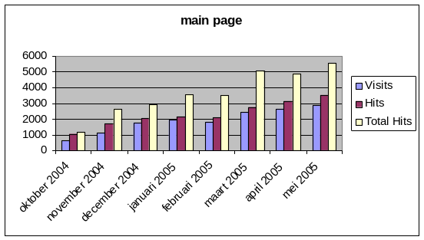

Example of analysis website visits

- Secretariat activities. The Secretariat has many different activities and roles. Besides the abovementioned tasks for the Board, the MSMG, the website and newsletters and the stakeholder events, the Secretariat acts as the first contact point for information, requests for presentations and requests for participation in the platform. The Secretariat also acted as contact point for other technology platforms, research networks and important organisations such as EUREAU. The Secretariat holds a database of all WSSTP contacts. The electronic newsletters were sent to all contacts and were also made available on the website.
- Contact with the European Commission. The Secretariat had regular contacts with DG Research of the European Commission, including a presentation to Pierre Valette. Information on the progress of the WSSTP was also given on a regular basis to DG Environment.

The Water Supply and Sanitation Technology Platform has a number of important measurable objectives, to which this SSA has contributed significantly:
- The production of the Vision Document, Strategic Research Agenda and Implementation Plan.
- Contributing to the European industry competitiveness, by providing a multi-stakeholder framework.
- Wide spread consultation on and dissemination of the results of the platform.
number of contacts.

The joint focus of the production of the three documents is a very unique process of bringing together the various groups of stakeholders. At the start of the project the water sector was not used to cooperate with each other. Within 2 years time, this very diverse water sector has jointly produced a Common Vision and a joint Research Agenda. This is a major achievement which would not have been possible without the Technology Platform and the support it received through this Specific Support Action.

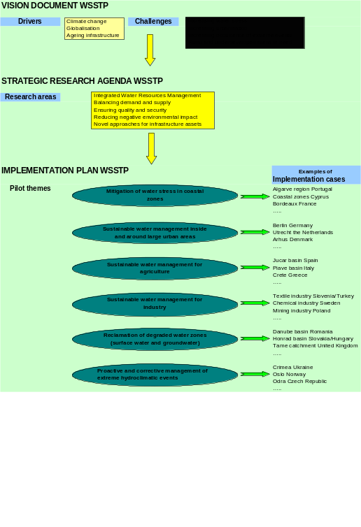
The fact that the water sector now has a multistakeholder forum will make it possible to jointly work on the research issues and the development of innovative technologies. This will be done through six pilot themes and the more than forty implementation cases all over Europe (and outside Europe) and will significantly contribute to the competitiveness of the European industry.

1.2. Dissemination and use

Consultation and Dissemination -Public Relation activities
Consultation and dissemination always have the full attention of the WSSTP. The consultation was carried out through expert groups, reference groups (the website) and through the stakeholder event. A PR plan was made and executed to improve contacts outside those directly involved in the platform. One of the activities was the mapping of significant stakeholders.

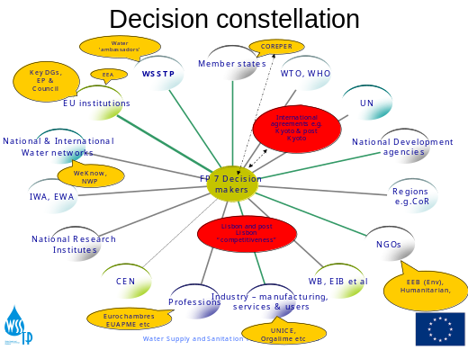

Stakeholder mapping as basis for the PR plan

PR activities during the contract period included an advertisement and banner in Euractive some months before the Stakeholder Event and just before the SHE but also an interview in European Voice in 2005.

On a regular basis an inventory is made of contacts of the WSSTP within the various parts of Europe. On the basis of the analysis actions were taken to improve the representativeness. This will also be made clear in the list of dissemination activities.
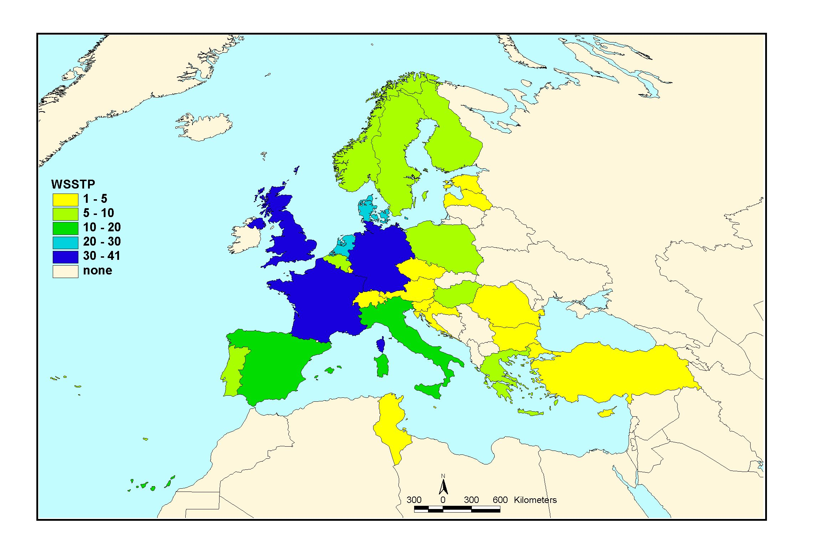
Representativeness of the WSSTP.

Dissemination activities of the Consortium included various different means:
Project deliverables: The deliverables of the project included:
- The individual reports of the working groups on vision and research agenda
- The merged version of the VD and the SRA
- The Implementation Plan as first step for the Strategic Deployment Strategy
- An overview document from the MSMG on national research programmes
- Analysis of Stakeholder participation
- Summary report on the outcome of the SHE in Budapest
- Inventories of stakeholder participation in WSSTP
- PR plan for WSSTP
- Annual contribution to the EC report on the progress in the development of technology platforms
- Annual report on openness and transparency of the WSSTP.

Articles in national and scientific magazines (some examples):
- Water21
- European Voice

PR Material
- Four issues of the newsletter
- Two issues of a WSSTP brochure
- Two posters
- A build on powerpoint presentation in various languages (the basic ppt is available on the website and each presenter updated the presentation during the contract period).

Representation at meetings, events, trade fairs and conferences
- Presentations in a passive way through stands, posters and flyers. An example is CER in Brussels

Representation at conferences through presentations such as:
- Stockholm Water Week
- World Water Forum Mexico

Representation at events for Industrial Leaders of Technology Platforms
- Recurring event

Contacts with related TP’s and networks, EU projects
- Close contacts with Integration for Water
- Contacts with TECHNEAU
- Contacts with Construction TP, Zero-emission, H2 fuel cell TP.

Above is just an introduction to all WSSTP’s activities. A full list of all activities can be found in the overview table below.

Overview table
Planned/actual  Dates | Type | Type of audience | Countries addressed | Size of audience | Partner responsible /involved
> Nov 2004 | Direct e-mailing, newsletter | All type | World | 1.000 | Kiwa, all
> Nov 2004 | Poster |  | All Europe |  | All partners
> Nov 2004 | Flyer |  | All Europe |  | All partners
> Nov 2004 | Website | All type |  |  | Kiwa, all partners
07-08-04 | Meeting ENDWARE | General public | EU | 20 | Kiwa
12-11-04 | Meeting WEKNOW | General public | EU | 30 | Kiwa
17-11-04 | Seminar  Frankfurt, Germany | water professionals | Germany | 17 | EASA-IOS
30-11-04 | Seminar  Munich, Germany | administrators | Bavaria | 10 | EASA
Dec 2004 | Workshop | Public sector research strategists and funders | UK | 28 | UKWIR
12-01-05 | Seminar  Frankfurt, Germany | Water professionals | Germany | 22 | EASA
11-02-05 | Seminar  Kalpakam, India | researcher | India | 18 | EASA
March 2005 | Board meeting | Water Utility Directors | UK | 12 | UKWIR
16-03-05 | Meeting, Nieuwegein | Higher education | EU | 10 | Kiwa
18-03-05 | Seminar  Berlin, Germany | researcher | Germany | 25 | EASA
20-04-05 | Workshop | Water utility managers | UK | 25 | UKWIR
20-04-05 | Meeting, Dutch mirror group, Delft | General public | EU | 10 | Kiwa
21-04-05 | Conference  Munich, Germany | Researcher,  water professionals | Germany | 120 | EASA
27-04-05 | Panel discussion  Munich, Germany | Water professionals | Inter-national | 35 | EASA
12-05-05 | Seminar  Oxford, UK | Master students,  faculty | Inter-national | 18 | EASA
13-06-05 | Conference WEKNOW, Bratislava | General public | EU | 400 | Kiwa
21-06-05 | Seminar  Munich, Germany | public | Germany | 55 | EASA
23-07-05 | Conference  Munich, Germany | public | Germany | 80 | EASA
22-08-05 | Conference  World Water Week  Stockholm, Sweden | water professionals | Inter-nationa | 35 | EASA
08-05-05 | Article Water 21 | General public | EU |  | Kiwa
June 2005 | Board meeting | Water Utility Directors | UK | 12 | UKWIR
06-06-05 | Article H2O magazine | General public |  |  | Kiwa
12-10-05 | Conference  Ljubljana, Slovenia | Water professionals | Slovenia | 160 | EASA
17-10-05 | Conference  Budapest, Hungary | Water professionals | Europe | 120 | All partners
13-11-05 | Exhibition, CER, Brussels | General public | EU | ?? | Kiwa
20-12-05 | Dechema, Germany | General public |  |  | Kiwa
20-12-05 | Seminar  Frankfurt, Germany | Water professionals | Germany | 22 | EASA
From Jan 2006 | Direct e-mailing | EUCETSA membership | EU | 1100 companies | Eucetsa
March 2006 | Board meeting | Water Utility Directors | UK | 12 | UKWIR
27-03-06 | Conference moderators, Katowice | General public |  |  | Kiwa
April 2006 | Workshop | Water utility managers | UK | 25 | UKWIR
02-06-05 | Article Water 21 | General public |  |  | Kiwa
15-06-06 | Expo APA, Bucharest | General public |  |  | Kiwa
28-06-05 | Autex Conference Slovenia | Research / Industry  Textiles | 25 | 50 | TNO
28-06-05 | Poster id | Research/Industry | 25 | 1000 | TNO
16-03-06 | Conference, 4th world water, Mexico | General public | World | 200 | Kiwa
16-03-06 | Panel discussion  WWF, Mexico | public | Inter-national | 170 | EASA
29-04-06 | conference  Essen, Germany | Water professionals | Germany | 450 | EASA
May 2006 | Conference | Multiple utility managers | UK | 50 | UKWIR
09-05-06 | Panel discussion  Berlin, Germany | public | Germany | 85 | EASA
23-05-06 | Seminar  Frankfurt, Germany | Water professionals | Germany | 25 | EASA
Since Spring 2006 to present | Eucetsa advertises WSSTP on web-site | Industry and associations, EU, general public | EU | - | Eucetsa
June 2006 | Workshop | Water utility managers | UK | 25 | UKWIR
06-06-06 | European Policy Summit Brussels | Broad water and environment | EU | 240 | Eucetsa European Water Partnership and Friends of Europe
July 2006 | Workshop | University researchers | UK | 20 | UKWIR
25-10-06 | Entsorga Exhibition | Industry (waste and treatment sectors) | Global attendance | 49000 attendees to Entsorga | Eucetsa
25-10-06 | Publications – Brochure | Industry and general public | EU | - | Eucetsa
15-11-06 | Seminar  Düsseldorf, Germany | researcher | Germany | ? | EASA
11-12-06 | Seminar  Munich, Germany | researcher | Germany | ? | EASA
15-01-07 | Symposium  Hong Kong | Researcher  governmental officials | Hong Kong  P.R. China | ? | EASA
26-01-07 | Seminar  Sapporo, Japan | Researcher  water professionals | Japan | ? | EASA-IOS
20-05-07 | Conference  12th Intern. Gothenburg Symposium, held in Ljubljana, Slovenia | researcher | Europe, USA,  Japan | ? | EASA-IOS

EUCETSA
Via the EUCETSA membership of a new organisation of which EUCETSA is a founding member – the European Water Partnership www.ewp.org – the WSSTP was given very good exposure at a high level conference organised jointly with “Friends of Europe” in May 2006.

The WSSTP project has been advertised within the EUCETSA company network, via our twelve member associations across Europe. They have been informed and consulted throughout the project especially regarding Working Group Industry which is of most relevance to the technology suppliers (and chaired by Eucetsa). The logo features prominently on Eucetsa’s website. Both e-mail and printed material in the form of a leaflet and poster have been widely distributed both to disseminate information and engage companies in an interactive process.

The WSSTP was also advertised (poster) at the Entsorga fair in Köln on October 25-28^{th,}, where EUCETSA had a stand. The fair attracted some 49,000 visitors, 30% from outside the European Union, but clearly we were able to communicate to a small proportion of this total audience, mainly drawn from the waste handling and processing areas. However, many companies did visit the stand and some had specific interest in WSSTP.

EUCETSA has maintained a comprehensive communication campaign targeting companies in the water sector both within Eucetsa membership and outside. Invitations to working groups, reports on meetings via E-mail and telephone have helped to promote awareness of the WSSTP and specifically the Vision Report and Strategic Research Agenda.

EUCETSA advertised WSSTP especially prior to the Budapest stakeholder event on the web portal EurActiv. (See media plan below)

Mediaplan* | Mon | 17. Oct | 24. Oct | 31. Oct
EUCETSA | Sun | 23. Oct | 30. oct | 06-Nov
 | WEEK | 42 | 43 | 44
SECTION
Homepage | Banner
Homepage | Button Top Right
Homepage | Button Top Left
Homepage | Side Button Left |  | X
Homepage | General Update Email
Environment | Banner |  | X
Environment | Button Top Right |  |  | X
Environment | Button Top Left
Environment | Side Button Left
Environment | Side Button Right | X
Environment | Environment Email |  | X
CSR/Social Europe | Banner | X
CSR/Social Europe | Button Top Right
CSR/Social Europe | Button Top Left |  | X
CSR/Social Europe | Side Button Left
CSR/Social Europe | Side Button Right |  |  | X
CSR/Social Europe | Science & Research Update Email | X
Sustainable Dev. | Banner |  |  | X
Sustainable Dev. | Button Top Right | X
Sustainable Dev. | Button Top Left
Sustainable Dev. | Side Button Left
Sustainable Dev. | Side Button Right |  | X
Sustainable Dev. | Sustainable dev. Email

“Water Supply and Sanitation: the European Water sector responding to global challenges”

Water issues have long been central to efforts to address poverty and improve human health in developing countries. Water is indispensable and increasingly precious everywhere as economic development intensifies. European know-how in water is unmatched in the world, because early industrialisation in Europe created a need to manage conflicts between needs of industry, agriculture, householders and other water users.

I consider this water technology platform as an outstanding example of a tangible contribution of a wide variety of different private and public stakeholders to challenges that we are facing, including the Millennium Development Goals, European competitiveness, sustainability and climate change.

It is vital to harness European technology and innovation to address these challenges, and we commend the efforts of all participants who are helping to develop or deploy solutions to resolve social, technical, and economic solutions, for instance in water management, conservation, and re-use.

The European Commission has been promoter and facilitator of this Platform, among the concrete measures established by the Environmental Technologies Action Plan, launched in January 2004. We are very proud to see one and a half year later that this Technology Platform was able to mobilise the whole European Water sector – and in particular the water industry which has taken the lead of it - around a process that will draw the research strategy for the future of this sector.

We look forward to seeing positive results of the stakeholder consultation that starts with the Budapest event. We expect to receive from you very valuable inputs that may contribute to the definition of our work programmes for the 7th Framework Programme.

Regretting of not having been able to open your meeting, I wish you all the best success.

Janez Potočnik

1.3 Publishable results
During this project 3 documents have been produced for the public:
The Vision Document : "Water Safe, Strong and Sustainable", was conceived and drafted by five working groups, consisting of water sector experts and representatives of water sector stakeholders. The vision paints a picture of what could be achieved by 2030 if resources for research and development resources would be made available and targeted to respond to the issues and challenges that the European water sector is facing.
The Strategic Research Agenda ; ‘Water Research- A necessary investment in our common future", describes the research which must be undertaken to realise the vision. The SRA is based on an integrated and participatory approach for water resources management. The solutions are integrated across individual sectors and disciplines and involve the civil society. The strengths of all stakeholders in the sector will be combined to enable the European water sector to offer innovative and sustainable technologies to the world.
The Implementation Plan describes the initial ideas for demonstration pilots and implementation cases and mechanisms for financial engineering of grants and debts. The Implementation Plan will use a systems approach, which encompasses water supply, sanitation, water use in agriculture and industry and river basin management to develop solutions for the global water market. The IP describes the strategy chosen for the execution of the SRA through six pilot themes of generic research, enabling technologies development and implementation cases. The financial engineering is addressed and will be further detailed and adapted to each implementation case in the Strategic Deployment Document.
These three documents are included in the annexes.

