
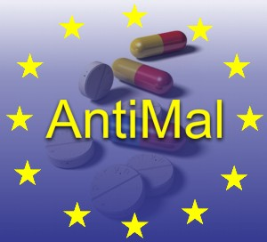

Project no. LSHP-CT-2005-018834

AntiMal Integrated Project

Development of New Drugs for the Treatment of Malaria

Thematic Priority Poverty Related Diseases

Final Periodic Activity Report

Period covered: 1st December 2005 to 31st May 2011

Date of preparation: July 2011

Start date of project: 1st December 2005 Duration: 66 months

Project coordinator – Professor Steve Ward
Liverpool School of Tropical Medicine

Table of Contents

Section 1 – Project Execution ……………………………………………… |  | 2
 | Introduction...………………………………………………………… | 2
 | Project Objectives.....………………………………………………… | 3
 | End Results…………………………………………………………… | 18
Section 2 – Dissemination and use ....………………………....…………… |  | 20
 | University of Liverpool………………………………..……………... | 20
 | INSERM ……………………………….…….…….…….…………... | 22
 | University of Milan …………………………….….……………….... | 24
 | University of Heidelberg………………………….…….……..……... | 24
 | University of York……………………………….………….………... | 27
 | CNRS Roscoff……………………………….……………….……..... | 25
 | 4SC AG…………….……………….……………..………………..... | 26
 | NeED..................................................................................................... | 27
 | Justus-Liebig University Giessen………………..……………….…... | 29
 | Council for Scientific and Industrial Research...................................... | 30
 | Centre National de Recherche et de Formation sur le Paludisme……. | 30
 | African Institute of Biomedical Science & Technology....................... | 31
 | University of Cape Town…………………………….…..…………... | 34

Section 1 – Project execution

Introduction

AntiMal (www.antimal.eu) is an integrated project initiated on the 1st December 2005 and funded for 66 months in total. The initiative is relevant to all aspects of call FP6-2004-LIFESCIHEALTH-5.

The main objective of the AntiMal Integrated Project (IP) was to generate novel antimalarial drugs with potential for use in humans, specifically to progress candidate molecules to the “first time into humans” stage of drug development. To achieve this goal, leading groups of malaria researchers from Europe and Africa with expertise in malaria biology, chemotherapy and drug development came together to exploit new scientific and political opportunities to secure the development of a portfolio of viable antimalarial drugs. Ultimately these new chemical entities will be commercially attractive to industrial partners and through the generation of Public Private Partnerships (PPP’s), will result in affordable new antimalarial drugs registered to internationally recognised standards.

The scientific programme of this IP comprised complementary clusters of basic and applied scientific investigation and established links with complementary programmes including the BioMalPar and EVIMalaR Networks of Excellence and the African Network for Drugs and Diagnostics Innovation (ANDI).

AntiMal focussed on the following areas: novel quinolines, novel peroxides, drugs targeting lipid metabolism, drugs directed against other targets (kinases, pyrimidine metabolism, hexose transporters, bisarylureas, chalcones, etc) and post candidate development. The project brought together European research institutes of established international reputation in the field of malaria biology and chemotherapy and their affiliated research groups in malaria-endemic areas. Through AntiMal’s programme of jointly executed research, 28 European research groups supported the network’s goals to generate viable lead drug molecules in collaboration with 7 industrial partners including 6 SMEs and 10 partners from malaria endemic countries (including 2 SMEs).

Coordinator:
Professor Steve Ward
Liverpool School of Tropical Medicine
Pembroke Place
Liverpool L35QA
UK
saward@liv.ac.uk

Project objectives

The principle goal of this integrated project (IP) is to generate novel antimalarials with potential for use in man within five years by focusing on the following objectives-

- Bringing together a critical mass of researchers from leading institutions.
- The integration of leading European malaria drugs research centres through a coherent, multidisciplinary and focused programme of research.
- Providing a vehicle for exploitation of the basic science knowledge generated by European research on malaria drugs and in particular by establishing a “virtual” pharmaceutical development organisation within Europe for malaria drugs.
- Establishing in the European landscape of malaria research the essential link to provide antimalarial candidate products for clinical evaluation as the essential link between basic science as undertaken by the BioMalPar Network of Excellence and the more advanced clinical evaluation as it is taken up by the European and Developing Countries Clinical Trials Partnership (EDCTP).
- Generation of a series of novel drugs to phase 1 clinical trials with the potential for safe, effective and affordable treatment of malaria within endemic countries.
- Contributing to the training of the next generation of malaria researchers.
- Contributing to building advanced research capacities in malaria-endemic countries in Sub-Saharan Africa.

Achievement of project objectives

- Bringing together a critical mass of researchers from leading institutions.

The AntiMal consortium is made up of a total of 37 institutions from across Europe and Africa offering a wide range of skills and abilities associated with malaria drug development.

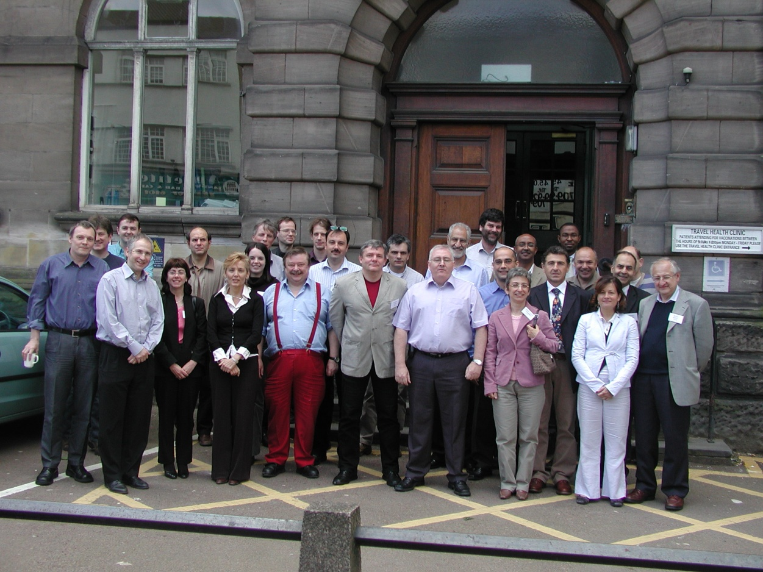

AntiMal consortium at the Kick off meeting on the 30th & 31st May 2006

Contractors Involved

Participant No | Participant Name | Participant short name | Country | Start date of participation | End date of participation
1 | Liverpool School of Tropical Medicine | LSTM | UK | Month 1 | Month 66
2 | University of Liverpool | UOL | UK | Month 1 | Month 66
3 | CNRS Montpellier II | CNRSM | France | Month 1 | Month 66
4 | St Georges Hospital Medical School | SGHMS | UK | Month 1 | Month 66
5 | The Research Programme of INSERM U609 | INSERM | France | Month 1 | Month 66
6 | University of Milan | UMIL | Italy | Month 1 | Month 66
7 | University of Heidelberg | UOH | Germany | Month 1 | Month 66
8 | CNRS Toulouse | CNRST | France | Month 1 | Month 66
9 | Institute of Molecular Science and Technology- CNR | ISTM | Italy | Month 1 | Month 66
10 | Biomedical Primate Research Centre | BPRC | Netherlands | Month 1 | Month 66
11 | University of Dundee | UOD | UK | Month 1 | Month 66
12 | Consejo Superior de Investigaciones Cientificas | CSIC | Spain | Month 1 | Month 66
13 | Swiss Tropical Institute | STI | Switzerland | Month 1 | Month 66
14 | University of York | UOY | UK | Month 1 | Month 66
15 | London School of Hygiene and Tropical Medicine | LSHTM | UK | Month 1 | Month 66
16 | University of Siena | NatSyn | Italy | Month 1 | Month 66
17 | Medica Research Unit, Albert Schweietzer Hospital | MRUG | Gabon | Month 1 | Month 66
18 | University of Nairobi | UON | Kenya | Month 1 | Month 66
19 | CNRS Roscoff | CNRSR | France | Month 1 | Month 66
20 | African Centre for Clinical Trials | ACCT | Kenya | Month 1 | Month 66
21 | LICA Pharmaceuticals A/S | LICA | Denmark | Month 1 | Month 66
23 | 4SCAG | 4SC | Germany | Month 1 | Month 66
24 | Cosmos Pharma | Cosmos | Kenya | Month 1 | Month 66
25 | Palumed | Palumed | France | Month 1 | Month 66
26 | Serono Pharmaceuticals Research Institute | SPRI | Switzerland | Month 1 | Month 36
27 | NeEd Pharmaceutical | NeEd | Italy | Month 1 | Month 66
28 | Justus-Liebig University Giessen | Giessen | Germany | Month 1 | Month 66
29 | Ghent University | Ghent | Belgium | Month 1 | Month 66
30 | Ludwig-Maximillians University Munich | LMU | Germany | Month 1 | Month 4
31 | National Technical University of Ukraine “Kiev Polytechnic Institute” | KPI | Ukraine | Month 1 | Month 66
33 | University of Strasbourg | ULP | France | Month 1 | Month 36
34 | Philipps University Marburg | UNIMAR | Germany | Month 5 | Month 66
35 | Kenya Medical Research Institute | KEMRI | Kenya | Month 13 | Month 66
36 | Institute of Primate Research | IPR | Kenya | Month 15 | Month 66
37 | Council for Scientific and Industrial Research | CSIR | South Africa | Month 13 | Month 66
38 | Centre National de Recherche et de Formation sur le Paludisme | CNRFP | Burkina Faso | Month 31 | Month 66
39 | African Institute of Biomedical Science and Technology | AiBST | Zimbabwe | Month 31 | Month 66
40 | University of Cape Town | UCT | South Africa | Month 31 | Month 66

2. The integration of leading European malaria drugs research centres through a coherent, multidisciplinary and focused programme of research.

It is the collaboration between the 37 partner institutions across Europe and Africa that has made the AntiMal project a success. The project was structured in a way that the diverse expertise of several institutions was combined to work on each scientific workpackage, allowing a collaborative, coherent, multidisciplinary approach. Examples are shown below:-

WP No | Participant ID
4.1.1.1 | LSTM | UOL | BPRC | COSMOS | ACCT | MRUG
4.1.1.2 | UOL | UMIL | LSHTM | NeED
4.1.2.1 | LSTM | UOL | BPRC | ACCT | COSMOS
4.1.2.2 | LSTM | UOL | LSHTM | ACCT | COSMOS
4.1.2.3 | CNRST | Palumed | LSHTM | UOL
4.1.2.4 | NATSYN | LSTM | SGMHS

As well as collaboration between partners on individual workpackages, the workpackages were assigned to cluster groups with a common theme. The aim of this structure was to enable like-minded researchers from each workpackage to exchange knowledge and information at cluster meetings and foster further collaboration.
The structure of the cluster groups is shown below:

Graphical representation of workpackages

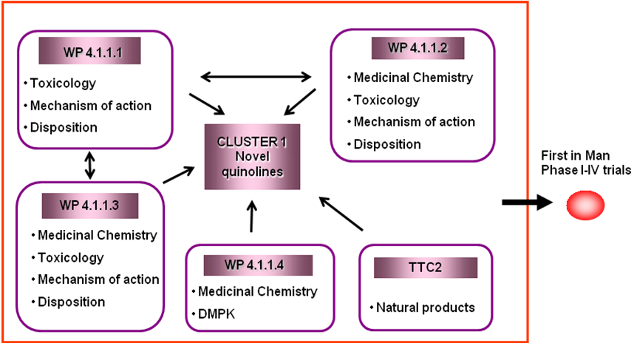

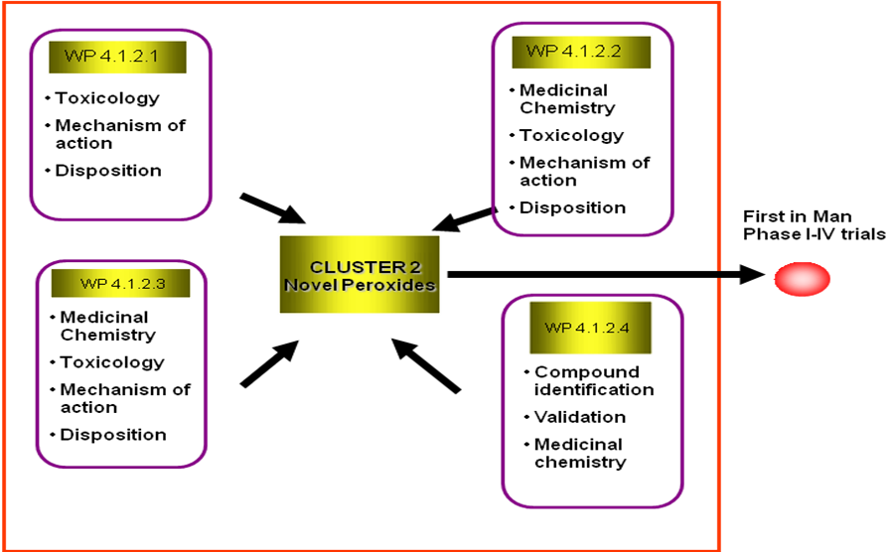

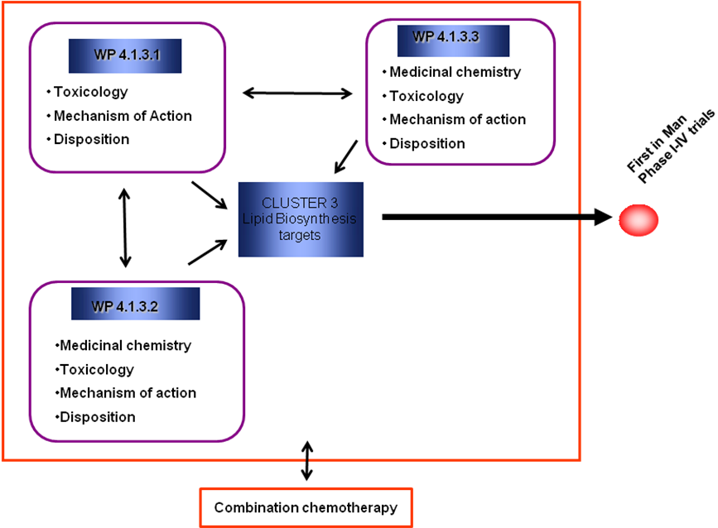

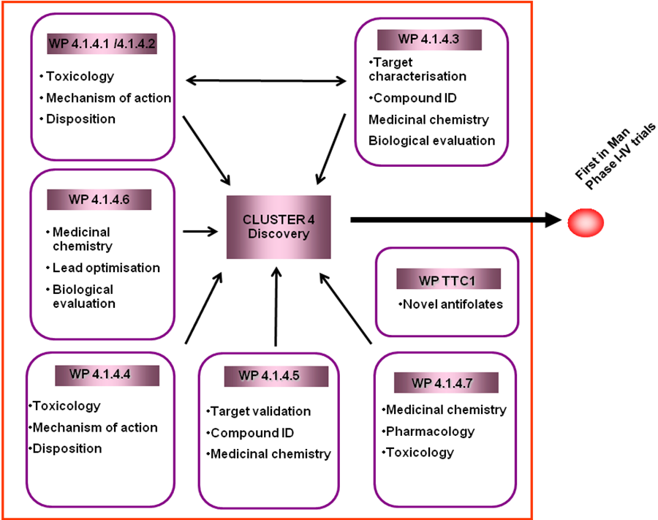

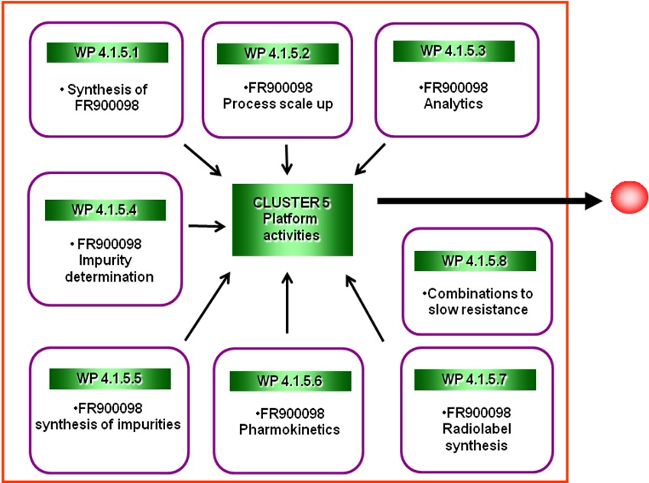

3. Providing a vehicle for exploitation of the basic science knowledge generated by European research on malaria drugs and in particular by establishing a “virtual” pharmaceutical development organisation within Europe for malaria drugs.

Pharmaceutical companies rationalise their portfolio of development candidates on an ongoing basis in order to fund the most promising candidates and discontinue funding those molecules that do not exhibit the essential characteristics of a drug compound. In order to establish a “virtual” pharmaceutical development organisation, an independent External Scientific Advisory Committee (ESAC) was established. This committee reviewed the progress of the scientific workpackages periodically throughout the duration of the project and advised on future funding. The committee comprised experts identified by both the consortium members and the EU Commission and initially contained the following 10 experts:

Andrew Waters
Hagai ginsburg
Ivan Addae-Mensah
Jean-Rene Kiechel
John Horton
Peter Folb
Pierre-Etienne Bost
Simon Efange
Solomon Nwaka
Jane Kengeya-Kayondo

A total of four review meetings were held during the project and ESAC reviewed the individual workpackage through reports and presentations by the workpackage PIs and questioned the scientists on methods and results. This resulted in a periodic reduction of the number of workpackages funded within the consortium as shown below:-

WP | PI | Start date of funding | End date of funding
4.1.1.1 | Steve Ward | Month 1 | Month 66
4.1.1.2 | Donatella Taramelli | Month 1 | Month 66
4.1.1.3 | Diego Monti | Month 1 | Month 24
4.1.1.4 | Collen Masimirembwa | Month 30 | Month 66
4.1.2.1 | Paul O’Neill | Month 1 | Month 66
4.1.2.2 | Paul O’Neill | Month 1 | Month 24
4.1.2.3 | Bernard Meunier | Month 1 | Month 24
4.1.2.4 | Giuseppe Campiani | Month 1 | Month 42
4.1.2.5 | Souleymane Sanon | Month 30 | Month 66
TTC2 | Chris Parkinson | Month 13 | Month 66
4.1.3.1 | Henri Vial | Month 1 | Month 66
4.1.3.2 | Henri Vial | Month 1 | Month 42
4.1.3.3 | Pat Bray | Month 1 | Month 51
4.1.4.1 | Christian Doerig | Month 1 | Month 66
4.1.4.2 | Christian Doerig | Month 1 | Month 24
4.1.4.3 | Francis Mulaa | Month 1 | Month 24
4.1.4.4 | Ian Gilbert | Month 1 | Month 24
4.1.4.5 | Michael Lanzer | Month 1 | Month 66
4.1.4.6 | Sanjeev Krishna | Month 1 | Month 42
4.1.4.7 | Arsalan Kharazmi | Month 1 | Month 66
TTC1 | Alexis Nzila | Month 13 | Month 66
4.1.5.1 | Serge Van Calenbergh | Month 1 | Month 24
4.1.5.2 | Hassan Jomaa | Month 1 | Month 24
4.1.5.3 | Hassan Jomaa | Month 1 | Month 24
4.1.5.4 | Hassan Jomaa | Month 1 | Month 24
4.1.5.5 | Martin Schlitzer | Month 1 | Month 24
4.1.5.6 | Francois Jehl | Month 1 | Month 24
4.1.5.7 | Hassan Jomaa | Month 1 | Month 24
4.1.5.8 | Livia Vivas | Month 1 | Month 66

This ensured that the available projects funds were used to progress the most promising workpackages and therefore use the resources in the most cost effective way.

4. Establishing in the European landscape of malaria research the essential link to provide antimalarial candidate products for clinical evaluation as the essential link between basic science as undertaken by the BioMalPar Network of Excellence and the more advanced clinical evaluation as it is taken up by the European and Developing Countries Clinical Trials Partnership (EDCTP).

In the second reporting period, AntiMal organised its first annual conference directly after the BioMalPar conference in order to link the two projects. These linked conferences enabled the partners to forge links with other institutions and was an excellent opportunity for members of the consortium who are also members of BioMalPar to meet their peers and discuss the roles of AntiMal and BioMalPar in the malaria community. Since the end of BioMalPar, AntiMal has linked itself with its successor EVIMALAR.

Although members of the AntiMal consortium have links with EDCTP, there have been no AntiMal funded molecules that have progressed to clinical trials through EDCTP. The clinical trials for workpackages 4.1.3.1 and 4.1.2.3 have been conducted in collaboration with Sanofi Aventis.

5. Generation of a series of novel drugs to phase 1 clinical trials with the potential for safe, effective and affordable treatment of malaria within endemic countries.

The experimental work of the project was performed under 5 clusters:

Cluster 1 Novel aminoquinolines:

Work Performed
This cluster was initiated with three discrete work packages with one additional work package being added through our AntiMal African capacity development initiative. The three initial projects focused on the aminoquinoline core with two project targeting blood stage P. falciparum malaria and the third targeting liver stage parasites. The African partner used the quinolones as proof of concept molecules for establishing in Silico and in vitro antimalarial DMPK expertise in S Africa and Zimbabwe. During the AntiMal project more than 300 novel compounds were synthesized and evaluated for antimalarial activity in vitro and in vivo.

Results
Three lead molecules were selected for further lead optimisation and eventual candidate selection. Two from WP 4.1.1.1, the fluoro N-tert butyl analogue (FAQ) and the chloro N-tert butyl analogue (CAQ) of amodiaquine, and one from WP 4.1.1.2, the quinolizidinyl - derivative of chloroquine (AM1) that later generated MG3. Through iterative rounds of biological testing and medicinal chemistry FAQ4 and MG3 were candidate selected. Both molecules have mechanisms of action similar to choroquine, they are highly active against CQ-R parasites, they can be readily synthesised in a three step, two-pot reaction at acceptable costs of goods compared to CQ, they demonstrate excellent in vitro safety profiles, and good DMPK.
Through the advice and recommendations of the ESAC, FAQ4 was selected as a candidate for full GLP development with MG3 as a potential backup. The candidate molecule FAQ4 has been through a complete GLP safety pharmacology programme including formal genotoxicity assessment, cardiovascular hERG liabilities and in vivo safety in two animal species. The results indicate that, as with all aminoquinolines (including chloroquine and amodiaquine) there are toxicological alerts in many of the pre-clinical studies, especially cardiovascular concerns that will need to be addressed carefully in any future clinical programme. The scale-up multi kg cGMP synthesis for FAQ4 has been completed and a tablet formulation of 4-FAQ has been developed and batches of tablets are being stability tested. MG3 has been through genotoxicity and hERG testing as well as safety evaluation in one species in vivo.
FAQ4 has completed pre-clinical evaluation and has successfully reached the stage where it could be tested for safety tolerability and pharmacokinetics in health human volunteers. MG3 requires a full safety tolerability evaluation in a second animal species prior to testing in humans.

Cluster 2 Novel peroxides

Work performed
At the start of AntiMal there were four workpackages within the cluster two based on novel peroxide monotherapies and two based on peroxide hybrids. The first workpackage (4.1.2.1) has generated a series of lead molecules based on an achiral tetraoxane template to avoid issues of chirality. The second workpackage (4.1.2.4) has focused on the isolation and structural characterisation of a novel class of endoperoxide from the marine sponge Plakortis simplex. Both projects have generated molecules with activity against drug sensitive and resistant parasites and several of the lead molecules show advantages over existing peroxides. The first of the hybrid projects (4.1.2.2) has exploited the reductive cleavage of the peroxide ring to generate a second antimalarial selectively within the parasite. The project has provided proof of concept data and the search is on for more drug like molecules for further development. The second hybrid project (4.1.2.3.) has linked a peroxide template with a quinoline template to aid targeting within the parasite. These molecules showed promising activity but will require much more detailed evaluation prior to lead identification and optimization. After year one an additional partner was introduced through our AntiMal African Capacity development initiative to work on natural product chemistries with potential antimalarial activity. During the AntiMal project more than 300 novel compounds were synthesized and evaluated for antimalarial activity in vitro and in vivo as part of this cluster.

Results
On recommendation of ESAC WP 4.1.2.2 was terminated although it had generated clear proof of concept that it was possible to deliver combination therapy through a single dual action drug. WP 4.1.2.3 was successfully developed further through Palumed and Sanofi Aventis through a full pre-clinical development package and is “parked” at the first into man transition awaiting onward clinical evaluation. WP 4.1.2.4 focused on the isolation and structural characterisation of a novel class of endoperoxide from the marine sponge Plakortis simplex. Although biological data demonstrate great promise, synthesis of a tractable synthetic molecule (or a simple and scalable synthetic route to the natural product) for onward development proved impossible. This class of molecule requires a significant breakthrough in chemistry for it to be reactivated as a drug discovery initiative,
The major highlight of cluster 2 is WP4.1.2.1. This workpackage was developed to generate a fully synthetic endoperoxide based on the tetroxane core. Through systematic iterations of medicinal chemistry and biological evaluation a lead molecule was optimised to generate the lead compound that was eventually candidate selected for onward development, RKA182. This molecule has a target product profile matching MMV’s required criteria. RKA182 has completed a full regulatory GLP preclinical package. The molecule has demonstrated exceptional antimalarial activity, superior to any peroxide antimalarial currently in clinical use, was shown to be non genotoxic and non- cardiotoxic. In vivo evaluations in the rat and the dog demonstrated a safety profile that was compatible with human use. The GMP multi kg scale up synthesis of this molecule is complete and pharmaceutical development to generate a suitable formulation is underway. A formal application has now been submitted to MMV to support completion of the preclinical work for this molecule along with Phase 1-IIA clinical studies. This work package also produced a larger series of excellent lead molecules and a back-up molecule to RKA182 suitable for further studies. In summary, this molecule is at the first into human transition and partnership and funding opportunities for onward development are being sought.

Cluster 3 Lipid targets

Work performed:
This cluster consisted of three very closely linked projects. The first workpackage, WP 4.1.3.1 has generated a series of molecules from bisquaternary ammonium salts which has produced a candidate drug molecule that has entered clinical trials in man. In the second work package, WP4.1.3.2, a series of bis-alkylamidine and bis-alkylguanidine drugs, which can mimic the choline structure, have been designed and synthesised. For these drugs, the cationic head is also separated by lipophilic alkyl chains (n≥12 methylene groups). A prodrug approach has been validated for bis alkylamidines. In the final workpackage, WP4.1.3.3, symmetrical and asymmetrical bis-benzamidine compounds have been designed and synthesized and tested. During the AntiMal project more than 150 novel compounds were synthesized and evaluated for antimalarial activity in vitro and in vivo as part of this cluster

Results
A range of lead molecules have been synthesised and tested within this workpackage. In general the molecules demonstrate excellent antimalarial activities in vitro and some show good in vivo activity against selected malarial models. Mechanism of action studies have shown that these molecules target the parasite by two independent mechanisms one based on inhibition of choline uptake and utilization and the other based on complexation with heme. This dual mechanism of action can explain the potency of the series and the difficulty in generating resistant parasites with these molecules, an excellent feature for onward progression. Structure activity relationships have been established. The principle challenge with this class of drug has been poor solubility and bioavailability making an oral drug formulation impossible to date. A range of strategies based on medicinal chemistry, pro-drug design and formulation have so far failed to generate an optimised antimalarial lead molecule for onward development as an oral treatment.
However the lead compound T3, a bis-thiazolium salt , has been taken into pre-clinical development by Sanofi Aventis. The candidate, SAR97276, has completed preclinical evaluation and has transitioned into human clinical trials. The drug showed adequate safety tolerability and pharmacokinetics in healthy volunteers and has undergone phase II evaluation in malaria patients. The drug is being developed as an alternative treatment for severe malaria for IV or IM administration.

Cluster 4 other targets

Work performed
This cluster was initiated with 7 diverse workpackages ranging from early concept target validation to more mature development projects. The first two workpackages (WP4.1.4.1 and WP4.1.4.2) were linked and focused on potential protein kinase targets. A third workpackage (WP4.1.4.3) also focused on a kinase target, 4-methyl -5 beta-hydroxyethylthiazole (UON). The fourth workpackage characterised potential targets in pyrimidine metabolism (WP4.1.4.4). The fifth workpackage was based on novel bisarylureas with an as yet unknown parasite target (WP4.1.4.5). The sixth workpackage (WP4.1.4.6) aimed at developing a high throughput screening assay for the hexose transporter PfHT. In the final workpackage in this cluster (WP4.1.4.7), a library of more than 1000 chalcones have been synthesized and evaluated against P falciparum. Later as part of efforts to develop African capacity in drug development a re-purposing project (TCC1) was introduced aimed at looking at the potential of low dose methotrexate as an antimalarial.

Results:
The first two workpackages (WP 4.1.4.1 and 4.1.4.2) were linked and initially focused on PfPK5 and PfPK6 which were confirmed as drug targets and recombinant enzymes have been generated and sent to Serono for HTS. At Serono a library of 20,000 different molecules were tested against PfGSK-3 and mammalian GSK-3. 17 compounds of a similar chemotype were found to be active. Following on from these studies the group has systematically evaluated the complete parasite kinome in order to identify validated targets. The project has gone on to look at interacting partners for key kinases, the exploitability of host red cell kinases and a series of studies aimed at generating high resolution crystal structures of key kinases as a route to novel inhibitor design. These studies will lead to future HTS and targeted medicinal chemistry drug discovery projects. In WP 4.1.4.6 it has been demonstrated that catechins inhibit PfHT and GLUT1 at micromolar concentrations. They also kill parasites. These data highlight that chemically diverse, non-glucose based compounds (catechins) can inhibit PfHT. Catechins also have some specificity of activity for facilitative hexose transporters. Further Studies on a comprehensive list of hexose derivatives and inhibitors have been completed. Ongoing discovery effort for inhibitors of GLUT1 has been initiated with Novartis. Within WP 4.1.4.5 work has continued to improve overall drug bioavailability, identify a chemical series capable of clearing parasites from an in vivo model after oral administration and thereby driving candidate selection. SC832988 was selected as a lead. Bioavailability is a major issue with this molecule. Formulation and medicinal chemistry strategies to overcome this limitation have so far failed. The current status is that a development candidate has not yet been selected to move forward with the planned pre-clinical activities. Within WP 4.1.4.7 the potential developability of the novel chalcone LC1500 has been re-evaluated. DMPK analysis demonstrated rapid metabolism by microsomal liver preparations from humans, rats and mice and rapid in vivo elimination in the rat. A major limitation of LC1500 was the finding that the drug tautomerises during experimental incubations. This makes LC1500 almost impossible to develop as a drug. A medicinal chemistry solution has been investigated and series of molecules that cannot undergo tautomerisation have been successfully synthesised and are undergoing biological testing. WP TCC1 has continued to look at the developability of low dose methotrexate as an antimalarial. The DMPK of the drug has been evaluated in a primate malaria model and mechanism of action studies have been carried out. Low dose methotrexate has been evaluated for exposure and pharmacokinetics in human trials.

Cluster 5 Post candidate development

Work performed

This cluster was originally made up of eight workpackages of which seven were focused on a single molecule, FR900098, a novel fosmidomycin derivative targeting isoprenoid biosynthesis. The final workpackage in this cluster (LSHTM) has provided a standardised service to the consortium for the in vitro and in vivo testing of molecules and also in vivo experiments to evaluate the therapeutic potential of drug combinations.

Results
To date a range of novel synthetic routes to the simple and cost effective synthesis of this molecule have been evaluated and analytical methods are being established to facilitate pre-clinical pharmacokinetic studies of FR900098. Evaluation by the ESAC concluded that although this molecule had some excellent biological characteristics it fell down on a number of key aspects of the target product profile making development to a single dose three-day cure a challenge. WP4.1.5.8 has provided screening support to many workpackages within AntiMal including WPs 4.1.1.2, 4.1.1.4, 4.1.2.1, 4.1.4.1 and WPs 4.1.5.1-4.1.4.7. Extensive in vitro and in vivo evaluation of molecules generated in the consortium has been completed during the 66 months of the project. The results generated by this workpackage have allowed workpackage leaders to decide on the suitability of molecules to achieve specific aspects of the TPP and whether further redesign is necessary. It has also been important is producing data for assessment by ESAC with regard to future funding decisions.

6. Contributing to the training of the next generation of malaria researchers.

The AntiMal PhD programme was set up to provide support for malaria students with expertise in basic and applied science related to drug development and registration. Using a rigorous selection process, 11 students were identified and during their time with AntiMal have attended a number of conferences and training workshops to improve their skills.

Activities attended by PhD students

Date | Activity
01/10/2006 | Start of work contracts
08/10/2006 | Induction course, Montpellier
10/04/2007 | 3rd Annual BioMalPar conference, EMBL, Heidelberg, Germany
13/04/2007 | 1st AntiMal conference, EMBL, Heidelberg, Germany
19/11/2007 | Course on “scientific writing and presenting in English”, London
14/04/2008 | 4th Annual BioMalPar conference, EMBL, Heidelberg, Germany
20/11/2008 | Course on “Managing Projects & the world of enterprise”, Montpellier, France
18/05/2009 | 5th Annual BioMalPar conference, EMBL, Heidelberg, Germany
02/11/2009 | 5th MIM Pan-African Malaria Conference, Nairobi, Kenya
2010 | Final defence of students at their respective universities

During their fourth year, 10 AntiMal PhD students finished their lab work and successfully defended their PhD theses. Ayenew Alemu, returned to his home country without finishing his PhD (due to health reasons). At present, 9 students have found new positions in academia.

Student | Final defence | QA Date | 2nd TAC | 3rd TAC | Current position
Abdi | 11/11/2010 | 13/04/2007 | 15/04/2008 | 21/10/2010 | Postdoc, Kemri
Alemu | No Defence | 26/10/2007 |  |  | Scientist
Berger | 28/06/2010 | 10/09/2007 | 21/07/2008 | 06/07/2009 | Postdoc University of Liverpool
Bouserjra | 18/03/2010 | 21/09/2007 | 03/09/2008 | 09/10/2009 | Postdoc University of Toulouse
Cui | 19/11/2010 | 05/09/2007 | 30/10/2008 | 01/10/2009 | Postdoc Centre for Drug Design, Minnesota
Finaurini | 28/04/2010 | 07/09/2007 | 08/07/2008 | 24/06/2009 | Postdoc, National Laboratory of Advanced Technologies Italy
Jeffers | 19/11/2010 | 05/07/2007 | 20/11/2008 | 28/09/2009 | Postdoc, Indiana University School of Medicine
Kaniti | 08/10/2010 | 06/09/2007 | 05/03/2009 | 01/01/2010
Marti-Gimeno | 20/09/2010 | 06/09/2007 | 21/10/2008 | 06/07/2009
Mimche | 28/04/2010 | 27/09/2007 | 08/07/2008 | 11/10/2009 | Postdoc, Emory University, Atlanta, USA
Slavic | 25/06/2010 | 04/07/2007 | 11/07/2008 | 18/06/2009 | Postdoc, Institute for Medical Research, Belgrade, Serbia

AntiMal consortium workshops
AntiMal has also provided opportunities for the training of individuals within the consortium in a number of generic and specific areas. During the five year project several workshops were held as summarised below:-

July 2007 – GLP/GCP Workshop, Liverpool, UK
The GLP/GCP workshop was held in Liverpool on the 24th, 25th and 26th of July 2007. A total of 30 participants attended the GLP course and 28 attended the GCP part of the workshop. Certificates were given to attendees and a questionnaire was completed. Relevant GLP/GCP documents were posted on the secure website.

Questionnaire feedback showed a positive response to the workshop with the GLP part of the course being particularly well received.

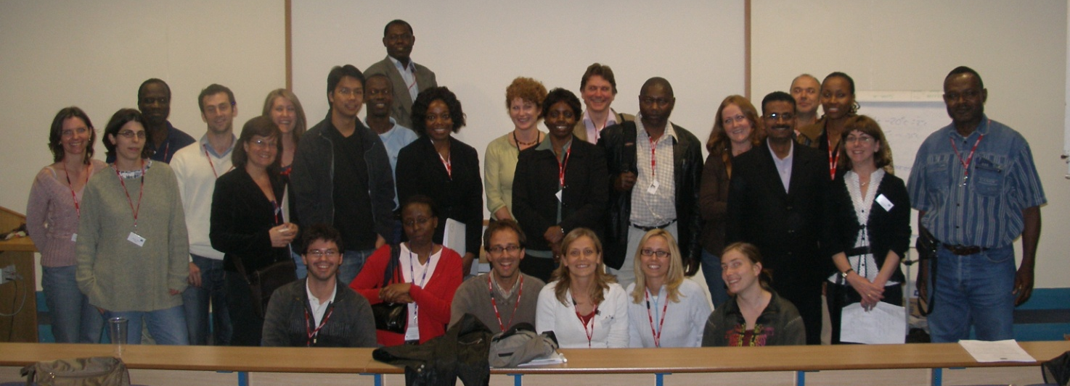

September 2007 – Project Management Workshop, Nairobi, Kenya

This workshop took place on the 19th, 20th and 21st September 2007 in Nairobi, Kenya. A total of 22 participants attended the workshop, the majority of which were African. Certificates were given to attendees and an evaluation questionnaire was completed by delegates. The workshop was an interactive learning experience and the feedback from the delegates was excellent.
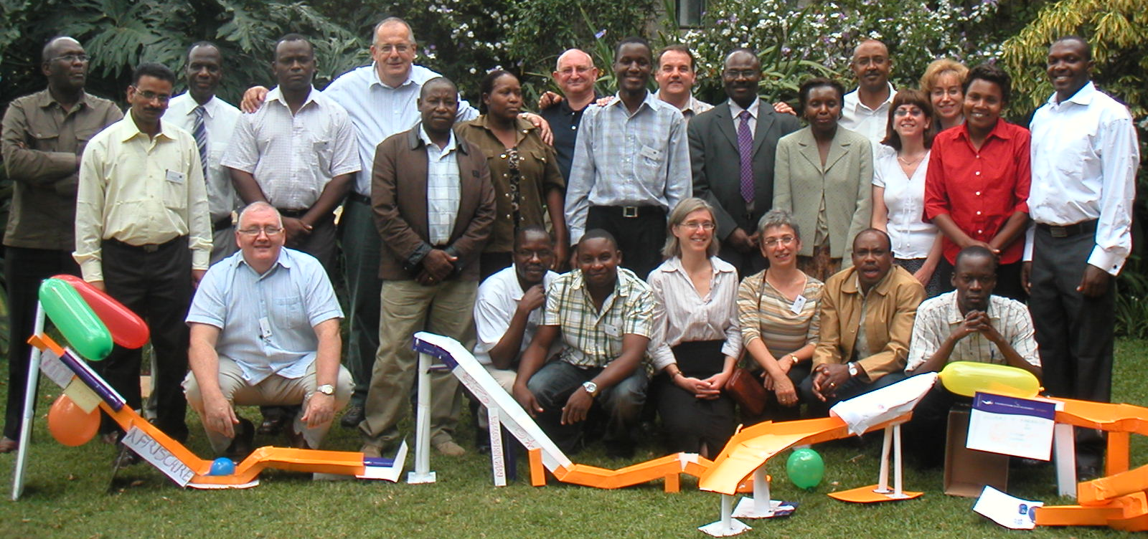

May 2009 – DMPK Workshop, Cape Town
During the period 25-29th May 2009, biologists and chemists interested in drug discovery and development participated in an intense course in which they learnt the latest strategies in the integration of ADMET (absorption, distribution, metabolism, excretion and toxicity) in Medicinal Chemistry. The course involved lectures and hands on exercises in computational modeling and attracted participants from different countries and biomedical research backgrounds. They included senior scientists, postdoctoral fellows and PhD students, a balanced mix that encouraged intellectual exchange of ideas and experiences.

The course was presented by lecturers with both academic and industrial experience in the sciences and technologies of drug discovery. These included Prof. Kelly Chibale (UCT), Prof. Guy Kip (St Jude’s Children’s Research Hospital, USA), Prof. Ismael Zamora (Lead Discovery Ltd, Spain), Prof. Ian Gilbert (University of Dundee, UK) Dr. Lourdes Cucurull-Sanchez (Pfizer) and Dr. Collen Masimirembwa (AiBST). The course design was such that each day’s lectures included an introductory lecture on the biological aspects of the DMPK parameter(s) of interest followed by a medicinal chemistry perspective of the parameter(s) and computational modeling approaches to addressing the various ADMET issues.

The overwhelming positive feedback from the participants was the ultimate measure of the success of the course. Comments from the delegates proved that this was a timely and relevant course in addressing the gap in knowledge on the importance of ADMET in drug discovery and an introduction to the tools of how to address ADMET issues in projects
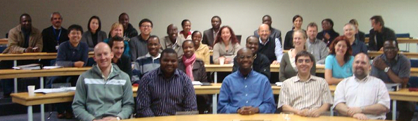
October 2009 – Leadership workshop, Lausanne, Switzerland
A 3-day leadership workshop was held from the 13th to the 15th October 2009 in Les Diablerets, Switzerland. A total of 21 members of the AntiMal consortium attended from several Institutes, including the University of Nairobi, the University of Milan, CNRFP, 4SC SGHMS and the University of Liverpool. Delegates with a variety of skill sets were each looking for a new way to lead and cultivate their teams.

The workshop was designed to be a highly interactive and practical skills development workshop, for academic professionals keen to improve their personal effectiveness, influencing skills, strategic thinking and leadership capabilities. The workshop was aimed at both junior and senior members of AntiMal, investigating working relationships already in place and how to invest time, and energy into the improvement of those relationships. Over the three days each delegate took part in a variety of activities which included looking at personality types, working under pressure and ways of communicating with others.

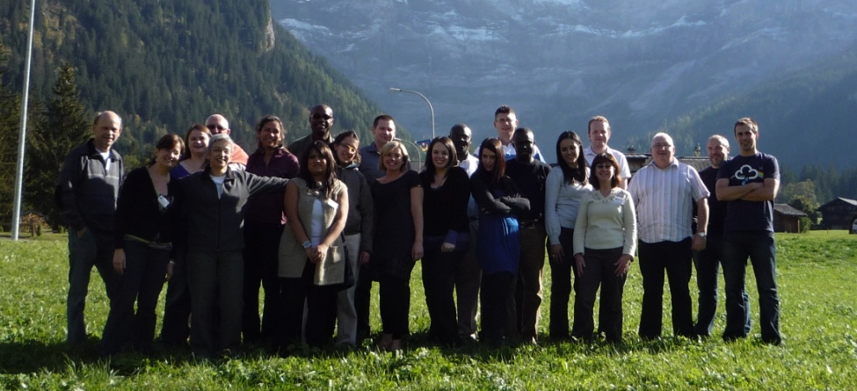

September 2010 – Intellectual Property and Clinical Trials Workshops, Libreville, Gabon
In September 2010 twenty-four members of the AntiMal consortium travelled to Gabon to attend a Clinical Trials and Intellectual Property training course at the Medical Research Unit based at the Albert Schweitzer Hospital in Lambaréné. The first day of training was devoted to the Intellectual Property (IP) course which provided the delegates with a better understanding of IP and how it relates to the work conducted by AntiMal. Topics covered included: - creating IP and its relevance to AntiMal, types of IP, database rights and patents. This proved to be very successful with the feedback reporting a high level of satisfaction with the overall course content and tuition received.

The following two-day programme concentrated on clinical trials and was lead by two trainers: Sherry Armstrong-Wilkinson from Clinical Research Africa, and Mkaya Mwamburi based at the University of Boston. The course was very interactive and delegates were encouraged to role play and discuss real life situations. Areas covered included: the process of new drug and vaccine development, clinical trial design & methodology, patient information & consent, safety reporting and clinical trials in Africa. Again the feedback was very positive with many delegates reporting that they would recommend the course to colleagues.
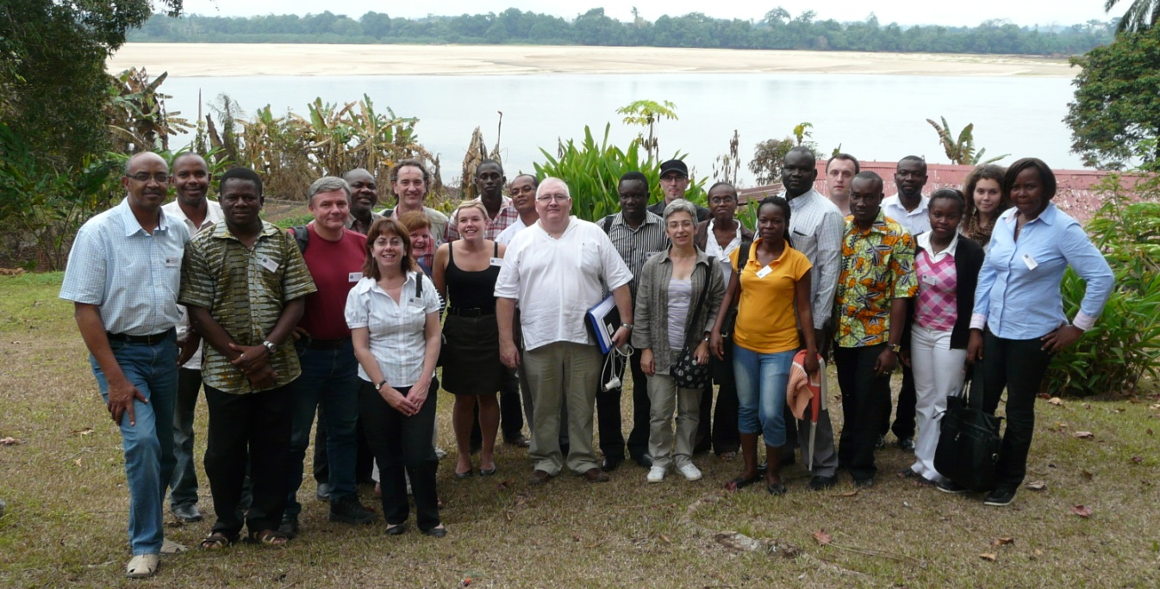

7. Contributing to building advanced research capacities in malaria-endemic countries in Sub Saharan Africa

In 2007 AntiMal and MIM/TDR collaborated on a competitive call to develop African capacity in key areas of relevance to drug discovery and development. A total of 20 proposals were received and these were evaluated by a panel consisting of experts identified by AntiMal, the EU Commission and MIM/TDR.

Following site visits it was decided to fund three groups and two workpackages. These groups joined the AntiMal consortium on the 1st June 2008.

AiBST (Zimbabwe) and UCT (South Africa) formed a collaboration to strengthen the DMPK platform at AiBST and medicinal chemistry at UCT.

The aim of the project was to set up or upgrade the in silico and in vitro ADMET evaluation platforms to support the selection of hits and to guide the lead optimisation process. In silico predictions of drug like properties (Lipinski’s Rules), have been performed using software such as GRID, GLIDE, GOLD, Metasite and Volsurf. In vitro drug ADMET profiling used HTS and LC-MS/MS platforms. A PhD student was jointly supervised by the PIs of the two institutions and two postdoctoral fellows and three technicians were employed by the project. The DMPK platform was applied to 29 compounds synthesised at the UCT.

Various series of compounds were synthesised and evaluated for anti-malarial activity and characterized with respect to ADMET properties. One was a 4-aminoquinoline series of 19 NCEs which had anti-malarial activity against chloroquine resistant plasmodium malaria. Metabolic characterisation of the natural product, Frutinone A; Evaluation of the inhibitory effects of herbal extracts on CYP; Synthesis of analogues of amodiaquine; metabolic stability assay setup at the UCT

Training played a significant part of capacity development in this workpackage. During the period 25-29th of May 2009, an intensive course with 28 participants in ADMET (absorption, distribution, metabolism, excretion and toxicity) in Medicinal Chemistry was organized in Cape Town, South Africa. From 22nd to 26th of June 2009, a workshop on Pharmacogenetics of Drug Metabolism was organized in Nairobi Kenya, for 34 pharmacists, chemists, pharmacologists and medical doctors. Lectures were presented by faculty members who acted as tutors with both academic and clinical experience in the sciences and technologies of Pharmacogenetics of Drug Metabolism. With regard to capacity development at other African institutes in the sciences and technologies of ADMET, four senior scientists from South Africa, Nigeria, and Egypt visited AiBST from 18th-22nd January 2010 for hands on training in the in silico and in vitro methods in ADMET.

Based on the capacity development success of this workpackage, Professor Kelly Chibale from UCT has been successful in leveraging further funding from the South African government for further South-South and South-North collaborations. This would not have been possible without the support of AntiMal.

CNRFP – Burkina Faso

CNRFP has been involved in the assessment of the antimalarial activity of medicinal plants used by traditional healers in Burkina Faso. This project has helped to strengthen research capacity at CNRFP by providing resources to hire and train scientists, purchase new equipment and visit the laboratories of European partner institutions to learn how to conduct the antimalarial testing required to test plant extracts.

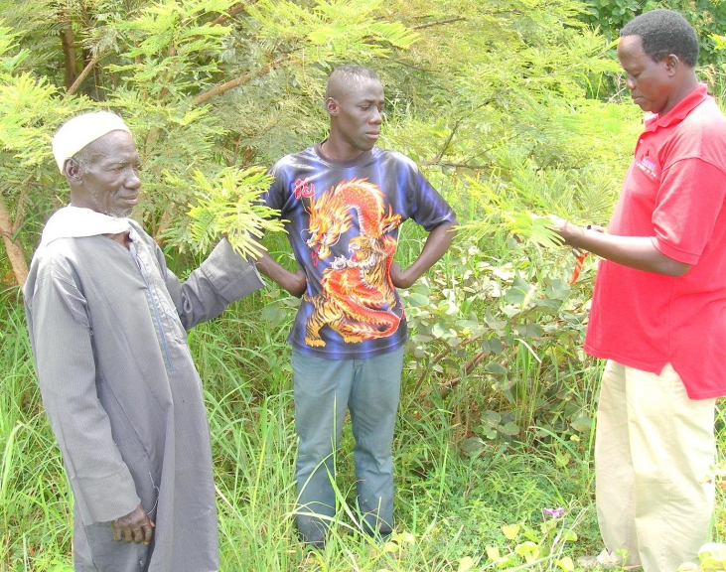
Donatella Taramelli (UMIL), Henri Vial (CNRSM) and Christian Doerig (INSERM) also visited the centre on behalf of AntiMal to provide advice and feedback on the project and the facilities available to CNRFP.

CNRFP has achieved the following with the assistance of AntiMal:-
- The lab has been refurbished and equipped with reagents and consumables.
- National and international GCLP requirements have been achieved
- Standard Operating Procedures (SOPs) have been written
- New staff have been recruited and trained.
- The expertise for keeping and running parasites cultures has been acquired.
- in vitro pharmacological assays of the crude extracts from the plants has been conducted
This training and infrastructure improvements should allow CNRFP to continue the assessment of the antimalarial activity of plants after the AntiMal project has ended.

End Results

The primary aim of this Integrated Project was to deliver at least one potential antimalarial drug to the first into man transition. The AntiMal project brought together a critical mass of researchers from leading institutions and the programme of research was structured in a coherent, multidisciplinary and focused way. Regular external expert reviews focused funding on those workpackages judged to have the greatest likelihood of achieving the project goals, thus establishing a “virtual” pharmaceutical development organisation within Europe for malaria drugs.

This approach has lead to the delivery of two molecules into clinical trials and a further three to the transition i.e. a full pre-clinical package. In addition there are a series of additional projects that have progressed significantly through the drug development process. This is a very successful outcome from an investment of 17.75 million Euros.

The AntiMal PhD programme has produced 10 PhD graduates, most of which have now moved to postdoctoral positions in labs around the world.

The training workshops have focussed on the development of both generic skills e.g. project management and leadership and also specific project related skills such as GCP, GLP, DMPK intellectual property and clinical trials and were available to all consortium partners.

The capacity development initiative has produced collaboration between researchers in Zimbabwe and South Africa that has developed further South-South and South-North links and has already proved successful in leveraging further funding for research activities. The group in Burkina Faso has gained knowledge in antimalarial assays to test extracts from plants used by traditional healers, has trained staff and students and has improved infrastructure with the institution.

AntiMal has been successful in harnessing some of the most effective translational antimalarial laboratories in Europe and Africa and created collaborations, relationships and critical mass that will be central to future drug discovery projects in infectious diseases. A significant number of the projects have been able to develop links with industry and PPPs and it is these links and collaborations that will be the future driving force of drug development in infectious diseases in the future and hopefully the future registration of new drugs to combat malaria that were developed within AntiMal.

2. Dissemination and use

University of Liverpool
Participant 2: Paul O’Neill

Publishable result 1

Description (functionality, purpose, innovation etc.):
Workpackage 4.1.1.1
Significant progress has been made this year which has led to candidate selection of FAQ4 as our lead 4-aminoquinoline antimalarial. With a robust scaled up synthesis of this molecule (1 kg) we are in a good position to exploit the properties of this molecule as next generation quinoline antimalarial

Workpackage 4.1.2.1
During this year we have discovered a synthetic route that delivers antimalarial tetraoxane (TX) endoperoxide analogues in high yields with activity superior to clinically used semi-synthetic antimalarials. This initial set of compounds was incorporated into a patent previously filed. We have also discovered a new class of TX molecule that only require a two-step synthesis and we will be filing a new (second) patent early in the New Year

Workpackage 4.1.3.3
Synthesis of pro-drugs complete, exploitation dependent on performance in in vivo model and this data is not available at present time
Partner(s) involved in the exploitation, role and activities University of Liverpool, Liverpool School of Tropical Medicine. Outsource company for synthesis - possibly

Sector(s) of application: 4.1.1.1, 4.1.2.1, 4.1.3.3 Antimalarial Chemotherapy and also prophylaxis

Exploitable use: Yes - we would anticipate that these classes of compound would be highly attractive to those pharmaceutical companies with antimalarial portfolios; GSK, Novartis, Sanofi etc.

Techn./econ. market considerations: For 4.1.1.1, 4.1.2.1 and 4.1.3.3 the pre-clinical package needs to demonstrate advantage over competitors.

Stage of development: candidates and prototypes

Planned date for commercial use: difficult to predict

Commercial Contacts: MMV have expressed interest in an alternative synthetic peroxide. We have also had contact from Sanofi. GSK may require back-up to Isoquine.

Protection measures: SEE ABOVE

Additional research:
4.1.1.1 - Further work beyond current planned pre-clinical See SA Ward comments as PI on this work package

4.1.2.1 - Scale up synthesis to 20 kg by CRO eg Carbogen. Full pre-clinical package involving suitable CRO eg Covance, Charles River. Work on back-up series.

4.1.3.3 - Selection of pro-drug, PK studies, pre-clinical toxicity etc in an approach the same as employed in 4.1.1.1

Additional information: 4.1.2.1
An antimalarial that can be prepared in 2 steps in the lab would have a significant impact in this area.

Can be published: Yes

Publishable result 2

Description (functionality, purpose, innovation etc.):
Workpackage 4.1.1.1
significant progress has been made this year which has led to candidate selection of FAQ4 as our lead 4-aminoquinoline antimalarial. Molecule is progressing through advanced preclinical evaluation.
Workpackage 4.1.2.1
During this year we have candidate selected RKA 182, developed a scale up synthesis and the molecule is progressing through formal preclinical evaluation. The first set of compounds have been patented. We have also discovered a new class of TX molecule that only require a two-step synthesis and we filed a second patent in Jan 2009.
Workpackage 4.1.3.3
Synthesis of novel series of triazoles complete.

Sectors of application: Medical field

Exploitable use:
Two patents have been filed and discussions initiated with GSK to explore potential for further development and exploitation of molecules discovered in project.

Techn./econ. market considerations: Several competitors in market

Stage of development: demonstrator

Planned date for commercial use: Difficult to predict

Owners involved: UOL, LSTM

Commercial Contacts: NA

Protection measures:
Patent protection on Amide and Mannoxane Series of Antimalarials;

MANNICH-BASE DISPIRO TETRAOXANE (MANNOXANE) COMPOUNDS
Richard Amewu, Francesc Marti, Stephen A. Ward, and Paul M. O’Neill
File reference of MD-P0900885GBX/MAN and has a UK patent application Number 0904935.4
DISPIRO TETRAOXANE COMPOUNDS
AMEWU RICHARD; O'NEILL PAUL MICHAEL; STACHULSKI ANDREW; ELLIS GEMMA; WARD STEPHEN ANDREW.
Patent no: WO2008038030

Additional research:
Additional funding will enable a further three series of drug candidates to be fully evaluated and back-ups to current development candidate.

Additional information: NA

Can be published: Yes

Publishable result 3

Description: Presently we are in the process of obtaining a European patent that is focused on RKA182 and the back-up molecule JC-3-39 which we intend to pursue as full development candidates. Since our initial patent represents prior art we are working on the best way forward to achieve coverage of these two molecules.
1 dispiro tetraoxane compounds and their use in the treatment of malaria and/or cancer wo2008038030 / us2010113436 (a1) We also filed a patent on the Mannoxane back-ups;
2.mannich base tetraoxanes (mannoxanes) and phenol substituted analogues wo2010109172 (a1)

Sectors of application: Medical Field - Malaria Chemotherapy
Exploitable use: Patents have been filed and MMV are interested in the possibility of adding RKA182 to their portfolio and funding the pharmaceutical development and Phase 1 clnical trial in humans. The project is up for review in July by MMV. We have also interest from Sanofi and Novartis and we will also engage GSK in the near future.

Techn./econ. market considerations: Resistance to artemisinins may provide these molecules with an advantage but this is to be confirmed.

Stage of development: Preclinical

Planned date for commercial use: NA

Owners involved: To be determined

Comercial Contacts: -

Protection measures: Patents listed below;

Additional research: Additional research is required into pharmaceutical development of candidate RKA182 and its back-up, manufacture of JC-3-39 and also mechanism of action studies for the tetraoxane class of antimalarial. For RKA 182 we may need to include additional preclinical work subject to MMV's view on our datapack.

Additional information: -

Can be published: Yes

INSERM Research
Participant 5: Christian Doerig

Publishable result 1

Description (functionality, purpose, innovation etc.): Target validation

Partner(s) involved in the exploitation, role and activities: NA

Sector(s) of application: Malaria

Exploitable use: Definition and prioritisation of molecular targets for drug discovery

Techn./econ. market considerations: NA

Stage of development: NA

Planned date for commercial use: NA

Comercial Contacts: Validation of targets is of crucial interest for industrial partners wanting to implement a drug discovery programme on malaria. These include MERCK-Serono, an ANTIMAL partner, as well as other entities.

Protection measures: It would be counterproductive to seek IP protection for the targets that are validated through our work in WP 4141.

Additional research: Additional targets in the parasite and its host cell are being investigated/validated. Screening on validated targets is ongoing.

Additional information: NA

Can be published: Yes
________________________________________________________________________________

University of Milan
Participant 6: Donatella Taramelli

Publishable result 1

Description (functionality, purpose, innovation etc.): Two complementary fluorimetric assays for the determination of aminoquinoline binding and uptake by human erythrocytes. We provide two simple, low cost and low tech procedures to measure with good precision and accuracy the binding and internalization into human erythrocytes of chloroquine and other aminoquinolines. The methods are based on the high fluorescence of the quinoline ring and are complementary. Method (A) evaluates residual drug in the supernatants of treated erythrocytes; method (B) quantifies the total uptake by whole cells and the fraction bound to the membranes. Drug uptake is dose-dependent and related to the number of erythrocytes. These assays could be useful when studying the cell interaction of quinoline type compounds not available in the radioactive form

Partner(s) involved in the exploitation, role and activities: None

Sector(s) of application: Clinical and experimental pharmacology

Exploitable use: In vitro predictive tests of drug distribution into RBC

Techn./econ. market considerations: NA

Stage of development: lab scale use

Planned date for commercial use: NA

Commercial Contacts: NA

Protection measures: NA

Additional research: NA

Additional information: NA

Can be published: Yes

Publishable result 2

Description (functionality, purpose, innovation etc.): Novel pyrrolizidinyl derivatives of 4-aminoquinoline were synthesised. When tested in vitro they showed high antimalarial activity, low toxicity, good efficacy in vivo in the murine model. Preclinical ADME-Tox profiling of one of them, MG3, which is non chiral and easy to synthesise, has been initiated and compared to that of rac AM1 and CQ.

Partner(s) involved in the exploitation, role and activities: CTG Pharma s.r.l.

Sector(s) of application: Medical field, human health

Exploitable use: Product (antimalarial drug)

Techn./econ. market considerations: NA

Stage of development: Late optimization – Preclinical

Planned date for commercial use: NA

Commercial Contacts: NA

Protection measures: CTG Pharma is the owner of a patent for these compounds. EP 846401 18.06.2008

Additional research: NA

Additional information: NA

Can be published: Yes

University of Heidelberg
Participant 7: Michael Lanzer

Publishable result 1

Description: Development of a drug against malaria

Sectors of application: Medical field

Exploitable use: The compound may be used as a drug to treat complicated malaria.

Techn./econ. market considerations: Malaria causes approximately 3225 million disease episodes annully. The treatment of malaria is complicated by emerging resistance, also to current first line treatments. A drug with a novel mode of action and an efficacy against mult-drug restistant parasites is beneficial.

Stage of development: pre-clinical testing (animal models)

Planned date for commercial use: -

Owners involved: The compound has been developed with the 4SC AG in Munich.

Commercial Contacts: -

Protection measures: The relevant compounds have been patented.

Additional research: -

Additional information: -

Can be published: Yes
________________________________________________________________________________

University of York
Participant 14: Keith Wilson

Publishable result 1

Description: Soluble constructs of the GSK3 Plasmodium kinase, producing protein suitable for crystallisation screening and other kinetic and biophysical studies.
This overcame problems of insolubility and stability in the early part of the project.

Sectors of application: Potential production of crystals for structural study (not achieved to date) for use in drug design studies.

Exploitable use: Potential production of crystals for structural study (not achieved to date) for use in drug design studies.

Techn./econ. market considerations: Not applicable to date

Stage of development: -

Planned date for commercial use: -

Owners involved: University of York

Commercial Contacts: None.

Protection measures: None.

Additional research: None.

Additional information: None.

Can be published: Yes
________________________________________________________________________________

CNRS Roscoff
Participant 19 : Laurent Meijer

Publishable result 1

Description (functionality, purpose, innovation etc.): We have pursued the screening for inhibitors of PfGSK-3 in two directions: [1] a general screen on libraries of low molecular weight molecules, and [2] the screening of a specific library of compounds designed around the first inhibitory scaffold identified in the previous screens. In total we have tested over 20,393 general compounds [1] and 58 derivatives [2]. In the latter case all compounds were tested on both PfGSK-3 and mammalian GSK-3. The collaboration with Dr. Conrad Kunick (Braunsweig University, Germany) has permitted the synthesis of analogues of the initial hits. Some compounds display a complete selectivity for PfGSK-3, in that they have absolutely no effects on mammalian GSK-3. Nevertheless, despite the number compounds synthesized and the diversity of substitutions at different sites of the scaffold, we are unable to understand the precise structure/activity relationship of this family. One possibility is that the compounds can bind in two different modes, and, consequently, there is an overlap of two different structure/activity relationships. We are also awaiting the co-crystallization of several inhibitors with PfGSK-3, a work carried out by Dr. Jean Whittingham and Dr. Keith Jones.

Partner(s) involved in the exploitation, role and activities: Laurent MEIJER (CNRS, France) Conrad KUNICK (Braunsweig University, Germany)

Sector(s) of application: the aim is treatment and/or prevention of malaria using a PfGSK-3 specific pharmacological inhibitor

Exploitable use: patent application under preparation

Techn./econ. market considerations: further optimization and characterization required

Stage of development: lead family of inhibitors

Planned date for commercial use: impossible to predict at this stage

Commercial Contacts: not applicable at this stage

Protection measures: patent application under preparation

Additional research: co-crystallization with PfGSK-3 under way

Additional information: NA

Can be published: Yes

Publishable result 2

Description (functionality, purpose, innovation etc.):
A family of pharmacological inhibitors specific to Plasmodium GSK-3 kinase. A patent application has been filed. A publication is in final stage of preparation.

Sectors of application: medical field (preclinical studies)

Exploitable use: Needs further invetsigation and optimization. Prevention of Plasmodium proliferation.

Techn./econ. market considerations: A patent application was filed. The CNRS is looking for potential clients to take a licence.

Stage of development: -

Planned date for commercial use: -

Owners involved: Owner: CNRS, Braunsweig University, INSERM

Commercial Contacts: -

Protection measures: patent has been filed

Additional research: -

Additional information: -

Can be published: Yes
________________________________________________________________________________

4SC
Participant 23: Stefano Pegoraro

Publishable result 1

Description (functionality, purpose, innovation etc.):
The sulfonyl-ureido-benzamidine substances represent a new class of antimalaria substances. Its application for the treatment of uncomplicated malaria is currently investigated.

Sectors of application: Medical field

Exploitable use: Product (antimalaria drug)

Techn./econ. market considerations: NA

Stage of development: Late optimization - Preclinical

Planned date for commercial use: NA

Owners involved: 4SC AG (www.4sc.com)

Commercial Contacts: NA

Protection measures: 4SC AG is the owner of two patents on the substance class.

Additional research:
The possible clinical development of a substance would require the involvment of other collaboration partners.

Additional information: NA

Can be published: Yes
________________________________________________________________________________

NeED
Participant 27: Daniela Jabes

Publishable result 1

Description (functionality, purpose, innovation etc.):
The synthesis of racemic AM1, the new antimalarial quinolizidinyl-alkyl derivative of 4-aminoquinoline under study, has been refined, the two enantiomers isolated and characterised for antimalarial activity and toxicity in vitro, efficacy and toxicity in vivo. Preclinical ADME-Tox profiling of rac AM1 and enantiomers has been initiated and compared to that of CQ

Partner(s) involved in the exploitation, role and activities: NeED Pharmaceuticals

Sector(s) of application: Medical field human health

Exploitable use: Product (Antimalarial drug)

Techn./econ. market considerations: NA

Stage of development: Late optimization – Preclinical

Planned date for commercial use: NA

Commercial Contacts: NA

Protection measures: NeEd Pharmaceutical is the owner of a patent for these compounds.

Additional research: NA

Additional information: NA

Can be published: Yes

Publishable result 2

Description (functionality, purpose, innovation etc.):
The International Patent CN 101346381 (A) entitled: "New anti-malaria derivatives of 4-aminoquinoline" has been published on January 14 2009. the patent covers new derivatives of 4-aminoquinoline which have a general formula A-X-Y-T where A is a 4-aminoquinolinic nucleus, X and Y are spacers and T represents a nitrogenous ring or an aminic group, substituted if necessary. These are powerful antimalarial compounds active on both chloroquine-sensitive and chloroquine-resistant strains of Plasmodium falciparum.

Sectors of application: Medical field

Exploitable use: drug for the prevention and treatment of malaria

Techn./econ. market considerations: NA

Stage of development: late optimization - Preclinical

Planned date for commercial use: NA

Owners involved: NeED Pharmaceuticals is the owner of the patent

Commercial Contacts: NA

Protection measures:
patent filed in Italy, extended as PCT and in other Countries
WO2007045987 (A1)
ITMI20052008 (A1)
EP1937686 (A1)

Additional research: NA

Additional information: NA

Can be published: Yes

Publishable result 3

Description (functionality, purpose, innovation etc.):
The International Patent ES2319201 (T3) entitled "4-AMINO-QUINOLINE OUINOLIZIDINYL-AND QUINOLIZIDINYLALKYL-DERIVATIVES WITH ANTIMALARIAL ACTIVITY" has been published on May 5, 2009. The patent relates to 4-amino-quinoline quinolizidinyl- and quinolizidinylalkyl-derivatives with antimalarial activity, in particular compounds of the general formula (I), in which R and n are as defined in the description,pharmaceutically acceptable salts thereof, complexes thereof with gold, rhodium or ruthenium and pharmaceutical compositions containing them. The compounds of the invention are active also on chloroquine-resistant strains of Plasmodium falciparum.

Sectors of application: Medical field

Exploitable use: prevention and treatment of malaria in man

Techn./econ. market considerations: NA

Stage of development: NA

Planned date for commercial use: NA

Owners involved: NeED Pharmaceuticals owns the patent

Commercial Contacts: NA

Protection measures:
WO2005037833 (A1)
EP1675855 (A1)
EP1675855 (B1)
CN1902199 (A)
AT417044 (T)

Additional research: NA

Additional information: NA

Can be published: Yes
________________________________________________________________________________

Justus-Liebig University Giessen
Participant 28: Hassan Jomaa

Publishable result 1

Description (functionality, purpose, innovation etc.):
Anion exchange chromatography technique for the determination of FR-900098 in biological fluids.

Sectors of application: Pharmacokinetic analysis; preclinical and clinical development

Exploitable use:
The new technique may be implemented at contract research organisations (CRO) or partners from the pharmaceutical industry.

Techn./econ. market considerations:
The availability of such techniques is essential for product development.

Stage of development: method principally operable

Planned date for commercial use: not foreseeable

Owners involved: Giessen

Commercial Contacts: NA

Protection measures: NA

Additional research: ongoing

Additional information: NA

Can be published: Yes

Council for Scientific and Industrial Research
Partner 37: Chris Parkinson

Publishable result 1

Description (functionality, purpose, innovation etc.):
Derivatisation of Dadahol and analogues as moderately active antimalarials. The dihydro-Benzofuran motiff as an antimalarial feature

Sectors of application: Medical field. Commercial application improbable. Can best be defined as advancement of knowledge through publication
Exploitable use: As above: commercial application improbable. Will retain analogues generated as part of screening collection. The molecules can be made available on request.

Techn./econ. market considerations: Materials not satisfactorily active for development. Technical considerations preclude market opportunities.

Stage of development: demonstration only

Planned date for commercial use: NA

Owners involved: CSIR

Commercial Contacts: CSIR

Protection measures: None. Public domain dissemination to be pursued

Additional research: Not applicable

Additional information: Programme to be terminated

Can be published: Yes
________________________________________________________________________________

Centre National de Recherche et de Formation sur le Paludisme
Partner 38: Souleymane Sanon

Publishable result 1

Description: Ethnobotanical survey and pharmacological screening ro research the antiplasmodial activity ressources from traditional medicine in Burkina Faso

Sectors of application: Antimalaria drug discovery

Exploitable use: Identify the lead for antimalarial drug discovery

Techn./econ. market considerations: -

Stage of development: Demonstration

Planned date for commercial use: n/a

Owners involved: Pharmacognosy Lab, University of Mediterranean, Marseilles France
Parasitology Lab, University of Mediterranean, Marseilles France
University of Milan, Italy

Commercial Contacts: N/A

Protection measures: N/A

Additional research: -

Additional information: -

Can be published: Yes

Publishable result 2

Description: Bioguided fractionation and antiplasmodial molecules isolation from medicinal plants in Burkina Faso

Sectors of application: Antimalaria drug discovery

Exploitable use: Identify the antiplasmodial molecules from plant extract for antimalarial drug discovery

Techn./econ. market considerations: -

Stage of development: Demonstration

Planned date for commercial use: n/a

Owners involved: Pharmacognosy Lab, University of Mediterranean, Marseilles France
Parasitology Lab, University of Mediterranean, Marseilles France
University of Milan, Italy

Commercial Contacts: N/A

Protection measures: N/A

Additional research: Finalize the actives molecules isolation by HPLC from fractions of T. avicenoides and to make the bioguided fractionation and actives molecules isolation from the fourth others plants

Additional information: -

Can be published: Yes
________________________________________________________________________________

African Institute of Biomedical Science & Technology
Partner 39: Collen Masimirembwa

Publishable result 1

Description (functionality, purpose, innovation etc.):
The following components of the Indutrial ADMET 'Tool Kit' have been setup:
(a) assay for compound purity determination
(b) assay for compund solubility determination
(c) assay for compound metabolic stability determination
(d) assays for CYP450 inhibition screens

Partner(s) involved in the exploitation, role and activities: The assays are being set up at AiBST in the context of the Antimal project towards capacity building in the integration of Industrial DMPK in the discovery of antimalarials. The direct beneficiary of the assays being Prof. Kelly Chibale at the University of Cape Town who is our research parnter under the same Antimal project.

Sector(s) of application: Lead discovery and optimisation

Exploitable use: Characterisation of the ADMET of new chemical entities towards the selction of lead compounds and the optimisation of potential candidate drugs

Techn./econ. market considerations: We are the first laboratory to setup such industrial ADMET platform in Africa. The platform is being setup as part of capacity building to support drug discovery efforts in the antimal project, with particular forcus on compounds synthesised in Prof. Kelly Chibale's laboratory at the UCT.

Stage of development: capacity building

Planned date for commercial use: not applicable

Commercial Contacts: not applicable

Protection measures: not applicable

Additional research: More Industrial DMPK assays are being set up to support lead discovery and lead optimisation in the discovery of new anti-malarials. Some of the assays include:
(a) permeability determination
(b) metabolite identification

Additional information: We are applying these assays to 29 new chemical entities synthesised in Prof. Kelly Chibale's laboratory. The results of these applications are publishable both as a drug discovery paradigm being setup in Africa and as follow ups of any novel ADMET properties of some of the compounds that might arise in the course of the characterisation work.

Can be published: Yes

Publishable result 2

Description (functionality, purpose, innovation etc.):
In Silico and In Vitro compound ADME profiling platform. The platform is composed of Pharmaceutical Industry standard assays for the prediction and measurement of the following ADME properties of a New Chemical Entity:
1. Purity
2. Solubility
3. Lipinski drugability properties
4. Metabolic stability
5. CYP inhibition

Sectors of application: The ADMET Tool-Kit will be applied in the early phases of drug discovery

Exploitable use:
It will be used to evaluate the suitability of compound series or chemical libraries for quality as hits, leads and/or candidate drugs.

Techn./econ. market considerations:
The platform is similar to that used by many Contract Research Organization (CRO) in developed countries which provide this service at cost to major pharmaceutical companies. The tool setup at AiBST will provide service to discovery projects in Africa, those funded by WHO-TDR and by EU at cost. Since these services are generally very expensive, every effort will be made to make them affordable for the mostly underfunded projects in Africa.

Stage of development: Demonstrator

Planned date for commercial use: Already started but to scale-up in 2010

Owners involved: The Industrial ADMET Tool-Kit is wholly owned by AiBST

Commercial Contacts:
Conducted ADMET profiling for several WHO-TDR projects at cost for 36 compounds. Demonstrated the utility of the tool through evaluating 49 compounds under this EU-AntiMal research project.

Protection measures:
The ADMET Tool Kit is not a novel invention but a tool already being used by many CROs in Europe and America. So there is no protection for it hence our being able to also set it up. All reagents and protocols used in the setting up of the tool are not patented. The commercial viability of the tools lies in the quality of data we are able to produce and the expertise to communicate the meaning of the data to our clients.

Additional research:
We have not completed and launched Phase I of the ADMET Took-kit. We are now working on phase two of this industrial tool kit. This phase will include the following additional assays:
1. Metabolite identification
2. Reaction phenotyping
3. Metabolic stability in hepatocytes
4. Mechanisms of Inhibition
5. Reactive metabolite identification
6. in vivo Pk in mice and rats

Additional information: NA

Can be published: Yes

Publishable result 3

Description (functionality, purpose, innovation etc.)::
In silico and in vitro physicochemical and ADMET technology platform. In silico predictions; pKa, LogP, PSA, solubility, metabolic stability, site of merabolism, permeability. In vitro determinations: logP, solubility, metabolic stability, CYP inhibition, and CYP identification

Sectors of application: preclinical drug discovery

Exploitable use: ADMET profiling of new chemical entities in the discovery phase

Techn./econ. market considerations: The platform is setup at semi-HTS level to provide support for drug discovery projects in Africa.

Stage of development: prototype

Planned date for commercial use: already in use

Owners involved: Wholly owned by the African Institute of Biomedical Science & Technology

Commercial Contacts: none

Protection measures: none, the technology is generic.

Additional research: need to add more assays to the current ADMET toolkit. Specific assays being those for metabolite identification and cell based metabolic assays.

Additional information: none

Can be published: Yes
________________________________________________________________________________

University of Cape Town
Partner 40: Kelly Chibale

Publishable result 1

Description: Potential Antimalarial drugs identified as reflected in the publications listed.

Sectors of application: Medical field

Exploitable use: Potential use in Malaria chemotherapy

Techn./econ. market considerations: Not applicable at this stage

Stage of development: N/A

Planned date for commercial use: N/A

Owners involved: Not applicable

Commercial Contacts: Not applicable

Protection measures: Not applicable

Additional research: Need future progression to demonstrate potential

Additional information: Not applicable

Can be published: Yes

