‘NerveRegeneration’
Nerve Guidance Channels Based on Synthetic Polymer-Polysaccharide Biomaterials

Current strategies to repair damaged axonal pathways in peripheral nervous system (PNS), besides autologous nerve grafts that is a gold standard procedure, have concerned the application of bridging techniques that guide axonal regeneration across the lesion site. ‘NerveRegeneration’ IRG project of Marie Curie actions within 7th Framework Programme is focused on the development and evaluation of a series of novel guide channels based on biocompatible and biodegradable polymers for PNS regeneration.
The goal of the ‘NerveRegeneration’ project was to develop novel polymeric materials of natural and synthetic origin to be constituents of nerve guidance channels, and analyse those biomaterials and the manufactured tubes through physical-chemical evaluation as well as in vitro biocompatibility. Optionally in vivo studies were considered.
Main objectives of the project were as follows: 1. Develop novel synthetic polymer and polysaccharide derivative based biomaterials; 2. Investigate influence of irradiation on those biomaterials – radiation is used as a fabrication technology and as a sterilization tool; 3. Develop fabrication method of guidance channels with improved biocompatibility and optimal biodegradability for efficient peripheral nerve reconstruction.
Materials chosen for development of nerve guidance channels included SP (synthetic polymer) and polysaccharides and its derivatives (PSC). Several PS, their blends and copolymers underwent extensive examination with respect to the proposed application, and their suitability to radiation sterilization. Selected PSC, such as hyaluronic acid, derivatives of cellulose and chitosan were investigated as potential candidates for admixture to SP or as an internal scaffold of the conduits.
SP materials of synthesized in-house poly(trimethylene carbonate) (PTMC), poly(L-lactic acid) (PLLA) and methyl cellulose (MC) were utilized for production of the conduits. Alternatively SP tube was filled with hydrogel formed in situ through crosslinking of CMCS chains during radiation sterilization. These two approaches are presented in the schemes below. In either case the tubes combine sufficient strength, mainly due to presence of PLLA constituent, and high flexibility because of PTMC rubbery-like polymer.
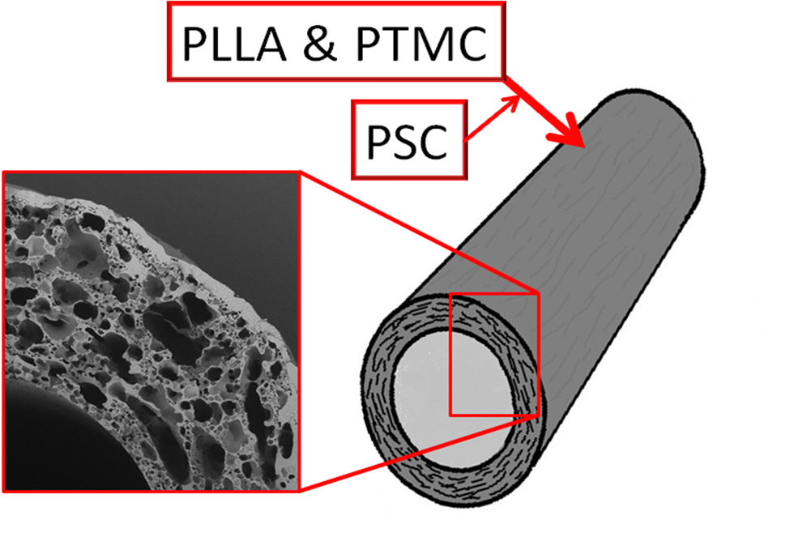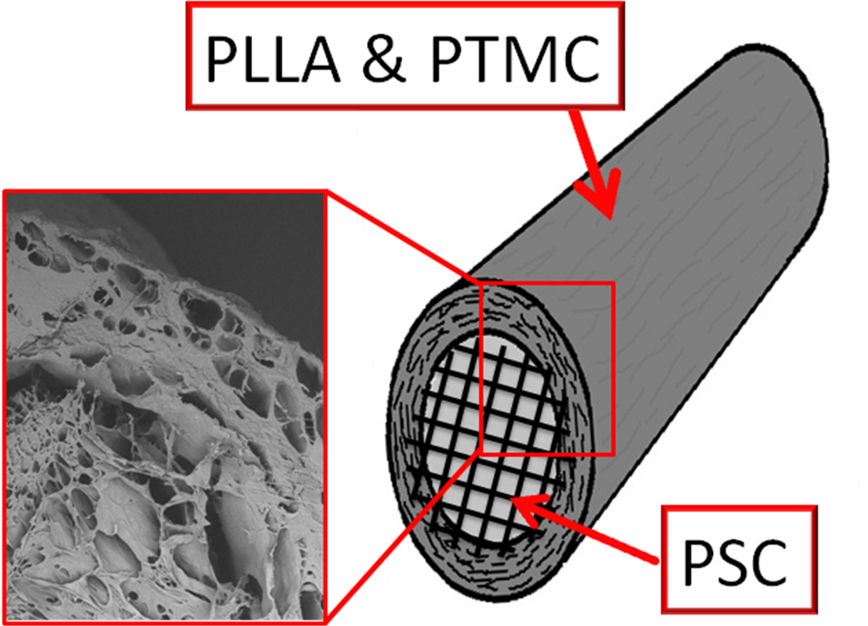
Scheme shows two approaches of nerve guidance channels design. a/ hollow tube, two-step fabrication process: PSC incorporation in situ into SP-based tube walls during tube formation, and terminal sterilization b/ tube with internal filling of PSC hydrogel, three-step production process: fabrication of SP tube, application of filling, and radiation-induced crosslinking combined with simultaneous sterilization.

Two methods of manufacturing of nerve guidance channels were proposed and consequently developed. METHOD1 was based on cyclic phase separation/precipitation of polymer or polymer blend from its solution deposited on a stainless steel bar in a non-solvent. METHOD1 allows for production of the tubes without utilisation of sophisticated equipment, yet resulting tubes combine considerable mechanical strength and high flexibility. Inclusion of PSC was possible in situ during production. METHOD2 is based on spraying of PS solution (addition of PSC is possible) onto rotating stainless steel bar that controls inner diameter of the resulting conduit. METHOD2 is efficient and obtained tubes have very reproducible properties.
Utilization of both methods resulted in production of channels of tailored porosity and mechanical performance. Extraction of integrated water-soluble PSC allow for controlling porosity and shows potential for releasing bioactive molecules such as NGF, which can be incorporated in the tube walls, directly in the vicinity of regenerating nerve. Internal filling/scaffold may be a carrier of nerve growth factors as well. In this case, manufacturing and sterilisation of the conduits can be followed by inclusion of NGF. It is anticipated that axons can grow inside the hydrogel, which provides 3D support, and if the gel contains NGF, the regeneration of injured nerve will proceed more effectively.
Biological evaluation of proposed compositions by means of LDH, MTT and Live/Dead in vitro assays proved lack of cytotoxicity of these biomaterials. Positive results of cell studies allowed for considering in vitro experimentations. Two types of pilot animal studies were designed and consecutively conducted. Subcutaneous implantation of the most promising compositions to asses interaction with tissue shown good biocompatibility of PTMC homopolymer synthesized in-house, PLLA/PTMC, and PLLA/PTMC/MC blends. Second stage of screening animal experimentations involved application of manufactured nerve guidance channels of PLLA/PTMC blend (manufactured with METHOD1) to assist regeneration of rat femoral nerve. Up to 90 days of observation, tubulisation (approximately 5 mm gap between nerve stumps) appeared to be significantly better technique than end-to-end suturing in terms of neuroma formation and regular nerve regeneration. Investigated material is of very good biocompatibility, allows for the proper guiding of the growing axons and is conducive to accumulation of neurotrophic factors inside, thus, facilitating the process of axons growth. It is anticipated that application of NGF immobilized within tube walls or internal filling made from biodegradable hydrogel of natural origin polymer will be beneficial for nerve regeneration.
Four-year project, December 2007 – November 2011, resulted in collection of vast amount of experimental data. At the project completion we can state that most of the tasks proposed in Annex I were successfully realized. Nevertheless, obtained results allow for opening new paths for continuation of the research on some issues and formulation of new subjects to explore. Accordingly, we state that research are continued on for instance: influence of irradiation on copolymers as function of their composition; nerve guidance tubes with internal filling / scaffold of natural polymer hydrogel; inclusion of NGF into the channels and its controlled release; animal studies of nerve regeneration with those guidance channels.

The new knowledge generated during implementation of the project of either fundamentals, such as radiation-induced modifications of polymeric materials or biomaterials, and application focused, e.g. fabrication, physico-chemical and biological testing of nerve guidance tubes certainly increases competitiveness of European science. Results of the conducted research are of interest of chemist, material scientist, medical device designers and manufacturers, as well as neurosurgeons who constantly seeking for new biomaterials and techniques to solve problems of peripheral nerve regeneration. Outcome of the completed project may be important for benefit of patients with nerves injury of PNS, whose treatment could be more effective.

