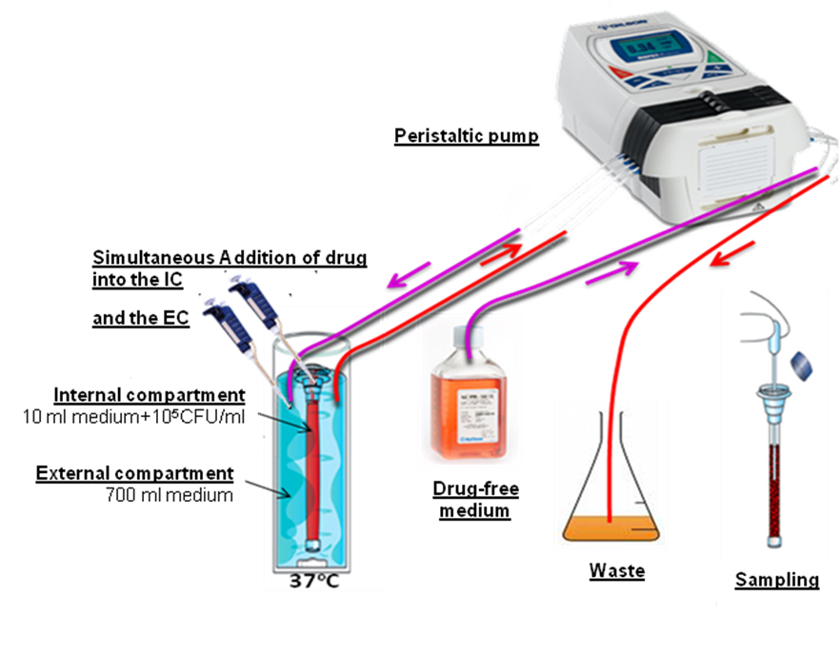

**Figure 1**. In vitro pkpd model simulating human pharmacokinetics and studying the pharmacodynamics of antifungal drugs against filamentous fungi.

 **Figure 3**. Kinetics of real time PCR conidial equivalents (CE) for three increasing inocula of A. fumigatus (left graph) and correlation between the area under the PCR CE-time curve and the area under the galactomannan index(GI)-time curves as in Fig. 2 (right graph). Results from experiments with a starting inoculum of 103CFU/ml were excluded from the analysis because the PCR signal was very close to the lower limit of detection resulting in highly variable results.

**Table 1.** Percent target attainment of the in vitro PKPD parameter associated with near maximum activity for each voriconazole dosage.

|  |  |  |  |  |  |
| --- | --- | --- | --- | --- | --- |
| **Voriconazole Dose (mg/kg)** | **Mean (95%CI)**  **fAUC0-12 (mg*h/l)a** | **Mean (95%CI) % target attainment** | | | |
| ***A. fumigatus*** | ***A. flavus*** | ***A. terreus*** | |
| 3 | 5.85(4.4-7.75) | 24(11-45) | 12(5-26) | | 4(2-11) | |
| 4 | 12.4(6.55-23.35) | 80(32-97) | 63(17-93) | | 36(6-83) | |
| 5 | 18.2(14.15-23.5) | 93(86-97) | 86(73-94) | | 68(47-83) | |

An external file that holds a picture, illustration, etc.
Object name is zac9991005040005.jpg Object name is zac9991005040005.jpg

**Figure 2.** Pharmacokinetic analysis of simulated doses of 1 mg/kg amphotericin B, 1 mg/kg caspofungin, and 4 mg/kg voriconazole in the new in vitro PK/PD model and comparison to results previously obtained by testing human plasma.

**In vitro PKPD model In vivo murine model**

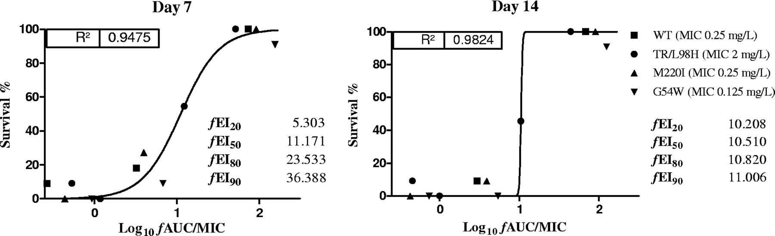

**Figure 4.**In vitro (left) and in vivo (right) voriconazole exposure-effect relationships against 4 *A. fumigatus* isolates with variable in vitro susceptibility to voriconazole.



**Figure 5.** Monte Carlo simulation analysis results. The % of patients that will attain the pharmacodynamic target associated with maximal in vitro activity we calculated for each MIC and susceptibility breakpoints were determined.

 An external file that holds a picture, illustration, etc.
Object name is zac0021087920004.jpg Object name is zac0021087920004.jpg

**Figure 6.** In vitro pkpd analysis of posaconazole against A. fumigatus.In vitro (A) and in vivo (B) pkpd relationships of posaconazole against 4 azole-susceptible and –resistant isolates and galactomannan index time-curves without (B) and with (C) human serum showing the absence of serum effect on posaconazole activity.

**A**

**C**

**D**

**In vivo pkpd relationship of posaconazole**

**B**



 



**Figure 7.** Voriconazole and amphotericin B simulated pharmacokinetics (upper graphs) and the resulting pharmacodynamics (down graphs) against three Aspergillus isolates with the same MICs.

**Figure 8.** In vitro interaction between voriconazole and amphotericin B simulating human pharmacokinetics of both drugs in the in vitro pkpd model**.**