www.fladar.org
Title: Flood zoning in east Attica using gauge calibrated radar rainfall and advanced modelling techniques
Floods are natural hazards with potential for many fatalities and significant economic losses. However the degree of vulnerability to any disaster is also a function of human acts and behavior. The main objective of the FLADAR project is to follow the steps suggested by the 2007/60/EC Directive on the assessment and management of flood risks in order to conduct initially a preliminary flood risk assessment and then draw flood hazard zones for a partially developed watershed in East Attiki (130km²). Until recently, land use in the area was solely rural. However, during the last fifteen years, an unorganized urban expansion stimulated from the infrastructure works for the 2004 Olympics and the increase of population in the country’s capital resulted in a mixed urban and rural environment. Even though there were concerns about several new flood prone locations, no comprehensive studies leading to flood hazard maps exist. Raingauge-calibrated radar rainfall, distributed hydrologic modeling, advanced methods of integrated modeling at a river basin scale and GIS analysis support the assessment and results of the study (Figure 1)
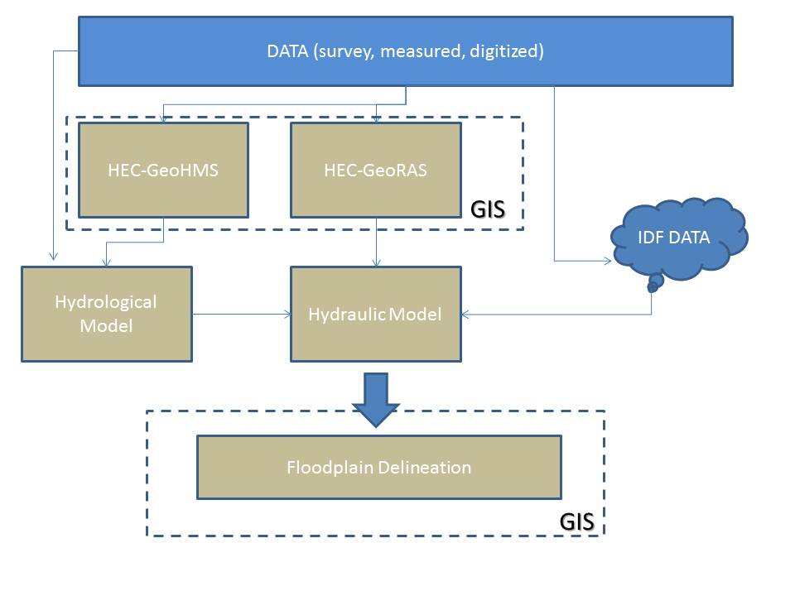
Figure 1: The schematic of the basic floodplain delineation steps
Radar rainfall data were provided by the National Observatory of Athens (NOA) for 4 storm events and were calibrated at selected stations of a raingauge network operated by the National Techincal University of Athens (NTUA). A radar systematic error ranging from 34% to 45% at 4 raingauges was removed using a multiplicative factor. The GIS preprocessed files were imported in the Vflo fully distributed hydrological model to capture the spatial variability of the basin’s rainfall-runoff. Up to Rafina stage gauge (the furthest downstream point where observed data are measured), the study area is described by 2755 cells of 200m size on the side.
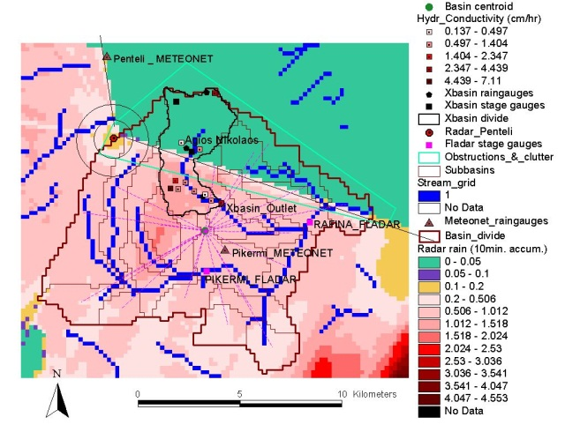 | 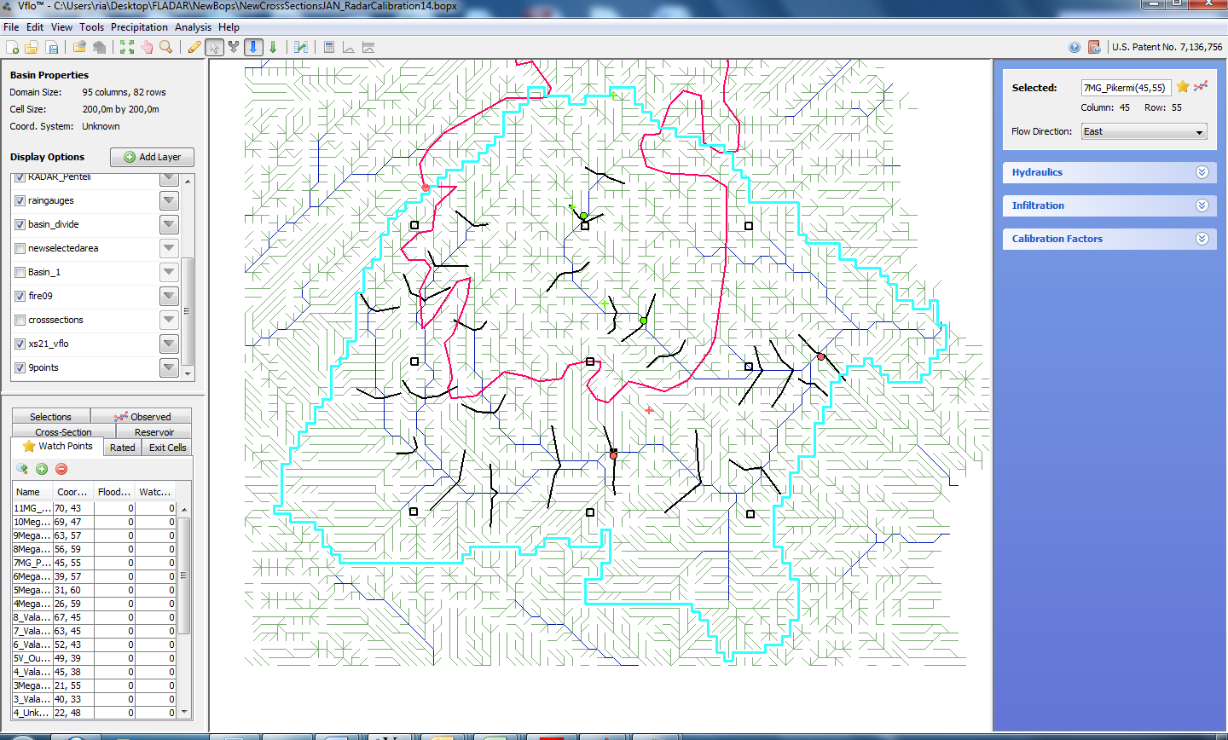
Figures 2a: Limited coverage of radar due to Penteli mountain; b. the extent of forest fire destruction as depicted in the GUI of the hydrological model
The next steps of the analysis involved setting up a hydraulic model and deciding on different ways to express the rainfall variability of rare storm events in the basin. The creation of one or more Random Rain components (OpenMI compliant) provided the opportunity to introduce storm movement to the watershed and statistically identify the range of flows (median, max, min) that may be expected at selected cross sections for events up to specific volume and rainfall intensity. The 100year 6hour design storm raises the stage at Pikermi cross section over bankfull conditions and has an even higher impact downstream to Rafina. However, the banks downstream Pikermi station are prone to erosion so a special attention should be placed there by the relevant authorities before a rare event takes place.
The final phase of the study, the GIS Floodplain delineation, is actually an iterative process because it may include, at a local level, erroneous results due to inaccurate depiction of cross sections, omission of significant ineffective/storage areas and coarse grid analysis. Thus, the exported hydraulic data should be looked closer, at a cross-sectional level, especially when dealing with locations of special interest such as potential evacuation routes for the communities. It is interesting to notice though that the preliminary study analysis, conducted at the beginning of the FLADAR project and using only topographic, land use, and settlement information, pinpointed in a quite precise manner the vulnerable areas in the watershed where urban planners and engineers should pay the most attention (Figure 3). Such comprehension could actually benefit many communities since it shows that in ungauged watersheds or subbasins where measured values are almost non-existent, there are simplified but still reliable ways to identify several defenseless areas to flood hazard and protect them in order to minimize future losses from flood events.
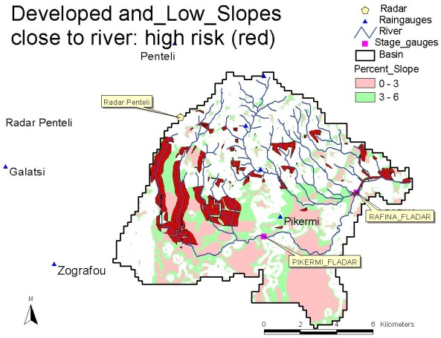 | 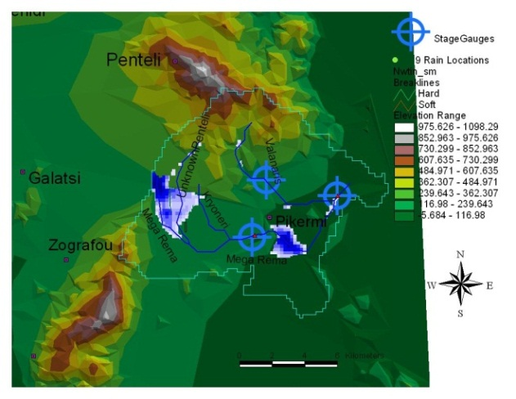
Figure 3: Comparison between the results of the preliminary (GIS only) study analysis and floodplain delineation

