 | INDIVIDUAL FELLOWSHIPS | 

Project n°: 219318
Project Acronym: HRModUrb
Project Full Name: High resolution models for flow and dispersion in urban areas
Marie Curie Actions
IEF-Final Report
Period covered: from 19-05-2008 to 18-05-2010
Period number: 1
Start date of project: 19-05-2008
Project beneficiary name: ____________
Project beneficiary organisation name: University of Surrey
Date of preparation: 15-07-2010
Date of submission (SESAM): ____________
Duration: 24 months
Version: 1
- Final publishable summary report
This section normally should not exceed 2 pages.

This is a comprehensive summary overview of results, conclusions and the socio-economic impacts of the project. The publishable report shall be formatted to be printed as a stand alone paper document. This report should address a wide audience, including the general public.

Please ensure that it:
- Is of suitable quality to enable direct publication by the REA.
- Is comprehensive, and describes the work carried out to achieve the project's objectives; the main results, conclusions and their potential impact and use and any socio-economic impact of the project. Please mention any target groups such as policy makers or civil society for whom the research could be relevant.
- Includes where appropriate, diagrams or photographs and the project logo, illustrating and promoting the work of the project.
- Provides the address of the project Website (if applicable) as well as relevant contact details.
The research work within the HRModUrb project falls mainly within the field of dispersion modelling, i.e. linking emissions to concentrations. Despite apparent public perception to the contrary, there is much uncertainty in our understanding of the air pollution system and the way emissions and impact are related. Nevertheless, air quality modelling is currently employed routinely as an air quality management and planning tool. Recent EU legislation recognise modelling in this role for assessing air quality in Europe.
Historically and understandably, dispersion models had been applied to quite simple situations, often just a single emission point (industrial stack) in a relatively simple (from the geometrical point of view) environment. Applying dispersion models in urban areas has proved particularly difficult due to the increased geometrical complexity, the number and the variety of emission sources, the range of different pollutant species and their complex chemical interactions, the particular microclimate and the interaction between different length scales. Complex urban models are currently able to simulate emission, dispersion, chemical reactions and deposition of a range of pollutants at spatial scales from regional (i.e. hundreds of km) to city (i.e. tens of km). Currently, at the neighbourhood and street scales (i.e a few metres to 1-2 km), the most advanced numerical models (CFD, Computational Fluid Mechanics models) are capable of solving nearly all the complexities, but their use is limited by the amount of computational resources needed, which make their operational use in air quality management impracticable. Simpler operational models have been developed, but their performance is limited when applied to complex geometries and meteorological conditions like those that can be found in a real urban environment. Several key physical phenomena have yet to be completely understood, and, in order to develop new high resolution (neighbourhood scale) models, new parameterisations have to be found. Wind tunnels, which have been the main experimental device in environmental fluid mechanics research for several decades, play an important role in developing this understanding. Large facilities, like the EnFlo wind tunnel at the University of Surrey, are though needed to simulate adequately atmospheric flows with their large range of turbulence scales.
Current operational canopy (i.e. valid for flow and dispersion within the streets) models usually adopt simple approaches, deriving flow and dispersion fields from basic parameters, such as wind speed and directions and a few additional meteorological conditions above the canopy, building plan area density of the neighbourhood and mean building height, as well as, obviously, the pollutant emissions. Previous studies, however, have demonstrated the influence specific geometrical features, such as the presence of a single building much taller than its neighbours and building height variability. These two features affect the turbulence field, and thus also the turbulent characteristics in their vicinity, and play an important role in shaping the three-dimensional wind field within the canopy and the exchange of pollutants between the canopy and the free flow above. This area was the main focus of the HRModUrb project.
Initial work in preparation of the wind tunnel experiments focussed on the identification of the model geometries with different typical morphological characteristics. The models were designed on the basis of the characteristics of a real urban area (in particular the DAPPLE site in central London). The models were then built, set-up and tested, with particular attention to the approach flow in the wind tunnel.
The experimental tests for the HRModUrb project were carried out at the EnFlo laboratory on small scale models of urban areas. Wind and turbulence characteristics were measured, particularly within the streets, using a 2-component laser Doppler anemometer (LDA), while tracer gas dispersion was measured by a fast response flame ionisation detector (FFID). A new technique to measure turbulent fluxes of tracer was also developed at EnFlo by combined use of the two instruments in the same experiment. The experiments were complemented by numerical simulations. CFD models, developed using the open source library OpenFOAMTM, were employed for comparison to reproduce the wind tunnel experiments and, in some cases, extend their scope. Recent advances in computer hardware do not yet allow the use of CFD models as operational air quality modelling systems but they are now mature enough to be employed with care to investigate underlying physical mechanisms.
The wind field and turbulence characteristics obtained in HRModUrb were analysed for different models and different approach flow conditions, so as to quantify the influence of the above mentioned parameters. A major feature of the work is the measurement of the exchange velocities between the street canyons and the flow above roof level - using the newly developed experimental technique. This parameter has rarely been determined from experimental campaigns, given the difficulties in its measurement and the usually very limited spatial resolution of many experiments. The results from comparison exercises have shown the inadequacy of the state-of-the-art neighbourhood and street scale models when geometrically complex urban areas are involved.
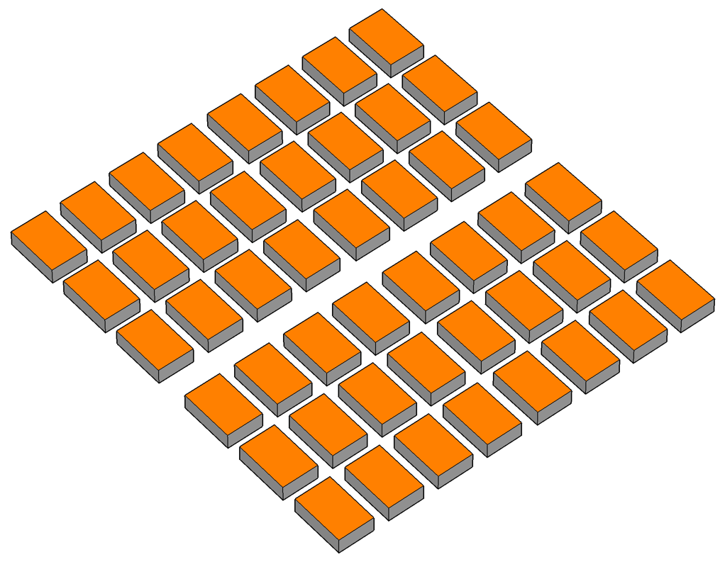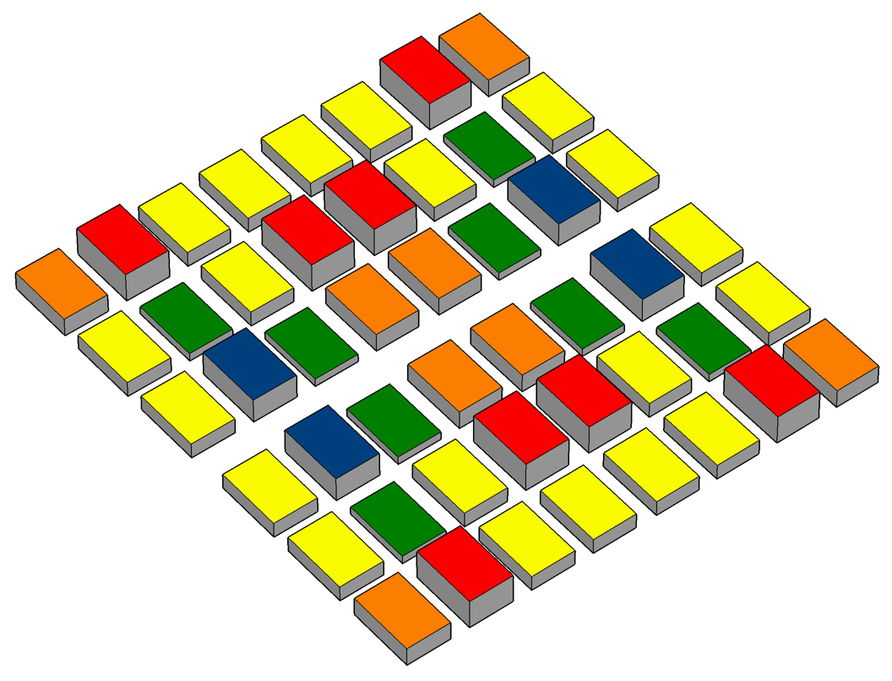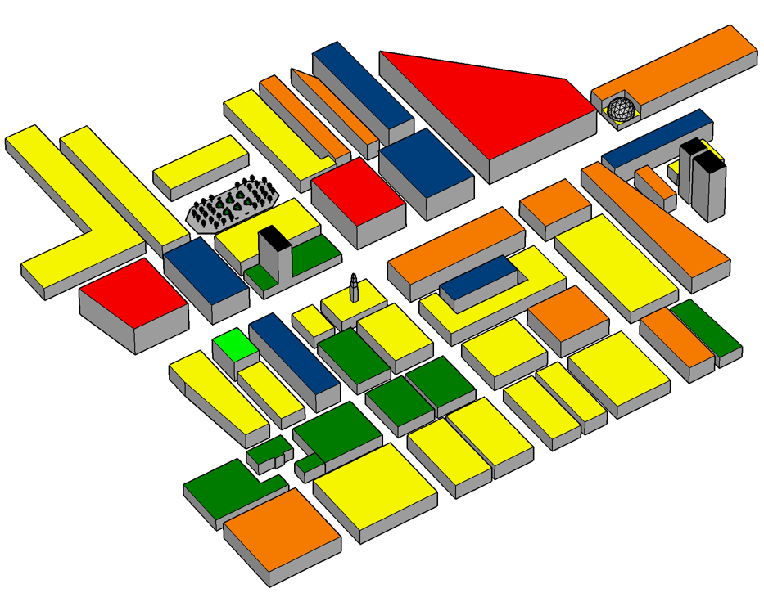
The CFD model was developed with the simplest possible settings, using the widely used, and generally accepted for this type of simulations, k-epsilon turbulence model. A detailed preliminary study was carried out in order to optimise the settings for the project purposes, and the comparison of numerical results with experimental data gave very good results.
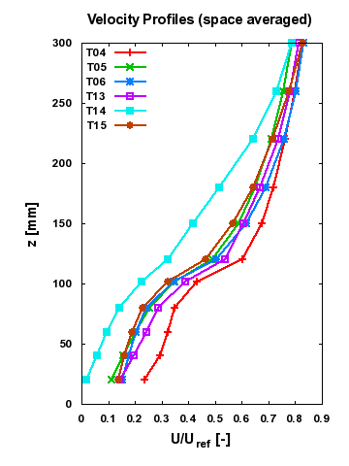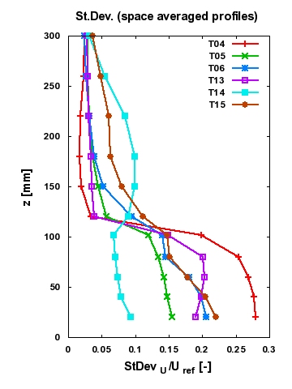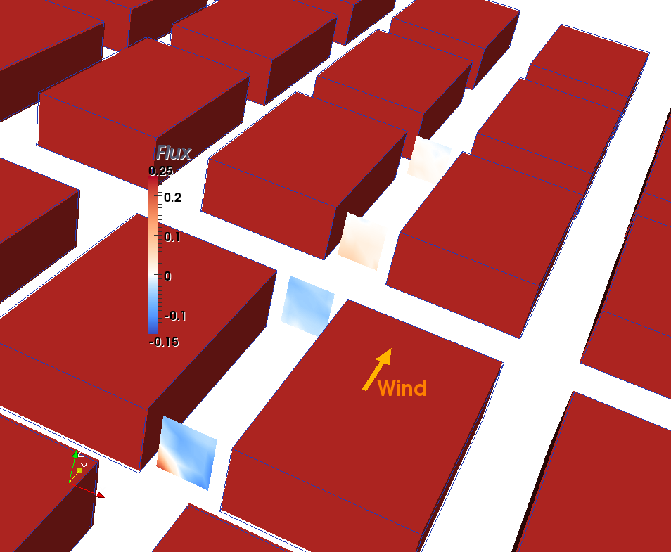
The large experimental and numerical database obtained was used to identify the main parameters to be considered for the development of a high-resolution neighbourhood scale model. In particular, the influence of building height variability, building (and street) shape factor and spatial averaging domain have been quantified, and pollutant exchanges between the streets at intersections, and between the urban canopy and the air flow above the roofs, have been measured for the first time in a systematic study. Thanks to the analysis of wind tunnel and CFD results, a new framework for the development of improved neighbourhood scale models has been proposed.
Starting from these proposed parameterisations, new mathematical models may be developed or existing ones enhanced, enabling neighbourhood scale models to become more reliable and limiting its inherent uncertainties. The intention is to be able to use these models with the same confidence as their regional and city scale counterparts but with much higher spatial and temporal resolution for the management of air quality in modern cities. The experimental/numerical database produced during the HRModUrb project can also be used as a basis to build mathematical models for other applications than air quality modelling. With some further research, for example, the derived parameterisations along with new ones purposely developed could be used to enhance the effectiveness of the current monitoring network, or elaborate new design guidelines for next generation monitoring systems (e.g. by using disperse mobile sensors). Other applications include, but are not limited to, emergency response from deliberate or accidental hazardous release, and urban microclimate modelling.
- Use and dissemination of foreground
Section A (public) – Dissemination measures
This section should describe the dissemination measures, including any scientific publications relating to foreground and specify any applications for patents etc in accordance with article II.11. Its content will be made available in the public domain thus demonstrating the added-value and positive impact of the project on the European Community.

- Dissemination activities

Presentations at international conferences

1) Carpentieri M, Robins A (2009). Neighbourhood scale models for flow and dispersion in urban areas. 7th International Conference on Air Quality, Istanbul, Turkey, 24-27 March, 2009

2) Carpentieri M, Robins A (2009), Neighbourhood scale flow and dispersion modelling. 7th International Conference on Urban Climate, Yokohama, 29 June-3 July, 2009.

3) Carpentieri M, Robins A (2009). Modelling flow and pollutant dispersion in urban areas. 5th European and African Conference on Wind Engineering, Florence, Italy, 19-23 July, 2009

4) Carpentieri M, Robins A (2009), Measurement of turbulent fluxes and pollutant mass exchanges in urban areas. Physmod 2009 workshop, Brussels,24-26 August, 2009.

5) Carpentieri M, Salizzoni P, Robins A, Soulhac L (2009), Validation of a neighbourhood scale dispersion model through comparison with wind tunnel data. Physmod 2009 workshop, Brussels,24-26 August, 2009.

Scientific publications

To be submitted: Carpentieri M, Hayden P, Robins A (2010), Measurement of pollutant turbulent fluxes in urban areas. To be submitted to Experiments in Fluids

3 more manuscripts in preparation.

Dissemination publications

1) Carpentieri M, Robins A (2010), Managing air quality in modern cities. Projects magazine, issue 16, April 2010.

    - Publications (peer reviewed)

The list of scientific publications (see articles II.11-12 of the grant agreement) starting with the most important ones, should specify:
  - publication name,
  - date and page in order to be able to identify it (see proposed template).

list of scientific (peer reviewed) publications, starting with the most important ones
NO. | Title | Main author | Title of the periodical or the series | Number, date or frequency | Publisher | Place of publication | Year of publication | Relevant pages

With regard to scientific publications published before or after the final report, such details/references and an abstract of the publication must be provided to the REA at the latest two months following publication. Furthermore, an electronic copy of the published version or the final manuscript accepted for publication shall also be provided to the REA at the same time for the purpose of publication by the REA if this does not infringe any rights of third parties.
Section B (confidential) - EXPLOITABLE FOREGROUND AND PLANS FOR EXPLOITATION

This section should specify the exploitable foreground and provide the plans for exploitation. It will be kept confidential and will be treated as such by the REA.

The applications for patents, trademarks, registered designs, etc. shall be listed according to the template provided hereafter.

The list should, specify at least one unique identifier e.g. European Patent application reference. If applicable, contributions to standards should be specified.

Table B1: List of applications for patents, trademarks, registered designs, etc.
Type of IP Rights: Patents, Trademarks,  Registered designs, Utility models, etc. | Application reference(s)  (e.g. EP123456) | Subject or title of application | Applicant(s) (as on the application)

Please complete the table hereafter:

Table B2: Overview table with exploitable foreground

Exploitable Foreground  (description) | Exploitable product(s) or measure(s) | Sector(s) of application | Timetable, commercial use | Patents or other IPR exploitation (licences) | Owner & Other Beneficiary(s) involved

In addition to the table, please provide a text to explain the exploitable foreground
[One text box per row in table B2]
Open space (2 pages maximum) composed as following:

- Its purpose
- How the foreground might be exploited, when and by whom
- IPR exploitable measures taken or intended
- Further research necessary, if any
- Potential/expected impact (quantify where possible)

- Scientist in charge questionnaire
RESEARCH TRAINING (IEF-IOF)/TRANSFER OF KNOWLEDGE (IIF) ASSESSMENT:

What is the size of the hosting research group? | 6 staff, 12 - 15 research staff

How many researchers have you supervised, within the past 10 years? Of which funded by:
EC/Marie Curie actions | 1
EC Other Funding | 7
If yes please specify contract number, programme and directorate general in charge | FMGE-CT98-0109  TMR Access to Large Scale Facilities  1/4/98 to 30/09/00
University fellowships | 0
National public bodies | 12
Industry | 2
Other, please specify:
How many researchers have you supervised within this project? | 1
Corresponding to how many person months? | 24

Number of publications resulting directly from the research project:
Recruited researcher(s) and yourself | 1 with 3 - 4 papers in progress
Recruited researcher(s) alone | -
Recruited researcher(s) with authors other  than yourself | -

Participation of the fellow researcher at conferences (number):
Passive | 5
Active | 5
How do you rate the overall success of the research training (IEF, IOF)/ transfer of knowledge (IIF)? | It has been a very productive period

General assessment: The period has been productive with significant research work completed and analysed. This will be published in the main journals for the subject. Conference and other presentations of the work have also been a success. The research has made an important contribution to our overall programme in urban meteorology and pollutant dispersion. We had some difficulties with intumentation failure that meant revising plans at short notice but nevertheless met our objectives. The main resulst was a delay in preparing journal papers. Dr Carpentieri is still at Surrey University (working on a new project) and that will make completion of the papers relatively straightforward.

RESEARCHERS ASSESSMENT:

Rate the overall level of the fellow researcher integration in the research team and the
host organisation with regards to:
participation in meetings/seminars | Very good
discussions of results and project-related  topics | Most helpful
co-operation with other team members | Excellent
co-operation with other researchers of the  host institution | Good

Rate the overall performance of the fellow researcher with regard to:
originality of fellow approach towards research (initiative/independent thinking) | Very good
capacity to develop new skills and to benefit from training | Good
productivity (research  results/publications/international conference attendance) | Good
communication skills | Good
group leader skills (collaboration with other groups/project management) | Good
training and/or teaching skills | Good
Please comment:
There was ample opportunity to paractice or demonstrate the skills listed above. We had known Dr Carpentieri from some time prior to his fellowship with us and this meant there was little time lost in his becomig familiar with the way things work here.

RESEARCH TRAINING OUTCOMES (IEF-IOF)/TRANSFER OF KNOWLEDGE (IIF):

Has this project provided additional links with other research groups or institutions? | Yes
If yes, indicate the number of contacts in each case
Universities | 4
Research Centres
Industry/private companies
If Other, please specify:
UK Met Office

Rate the importance of the following outcomes of the research training/transfer of knowledge:
results of the research | High
number of publications | Medium
development of research | High
establishment of international collaborations | High
transfer of knowledge/technology | High
training of researcher | High
further academic qualifications (PhD, habilitation etc.) for fellows | Medium
Please comment:
The quality of publications is more important than the number.
In this case, further qualififcations was not an issue, though developing a career was and we treated that very seriously.

YOUR OPINION ABOUT THE MARIE CURIE ACTIONS:

Do you have any other comments or suggestions of how to improve the concerned Marie Curie actions?
The initial agreement was very slow to arrive and there was a good deal of confusion at that stage that should have been avoided.

Did you have previous knowledge of the Marie  Curie actions? | Yes, but not directly

If yes, what sort of image do you think that the  Marie Curie actions have among the scientific community in your research area? | They have a high standing - rank highly on the CV

Attachments: | None - I understand that the financial statement is sent separately

Date:  Signature Scientist in Charge:  Alan Robins | Date:  Signature Researcher:  Matteo Carpentieri

