FRONT PAGE

PROJECT FINAL REPORT

Grant Agreement number: PIEF-GA-2008-219483
Project acronym: P Nanoparticles
Project title: P4 as precursor for metal phosphide nanoparticles and N2 activation and
reduction to organic derivatives.
Funding Scheme:
Period covered: from 02/06/2008 to 01/06/2010
Name of the scientific representative of the project's co-ordinator, Title and Organisation:
Prof. P. Le floch, Directeur de Recherche, CNRS
Tel: +33 1 69 33 44 00
Fax: +33 1 69 33 44 40
E-mail: anne-florence.eyssautier@polytechnique.edu
Project websiteError: Reference source not found address:
  - Final publishable summary report

This section must be of suitable quality to enable direct publication by the Commission and should preferably not exceed 40 pages. This report should address a wide audience, including the general public.

The publishable summary has to include 5 distinct parts described below:

- An executive summary (not exceeding 1 page).

Two different topics were studied during the two years of the project. The first one involved the use of white phosphorus P₄ as a stoichiometric P atom donor for the synthesis of nanocristals of metal-phosphides M_{x}P_{y}. The second topic dealt with the activation of dinitrogen. These projects may appear unrelated, but in fact in the strategy envisioned, they do both rely on the use of transition metals in a reduced form.
Two metal phosphides were selected for the first part of the project: Ni₂P and InP. Indeed, these two compounds are of primary importance, as Ni₂P is an industrial catalyst for the hydrodesulfuration of crude oil, and InP is a semiconductor. It has been shown that nanocristals of semi-conductors possess luminescent properties that depend a) on the chemical elements, b) on the size of the nanocristal c) on the shape of the nanocristal and d) the efficient trapping of the electron/hole pair in the nanocristal.
Our purpose was to design the appropriate chemical systems and to understand the mechanisms by which the desired M_{x}P_{y} could be formed. In a preliminary work, we had shown that either monometallic Ni(0) precursor or Ni(0) nanoparticles would be used to generate the corresponding Ni₂P upon reaction with stoichiometric amounts of white phosphorus. This work opened the way for the extension of this strategy to In(0) precursors. The In(0) nanoparticles could be generated from the air and water sensitive In(I) precursor, Cp*In (Cp* = pentamethyl cyclopentadienyl). The formation of nanoparticles of InP with excellent dispersion in size could be achieved. The luminescent properties of these nanocristals were not satisfactory since nanoparticles of InP are known to oxidize rapidly in air.

The second part of the project dealt with the activation of dinitrogen N₂, as well as its functionalization into amines of the type NR₃. This task is of major importance as amines are industrially synthesized from NH₃, which is in turn synthesized from N₂ under strenuous conditions (Haber Bosch process, heterogeneous catalysis). We have based our work on known Mo(0) complexes which feature N₂ as ligand. We focused on the use of Mo(dppe)₂(N₂)₂ to evaluate the possible involvement of radical species R° to generate NR₃. R° were chosen as bulky silyl derivatives R’₃Si°.

- A summary description of project context and objectives (not exceeding 4 pages).

Nanoparticles, (NPs) continue to be a very active research domain both in chemistry and physics, in particular because of quantum confinement phenomena directly linked to their size. Quite interestingly, the synthesis of nanocristals was essentially done by physicists essentially interested by the physical properties of the materials rather than by the synthesis itself. As a consequence, many of the research groups involved in this very competitive area prepare nanoparticles following “recipes”, without a deep understanding of the mechanisms of the reactions involved. Nevertheless, quite recently, inorganic chemists have become involved in this domain with an aim at understanding the syntheses and in a near future, hopefully, extend the acquired knowledge to the synthesis of other targets. We, as organometallic chemists, have been involved in the design and isolation of transition metal complexes and the studies of their reactivity. These studies are coupled to molecular modeling, which can bring some light on the reaction mechanisms. In particular, our group has acquired a vast knowledge on the stabilization of transition metal complexes in which the metal is in a reduced state. Based on this knowledge, several targets of the metal phosphide family have been chosen: Ni₂P, InP and GaP. The methods for the synthesis of these species are numerous, and rely on the access on the metal precursors. One of our goals was to devise a general method to these species.
Note first that semiconductors represent a rapidly growing market, touching, inter alia, domains of communication, computers and automobile. Moreover, the stability of these species in hostile environments (high temperatures, high frequencies) has been utilized advantageously in optoelectronics. In this context, mastering the syntheses of InP and GaP is of considerable importance. In terms of chemical properties, M_{x}P_{y} possess variable properties which depend to a great extent on the ratio x/y. For example, Ni₂P only is a catalyst for hydrodesulfuration. A direct control of this ratio is again of major importance.

As mentioned above, one can find in the literature several syntheses of M_{x}P_{y}, which is a clear sign of a lack of a general synthetic method. Nevertheless, the syntheses imply the “decomposition” of a metallic precursor reacted with a « P atom donor » at high temperature, in the presence of a mixture of surface ligand/solvent. Two “P atom donors” have been to a large extent. First and foremost, TOP (tri-octylphosphine) has been used in the syntheses of N both as a solvent and “P atom donor”. However, TOP features three strong P-C bonds which need to be broken during the process, which implies temperatures higher than 300°C. Even so, the efficiency of the P-C bond breaking is not high, and large excesses of TOP are used. One understands readily that a precise x/y control is not accessible to this strategy.
The second widely used “P atom donor” is P(SiMe₃)₃. This molecule is highly sensitive and reactive. It has been used for the synthesis of III-V quantum dots (QD) such as InP. InP is an excellent candidate for applications in optoelectronics and in imaging. The reaction mechanism involving is not known precisely, but because of the species involved, it can be inferred that PH₃, a deadly gas at 10 ppm level is formed in an early stage, before reacting with the metallic precursor.
It was our goal to use a 1) general “P atom donor, 2) cheap, 3) stoichiometric and 4) highly reactive. White phosphorus, P₄, synthesized industrially on the hundreds of thousands of tons per year, and commonly manipulated on the ton scale, was first selected. This molecule is the basis molecule for phosphorus chemistry. In this compound the P-P bond is weak, and accordingly, P₄ is a highly reactive molecule. Secondly, red phosphorus, a second phosphorus allotrope was also envisaged. This compound is much less reactive than P₄, being polymeric and insoluble, but has the advantage of being kept and handled in air. Numerous studies dealing with the coordination chemistry of P₄ have been reported in the literature, and its behavior depends on the nature of the metal and the ligands.
Thus, “simple coordination” to M via a lone pair at P (A) or insertion of the M into a P-P bond (B) can be observed.
Preliminary results of our group proved that a single source of Ni(0) monometallic precursor or a Ni(0) nanoparticle could react in a stoichiometric fashion with P₄ to generate Ni₂P nanoparticles.
The first goal was thus to extend this methodology to In(0) nanoparticles. The second goal was to modify the stoichiometry of Ni/P to reach other phases.

- A description of the main S&T results/foregrounds (not exceeding 25 pages)

The case of InP was studied. The strategy we developed relied on the use of P4 with the appropriate source of In(0). In fact, the In(0) mono-molecular species do not exist, and we had to turn our attention on the synthesis of In(0) nanoparticles in order to make them react in a second stage with stoichiometric amounts of P₄. The first report of the literature dealing with the synthesis of such nanoparticles dates back from 2001 (Chaudret et al. Angewandte Chem. Int Ed. Engl., 2001, 40, 448). It relies on the following reaction:
It is supposed to be a thermal decomposition of a In(I) precursor [CpIn]. It is interesting to note that water is a reagent in this reaction. More recently, Micic et al has reported the use of other In precursors for the synthesis of In(0), which were subsequently reacted with P(SiMe₃)₃ to obtain InP nanowires (Micic et al. JACS 2004, 126, 2632). Our strategy relied on a one pot reaction, involving NP synthesis followed by a reaction with P₄. After many trials and errors, we were able to find that precise amounts of water were needed to decompose a chosen precursor unlike what was proposed in the article.

With a reproducible access to In(0) NPs, their reactivity toward P₄ was tested. After isolation, different techniques were used for their analysis: TEM, EDX analysis, UV-vis and fluorescence. TEM pictures, shown below, prove a mono dispersity in size of the particles, which allow a 2D self-organization on the TEM grid over large distances.
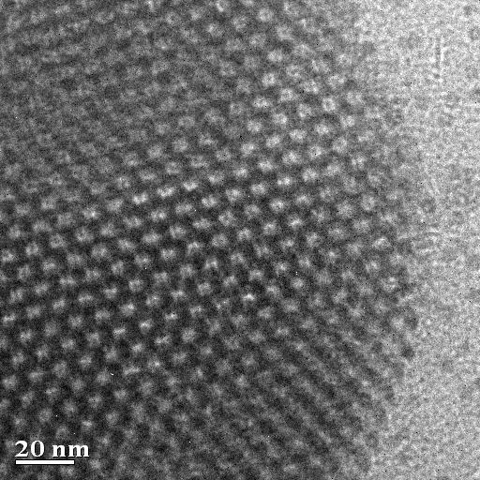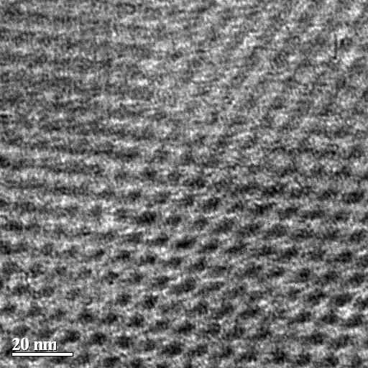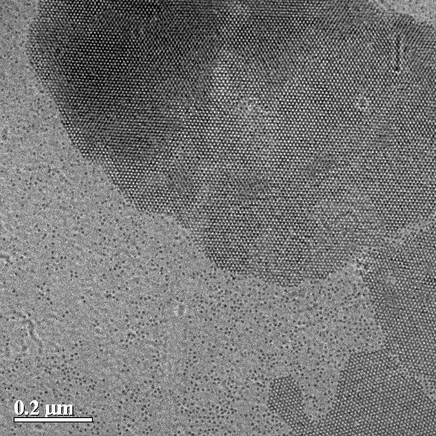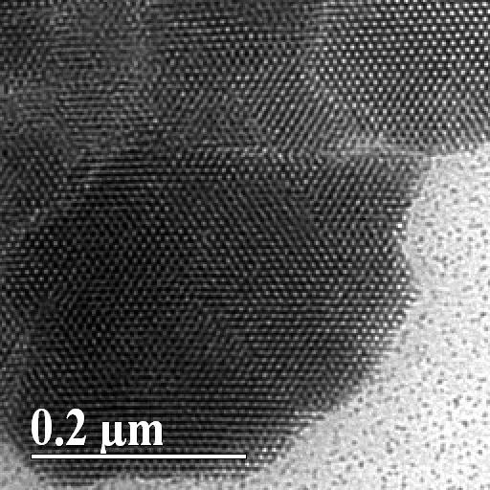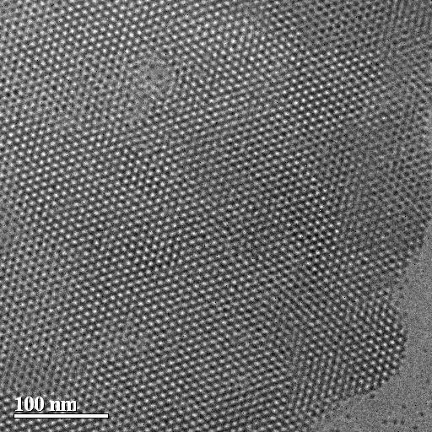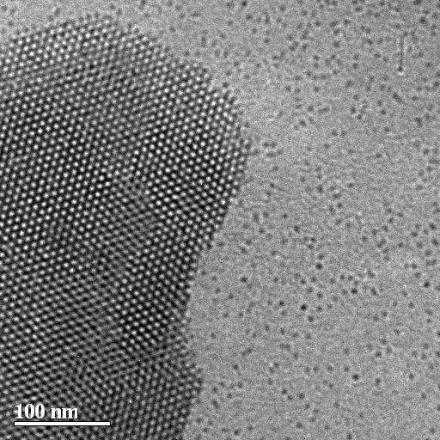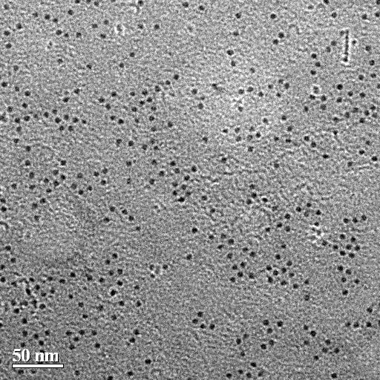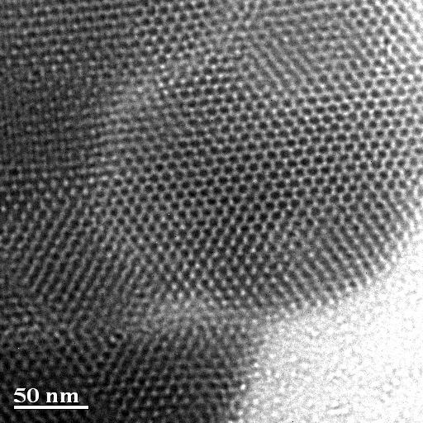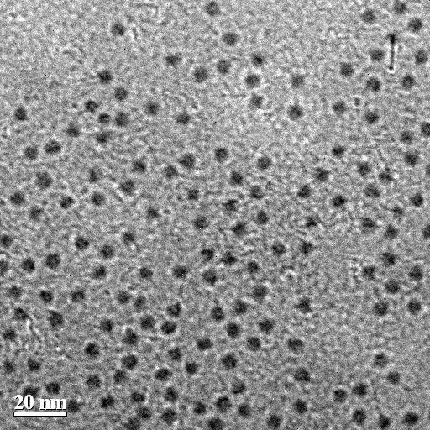

TEM pictures of InP.
Their average size is of 5.5 nm. Results of the elemental analysis via EDX, show a ratio In/P of 1/0.8, close to the expected ratio. Yet it showed the presence of other species containing In and not P. Furthermore, UV-vis spectra did not show the expected absorption band, and the NPs were not luminescent. This last fact is not so surprising as it is well known that InP nanoparticles are readily oxidized by air, thus losing their luminescent properties.
Nevertheless, these results showed that a reaction occurred between In(0) and P₄, proving our strategy right.
It was then our interest, as chemists, to understand the mechanism of formation of In(0) from the In(I) precursor. An NMR study allowed the characterization of the by-products of this reaction. Overall the reaction of the chosen precursor Cp*In (Cp* = pentamethyl-cyclopentadienyl) with water follows the path depicted below:

In fact, this reaction is rather peculiar to In, as In(I) is in general unstable toward dismutation. Only bulky, strongly electron donation ligands allow the In(I) stabilization such as Cp*In. However, when Cp*In reacts with H₂O, an acid base reaction occurred, leading to the formation of the unstable In(OH) species, which dismutated very fast to In(0) and In(III). Thus, from 3 equivalents of In(I), two equivalents of In(0) were formed together with one equivalent of In(III).
This last by-product was difficult to separate from the In(0), and the reaction with P₄ was then conducted without intermediate purification. After formation of the InP nanoparticles, the separation of the In(III) was easier but not quantitative as shown by the elemental analysis presented above.

- The potential impact (including the socio-economic impact and the wider societal implications of the project so far) and the main dissemination activities and exploitation of results (not exceeding 10 pages).

- The address of the project public website, if applicable as well as relevant contact details.

  - Use and dissemination of foreground

A plan for use and dissemination of foreground (including socio-economic impact and target groups for the results of the research) shall be established at the end of the project. It should, where appropriate, be an update of the initial plan in Annex I for use and dissemination of foreground and be consistent with the report on societal implications on the use and dissemination of foreground (section 4.3 – H).
The plan should consist of:

- Section A

This section should describe the dissemination measures, including any scientific publications relating to foreground. Its content will be made available in the public domain thus demonstrating the added-value and positive impact of the project on the European Union.
- Section B

This section should specify the exploitable foreground and provide the plans for exploitation. All these data can be public or confidential; the report must clearly mark non-publishable (confidential) parts that will be treated as such by the Commission. Information under Section B that is not marked as confidential will be made available in the public domain thus demonstrating the added-value and positive impact of the project on the European Union.
Section A (public)

This section includes two templates

- Template A1: List of all scientific (peer reviewed) publications relating to the foreground of the project.

- Template A2: List of all dissemination activities (publications, conferences, workshops, web sites/applications, press releases, flyers, articles published in the popular press, videos, media briefings, presentations, exhibitions, thesis, interviews, films, TV clips, posters).

These tables are cumulative, which means that they should always show all publications and activities from the beginning until after the end of the project. Updates are possible at any time.

template A1: list of scientific (peer reviewed) publications, starting with the most important ones
Is/Will open access provided to this publication?1 0 Article published 2 3 Title of the periodical or the seriesNumber, date or frequencyPublisherPlace of publicationYear of publicationRelevant pagesPermanent identifiers NO.  template A2: list of dissemination activities  (if available) |  |  |  |  |  |  |  |  | Title
NO.Main author | Type of activities | Main leader | Title | Date/Period | Place | Type of audience | Size of audience | Countries addressed
1 | Conference |  | European Conference on Nanotechnologies | 26 February 2010
2
3

Section B (Confidential or public: confidential information to be marked clearly)
Part B1

The applications for patents, trademarks, registered designs, etc. shall be listed according to the template B1 provided hereafter.

The list should, specify at least one unique identifier e.g. European Patent application reference. For patent applications, only if applicable, contributions to standards should be specified. This table is cumulative, which means that it should always show all applications from the beginning until after the end of the project.

Template B1: List of applications for patents, trademarks, registered designs, etc.
Type of IP Rights: | Confidential  Click on YES/NO | Foreseen embargo date  dd/mm/yyyy | Application reference(s) (e.g. EP123456) | Subject or title of application | Applicant (s) (as on the application)

Part B2
Please complete the table hereafter:

Ex: New superconductive Nb-Ti alloyExploitable product(s) or measure(s)Sector(s) of applicationTimetable, commercial or any other usePatents or other IPR exploitation (licences)Owner & Other Beneficiary(s) involvedForeseen embargo date  In addition to the table, please provide a text to explain the exploitable foreground, in particular:  - Its purpose  - How the foreground might be exploited, when and by whom  - IPR exploitable measures taken or intended  - Further research necessary, if any  - Potential/expected impact (quantify where possible)  - Report on societal implications  - Replies to the following questions will assist the Commission to obtain statistics and indicators on societal and socio-economic issues addressed by projects. The questions are arranged in a number of key themes. As well as producing certain statistics, the replies will also help identify those projects that have shown a real engagement with wider societal issues, and thereby identify interesting approaches to these issues and best practices. The replies for individual projects will not be made public.  - A General Information (completed automatically when Grant Agreement number is entered.  Beneficiary X (owner)  Beneficiary Y, Beneficiary Z, Poss. licensing to equipment manuf. ABC  A materials patent is planned for 2006  2008  2010  1. Medical  2. Industrial inspection  MRI equipment  dd/mm/yyyy | Type of Exploitable Foreground |  |  |  |  |  |  |  |  |  |  |  |  |  |  |  |  |  |  |  |  |  |  |  |  |  |  |  |  |  |  |  | Description  of exploitable foreground
Confidential  Click on YES/NO | Grant Agreement Number:
 |  |  |  |  |  |  |  |  |  |  |  |  |  |  |  |  | PIEF-GA-2008-219483
 | Title of Project:
P4 as precursor for metal phosphide nanoparticles and N2 activationion and
reduction to organic derivatives activation and
reduction to organic derivatives.
 | Name and Title of Coordinator:
 |  |  |  |  |  |  |  |  |  |  |  |  | Pascal Le Floch, Prof. Dr.
 |  |  | B Ethics
 |  | 1. Did your project undergo an Ethics Review (and/or Screening)?  - If Yes: have you described the progress of compliance with the relevant Ethics Review/Screening Requirements in the frame of the periodic/final project reports?  Special Reminder: the progress of compliance with the Ethics Review/Screening Requirements should be described in the Period/Final Project Reports under the Section 3.2.2 'Work Progress and Achievements' |  |  |  |  |  |  |  |  |  |  |  |  |  |  |  |  |  |  |  |  |  |  |  |  |  |  |  | 0No
 |  | 2. Please indicate whether your project involved any of the following issues (tick box) : |  |  |  |  |  |  |  |  |  |  |  |  |  |  |  |  |  |  |  |  |  |  |  |  |  |  |  | NO
 |  | Research on Humans
 |  | - Did the project involve children?
 |  | - Did the project involve patients?
 |  | - Did the project involve persons not able to give consent?
 |  | - Did the project involve adult healthy volunteers?
 |  | - Did the project involve Human genetic material?
 |  | - Did the project involve Human biological samples?
 |  | - Did the project involve Human data collection?
 |  | Research on Human embryo/foetus
 |  | - Did the project involve Human Embryos?
 |  | - Did the project involve Human Foetal Tissue / Cells?
 |  | - Did the project involve Human Embryonic Stem Cells (hESCs)?
 |  | - Did the project on human Embryonic Stem Cells involve cells in culture?
 |  | - Did the project on human Embryonic Stem Cells involve the derivation of cells from Embryos?
 |  | Privacy
 |  | - Did the project involve processing of genetic information or personal data (eg. health, sexual lifestyle, ethnicity, political opinion, religious or philosophical conviction)?
 |  | - Did the project involve tracking the location or observation of people?
 |  | Research on Animals
 |  | - Did the project involve research on animals?
 |  | - Were those animals transgenic small laboratory animals?
 |  | - Were those animals transgenic farm animals?
 |  | - Were those animals cloned farm animals?
 |  | - Were those animals non-human primates?
 |  | Research Involving Developing Countries
 |  | - Did the project involve the use of local resources (genetic, animal, plant etc)?
 |  | - Was the project of benefit to local community (capacity building, access to healthcare, education etc)?
 |  | Dual Use
 |  | - Research having direct military use |  |  |  |  |  |  |  |  |  |  |  |  |  |  |  |  |  |  |  |  |  |  |  |  |  |  |  | 0 Yes 0 No
 |  | - Research having the potential for terrorist abuse
C Workforce Statistics
3. Workforce statistics for the project: Please indicate in the table below the number of people who worked on the project (on a headcount basis).
Type of Position |  |  |  |  |  |  |  |  |  |  |  |  |  |  |  |  |  |  | Number of Women |  |  |  |  |  | Number of Men
Scientific Coordinator |  |  |  |  |  |  |  |  |  |  |  |  |  |  |  |  |  |  |  |  |  |  |  |  | 1
Work package leaders
Experienced researchers (i.e. PhD holders) |  |  |  |  |  |  |  |  |  |  |  |  |  |  |  |  |  |  | 1
PhD Students
Other
4. How many additional researchers (in companies and universities) were recruited specifically for this project? |  |  |  |  |  |  |  |  |  |  |  |  |  |  |  |  |  |  |  |  |  |  |  |  |  |  |  |  |  | 0
Of which, indicate the number of men:

D Gender Aspects
5. Did you carry out specific Gender Equality Actions under the project? |  |  |  |  |  |  |  |  |  |  |  |  |  |  |  |  |  |  |  |  |  |  |  |  |  |  |  | ○  ☒ |  |  | Yes  No
6. Which of the following actions did you carry out and how effective were they?
Very  effectiveDesign and implement an equal opportunity policy○○○○○Set targets to achieve a gender balance in the workforce○○○○○Organise conferences and workshops on gender○○○○○Actions to improve work-life balance○○○○○○Other: |  |  |  |  |  |  |  | Not at all  effective
7. Was there a gender dimension associated with the research content – i.e. wherever people were the focus of the research as, for example, consumers, users, patients or in trials, was the issue of gender considered and addressed?
 |  |  |  |  |  |  | ○ | Yes- please specify
 |  |  |  |  |  |  | ☒ | No
E Synergies with Science Education
8. Did your project involve working with students and/or school pupils (e.g. open days, participation in science festivals and events, prizes/competitions or joint projects)?
 |  |  |  |  |  |  | ○ | Yes- please specify
 |  |  |  |  |  |  | ☒ | No
9. Did the project generate any science education material (e.g. kits, websites, explanatory booklets, DVDs)?
 |  |  |  |  |  |  | ○ | Yes- please specify
 |  |  |  |  |  |  | ☒ | No
F Interdisciplinarity
10. Which disciplines (see list below) are involved in your project?
 |  |  |  |  |  |  | ○ | Main discipline: Chemical sciences (chemistry, other allied subjects)
 |  |  |  |  |  |  | ○ | Associated disciplineError: Reference source not found: |  |  |  |  |  |  |  | ○ |  |  |  | Associated disciplineError: Reference source not found:
G Engaging with Civil society and policy makers
11a Did your project engage with societal actors beyond the research community? (if 'No', go to Question 14) |  |  |  |  |  |  |  |  |  |  |  |  |  |  |  |  |  |  |  |  |  |  |  |  |  |  |  | ○  ☒ |  |  | Yes  No
11b If yes, did you engage with citizens (citizens' panels / juries) or organised civil society (NGOs, patients' groups etc.)?
 |  |  |  |  |  |  | ○ | No
 |  |  |  |  |  |  | ○ | Yes- in determining what research should be performed
 |  |  |  |  |  |  | ○ | Yes - in implementing the research
 |  |  |  |  |  |  | ○ | Yes, in communicating /disseminating / using the results of the project
11c In doing so, did your project involve actors whose role is mainly to organise the dialogue with citizens and organised civil society (e.g. professional mediator; communication company, science museums)? |  |  |  |  |  |  |  |  |  |  |  |  |  |  |  |  |  |  |  |  |  |  |  |  |  |  |  |  | ○  ○ |  | Yes  No
12. Did you engage with government / public bodies or policy makers (including international organisations)
 |  |  |  |  |  |  | ☒ | No
 |  |  |  |  |  |  | ○ | Yes- in framing the research agenda
 |  |  |  |  |  |  | ○ | Yes - in implementing the research agenda
 |  |  |  |  |  |  | ○ | Yes, in communicating /disseminating / using the results of the project
13a Will the project generate outputs (expertise or scientific advice) which could be used by policy makers?
 |  |  |  |  |  |  | ○ | Yes – as a primary objective (please indicate areas below- multiple answers possible)
 |  |  |  |  |  |  | ○ | Yes – as a secondary objective (please indicate areas below - multiple answer possible)
 |  |  |  |  |  |  | ☒ | No
13b If Yes, in which fields?
Agriculture  Audiovisual and Media  Budget  Competition  Consumers  Culture  Customs  Development Economic and Monetary Affairs  Education, Training, Youth  Employment and Social Affairs |  |  |  |  |  |  |  |  |  |  | Energy  Enlargement  Enterprise  Environment  External Relations  External Trade  Fisheries and Maritime Affairs  Food Safety  Foreign and Security Policy  Fraud  Humanitarian aid |  |  |  |  |  |  |  |  |  |  |  | Human rights  Information Society  Institutional affairs  Internal Market  Justice, freedom and security  Public Health  Regional Policy  Research and Innovation  Space  Taxation  Transport
13c If Yes, at which level?
 |  |  |  |  |  |  | ○ | Local / regional levels
 |  |  |  |  |  |  | ○ | National level
 |  |  |  |  |  |  | ○ | European level
 |  |  |  |  |  |  | ○ | International level
H Use and dissemination
14. How many Articles were published/accepted for publication in peer-reviewed journals? |  |  |  |  |  |  |  |  |  |  |  |  |  |  |  |  |  |  |  |  |  |  |  | 0
To how many of these is open access provided?
How many of these are published in open access journals?
How many of these are published in open repositories?
To how many of these is open access not provided?
Please check all applicable reasons for not providing open access:
❑ publisher's licensing agreement would not permit publishing in a repository
❑ no suitable repository available
❑ no suitable open access journal available
❑ no funds available to publish in an open access journal
❑ lack of time and resources
❑ lack of information on open access
❑ other: ……………
15. How many new patent applications (‘priority filings’) have been made? ("Technologically unique": multiple applications for the same invention in different jurisdictions should be counted as just one application of grant). |  |  |  |  |  |  |  |  |  |  |  |  |  |  |  |  |  |  |  |  |  |  |  |  |  | 0
16. Indicate how many of the following Intellectual Property Rights were applied for (give number in each box). |  |  |  |  |  |  |  |  |  |  |  |  |  |  |  |  |  |  |  |  |  | Trademark
 |  |  |  |  |  |  |  |  |  |  |  |  |  |  |  |  |  |  |  |  |  | Registered design
 |  |  |  |  |  |  |  |  |  |  |  |  |  |  |  |  |  |  |  |  |  | Other
17. How many spin-off companies were created / are planned as a direct result of the project? |  |  |  |  |  |  |  |  |  |  |  |  |  |  |  |  |  |  |  |  |  |  |  |  |  | 0
Indicate the approximate number of additional jobs in these companies:
18. Please indicate whether your project has a potential impact on employment, in comparison with the situation before your project:
 |  |  |  | ❑ |  | Increase in employment, or |  |  |  |  |  |  |  |  | ❑ |  |  | In small & medium-sized enterprises
 |  |  |  | ❑ |  | Safeguard employment, or |  |  |  |  |  |  |  |  | ❑ |  |  | In large companies
 |  |  |  | ❑ |  | Decrease in employment, |  |  |  |  |  |  |  |  | ☒ |  |  | None of the above / not relevant to the project
 |  |  |  | ❑ |  | Difficult to estimate / not possible to quantify
19. For your project partnership please estimate the employment effect resulting directly from your participation in Full Time Equivalent (FTE = one person working fulltime for a year) jobs:  Difficult to estimate / not possible to quantify |  |  |  |  |  |  |  |  |  |  |  |  |  |  |  |  |  |  |  |  |  |  |  |  |  |  | Indicate figure:  ☒
I Media and Communication to the general public
20. As part of the project, were any of the beneficiaries professionals in communication or media relations?
 |  |  |  |  |  |  | ○ | Yes |  |  |  | ☒ |  | No
21. As part of the project, have any beneficiaries received professional media / communication training / advice to improve communication with the general public?
 |  |  |  |  |  |  | ○ | Yes |  |  |  | ☒ |  | No
22 Which of the following have been used to communicate information about your project to the general public, or have resulted from your project?
 |  |  |  | ❑ |  | Press Release |  |  |  |  |  |  |  |  | ❑ |  |  | Coverage in specialist press
 |  |  |  | ❑ |  | Media briefing |  |  |  |  |  |  |  |  | ❑ |  |  | Coverage in general (non-specialist) press
 |  |  |  | ❑ |  | TV coverage / report |  |  |  |  |  |  |  |  | ❑ |  |  | Coverage in national press
 |  |  |  | ❑ |  | Radio coverage / report |  |  |  |  |  |  |  |  | ❑ |  |  | Coverage in international press
 |  |  |  | ❑ |  | Brochures /posters / flyers |  |  |  |  |  |  |  |  | ❑ |  |  | Website for the general public / internet
 |  |  |  | ❑ |  | DVD /Film /Multimedia |  |  |  |  |  |  |  |  | ❑ |  |  | Event targeting general public (festival, conference, exhibition, science café)
23 In which languages are the information products for the general public produced?
 |  |  |  | ❑ |  | Language of the coordinator |  |  |  |  |  |  |  |  | ❑ |  |  | English
 |  |  |  | ❑ |  | Other language(s)

Question F-10: Classification of Scientific Disciplines according to the Frascati Manual 2002 (Proposed Standard Practice for Surveys on Research and Experimental Development, OECD 2002):

Fields of science and technology

1. Natural Sciences
1.1 Mathematics and computer sciences [mathematics and other allied fields: computer sciences and other allied subjects (software development only; hardware development should be classified in the engineering fields)]
1.2 Physical sciences (astronomy and space sciences, physics and other allied subjects)
1.3 Chemical sciences (chemistry, other allied subjects)
1.4 Earth and related environmental sciences (geology, geophysics, mineralogy, physical geography and other geosciences, meteorology and other atmospheric sciences including climatic research, oceanography, vulcanology, palaeoecology, other allied sciences)
1.5 Biological sciences (biology, botany, bacteriology, microbiology, zoology, entomology, genetics, biochemistry, biophysics, other allied sciences, excluding clinical and veterinary sciences)

2 Engineering and technology
2.1 Civil engineering (architecture engineering, building science and engineering, construction engineering, municipal and structural engineering and other allied subjects)
2.2 Electrical engineering, electronics [electrical engineering, electronics, communication engineering and systems, computer engineering (hardware only) and other allied subjects]
2.3. Other engineering sciences (such as chemical, aeronautical and space, mechanical, metallurgical and materials engineering, and their specialised subdivisions; forest products; applied sciences such as geodesy, industrial chemistry, etc.; the science and technology of food production; specialised technologies of interdisciplinary fields, e.g. systems analysis, metallurgy, mining, textile technology and other applied subjects)

3. Medical Sciences
3.1 Basic medicine (anatomy, cytology, physiology, genetics, pharmacy, pharmacology, toxicology, immunology and immunohaematology, clinical chemistry, clinical microbiology, pathology)
3.2 Clinical medicine (anaesthesiology, paediatrics, obstetrics and gynaecology, internal medicine, surgery, dentistry, neurology, psychiatry, radiology, therapeutics, otorhinolaryngology, ophthalmology)
3.3 Health sciences (public health services, social medicine, hygiene, nursing, epidemiology)

4. Agricultural sciences
4.1 Agriculture, forestry, fisheries and allied sciences (agronomy, animal husbandry, fisheries, forestry, horticulture, other allied subjects)
4.2 Veterinary medicine

5. Social sciences
5.1 Psychology
5.2 Economics
5.3 Educational sciences (education and training and other allied subjects)
5.4 Other social sciences [anthropology (social and cultural) and ethnology, demography, geography (human, economic and social), town and country planning, management, law, linguistics, political sciences, sociology, organisation and methods, miscellaneous social sciences and interdisciplinary , methodological and historical S1T activities relating to subjects in this group. Physical anthropology, physical geography and psychophysiology should normally be classified with the natural sciences].

6. Humanities
6.1 History (history, prehistory and history, together with auxiliary historical disciplines such as archaeology, numismatics, palaeography, genealogy, etc.)
6.2 Languages and literature (ancient and modern)
6.3 Other humanities [philosophy (including the history of science and technology) arts, history of art, art criticism, painting, sculpture, musicology, dramatic art excluding artistic "research" of any kind, religion, theology, other fields and subjects pertaining to the humanities, methodological, historical and other S1T activities relating to the subjects in this group]

- FINAL REPORT ON THE DISTRIBUTION OF THE European Union FINANCIAL CONTRIBUTION

This report shall be submitted to the Commission within 30 days after receipt of the final payment of the European Union financial contribution.

Report on the distribution of the European Union financial contribution between beneficiaries

Name of beneficiary | Final amount of EU contribution per beneficiary in Euros
1.
2.
n
Total

Usually the contact person of the coordinator as specified in Art. 8.1. of the Grant Agreement.
Open Access is defined as free of charge access for anyone via Internet. Please answer "yes" if the open access to the publication is already established and also if the embargo period for open access is not yet over but you intend to establish open access afterwards.
A permanent identifier should be a persistent link to the published version full text if open access or abstract if article is pay per view) or to the final manuscript accepted for publication (link to article in repository).
A drop down list allows choosing the dissemination activity: publications, conferences, workshops, web, press releases, flyers, articles published in the popular press, videos, media briefings, presentations, exhibitions, thesis, interviews, films, TV clips, posters, Other.
A drop down list allows choosing the type of public: Scientific Community (higher education, Research), Industry, Civil Society, Policy makers, Medias, Other ('multiple choices' is possible).
Note to be confused with the "EU CONFIDENTIAL" classification for some security research projects.
A drop down list allows choosing the type of IP rights: Patents, Trademarks, Registered designs, Utility models, Others.
A drop down list allows choosing the type sector (NACE nomenclature) : http://ec.europa.eu/competition/mergers/cases/index/nace_all.html
19 A drop down list allows choosing the type of foreground: General advancement of knowledge, Commercial exploitation of R&D results, Exploitation of R&D results via standards, exploitation of results through EU policies, exploitation of results through (social) innovation.
Insert number from list below (Frascati Manual).
Open Access is defined as free of charge access for anyone via Internet.
For instance: classification for security project.

