Publishable long summary

Context: The FLAG project
The FemtoNano FP7-PEOPLE-IIFproject coordination is provided by the group MAP/LPCES/ICMMO/UPS. This project is a part of a bigger international project called FLAG (Femtosecond Laser Applications in Glasses), which consists in a collection of several specific supports.
1/ ANR Blanc, PRES UniverSud Paris and RTRA (LPPM/UPS, LSI/CEA, LISV/UVSQ, SOLEIL)
2/ ASTRE (Thales Research & Technology, 3S-Photonics, LPPM/UPS)
4/ PAI or PHC (ALLIANCE-UK, FAST-Australia,PRA-Chine), FP7-PEOPLE-IIF (China)
5/ FP7-PEOPLE-IRSES 2010-2014 (ORC Southampton UK, Germany, Australia)

With the PRES label, we formalized the fundamental core of our project at the root of this project. With the support of the Essonne French Department (ASTRE procedure) we have completed our project by imparting it a direction towards innovations (inclusion of companies in the network). With the RTRA, it is a multi-center link that is financed through a postdoctoral researcher using all means of the network. Finally, the Integrated Action Programs (PAI also called PHC) from the Ministry of foreign affairs and the PEOPLE IIF program of the European Commission, have given an international dimension to the project promoting exchanges with ORC-Southampton (UK), Shanghai and Wuhan (China) and Sydney (Australia). This international dimension will be further established in a European project FP7-PEOPLE-IRSES that will start in September 2010. The consortium structure is represented in the diagram below. The tasks associated with each partner are recalled in the squares.

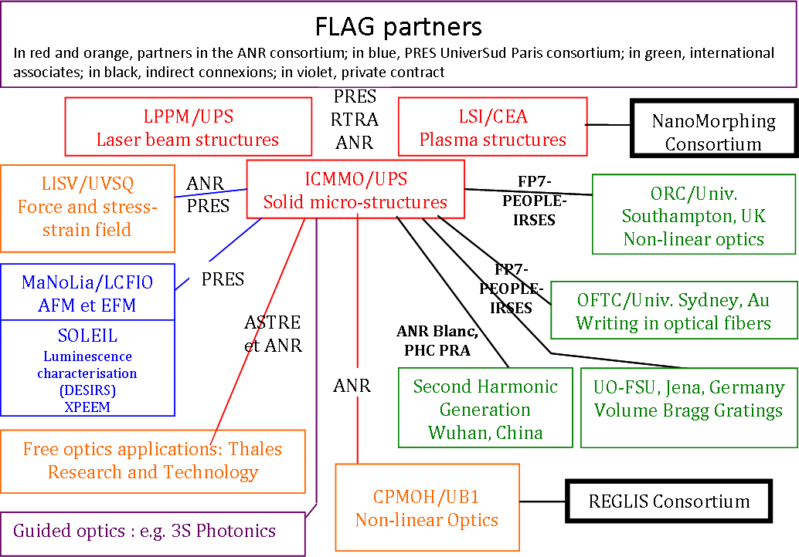

Introduction
Glasses doped with nanoclusters have attracted considerable attention for their ultrafast nonlinear response and large third-order nonlinear susceptibility. They are expected to be promising materials for ultrafast all-optical switches in the tera-hertz (THz) region. Many studies have been carried out on fabrication and characterization of nanoparticle-doped glasses, but it is difficult to control the spatial and size distribution of nanoparticles in materials by the traditional fabrication method such as melting-quenching, sol-gel, ion exchange and ion implanting etc. For the applications in integrated optoelectronics, a well-defined assembly and spatial distribution of nanoparticles in materials is essential. Femtosecond laser (fs) pulses have shown predominant advantage in the space-selective microscopic processing and formation of the three-dimension (3D) modified microstructures, which is attributed to its ultrashort pulse and ultrahigh peak power. Nonlinear optical effects are dominant in the process of femtosecond laser interaction with dielectrics, and this process is strictly limited by the threshold intensity of incident laser.

Project objectives
In this project, we investigate Femtosecond laser induced nanoclusters in glasses for photonic applications. The scientific research and technological objectives of the proposal are as follow:
- to prepare suitable glassy material for nanoclusters precipitation and deformation
- to manipulate, to master the nanocluster shape, their distribution and their orientation within the dielectric matrix. This will allow structuring the linear/non-linear optical properties in the dielectric matrix on demand.
- to study the processes of the formation of metallic or oxyde in silica-based glasses by means of femtosecond laser.
- to investigate the potential applications based on nanocluster containing glasses during the return phase of the project.

Work performed
The first part involves the preparation of the glass matrix material suitable for nanoclusters formation and shaping. During this task the work was the preparation of suitable glassy materials for nanoclusters precipitation. We have thus synthesized and characterized various series of silica based glasses with the following compositions: Na₂O-CaO-SiO₂-Me (Me = Ag, Au, Eu, Sm ions) and Li₂O-Nb₂O₅-SiO₂ by conventional melting quenching technique.

The second part involves the experiment of modification of gold (silver) nanoparticles in Au³⁺(Ag⁺)-doped silicate glasses by varying the fs laser irradiation parameters (laser wavelength, pulse energy, scanning speed, numerical aperture, polarization orientation, scanning direction). We have study the mechanisms of interaction of this material with femtosecond laser in order to control the nanocluster size, filling factor and shape inside the dielectric matrix, and thus to optimise the composite material for the potential targeted applications. We have thus study of the processes of formation and growth of metallic nanoclusters in the different glass compositions mentioned above. This includes various experiments such TEM and SEM for nanoclusters observations, absorption spectroscopy to study the surface plasmon resonance changes with irradiation, linear dichroism for evidencing nanoclusters shaping, refractive index changes (isotropic and anisotropic) and so on …

The third part is investigation on the influence of irradiation conditions including scanning direction and polarization orientation (but also laser wavelength, pulse energy, scanning speed, numerical aperture), and the oxide glass matrix (Li₂O-Nb₂O₅-SiO₂ series) on the precipitation behaviours of nanoclusters (e.g. LiNbO₃). As above we have study the mechanisms of interaction of this material with femtosecond laser in order to control the nanocluster size inside the dielectric matrix, and thus to optimise the composite material for the potential targeted applications. In this part we have specifically focused our attention on birefringence behaviour and oriented crystallization behaviour under certain fs laser irradiation.

Main results
A series of the main achieved research results are summarized as follows:

Development of 3D femtosecond direct writing bench
The realization of a 3D writing bench for femtosecond laser glass micro-processing. A few specificities of this setup are as follows: a high writing speed (cm/s) and thus a high repetition rate tunable from 100 kHz up to 20 MHz, 10 μJ pulse energy, high mechanical stability to minimize photo-induced losses or the ability to move in 3D with a resolution of one hundred nanometers. This femtosecond laser will be merged into a technical multi-user platform within the ICMMO/UPS offering access to ultra-fast, high power and high repetition rate laser technology.

Exploration of both experimentally and analytically the physical processes whereby the nanoclusters are oriented: The nanocluster photo-precipitation is achieved in a space configuration centered on the focus. Heat diffuses radially, and the beam scanning modifies the previous radial geometry into a plane one. For this technique, it is clear that crystallization is achieved in a very large temperature gradient that has a plane geometry with a gradient perpendicular to it and to the direction of scanning. Consequently, if crystallization is sensitive to temperature gradient, it will be defined by the laser scanning orientation in the glass…

Nanoclusters photo-precipitation with high packing density and small size
Recently, laser-based techniques leading to 3D photo-precipitation and further modifications of the metal clusters have proved to be a very powerful and flexible tool to control the size, the density, and spatial distribution of the metallic nanoparticles, and thus optimize the linear and nonlinear optical properties of such materials. In this project, we were able to photo induce locally in 3D, small gold nanoclusters (Typ 5nm) with a very high packing density (as shown in Fig. 1 below) inside Na₂O-CaO-SiO₂ glass matrix.

Gold nanocluster shaping
By irradiation of a Ti: Sapphire fentosecond laser in gold nanoparticles doped silicate glass, strong birefringence but also linear dichroism at the surface plasmon resonance wavelengths has been observed. Nanoclusters shaping due to linear polarized irradiation are likely at the root of these observations.
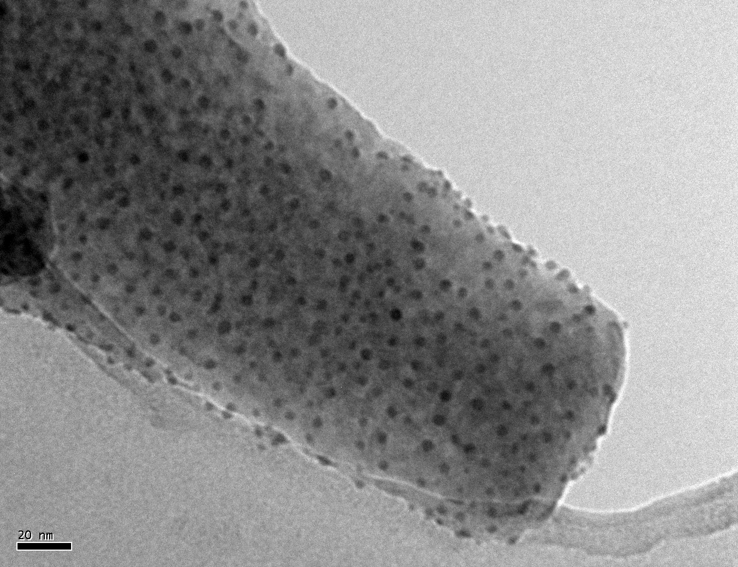
Fig. 1 TEM observation for the 20Na₂O-10CaO-70SiO₂-0.01 Au ions glass after femtosecond laser irradiation.

Asymmetric stress field and chiral mechanical structures
We reveal the stress fields induced by femtosecond laser irradiation varying intensity and writing direction. In this view, we have collected the topography on the edge of cleaved glass samples that is produced by the relaxation of the force on internal surface. It reveals partly the photo-induced stress field. This gives us some indication about the distribution of forces in play during the interaction and thus the structures in the plasma. In addition, the stress field is dissymmetric. Before the focus, a shear stress is detected showing chirality in this interaction process as it was previously reported in pure silica. Furthermore, as we have shown in pure silica, but here in a silicate glass, there is a directional dependence of the stress field for pulse energy above a threshold. The disturbed area is not the same when beam is scanned upward or downward. This arises from the beam structure (asymmetric phase of the electromagnetic field).

Directional dependent writing
It is well recognized that reversing the writing direction should not affect material processing and associated modifications. However, in 2003 and 2008, we demonstrate that when scanning the femtosecond laser beam along the +x and –x directions, the structures (i.e. laser-induced stress) written within pure SiO₂ are partly mirrored. This was the first evidence of “non-reciprocal” or directional dependent photosensitivity in centrosymetric medium. Here, we revealed that this remarkable phenomenon is not specific of pure siliuca glass but can also be observed in Li₂O-Nb₂O₅-SiO₂ series. In addition, we investigated the dependence of this directional dependent writing on writing speed and on the writing geometry (i.e. stage movement direction couple with laser polarization direction).

Strong Birefringence in multicomponent silica-based glasses
Current advanced femtosecond laser systems offer a myriad of material interactions in glassy media, such as surface machining, annealing, 3D refractive index changes profiling etc. Recently, other properties have also arisen, like chirality, non-reciprocal writing, oxidation-reduction, cluster modification and so on. However to our knowledge, form birefringence and related original structures such as self-organized nanogratings, are spectacular but they appear to be only in pure silica. For instance, in BK7 or SiO₂-SnO₂, (16 mol %), no such birefringence is detected. Here we were able to photo induce strongly birefringent Li₂O-Nb₂O₅-SiO₂ silica-based glasses with ultra short laser pulses, which can be tailored to exhibit a controllable birefringent behaviour.

Laser-induced precipitation of micro-crystal in the volume of silica-based glasses
Here we were able to photo induce LiNbO3 micro-crystals in the volume of Li₂O-Nb₂O₅-SiO₂ glasses with ultra short laser pulses. The c-axis orientation can be chosen by playing with the laser scanning direction. We define the laser processing windows in terms of pulse energy, repetition rate, scanning speed for successful crystallization. We also investigate the influence of the glass matrix composition.

Expect final results and potential impact
Hence, by femtosecond laser irradiation, it is now possible to write crystalline dots and lines inside the glass directly. Such techniques may pave the way to the formation of three-dimensional optical memories, ultrafast optical switches, integrated solid state displays and compact solid state laser etc. It appears as a powerful tool for writing optical waveguides, photonic crystals, non-linear materials and maybe also for integrated optic-electronic devices. As a matter of fact, it can be used after some progress for inducing oriented micro-crystallization and later nano-crystallization. But until now, there is no rational definition which can lead to an easy control of crystal growth orientation inside glasses. We are currently working in this direction towards a quantitative interpretation.

