Final publishable summary report

It is well known that migration brings about profound changes in people’s lives, which can lead to stress. The process of adapting to the host society and to organize their lives in this new context is generally referred to as acculturation. While many antecedents of and influences on this process have been studied, most research relies on an individual’s self-reported account of what has led to higher or lower well-being.
This Marie Curie project set out to add a further dimension to the investigation of immigrants’ well-being: research from the intersection of motivational and cross-cultural psychology has revealed that people all over the world become unhappy or even depressed when their explicit goals are incongruent with their implicit needs (Baumann, Kaschel & Kuhl, 2005; Hofer &Chasiotis, 2003; Hofer, Chasiotis& Campos, 2006). If an individual’s implicit motivation is at odds with consciously desired, explicit goals, this tension is experienced as emotional distress (Winter, 1996).
This link is particularly important during stressful life events typical for immigrants, like relocation and loss of social contacts. For example, immigrants who self-reportedly seek assimilation into the host culture, but still feel unhappy and homesick, may experience a discrepancy between explicit motives and their strong, implicit attachment to their culture of origin (Sam, 2006). We have therefore suggested that a simultaneous assessment of implicit motives and explicit goals is necessary for a more comprehensive understanding of migrants’ psychological outcomes.
To complement the focus on motivation and acculturation orientation we furthermore set out to also investigate the role of identity (Marcia, 1980) as a determinant of well-being. It has been shown that motive congruence is not only related to well-being, but also to the identity status of an individual (Hofer, Busch, Chasiotis, &Kiessling, 2006), and that ethnic identity, in turn, is also related to well-being (Liebkind, 2006). Furthermore, identity formation and acculturation orientation share conceptual similarities in so far as both are concerned with negotiate between an exploration into the non-parental host culture and a commitment or maintenance of the parental culture. We suggest that an alignment between both (e.g., actively maintaining one’s culture of origin and taking over parental views of one’s identity) are more beneficial for experiences of well-being than mismatching constellations (e.g., taking over views from one’s parents while at the same time actively exploring the host society).
The inclusion of these areas (motivation, acculturation, and identity) has led to the formulation of a comprehensive path model towards the experience of psychological well-being (see Figure 1).

Figure 1: Conceptual path model towards well-being
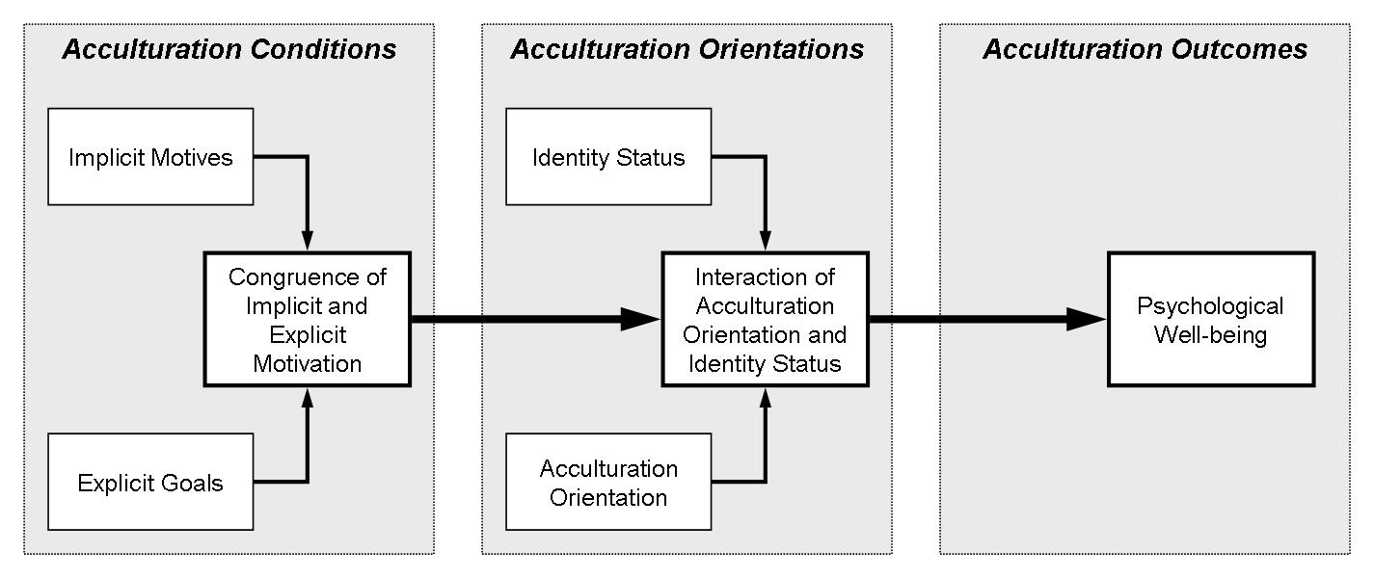

In our study (Bender, Chasiotis, Hofer, & van de Vijver, 2011), we have assessed 134 bicultural Turkish-Dutch individuals, and have asked them to fill out a Picture Story Exercise to assess their implicit motivation (Winter, 1991), the PRF (Personality Research Form) to obtain indices of explicit motivation (Jackson, 1989), and the Extended Objective Measure of Ego Identity Status (EOM-EIS) (Bennion& Adams, 1986), as well as to respond to a scale on acculturation orientation (Arends-Tóth& Van de Vijver, 2006). As outcome variables, we administered several scales on subjective well-being (cognitive: SWLS, Satisfaction with Life Scale, Diener, Emmons, Larsen, & Griffin, 1985; affective: PANAS, Positive And Negative Affective Schedule, Watson, Clark, &Tellegen, 1988).
In support of our notion of a path from implicit and explicit motivation to the interaction of acculturation orientation and identity status towards psychological well-being holds (see Figure 2), we could obtain a satisfactory model fit using structural equation modelling for the relational domain (i.e., implicit and explicit affiliation, achieved identity, adaptation, and cognitive well-being). In particular, we found that an achieved identity was best predicted by a congruence of explicit and implicit affiliation motivation. In turn, a pronounced achieved identity only leads to the experience of cognitive well-being if the individual does not exhibit a strong adaptation orientation. In other words, it might not be beneficial for individuals who have established a clear sense of their identity on the basis of aligning explicit goals and implicit desires to adapt to the host culture. Arguably, an already strong sense of identity is more difficult to malleable, and in terms of individual well-being other approaches might be more promising.
Quite similarly, we also found that individuals that have adopted their identity largely from their parents (foreclosure identity status) experience lower negative affect when they actively maintain their culture of origin. At the same time however, they still report a low cognitive well-being. While an alignment thus seems to be a buffer against negative affect, people might still be cognitively aware of their problematic situation.
But are there other pathways that are more conducive for an adaptation orientation when following this line of thought? Indeed: Individuals that are still in a state of moratorium (who are still exploring their identity) and pursue an adaptation orientation show higher cognitive well-being. Individuals, that do not explore their identities anymore (low moratorium), however, benefit from a maintenance orientation – a combination that also leads to high cognitive well-being.

Figure 2: Obtained path model towards well-being

To summarize, this study represents the first to include implicit measures in the investigation of acculturation, and we could demonstrate that motivational congruence (implicit/explicit) is an important and up till now neglected predictor of well-being. We found evidence for the proposed path model: Motivational congruence (implicit/explicit) predicts an achieved identity status, which in turn interacts with adaptation to predict well-being. Including these variables provides a more fine-grained analysis that explains the complex situation of immigrants, both with regard to cognitive as well as affective measures of well-being. We observed that individuals with a firmly established sense do not benefit from pursuing the orientation to substantially adapt to the host culture. Complementing this finding, we also showed that relying on parental views for the establishment of one’s identity goes better together with an active pursuit of maintaining one’s culture of origin, while an ongoing exploration of one’s identity in a moratorium holds more positive effects for well-being when actively exploring the host culture.

