1. FINAL PUBLISHABLE SUMMARY REPORT

Influenza virus continues to represent a major global health problem and the recent pandemic caused by a H1N1 strain on influenza A (swine flu) is a good example of its potential global threat to health. In most cases vaccination confers in most of the cases protection against the disease, mainly due to a robust response mediated by antibodies. One of the major goals of the currently availiable vaccines is to induce a robust neutralizing antibody response against the major antigens in the virus. However, the current availiable available vaccines against influenza are hampered by the need of yearly vaccinations in order to protect against new circulating variants of the virus. Another important limitation of the current influenza vaccines is the development of suboptimal immunogenicity in the elderly, in patients with serious chronic diseases and in the immunocompromised and young children, which correlates with higher morbidity and mortality in these risk groups. The reduced efficacy of the vaccines in these groups is mainly related with deficiencies in their immune responses. In addition, the presence of adjuvant in the formulation of most of the commercially available vaccines has been questioned due to potential health risks associated with their toxicity. Many of this problematic is associated with the fact that the mechanisms that make the infuenza vaccine effective are poorly understood. A better understanding of the mechanisms of the vaccine works could overcome, at least partially, the effects of antigenic variation in the influenza virus and it could help to the development of more efficacious therapies against the disease.
One of the main objectives of the INIMIN project was to elucidate the mechanisms that lead to the initiation of the protective response agaisnt an influenza vaccine in the lymph node, the organ where the protective response against the vaccine is initiated. By multiple approaches, including innovative microscopy techniques such as multiphoton intravital 2-photon microscopy, spinning disk confocal microscopy and standards techniques such as electron microscopy or FACS, we found that a type of specialized cells, referred to as subcapsular sinus macrophages and located in the lymphatic vessel entrance in the lymph node, captured inactivated influenza virus and helped to prevent the systemic spread of virus in the body. However, these cells were not required for the generation of influenza-specific antibodies. Instead, our study showed that a new type of cells, lymph node resident dendritic cells which reside in the lymph node, captured the virus using a specific type of receptor named SIGN-R1 and promoted the production of specific antibodies against the virus. These findings described a novel pathway of antigen transport to the follicles and an important new role to the lymph node-resident DC in the initiation of the protection against influenza virus. Our results have implications for the generation of durable humoral immunity to viral pathogens through vaccination. For example, knowing which cells are important in the capture and transport of the virus to the B cell areas where the antibody response will be initiated could help the design of new therapies that specifically target these cells. These new therapies could improve the ability of these cells to respond against the vaccine thereby improving the antibody response and the efficiency of the vaccine. A summary of these findings is represented graphically in Figure 1.

The results of this study have been published in the high-impact factor Nature Immunology journal. In addition, we have published four other reviews in other important journals in the field of immunology such as Annual Reviews in Immunology or Current Opinion in Immunology, where we discuss the relevance of our findings in the context of the immune responses to virus.
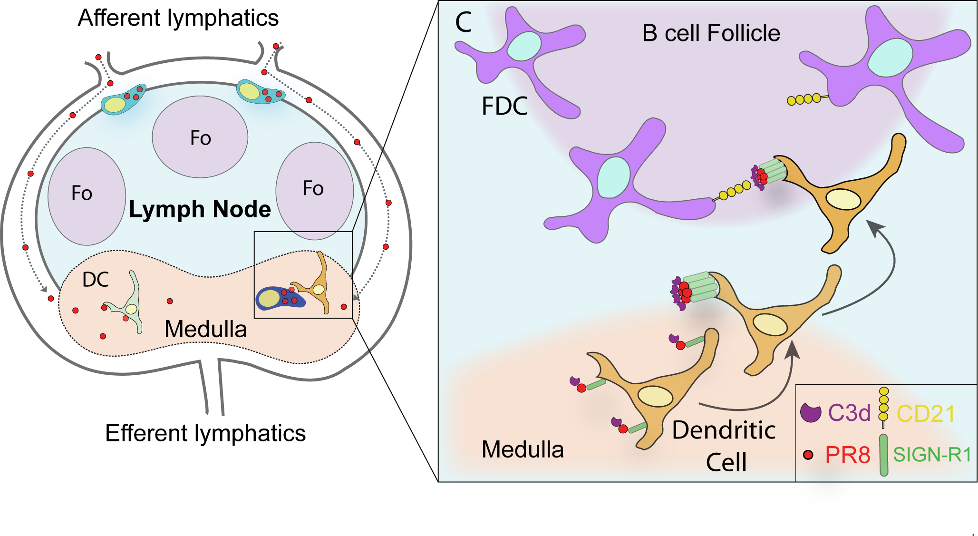
Figure 1. Model for the capture and trafficking of influenza virus in the lymph node. The left panel represents the different areas of the lymph node. The lymph-borne UV-inactivated influenza virus (red dots) fills the sinuses of the lymph node and is captured by lymph node resident dendritic cells (DC). The right part of the graph shows the DC-mediated transport of influenza virus from the medullary area to the B cell follicle where the antibody response will be initiated. This transport is dependent on the receptor SIGN-R1. (Gonzalez et al., 2010).

