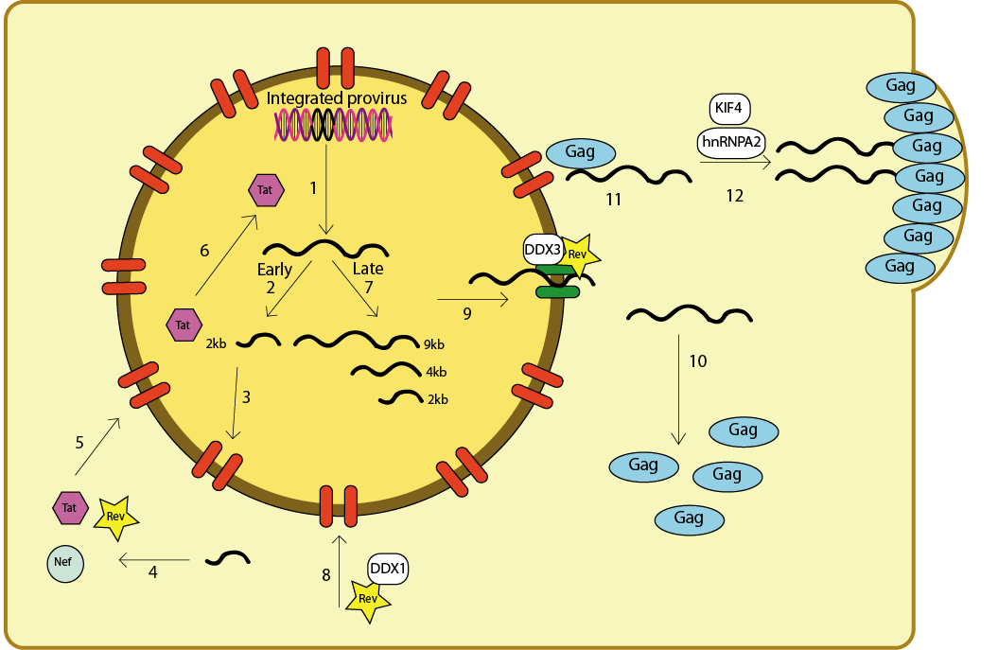

Figure 1. Overview of HIV-1 RNA biology. In the early phase of gene expression viral RNAs are transcribed (step 1), capped, polyadenylated, spliced (step 2), exported to the cytoplasm (step 3) and translated into Tat and Rev (step 4 and 8). Tat and Rev enter the nucleus (step 5, step 8) where they transactivate viral transcription (step 6) and modulate RNA splicing (step 7), respectively. Rev is crucial to the export of the gRNA and 4kb class of viral mRNAs that contain introns as they are not fully spliced (step 9). gRNA is translated into Gag and Gag-Pol (step 10) and/or packaged (step 11). Both Gag and gRNA are thought to be transported to the plasma membrane assembly site via microtubules (step 12). The virus diverts several cellular factors (white boxes) to aid its gene expression and assembly steps. Adapted from (18).

SVC21 wt
mock
SVC21 ΔP1
LAI wt
LAI ΔDIS

Figure 2. Visualisation of centrosomes in HIV-1-producing cells. Hela M cells were transfected with HIV-1 expressing molecular clones (wild type SVC21 or LAI and mutant ΔP1 and ΔDIS) and fixed 20 hours post transfection with 3.7% formaldehyde. Cells were permeabilised with 0.1% Triton X100 and blocked in 5% bovine serum albumin. Samples were probed with anti Gag and anti pericentrin antibodies which were visualised with secondary antibodies conjugated to alexafluor 488 (green) or 546 (red). Nuclei were stained with Dapi. Overlay pictures are shown with Gag in green, pericentrin in red and nuclei in blue. ΔP1 and ΔDIS mutants are deleted in the RNA packaging and dimerisation motifs, respectively, which reside in the 5’ untranslated region of the gRNA. Results are equivalent in C33A, 293T, SupT1 or Jurkat cell lines.

Figure 3. Knock-down of kinesins differentially affects production of HIV-1 infectious particles. Virus production and infectivity (white and black bars, respectively) were determined upon pLAI-siRNA co-transfection as fold change over control transfections with a non-targeting, negative control siRNA (siNegCtl). A small sample of the results for three independent experiments is shown. siRNAs targeting DDX3 and TSG101 were included as positive controls (3, 15). The University’s Technology Transfer office advised me not to disclose the identity of the kinesin proteins to protect potential intellectual property rights.

Figure 4. Cell-viability upon siRNA transfection. Cell viability was measured in a CellTiterGlo ATP production assay (Promega) according to the manufacturer's instruct-tions. Zeocine was added as positive control for inducing cell death. RLU, relative light units.

A.
B.

Figure 5. siRNAs targeting KIF7 reduce total Gag production. Panel A show HIV-1 particle production in 293T cells, panel B in HeLa cells. The upper panels show infectious particle production (black bars), Gag production in supernatant (white bars) and intracellular Gag production (checked bars). The values are indicated as relative to virus production in the presence of negative control siRNAs (NC) which is set as 1. A pool of 3 siRNAs was used to target KIF7 and the positive control TSG101, which has an established role in HIV-1 budding. The lower panels show infectious particle production for the individual KIF7 targeting siRNAs.

