1. **Final publishable summary report**

*This section normally should not exceed 2 pages.*

*In the course of this project we carried out a detailed structural and functional characterisation of doped ZnO nanowires synthesised within polycabonate templates via a direct electrodeposition technique. The composition and structure of the nanowires were investigated using transmission electron microscopy (TEM), X-ray diffraction (XRD), extended x-ray absorption fine structure (EXAFS) and x-ray absorption near edge structure (XANES). The magnetic properties of the systems were studied using a superconducting quantum interference device (SQUID) magnetometry.*

*In the case of transition metal doped ZnO nanowires such Co-doped ZnO nanowires it was observed that although the nanowires are polycrystalline in nature they are highly textured and have both single crystal and polycrystalline regions. Using TEM and corresponding elemental detection methods it was also observed that there were no detectable variation in the composition between the different regions of the nanowire*

*EXAFS and XANES measurements the absence of secondary phases such as ZnCo alloys or Co nanoclusters and proved that Co is fully incorporated into the lattice*

*Magnetic measurements confirmed the presence of a magnetically ordered phase at T<350 K, which is attributed to dilute Co2+ ions in the ZnO nanowires.*

*Co-doping with Ag+ or Cu+ to produce p-type materialwas achieved by simple bath modification; Ag-doping resulted in the formation of a black film due to the generation of colour centres in the material; this effect is still being investigated at the host institution.*

*In this project have used a simple low-cost, low temperature electrodeposition process to synthesise doped ZnO nanowires with ordered architectures. A thorough characterisation of these 1-d nanostructured arrays has helped us develop a better fundamental understanding of the relationship between structure and functional properties of these materials which are potential candidates for use in future functional electronic devices.*

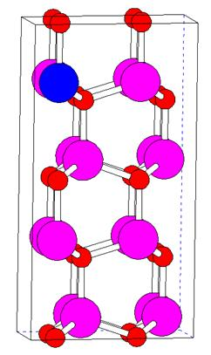

*TEM image of a Zn1-xCoxO nanowire showing the textured nature of the nanowire with (002) growth direction being the most dominant(left) ; Pictorial depiction of a the subsititional position of the Co2+ ion in the ZnO lattice;*

**

*Magnetic hysteresis loops for Zn1-xCoxO nanowires at 5 and 293 K. Inset shows clear hysteresis at low fields*