FRONT PAGE

PROJECT FINAL REPORT
Grant Agreement number: 223340
Project acronym: TBsusgent
Project title: Sustaining research momentum over the coming decades: mentoring the next generation of researchers for tuberculosis
Funding Scheme: SP1-Cooperation
Period covered: from May 2010 to April 2012
Name of the scientific representative of the project's co-ordinator, Title and Organisation:
Dr Keertan Dheda, University College London
Tel: +27 21 4066509
Fax: +27 21 4047651
E-mail: keertandheda@yahoo.co.uk
Project website address: www.tbsusgent.org
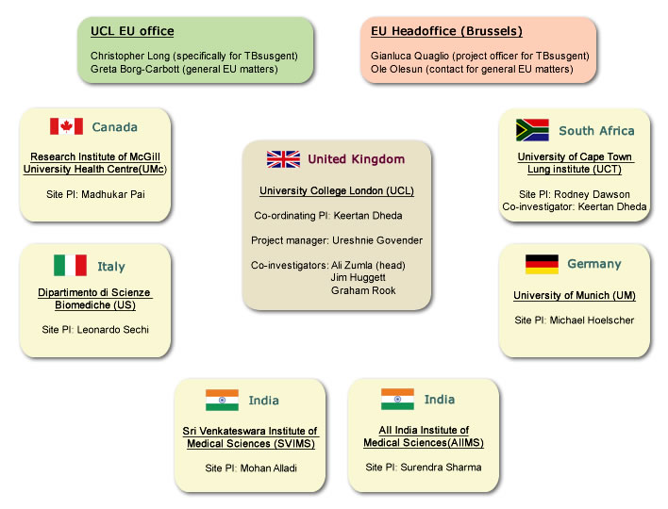
Figure 1. The EU project management team and TB Susgent Collaborators.

Table 1. The members of the consortium and their key focus of activities are outlined in the table above.

A
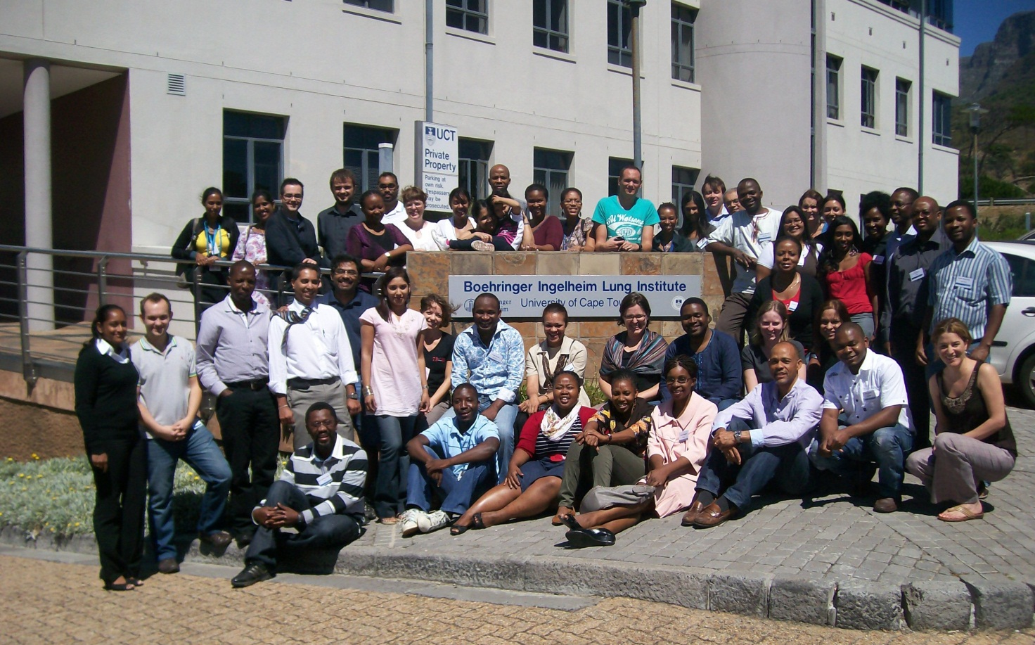
B
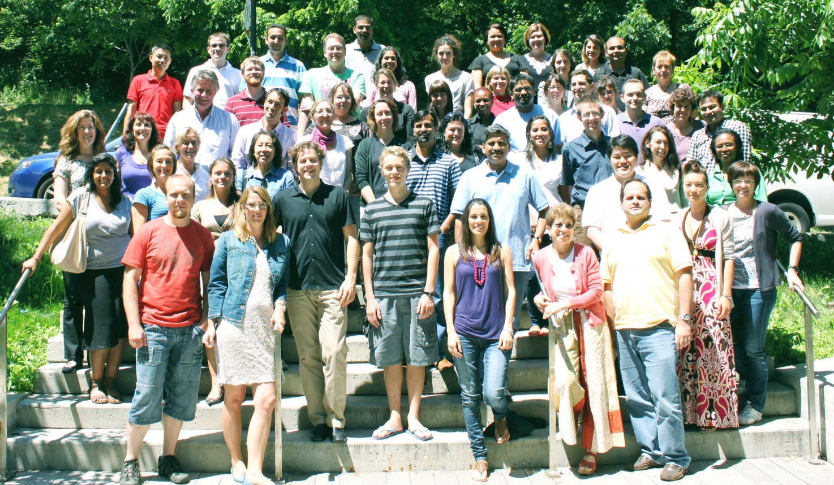

C
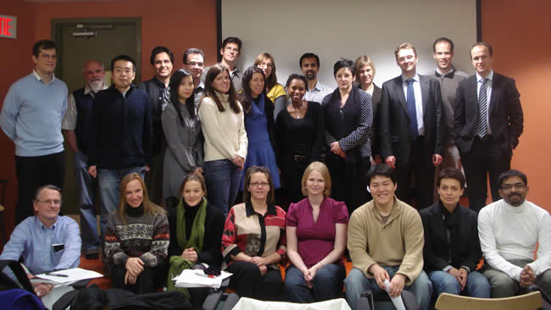
Figure 3 A, B and C National and international delegates that attended diagnostics research courses (jointly run by UCT and McGill in South Africa).

Table 2. The postgraduate students elected to conduct research under the TB Susgent grant.
Beneficiary number | Name of trainee | Programme type | Project
1 (UCL) | Anil Pooran | PhD | The role of IL-4 and IL-4δ2 in TB-specific host immunity  in South Africa
1 (UCL) | Tamaryn Cashmore | MSc | The diagnosis of M.tuberculosis (M.tb) infection using novel biological samples and immuno-diagnostic assays
 | Ranks Lloheonya | PhD | Different rechallenge regimens in CADR and antigen-specific expression profiles in the skin of TB patients
2 (US) | Valentina Rosu | PhD | Purification of MTB HBHA, cloning and purification of other Mycobacterial proteins
2 (US) | Speranza Masala | PhD | Isolating and Typing of MTB isolates
2 (US) | Tabrez Shaik Hussein | PhD | Isolating and Typing of MTB isolates
3 (AIIMS) | Hridesh Mishra | PhD | Smoking / TB clinical trials
4 (SVIMS) | Prakash Babu | PhD | Vitamin D and tuberculosis
5 (UCT LI) | Richard Van Zyl Smit | PhD | The role of tobacco smoke constituents in subverting pulmonary host immunity to tuberculosis
5 (UCT LI) | Shahieda Adams | PhD | An evaluation of immunodiagnostic tests for Tb and determinants of Tb infection in a population of health care workers in the Western Cape
5 (UCT LI) | Elize Pieterson | PhD | Impact of geographical, clinical and social factors related to XDR-TB on tuberculosis health care service delivery in South Africa
5 (UCT LI) | Jonny Peter | PhD | Novel clinical and immunological approaches to smear negative TB in a resource-limited high TB/HIV prevalent setting
5 (UCT LI) | Vinod Patel | PhD | Novel tools for the diagnosis of TB meningitis
5 (UCT LI) | Hoosain Khalfey | PhD | Use of RCTQ steriods for treatment of community acquired pneumonia
5 (UCT LI) | Karen Shean | MSc | Multi Drug–Resistant and Extensively Drug Resistant tuberculosis in the Western Cape Province, South Africa
5 (UCT LI) | Alice Maredza | PhD | The role of regulatory T cells in tuberculosis
5 (UCT LI) | Laura Lenders | MSc | Evaluation of newer and novel technologies for TB diagnosis using samples obtained from different biological compartments
5 (UCT LI) | Malika Davids | PhD | Preliminary immunological studies in patients with extensively drug resistant tuberculosis (XDR-TB)
6 (McGill) | Alice Zwerling | PhD | Evaluation of biomarkers and novel tests for tuberculosis
6 (McGill) | Daphne Ling | PhD | Alternative and innovative approaches to TB diagnostics research: going beyond the test accuracy paradigm
6 (McGill) | Hojoon Sohn | PhD | Role and cost-effectiveness of POC tests for TB
6 (McGill) | Jessica Minion | MSc | LED microscopy for diagnosis of tuberculosis
6 (McGill) | Laurence Brunet | MSc | Tobacco Smoking and Spectrum of Tuberculosis Infection and Disease in South African Patients with Suspected Tuberculosis
6 (McGill) | Caroline Chartrand | MSc | Evaluation of rapid diagnostics for influenza
6 (McGill) | Ioana Nicolau | MSc | Evaluatio of SmokeScreen and IsoScreen assays in TB patients in Montreal
7 (UM) | Gabriel Rojas | PhD | Evaluation and improvement of novel diagnostic tools for the rapid detection of M. tuberculosis in HIV-negative and HIV-positive adults with pulmonary TB
7 (UM) | Dickens Omondi Kowuor | MSc | TB diagnsostics in high burden settings
Table 3. McGill Students involved in WP 6 ( Epidemiology and bio-statistics), and trips attended by McGill epidemiologists and biostatistician (attached below).
 | Name of trainee | Qualifications | Program type |  | Project |  |  | Date of Completion
 | Alice Zwerling | MSc | PhD |  | Evaluation of biomarkers and novel tests for tuberculosis |  |  | 2012 (expected)
 | Daphne Ling | MPH | PhD |  | Alternative and innovative approaches to TB diagnostics research: going beyond the test accuracy paradigm |  |  | 2012 (expected)
 | Hojoon Sohn | MPH | PhD |  | Role and cost-effectiveness of POC tests for TB |  |  | 2014 (expected)
 | Jessica Minion | MD | MSc |  | LED microscopy for diagnosis of tuberculosis |  |  | Summer 2010 (completed)
 | Laurence Brunet | BSc | MSc |  | Tobacco Smoking and Spectrum of Tuberculosis Infection and Disease in South African Patients with Suspected Tuberculosis |  |  | Summer 2010 (completed)
 | Caroline Chartrand | MD | MSc |  | Evaluation of rapid diagnostics for influenza |  |  | Summer 2011 (completed)
 | Ioana Nicolau | BSc | MSc |  | Evaluatio of SmokeScreen and IsoScreen assays in TB patients in Montreal |  |  | Summer 2011 (completed)
 | Molebogeng Rangaka | MD | Visiting scholar |  | The predictive value of IGRA for incident TB disease in low, middle and high income countries: A systematic review |  |  | July 2010
Research Project |  |  |  | Dates |  | Location | Institution |  | Trainee who participated | Local supervisors
Incremental value of IGRAs beyond conventional tests in adults evaluated for suspected active pulmonary TB in South Africa |  |  |  | Sept - Dec 2009 |  | Cape Town | University of Cape Town |  | Daphne Ling | Prof. Keertan Dheda
Tobacco Smoking and Spectrum of Tuberculosis Infection and Disease in South African Patients with Suspected Tuberculosis |  |  |  | Sept - Dec 2009 |  | Cape Town | University of Cape Town |  | Laurence Brunet | Prof. Keertan Dheda
Longitudinal study repeating the QFT test over 4 time points in HCWs in Sevagram, India |  |  |  | Feb - March 2010 |  | Sevagram, India | Mahatma Gandhi Institute of Medical Sciences, Sevagram, India |  | Alice Zwerling | Prof. SP Kalantri & Dr Rajnish Joshi

Table 4. McGill trainees have received support from TBsusgent to attend the following external biostatistics and TB epidemiology courses
Course or workshop | Dates | Location | Institution | Trainee who participated | Instructors
International Child TB Training Conference | Sept 14 - 18, 2009 | Cape Town, S Africa | Stellenbosch University, S Africa | Daphne Ling | Prof Ben Marais et al.
Advanced Diagnostic Research (CE10) | March 8 - 12, 2010 | Utrecht, The Netherlands | University of Utrecht Graduate school of Life Sciences | Daphne Ling | Prof Carl Moons
Using Stata Effectively: Data Management, Analysis, and Graphics Fundamentals | May 19–20, 2010 | Boston, USA | Stata Corp | Caroline Chartrand; Daphne Ling; Hojoon Sohn | Stata staff
Introduction to Infectious Disease Modelling & Its Applications | 05 - 16 July 2010 | London | London School of Hygiene & Tropical Medicine, London, UK | Hojoon Sohn | Prof Emilia Vynnycky & Prof Richard White
Applied logistic regression and survival analysis | July 12 – 16, 2010 | Columbus, Ohio | Ohio State University | Daphne Ling | Prof Stan Lemeshow & Prof David Hosmer

Usually the contact person of the coordinator as specified in Art. 8.1. of the Grant Agreement.
Username: uctli, password: susg01

