Figure 1: The catchment area of different railway stations in Amsterdam

1. Amsterdam Centraal
3. Amsterdam Zuid
6. Amsterdam Lelylaan
7. Amsterdam Muiderpoort

Figure 2: The utility from using different access modes to the station at different distances from the station
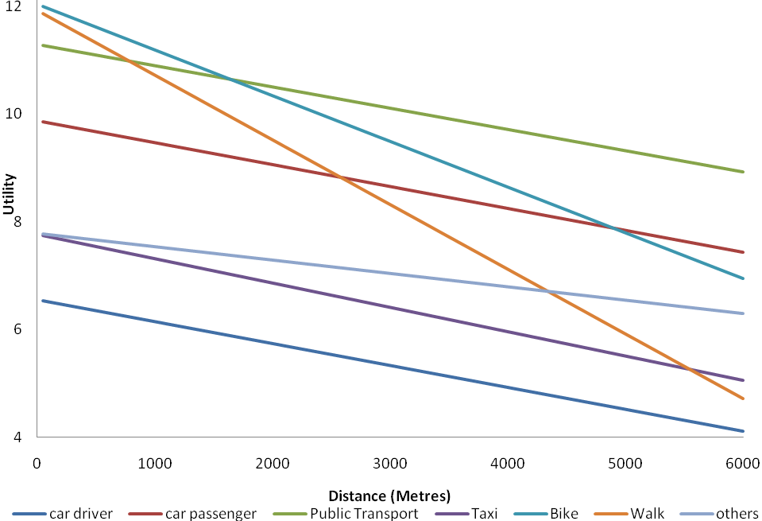

Figure 3: Location of commercial land uses per building height in Amsterdam

