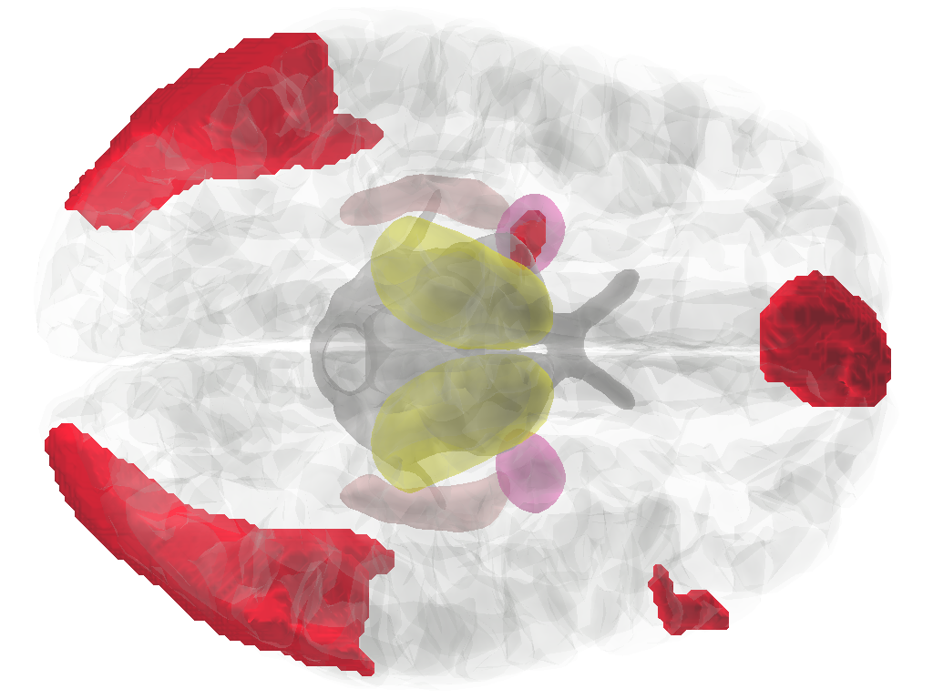
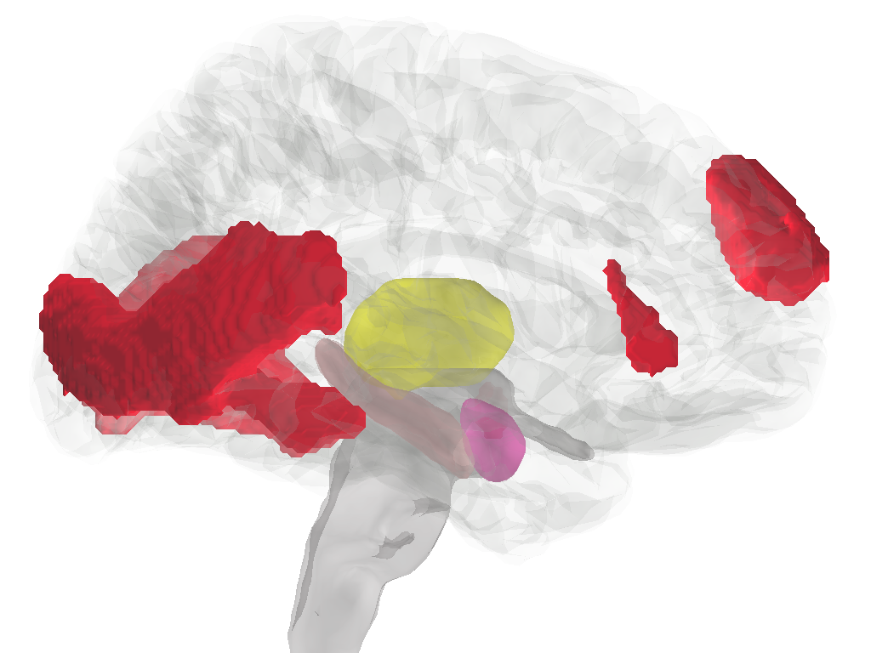
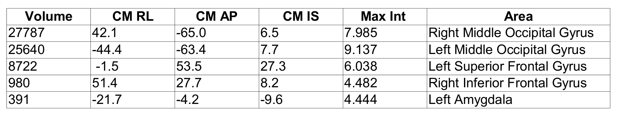
Figure 1. Negative high arousal stimuli vs Neutral low arousal stimuli in all participants.

