
Figure 1. Project logo.

The original overall goal of the project was the achievement of Doppler shifting, sharp dynamic (i.e., time dependent) reflecting/refracting interfaces in metamaterial media. This goal was to be implemented a) at THz wavelength and b) in a 1D waveguide layout. A thorough analysis during the first months has indicated difficulties that have motivate a change of the main goal, towards the fabrication of a low-loss metamaterial 2D interface (for 3D systems), which allows a fine and novel control on the refraction and reflection phenomena.

We have now fully theoretically studied, simulated, fabricated and characterized such interfaces started during phase 1. We have experimentally demonstrated a modification of Snell's law of refraction. The ohmic losses in our system are under 10%.

We have studied the single elements (meta-atoms) that compose the metasurface. These meta-atoms work as antennas with two resonances, and introduce light scattering in cross polarization. We have found general rules to control the amplitude, phase and polarization of scattering by these elemental antennas.

With the results of such study, we predict that these antennas can be used as basic building blocks for a lot of applications. We have demonstrated these ideas by studying, simulating, fabricating and characterizing vortex masks (figure 2).

The work has been a complete success on the scientific side. Beside other published and incoming papers, we have published a paper in Science magazine (cover story), which has also featured a perspective commentary on our work by Nader Engheta, a leading expert of metamaterials. Our work has been featured as cover story by Physics Today magazine, November 2011 issue. Additional studies on the vortex masks are upcoming as cover story in January in Applied Physics Letters. We already have received invitations to a number of international conferences. The invitations received by Dr. Gaburro include Photonics West 2012 conference (San Francisco, USA, January 2012), Meta 2012 (Paris, France, April 2012) and Annual Meeting of Optical Society of America (Colorado Springs, USA, June 2012).
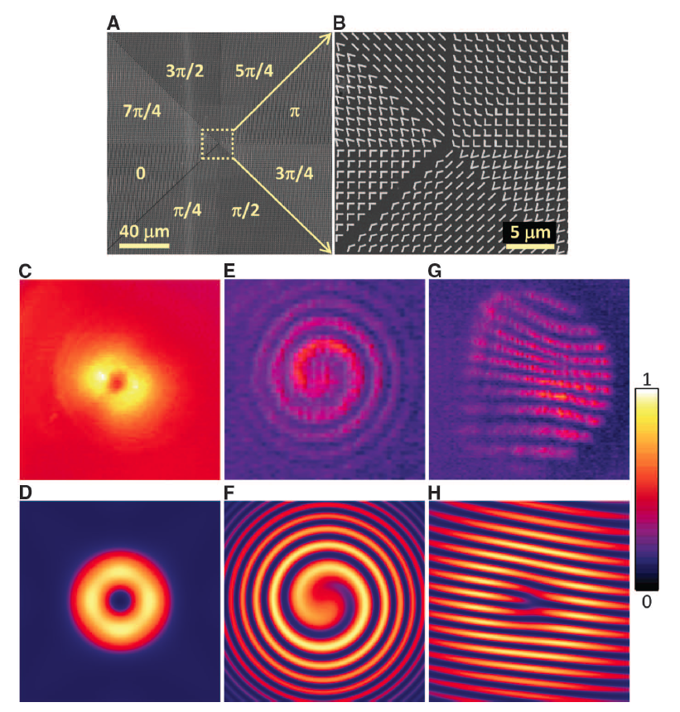
Figure 2. (A) SEM image of a plasmonic interface that creates an optical vortex. The plasmonic pattern consists of eight regions, each occupied by one constituent antenna of a specially designed eight-element set. The antennas are arranged so as to generate a phase shift that varies azimuthally from 0 to 2p, thus producing a helicoidal scattered wavefront. (B) Zoom-in view of the center part of (A). (C and D) Respectively, measured and calculated far-field intensity distributions of an optical vortex with topological charge one. The constant background in (C) is due to the thermal radiation. (E and F) Respectively, measured and calculated spiral patterns created by the interference of the vortex beam and a co-propagating Gaussian beam. (G and H) Respectively, measured and calculated interference patterns with a dislocated fringe created by the interference of the vortex beam and a Gaussian beam when the two are tilted with respect to each other. The circular border of the interference pattern in (G) arises from the finite aperture of the beam splitter used to combine the vortex and the Gaussian beams (20). The size of (C) and (D) is 60mmby 60mm, and that of (E) to (H) is 30 mm by 30 mm.

