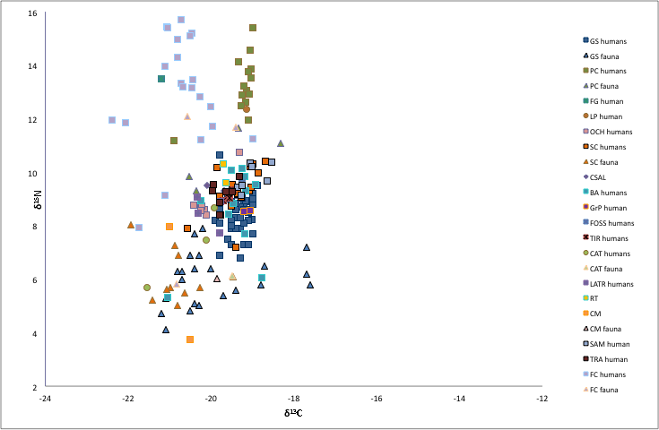

Figure 1. Stable C and N isotope data on the Neolithic samples. Legend: GS=Grotta Scaloria, PC=Passo di Corvo, FG=Foggia, LP=Lama dei Peligni, OCH=Occhito, SC=Serra Cicora, CSAL=Carpignano Salentino, BA=Bari, GrP=Grotta Patrizi, FOSS=Fossacesia, TIR=Tirlecchia, CAT=Catignano, LATR=Latronico, RT=Ripatetta, CM=Casalmoro, SAM=Samari, TRA=Trasano, FC=Fornace Cappuccini.

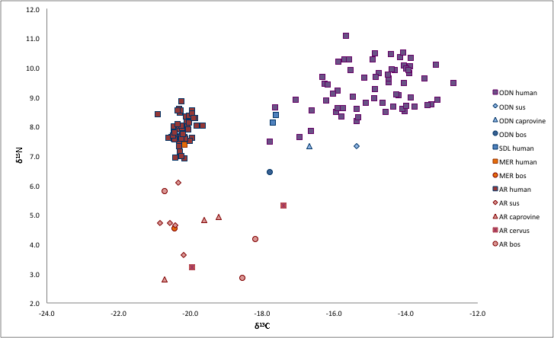

Figure 2. Stable C and N isotope data on the Bronze Age samples. Legend: ODN=Olmo di Nogara, SDL=Sedegliano, MER=Mereto, AR= Arano di Cellore di Illasi.

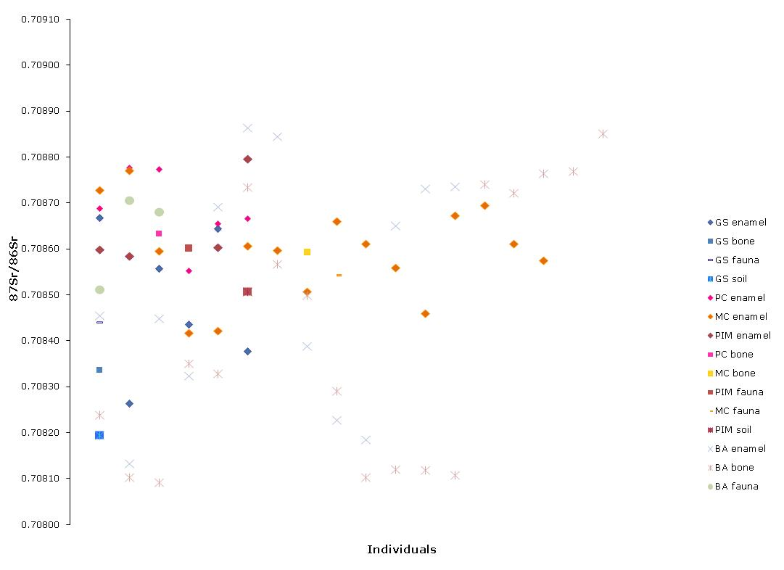

Figure 3. ⁸⁷Sr/⁸⁶Sr concentration in human, animal bone and enamel. Soil samples are also depicted.

