Summary description of the project objectives
Our research objectives are the development of sensitive, robust, and versatile sensors for nucleic acids in point-of-care or in-the-field type assays that can be used for the detection of microorganisms in third world water supplies, in food products, or in medical applications such as the bedside identification of blood borne organisms causing sepsis. The advantages of magnetic relaxation switch (MRS) methodology for point-of-care assays include its use of radiofrequency radiation rather than light (indifference to light based interferences), and its use of solution phase chemistry (no solid phase, no separation of free and bound as in ELISA's). Current state of the art methods of identifying microorganisms are typically microscopy based or culture based and are not readily adaptable to such point of care uses.

Description of the work performed since the beginning of the project

The attainment of the research objectives of this grant were divided in two phases: a) Phase I provided fundamentally new methods for the rapid detection of nucleic acids with application on microorganisms’ detection using MRS methods; b) Phase II will provide the proof of concept for application of MRS within a new tumoral cell lines detection in vitro system. The proposed research is highly interdisciplinary, joining concepts of Nanoparticle synthesis, surface chemistry, Magnetic Resonance and nucleic acid sequences defining the family of the microorganism. In the field of detecting and quantifying nucleic acids there are two big research areas:
1) Non amplification methods (that include techniques like “ Fluorescence in situ Hybridization” or “Northern Blot”).
2) Amplification based methodologies (that include techniques like “Reverse Transcription-PCR” or “Nucleic Acid Sequence-Based Amplification”).
In the first period of the Phase I (2010), our approach was the identification of microorganisms based on ribosomal RNA (rRNA) detection using a non-amplification methodology. The rRNA sequence were chosen considering: a) rRNA is present is all organisms; b) rRNA is the most abundant nucleic acid in bacteria; c) Can be detected without amplification methods; d) rRNA contain highly conserved sequences and hyper-variables sequences that allow us to design general and species-specific probes; e) Existence of free databases with specific probes targeting rRNA.
In first year of research we validated the MRS technology as a “Non amplification” technique and our efforts were focused on the objectives 1, 2 and 3 described in the grant proposal (Part B).
In the second period of Phase I (2011) our research was focused on the development of a new amplification-based methodology for ultrasensitive detection of nucleic acids. Firsts results showed big potential in this new area that will expand the sensibility of nucleic acids and microorganisms’ detection using the MRS technology.

Description of the main results achieved so far

Phase I: The MRI_Nanobiosensor project has proved for first time the application of MRS methodology for identification of rRNA and, hence, microorganism detection using a non-amplified technique. Based on Fuchs work , we selected a 18-bases oligonucleotide sequence as our target molecule for the switch, the one that Fuchs identified as 100% accessible. The detection by MRS was achieved by using superparamagnetic nanoparticles functionalized with complementary oligonucleotides.
The switch showed very good response with ΔT2 values over 40 ms (ΔT2 = /T2 initial - T2 final/) that could be tuned adjusting the initial concentration of the reactants. Incubation with non-complementary strand didn't produce any signal showing that our MRS was selective towards the oligonucleotide sequences (Fig. 1).

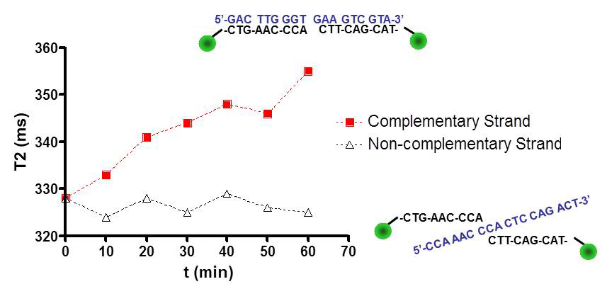
Figure 1. Selectivity study of the MRS with non-complementary strands. In this conditions clustering of the nanoparticles produced a ΔT2=28ms. No clustering was observed with the non-complementary strand.

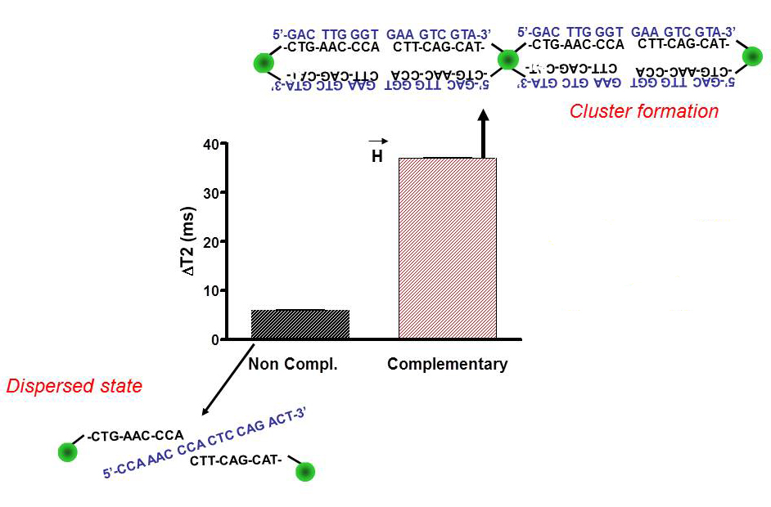
Figure 2. Magnetic Field Enhanced Target Aggregation experiment with non-complementary rRNA strand and with the complementary strand. Magnetic clustering enhances MRS signals.

Applying the Magnetic Field Enhanced Target Aggregation technique to our switch (Fig. 2) the sensitivity was increased nearly a double when applied sequentially to normal MRS technique. It was also discovered that the MRS system was extremely sensitive to buffer changes and both, ΔT2 values and selectivity were dramatically affected when we moved to other buffers.
MRI_Nanobiosensor project have also bridged the gap for a new ultrasensitive MR sensor of nucleic acids in amplification methodologies (PCR, rt-PCR, etc.) with a wide range of applications in molecular biology and biochemistry.
The need for sequence independent PCR detection methods has led to the search for fluorochromes which bind to dsDNA tightly, with ever greater increases in fluorescence upon binding. Our approximation to this problem has been the attachment of a fluorochrome to the surface of a superparamagnetic nanoparticle to obtain DNA binding fluorochrome-magnetic nanoparticles. The new sensor showed a slightly higher sensibility when used to monitor a model PCR reaction by fluorescence. When monitored by magnetic resonance (MR), the sensitivity of the sensor was up to 10 times higher than registration by standard methods based in fluorescence.
Phase II: We developed a new proof of concept application of MRS termed Surface Mediated Magnetic Relaxation Switch (SM-MRS) for in vitro detection of tumoral cell lines through its abnormal glycosylation patterns and specific lectin functionalized nanoparticles (NPs) (or viceversa). Preliminary experiments with carbohydrate functionalized magnetic NPs and different lectin-decorated surfaces (glass and polymer) were performed and analyzed by MRI and relaxometry. The SM-MRS showed a good response and selectivity towards selected carbohydrates that may be easily translated to point of care devices. Cell experiments to determine the response of carbohydrate-decorated NPs against cancer cell lines within our platform were performed but reported limited or null sensitivity on the conditions studied. Further experiments are in process to validate both, the application and the proof of concept defined above.

Expected final results and their potential impact and use
MRI_Nanobiosensor project succeeded in both phases: Phase I, designing nucleic acid biosensors for both, amplifying and non-amplifying methods and Phase II, design of new platform with potential application on tumoral cell detection.
Phase I: For the non-amplifying method a stable nanoparticle platform able to detect rRNA from E.Coli were obtained. Measurements were accurate and fast but sensible to external factors like ionic strength and type of buffer used. These factors limited the clinical applications at present.
For the amplifying method, the success was achieved by combining three novel principles: (i) fluorochrome mediated, DNA binding surface design, (ii) multivalency enhanced, solution phase, microaggregate formation when fluorochrome functionalized NP’s bind DNA and, (iii) detection of NP/DNA microaggregates by MR. These three principles were combined to obtain a highly sensitive general method of detecting, without risk of post-amplification contamination, the DNA generated by the PCR reaction. This general method can be applied in basic research and translated to clinics (clinical microbiology, virology, hematology, etc.). A patent covering these applications have already been filed and recently licensed to T2-Biosystems company.
Phase II: A new analytic platform, so-called Surface Mediated Magnetic Relaxation Switch (SM-MRS), has been designed and tested with carbohydrate functionalized NPs. The preliminary results showed good response with proteins, and might offer several potential applications in biomedicine such as array cancer screening.

Dmitri Ivnitski, Ihab Abdel-Hamid, Plamen Atanasov and Ebtisam Wilkins, Biosensors and Bioelectronics, 1999, 14, 599-624
B. M. Fuchs, G.Wallner, W.Beisker, I. Schwippl, W. Ludwig and R. Amann, Appl Envirom Microbiol, 1998, 64, 4973–4982
David Alcantara, Yanyan Guo, Hushan Yuan, Craig J. Goergen, Howard Chen, Hoonsung Cho, David E. Sosnovik, Josephson, L. Angew. Chem. Int. Ed., 2012, 51, 6904-7

